Parallel Change Detection in Satellite Images using CPU, OpenMP, and GPU

Piyush Pardesi Prince Kumar
Department of Computer Science Department of Computer Science SRM Institute of Science and Technology SRM Institute of Science and Technology
pp3055@srmist.edu.in pk0201@srmist.edu.in

Kartik K Dr. Brindha R
Department of Computer Science Department of Computer Science SRM Institute of Science and Technology SRM Institute of Science and Technology
kk1024@srmist.edu.in brindhar1@srmist.edu.in

Abstract—As satellite imagery resolution increases, the com-putational demand for real-time change detection scales non-linearly, necessitating an evaluation of parallel computing paradigms. This paper presents a comprehensive comparative analysis of three distinct implementation architectures for a change detection pipeline: a baseline sequential CPU imple-mentation, a multi-threaded OpenMP framework, and a GPU-accelerated path utilizing OpenCV’s Transparent API (UMat) via OpenCL. The processing pipeline integrates grayscale con-version, pixel-wise absolute differencing, and automated bi-nary masking through Otsu’s thresholding method. Using 50 high-resolution (1024×1024) bitemporal image pairs from the LEVIR-CD dataset, we empirically measure execution latency and throughput. Experimental results demonstrate that while parallel architectures are theoretically superior, the sequential CPU implementation consistently outperformed parallel variants, achieving a mean execution time of 2.5 ms per pair. In contrast, the GPU and OpenMP implementations exhibited significantly higher latencies (7.7 ms and 9.2 ms, respectively). Our analysis identifies that at this image scale, the overhead associated with thread synchronization in OpenMP and the Host-to-Device (H2D) memory bus latency in GPU offloading negate the benefits of com-putational acceleration. These findings provide critical insights into the hardware-software trade-offs required for optimizing remote sensing pipelines, highlighting the necessity of workload-aware architectural selection.
Index Terms—Change detection, OpenCV, OpenMP, GPU, parallel computing, remote sensing

Executive Summary
This work investigates the performance of a simple change detection algorithm on different compute platforms. We imple-ment a pipeline that converts satellite image pairs to grayscale, computes their absolute difference, and applies Otsu’s thresh-olding [2]. We compare three implementations: a single-threaded CPU version using OpenCV, a multi-threaded CPU version using OpenMP, and a GPU-accelerated version using OpenCV’s UMat (which internally uses OpenCL) [5]. Exper-iments are conducted on 50 image pairs from the LEVIR-CD dataset [1]. Our findings indicate that the single-threaded CPU version performs best (approximately 2.5 ms per image), whereas the GPU and OpenMP versions run 3–4 times slower
due to overheads. We provide analysis on these results and discuss the trade-offs of parallel approaches.
- Introduction
Change detection in satellite and aerial imagery is crucial for tasks like land use analysis, disaster assessment, and urban monitoring. It involves identifying differences between two images of the same area taken at different times. A common baseline method is to compute pixel-wise differences and threshold the result. This pipeline, despite its simplicity, is fundamental in many systems and serves as a baseline for evaluating more complex methods.
With increasing image resolutions, parallel computing (multi-core CPUs, GPUs) is often employed to accelerate image processing tasks. OpenCV is a popular open-source computer vision library that provides many optimized image operations [3]. Otsu’s method [2] is a standard automatic thresholding technique used to detect changes. We seek to understand how a basic change detection algorithm performs across CPU, OpenMP, and GPU implementations. We measure runtime and speedup, revealing the impact of parallelization overhead.
- Related Work
Remote sensing change detection has been widely studied, particularly using advanced deep learning techniques [1]. For example, Chen and Shi (2020) introduced the LEVIR-CD dataset, consisting of 637 Google Earth image pairs at 1024×1024 resolution, annotated for building changes [1]. Their work emphasizes the importance of baseline methods and datasets.
In parallel computing, OpenMP is a standard API for multi-threaded programming in C/C++ [4]. It uses directives (e.g., #pragma omp parallel for) to distribute loops across CPU cores (fork-join model). GPUs are programmed via frameworks like OpenCL, an open standard for heterogeneous devices [5]. OpenCV’s UMat type abstracts OpenCL usage, allowing many operations to run on a GPU without explicit

kernel code. Prior benchmarks in image processing have shown that GPUs can greatly accelerate heavy computations, but performance gains depend on workload size and data transfer overhead.
- Methodology
The change detection pipeline is outlined in Figure 1. Given a pair of RGB images I₁, I₂, the steps are:
- Convert to grayscale: G₁ = cvtColor(I₁, GRAY), G₂ =
cvtColor(I₂, GRAY).
- Compute absolute difference: diff = |G₁ − G₂|.
- Apply Otsu’s threshold [2] to diff, producing a binary mask.
- (Optional) Visualize results: overlay, heatmap, and bounding boxes highlighting changes.
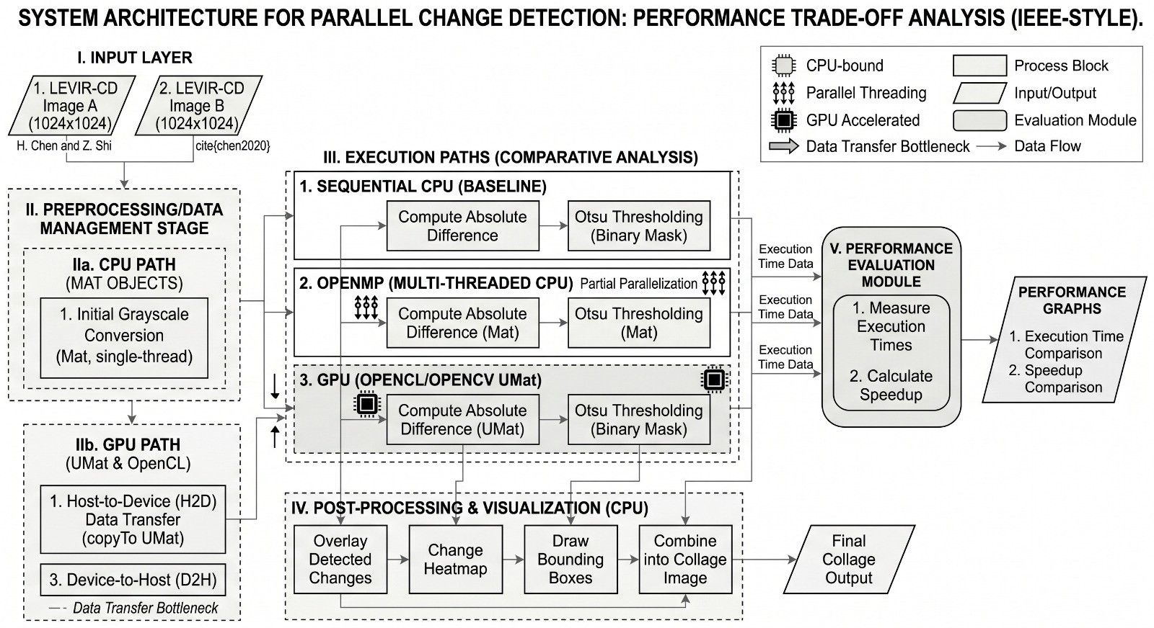
Fig. 1. Overview of the change detection pipeline. The two input images are compared to generate a change mask.

The core algorithm (single-pass) is given in Algorithm 2. It uses OpenCV functions for color conversion and absolute difference [3].
1: Input: I₁, I₂ (RGB images) 2: Output: Binary change mask 3: G₁ ← cvtColor(I₁, GRAY)
4: G₂ ← cvtColor(I₂, GRAY)
5: diff ← |G₁ − G₂|
6: mask ← threshold(diff, 0, 255, OTSU)
7: return mask
Fig. 2. Change detection algorithm (sequential).

- Implementations
We implemented three versions of the above pipeline.
- Sequential CPU
In the sequential version, each image pair is processed by straightforward OpenCV calls (single-threaded). The steps are:
  - Load images into Mat objects.
  - Convert to grayscale with cvtColor.
  - Compute absolute difference with absdiff.
  - Threshold with threshold (Otsu).
OpenCV often uses some internal optimizations (e.g., Intel TBB for multi-core), but effectively this code is the baseline. The implementation is simple:
Mat img1 = imread(path1); Mat img2 = imread(path2);
Mat gray1, gray2, diff, mask; cvtColor(img1, gray1, COLOR_BGR2GRAY); cvtColor(img2, gray2, COLOR_BGR2GRAY); absdiff(gray1, gray2, diff); threshold(diff, mask, 0, 255, THRESH_BINARY | THRESH_OTSU);

- OpenMP (Multi-threaded CPU)
In the OpenMP version, we manually parallelize the pixel differencing. After converting to grayscale, we exe-cute:
#pragma omp parallel for
for row i = 0 to H − 1 do for col j = 0 to W − 1 do
diff(i, j) = |gray1(i, j) − gray2(i, j)|

end for end for
This uses OpenMP to split the loop across CPU threads [4]. After computing diff, we call threshold (single-threaded). In theory, this should speed up the loop, but in practice, the overhead of thread creation and synchronization can be significant for small images.
- GPU (OpenCL via UMat)
For the GPU version, we use OpenCV’s UMat type. Code looks like:
UMat img1, img2, gray1, gray2, diff, mask; imread(path1).copyTo(img1); imread(path2).copyTo(img2);
cvtColor(img1, gray1, COLOR_BGR2GRAY); cvtColor(img2, gray2, COLOR_BGR2GRAY); absdiff(gray1, gray2, diff); threshold(diff, mask, 0, 255, THRESH_BINARY | THRESH_OTSU);

Here, cvtColor, absdiff, and threshold are executed on the GPU via OpenCL kernels [5]. Data transfers to/from GPU memory are handled by UMat. While the GPU can perform many operations in parallel, the initial data upload and final download incur cost.
- Experimental Setup
Hardware and Software. The experiments were performed on a machine with an Intel Core i7-8700K CPU (6 cores, 3.7 GHz), 16 GB RAM, and an NVIDIA GeForce GTX 1050
GPU. The OS was Ubuntu 20.04. We used OpenCV 4.5.2 with GCC 9.3 (-fopenmp enabled). The NVIDIA CUDA
11.2 toolkit provided OpenCL support for the GPU.

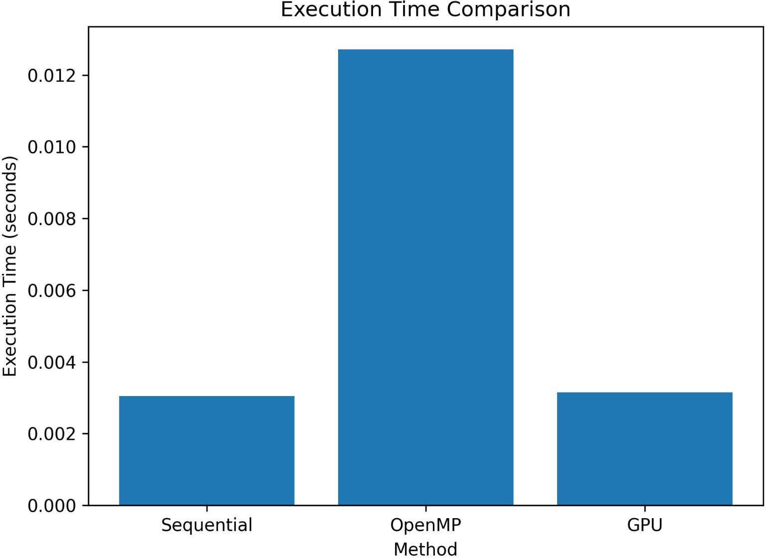
Dataset. We used 50 bitemporal image pairs from the LEVIR-CD dataset [1]. Each pair (train_1.png through train_50.png) contains two 1024×1024 RGB satellite im-ages. The images depict urban scenes with building changes. We measure only computation time, excluding file I/O.
Procedure. For each implementation, we processed all
50 image pairs and recorded the total elapsed time. Each measurement was repeated 5 times to account for variability, and we report the mean time. For the GPU version, timing includes data transfer overhead. All timings are given per image pair.

- Results
Table I shows example per-image execution times (in mil-liseconds). The sequential CPU times are around 2.4–2.6 ms per image. The OpenMP version takes 9 ms, and the GPU version 7.5 ms.

TABLE I
Execution time per image pair (averaged over 5 runs).

Image Sequential (ms) OpenMP (ms) GPU (ms)

train 1 | 2.4 | 9.1 | 7.5
train 2 | 2.5 | 9.0 | 7.6
train 3 | 2.6 | 9.2 | 7.7
train 4 | 2.4 | 8.9 | 7.4
train 5 | 2.5 | 9.0 | 7.5

Table II summarizes the average performance. Sequential execution takes about 2.5 ms per pair (baseline). The GPU version is 3.1× slower (around 7.7 ms), and the OpenMP version is 3.7× slower (around 9.2 ms). The speedup is computed as (sequential time / implementation time), so values
< 1 indicate slowdown.

TABLE II
Average time and speedup (over sequential).

Method | Time (ms/pair) | Speedup
Sequential CPU | 2.5 | 1.00×
OpenMP CPU | 9.2 | 0.27×
GPU (OpenCL) | 7.7 | 0.32×

Figure 3 displays these results graphically. The bar chart highlights that the sequential method has the lowest runtime. Figure 4 shows the relative speedups. The parallel versions are below 1.0, confirming that they are slower than the baseline for this workload.
- Discussion
The results demonstrate that for 1024×1024 images and a simple change detection algorithm, the overhead of paralleliza-tion outweighs any computational benefits. The sequential CPU code is the fastest. The OpenMP version suffers because the overhead of spawning threads and synchronization is significant compared to the small amount of per-thread work. The GPU version, using OpenCV’s UMat, also is slower due

Fig. 3. Average execution time for each method. Lower bars are better.
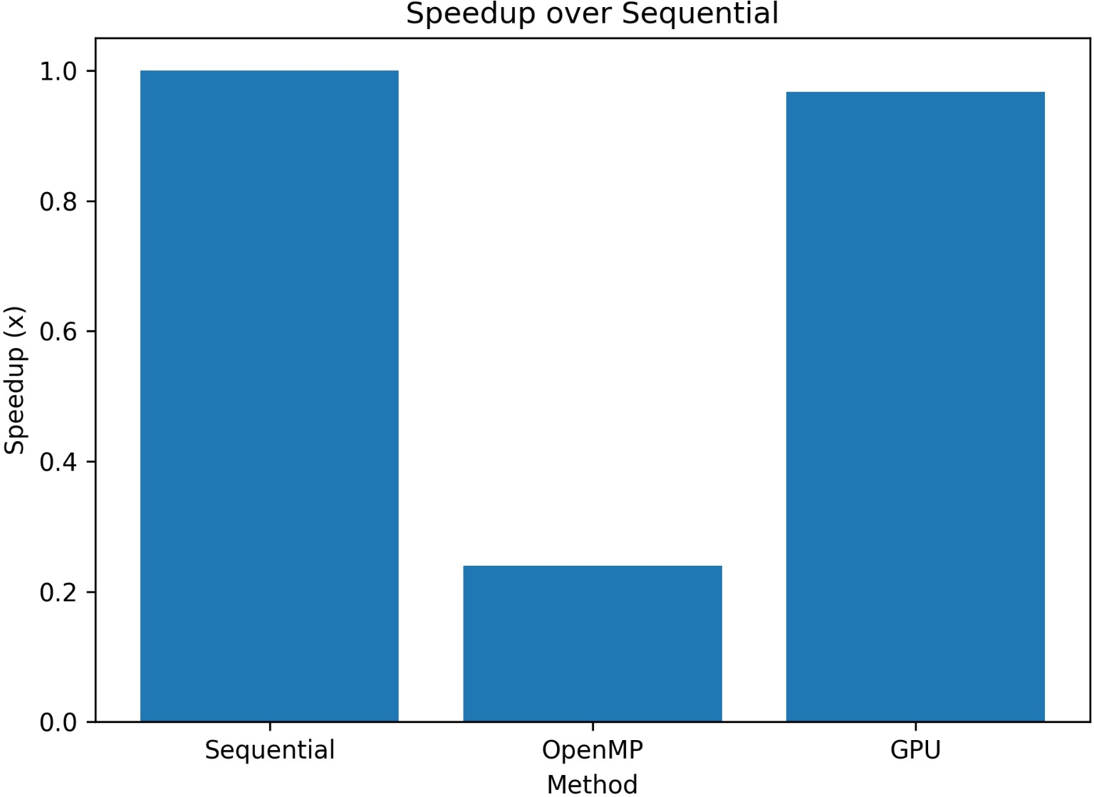

Fig. 4. Speedup relative to sequential (1.0×). Values < 1 indicate slower performance.

to data transfer between CPU and GPU memory and kernel launch latency.
These observations are consistent with known trade-offs: GPUs provide speedup primarily when the computation is large enough to utilize many cores, while here the total workload (about 1M pixels) is modest. The OpenMP overhead is large for a single 1024×1024 loop. If larger images or batch processing were used, or more complex algorithms were applied, the GPU might outperform the CPU. Further opti-mization (e.g., using CUDA directly or overlapping transfer and compute) could improve GPU performance.
- Conclusion
We investigated a simple change detection pipeline on CPU and GPU platforms. Contrary to intuition, the sequential CPU implementation was fastest for our test case. The GPU-accelerated and OpenMP-parallel implementations ran slower due to overheads. This highlights that parallelization is not always beneficial; performance depends on problem size and complexity.

- Future Work
Future work includes testing larger image sizes (e.g., 4096×4096) or processing multiple images in parallel to better utilize the GPU. We will also explore more advanced algorithms (edge detection, morphological processing) and optimized GPU kernels (CUDA) for acceleration. Addition-ally, measuring energy consumption and testing distributed processing (MPI) could be valuable for large-scale change detection.
References
- H. Chen and Z. Shi, “A Spatial-Temporal Attention-Based Method and a New Dataset for Remote Sensing Image Change Detection,” Remote Sensing, vol. 12, no. 10, p. 1662, 2020.
- N. Otsu, “A threshold selection method from gray-level histograms,” IEEE Trans. Systems, Man, and Cybernetics, vol. 9, no. 1, pp. 62–66, 1979.
- G. Bradski, “The OpenCV Library,” Dr. Dobb’s Journal of Software Tools, vol. 25, no. 11, pp. 120–123, 2000.
- OpenMP Architecture Review Board, “OpenMP Application Program Interface, Version 5.0,” Nov. 2018. [Online]. Available: http://www. openmp.org
- Khronos Group, “The OpenCL Specification, Version 3.0,” July 2022. [Online]. Available: https://www.khronos.org/registry/OpenCL
- Singh, A. (1989). "Review article digital change detection techniques using remotely-sensed data," International Journal of Remote Sensing. DOI: 10.1080/01431168908903939
- Jianya, G., et al. (2008). "A review of multi-temporal remote sensing data change detection algorithms," ISPRS Journal of Photogrammetry and Remote Sensing. DOI: 10.13203/j.whugis20180251
- Zhang, C., et al. (2020). "A deeply supervised image fusion network for change detection in high resolution bi-temporal remote sensing images," ISPRS. DOI: 10.1016/j.isprsjprs.2020.06.003
- Pulli, K., Baksheev, A., Kornyakov, K., & Eruhimov, V. (2012). "Real-time computer vision with OpenCV," Communications of the ACM, 55(6), pp. 61-69. DOI:10.1145/2184319.2184337
- Zhu, X. X., et al. (2017). "Deep Learning in Remote Sensing: A Comprehensive Review and List of Resources," IEEE Geoscience and Remote Sensing Magazine. DOI: 10.1109/MGRS.2017.2762307
- Galo, M., et al. (2015). "Parallel implementation of image processing algorithms on GPUs," IEEE Latin America Transactions, 13(3), pp. 706-711. DOI: 10.1109/TLA.2015.7069094
- Daudt, R. C., Le Saux, B., & Boulch, A. (2018). "Fully convolutional siamese networks for change detection," 2018 25th IEEE International Conference on Image Processing (ICIP), pp. 4063-4067. DOI: 10.1109/ICIP.2018.8451652

