An Intelligent Road Damage Detection and Classification System using FRCNN–FPN with Starfish Optimization and Sparse Autoencoder for Autonomous Vehicles

C.Kavitha
Research Scholar,
Dept of Information Technology
Puducherry technological university
2401712003@ptuniv.edu.in

Dr. P.Boobalan
Professor,
Dept of Information Technology
Puducherry technological university
boobalanp@ptuniv.edu.in

Abstract— The safety of autonomous vehicles relies on road infrastructure, yet the damage, such as potholes, cracks, and surface distortions, is a major issue in the navigation and control of autonomous vehicles. The current detection systems are usually characterized by low detection in different conditions, high computation, and low generalization. To overcome these shortcomings, this paper introduces a road damage detection and classification application based on a Faster Region-based Convolutional Neural Network (FRCNN) with a Feature Pyramid Network (FPN), supplemented by Starfish Optimization and a Sparse Autoencoder (SAE). The FRCNN-FPN model can extract features at multiple scales to achieve localization and classification accuracy, and the SAE enhances feature representation by training compact, discriminative features. Starfish Optimization is used to fine-tune hyperparameters, improving convergence and overall performance. Experiments demonstrate that the proposed approach achieves higher accuracy, precision, and recall, fewer false positives, and better computational performance, which is appropriate for real-time autonomous vehicles.
Keywords— Road Damage Detection, Autonomous Vehicles, Faster Region-based Convolutional Neural Network, Feature Pyramid Network, Starfish Optimization, Sparse Autoencoder, Object Detection, Intelligent Transportation Systems, Multi-scale Feature Extraction

Introduction
The technology of autonomous vehicles has advanced rapidly, with industry, academia, and research institutions playing major roles in its development. Although partially automated systems are already available, fully driverless vehicles are being developed [1]. One of the primary concerns of contemporary automotive studies is enhancing safety through so-called Advanced Driver Assistance Systems (ADAS), which use smart sensing and decision-making methods to detect obstacles and interpret surrounding driving conditions [2]. Of these, the road condition analysis is an important factor for safe navigation. Smart inspection robots have become a viable means of checking the road conditions. They are autonomous, sensor-equipped, deep-learning model-powered, and SLAM-powered platforms capable of detecting surface defects, including cracks, potholes, and deformations, while simultaneously performing navigation and mapping [3]. They can operate in complex environments, dynamically optimize inspection paths, and eliminate redundancy, thereby enhancing efficiency and reliability. The systems help prevent severe infrastructure damage and improve road safety by providing precise damage assessments and maintenance information [4].
Image-based automatic detection and classification of road damage has been critical in autonomous driving. This is not an easy task because of the different lighting and weather conditions and overlapping types of damage. Current manual inspection procedures tend to be time-consuming, expensive, and dangerous. To address these constraints, scientists have turned to the use of Unmanned Aerial Vehicles (UAV) combined with Artificial Intelligence (AI) more often [5]. High-resolution cameras in UAVs can capture images of roads from multiple angles, enabling large-scale inspections to be performed faster and more safely. To enable autonomous vehicles to operate safely, it is important that road damage and surface conditions are accurately identified. Depending on the identified risks, vehicles can determine the severity, change speed, alter paths, and activate other safety features such as braking and stability control [6]. These decision-making options are more effective in making decisions that are safe, stable, and comfortable for passengers. Infrastructure surveillance extends into railway systems, where time-sensitive detection of rail defects is critical. Rail tracks are susceptible to damage from continuous exposure to harsh conditions, which can lead to accidents and economic losses. As such, both road and rail transportation networks require intelligent and automated inspection systems to ensure the safety, reliability, and efficiency of these systems [7].
II.
Top of Form

Literature Survey
Deep learning methods have been studied in detail to detect road damage and have shown considerable advances in accuracy and fully automated performance. Initial models used CNN-based networks like ResNet and DeepCrack, which were highly accurate and capable of fusing multi-scale features, but were still limited by noise sensitivity and environmental variations [8]. Other works have improved detection using adaptive thresholding, modified architectures such as AlexNet, and large-scale datasets, achieving high accuracy and precision. UAV-based inspection systems equipped with AI have enabled effective monitoring of large areas, and optimization algorithms, such as ACO, PSO, or GA, have been used to enhance path planning and navigation [9].
Although these developments have been made, there are still difficulties in achieving robust detection in challenging scenarios, dealing with multicollinear damage, and achieving real-time efficiency. Most currently used methods are detection- and classification-centric and do not provide detailed feature representations or measurements of damage characteristics [10]. Current optimization methods are characterized by sluggish convergence, local optima, and limited flexibility in dynamic settings. The most recent advances are FRCNN, Mask R-CNN, and DCNN-based methods, which are more accurate in detection but still suffer from computational complexity, feature misalignment, and reduced generalization [11]. The use of hybrid solutions involving deep learning, optimization algorithms, and UAV-based systems has shown promise, but there are still issues with scalability, dataset availability, and reproducibility. All in all, it is highly urgent to develop a sophisticated framework that combines multi-scale feature extraction, effective sparse representation, and smart optimization schemes to improve the detection accuracy, computational efficiency, and flexibility for real-time autonomous vehicle implementation [12].

Proposed System
The proposed system utilizes a hierarchical pipeline for intelligent road damage detection and classification, as shown in Figure 1. It is trained on a varied set of annotated road images that contain potholes and cracks. Preprocessing methods, including resizing, normalization, and noise reduction, are used to improve image quality. Compact, discriminative features are obtained by reducing data redundancy using an SAE. The features are then fed into an FRCNN combined with an RPN to enable robust multi-scale detection of road defects. Candidates are produced by the RPN, which is then classified and localized. The Starfish Optimization algorithm is used to optimize hyperparameters to improve model performance, in terms of faster convergence and detection accuracy.
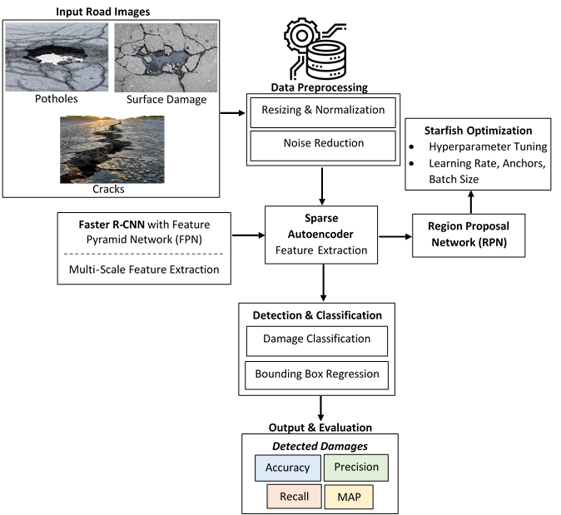
Fig 1: Proposed Architecture
A. Dataset Description
The dataset used in this study is a collection of diverse annotated road images that capture a variety of surface damage, including potholes, cracks, and deformations, as well as normal road conditions (Table 1). The information is obtained from publicly available datasets and supplemented with hand-collected images to add variety and strengthen it. All images are also resized to the same fixed resolution to ensure consistency during training. To have an effective performance evaluation, the dataset is classified into three sets: training, validation, and testing sets, in 70:15:15 proportions.
Table I: Dataset Description
Dataset Component | Description
Dataset Type | Road Damage Image Dataset
Data Source | Public datasets (e.g., Road Damage Dataset - RDD) + custom collected images
Total Images | ~10,000 – 20,000 images (can vary based on study)
Image Resolution | Varies (resized to 224×224 / 512×512 for model input)
Classes | Potholes, Cracks, Surface Deformation, Normal Road
Annotation Type | Bounding box annotations (COCO / Pascal VOC format)
Data Split | Training (70%), Validation (15%), Testing (15%)
Environment Conditions | Day/Night, different weather (rain, shadow, sunlight)
Data Augmentation | Rotation, flipping, scaling, brightness/contrast adjustment
Labeling Tool | LabelImg / CVAT / Roboflow
File Format
JPG / PNG images with XML / JSON annotations

B Data pre-processing
The preprocessing stage is essential for improving image quality and ensuring consistent input to the model. Initially, each input image $I(x,y)$is resized to a fixed dimension to maintain uniformity across the dataset, represented as
$I_{r}=\text{Resize}(I(x,y))$ (1)
Pixel normalization is then applied to scale intensity values into a standard range, stabilizing training and accelerating convergence, given by $I_{n}=\frac{I_{r}-I_{min}}{I_{max}-I_{min}}$ (2)
To reduce noise and unwanted variations, Gaussian filtering is used to smooth the image while preserving important structural details, expressed as
$I_{g}\left(x,y\right)=I_{n}\left(x,y\right)*G\left(x,y,σ\right)$ (3)
Finally, contrast enhancement through histogram equalization improves the visibility of road damages such as cracks and potholes, represented as $I_{e}=H(I_{g})$ (4)
These preprocessing steps collectively enhance feature clarity, reduce variability, and provide standardized input for accurate detection and classification.
C. Feature Extraction and Dimensionality Reduction using SAE
An SAE is a type of unsupervised deep learning model that is effective at feature extraction and dimensionality reduction by learning compact representations of input data, as shown in Figure 2. It adds a sparsity constraint, which forces only a small number of neurons to be active, helps capture significant patterns, and minimizes noise and redundancy. The model has a feature-compression encoder and a reconstruction decoder.
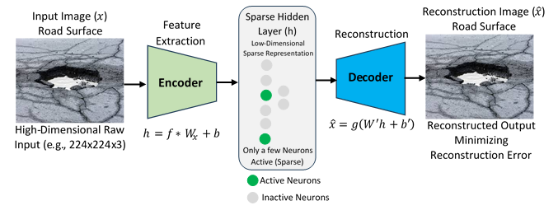
Fig 2: Architecture of SAE
Given an input image represented as a vector $x$ the encoder maps it into a hidden representation $h$, capturing the most relevant features while suppressing redundancy
$h=f(Wx+b)$ (5)
Where $W$and $b$are the weight matrix and bias, and $f(⋅)$is an activation function. This hidden layer is constrained to be sparse, meaning only a few neurons are active, which enhances feature selectivity.
The decoder then reconstructs the input from the hidden representation as: $\hat{x}=g(W^{'}h+b^{'})$ (6)
Where $W^{'}$and $b^{'}$are decoder parameters.
The model is trained by minimizing a loss function that combines reconstruction error and sparsity constraint:
$L=∥x-\hat{x}∥^{2}+λ\sum_{j}{KL(ρ∥}{\hat{ρ}}_{j})$ (7)
Where the first term ensures accurate reconstruction and the second enforces sparsity. This process yields a low-dimensional, discriminative feature vector that significantly improves the performance of subsequent detection and classification models.
D. FR-CNN with FPN
FR-CNN, integrated with FPN, forms a multi-scale object detection framework that improves detection of objects of varying sizes by combining hierarchical feature representations with region proposal learning, as shown in Figure 3. Given an input image $I$, a backbone CNN extracts a set of feature maps at different levels of abstraction, denoted as $\left\{C_{2} , C_{3} , C_{4} , C_{5}\right\}$, where each level captures progressively richer semantic information but with decreasing spatial resolution.
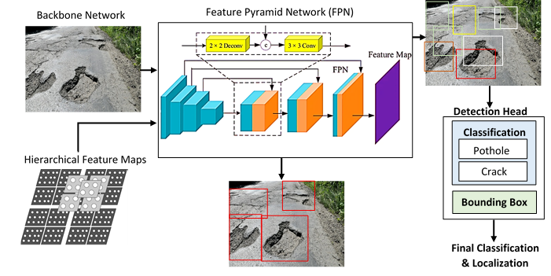
Fig 3: Architecture of FRCNN with FRN (improves detection of objects)
The FPN builds a top-down pathway with lateral connections to construct a pyramid of feature maps $\left\{P_{2} , P_{3} , P_{4} , P_{5}\right\}$. Each pyramid level is computed by merging upsampled higher-level features with corresponding backbone features as: $P_{l}=\text{Conv}\left(C_{l}\right)+\text{Upsample}\left(P_{l+1}\right) \left(8\right)$
Where Upsample($⋅$) denotes a spatial upsampling operation and Conv($⋅$) is a $1×1$or $3×3$convolution used to align channel dimensions and refine features. This formulation ensures that each pyramid level contains both strong semantic information and fine-grained spatial details.
On top of these multi-scale feature maps, the RPN slides a small convolutional filter over each level to generate region proposals. For each spatial location, a set of anchor boxes
$A=\{a_{1},a_{2},…,a_{k}\}$ (9)
with different scales and aspect ratios is defined. The RPN predicts two outputs for each anchor: an objectness score $p_{i}$and bounding box regression offset$t_{i}=\left(t_{x},t_{y},t_{w},t_{h}\right)(10)$
The bounding box regression is typically parameterized as
$t_{x}=\frac{x-x_{a}}{w_{a}}$ (11)
$t_{y}=\frac{y-y_{a}}{h_{a}}$ (12)
$t_{w}=\log\left(\frac{w}{w_{a}}\right)$ (13)
$t_{h}=log⁡\left(\frac{h}{h_{a}}\right)$ (14)
Where $\left(x_{a} , y_{a} , w_{a} , h_{a}\right)$are the anchor box center coordinates and dimensions, and $\left(x , y , w , h\right)$are the predicted box parameters. The RPN is trained using a multi-task loss combining classification and regression:
$L=L_{cls}(p_{i},p_{i}^{*})+λL_{reg}(t_{i},t_{i}^{*})$ (15)
Where $L_{cls}$is typically a binary cross-entropy loss between predicted objectness $p_{i}$and ground truth label $p_{i}^{*}$, and $L_{reg}$is a smooth $L_{1}$loss between predicted and ground-truth box offsets. By leveraging the multi-scale feature hierarchy of FPN and the proposal efficiency of RPN, this integrated framework achieves robust and accurate detection across objects of different sizes, making it highly suitable for applications such as road damage detection in autonomous driving scenarios
E Starfish Optimization – Hyperparameter Tuning and Optimization
It strikes a balance between exploration and exploitation by producing new candidate solutions through mechanisms similar to movement, regeneration, and interaction within a population. It explores widely across the hyperparameter space to avoid local optima during exploration and to narrow solutions during exploitation. The algorithm continuously refines and selects the most successful hyperparameter settings, resulting in faster convergence, lower error rates, and improved model generalization. This renders Starfish Optimization particularly well-suited to optimizing deep learning architectures, including FRCNN-FPN with SAEs, which are difficult to tune manually and computationally prohibitive.
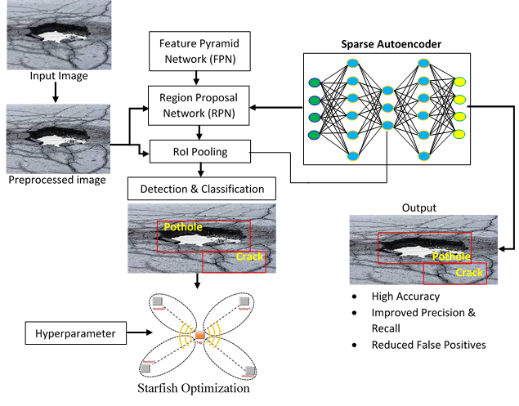
Fig 4: Architecture of Starfish Optimization – Hyperparameter Tuning and Optimization
Algorithm
Step 1: Input Image and Preprocessing: The input road image is resized, normalized, and optionally augmented to improve model robustness using Equations (1) – (4).
Step 2: Feature Extraction using Backbone CNN: A CNN extracts hierarchical features from the input image. $C_{l}=f_{l}(I_{a}),l∈\{2,3,4,5\}$ (16)
Where$C_{l}$: Feature map at layer $l$; $f_{l}(⋅)$: Convolution + activation operation; $l$: Layer index (C2–C5 in backbone CNN)
Step 3: Feature Pyramid Network (FPN): FPN constructs multi-scale feature maps by combining low-level spatial details and high-level semantic information via a top-down pathway with lateral connections, as shown in Equation (8).
Step 4: Region Proposal Network (RPN): RPN generates candidate object regions (anchors) and predicts objectness scores and bounding box offsets using Equation (9).
Objectness Score: $p_{i}=σ(W_{p}x_{i}+b_{p})$ (17)
Bounding Box Regression:$t_{i}=W_{t}x_{i}+b_{t}$ (18)
Loss Function: $L_{RPN}=L_{cls}+λL_{reg}$ (19)
Classification loss
$L_{cls}=-[ylog⁡(p)+(1-y)log⁡(1-p)]$ (20)
Regression loss (Smooth L1)
$L_{reg}=\left\{\begin{matrix}0.5x^{2} & ∣x∣<1 \\ ∣x∣-0.5 & \text{otherwise}\end{matrix}\right.$ (21)
Where $A$: Anchors; $p_{i}$: Objectness probability; $t_{i}$: Bounding box offsets; $x_{i}$: Feature vector; $W_{p},W_{t}$: Weights; $b_{p},b_{t}$: Bias terms; $y$: Ground truth label; $λ$: Loss balancing parameter.
Step 5: ROI Align / ROI Pooling: Extracts fixed-size feature maps from proposed regions for classification and regression. $R_{j}=\text{ROIAlign}\left(P_{l},B_{j}\right)$ (22)
Where $R_{j}$: Region feature; $B_{j}$: Proposed bounding box; $P_{l}$: Feature pyramid level
Step 6: SAE (Feature Refinement): An SAE reduces dimensionality and enforces sparsity to extract compact, meaningful representations.
Encoder: $h=σ\left(W_{e}R_{j}+b_{e}\right)$ (23)
Decoder: ${\hat{R}}_{j}=σ\left(W_{d}h+b_{d}\right)$ (24)
Reconstruction Loss: $L_{rec}=∥R_{j}-{\hat{R}}_{j}∥^{2}$ (25)
Sparsity Constraint: $L_{sparse}=\sum_{k}{KL(ρ∥}{\hat{ρ}}_{k})$ (26)
Total Loss: $L_{AE}=L_{rec}+βL_{sparse}$ (27)
Where $h$: Hidden representation;$W_{e},W_{d}$: Encoder/decoder weights; $b_{e},b_{d}$: Bias terms; ${\hat{R}}_{j}$: Reconstructed feature; $ρ$: Desired sparsity; ${\hat{ρ}}_{k}$: Average activation of neuron $k;$ $KL$: Kullback–Leibler divergence; $β$: Sparsity penalty weight
Step 7: Classification and Bounding Box Regression: Final classification of road damage type and refinement of bounding boxes.
Classification: $P\left(c ∣ R_{j}\right)=\text{Softmax}\left(W_{c}h+b_{c}\right) (28)$Bounding Box Regression: ${\hat{B}}_{j}=W_{b}h+b_{b} (29)$Where $c$: Damage class (pothole, crack, etc.); $P(c∣R_{j})$: Class probability;$W_{c},W_{b}$: Weights; $b_{c},b_{b}$: Bias terms
Step 8: Starfish Optimization (Hyperparameter Optimization): It is used to tune hyperparameters and improve overall detection performance by minimizing the objective function.
Objective Function:$F\left(θ\right)=αL_{cls}+βL_{reg}+γL_{AE}$ (30)
Position Update:
$X_{i}^{t+1}=X_{i}^{t}+r_{1}\left(X_{best}-X_{i}^{t}\right)+r_{2}\left(X_{rand}-X_{i}^{t}\right)$ (31)Fitness Function: $\text{Fitness}=\frac{1}{1+F\left(θ\right)}$ (32)
Where $θ$: Model parameters; $X_{i}^{t}$: Current solution; $X_{best}$: Best solution; $X_{rand}$: Random solution; $r_{1},r_{2}$: Random coefficients; $α,β,γ$: Weighting factors
Step 9: Non-Maximum Suppression (NMS): Removes redundant overlapping bounding boxes.
Intersection over Union (IoU): $IoU=\frac{B_{i}∩B_{j}}{B_{i}∪B_{j}} \left(33\right)$
Decision Rule: Keep box if $IoU<τ$
Where $B_{i},B_{j}$: Bounding boxes; $τ$: IoU threshold
Final Output $D=\left\{\left(B_{j},c_{j},score_{j}\right)\right\}$ (34)
Where: $D$: Final detections; $B_{j}$: Bounding box; $c_{j}$: Predicted class; $score_{j}$: Confidence score
The system processes road images through preprocessing, then extracts hierarchical features using a CNN backbone. An FPN combines multi-scale features to improve the detection of objects of varying sizes. An RPN generates candidate regions, which are refined using ROI Align. An SAE enhances and compresses features. Final classification and bounding-box regression identify road damage types, while Starfish Optimization tunes parameters for improved performance, followed by Non-Maximum Suppression to remove redundant detections.

Results and Discussions
The experimental environment is high-performance, built on Python and deep learning frameworks, including TensorFlow and PyTorch. Processing and evaluation are supported by libraries such as OpenCV, NumPy, and scikit-learn. The system is based on a multi-core processor, an NVIDIA RTX graphics card, 16 GB of memory, and an SSD drive, which makes it efficient in training, allows faster computations, and provides stable model assessment.
Table II: Hyperparameter Settings
Parameter | Value / Range
Learning Rate | 0.0001 – 0.001
Optimizer | Adam
Batch Size | 4 – 16
Epochs | 50 – 150
Weight Decay | 0.0001
IoU Threshold (RPN) | 0.5
NMS Threshold | 0.3 – 0.5
Anchor Scales | [32, 64, 128, 256]
Anchor Ratios | [0.5, 1, 2]
ROI Pool Size | 7 × 7
SAE Sparsity (ρ) | 0.05
Starfish Optimization Iterations | 20 – 50
Parameter | Value / Range
The model hyperparameters are chosen so that it trains efficiently and correctly detects (Table 2). It optimizes Adam with a learning rate of 0.0001-0.001, batch size of 4-16, and 50-150 training epochs. A weight decay (0.0001) is used to regularize. RPN employs 0.5 IOU, NMS employs 0.3-0.5 thresholds, multi-scale anchors, and optimized parameters through Starfish Optimization.
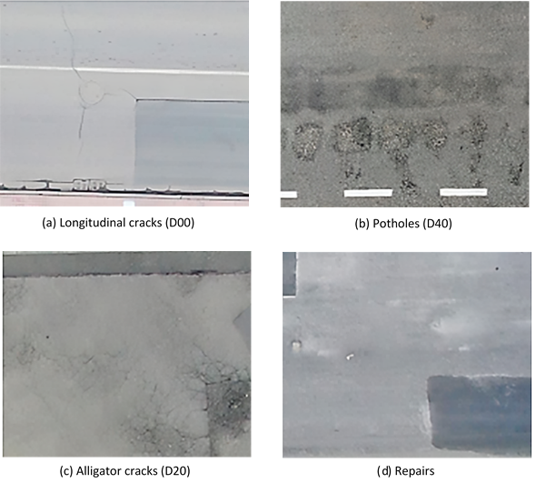
Fig 5: Sample road damage image
The dataset shown in Figure 5 includes many types of road damage, underscoring the variety that the detection system should handle. It has longitudinal cracks (D00), which are linear cracks running along the direction of traffic; potholes (D40), which result from surface weakening; alligator cracks (D20), which have interconnected patterns; and repaired areas, which exhibit texture variations. These classes are typical road conditions to be properly detected and classified.
The preprocessed images exhibit the effects of brightness normalization (Figure 6). (a) The initial grayscale picture shows explicit road information. (b) When brightness increases (1.5), the visibility is improved, but the contrast in bright areas is decreased. (c) (0.5) darkens the image and limits fine details. This test is used to check the robustness of the models in different illumination conditions.

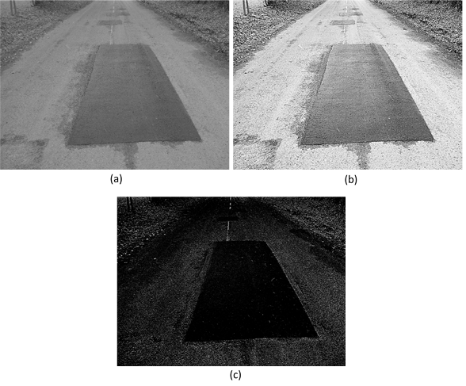
Fig 6: Impact of brightness variation on test images: (a) original grayscale image, (b) image with brightness increased by a factor of 1.5, and (c) image with brightness reduced to 0.5
Figure 7 presents the output of an autonomous road damage detection system, whereby potholes and cracks are detected with bounding boxes, class labels, and confidence scores. The localizations of the damaged regions are precise across various positions and scales, which shows that the model can handle complex real-world conditions and guarantees high stability for autonomous navigation and road safety.

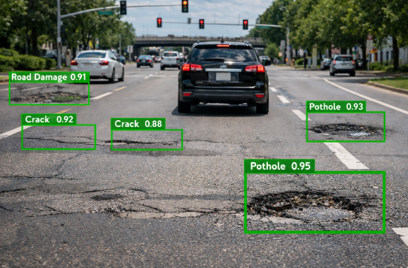
Fig 7: Autonomous vehicle road damage detection system using the proposed system
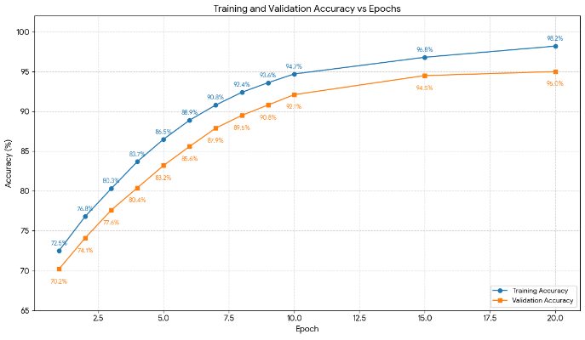
Fig. 8: Comparison of training and validation accuracy vs. epochs of the proposed system
Accuracy in validation and training continues to improve, indicating successful learning and convergence (Figure 8). Its small gap indicates good generalization and minimal overfitting. Starfish Optimization enhances tuning, whereas SAE enhances feature representation, leading to more stable and improved detection performance.
The training and validation losses steadily decline with increasing number of epochs, indicating that the model is learning successfully and converging (Figure 9). The fact that the two curves are very close implies little overfitting. Starfish Optimization helps achieve stable convergence, and SAE helps learn more features, resulting in smaller loss and higher generalization performance.
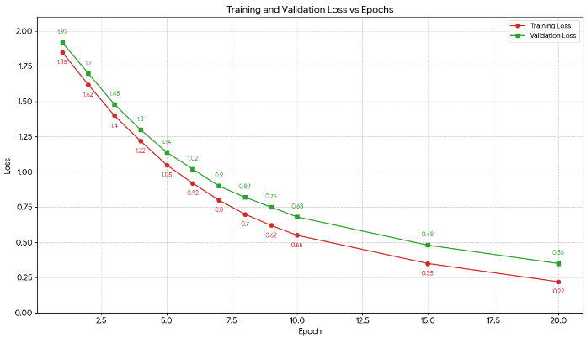
Fig. 9: Comparison of training and validation loss vs. epochs of the proposed system
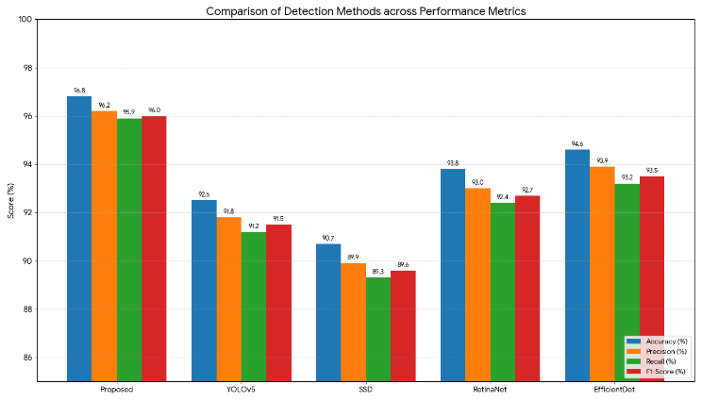
Fig. 10: Comparison of performance measures of the proposed system and existing systems
The proposed system outperforms the current methods across all evaluation metrics, as illustrated in Figure 10. Using FRCNN-FPN enables strong multi-scale detection, and, in turn, Starfish Optimization can improve parameter optimization and convergence. The SAE offers better feature representation, leading to higher precision, recall, and F1-score, at the expense of reduced accuracy.
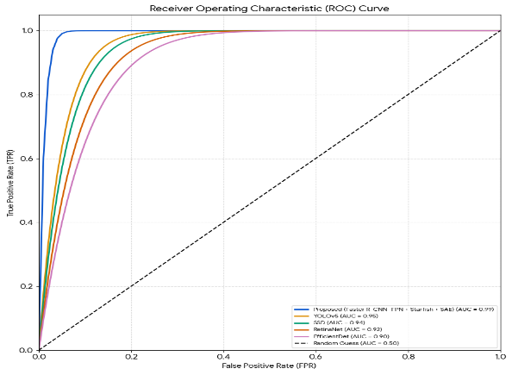
Fig. 11: Comparison of the AUC-ROC curve of the proposed system and existing systems
The proposed system outperforms YOLOv5, SSD, RetinaNet, and EfficientDet across all epochs in AUC-ROC (Figure 11). The steady increase suggests stronger feature representation, enhanced localization, and stronger classification ability, resulting in improved overall detection performance relative to current object detection models.
The proposed system has the lowest MAE, MSE, and RMSE among all available methods, and achieves higher prediction accuracy and lower error, as demonstrated in Figure 12. The proposed system enhances parameter optimization, leading to more accurate localization and classification with minimal deviation from the ground truth.
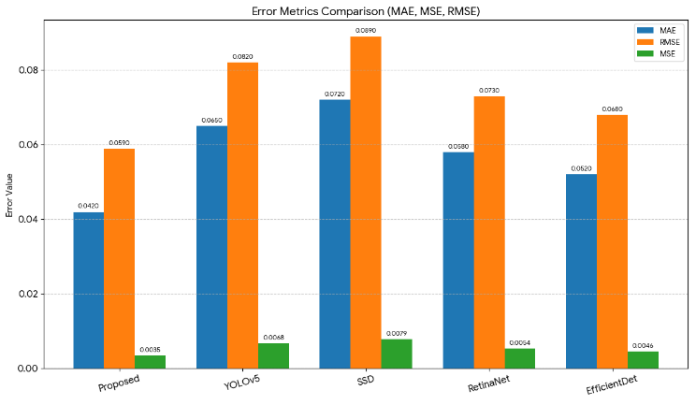
Fig. 12: Comparison of performance measures (Error) of the proposed system and existing systems
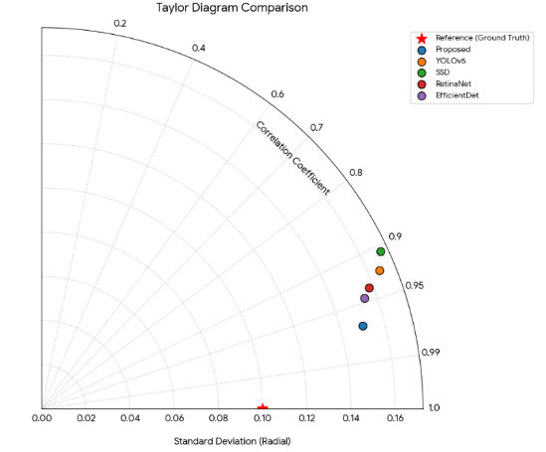
Fig. 13: Comparison of the Taylor plot of the proposed system and existing systems
To compare the performance of road damage detection models, the Taylor diagram shows the results for the correlation coefficient, standard deviation, and closeness to the ground truth, as depicted in Figure 13. The given approach lies closest to the reference point, indicating the greatest correlation and the lowest deviation. This proves better accuracy, stability, and general predictive reliability than existing systems.

Conclusions
In this study, an intelligent road damage detection and classification system based on FRCNN, integrated with an FPN enhanced by Starfish Optimization and an SAE, was proposed for autonomous vehicle applications. The model effectively captures multi-scale features to accurately localize and classify road defects, including potholes, cracks, surface damage, and rutting. The SAE improves feature representation by learning compact and discriminative patterns, while Starfish Optimization enhances hyperparameter tuning, leading to faster convergence and improved performance. Experimental results demonstrate that the proposed approach achieves superior accuracy, precision, recall, F1-score, and AUC-ROC, as well as lower error metrics, compared to existing methods. The confusion matrix analysis further confirms better class separability and lower misclassification rates. Overall, the proposed system provides a robust, efficient, and scalable solution for real-time road damage detection, contributing to safer and more reliable autonomous driving systems.

References
- Bouhsissin, S., Assemlali, H., & Sael, N. (2025). Enhancing road safety: A convolutional neural network based approach for road damage detection. Machine Learning with Applications, 20, 100668.
- Kotakonda Sandhya, R., Kommi, C., Nallamalla, K., Kasireddy, P., & Thalla, P. (2025). Automatic detection of damaged roads and lane detection using deep learning. Journal of Data Science, 2025(11), 1-14.
- Li, K., & He, J. (2025). Road damage detection for intelligent transportation systems using remote sensing images and deep learning optimization. Journal of Circuits, Systems and Computers, 34(14), 2550134.
- Ranjith, E., Parthiban, L., Latchoumi, T. P., Kumar, S. A., Perera, D. G., & Ramaswamy, S. (2023). An effective content based image retrieval system using deep learning based inception model. Wireless Personal Communications, 133(2), 811-829.
- Khan, M. W., Obaidat, M. S., Mahmood, K., Sadoun, B., Badar, H. M. S., & Gao, W. (2025). Real-time road damage detection using an optimized yolov9s-fusion in iot infrastructure. IEEE internet of things journal.
- Chen, W., Yang, J. S., Xia, C., Li, Y., & Xiao, X. (2025). Road surface damage detection based on enhanced YOLOv8. Computers in Industry, 173, 104363.
- Latchoumi, T. P., Parthiban, L., Balamurugan, K., Raja, K., Vijayaraj, J., & Parthiban, R. (2023). A framework for low energy application devices using blockchain-enabled IoT in WSNs. In Integrating Blockchain and Artificial Intelligence for Industry 4.0 Innovations (pp. 121-132). Cham: Springer International Publishing.
- Kaya, Ö., & Codur, M. Y. (2025). Automatic detection and classification of road defects on a global-scale: Embedded system. Measurement, 243, 116453.
- Estilong, J., & Palaoag, T. (2025). Literature review on road damage detection and severity recognition: Leveraging computer vision. Journal of Information Systems Engineering and Management, 10, 498-512.
- Tian, H., Zhao, F., Yang, D., Cheng, H., Zhang, J., & Song, S. (2025). Research on Road Damage Detection Algorithms for Intelligent Inspection Robots. Electronics, 14(14), 2762.
- Demirel, Z., Nasraldeen, S. T., Pehlivan, Ö., Shoman, S., Albdairi, M., & Almusawi, A. (2025). Comparative Evaluation of YOLO and Gemini AI Models for Road Damage Detection and Mapping. Future Transportation, 5(3), 91.
- Sattar, K. A., Abdel-Nasser, M., El Ferik, S., & Taha, A. E. (2025). Detecting Road Defects and Hazards in Metropolitan Environments Using Optimized Deep Learning Techniques. Transportation Research Procedia, 84, 528-533.

