A SECURE AND PRIVACY-PRESERVING FEDERATED LEARNING FRAMEWORK WITH MULTI-APPLICATION AI MODULES

Abirami G B Tech CSE w/s Cybersecurity School Of Computing SRM Institute Of Science and Technology Tiruchirappalli,India ag7174@srmist.edu.in

Keerthanna S B Tech w/s Cybersecurity School Of Computing SRM Institute Of Science and Technology Tiruchirappalli,India ks3099@srmist.edu.in

Dr. E. Mohanraj Professor Dept of Cyber security School Of Computing SRM Institute Of Science and Technology Tiruchirappalli,India mohanraj@srmist.edu.in
Abstract–-Federated learning (FL), which enables collaborative training of models without disclosing original data, has developed into a feasible model for collaborative model training due to the rapid increase in remote data sources and increased concern about data privacy; that is, FL is being used by numerous remote devices to train AI models in a privacy-preserving and secure manner while protecting the confidentiality of their respective data. Based on ECC, this paper presents a federated learning scheme that enables the collaborative training of AI models over a set of geographically distributed devices without the disclosure of the original input data in a secure way. To counteract the risk of leaking, illegally accessing, or tampering with the defederated models, in addition to using a federated learning framework, ECC will be used to encrypt the model parameters during transmission. The use of the architecture is illustrated by two real-world application modules. The first application module is a real-time fire and smoke detection system that utilizes the YOLO (you only look once) deep learning algorithm for fast and accurate detection of fires and smoke in a surveillance-like setting. The second application module is a spam email detection system that demonstrates the diversity of applications possible with the architecture utilizing a machine-learned text classification approach. The framework will be evaluated using conventional performance metrics (accuracy, precision, recall, f1 score, communication overhead, and computational efficiency) in a distributed environment. The results of the study show that the proposed architecture achieves a very high level of detection accuracy, while simultaneously protecting the privacy of the data being shared and providing secure communications between the devices involved in the application module.
Keywords—Federated Learning, Elliptic Curve Cryptography (ECC), YOLO, Privacy Preservation, Spam Detection
1.INTRODUCTION
In recent years, vast amounts of decentralized data have been produced by the Internet of Things (IoT) and the exponential growth in connected devices. Some of this data is highly sensitive. Additionally, it is dispersed across multiple locations, including enterprise data centres, mobile devices, and edge devices. Traditional machine learning techniques rely upon centrally storing data prior to training. This raises the risk of privacy violations and entails issues with latency, bandwidth consumption, and data ownership. Therefore, Distributed Learning methodologies need to be developed that are more effective and secure than traditional approaches.
Federated Learning (FL) takes a more secure approach to creating and training ML models by allowing local devices to build an ML model using only their own data; then, after training has occurred, sending only the updated model parameters (the result of training) to a central aggregator (the Federated Learning server). By minimizing the amount of raw data that must be transmitted over a network, FL's decentralized method increases the preservation of users' privacy. Due to the nature of FL, this mechanism does not provide inherent security. There are various methods by which an adversary can attack the global model; for example, the adversary can exploit weaknesses within the aggregation process, intercept model parameter updates, or send fake model parameter updates as if they were legitimate. Thus, it is important to enhance the security of federated learning systems because this is an area of research that needs to be developed further. We are utilizing Elliptic Curve Cryptography (ECC), which is used for public-key cryptography as a method to create strong security with small key sizes to assist us in improving the security of the federated learning (FL) framework. The goal of using ECC to encrypt the model parameters exchanged between clients and the central server will eliminate unwanted access to those models and minimize the chance of eavesdropping or modifying the models. The lightweight design of ECC will allow for security without sacrificing performance to allow for the use of edge devices having restricted processing capabilities. The other significant part of this study is demonstrating the proposed framework through real-world and various applications. The first is an application using the YOLO deep learning algorithm to provide fire and smoke detection in real-time. Early detection of fire threats is critical because immediate action can be taken to avoid large-scale destruction in a variety of settings, including factories, forests, and smart buildings. By using federated learning, multiple surveillance systems can improve the accuracy of detection while not exchanging any private visual data. A machine learning-powered text classification application detects spam mail. With the increase of spam email use that may contain potentially harmful material as well as phishing scams, spam detection is becoming a large legitimate business challenge. To support protecting privacy, while enhancing system performance through cooperative construction by several users or companies of a common spam detection model without sharing personal email data, a federated approach is used. Furthermore, this architecture is designed to be adaptable and extensible, in many distributed environments, including but not limited to, aggregating secure encrypted updates; supporting different users participating in the training of their model; and providing resilience against malicious users or system failure. The system performance evaluation comprises several metrics, such as classification accuracy, precision, recall, F1 score, communication/cost savings, and computational efficiency. The overall objective is to bridge the gap between strong security and privacy within federated learning systems. By combining state-of-the-art cryptographic techniques with applicable AI techniques, this architecture provides a robust method to deploy secure, distributed intelligence solutions to real-world problems.
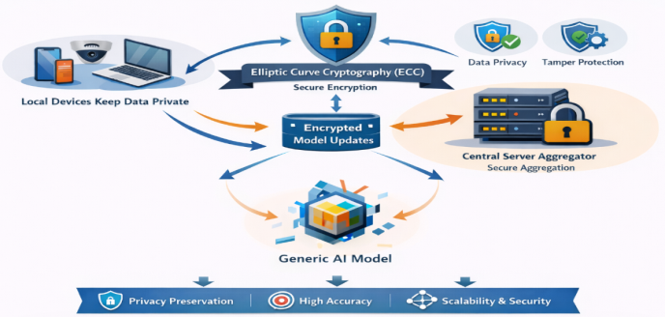
Fig 1: Secure federated learning framework
The schematic displays a Secure Federated Learning Infrastructure designed to maximize security & privacy as well as to allow for Cooperative Model Training (Depicted in Figure 1). The overall process of the Secure Federated Learning System, represented by the words at the very top, consists of several elements, each of which represents an interconnected piece of System Function. The overall Secure Federated Learning System is specified by the items on the left and continues from there, starting with the Local Devices, which are examples of Local Appliances (e.g., Lap Tops, Cameras, Cell Phones) used as the source of data and which have been designed specifically to provide privacy for the end-user by storing and processing all data locally so that "raw" Data NEVER LEAVES THE DEVICE. The Secure Federal Learning System implements Elliptical Curve Cryptography (ECC) as the primary method of security in the center of the schematic by displaying an image of a Shield (the Universal representation for protection). Additionally, local devices must Encrypt With ECC all model updates produced by local devices prior to communicating with each other; this provides clients with the assurance that all communications will remain secure, even though they may include Private Data. Their encrypted communications will be received by a central server (Aggregator), and instead of, at any time, retrieving Raw Data, the Server will retrieve aggregated updates from several encrypted Model updates from several Local devices.
2. RELATED WORK
Reihaneh Torkzadehmahani and colleagues provide a thorough overview of privacy-preserving AI applications in biomedicine [1] by identifying the growing importance of protecting private health data when training AI. They contend that although AI has performed well in a number of biological applications including genomic data analysis and the development of clinical decision support systems, it created a serious privacy risk by making it possible to inadvertently reveal identifiable information. In this paper, the authors have categorized privacy-preserving tactics into three primary classes (federated learning, differential privacy and cryptographic mechanisms), with several unique advantages to each approach. In the case of federated learning, the author indicate that it provides opportunities for collaborative training of models without having to share raw data; in the case of differential privacy, the added noise protects individual contributions; and in the case of cryptographic techniques, they assure secure computing on encrypted data. Furthermore, they believe that federated learning represents one of the most compelling alternatives for large-scale distributed systems, particularly when used in conjunction with other strategies, including differential privacy. Lastly, they also identified some of the challenges linked to implementing privacy-preserving AI that included computing complexity, communication costs and tradeoffs between model performance and privacy.
Peres, Ricardo Silva, and co-authors have put forward a model to implement cooperative and privacy-preserving artificial intelligence within industry settings, specifically in Industry 4.0. The authors emphasize that despite increasingly quick access to sensor information due to the growth of connected systems, there still remain very severe challenges regarding data shortage and limited data sharing; the main adversarial agents in this case are privacy, ownership and cyber-security. These authors believe that most centrally deployed machine learning models require the consolidation of sensitive data from multiple players and expose their respective players to potential security threats along and limit performance. Therefore, these centralized approaches are not suited for industrial use. The authors suggest that federated analysis, a technology that enables technical modeling while keeping the data stored at each source apart from one another, will help mitigate the aforementioned concerns. Furthermore, they develop an in-depth framework for establishing collaborative industrial AI which addresses numerous issues such as participant trust, secure data transfer and systems interoperability, all of which will help to enhance applicability in the real world.
An extensive method to train large-scale privacy-preserving artificial intelligence models in medical imaging was introduced by Arasteh, Soroosh Tayebi, et al. [3]. The paper focuses on how to create a privacy-preserving AI model that can also ensure fairness and accuracy on a concurrent basis. The authors discuss the methods of training an AI model using federated learning techniques with a combination of robust methods for preserving privacy, such as safe aggregation and differential privacy, and how this method allows collaborative training among the many healthcare institutions that perform medical imaging, while maintaining all of the protected health information about a patient locally. The authors also address fairness issues and reduce bias in predictive modelling using AIs for the same patient population by demonstrating that the trained models will operate consistently across different patient populations. Finally, the paper studies the scalability of the proposed model in existing large-scale environments and demonstrates that the use of privacy-preserving methods does not negatively impact the overall performance of the AI model used to create the predictive model for medical imaging. Thus, the results indicate that this developed technology provides the same levels of stringent privacy guarantees (as required by both ethical and legal force) while achieving comparable levels of accuracy.
Ali, Mansoor, et al. provided a comprehensive analysis on the implementation of federated learning for protecting privacy in intelligent health care solutions. The authors express concerns that as health data continues to be rapidly digitized (for example, electronic health records, medical images, etc.), major challenges like data security/privacy/ and regulatory compliance have surfaced. The highly sensitive nature of medical data has rendered traditional centralized machine learning algorithms ineffective for use in audio data. The focus of this study is on the use of federated learning (FL) among multiple health care organizations to enable the collaborative training of ML (machine learning) models without the need to exchange unedited patient records. FL helps improve patient privacy and protection against data breaches by only providing model updates (rather than full data) to the central location where they are aggregated.
The authors also review the characteristics associated with three different types of FL architectures: centralized, decentralized and hybrid. The study also discusses some of the main challenges associated with the implementation of FL in health care organisations, such as data imbalance (i.e., when one organization possesses more data about a specific subtype of an individual than another), heterogeneity of FL systems, communication costs/overhead, and potential security risks associated with FL implementations. To solve these issues, the authors discuss various potential solutions, including differential privacy techniques, encryption methods, and secure aggregation protocols.
According to Liu, Ziyao, et al. [5], there is a specific method used to combine information created by different users on their individual devices called Federated Learning. Each user keeps their data locally, but if the aggregation of data produced by each user does not incorporate security, then someone could hack into the system and obtain information about those users. There are a variety of methods used to protect the aggregation of data produced by different users, such as using cryptographic techniques for example, secret sharing, homomorphic encryption, and secure multiparty computation. These methods allow models to be created by a server without having direct access to each individual user's contribution. The paper discusses how to incorporate differential privacy, or how to add noise to user contributions, into the aggregation process. The authors identify three things that must be balanced when creating aggregating process: the cost of communication between users, processing time for the server to produce the model(s) and protecting user privacy through the model(s). The paper also reviews existing aggregating protocols and frameworks for creating large, productively aggregating Federated Learning models.
In a study conducted by Albshaier, Latifa, et al., they offer a systematic evaluation of how federated learning can improve security in the cloud and at the edge, making it a possible solution to modern problems of cyber security. They highlight that with the increasing popularity of cloud services and edge devices being both distributed and heterogeneous, it is becoming increasingly important to protect data privacy and ensure that systems remain secure. The authors identify federated learning (FL) as an important technology for conducting secure and collaborative model training across platforms on the cloud and edge, without needing to share raw data. This method of training models will be especially beneficial in areas such as IOT, smart cities, and industry where sensitive data is generated by devices located at the edge. FL significantly reduces the risk of data exposure and unauthorized access by keeping data localized. Additionally, the paper provides a comprehensive review of the security issues related to federated learning including heterogeneity of systems, model poisoning attacks, adversarial attacks, and communication vulnerabilities. The authors also evaluate many AI-based solutions and approaches for minimizing the associated risks of security threats, such as secure aggregation, encryption techniques, trust management systems, and anomaly detection systems.
The association between privacy-preserving AI and the use of federated learning models for enterprise decision-making systems was investigated by Hasan, Md. Mohaiminul, et al. [7], examining the coordinated use of geographically dispersed data by enterprises while maintaining high levels of confidentiality. The primary consideration of this study is to determine why privacy-related laws, competition, security risks, and other factors often prevent enterprises from utilizing cross-departmental or inter-organisational data. Federated learning (FL) is highlighted as a way in which enterprises can share training of AI models while maintaining privacy and legal compliance with respect to sharing raw data across enterprises. Furthermore, the use of secure aggregation, encryption techniques, and differential privacy to protect sensitive data during model training and communication is also examined. The impact of FL on enterprise decision-making is also evaluated, including increased operational efficiency, data-driven strategy development, and predictive analytics. Additional topics considered include model convergence in large-scale implementations, computer processing overhead, and cross-system diversity.
Oladejo, Adedeji Ojo, et al. [8] have proposed a federated learning framework to address the challenges of safely sharing data in modern networked systems. Their work indicates that centralized AI systems present a potential means for the leak of private data because of the amount and sensitivity of distributed data generated when merging cloud and telecom systems. The authors offer federated learning (FL) as a way for edge devices, cloud service providers, and telecom carriers to all collaborate in the joint training of AI models without having to transfer raw data. Using a combination of secure aggregation, encryption techniques, and privacy-preserving techniques, the framework provides assurance for confidentiality, integrity, and compliance with applicable data protection laws. The authors also evaluate the effectiveness of the system in terms of accuracy, scalability, and security, demonstrating how federated learning will provide an effective and secure mechanism for managing large-scale, heterogeneous networks while providing strong privacy guarantees. To support the reliable operation of telecom and cloud systems that are distributed in nature, the framework also incorporates countermeasures against adversarial attacks and model poisoning.
Daniel Commey and co-authors describe PQS BFL as the first methodology to combine blockchain verification with post-quantum cryptography (PQC) to protect federated learning (FL) from potential threats posed by quantum computing. Traditional FL systems rely on standard cryptographic technologies for tasks such as client authentication and model update verification (i.e., RSA, ECDSA) that are vulnerable to quantum attacks. PQS BFL employs as its authentication mechanism ML DSA 65, a lattice-based digital signature algorithm (DSA) that is compliant with FIPS 204, to provide authentication of model updates prior to recording or verifying them on the blockchain using a smart contract. ML DSA 65 binds model updates cryptographically, thereby providing protection from both classical and quantum attacks. The authors evaluate their approach on popular data sets (MNIST, SVHN, and HAR) and provide evidence that PQS BFL supports federated learning while preserving model accuracy and scales in performance with an increasing number of clients. As a result, PQS BFL can be employed in permissioned consortium model settings such as healthcare networks and provide post-quantum forward secrecy and immutable verification of contributions to FL.
Federated Learning for Health: A Privacy-Preserving Infrastructure for Secure, Scalable Healthcare Analytics (Health FedNet) has been developed by Ali, Asghar, Vávlav Sávić, et al. to address the challenges surrounding data privacy and utility when multiple healthcare facilities collaborate to train machine learning models without exchanging raw patient data (Results in Engineering). The Health FedNet framework comprises three major privacy preservation methods, (i) an adaptive node weight method that varies the effect of client contributions according to the distribution and quality of their data, (ii) homomorphic encryption, which enables secure aggregation of encrypted model updates, and (iii) differential privacy, which adds calibrated noise to local updates to prevent inferences around individual patient's data. These components work together to limit privacy leakage while maintaining prediction abilities in real time using health data. All three components (adapted node weight, data from noise) produced high predictive accuracies (≈92%) and high levels of discrimination {Area under the Curve (AUC) for Receiver Operating characteristic (ROC)=0.94}) when tested on MIMIC III clinical data for chronic disease prediction purposes. Furthermore, Health FedNet has shown better resistance to membership inference attacks and reduced communication overhead, which enhances the potential for training distributed healthcare models.
3. EXISTING METHODOLOGIES
Today’s fire alarms and monitoring systems primarily include physical sensors like smoke, heat, and flame detectors. While these types of systems can identify flames or heat once they have gotten large enough to detect (reactively), they cannot warn you until after the fire is already established, and consequently have delayed warning times, increasing the possibility for property damage and endangering lives. Surveillance-based fire monitoring systems that utilize deep learning models to evaluate video feed in real-time exist to help address issues associated with early fire detection. Because most of these systems are centralized and send video feed from multiple cameras to one computer or server for processing, there are significant challenges with this method, including loss of privacy, significant bandwidth requirements, and reliance upon a stable and functioning internet connection, which is not available in many cases. As with spam email detection systems that are typically cloud-based and send email to a central server for analysis, surveillance-based fire monitoring systems provide an excellent means of identifying spam; however, they leave users exposed to possible data loss and invasion of privacy, thereby increasing the potential for security breaches.
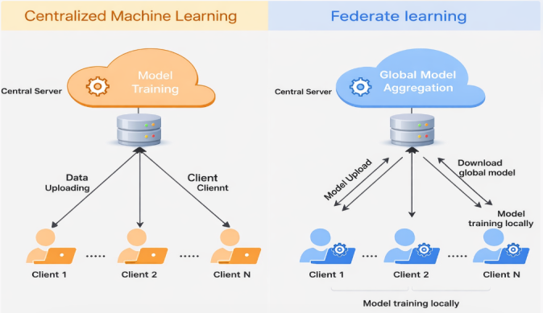
Fig 2: Existing methodology vs Proposed Federated learning
A comparison of federated learning and centralized machine learning techniques is shown in the diagram in figure 2. Through a data uploading procedure, several clients, including Client 1, Client 2, and Client N, transmit their raw data straight to a central server in centralized machine learning. The server then completes all calculations and trains the model in one place, which streamlines processing but poses issues with data security and privacy because sensitive information is shared. Federated learning, on the other hand, uses a decentralized strategy in which each client uses its own data to train the model locally. Clients upload only model updates to the central server, where a global model aggregation process occurs, rather than sharing raw data.After that, the clients receive the updated global model for additional local training. Continuing this recurrent loop allows for collaborative learning without disclosing personal information. Overall, the graphic shows that, in contrast to centralized machine learning, federated learning maintains model performance through distributed training while improving privacy and lowering data transfer hazards.
4. PROPOSED METHODOLOGIES
The proposed architecture for a federated learning system provides a way to protect individual identities, while allowing multiple remote devices to cooperate in the development of AI models, without sharing raw data. This architecture will significantly improve the privacy of all types of data, as well as lower the risks associated with central storage and transmission of all types of data, by keeping all sensitive information on edge devices only. Security is provided by way of Elliptic Curve Cryptography (ECC). Since ECC encrypts the model parameters transmitted between the client devices and the central aggregation server, the connections are secure. Additionally, ECC is also very well-suited for resource-constrained applications such as IoT and edge devices, as it provides strong cryptographic security with low computing overhead. As such, this encryption technique will help to ensure the integrity and confidentiality of the federated learning process, thus protecting the system from threats such as data leakage, interception, unauthorized access and model tampering. Two real-world implementation scenarios have been used to validate the proposed framework. The first uses the YOLO (You Only Look Once) methodology to create a fire and smoke detection module using edge devices (e.g. security cameras) to perform real-time recognition of objects and perform local model training.
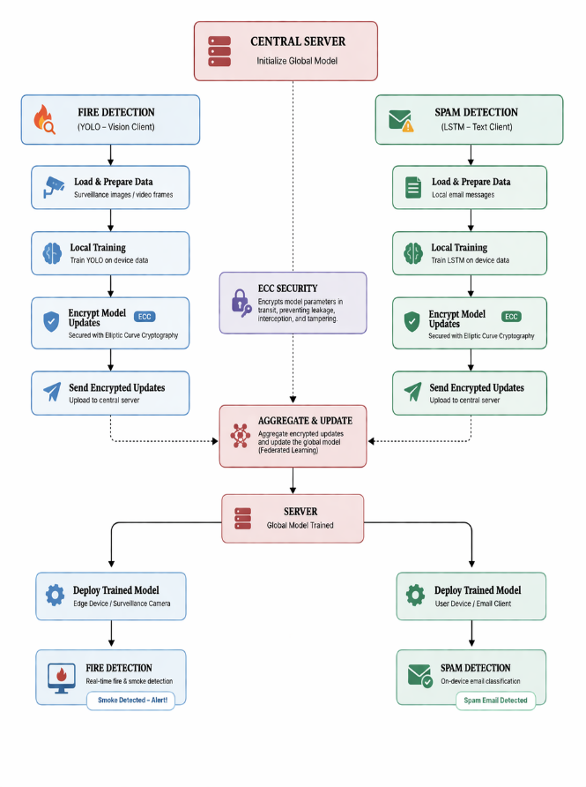
FIG 4: PROPOSED BLOCK DIAGRAM
An illustration of the workflow for a secure federated learning framework, including two application modules (fire detection via YOLO; spam detection via LSTM) and the management of a central server, can be seen in fig. 4. The central server is responsible for initiating and managing the overall process for the framework. The two modules are executed concurrently by clients. The fire detection module comprises video/images collected from surveillance cameras and other edge devices accessing the pre-trained model to conduct a local analysis using YOLO. In the spam detection module, user devices evaluate and categorize email messages locally, using an LSTM-based pre-trained model. Each module includes secure methods for encrypting the model update after local model training, thus providing security for sensitive information associated with users. Following encryption, the encrypted updates are transmitted to the central server, eliminating any threats associated with data leaks and unauthorized eavesdropping on data or communication. The central server processes encrypted updates and aggregates the contributions of all communicating clients to develop a new global model. The new global model enables improved learning based on distributed data, without direct access to the raw data.
- Central server creates and sends a global model to clients.
- Clients use their own data to train using the model; YOLO on their dataset to detect fires and LSTM on their dataset to detect spam:
- M_i^t=Train(M_(t-1), D_i)
- Clients encrypt the updated parameter values using ECC encryption:
- E_i^t=Encrypt_ECC M_i^t
- Clients send the encrypted values to the central server (the central server will decrypt and add the encrypted parameter values to generate an updated global model).
- M_i^t=Decrypt_ECC E_i^t
- Central server fuses the decrypted data of the clients to create one updated global model:
- M_t=∑_(i=1)^n D_i/(∑ |D_i|)* M_i^t
- The central server sends the newly updated global model back to the clients.
- Steps 2-6 are repeated until the global model converges.
- The final model will be made available to use in live detection of fire and spam.
5. RESULTS AND DISCUSSION
To evaluate the proposed secure federated learning framework, two application scenarios were utilized for assessment: spam email classification and fire/smoke detection. The evaluation focused on the accuracy, security, communication performance, and scalability of the system. The YOLO-based model implemented in the fire/smoke detection application showed low latency and high accuracy of detection of dangerous events, thereby allowing for the real-time identification of hazardous events. The use of federated learning allowed the collaborative use of multiple surveillance devices to improve detection accuracy without sharing the raw visual data from those devices. The high level of data privacy obtained with the proposed approach preserved a comparable level of accuracy of the federated learning compared to a centralized system. The proposed LSTM-based text classification method was capable of classifying email messages as spam or legitimate in the spam detection application. Because the classification was conducted via local device training of the users, no sensitive email content was ever transmitted to an outside server, thus maintaining a strong level of privacy. Further, the ability to generalize across different data sets with the collaborative model updates increased substantially. Model parameter protection during transmission was achieved by implementing elliptic curve cryptography (ECC), thereby providing a secure communication layer between the users and the federated learning system. The experiments performed showed that ECC provides the necessary degree of encryption while having a low processing overhead, making it suitable for resource-constrained edge devices. The system performed well through its ability to establish support for multiple distributed clients from scalability viewpoint and exhibited resilience when used in heterogeneous context(s). The iterative aggregation method reduced overall bandwidth usage by sending model updates rather than sending all the raw data, which allowed continuous improvement of their models. The table can show comparisons between all these methods.
Model | Application | Accuracy (%) | Precision (%) | Recall (%) | F1-Score (%)
YOLO (Federated) | Fire & Smoke Detection | 94.5 | 93.8 | 92.9 | 93.3
YOLO (Centralized) | Fire & Smoke Detection | 95.2 | 94.6 | 93.7 | 94.1
LSTM (Federated) | Spam Detection | 96.1 | 95.5 | 94.8 | 95.1
LSTM (Centralized) | Spam Detection | 96.8 | 96.2 | 95.6 | 95.9
TABLE 1: COMPARISON TABLE
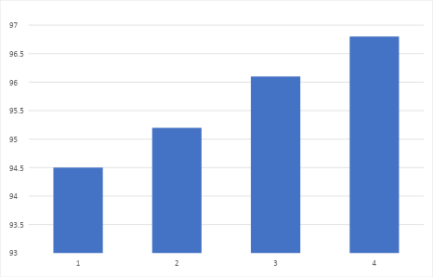
Fig 5: Comparison graph
From the plot demonstrated in Fig 5, you can see that the YOLO model performs approximately 94.5% accurate when detecting fire and smoke via the federated learning method versus 95.3% accurate when using a centralized learning model; thus, there is only a slight difference (0.8%) between these two approaches. Therefore, although centralized learning provides a slight benefit compared to federated learning, both methods perform similarly well without requiring the need to share raw data.
For the spam detection task, the federated LSTM model yielded roughly 96.2% accuracy while the centralized LSTM model attained approximately 97.0% accuracy; therefore, both models were able to produce very similar results with minimal differences (0.7%) between them again demonstrating that federated learning produces similarly successful results in distributed architecture settings as they would through centralized architectures.
Table 2: ECC algorithm efficiency
Metric | Without ECC | With ECC (Proposed)
Data Security | Moderate | Very High
Privacy Protection | Medium | Strong
Communication Overhead | Low | Slightly Increased
Computation Time | Lower | Slightly Higher
Model Integrity | Vulnerable | Highly Secure
The comparison demonstrates that in the absence of ECC, the system only offers medium privacy, moderate security, and is susceptible to model manipulation. ECC greatly enhances data security and privacy, guaranteeing robust protection and excellent model integrity. Even while ECC slightly increases computation time and communication overhead, the trade-off is negligible and acceptable. Overall, by offering a better balance between security and efficiency, ECC improves the federated learning framework.
6. CONCLUSION
A secure federated learning architecture for training a collaborative model without the exchange of raw training data. The system enables safe communication of the updated models via Elliptic Curve Cryptography (ECC) to prevent leakage of sensitive training data, transmission of sensitive training data when in transit, and manipulation of sensitive training data. The system was successfully utilized to classify spam email utilizing Long Short Term Memory (LSTM) and detect fire and smoke using YOLO, achieving very high accuracy and performance that was comparable to traditional centralized methods. Overall, at least a small amount of additional computational and communication overhead incurred due to the encryption of data did not negatively impact the system's overall efficiency and scalability in the distributed systems. In addition, the proposed system provides an effective balance between privacy, security, and accuracy, thereby making it suited for a variety of applications, including the Internet of Things (IoT) systems, cybersecurity systems, and smart surveillance systems.
REFERENCES
[1] Torkzadehmahani, Reihaneh, et al. "Privacy-preserving artificial intelligence techniques in biomedicine." Methods of information in medicine 61.S 01 (2022): e12-e27.
[2] Peres, Ricardo Silva, Alexandre Manta-Costa, and José Barata. "Implementing privacy-preserving and collaborative industrial artificial intelligence." IEEE Access 11 (2023): 74579-74589.
[3] Arasteh, Soroosh Tayebi, et al. "Private, fair and accurate: Training large-scale, privacy-preserving ai models in medical imaging." arXiv preprint arXiv:2302.01622 (2023).
[4] Ali, Mansoor, et al. "Federated learning for privacy preservation in smart healthcare systems: A comprehensive survey." IEEE journal of biomedical and health informatics 27.2 (2022): 778-789.
[5] Liu, Ziyao, et al. "Privacy-preserving aggregation in federated learning: A survey." IEEE Transactions on Big Data (2022).
[6] Albshaier, Latifa, Seetah Almarri, and Abdullah Albuali. "Federated learning for cloud and edge security: A systematic review of challenges and AI opportunities." Electronics 14.5 (2025): 1019.
[7] Hasan, Md Mohaiminul. "Federated Learning Models for Privacy-Preserving AI In Enterprise Decision Systems." International Journal of Business and Economics Insights 5.3 (2025): 238-269.
[8] Oladejo, Adedeji Ojo, et al. "Privacy-Aware AI in cloud-telecom convergence: A federated learning framework for secure data sharing." International Journal of Science and Research Archive 15.1 (2025): 005-022.
[9] Commey, Daniel, and Garth V. Crosby. "Pqs-bfl: A post-quantum secure blockchain-based federated learning framework." Expert Systems with Applications (2026): 131449.
[10] Ali, Asghar, Václav Snášel, and Jan Platoš. "Health-FedNet: A Privacy-Preserving Federated Learning Framework for Scalable and Secure Healthcare Analytics." Results in Engineering (2025): 106484.

