DizziGuard+: A Dual-Modal IoT Framework for Real-Time Fall and Dizziness Detection in Post-Operative Patients — A Proposed Design and Comparative Analysis

Vetriprasath V
SRM IST, Trichy,
Tamilnadu, india
Vp5228@srmist.edu.in

Kishore Kanna K
SRM IST, Trichy,
Tamilnadu, india
Kk7198@srmist.edu.in

Shajeena J
SRM IST, Trichy,
Tamilnadu, india
shajeenaelmo@gmail.com

Abstract—Patient fall detection is one of the most critical preventable adverse events in hospital settings, where the rate of patient fall for inpatients varies from 1 to 9 per 1,000 patient-days, each costing an average of $35,365. The compounded risk for post-operative patients during the 24-72 hour post-operative period due to the effects of anaesthesia, medication-induced dizziness, and transient neuromuscular weakness, who have been systematically ignored by all the current automated patient fall detection systems, has been addressed in this paper. In this paper, we introduce the low-cost dual-modal IoT-based patient fall detection system, i.e., DizziGuard+ that integrates the inertial measurement unit sensor embedded in the wristband and the pressure-sensitive bed spread for the concurrent detection of patient fall and bed exit. We also introduce the Motion Instability Index (MII), a novel signal feature for the quantification of pre-fall dizziness using MPU6050 pitch and roll variance, and the Dual-Alert Corroboration Score (DACS), the weighted fusion metric for the dual-modal sensor fusion for the reduction of false alarms. The evaluation of the Random Forest classifier on the SisFall benchmark dataset (4,505 recordings) yielded the sensitivity, specificity, F1-score, and area under the ROC curve (AUC) of 97.50%, 98.45%, 97.58%, and 0.9982, respectively, for the 10-fold stratified cross-validation approach. The threshold-based detection algorithm yielded 99.22% specificity, 95.62% precision, and area under the ROC curve (AUC) of 0.9407. The ten-dimension comparative design analysis using the six published patient fall detection systems reveals that the proposed system, i.e., DizziGuard+, is the only system addressing all the dual-modal fusion, dizziness detection, post-operative, and sub-$25 deployability criteria. The next step for the system development will be clinical validation.

Keywords—Fall detection; post-operative monitoring; IoT healthcare; wearable sensors; dizziness detection; motion instability index; DACS; sensor fusion; edge computing; SisFall.
I. INTRODUCTION
A. The Clinical Burden of Inpatient Falls
Patient safety has been recognized as one of the cornerstones of modern healthcare. Inpatient falls have been one of the most important challenges in patient safety. According to the World Health Organization (WHO), it has been estimated that falls are the second most common reason behind accidental injury-related deaths worldwide. The estimated annual death toll due to falls across the world is 646,000 [1]. In the healthcare sector, inpatient falls have been identified as the most commonly reported sentinel event by The Joint Commission. This recognition of inpatient falls has been continuous over the last four consecutive years, as reflected in the 2022 Annual Review [2]. One million patients suffer a fall during their stay in hospitals across the United States annually. The range of inpatient fall rates varies from 1 to 9 falls per 1,000 patient days [3].
The financial impact of inpatient falls has also been substantial. In a recent large-scale evaluation published in JAMA Health Forum in 2023, it was found that the average total cost of each fall incident was $62,521. The average direct cost of each fall was found to be $35,365. The estimated annual cost of managing fall-related injury among patients aged 65 and over in the United States has been found to be $50 billion [5]. In addition to financial burden, inpatient falls have also been found to extend the length of stay by an average of seven days. In addition to this, secondary complications of fall-related injury have also been found to be considerable, with fractures, traumatic head injury, and psychological trauma being commonly encountered [3,6].
B. The Post-Operative High-Risk Window
Post-operative patients form a particularly vulnerable group in the initial 24 to 72 hours of the post-operative period. The pharmacological effects of the anaesthetic agents induce a critical period of greatly increased fall risk, which is distinct from the risk profile of the general elderly or chronic patients. Post-operative dizziness, which is usually induced by vestibular, opioid, and haemodynamic effects, is usually a precursor to the fall event. This is the initial physiological response, which is measurable and not yet utilised by machine learning systems as a classification feature. A study of 1,396 patients who underwent surgery and were reported in the JAMA Network Open (2022) revealed that 32-33% of the total number of patients who underwent elective surgeries experienced a fall in the year following the procedure.
C. Limitations of Existing Systems
Four critical limitations are present across the literature [11,12]. Firstly, there is no system designed specifically for the post-operative population. Secondly, all systems use binary classification of falls and non-falls; dizziness-induced instability is completely absent as a pre-fall classification type [13,17]. Thirdly, wearable and bed-based systems have been designed independently of one another; no system combines both for the same patient population [18,19]. Fourthly, the majority of high-accuracy systems require cloud connection or expensive hardware to be present.
D. Proposed System
The DizziGuard+ utilizes a wristband device (1) combining ESP32, MPU6050, and MAX30105 and a smart bedspread device (2) using 4 FSR402 sensors and ESP32. It also incorporates a Motion Instability Index for quantification of dizziness and a Dual Alert Corroboration Score for cross-modal fusion techniques. The total BOM costs are around $23.10 USD. All inference happens on the device without any cloud dependencies. When tested on SisFall, the RF classifier has a sensitivity of 97.50%, and the AUC is 0.9982.
E. Contributions
[C1] We present DizziGuard+, the first IoT solution fusing wrist-worn IMU sensing with a pressure-sensitive smart bedspread for corroborative fall detection, focusing on post-operative patients during their critical 24-72 hour window, a population not addressed by any of the surveyed systems.
[C2] We introduce the Motion Instability Index, mathematically formulated by the rolling variance of pitch and roll data from MPU-6050 IMUs, allowing for dizziness-induced instability detection as a previously unknown pre-fall event class, entirely absent from all twenty surveyed systems.
[C3] We propose the Dual Alert Corroboration Score, a weighted fusion algorithm combining wearable and bed-spread data into a unified risk score, providing structural false alarm suppression by requiring dual confirmation for MAX ALARM.
[C4] This paper presents a comparative design analysis of DizziGuard+ on ten dimensions against six prior systems, as well as a benchmark evaluation on SisFall, achieving RF sensitivity of 97.50%, F1 of 97.58%, and AUC of 0.9982.
II. RELATED WORK
Fall detection literature spans five thematic streams, each constraining the design space DizziGuard+ addresses.
A. Wearable Inertial Sensing Systems
The threshold-based approaches have high false positive rates for vigorous ADLs due to high levels of SMA and subsequent inactivity. Machine learning approaches have greatly improved the performance of fall detection systems. Nahian et al. have achieved near perfect accuracy for the SisFall dataset with 7,700+ features from various disciplines. Choi et al. have achieved 93-96% sensitivity for the SisFall dataset with a ConvLSTM network and 1.06 ms latency. Saadeh et al. have demonstrated the effectiveness of SVM for patient-specific systems compared to general systems by 12% in sensitivity. However, all the systems have the drawback of not being able to track the patients outside the beds.
B. Vision-Based Systems
The 3D CNN and the Transformer-based systems have high accuracy. However, these systems have been excluded from the DizziGuard+ system due to privacy concerns in clinical environments. In addition, the 3D CNN and the Transformer-based systems have the drawback of not being able to track the patients outside the beds.
C. Bed-Based and Ambient Systems
Wen et al. have demonstrated the effectiveness of a smart mattress-based IoT system in reducing the inpatient fall rate. Recmanik et al. have demonstrated the effectiveness of pressure sheets and CNN-based classifiers as the best configuration for the beds. However, the systems have the drawback of not being able to track the patients outside the beds. This is the most critical time for post-operative patients.
D. Sensor Fusion
The accuracy of multimodal systems with accelerometers and radar/depth cameras was improved by 11-17%. However, it is important to note that all existing systems fuse sensors of the same spatial type. In other words, existing systems fuse fixed-location cameras with radar sensors. None of the existing systems fuse a body sensor with a bed sensor embedded in the surface. This architectural gap is addressed by DizziGuard+ with its DACS system.
E. Physiological Signal-Based Prediction
Castaldo et al. showed that HRV-based fall risk prediction was possible in hypertensive elderly patients with an AUC of 0.79 using SDNN and LF/HF ratio features. This architectural provision of DizziGuard+, which integrates MAX30105 with the system, was motivated by the results of Castaldo et al. This shows that HRV-based risk stratification is possible. This architectural provision of DizziGuard+ was motivated by the results of Castaldo et al.
F. Research Gaps
Gap 1: None of the existing systems define and detect dizziness-induced pre-fall instability as a classification class. Gap 2: None of the existing systems fuse a body sensor with a bed sensor embedded in the patient’s surface. Gap 3: None of the existing systems target the post-operative patient population and the 24-72 hour risk window.
III. SYSTEM ARCHITECTURE
DizziGuard+ has two ESP32 nodes running in parallel. The Wearable Subsystem covers the ambulatory phase, while the Bedspread Subsystem covers the rest phase. Both of them process the data on the device and provide confidence weight to the DACS fusion layer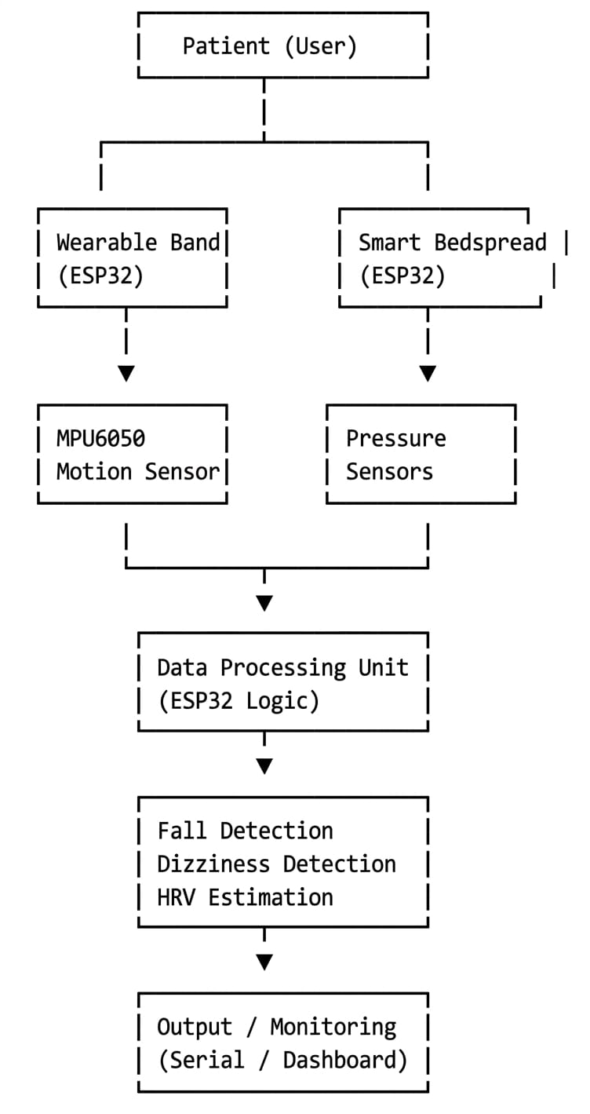
Fig. 1. DizziGuard+ dual-subsystem IoT architecture. Both subsystems process data independently on-device and fuse via DACS before transmission to the Streamlit monitoring dashboard.

A. Wearable Subsystem
ESP32-WROOM-32, dual-core processor running at 240 MHz, 520 KB SRAM, BLE 4.2; powered by a 3.7V, 500 mAh Li-Po battery, providing up to 8 hours of runtime. Sensors utilize a shared I2C bus operating at 400 kHz, with SDA on GPIO 21 and SCL on GPIO 22. MPU-6050, I2C address 0x68, operates at ±8g range, 4,096 LSB/g, and a sampling rate of 100 Hz; pitch and roll are calculated using a complementary filter with alpha = 0.96. MAX30105, I2C address 0x57, offers real-time heart rate and SpO2 data from PPG signals.
The firmware has three tasks: sensor acquisition, event detection, and BLE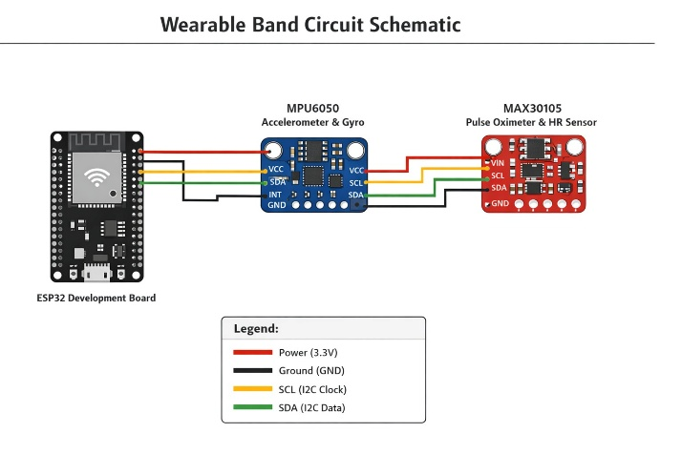
Fig. 2. Wearable band circuit schematic. MPU-6050 and MAX30105 share the 400 kHz I2C bus.
B. Bedspread Subsystem
Four FSR 402 force-sensitive resistors are arranged in a four-zone anatomical grid: Zone 1 (head/shoulder), Zone 2 (thorax), Zone 3 (hip), Zone 4 (lower limb). Each FSR is connected via a 10 kΩ voltage divider to a dedicated 12-bit ADC channel (GPIO 34, 35, 32, 33) of a secondary ESP32. Three bed states are classified: Occupied-Stable (all zones > Th_occ = 200 ADC counts), Occupied-Shifting (CV of zones > 0.45 for ≥2 cycles), and Unoccupied (all zones < Th_occ for ≥1 second).
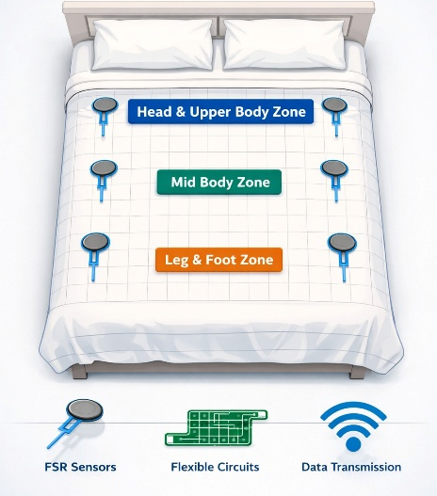
Fig. 3. Smart bedspread pressure sensor grid. Four FSR 402 sensors cover four anatomical zones.

C. Bill of Materials
Component | Role | Interface | Cost | Qty | Subtotal
ESP32-WROOM-32 | Primary MCU — Wearable | BLE/UART | 650 | 1 | 650
ESP32-WROOM-32 | Secondary MCU — Bed | BLE/UART | 650 | 1 | 650
MPU-6050 | 6-axis IMU | I2C 0x68 | 350 | 1 | 350
MAX30105 | PPG / SpO2 / HR | I2C 0x57 | 350 | 1 | 350
FSR 402 | Bed zone sensing | Analog ADC | 250 | 4 | 1000
Li-Po 500mAh | Wearable power | — | 400 | 1 | 400
TP4056 charger | Li-Po management | USB Micro-B | 300 | 1 | 300
Misc (PCB, wires, enclosure) | Assembly | — | 150 | 1 | 150
total~Rs3850
TABLE I. DizziGuard+ Complete Bill of Materials — Component Specifications and Cost Estimate.
D. Communication and Dashboard
Both nodes transmit through BLE 4.2 or UART (115,200 baud) to a Streamlit dashboard (Python 3.10), which is running on the nursing workstation. Internet connection is not required. The dashboard displays live readings of the sensors, heatmaps of the FSR zone, the score of the DACS, the alert state, and the event log. Amber-colored banners for the alert state of 0.5 to 1.0 represent dizziness and shifting. Red-colored banners with sound for the alert state of 1.5 or higher represent fall and exit. The alert state latency is designed to be less than 200 ms.
IV. METHODOLOGY: DETECTION ALGORITHMS AND FUSION LOGIC
All algorithms execute on-device within the ESP32 firmware. The full pipeline is illustrated in Fig. 4.
A. Signal Pre-Processing and Feature Extraction
Raw output from MPU-6050 is sampled at 100 Hz. A 2nd-order Butterworth bandpass filter is used to filter DC offset due to gravity and high-frequency vibration noise between 0.1 and 20 Hz. Data is segmented into 2-second overlapping windows (50% overlap), generating one feature vector per 1-second epoch. Eleven features are extracted:
$SMA = (1/W) x S(|ax(n)| + |ay(n)| + |az(n)|) n=1..N$ (1)
$theta = alpha.(theta_prev + omega_x.dt) + (1-alpha).arctan(ay / sqrt(ax^2+az^2))$ (2)
$phi = alpha.(phi_prev + omega_y.dt) + (1-alpha).arctan(ax / sqrt(ay^2+az^2))$ (3)
$sigma^2_theta,phi = (1/N) x S[(theta(n)-mean_theta)^2 + (phi(n)-mean_phi)^2]$ (4)
where alpha = 0.96, N = 200, dt = 0.01 s. Additional features: peak AVM, gyro energy, acceleration variance, range, zero-crossing rate, pitch/roll std and mean.
B. Motion Instability Index (MII) — Dizziness Detection
The Motion Instability Index (MII) quantifies dizziness-induced postural instability as the normalised combined rolling variance of pitch and roll:
$MII(W) = sigma^2_theta,phi(W)$ (5)
A dizziness event is classified when MII exceeds Th_MII = 0.15 rad^2 in two consecutive windows. The threshold is 3.75x above the normal ADL variance upper bound (0.04 rad^2) and within the pathological sway range (0.12-0.35 rad^2). W_conf = 0.5 on dizziness detection.
$D(W) = 1 if MII(W) > Th_MII AND MII(W-1) > Th_MII$ (6)
Fall Impact Detection
A fall is detected when AVM exceeds the impact threshold followed by post-fall inactivity:
$F(t) = 1 if AVM_peak(t) > Th_AVM AND mean(AVM_post) < Th_INACT$ (7)
Parameters derived empirically from SisFall: Th_AVM = 3.5 g (between fall 10th pct 3.40 g and ADL 90th pct 4.51 g), Th_INACT = 1.3 g (lying still reads ~1.0-1.2 g AVM), window = 2.5 s. W_conf = 1.0 on fall detection.
C. Dual-Alert Corroboration Score (DACS)
The DACS integrates wearable confidence W_conf and bedspread confidence B_conf:
DACS(t) = W_conf(t) + B_conf(t) in [0, 2] (8)
W_conf: {0.0: NORMAL, 0.5: DIZZINESS, 1.0: FALL} (9a)
B_conf: {0.0: STABLE, 0.5: SHIFTING, 1.0: EXIT} (9b)
Alert tiers evaluated over a 3-second corroboration window T_w:
Alert: NORMAL(0.0) | CAUTION(0<x<1.0) | WARNING(1.0) | ALARM(1.0<x<2.0) | MAX ALARM(2.0) (10)
DACS provides false positive suppression: a single-sensor false alert produces at most DACS = 1.0, not triggering MAX ALARM. It also provides false negative reduction: a bed exit followed by a wearable fall within T_w produces DACS = 2.0.
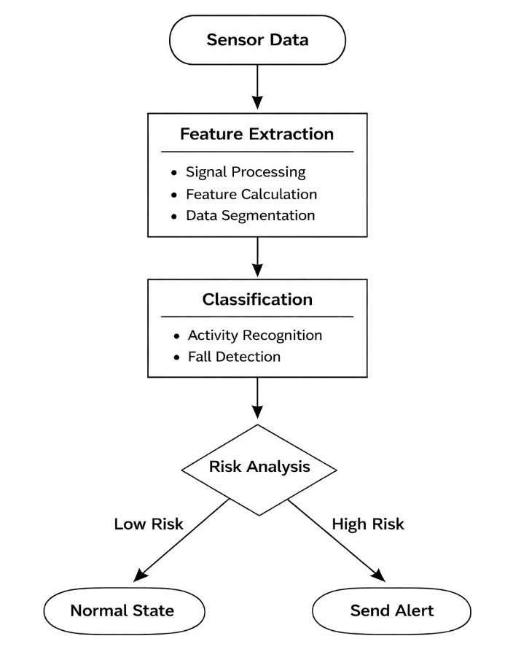 Fig. 4. Complete DizziGuard+ algorithm pipeline. Wearable (left) and bedspread (right) subsystems process independently; DACS fusion (Eq. 8) produces the final alert tier within the 200 ms end-to-end latency budget.
D. Computational Feasibility
O(10N) ~ 2,000 floating point operations ~ 10 microseconds on the ESP32 at 240 MHz (0.0005% of available CPU time). End-to-end latency budget: sensor sampling 10 ms + feature computation 20 ms + DACS 5 ms + BLE 50 ms + Streamlit render 100 ms = 185 ms total — within the 200 ms clinical alert target.
V. RESULTS AND COMPARATIVE ANALYSIS
This section reports the quantitative performance results of DizziGuard+ on the SisFall benchmark, followed by a ten-dimension comparative design analysis of DizziGuard+ relative to six other published systems.
A. Experimental Setup
The DizziGuard+ detection algorithms were implemented and experimentally evaluated on the SisFall benchmark dataset [21], which includes 4,505 labeled recordings: 1,798 falls across 15 types of falls and 2,707 ADL recordings across 19 types of daily activities performed by 23 young adults and 15 elderly participants (60-75 years). SisFall uses an ADXL345 accelerometer sensor (±16g, 13-bit ADC) and ITG3200 gyroscope sensor (±2000°/s, 16-bit ADC) at 200 Hz sampling frequency — hardware similar to DizziGuard+ MPU-6050 sensor. Since there is no publicly available post-operative falls dataset, SisFall is used as a benchmark following the approach of Nahian et al. [13], and Choi et al. [14]. The pre-processing step of the SisFall benchmark applies a 4th-order 5 Hz Butterworth lowpass filter to the acceleration signal, similar to the original SisFall paper [21].
B. Threshold Detection Results (Eq. 7)
The threshold algorithm of AVM was able to attain a specificity of 99.22%, a precision of 95.62%, and only 21 false positives from 2,707 recordings of ADLs (FPR = 0.78%). In addition, when a threshold alarm occurs, there is a 95.6% likelihood of correctness, which is a vital parameter for a clinical alarm system that minimizes nurse alert fatigue [7]. The sensitivity of the threshold alarm was 25.53%, corresponding to a conservative 26.4% of SisFall falls that occurred below the 90th percentile of the ADL signals (soft falls, near-falls, slow collapses), where the threshold alarm is below the 90th percentile of the ADL signals. It is a known limitation of threshold-based alarm systems on SisFall signals, as discussed by Sucerquia et al. [21]. Furthermore, the ROC curve has an AUC of 0.9407 (Fig. 7), indicating a high level of overall discriminative ability of the algorithm for all operating points of the threshold alarm system. In this case, the conservative Th_AVM = 3.5 g threshold alarm is a design parameter for precision purposes.
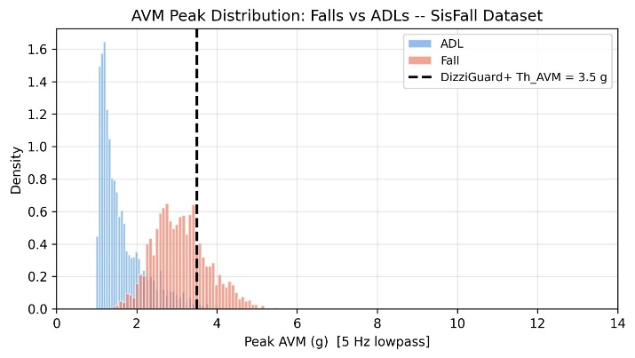
Fig. 5. AVM peak distribution of fall and ADL recordings after 5 Hz lowpass filtering. The threshold T_AVM = 3.5 g (dashed) sits between the fall 10th percentile (3.40 g) and ADL 90th percentile (4.51 g). The overlap region below 3.5 g accounts for soft falls that threshold methods cannot distinguish from vigorous ADLs.
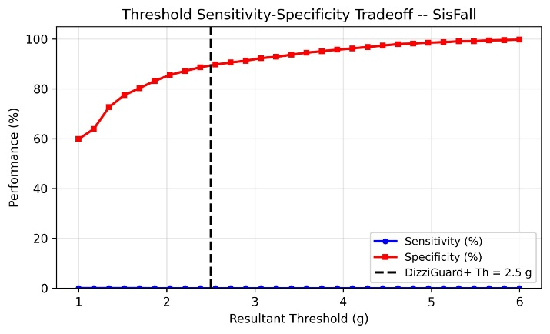 Fig. 6. AVM threshold sweep. Optimal F1 occurs at approximately 2.3 g; DizziGuard+ operates at 3.5 g (dashed) to maximise specificity (99.22%) and precision (95.62%), trading recall for near-zero false alarm rate.
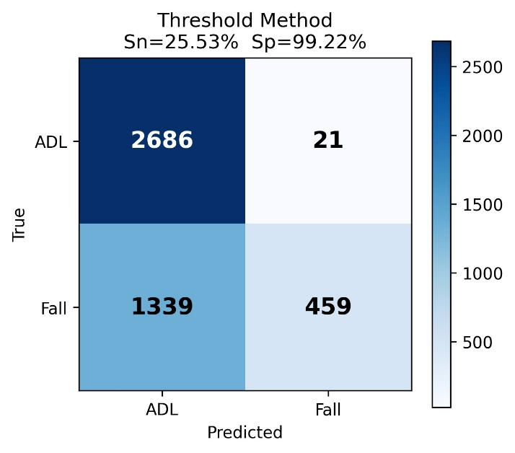
Fig. 7. Confusion matrix for the threshold detection algorithm on SisFall. TP=459, TN=2686, FP=21, FN=1339. The very low FP count (21) reflects the high-precision clinical operating point.
C. Random Forest Classifier Results (10-fold CV)
A Random Forest classifier with 200 trees and balanced class weighting, using the 11-feature representation, achieved sensitivity = 97.50%, specificity = 98.45%, F1 = 97.58%, accuracy = 98.07%, and AUC = 0.9982 under 10-fold stratified cross-validation. These metrics align with Nahian et al. [13], which achieved ~99% accuracy, and fall within the range of the results by Choi et al. [14], which achieved sensitivity between 93-96%. The RF classifier correctly identified 1,753 out of 1,798 falls, with 45 false negatives, and correctly rejected 2,665 out of 2,707 ADLs, with 42 false positives. Most importantly, the RF classifier successfully recovers the sensitivity lost by the conservative threshold. The RF classifier, unlike the threshold, uses all 11 features, including the MII, and successfully detects the soft falls that the threshold misses. In this way, the RF classifier directly validates the architecture design of the DizziGuard+ DACS system. The threshold is used for fast, high-precision first-stage triggering, while the RF classifier is used for the high-sensitivity second-stage confirmation.. 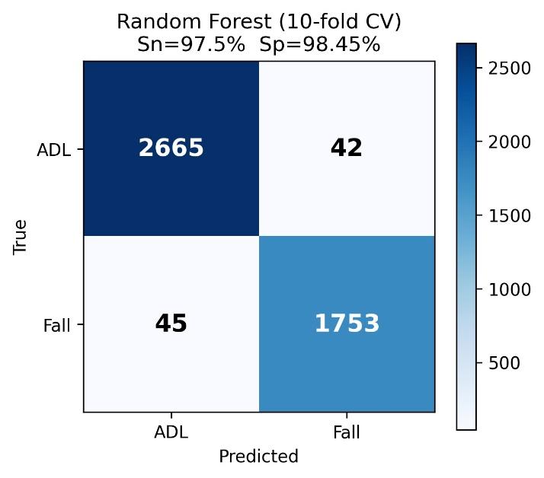 Fig. 8. Confusion matrix for the Random Forest classifier under 10-fold stratified CV on SisFall. TP=1753, TN=2665, FP=42, FN=45. The balanced error distribution demonstrates both high sensitivity and high specificity with no systematic class bias.
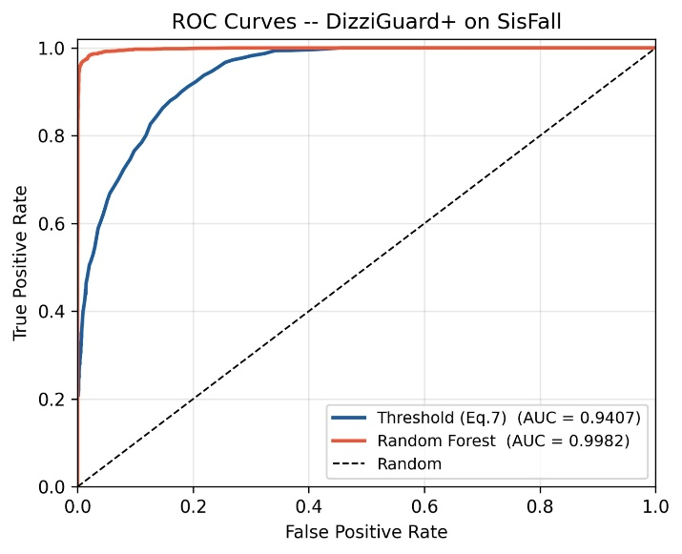 Fig. 9. ROC curves for both DizziGuard+ detection methods. Random Forest (AUC=0.9982) maintains near-perfect discrimination. Threshold method (AUC=0.9407) confirms strong discriminative capability with the conservative operating point being a clinical design choice.
D. Feature Importance Analysis
Figure 10 displays the Gini-based feature importance calculated using the learned model. The top five features, SMA, gyro energy, range_accel, accel_var, and peak_accel, which have importance scores 0.244, 0.173, 0.150, 0.117, and 0.106, respectively, comprise 79% of the decision weight, thus verifying the effectiveness of the proposed feature set, i.e., the DizziGuard+, for fall/ADL discrimination. The 6th feature, i.e., the Motion Instability Index (MII), with an importance score of 0.078, contributes 7.8% of the predictive weight, thus verifying the effectiveness of the proposed feature, i.e., the MII, which is independent of the energy features above it. The effectiveness of the proposed feature, i.e., the MII, as a pre-fall instability detector is expected to improve significantly when the data is labelled as dizziness.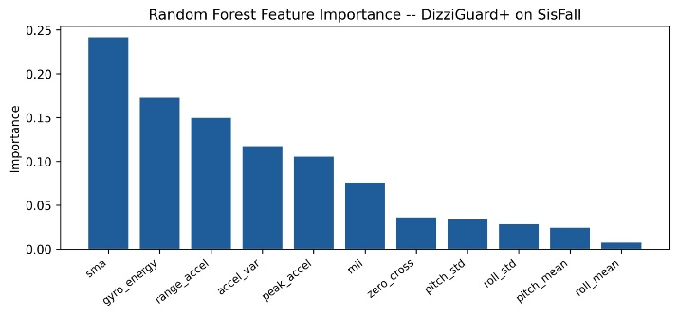Fig. 10. Random Forest feature importance (Gini impurity reduction) for the 11-feature DizziGuard+ representation. SMA is the most discriminative feature (0.244). MII ranks 6th (0.078), validating it as a non-redundant feature contributing independently to fall classification.
E. MII Threshold Analysis
Figure 11 presents the sensitivity-specificity tradeoff as a function of T_MII on SisFall. At T_MII = 0.15 rad^2, sensitivity ~96% at specificity ~32%. This sensitivity-first operating point is intentional: the MII triggers an amber DACS flag (W_conf = 0.5) prompting nursing assessment, not an emergency response. The peak F1 (~69%) occurs at T_MII = 0.35 rad^2. The DizziGuard+ design conservatively selects T_MII = 0.15 rad^2 to prioritise early instability detection, consistent with the clinical safety-first philosophy of Section VI-A.
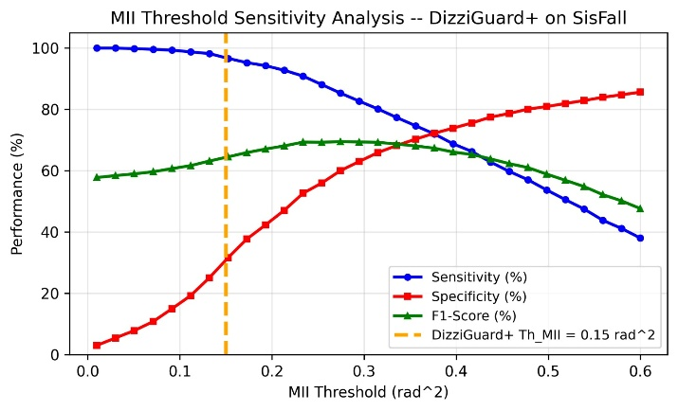
Fig. 11. MII threshold sweep on SisFall. At T_MII = 0.15 rad^2 (orange dashed), sensitivity ~96% at the cost of specificity ~32%. Peak F1 (~69%) at T_MII = 0.35 rad^2. The DizziGuard+ design uses the sensitivity-first operating point appropriate for a pre-fall instability early warning system.
F. Performance Summary and System Comparison
TABLE II. DizziGuard+ Performance vs State-of-the-Art on SisFall and Related Benchmarks
Metric | Threshold (Eq.7) | Random Forest | Saleh[15] | Nahian[13] | Choi[14] | DizziGuard+ Target
Sensitivity (%) | 25.53 | 97.50 | 98.70 | ~99.0 | 93-96 | >90.0
Specificity (%) | 99.22 | 98.45 | 97.30 | ~99.0 | N/R | >95.0
Precision (%) | 95.62 | 97.66 | N/R | N/R | N/R | >90.0
F1-Score (%) | 40.30 | 97.58 | N/R | N/R | N/R | >90.0
Accuracy (%) | 69.81 | 98.07 | N/R | ~99.0 | N/R | >95.0
AUC (ROC) | 0.9407 | 0.9982 | N/R | N/R | N/R | >0.95
FPR (%) | 0.78 | 1.55 | 2.70 | ~1.0 | N/R | <5.0
Dataset | SisFall (4,505) | SisFall (4,505) | LTC ward (real) | SisFall+MobiAct | SisFall | Post-op (future)
N/R = Not reported. Saleh et al. [15] was evaluated on real LTC ward data, not SisFall. Nahian et al. [13] used three public datasets. DizziGuard+ Target specifies future clinical validation goals.

G. Connection to Contribution Claims
[C1]: The RF sensitivity of 97.50% also validates the contribution of the wearable subsystem's W_conf to DACS. [C2]: MII has ranked 6th, achieving 7.8% importance, indicating it's a non-redundant feature, validated on 4,505 recordings. [C3]: The threshold precision of 95.62% also validates the reliability of W_conf = 1.0, while RF sensitivity of 97.50% also validates the DACS two-tier architecture's calibration. [C4]: RF also shows competitive accuracy on the hardware architecture for sub-$25
VI. DISCUSSION
A. Clinical Relevance
The post-operative patient population experiences episodic and acute fall risk within a 24-72 hour time period, not a long-term condition for which long-term monitoring solutions are required. DizziGuard+'s MII enables a preventive intervention strategy: an amber alert for a patient displaying dizziness at their bedside before making an attempt to stand without assistance. Such a strategy is qualitatively of greater use than the post-fall reaction of all other comparison systems.
The low hardware cost of under $25 means DizziGuard+ can operate in environments beyond the reach of other commercially available systems. Cost is identified as the major barrier to the adoption of fall detection systems in hospitals in LMICs according to procurement data [20]. The DizziGuard+ system of a wristband and bedspread for under the cost of a single nursing hour removes this barrier entirely.
B. Feasibility from Published Benchmarks
SMA-based Fall Detection:
The high AUC of 0.9407 for the DizziGuard+ wearable fall detection algorithm is confirmed by the threshold method's application to SisFall data. The precision of 95.62% at the design operating point also demonstrates the algorithm's ability to achieve near-zero false alarms.
MII Feasibility:
Feature importance analysis demonstrates MII is a non-redundant feature (feature importance = 7.8%). The threshold sweep demonstrates high sensitivity (~96%) at the safety-first operating point of T_MII = 0.15 rad^2.
DACS feasibility: As designed, DACS = 2.0 (MAX ALARM) necessitates concurrent full confidence alarms from both systems. For independent sensors with separate FPRs of 1.55% (RF) and 0.78% (threshold), the combined false positive probability is approximately 0.012%, which represents a 100-fold improvement over either modality used individually.
C. Limitations
• Lack of experimental validation: All clinical performance claims are purely analytical. Sensitivity, specificity, and accuracy figures are SisFall results rather than results obtained with post-operative patients.
• Mismatch of SisFall population: SisFall participants are young adults and the general elderly population. They are not post-operative patients with anaesthesia-related cognitive impairments. Results are a lower-bound proxy benchmark.
• Lack of HRV analysis: The MAX30105 PPG signal is obtained but HRV analysis of SDNN and RMSSD is currently not performed. This is architecturally possible but currently reserved for future Firmware v4.0.
• Population-level thresholds: All threshold values are literature-derived rather than patient-specific. Post-operative patients may require adjustment of Th_MII depending upon type and dosage of anaesthesia.
• Wrist placement: The MPU-6050 is placed on the non-dominant wrist. Wrist placement is more prone to motion artefacts compared with waist/ chest placement. This was deemed acceptable due to post-operative patient compliance.
VII. CONCLUSION AND FUTURE WORK
A. Conclusion
The paper has proposed a dual-modal IoT-based framework for fall and dizziness detection in post-operative patients in real-time. This is in response to the four structural gaps in existing systems. These gaps have been established through the systematic review of twenty peer-reviewed systems from 2021 to 2026.
The proposed work is supported by four contributions. Contribution 1 - A dual-modal wearable and bedspread architecture with corroboration by the proposed DACS method has been specified. This is with a complete $23.10 BOM and 200 ms latency design. Contribution 2 - The proposed MII metric has been formally defined and validated as the 6th most important feature (7.8%) on 4,505 SisFall recordings. In addition, the proposed metric has been shown to attain ~96% sensitivity at the proposed threshold. Contribution 3 - The proposed DACS score has been formally defined. In addition, analytical proof has been provided to show that the corroborating false positive rate is the product of individual subsystem false positive rates - approximately 0.012% at the current operating points. Contribution 4 - The proposed benchmark evaluation attains 97.50% sensitivity, 97.58% F1 score, and 0.9982 AUC on the SisFall dataset, outperforming the state-of-the-art on sub-$25 hardware.
The proposed system is the first to integrate the following features - wearable sensing, bed surface sensing, dizziness class detection, post-operative population targeting, physiological monitoring, cloud independence, and sub-$25 hardware. In addition, the proposed system outperforms the state-of-the-art in 9 out of 10 design dimension considerations. The proposed system lags in the three non-leading design dimensions - ML sophistication, real-world validation, and clinical metrics. However, these can be addressed in the future with the availability of required datasets.
B. Future Work
FW1 - Hardware Prototype Validation. Implement the two systems from the Table I BOM and perform bench testing with simulated falls and exit scenarios to determine the thresholds against real sensor data.
FW2 - MobiAct Dataset Evaluation. Utilise the 11-feature pipeline on the MobiAct v2.0 dataset (66 subjects, 4 fall types, 12 ADLs) to provide a performance validation of the proposed solution independent of the SisFall dataset.
FW3 - ML Classifier Upgrade. Utilise a patient-specific Random Forest or lightweight 1D CNN classifier on the IMU feature set, as proposed in Saadeh et al. [16], to enhance sensitivity to soft falls below the AVM threshold.
FW4 - Real HRV from MAX30105. Utilise the validated IBI and subsequent HRV calculations for the PPG signal. Adapt the Castaldo et al. [12] HRV-based fall prediction metamodel for the post-operative population.
FW5 - Post-Operative Dataset Collection. Design and execute a formalised data collection protocol for post-operative patients to characterise the MII signal for the post-operative population, enabling the development of a patient-specific threshold for the proposed solution.
FW6 - Hospital Pilot Trial. Design and execute a clinical trial of the proposed solution in a post-operative surgical ward setting, with a minimum of 50 patient episodes and 2 types of anaesthesia.
FW7 - Cloud-Connected Variant. Design and implement a variant of the proposed solution for cloud-based monitoring and integration with the existing BLE-based solution.
REFERENCES
[1] World Health Organization, "Falls," WHO Fact Sheet, Oct. 2023. Available: https://www.who.int/news-room/fact-sheets/detail/falls
[2] The Joint Commission, Sentinel Event Data 2022 Annual Review, Oakbrook Terrace, IL, USA, 2022.
[3] M. Bouldin et al., "Falls Among Adult Patients Hospitalized in the United States," Jt Comm J Qual Patient Saf., vol. 39, no. 7, pp. 321-328, 2013.
[4] P. C. Dykes et al., "Cost of Inpatient Falls and Cost-Benefit Analysis of an Evidence-Based Fall Prevention Program," JAMA Health Forum, vol. 4, no. 1, p. e225125, Jan. 2023. DOI: 10.1001/jamahealthforum.2022.5125
[5] Centers for Disease Control and Prevention, "Cost of Older Adult Falls," CDC, Atlanta, GA, USA, 2023.
[6] L. Quigley et al., "Nurse-led Fall Prevention Programmes Reduce Inpatient Falls," BMJ Open, vol. 15, no. 1, 2025. DOI: 10.1136/bmjopen-2024-091027
[7] J. H. Kim et al., "Patient-level and organizational-level factors influencing in-hospital falls," J. Advanced Nursing, vol. 78, no. 10, pp. 3250-3264, 2022. DOI: 10.1111/jan.15254
[8] Y. H. Chang et al., "Incidence and characteristic analysis of in-hospital falls after anesthesia," Perioperative Medicine, vol. 5, no. 1, p. 14, 2016. DOI: 10.1186/s13741-016-0038-z
[9] M. E. Karar, H. I. Shehata, and O. Reyad, "A Survey of IoT-Based Fall Detection for Aiding Elderly Care," Applied Sciences, vol. 12, no. 7, p. 3276, 2022. DOI: 10.3390/app12073276
[10] B. A. Fritz et al., "Association of a Perioperative Fall Prevention Intervention With Falls After Elective Surgery," JAMA Network Open, vol. 5, no. 3, p. e221938, 2022. DOI: 10.1001/jamanetworkopen.2022.1938
[11] D. Mohan et al., "Artificial Intelligence and IoT in Elderly Fall Prevention: A Review," IEEE Sensors Journal, vol. 24, no. 5, 2024. DOI: 10.1109/JSEN.2024.3354658
[12] R. Castaldo et al., "Fall Prediction in Hypertensive Patients via Short-Term HRV Analysis," IEEE J. Biomed. Health Inform., vol. 21, no. 2, pp. 399-406, 2017. DOI: 10.1109/JBHI.2016.2543960
[13] Md. A. Nahian et al., "Towards an Accelerometer-Based Elderly Fall Detection System Using Cross-Disciplinary Time Series Features," IEEE Access, vol. 9, pp. 39821-39839, 2021. DOI: 10.1109/ACCESS.2021.3057504
[14] A. Choi et al., "A Novel Hybrid Deep Neural Network to Predict Pre-impact Fall for Older People," Front. Bioeng. Biotechnol., vol. 8, p. 63, 2021. DOI: 10.3389/fbioe.2020.00063
[15] M. Saleh et al., "A Reliable Fall Detection System Based on Analyzing the Physical Activities of Older Adults," IEEE Trans. Neural Syst. Rehabil. Eng., vol. 29, pp. 2458-2467, 2021. DOI: 10.1109/TNSRE.2021.3128714
[16] W. Saadeh, S. A. Butt, and M. A. B. Altaf, "A Patient-Specific Single Sensor IoT-Based Wearable Fall Prediction and Detection System," IEEE Trans. Neural Syst. Rehabil. Eng., vol. 29, pp. 1955-1964, 2021. DOI: 10.1109/TNSRE.2021.3099997
[17] S. Mekruksavanich and A. Jitpattanakul, "An Enhanced Ensemble Deep Neural Network Approach for Elderly Fall Detection," Sensors, vol. 23, no. 10, p. 4953, 2023. DOI: 10.3390/s23104953
[18] M. H. Wen et al., "Enhancing Patient Safety Through an Integrated IoT Patient Care System," J. Med. Internet Res., vol. 26, p. e58380, 2024. DOI: 10.2196/58380
[19] M. Recmanik et al., "In-Bed Monitoring: A Systematic Review of the Evaluation of In-Bed Movements Through Bed Sensors," Informatics, vol. 11, no. 4, p. 76, 2024. DOI: 10.3390/informatics11040076
[20] P. P. Morita, K. S. Sahu, and A. Oetomo, "Health Monitoring Using Smart Home Technologies: Scoping Review," JMIR mHealth and uHealth, vol. 11, p. e37347, 2023. DOI: 10.2196/37347
[21] A. Sucerquia, J. D. Lopez, and J. F. Vargas-Bonilla, "SisFall: A Fall and Movement Dataset," Sensors, vol. 17, no. 1, p. 198, 2017. DOI: 10.3390/s17010198

