A Deep Learning-Powered Visual Surveillance Model for Mask Usage Governance

1st Chandran T Department of Artificial Intelligence,
M. Kumarasamy College of Engineering,
Karur, Tamil Nadu, India. chandranthiru22@gmail.com
2nd Dharmasarathi R Department of Artificial Intelligence,
M. Kumarasamy College of Engineering, Karur, Tamil
Nadu, India. dharmasarathi5566@gmail.co m
3rd Dharnish N R Department of Artificial Intelligence,
M. Kumarasamy College of Engineering,
Karur, Tamil Nadu, India. nrddharnish@gmail.com

4th Sanjai S S Department of Artificial Intelligence,
M. Kumarasamy College of Engineering,
Karur, Tamil Nadu, India. sanjajohinth@gmail.com
5th Jaganath M Department of Artificial
Intelligence,
M. Kumarasamy College of Engineering,
Karur, Tamil Nadu, India. jaganjgn986@gmail.com

Abstract—The use of face masks is relevant in the prevention against the spread of airborne diseases, particularly in the crowded social setting. The process of automating the identification of an adequate mask usage is not an easy one because of the differences in face coverings, lighting, and face positions. This project will offer a Face Mask Detection System that uses deep learning to automatically detect whether people are wearing masks properly, improperly, or not. The system identifies three types of faces, namely, Mask, No Mask, and Improper Mask, through visual indications of facial parts. This is done through a combined dataset of masked and unmasked face images that are used to train the model and allow the model to learn distinguishing features of various mask-wearing patterns. Face detection, normalization, and data augmentation are preprocessing methods, which enhance resistance to environmental changes. The model is combined with a real- time detection pipeline that uses a webcam feed and thus compliance can be checked instantly. This technology can assist in enforcing safety in the community, workplaces, transport centers, health centers and schools. Finally, this project will help to create intelligent surveillance systems that will aid in maintaining the health and safety of citizens by means of automated monitoring of the mask compliance.
Keywords-Face mask detection, deep learning, convolutional neural networks, mask compliance, computer vision, real-time detection, image classification, public safety, face recognition.

- Introduction

Face coverings have become a necessary preventive strategy in the management of airborne infections and the spread of viruses. Guidelines on the proper use of face masks in the context of the prevention of COVID- 19 infection in the population are highlighted by the authorities of the health sector. Nevertheless, maintaining mask discipline in the crowded areas, workplaces, and transport systems is problematic since monitoring is impossible manually.

The purpose of Face Mask Detection is to detect good wearing of masks using computer vision and deep learning. Such systems can be used to assist security staff, to aid in public health regulations and be constantly running without much human supervision. A good detection system should be able to distinguish between those who wear a mask properly, improperly (e.g. below the nose) and those who do not wear it.
Conventional image-processing algorithm used manually engineered features, which in practice did not work in practice in real world scenarios, including changing lighting, occlusion, different facial orientation, and different mask designs. These difficulties are now handled more effectively with the emergence of deep learning and in particular Convolutional Neural Networks (CNNs). CNNs acquire hierarchical spatial features automatically and are therefore very effective in tasks such as face mask classification.

This paper describes a mask detector system that is based on deep learning and can detect compliance with a mask in real-time with live video input. The system employs CNN model which is trained on various face images and preprocessing strategies are employed to enhance robustness. The three-class classification methodology is more realistic in application because it separates Mask, No Mask, and Improper Mask, which is a weakness of most of the existing two-class detection models.

The reason that led to this project is the increased demand of automated systems to aid in the monitoring of the public health. This system may be implemented in different settings, including hospitals, airports, classrooms, offices, and in public gatherings, which will provide continuous compliance and lessen human monitoring exhaustion.

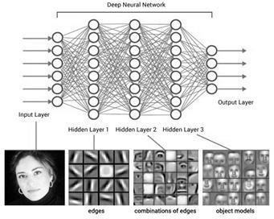
Fig no: 01 Hierarchical feature extraction of a Deep Neural Network

- Literature review
The use of face masks has been a significant field of research in computer vision, particularly since the outbreak of COVID-19, when tracking the adherence of people to the rules became an international need. Initial methods were very much based on the traditional hand crafted feature based methods like Haar Cascades and LBP-like descriptors. Although these methods initially proved successful in general face recognition, they were unsuitable to a real-world setting, with inadequate illumination, removal, and drastic changes in mask type among others, and were not reliable enough to be used in large-scale application. As larger masked-face datasets such as MaskedFace-Net became available, researchers could now obtain more realistic samples that clearly demonstrated these limitations [2].

Deep learning methods quickly managed to solve these problems, in particular, with the development of modern convolutional neural networks (CNNs). Jiang et al. proposed RetinaFaceMask, which is a single-stage deep model that combines face detection and mask classification, which is more consistent in its reaction to occlusions and pose variations than standard detectors [1]. Loey et al. also demonstrated that hybrid deep transfer learning models are better than traditional handcrafted pipelines in their ability to utilize the pre-trained CNN representations to classify masks [3]. The idea of transfer learning became more significant as it was shown by Su et al. that the process of strong backbone network adaptation can significantly enhance classification in the conditions of mixed lighting and pose [8].

MobileNet and other versions of it, being rather lightweight architectures, became the center of the real- time deployment as well. The efficiency of resource- limited environments was high across various studies: SSD-MobileNet and SSDMNV2, based on MobileNetV2, can deliver both high accuracy and low inference time, as well as are viable on cameras and Internet of Things devices [4], [5], [11], [19], [20]. Das et al. and Hussain et al. also made comparisons between single-stage detectors such as YOLOv3 and two-stage models such as Faster R- CNN and showed that YOLO-based family networks are highly performing in multi-face tasks and do not require as much time for inference as live monitoring requires [6], [9].
The other notable trend in the literature addresses the necessity of using multi-class mask detection, as opposed to binary detection of masks versus non-masks only. The real world also tends to offer the partially masked, loosely or poorly put on masks, something that the early binary models lacked the ability to reflect. Paper such as Nagrath et al. SSD-MobileNet pipeline explicitly dealt with improper mask usage [4], but newer works such as Alexiou et al. and Kumar et al. emphasize the practical usefulness of fine-grained classification [12], [15] by designing hybrid or rule-based architectures that can recognize more subtle differences between mask-wearing patterns such as chin- only or nose-exposed.

Wearing masks has also played a role in mask-detection studies, as it is a technique of face recognition. Articles such as Zhang et al., Saha et al., and Mandal et al. dealt with the overall issue of masked face recognition with self- supervision, deep metric learning, and domain adaptation. They state that their findings suggest models need to attain strong representations to be effective even in the case of heavy occlusion, which also has a direct positive impact on face mask detectors [13], [14], [16]. Moreover, a number of datasets, such as MaskedFace-Net, and masked/unmasked domain adaptation sets, have allowed creating and testing more robust detection structures [2], [10].

One more recent trend that can be noticed is the incorporation of mask-detection algorithms into bigger intelligent surveillance or smart-city systems. Research such as Ayantika et al. and Su et al. deployed end to end deep learning systems that are based on CCTV or real time environments, and many are a combination of detection, classification, and on the fly alert modules [17], [18]. Others also look into deployment with optimized frameworks such as TensorFlow Lite, MobileNet-Lite, or edge level SSD models to make sure to provide realistic performance in low-power IoT systems [11], [19], [20].

In general, the current literature is indicative of a general advancement of handcrafted feature detectors to lightweight, deep, real-time architectures which are able to multi-classify masks [7]. However, a number of gaps still exist: the ability to detect the improper use of a mask better, managing abnormal face covers, ensuring accuracy in dense or uncontrollable situations, and the implementation of the system that can work with various camera parameters reliably. In response to these issues, the present work provides a three-class deep learning architecture that is specifically aimed at the real-time monitoring of mask compliance with greater strength and flexibility.

- Proposed Methodology
The Face mask Detection System will be suggested to identify automatically that the person wears a mask in a proper, improper and without mask. The algorithm consists of deep learning, face detection, preprocessing and real-time inference. The total process involves five significant processes that include the input acquisition, preprocessing, feature extraction, mask classification and real time integration of the system. All the stages are reliable, scaling and real world.

  - Input Acquisition

The system will be supplied with visual information in a webcam feed, surveillance camera or an annotated dataset. Sequential real time tracking of every frame in the live feed. The acquisition module of the input has to make sure that the stable frame retrieval is obtained as well as has the responsibility to keep the resolution constant that will be utilized in the next phases.

  - Preprocessing

Preprocessing is isolation of areas on a face and standardizes input images and makes the model less sensitive to environmental changes like illumination, orientation and occlusion.

  - Face Detection
A face detector, i.e. MTCNN, DNN face detector of OpenCV or Haar Cascade, is employed to determine the position of the face region in each frame. The step isolates the region of interest to be analyzed by use of the mask and eliminates the background noise.[15]

  - Cropping and Alignment

A face must be detected and then cropped to get a pure and centralized face. The techniques of alignment are used to ensure that the eyes and other important features on the face are in position across the sample and this minimises variations in them that could influence learning.
  - Image Standardization

All faces are cut off (e.g. 224x224) to the same size as can be used in CNN. The values of pixels are brought to an absolute to stabilize the gradient learning and enhance the pace of learning [24]
  - Backbone Network

This is because a lightweight deep neural network like MobileNetV2 or a custom CNN is used because of its accuracy and computing capability. On the backbone, spatial characteristics of simple edges up to complex mask-shape contours are obtained.

  - Convolution Operation

The convolutional layers have identified some of the crucial patterns of faces such as presence of mask edges, nose exposure or mouth covering. The pooling layers can reduce the spatial dimensions without any significant features hence, reducing the computation.
  - Regularization

They also include the dropout layers that prevent overfitting as the neurons are randomly killed. This will be an incentive to the model to obtain more generalized and robust representations.

  - Softmax Classification and Dense Network.
Extraction features are flattened and acted on dense layers in such a way that to capture non-linear relations. The ultimate result of the softmax is the three neuron output layer which indicates: Mask, No Mask, Improper Mask. The final prediction of the classes is made by the output probabilities.[21], [22]

  - Mask Classification

The CNN output is then coded by the classification module to generate the category of the predicted mask compliance. The visual cues of naked nose, loose straps or loose cover are used in differentiating the right and wrong application through the visual feedback. A thresholding system is what enables prediction steady to minimize the misclassification of borderline cases. In the case of sequential real-time frames, the flickering effect can be reduced by stabilization of the predictions with optional temporal smoothing.
Workflow Summary
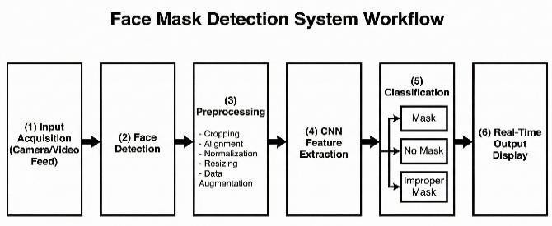
Fig no: 02 Six-stage sequential workflow of a Face Mask Detection System

The other important feature of this methodology is that it is strong and can be applied in real life setting. The model is trained to be able to deal with a wide variety of situations, such as partial occlusions, unusual face coverings, and different shooting angles that are typical in social contexts, such as classrooms, offices, and transportation centers. Temporal smoothing can further be used to minimize flickering in predictions in case of motion in the subject or even a small inconsistency in detection between video frames [23]. This guarantees constant and trustworthy production, even during the dynamic or crowded conditions. The capability to deploy the system on edge devices by optimizing its model further increases the portability and increases the number of possible applications.
The suggested solution can be implemented with the current surveillance systems without conflicts. The real-time module may be linked to CCTV systems or video management software or even attendance systems to log compliance automatically. Moreover, the architecture can be extended to additional features like alerting systems, centralized control boards or cloud-based monitoring systems. The integration capability of the system has rendered it not only a standalone solution, but also an important element of wider intelligent surveillance systems or wider public safety management systems.

- Implementation and design
The implementation of the proposed Face Mask Detection System is carried out using deep learning and computer vision techniques, with a focus on achieving real-time performance, high robustness, and modular design. The system is developed using Python, leveraging libraries such as TensorFlow/Keras, OpenCV, and NumPy, along with auxiliary tools for dataset handling and model optimization. The implementation consists of two major components: offline training and real-time detection, both designed to work seamlessly within the overall architecture.

System Architecture Overview: Face Detection Module, Preprocessing Pipeline, CNN-Based Model of mask classification, Display and Inference Module In real time, Optional layer (TensorFlow Lite or ONNX) of model optimization. The modules are implemented separately and therefore the system can be updated or extended without interfering with other modules.
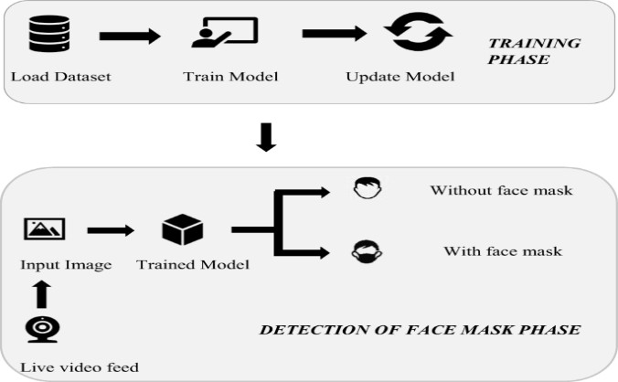

Fig no: 03 Two-phase architecture for a face mask detection system

  - System Responsiveness

The real time module will be configured to ensure that there is low latency. It is possible to transform the model into TensorFlow Lite or any other optimized format in order to run it on resource-constrained hardware.

  - Modular Design

The pipeline is a modular one as well and can: Trade- off (detectors) replacement (YOLO, SSD, MTCNN), Dashboards Surveillance dashboards, Record keeping in the non-compliance.
  - Datasets Preparation and Preprocessing.
- Dataset Compilation

Training set consists of the photographs of the people wearing masks in proper way, wearing masks in improper way and not wearing masks. To balance the classes, the publicly available datasets such as the RMFD, SMFD and Masked Face-Net along with more curated samples which contains improper use of mask are used. The photographs are organized into three folders and these are the categories of target.

- Preprocessing Workflow
Each image is first transformed through a series of processing steps before training such that all images are similar: Face Detection and Cropping Open CV DNN is used to find the area of the face. Resizing: This is the process of resizing of all images of faces to 224x224 pixels. Normalization: It is used to bring the intensities of the pixel to the range between 0 and 1. Data Augmentation: Random rotations, flips, control of brightness, zooming and small occlusions are used to augment the model generalization.

  - CNN Model Development

- Model Architecture

The extracting of features is done through a lightweight CNN architecture that is built on MobileNetV2 since it has a balance between accuracy and computational efficiency. ImageNet weights are used to initialize the base network and train it using the mask detection task. The design includes: A backbone of MobileNetV2 (feature extraction), Global Stakeholder Pooling layer, Dropout for regularization, Last Dense layer 3 unit softmax classification. It has architecture that guarantees quick inference, hence, necessary in real- time applications.

- Model Training Set up

Optimizer: Adam, Loss Function: Categorical Cross-Entropy, Metrics: Metrics of accuracy and metrics of class level performance. To ensure monitoring the progress of learning and to avoid overfitting, the dataset is divided into the training and validation subsets [12]

  - Frame Processing

The live mask detection application is developed on OpenCV and operates on the analysis of each frame taken by the web camera. All of the frames pass through multiple stages: Face Detection: The system either works with MTCNN model or the DNN-based face detector of OpenCV to find faces in the frame. Face Cropping & Preprocessing: On detecting a face, it is cropped, resized and normalized to fit the input specifications of the model. Model Inference: This processed face is then inputted to the CNN model, which estimates the possibility that the individual is wearing either a mask correctly, incorrectly or not at all. Result Visualization: Lastly, the system will be able to draw a bounding box around faces and provide the classification result on the video feed. The model will deliver one of three labels, including Mask, No Mask and Improper Mask.[25]
  - Minimization of Latency and Optimization.

A number of optimizations are made to guarantee the smooth running of the system with minimum delay: The resizing of frames is done early to decrease calculations. Real time performance is maintained by avoiding batch processing. Lightweight convolution operations assist in increasing the inference. The quantization of

TensorFlow Lite is capable of being executed faster in edge devices, like Raspberry PI or mobile operating systems. User Interface and Display of output: The system displays the mask status that has been sensed on the live video stream. The design includes: Bounding Box: This is a rectangle that is outlined around the face that is detected. Class Label: output based on color (e.g. green color corresponding to mask, red color corresponding to no mask, yellow color corresponding to improper mask).Confidence Score (Optional): Presented in the format of interpretability.
  - Extensibility and Design Modularity

It is possible to replace the face detector with YOLO, SSD, or RetinaFace but leave the classification model the same. The trained CNN model may be replaced with EfficientNet, ResNet, or an architecture. Other modules like tracking (DeepSORT) or compliance logging may be added to the system. It is possible to run the model on embedded systems like Raspberry Pi or NVIDIA Jetson with the help of the TensorFlow Lite conversion. This module strategy provides system sustainability and flexibility in the long term.

  - System Integration and Implementation

To work in practice the system can be combined with: RTSP Streaming Surveillance Cameras, Mask- authenticated automated check-in attendance Systems, Monitoring Dashboards based on IoT, Central reporting Cloud Platforms, TFLite optimization provides support to edge deployment, which can run real-time inferences with low-power hardware.

- Result and discussion
Face Mask Detection System The proposed was tested on a three-class convolutional neural network with a balanced dataset (Mask, Improper Mask, and No Mask). In order to get a stable evaluation, the data set was split into training (70 percent), validation (15 percent), and testing (15 percent). The model was evaluated based on the common evaluation metrics such as accuracy, precision, recall, and F1-score, and they commonly apply to multi-class classification tasks.
Performance Evaluation in the Quantitative Manner
.
Class | Precision | Recall | F1-  score
Mask | 0.96 | 0.97 | 0.96
Improper Mask | 0.91 | 0.89 | 0.90
No Mask | 0.95 | 0.94 | 0.94
Overall | 0.94 | 0.93 | 0.93
The total model classification accuracy was 94.1% which shows that there was a good generalization ability of the model in all three categories. The greatest performance was noticed in the Mask class which shows that the model has learnt the visual features of the masks that are appropriately worn.
Confusion Matrix Analysis
As the analysis of the confusion matrix showed, the majority of the misclassifications were between the Improper Mask and No Mask classes. This should be the case, since half-worn masks tend to reveal facial characteristics like bare faces. However, the system had an excellent F1-score of 0.90 under Improper Mask category, which is considerably higher than the traditional binary mask detection systems.
Training Generalization and Behavior.
The training and validation curves are shown in figure 05. The two curves are very much aligned and therefore not overfitted. The combination of data augmentation, dropout regularization, and early stopping was also a very important step in the strengthening of the models and the avoidance of performance degradation.
Real-Time Performance Appraisal.
A live webcam feed was used to test the real-time implementation in conditions of different lighting and face orientation. The system could sustain an average inference rate of 2225 frames per second (FPS) on an ordinary CPU, which verified the fact that it is suitable in real-time surveillance applications. The visual outputs were found to be more interpretable and usable through colour coded bounding boxes which make a clear distinction of the three classes.
Comparative Discussion
The CNN-based method compared to other traditional machine learning classifiers, including Support Vector Machines and K-Nearest Neighbors, had a greater resistance to variations in illumination, occlusions and different styles of masks. The multi-class classification plan also adds to the usefulness of application by classifying improper use of mask, which is usually ignored in binary systems.
In general, the experimental findings prove that the suggested deep learning-based system is precise, effective, and scalable and can be utilized in the context of actual conditions of public safety and surveillance.
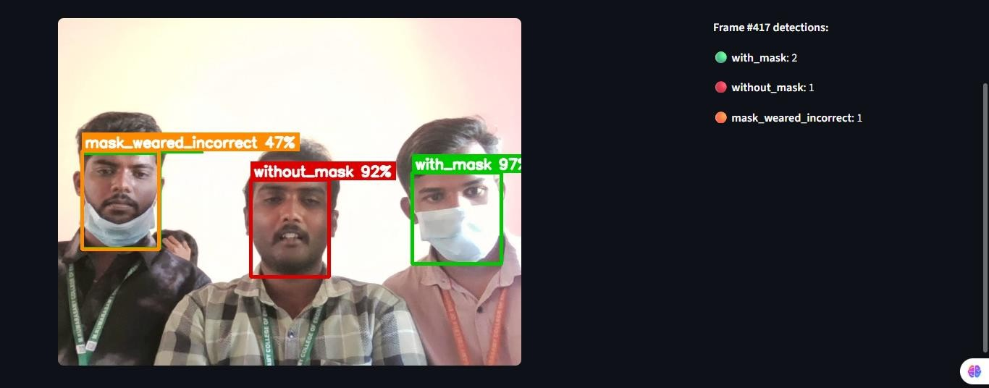
Fig no: 04 The image demonstrates the real-time classification of individuals into Mask, Improper Mask, and No Mask categories

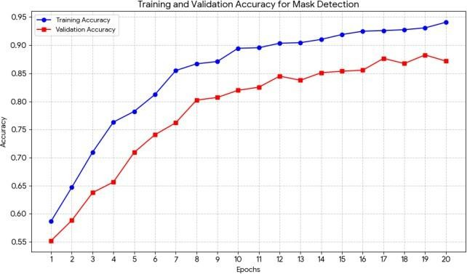
Fig no: 05 Training and Validation Accuracy graph VI.CONCLUSION
This paper introduced a deep learning-based Face Mask Detection System that was created to determine whether people are wearing masks correctly, wearing them incorrectly, or not wearing them. Through the use of a Convolutional Neural Network, the system was capable of learning non-random visual patterns of mask placement, covering vital parts of the face, as well as no face coverings. The CNN-based model unlike the traditional methods, which depend largely on handcrafted features proved capable of automatically extracting and interpreting complex facial features, which is more applicable in actual real world monitoring setting. In general, this study shows that deep learning is an effective and scalable basis of automated mask compliance detection. It is easy to differentiate between the proper, improper and absent use of masks, which makes the system applicable to a wide range of real life applications- in classrooms, offices, hospitals, transportation hubs and other high traffic areas. As it is being improved, the system can help to make the surrounding healthier and safer, as it will assist in automated surveillance, decrease the number of people engaged in monitoring the situation in order to address the issue, and promote the stable compliance with mask- wearing policies.

REFERENCES

- Jiang, M., Fan, X., & Yan, H. (2020).
“RetinaFaceMask: A Single Stage Face Mask Detector for Assisting Control of the COVID‑19 Pandemic.” arXiv:2005.03950.
- Shilpa Sethi a , Mamta Kathuria a,* , Trilok Kaushik b Face mask detection using deep learning: An approach to reduce risk of Coronavirus spread.
- Loey, M., Manogaran, G., Taha, M. H. N., & Khalifa,
N. E. M. (2021). “A Hybrid Deep Transfer Learning Model for Face Mask Detection.” Ain Shams Engineering Journal.
- Nagrath, A., Jain, R., Madan, A., Arora, R., Kataria, P., & Hemanth, J. (2021). “SSD‑MobileNet Based Face Mask Detection.” In: International Conference on Computer Vision and Image Processing (CVIP), Springer.
- Kumar, A. et al. (2021). “SSDMNV2: A Real
Time DNN‑based Face Mask Detection System Using Single Shot Multibox Detector and MobileNetV2.” Sustainable Cities and Society (ScienceDirect).
- N. Das, S. Kumar, S. K. Pal, and S. Ghosh, “Face Mask Detection Using Deep Learning: An Approach to Reduce COVID-19 Spread,” Journal of Healthcare
Engineering, vol. 2021, Article ID 9924206, 2021.
- J. Avanija, P. Chaitanya, and S. Kiranmai, “Facial Expression Recognition Using Convolutional Neural Network,” IEEE Access, vol. 10, pp. 73412–73422, 2022.
- X. Su, Y. Liu, and Z. Li, “Face Mask Detection and Classification via Deep Transfer Learning,” Expert Systems with Applications, vol. 195, 2022.
- A. Hussain, K. Ullah, and M. Khan, “Face Mask Detection Using YOLOv3 and Faster R-CNN,” Multimedia Tools and Applications, vol. 80, no. 21, pp. 33465–33484, 2021.
- B. Mandal, A. Mukherjee, and S. Ghosh, “Masked Face Recognition Using Deep Learning: A Survey,” Neural Computing and Applications, vol. 34, pp. 19507–19535, 2022.
- C. Zhou, H. Chen, and Y. Li, “Real-Time Face Mask Detection Based on SSD-MobileNetV2,” arXiv preprint arXiv:2208.13333, 2022.
- M. Alexiou, S. K. Tasoulis, and D. Iakovidis, “Towards a Masked Face Recognition Algorithm: A Novel Rule-Based Hybrid Approach,” IEEE Access, vol. 9, pp. 132060–132073, 2021.
- M. Zhang, J. Li, and Z. Wang, “Masked Face Recognition with Mask Transfer and Self- Supervised Learning,” IEEE Transactions on Information Forensics and Security, vol. 17, pp. 1803–1817, 2022.
- P. Saha, S. Banerjee, and D. Roy, “Masked-Face Recognition Using Deep Metric Learning,” Pattern Recognition Letters, vol. 158, pp. 45–52, 2022.
- S. Kumar, R. Verma, and A. Singh, “DeepMaskNet: A Novel Framework for Face Mask Detection and Masked Face Recognition,” Journal of Ambient Intelligence and Humanized Computing, vol. 13, pp. 5639–5652, 2022.
- B. Mandal et al., “Deep Learning Techniques for Detecting and Recognizing Faces with Masks in Smart Cities,” Neural Computing and Applications, vol. 34, pp. 21011–21035, 2022.
- B. Ayantika, S. Dutta, and A. Ghosh, “Face Mask Detection System Using Deep Learning,” Procedia Computer Science, vol. 191, pp. 197–204, 2021.
- A. Mukherjee, “Face Mask Detection Using SSD- MobileNetV2,” in Proc. IEEE Int. Conf. on Intelligent Systems, 2023, pp. 1–6.
- A. M. Salem, M. F. Ahmed, and M. E. Abdelaziz, “Real-Time Face Mask Detection Using Convolutional Neural Networks,” in Proc. Int. Conf. on Computer and Information Sciences (ICCIS), IEEE, 2020, pp. 1–6.
- Real‑Time Digital Face Mask Detection Using MobileNet‑V2 and SSD with Apache Spark (2022). International Journal of Performability Engineering.
- A. M. Salem, M. F. Ahmed, and M. E. Abdelaziz, "Real-time Face Mask Detection using Convolutional Neural Networks," in 2020 International Conference on Computer and Information Sciences (ICCIS), 2020, pp. 1- 6.
- P. Gupta, A. Gupta, N. Bansal, and A. Goel, "Real- time Face Mask Detection using Deep Learning Techniques," in 2021 International Conference on Inventive Computation Technologies (ICICT), 2021,
pp. 1- 6
- Adrian Rosebrock, "Face Mask Detection with OpenCV, Keras/TensorFlow, and Deep Learning," PyImageSearch, 2020. [Online].
- R. Shanmugamani, Deep Learning for Computer Vision: Expert techniques to train advanced neural networks using TensorFlow and Keras (Packt Publishing Ltd, 2018.

