DATABASE – DRIVEN BILLING MANAGEMENT SYSTEM
U.B. Tharaa Dhanvanthini A. Roshan Arputharaj S. Archana
Department of CSE-AIML Department of CSE-AIML Department of CSE-AIML
SRM Institution of Science and Technology, SRM Institution of Science and Technology, SRM Institution of Science and Technology,
Tiruchirappalli, Tamilnadu, India Tiruchirappalli, Tamilnadu, India Tiruchirappalli, Tamilnadu, India
td7997@srmist.edu.in ra7027@srmist.edu.in as5288@srmist.edu.in
------------------------------------------------------***-----------------------------------------------------
ABSTRACT- Billing and record keeping are still done manually in many small poultry retail establishments. These methods can limit the clarity of daily financial records, lead to computation errors, and make inventory monitoring more challenging. As the company expands and the volume of transactions increases, the issue becomes more serious. This study presents a database-driven billing management system intended to optimize and boost the effectiveness of retail billing operations to overcome these restrictions. The suggested system runs on an integrated database environment that facilitates automatic report generation, effective inventory management, and systematic transaction recording. This solution significantly reduces the likelihood of human calculation errors and improves the general effectiveness of everyday operations by implementing an automated billing mechanism. A digital solution was created to improve the effectiveness of billing processes and methodically maintain accurate records of sales transactions and inventory levels in retail poultry stores. The system incorporates features into a consolidated operational platform, including automatic invoice production, product weight assessment, price calculation, and transaction recording. This solution significantly reduces human errors and enhances the effectiveness and uniformity of billing operations by introducing digital mechanisms for standard operational duties. Retailers can monitor sales trends, control inventory levels, and effectively generate transaction summaries owing to the architectural design's support for methodical data storage. The suggested methodology offers a solution for small poultry companies to transition from manual bookkeeping procedures to a more effective and data-driven management framework by combining an organized system architecture with automated workflows. A Khata (credit ledger) module is also included in the system to track outstanding amounts, handle customer credit transactions, and organize payment records. Improvements in billing accuracy, transaction processing efficiency, and operational clarity are highlighted in the evaluation of the installed system, allowing for more efficient and well-organized management of poultry retail shops.
KEYWORDS
Database Management System, Poultry Retail Automation, Billing System, Inventory Management, SQL, Point-of-Sale Systems.
I. INTRODUCTION
Digital technology has changed how businesses transact and manage operational data, which is significantly influencing retail companies with the increasing use of automated systems for keeping accurate records of transactions and tracking inventory. Retailers, especially smaller retailers such as chicken stores, can suffer from errors, irregular record keeping, and poor data management resulting from the old manual billing process. Additionally, retailers have challenges in managing their customers' card records, as well as billing and inventory. To help address this problem, the proposed system includes a Khata module to improve financial tracking of customers' credit transactions and to create an electronically managed record of those transactions. Database management systems (DBMS) create a systematic base of how to manage and organize large quantities of transaction data. Using a relational database structure, companies can store their data in tables that are related to each other; companies can easily access the stored data using structured queries [4]. Modern retail businesses also utilize database-driven transactions to improve their tracking of inventory and monitoring of sales [7]. Examples of products in poultry stores include live chickens, processed meat cuts, eggs, and other perishable food items. As the size of the company increases, it becomes more difficult to track these transactions purely by maintaining a hard copy with paper and an ink pen. To help alleviate this concern, this research paper presents an entirely relational database poultry retail billing management system using relational database technology, which allows for the automation of financial reporting and the automation of inventory tracking and billing.
II. RELATED WORK
The study of retail automation has expanded greatly, particularly with regard to improving inventory management processes as well as transaction processing in the retail environment. Prior works on the Point-Of-Sale (POS) system [1] show automated billing systems allow retailers to acquire transaction data from customers and maintain an organized record of sales transactions in a single database. Therefore, automated billing systems can improve the accuracy of the invoice creation process by greatly reducing the amount of manual calculations during the creation of invoices. Another significant feature of inventory management systems is to accurately maintain accurate records of products and to be able to trace the movement of stock within a store. By tracking sales and updating product availability, the technologies mentioned above can contribute to greater control of inventory, thus reducing the potential for stock shortages or oversupply.
The companies that manage perishable products depend heavily on these tools for efficiently managing stock in order to minimize waste and manage financial losses due to spoilage. By combining data storage and transaction management as part of a database driven billing solutions; the retail operational capabilities of the solutions are enhanced. Maintaining billing and sales data in relational database systems allows retailers to generate analytical reports which contribute to the evaluation of sales patterns, success of the business, and assistance with decision making processes. Recent research indicates that combining database technology with retail automation systems improves data consistency, reliability, and operational effectiveness. Due to the low availability of inexpensive and easily usable digital systems designed for daily use by small poultry retailers, many poultry retailers continue to generate invoices manually. The proposed system builds on these concepts by incorporating invoice generation, inventory management, and waste tracking into a single relational database structure tailored specifically for poultry retailers.
III. SYSTEM OVERVIEW
The Poultry Retail Billing Management System is a computer application that automates day-to-day retail operations for poultry suppliers using a database system. The System consists of several Modules that access an Integrated Relational Database to efficiently manage operational data. The database contains Records of User, Product, Price, Billing, Waste and Sales Data. It uses Structured Queries to connect each module with the Database to retrieve and store data in a consistent manner. The First Phase of the System begins with User Authentication, which allows Users to access the System for the purpose of managing Product Records and Price Information. The system supports the sale of Eggs, Broiler Chickens, Country Chickens, Processed Poultry Parts, and Other Poultry Retail Products. The Billing Process automatically Records Customer Transactions to the Database and Retrieves Product Records to determine Total Cost of Sale based on Quantity and Price. The System also provides a Khata (Credit Ledger) Module to manage Customer Credit and Payment Information. The System maintains Records of Waste due to Spoilage or Unsold Inventory to allow Users to monitor the Loss of Product Value. The System also generates Sales Reports to assist Businessowners evaluate the Efficiency of their Operations and Performance of Sales Based on Data from Transactions. The System contains a Khata, or Credit Ledger, for the recording of Credit transaction between the Retailer and their individual clients, which supports tracking of payments due to the retailer by their clients, as well as allowing for adjustments of payments made and Credit transaction records. The Khata functionality is able to provide the Retailer with accurate financial tracking by keeping individual client records and automatically determining an individual's available balance by considering their historically documented Credit and Payment activity. The ability to provide those functions via the Khata module increases the functionality of the overall System and provides greater reflection of the processes utilized during actual Retail operations.

IV. SYSTEM ARCHITECTURE
The Poultry Retail Billing Management System is designed with a modular structure where a central relational database, application processing modules, and user interface are linked together. This allows retailers to perform product management, billing and report generation through the user interface. The application layer processes these requests through modules that manage billing activities, update inventory and monitor waste. The relational database holds all the data related to users, products, transactions and inventory status that provide all operational activities. The integrated system provides poultry retail businesses with accurate reporting, consistent record-keeping and efficient data management.
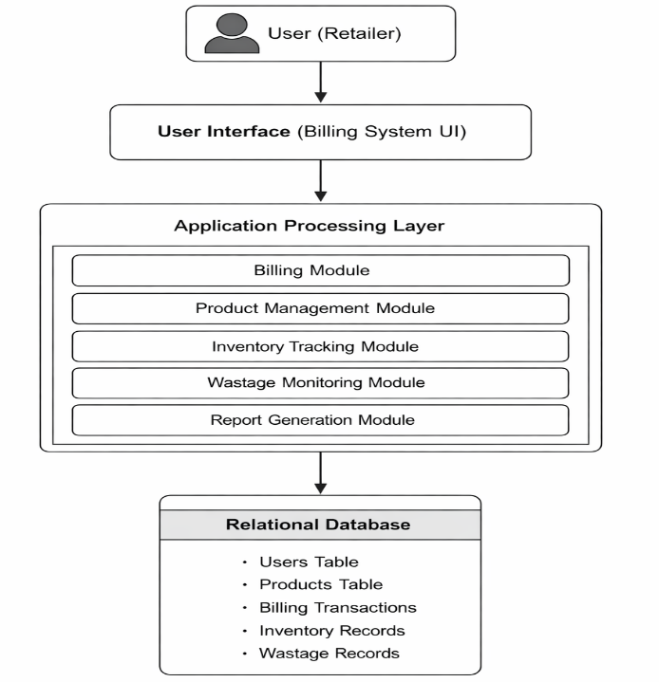

Fig. .1. System architecture of the proposed poultry retail billing management system.
The architecture provides an overview of how the relational database, application modules, and user interface interact to carry out certain business functions. Each application module interacts in different ways with a relational database to ensure accurate invoicing, inventory management, and reporting by storing and accessing information from the main database during operational processes.

V. DATABASE DESIGN
The proposed Poultry Retail Billing Management System uses a relational database model to organize and manage operational data in a systematic manner; in addition to maintaining the uniformity of items, transactions, and inventory records, the proposed system will use a relational database model to store its data in related tables. By establishing the appropriate primary keys and relationship attributes for each table, the system can ensure that the data maintained in the database is accurate and free of duplication. These relationships enable seamless communication between the various components of the system. For instance, the system can utilize product IDs stored in the product table while processing sales to provide accurate pricing and item information. Additionally, as billing transactions occur, the inventory records will automatically be updated to ensure that the stock levels match the actual sales made; given the perishability of poultry products, the waste table also allows the system to track product losses caused by spoilage or unsellable inventory uniquely and to preserve the integrity of the inventory data. Overall, by utilizing a relational database model to store operational data, the system will offer reliable data storage, increased data consistency, and effective data retrieval; additionally, the database design will enable the creation of analytical sales reports that will assist retail poultry owners in analyzing their business performance.
TABLE I
DATABASE TABLE STRUCTURE
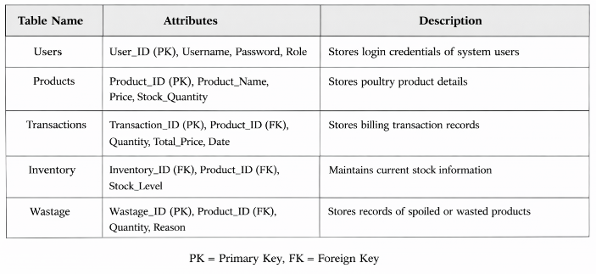
In a relational database structure, user authentication, product details, billing transactions, inventory levels, and waste records can be connected using many different tables that are inter-related. Foreign keys are used to associate related tables by creating links between them; whereas, primary keys define the uniqueness of each entity in the database.
VI. METHODOLOGY
Using a standard structured methodology that is based on system implementation methods and database design principles, the billing management system being developed follows a clearly defined process. The first step in this process is to analyse the operational requirements of retail chicken businesses, in order to determine the critical features that should be included in the bill management system. These critical features include things like financial reporting, inventory control, invoicing automation, and waste tracking. The information obtained from this analysis will then be used to develop an Entity-Relationship (ER) diagram, which is a conceptual model of the data in the system. It shows all of the entities in the system, as well as how they relate to each other. The conceptual data model is then transformed into a relational schema, which defines all of the primary key and foreign key relationships in the system as well as the tables that will be used to store the data. After creating the logical structure for the database, the system enters into the implementation phase, where actual database tables are created, and SQL commands are used to perform data manipulation operations. Data Definition Language (DDL) is used to define the database structure, and to insert, update, and delete records Data Manipulation Language (DML) is used. Other advanced database features such as joins, views, triggers, and cursors are utilized to enhance the functionality of the system beyond the basic SQL functions. These features can allow the system to automate certain processes (such as generating reports) and to perform complex data retrieval operations. Finally, to ensure that the billing calculations, the database edits and the report generating system are operating correctly, the system must be tested and validated using actual transaction data.
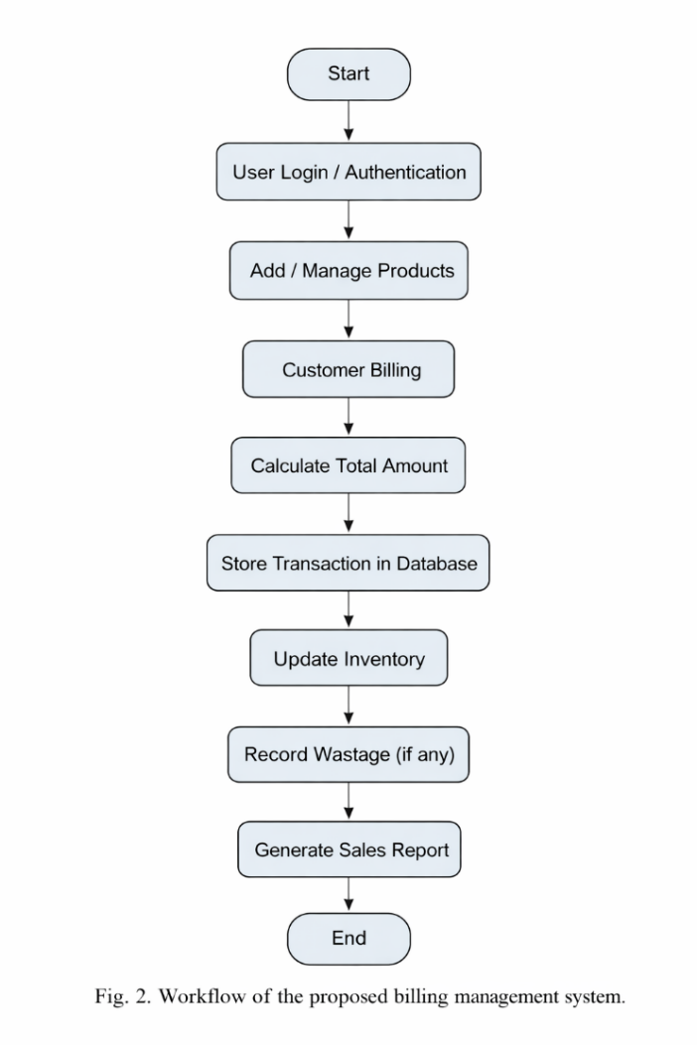
Fig. 2. Operational workflow of the proposed poultry retail billing management system.
User authentication at initial startup begins the activity series for the Poultry Retail Billing Management System through the established workflow diagram. This diagram continues from user authentication, then to product-management; computes the amount owed for items purchased by the customer; stores database transactions; updates inventory; records waste; and generates and sends reports of sales automatically for performance analysis.
VII. IMPLEMENTATION
The aim of the implementation stage is to realize the recommended poultry retail management system as a true operational structure. The poultry retail management system will include a well-organized and synchronized way of providing an accurate record of all the administration jobs related to the poultry retail industry, including handling products; completing billing transactions; verifying inventory levels; etc. Implementation was accomplished by using multiple functional modules that operate together to maintain the daily operations of a poultry retail business. In order to protect the integrity of confidential business information and maintain security, the user authentication module only permits access to those employees with valid authorization. After the operator has been verified through the user authentication module, the operator is permitted by the poultry retail management system to perform various administrative duties from the system interface. The product management module provides the operator with the tools necessary to maintain product data consisting of item description, unit price, and the number of units currently on hand. This module allows the operator to create, edit, or delete records or files in the poultry retail management system's database, which enables the poultry retail management system to maintain accurate product data. The billing module calculates the total dollar value of the transaction by processing all product selections and quantity data entered by the operator. This automated process enhances the effectiveness with which businesses complete their consumer transactions while also decreasing calculations performed by humans. While doing these two functions, the inventory management system keeps up-to-date inventory records as the system updates the inventory level automatically each time a product is purchased. The operations data (e.g., products, transaction logs, inventory changes) for the company resides in one common database to allow for efficient retrieval of information, and creating reports to monitor a company's performance is made possible with this organization of data. The purpose of implementing this proposed system is to provide a reliable and efficient way of digitally managing the invoicing for chicken retail and the inventory operations in a systematic manner.
VIII. RESULT AND DISCUSSION
The proposed poultry retail billing management system provides a systematic approach to improve operational performance for small retailers. The solution aims to reduce the downsides associated with the manual tracking of sales and traditional billing processes due to the integration of automated billing processes, inventory tracking, and database management. Billing automation, which is one major result of the proposed system, helps overcome many of the problems associated with traditional poultry retail billing by reducing human error, inaccurate records, and lengthy transaction times associated with manual billing. The testing of the prototype demonstrated improved inventory tracking and waste tracking as well as faster production of billing. By automating the billing process, the implementation of an automated billing system addresses these problems by accurately calculating pricing and processing transactions in a timely manner. As a result, customer service efficiency may be improved at retail establishments. The other major benefit to be gained from this system is the enhancement of inventory management. Since there is a real-time connection between the billing transactions and inventory records, the stock levels can automatically be updated each time a product is sold. This helps avoid discrepancies between what is on paper and what is actually in the inventory, and it allows store managers to maintain an accurate understanding of the quantity of product that is available. Additionally, good inventory management will help eliminate situations such as product shortages or overstocking. Additionally, the use of database-driven record storage will help ensure the integrity of the system's data. By using a database to systematically store all information regarding the products, transactions, and operations of the business, it provides efficient access to retrieve data and provides for long-term record-keeping. The structured method of the database will allow the store owner to access information regarding previous sales as desired. Furthermore, the reporting feature will allow business owners to analyze operational and sales trend information. Business owners can discover peak sales periods, products that are commonly sold, and trends in their overall business based on analysis of the reports generated. By using these processes and tools, business owners will be able to plan and make decisions more effectively.
TABLE II
BILLING TRANSACTION
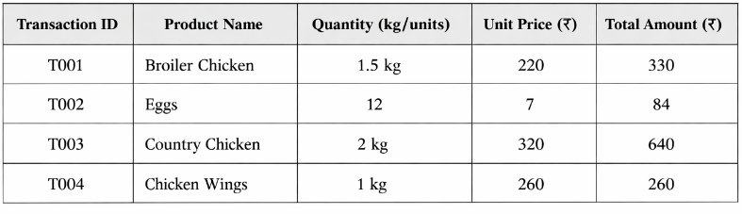
This document contains samples of billing transactions produced by the recommended Chicken Retail Billing Management System. The automated billing module calculates the total amount of all transactions from chicken purchases for accurate and efficient billing operations based on the product quantity and the unit price.
TABLE III
INVENTORY UPDATE
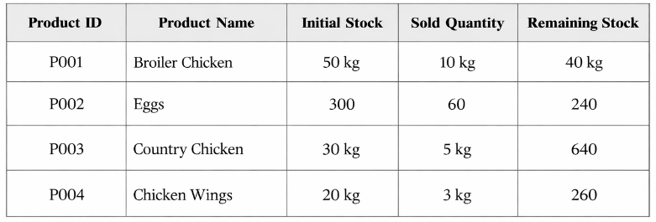
The inventory management component continuously updates the stock amounts each time there is a sale, helping to make sure that the inventory on hand matches the amount sold in real time at all times.
The method proposed for poultry retail operation management will provide a more systematic and reliable management strategy than managing your poultry retail operations using a traditional manual record-keeping system. The digital method proposed will allow for maintaining accurate, systematic records of billing and stock. The use of manual records for billing or tracking of stock will assist in providing accurate records, but may result in errors in calculations or provide inconsistent records of commercial transactions.
Future Improvements
Future improvements can be made to the proposed system by incorporating responsive web technologies to provide seamless access through desktop computers, tablets and cell phones. Moreover, integrating real-time analytics and cloud-based data storage will allow for increased scalability of the system, and increased monitoring of the poultry retail business.
IX. CONCLUSION
This study describes a database-driven poultry retail billing management system as a way to improve the efficiency of retail operation through automation and structured data management. The solution integrates inventory tracking, waste monitoring, billing processes, and reports on one database platform. The intention of the system is to reduce error in calculations, maintain accurate records of products, and eliminate redundancy in the management of transactions by using a digital platform to replace traditional manual methods of billing. The use of a single centralized relational database allows business leaders to have the ability to easily retrieve business data to access sales-related information, basic financial transactions, and purchase order updates orderly. Consequently, business leaders will also have the ability to track on a daily basis all elements that affect sales activity and will also be able to monitor the overall success of the company through the automated billing system and reporting system. Overall, the proposed solution would provide poultry retail operators with an effective option for improving management through the increased accuracy, efficiency, and consistency of the billing and inventory process. By adding advanced data analytics and more accessible methods of communication over numerous digital platforms, future improvements will greatly enhance the potential of this system.
X. REFERENCES
[1] G. B. Mangmang, “Development and Implementation of a Point-of-Sale System,” Journal of Retail Technology, 2018.
[2] Inventory Management System for Small Enterprises, International Journal of Research Publication.
[3] Billing Management System for Retail Businesses, International Journal of Scientific Research.
[4] R. Elmasri and S. Navathe, Fundamentals of Database Systems, Pearson Education, 2016.
[5] A. Silberschatz, H. Korth, and S. Sudarshan, Database System Concepts, McGraw-Hill, 2019.
[6] Oracle Corporation, Oracle Database SQL Language Reference, 2023.
[7] C. J. Date, An Introduction to Database Systems, Addison-Wesley, 2004.
[8] Retail Transaction Processing Systems, International Journal of Computer Applications.
[9] A. Silberschatz, H. F. Korth, and S. Sudarshan, Database System Concepts, 6th ed. New York, NY, USA: McGraw-Hill, 2011.
[10] R. Elmasri and S. B. Navathe, Fundamentals of Database Systems, 7th ed. Boston, MA, USA: Pearson Education, 2016.
[11] S. Sharma and R. Kumar, “Design and Implementation of Online Billing System,” International Journal of Computer Applications, vol. 145, no. 5, pp. 15–19, 2016.
[12] A. Patel and M. Shah, “Web Based Billing System for Retail Shops,” International Journal of Advanced Research in Computer Science, vol. 8, no. 3, pp. 212–216, 2017.
[13] R. Gupta and P. Singh, “Development of Automated Billing System Using Database Technology,” International Journal of Engineering Research and Technology, vol. 9, no. 4, pp. 45–49, 2020.
[14] M. Kaur and H. Singh, “Design of Secure Online Payment and Billing System,” International Journal of Computer Science and Information Technologies, vol. 10, no. 2, pp. 85–90, 2019.
[15] N. Jain and S. Agarwal, “Web-Based Retail Billing and Inventory Management System,” International Journal of Computer Engineering and Applications, vol. 12, no. 6, pp. 55–60, 2018.

