AI SMART INVENTORY AND FORECASTING SYSTEM FOR MEDICAL SHOP
Bharatika RS Yogesh P
Department of CSE-AIML Department of CSE-AIML
SRM Institution of Science and Technology, SRM Institution of Science and Technology,
Tiruchirappalli, Tamilnadu, India Tiruchirappalli, Tamilnadu, India
rr7356@srmist.edu.in ra7027@srmist.edu.in
------------------------------------------------------***-----------------------------------------------------
ABSTRACT-Managing what you have in stock is really important for stores that sell things for pharmacies where peoples health is on the line. When pharmacies do not have the medicines people need it makes people unhappy. Small pharmacies often have a time keeping the right amount of stock because they do not have good tools to predict what they will need. They usually keep track of stock by hand. Use simple billing software, which can lead to mistakes in knowing how much stock they really have. This can cause pharmacies to run out of stock or have much stock that expires before it can be sold. These problems cost pharmacies money. Also make people question if they can really get the medical help they need from these pharmacies.This project is about creating an inventory system for small pharmacies that uses artificial intelligence to help with stocking and predicting what people will want to buy. The system looks at what has been sold in the past what people are buying now. What is in stock to predict what will be needed in the future. It uses computer models that can learn to make these predictions. Based on what the system predicts it tells the pharmacy how to order and sends alerts when stock is running low. The system also keeps an eye on when medicines will expire so that pharmacies do not waste products.Using this system helps people who own small pharmacies make good decisions about what to stock and when. It helps them work efficiently reduces losses from bad stock decisions and makes sure people can always get the important medicines they need. This project shows how artificial intelligence can make inventory systems better and help small businesses use new technology.The proposed system is an AI-Based Smart Inventory and Demand Forecasting System for Small Medical Shops. The AI-Based Smart Inventory and Demand Forecasting System for Small Medical Shops is important for pharmacies. The AI-Based Smart Inventory and Demand Forecasting System for Small Medical Shops helps small pharmacies manage their inventory. The AI-Based Smart Inventory and Demand Forecasting System for Small Medical Shops is a solution, for pharmacies that want to use artificial intelligence to improve their inventory management.
KEYWORDS
Artificial Intelligence, Inventory Management System, Demand Forecasting, Machine Learning, Pharmacy Automation, Smart Retail System, Predictive Analytics
I. INTRODUCTION
Inventory management is key to running a retail business. This is especially true for shops where medicine availability directly impacts customer health and satisfaction.Pharmacy stores handle medicines, each with different demand levels, storage conditions and expiration dates.Managing these products requires monitoring and planning.Many small medical shop owners still use methods like manual record keeping or basic billing systems. These methods do not provide analysis to help with decision-making.One of the challenges for pharmacy owners is predicting future demand for medicines.The demand for medicines changes due to factors like illnesses, environmental conditions and unexpected health outbreaks.For example medicines for fever, flu and respiratory infections are in demand during certain times of the year.When shop owners can't accurately estimate demand they might buy much stock that expires or have too little stock leading to shortages.Both situations hurt business profitability and customer satisfaction.New technologies like intelligence and machine learning are helping retail management make better decisions.AI systems can process amounts of data and identify patterns that are hard to see manually.By using algorithms these systems can estimate future demand and help business owners keep the right inventory levels.The goal of this research is to create an AI-based system for medical shops to manage their inventory and forecast demand.The proposed system combines machine learning with real-time inventory monitoring to help pharmacy owners manage their medicine stock better.It provides demand predictions alerts for low-stock items and restocking recommendations.With this system small pharmacies can improve efficiency reduce medicine waste and provide service by ensuring essential medicines are always available.Inventory management and pharmacy stores are crucial, for providing the medicines to customers on time.Medicine demand and inventory levels are critical for pharmacy owners to manage effectively.AI-based systems can help with inventory management and forecasting making it easier for pharmacy owners to make decisions.
II. RELATED WORK
In the few years people who do research have become more interested in using artificial intelligence and machine learning to make inventory management and demand forecasting better. Old inventory systems mostly used math and people had to guess the numbers. These ways were good for situations but they had a hard time dealing with customers who wanted different things and markets that were changing fast. As stores got more complicated researchers started looking for ways to look at a lot of sales data and make better predictions.A lot of studies have looked at using forecasting models to understand sales patterns. People use things like Autoregressive Integrated Moving Average, Linear Regression and Artificial Neural Networks to guess what people will want to buy in the future. These models help businesses see sales trends what happens at times of the year and how customers buy things. By using these forecasting techniques companies can plan their inventory better. Avoid problems like not having enough products or having too many.Big stores and online shopping platforms are already using intelligence to manage their inventory and make their supply chain better. These systems use analytics to watch products move guess when demand will change and decide when to restock automatically. This means businesses can keep the right amount of inventory and save money.However a lot of these solutions are made for companies and need a lot of money, special equipment and skilled people to work. Small businesses, like medical shops often have a hard time using these systems because they do not have enough resources or technical expertise. Also a lot of inventory tools just track how much stock is left and do not have features like guessing demand or watching when medicine will expire.Because of these problems there is a need for a simple and affordable inventory management solution that can help small pharmacy businesses. The system that is proposed in this research tries to fix this problem by combining demand forecasting watching inventory in time and tracking when things will expire all in one smart platform. By putting these features the system gives a practical solution that can help small medical shop owners manage their inventory better and make smarter buying decisions. The inventory management solution is what small medical shops need to manage their inventory efficiently. The demand forecasting feature is what will help small medical shops guess what products will be needed. The real-time inventory monitoring feature is what will help small medical shops keep track of their products. The expiration tracking feature is what will help small medical shops keep their products from expiring. The inventory management solution is the key, to helping medical shops manage their inventory better.
III. SYSTEM OVERVIEW
The proposed Smart Inventory and Forecasting System helps small medical shop owners manage their medicine stock better and make restocking decisions. Many small pharmacies struggle to find the balance between the medicines they have in stock and what customers want to buy.The system uses intelligence to look at sales data and help with smarter inventory management.It collects information from transactions at the pharmacy such as medicine names, quantities sold current stock levels and expiry dates.This data is stored in a database where it is organized and processed.By looking at sales records the system finds patterns in how medicines are used and in demand.The system keeps an eye on medicine stock levels all the time.It regularly checks how much of each medicine is in stock and compares it to a limit.If a medicines stock gets low the system sends a notification to the shop owner so they can restock on time.The system also predicts what medicines will be in demand in the future by using machine learning.It studies past sales patterns to estimate what will be needed. Suggests how much to reorder.It also tracks when medicines expire and alerts the user when they are about to expire.By combining predicting demand monitoring stock and tracking expiry dates the system helps medical shop owners manage their stock better.This reduces medicine waste. Makes sure essential medicines are available for customers.The Smart Inventory and Forecasting System makes it easier for small pharmacies to manage their medicine stock and meet customer needs.The system helps small medical shop owners make decisions, about restocking medicines.The medicine inventory management system uses AI to analyze sales data.The system sends notifications to shop owners when medicine stock levels are low.The system predicts medicine demand using machine learning techniques.
IV. SYSTEM ARCHITECTURE
The proposed system has parts that work together to help manage inventory in a smart way.The system is built with layers.These layers include a user interface, data processing, machine learning and a database.The user interface layer has a dashboard.The dashboard lets the pharmacy owner see inventory status, forecast demand and get alerts when stock is low.The owner can easily add sales data, update inventory and see what the system recommends.The data processing layer collects sales and inventory data.It Organizes this data.Then it prepares the data for the machine learning module.The machine learning module is the brain of the system.It uses past sales data to predict demand.These predictions are compared to inventory levels.This helps decide if more stock needs to be ordered.The database layer stores all important information.This includes medicine details, sales records and expiration dates.The database keeps data safe and easy to access.These parts work together.They help pharmacy owners manage inventory automatically.The system provides an experience for owners.It helps them make decisions, about inventory.The system uses data and predictions to do this.It helps owners keep track of inventory levels.The system alerts owners when stock is low.This helps prevent stockouts and overstocking.
V. DATABASE DESIGN
The database design is a part of the system. It helps to store and manage data in an efficient way. For the AI Smart Inventory and Forecasting System we use a database to keep track of information about medicines, sales records, stock levels and what we think people will need in the future.The database has tables. Each table stores information. The Medicine table has details like the medicine ID, the name of the medicine what category it belongs to, who made it and when it expires. The Inventory table keeps track of how stock we have of each medicine. It also stores the minimum amount of stock we need so we do not run out.The Sales table records what happens in each transaction. This includes the medicine ID how much was sold the date of the sale and the transaction ID. We use these records to keep a history of sales. They are also used to help the forecasting model make predictions. The Forecast table stores what the AI model thinks people will need in the future.All the tables are connected. This means the system can easily get and update data when it needs to. This design helps keep the data consistent. It also lets the system quickly look at inventory and sales information. If we do things like index the data properly and manage the database well the system will work better. It will help us keep an eye on the inventory efficiently. The AI Smart Inventory and Forecasting System and its database design are very important, for managing medicines and sales records.
TABLE I
DATABASE TABLE STRUCTURE
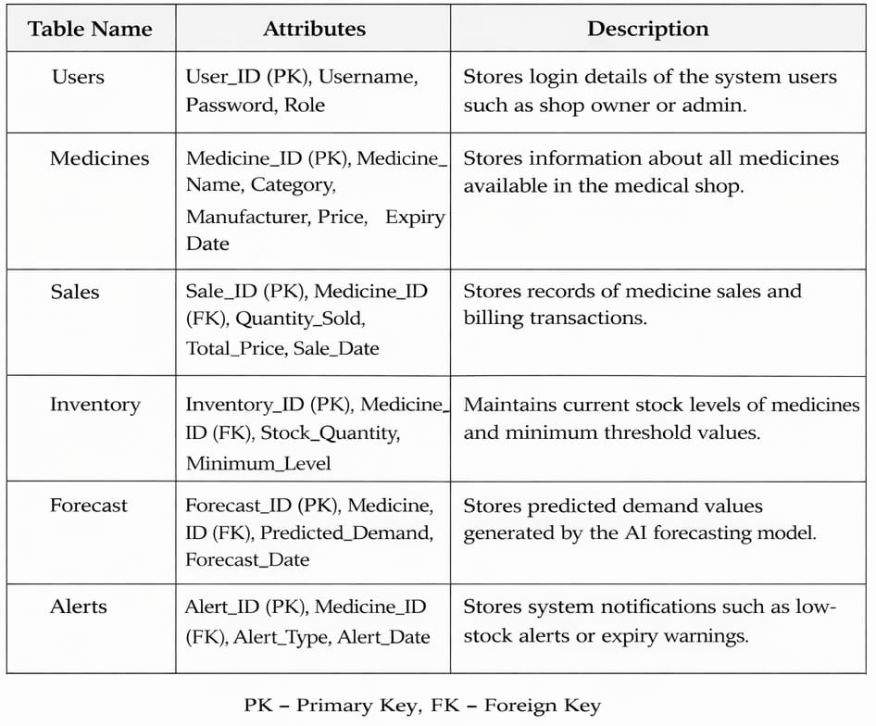
The system uses a relational database to manage information about medicines, sales, inventory, and demand forecasting. The Users table stores login details, while the Medicines table contains information about available medicines. The Sales table records transactions used for forecasting demand. The Inventory table tracks stock levels, while the Forecast table stores predicted demand generated by the AI model. The Alerts table records notifications for low stock and medicine expiry. This database structure ensures organized storage and efficient inventory management.
VI. METHODOLOGY
The way the proposed AI Smart Inventory and Forecasting System works is to make inventory management better by looking at sales data and guessing what people will want in the future. The system has a steps that help it collect data make sense of it teach the forecasting model and support good inventory decisions.The first thing the system does is collect data. It gathers sales records and inventory details from the medical shop. This includes things like the name of the medicine how much was sold and when it was sold. This old data is important because it helps the system understand what people wanted before.After the system gets all the data it makes sure the data is good to use. It removes records fills in missing information and organizes everything so it is easy to understand. It also changes dates and numbers into a format that's easy for the computer to read.The next thing the system does is find the information. It looks at things like how many medicinesre sold each day how often people buy them and if there are any patterns that happen at the same time every year. This information helps the forecasting model understand how peoples demand for medicine changes over time.Once the system has all the information it uses a special kind of computer program to make predictions. This program is like a teacher that helps the system learn from sales data so it can guess what will happen in the future. After the program is trained it can tell the system how much of each medicine will be needed.Finally the system compares its predictions with how medicine the shop has in stock. If the system thinks the shop will need medicine than it has it tells the owner to order more. The system also checks when the medicines will expire and sends warnings if any are close, to going bad. This helps the shop owner throw away medicine and keep the right amount in stock.
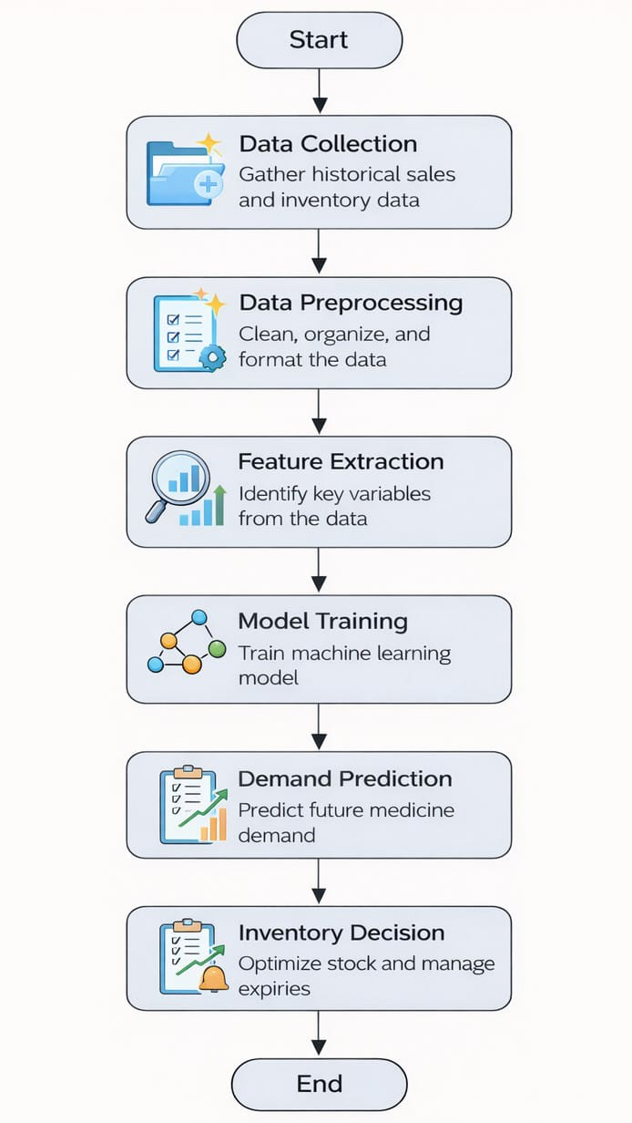
Fig. 2. Methodology workflow of the AI-based smart Inventory and Forecasting System
The workflow diagram represents the operational sequence of the proposed poultry retail billing management system, starting from user authentication and proceeding through product management, billing calculation, database transaction storage, inventory updating, wastage recording, and concluding with automated sales report generation for performance analysis.
VII. IMPLEMENTATION
The implementation of the proposed system involves creating a software platform. This platform combines inventory management with forecasting algorithms that use intelligence.The system can be built using web technologies and programming frameworks.The front-end interface can be created using HTML, CSS and JavaScript. This provides a dashboard for pharmacy owners to use.The dashboard lets pharmacy owners interact with the system easily.The backend processing can be done using programming languages like Python or Java. These languages are good for machine learning applications.The machine learning forecasting model can be built using libraries like Scikit-learn or TensorFlow. These libraries provide tools, for training predictive models with historical data.The model uses data to make predictions.The database system can be built using MySQL or PostgreSQL. This stores medicine details, inventory records and sales transactions.During system operation the user enters sales data into the system.This data is stored in the database. Processed by the forecasting module.The system then updates inventory levels.It generates demand predictions that are shown on the dashboard.Restocking alerts are also displayed on the dashboard.The system helps pharmacy owners manage their inventory.
VIII. RESULT AND DISCUSSION
The proposed AI-based inventory management system shows improvements in managing medicine stock and predicting demand compared to traditional manual methods.In pharmacies inventory is usually handled manually. This often leads to problems like stock shortages, overstocking or medicines expiring before they are sold.The developed system addresses these issues by combining sales analysis with machine learning-based forecasting.During testing historical sales data was used to train the forecasting model.The model analyzed sales patterns and generated predictions for future demand.The results show that the system can estimate medicine demand with accuracy.This helps pharmacy owners plan their inventory effectively.By predicting which medicines are likely to be in demand the system supports better purchasing decisions.Another important outcome of the system is its ability to generate stock alerts.When predicted demand exceeds stock the system automatically notifies the user to reorder medicines.This feature helps reduce stock shortages and ensures essential medicines remain available for customers.The system also monitors expiry dates of medicines stored in the database.If a medicine is approaching its expiry date the system generates an alert.The shop owner can then take action, such as offering discounts or prioritizing the sale of those medicines.This helps reduce wastage and financial loss.The systems demand forecasting capability helps maintain stock levels.Of keeping large quantities of medicines that may not be sold the shop owner can maintain balanced inventory based on predicted demand.This approach reduces storage costs and improves inventory operations.The system provides an user-friendly interface.Pharmacy owners can easily monitor sales records, stock levels and prediction results.Even users with technical knowledge can operate the system without difficulty.The dashboard presents information in a clear and organized manner.This makes inventory management faster and more convenient.Overall the experimental results suggest that the proposed system can significantly improve inventory control.It can reduce medicine wastage. Support better decision-making for pharmacy owners.The system offers an intelligent solution for modern pharmacy operations by integrating machine learning, with traditional inventory management practices.
TABLE II
MEDICINE SALES AND DEMAND PREDICTION
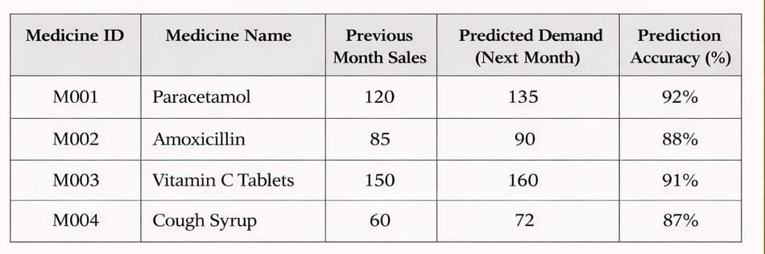This table illustrates the inventory monitoring functionality of the proposed system. The system continuously tracks the available stock of medicines and compares it with the predefined minimum stock level. When the available quantity falls below the threshold value, the system generates a reorder alert to prevent stock shortages.
TABLE III
MEDICINE EXPIRY MONITORING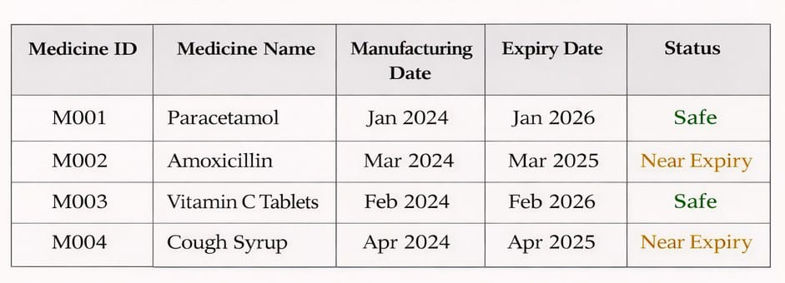This table shows how the system monitors the expiry dates of medicines stored in the database. The system automatically identifies medicines that are approaching their expiration date and generates alerts to help pharmacy owners manage sales and reduce wastage.
Comparison with manual system
Pharmacy inventory management is generally done by hand using notebooks or spreadsheets. Pharmacists have to check how stock they have update sales records and keep an eye on medicine expiry dates all by themselves. This takes a lot of time. Can lead to mistakes like getting the stock levels wrong and having trouble finding medicines that are close to expiring.The new AI-based inventory management system does all these things for them by keeping a list of medicines. It updates stock levels automatically checks expiry dates and looks at sales data to figure out what people will want to buy in the future. This means the system is an more reliable way to manage pharmacy inventory than doing it by hand. The AI-based inventory management system is also more efficient, than methods.
Future Enhancement
In the future the system will be even better when it has cloud storage. This means people can get to the information from anywhere and it will be safe. They can also make an app for phones so pharmacy owners can see how much stock they have and get warnings when they need to. The system can also get some tools like special computer programs that can guess what people will buy and scanners that read the little codes on products. These tools will help pharmacy owners know what to order and make it easier to keep track of what they have, in stock. The system will be faster. Work better. The pharmacy owners will like the tools because they will make their jobs easier. They will be able to use the cloud storage and the special app to make their work easier. The system will have cloud storage and the special computer programs and scanners will make it better.
IX. CONCLUSION
This research is about a Smart Inventory and Demand Forecasting System that uses intelligence to help small medical shops manage their medicine inventory. The system uses machine learning and real-time inventory monitoring to make predictions about demand and send automatic stock alerts. It looks at sales to figure out what people are buying and how much medicine will be needed in the future.The system helps pharmacy owners make decisions about what to buy and how much to keep in stock. It also keeps an eye on the expiration dates of medicines so shop owners can take action before they go bad. This helps cut down on wasted medicine and money lost. These features are important because they help reduce waste and losses that happen a lot in inventory systems.The system makes daily work easier by keeping all the information in one place and making it easy to use. Pharmacy owners can see how stock they have what has been sold and what the system predicts will happen next. They do not need to be experts to use it. This makes the system a good choice for businesses that usually do things by hand.Using this system can make inventory more accurate reduce mistakes and help pharmacy owners make decisions. It combines intelligence with how inventory is controlled to make a reliable and efficient way to run a pharmacy. As artificial intelligence gets better systems like this will be very important for making businesses run smoothly and for using data to make decisions, in small stores.
X. REFERENCES
[1] S. Chopra and P. Meindl, Supply Chain Management: Strategy, Planning, and Operation, 7th ed. Boston, MA, USA: Pearson, 2019.
[2] H. Heizer, B. Render, and C. Munson, Operations Management, 13th ed. New York, NY, USA: Pearson, 2017.
[3] T. Hastie, R. Tibshirani, and J. Friedman, The Elements of Statistical Learning: Data Mining, Inference, and Prediction. New York, NY, USA: Springer, 2016.
[4] I. Goodfellow, Y. Bengio, and A. Courville, Deep Learning. Cambridge, MA, USA: MIT Press, 2016.
[5] S. Russell and P. Norvig, Artificial Intelligence: A Modern Approach, 4th ed. Upper Saddle River, NJ, USA: Pearson, 2021.
[6] R. S. Sutton and A. G. Barto, Reinforcement Learning: An Introduction, 2nd ed. Cambridge, MA, USA: MIT Press, 2018.
[7] J. Brownlee, Machine Learning Mastery with Python. Melbourne, Australia: Machine Learning Mastery, 2017.
[8] J. Han, M. Kamber, and J. Pei, Data Mining: Concepts and Techniques, 3rd ed. San Francisco, CA, USA: Morgan Kaufmann, 2012.
[9] G. E. P. Box, G. M. Jenkins, and G. C. Reinsel, Time Series Analysis: Forecasting and Control, 5th ed. Hoboken, NJ, USA: Wiley, 2015.
[10] K. P. Murphy, Machine Learning: A Probabilistic Perspective. Cambridge, MA, USA: MIT Press, 2012.
[11] A. Géron, Hands-On Machine Learning with Scikit-Learn, Keras, and TensorFlow, 2nd ed. Sebastopol, CA, USA: O’Reilly Media, 2019.
[12] T. M. Mitchell, Machine Learning. New York, NY, USA: McGraw-Hill, 1997.
[13] D. Simchi-Levi, P. Kaminsky, and E. Simchi-Levi, Designing and Managing the Supply Chain, 4th ed. New York, NY, USA: McGraw-Hill, 2008.
[14] M. R. Lyu, Handbook of Software Reliability Engineering. New York, NY, USA: McGraw-Hill, 1996.
[15] A. Rajaraman and J. D. Ullman, Mining of Massive Datasets. Cambridge, U.K.: Cambridge University Press, 2011.

