A Novel Compact-Low Profile Four Port MIMO Antenna for V2X Application

Akash S
Department of ECE
SRM TRP Engineering College
Tamilnadu,India.621105
814722106008@trp.srmtrichy.edu.in
Balasankar S
Department of ECE
SRM TRP Engineering College
Tamilnadu,India.621105
814722106016@trp.srmtrichy.edu.in
Dr.P.Thiruvalar Selvan
Department of ECE
SRM TRP Enginering College
Tamilnadu,India.621105
thiruvalarselvan@trp.srmtrichy.edu.in
Manikandan R
Department of ECE
SRM TRP Engineering College
Tamilnadu,India.621105
814722106061@trp.srmtrichy.edu.in

Abstract—This study offers a miniature, low-profile a four -Antenna with numerous inputs and outputs. This is designed to be used in V2X communication systems operating at sub-6 GHz frequency band. The antenna is planned to use with a lossy FR-4 substrate and is 24 x 24 x 1.6 mm. The microstrip feeding approach is used to drive four orthogonal radiating elements, which provide pattern diversity and minimize Mutual connection of the radiative elements.
This antenna is proposed to operate at 4.15 GHz and has an resistance bandwidth extending from 3.85 GHz to 4.59 GHz. The suggested antennas has excellent impedance matching properties, as the reflection coefficient measures -23 dB. The proposed antenna also has high port-to-port isolation, which is approximately -29 dB, without using any structure can be decoupled.
The suggested antenna exhibits a continuous bidirectional radiation pattern, and peak value of the radiation is approximately 1.5 dBi. The proposed antenna was simulated with CST Studio Suite, which verifies its potential application in V2X communication systems.

Keywords—MIMO antenna, V2X, compact antenna, isolation, sub-6 GHz, microstrip

Introduction
The rapid advancement of intelligent transportation systems (ITS) has significantly increased the demand for reliable and high-speed Vehicle-to Everything (V2X) communication, enabling efficient interaction among vehicles, infrastructure, and pedestrians to enhance road safety and traffic management [1]–[3]. MIMO antenna systems are critical for satisfying these objectives by improving channel capacity, spectral efficiency, and link reliability [4]–[6]. However, the design of compact MIMO antennas suitable for vehicular environments remains a challenging task due to mutual coupling, limited physical space, and interference effects [7], [8]. Several methods, including defective ground structures (DGS), parasitic elements, and neutralisation lines, Proposed methods for improving isolation and reducing coupling among all antenna elements; however, these approaches frequently result in increased structural complexity and fabrication cost, as discussed in the IEEE Conference 2 paper [9]-[14]. Furthermore, this four-port MIMO antenna is meant for sub-6 GHz V2X functions . It is compact and low profile, described at IEEE Conference 1 paper, demonstrates strong isolation and good impedance matching without the need for extra decoupling mechanisms, resulting in stable radiation characteristics [15]-[20]. Recent research emphasizes the need of achieving compact size, excellent isolation, and constant radiation performance for next-generation communication systems [21–25]. Motivated by these advancements, this work focuses on developing a compact and low-complexity the MIMO antenna design provides strong isolation and better performance, making it ideal for V2X communication applications.[26]–[31].

Literature survey
Multiple MIMO antenna layouts have been proposed for automotive communication systems as well as wireless communication systems. Conventional MIMO antennas include dual-port, multi-port, polarization diversity, spatial diversity, and pattern diversity.
Several researchers have proposed various decoupling techniques, including defective ground structure, neutralization lines, parasitical elements, and metamaterials, for improving isolation between the elements of MIMO antennas. Although the proposed techniques improve performance of the MIMO antennas, they also increase the complication of the design as well as the complication of the fabrication process.
Several small MIMO antennas have been proposed for operated at sub-6 GHz frequencies. The recommended MIMO antennas include monopole, slot, and patch-type MIMO antennas.
Several researchers have focused their research on reducing the size of the MIMO antennas while maintaining a high gain as well as a high isolation value. Although several MIMO antennas have been proposed, most of them have a dual-port structure.
Thus, there is a need for designing a simple, A small four-port MIMO antenna with strong isolation value.

Proposed model

Existing method
For the traditional MIMO antenna system, two-port antenna configurations are commonly adopted Because to their straightforward form and simplicity of implementation. In the two-port antenna structure, several decoupling techniques, includingDefective ground structures, neutralization lines, parasitic elements, electromagnetic bandgap structures have been widely implemented to enhance the antenna's isolation performance. However, it has also been observed that the use of these decoupling structures generally complicates the structure the antenna system's cost and size will increase. In case of compact antenna structures, the antenna elements are closely spaced, resulting in significant electromagnetic interaction between the antenna elements. This often compromises impedance matching performance and antenna efficiency, and envelope the correlation coefficient. When using multiport antenna systems, it becomes even more complex to maintain high isolation performance. In addition, several antenna structures have been implemented within a narrow band or by utilizing complex optimization techniques. However, these complexities make the traditional approach unsuitable for the vehicular communication system.

Proposed method
The recommended antenna is a unique compact low profile four-port MIMO system designed on a lossy substrate material, i.e., the substrate is made of FR-4 material with a 4.3 value of dielectric constant and 1.6 mm of thickness. The recommended antenna was designed to occupy a small space of 24 x 24 x 1.6 mm³, it has highly suitable for embedding it into a constrained space environment, especially in vehicular applications. The proposed design comprises four identical radiating elements connected to the microstrip feed lines and arranged in an orthogonal configuration to provide effective pattern diversity and reduce cross-talk effects. The suggested MIMO antenna design is optimized at resonance frequency of 4.15 GHz, with an impedance bandwidth spanning 3.85 GHz to 4.59 GHz. The most significant part of the proposed model
is that it can provide high isolation between the antenna ports, i.e., –29 dB, Without the usage of any additional decoupling elements.
The symmetric structure ensures a balanced current distribution, ensuring balanced performance across all ports. Also, the compact nature of the structure aids in integration efficiency in V2X technology. In addition, balanced impedance matching, radiation properties, Low correlation between elements is important for efficient MIMO technology. The antenna is simulated and analyzed via CST Studio Suite. From the results, it is evident that the suggested architecture provides a balanced trade-off between compactness, isolation, and performance, which made a suitable candidate for V2X technology operates in sub-6 GHz spectrum.

Block Diagram
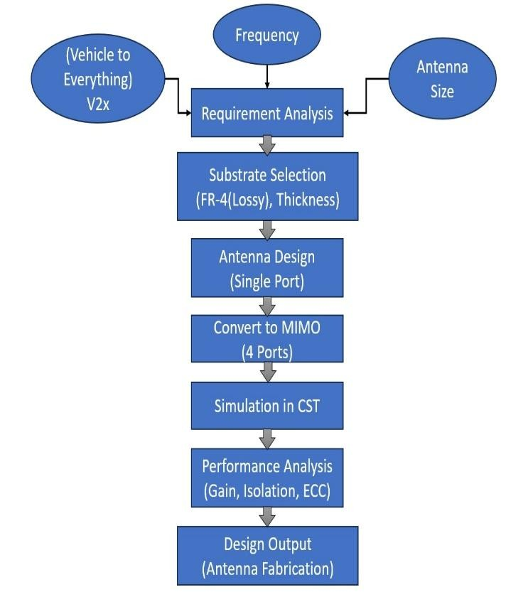

Proposed MIMO Antenna
The complete antenna is a low-profile, four-port device designed for sub-6 GHz V2X application equipment. This antenna is constructed from a substrate with lossy FR-4 material, it has 1.6 mm thickness with a dielectric constant
of 4.3. From the suggested antenna, the dimensions is given by 24 x 24 x 1.6 mm³, making it ideal for vehicles with little space. A microstrip line is used to stimulate the four identical portions of the proposed antenna. All elements are in an Perpendicular configuration to obtain pattern diversity and reduce coupling of close to the parts.
The suggested antenna is developed for operation at 4.15 GHz, covering a bandwidth between 3.85-4.59 GHz. The suggested antenna's compact configuration maximizes the use of available area while ensuring acceptable radiation characteristics. One notable feature of the recommended design is the excellent isolation between the antenna ports operate without the need for extra decoupling components such as defective ground structures or neutralisation lines, this results in high level of isolated between the antenna ports are roughly -29 dB. The symmetric configuration of the proposed antenna ensures uniform current distribution, thus providing uniform performance across all ports. The surface current distribution clearly indicates that the connection between the antennas is reduced due to the orthogonal configuration and the proposed MIMO antenna was optimized in its design. The planned antenna also ensures good impedance matching, with reflection coefficient of around -23 dB and bidirectional radiation pattern that are appropriate for vehicular communication systems.

The suggested MIMO antenna additionally ensures that the the envelope correlation coefficient is poor, and significant diversity gain prove its suitable for effective communication systems. The suggested MIMO antenna strategy is Simulated and analysed in the CST Studio Suite, and its outcomes demonstrate its applicability for effective communication systems.

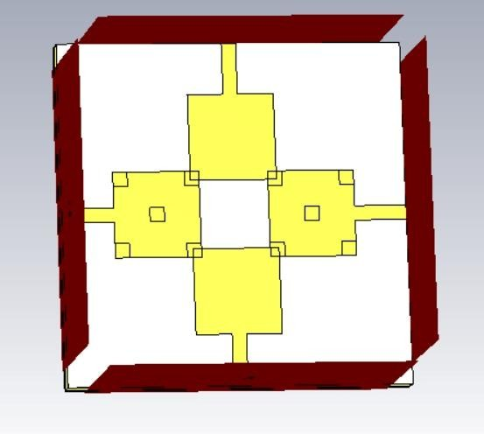
Fig. 1 Front side of MIMO antenna

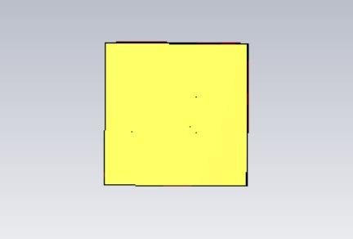
Fig. 2 Back side of the antenna

The recommended compact four-port MIMO antenna 3D construction was showed in Fig. 1 The proposed MIMO antenna design uses a FR-4 material as a substrate and four identical radiating elements placed orthogonally around a central area with copper material. The suggested MIMO antenna design features a microstrip feed line for each element to enable the independent operation of all four elements. The central area's etching provides Improved isolation of nearby radiating parts. The proposed MIMO antenna symmetric structure provides equal current distribution for better radiation characteristics. The boundary area represents the simulation boundary used in CST for electromagnetic analysis.

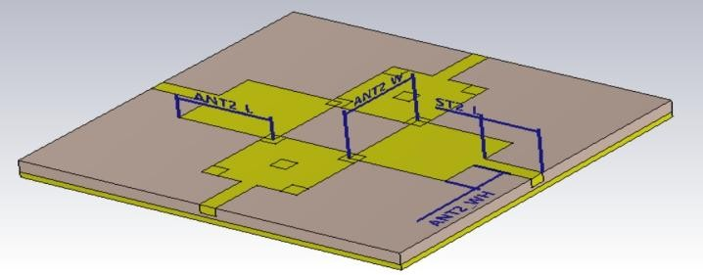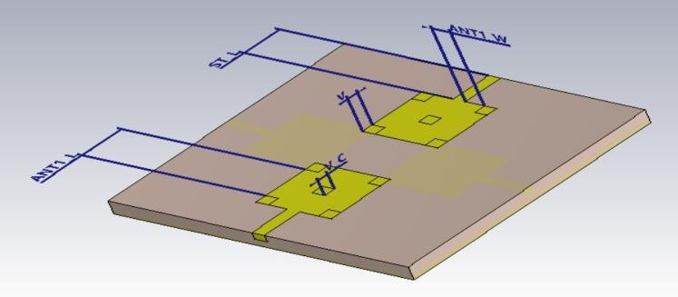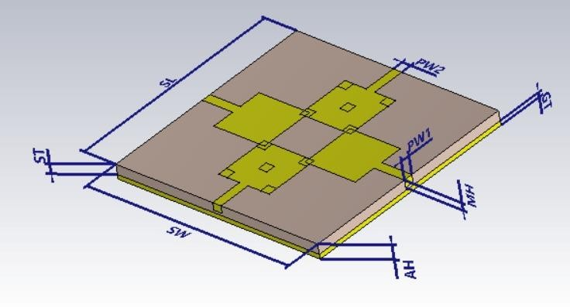
Fig.3 Dimension of the Antenna

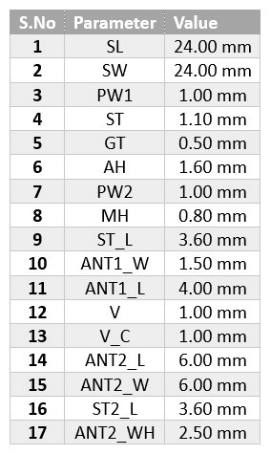
Table 1. Dimension specifications for the antenna
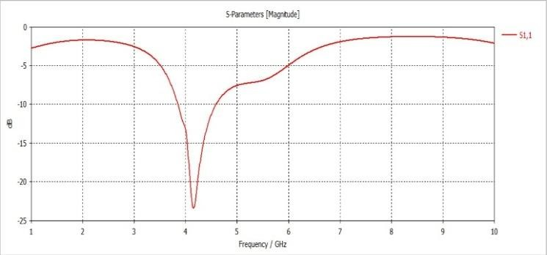

Fig.4 Simulated S11 of the MIMO

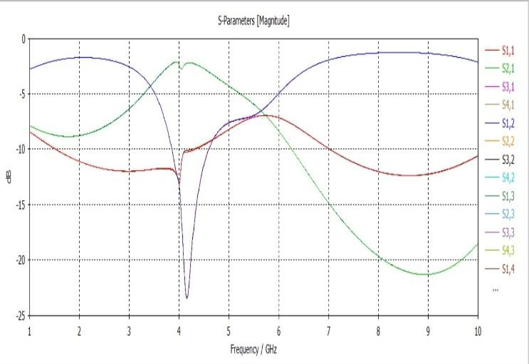
Fig.5 Simulated of the MIMO
Fig 3 The suggested four-port MIMO antenna design's simulated S-parameters are shown below. The antenna id observed that has good impedance matching capabilities, where the reflection coefficient (S₁₁) reaches –23 dB at its resonance frequency at 4.15 GHz. The antenna's impedance bandwidth ranges between 3.85 GHz and 4.59 GHz, meeting its requirements for sub-6 GHz V2X technologies. Also, the mutual coupling is done among the antenna parts. but it quites low, with isolation between the ports reaching -29 dB. This is achieved without any decoupling structures, which clearly indicates the effectiveness of the suggested design. It's obvious that the planned antenna has efficient performance characteristics with minimal signal interferences between the ports, thus ensuring reliable MIMO communication systems.
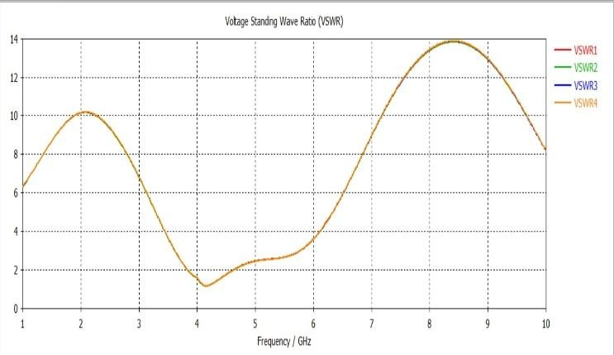
Fig.6 VSWR of the antenna
E. Correlation between envelopes and Diversity Gain
Multiple Input, Multiple Output (MIMO) technologies improve wireless throughput, this represents the amount of data that may be sent each second. This shows that you have a radio capable of sending and receiving data from many channels at the same time. Antenna diversity is a situation when many antennas are employed in the single Equipment. The connection between two antennas, also known as diversity gain, is used to evaluate the benefits of employing several antennas.

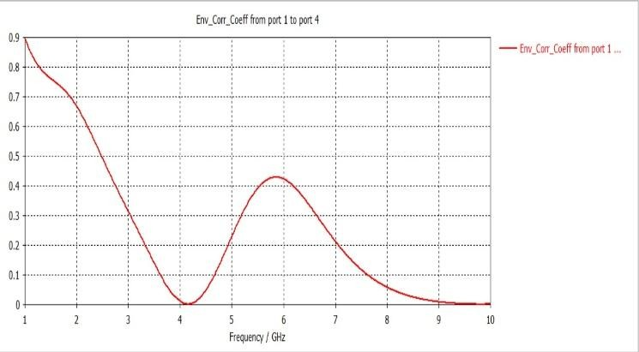
Fig.7 Envelope the correlation coefficient
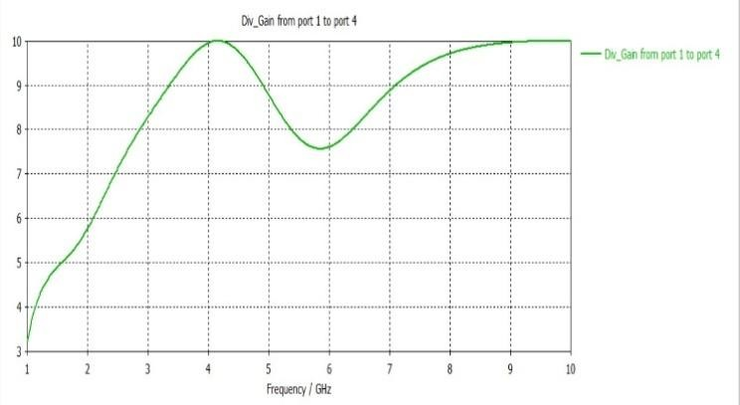
Fig.8 Diversity gain of the Antenna
Fig. 7 displays the ECC and how distinct the emission patterns of the two antennas are differ from other. This implies that If one antenna is vertical polarization and the other is completely polarized in the horizontal plane, they cannot interact.
F. Envelope Correlation
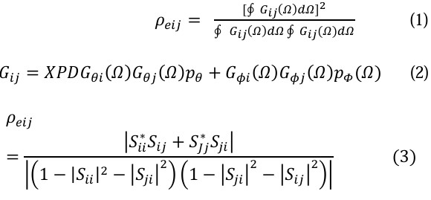
The above-mentioned Gaussian distribution is denoted by Pθ (Ω) and PΦ (Ω).
When Pθ (Ω) = PΦ (Ω) = 1 (isotropic power distribution), XPR = 0 dB, and the structure is lossless, use S-parameters for envelope correlation.
G. Diversity Gain

The existing antenna must be enhanced Increase isolation and reduce antenna beam size for future communication. Monopole antennas are found in lower bands. and have a wider bandwidth. 90% reduction in radiation losses. The antenna is mostly utilized in automobile applications.

Result and Discussion
The expected four-port MIMO antenna was fabricated by CST Studio Suite software. S-parameters and the antenna performance is determined by its radiation properties. The antenna impedance matching is strong, the reflection coefficient (S₁₁) is around -23 dB at 4.15 GHz. The Developed antenna works in the frequency ranges from 3.85 GHz to 4.59 GHz and has a -10 dB bandwidth. This frequency band is ideal in sub-6GHz V2X communication. The antenna has a strong port-to-port isolation of about -29 dB. This means that there is no connection between antenna elements. The antenna features a fantastic radiation pattern, allowing for stable bidirectional radiation. The antenna has highest gain of about 1.5 dBi. The envelope correlation coefficient (ECC) is relatively low, i.e., less than 0.01. The antenna has a diversity gain of roughly 10 dB.
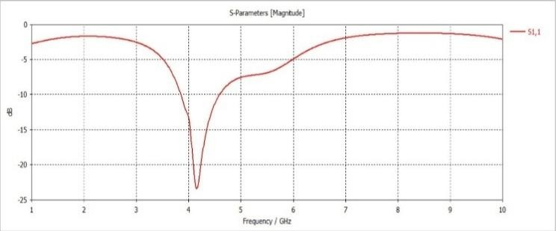
Fig.7 Simulation of S parameter
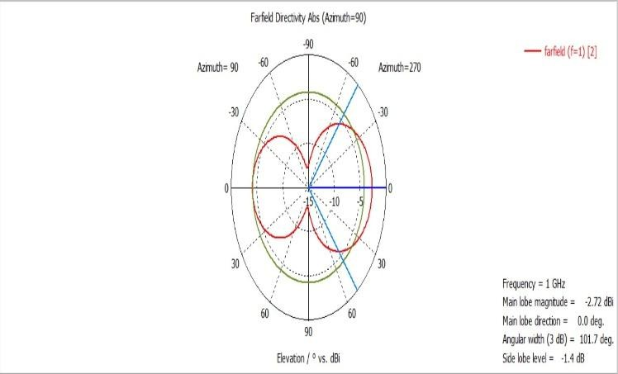
Fig.8 1D Far-field results
The fig.8 illustrates the far-field emission project of the recommended spatial antenna. This fig depicts the directional radiation qualities, regardless of distance. The radiation pattern is consistent and symmetrical.The radiation pattern is uniform and symmetrical. This radiation pattern confirms the efficacy of the suggested antenna. The radiation pattern depicts the dispersion of energy in space, which is critical to the performance of the proposed V2X communications system.

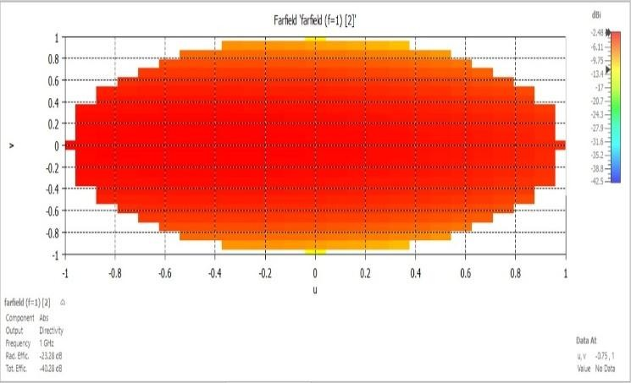
Fig.9 2D results

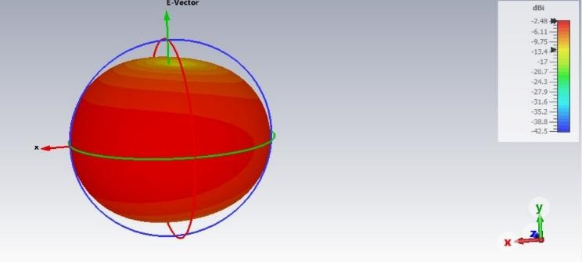
Fig.10 The three-dimensional radiation pattern
between 3.85 GHz and 4.59 GHz

Conclusion
This research presents a new low-profile a spatial antenna for V2X applications systems running at frequencies less than 6 GHz. The antenna was created on a FR-4 lossy substrate with minimum dimensions of 24 × 24 × 1.6 mm³ and has good impedance matching with S₁₁ ≈ 23 dB and bandwidth of 3.85-4.59 GHz. The proposed antenna provides 29 dB isolation without the use of decoupling devices, exhibiting its simplicity. The antenna has good radiation properties and a tall gain of 1.5 dBi. The suggested antenna features minimal ECC and good diversity gain, demonstrating its efficiency in V2X communication systems.

References

[1] Hanish Chaitanya Bodepudi , Arun Raaza , Das Shyam Sundar , Shailesh B.Sargade , “A Novel Design of Low Profile Two Port Antenna for V2X Applications,” Seventh Sense Research Group, vol. 12 issue 3, pp.61-67, March 2025.
[2] Ping Wang et al., “Wideband Gain Enhancement of High-Isolation and Quasi-Omnidirectional Metamaterial MIMO Antenna for Vehicular Radar,” IEEE Transactions on Instrumentation and Measurement, vol. 71, pp. 1-12, 2022.

[3] Mehr E Munir, Moustafa M. Nasralla, and Maged Abdullah Esmail, “Design and Analysis of Super-Compact Millimeter Wave Antenna for 5G Vehicular Networks,” IEEE 99th Vehicular Technology Conference (VTC2024 Spring), Singapore, pp. 1-8, 2024.
[4] Arun Kumar Saurabh, Rupam Bharati, and Manoj Kumar Meshram, “Wideband 32-Element 3D-MIMO Antenna for Vehicular Applications,” AEU - International Journal of Electronics and Communications, vol. 186, 2024.
[5] Xu, Y.; Dong, Y.; Wen, S.; Wang, H. Vertically polarized quasi-Yagi MIMO antenna for 5G N78 band application. IEEE Access 2021, 9, 7836–7844.
[6] Sakli, H.; Abdelhamid, C.; Essid, C.; Sakli, N. Metamaterial-based antenna performance enhancement for MIMO system applications. IEEE Access 2021, 9, 38546 38556.
[7] Garg, P.; Jain, P. Isolation improvement of MIMO antenna using a novel flower shaped metamaterial absorber at 5.5GHz WiMAX band. IEEE Trans. Circuits Syst. 2020, 67, 675–679.
[8] Bhattacharya, A.; Roy, B. Investigations on an extremely compact MIMO antenna with enhanced isolation and bandwidth. Microw. Opt. Technol. Lett. 2020, 62, 845–851.
[9] Pei, T.; Zhu, L.; Wang, J.; Wu, W. A low-profile decoupling structure for mutual coupling suppression in MIMO patch antenna. IEEE Trans. Antennas Propag. 2021, 69, 6145–6153.
[10] Tiwari, R.N.; Singh, P.; Kumar, P.; Kanaujia, B.K. High isolation 4-port UWB MIMO antenna with novel decoupling structure for high speed and 5G communication. In Proceedings of the 2022 International Conference on Electromagnetics in Advanced Applications (ICEAA), Cape Town, South Africa, 5–9 September 2022; pp. 336 339.
[11] Khalid, M.; Iffat Naqvi, S.; Hussain, N.; Rahman, M.; Mirjavadi, S.S.; Khan, M.J.; Amin, Y. 4-port MIMO antenna with defected ground structure for 5G millimeter wave applications. Electronics 2020, 9, 71.
[12] Tang, X.; Yao, Z.; Li, Y.; Zong, W.; Liu, G.; Shan, F. A high performance UWB MIMO antenna with defected ground structure and U-shape branches. Int. J. RF Microw. Comput. Aided Eng. 2020, 31, e22270.
[13] Tiwari, R.N.; Singh, P.; Kanaujia, B.K.; Kumar, P. UWB MIMO antenna with decoupling strip for 5G applications. In Proceedings of the 2021 International Applied Computational Electromagnetics Society Symposium (ACES), Hamilton, ON, Canada, 1–5 August 2021; pp. 1–4.
[14] Barani, I.R.R.; Wong, K.L.; Zhang, Y.X.; Li, W.Y. Low profile wideband conjoined open-slot antennas fed by grounded coplanar waveguides for 4 × 4 5G MIMO operation. IEEE Trans. Antennas Propag. 2020, 68, 2646 2657.
[15] Saadh, A.W.M.; Ramaswamy, P.; Ali, T. A CPW fed two and four element antenna with reduced mutual coupling between the antenna elements for wireless applications. Appl. Phys. A 2021, 127, 88.
[16] Mendez, J.A.T.; Aguilar, H.J.; Merino, A.R.; Toledo, L.A.V.; Villanueva, R.G. Four ports wideband drop-shaped slot antenna for MIMOapplications. J. Electromagnet. Waves Applicat. 2020, 34, 1159–1179.
[17] Ahmed,B.T.; Rodriguez, I.F. Compact high isolation UWB MIMO antennas. Wirel. Netw. 2022, 28, 1977–1999.
[18] Wang,M.;Nan, J.; Liu, J. High-isolation UWB MIMO antenna with multiple X-shaped stubs loaded between ground planes. Int. J. Antennas Propag. 2021, 2021, 1155471.
[19] Addepalli, T.; Anitha, V.R. A very compact and closely spaced circular shaped UWB MIMO antenna with improved isolation. Int. J. Electron. Commun. (AEU) 2020, 114, 153016.
[20] Sharma,M.;Dhasarathan, V.; Patel, S.K.; Nguyen, T.K. An ultra-compact four-port 4 × 4 superwideband MIMOantennaincluding mitigation of dual notched bands characteristics designed for wireless network applications. Int. J. Electron. Commun. (AEU) 2020, 123, 153332.
[21] Tiwari, R.N.; Singh, P.; Kanaujia, B.K.; Kumar, S.; Gupta, S.K. A low profile dual band MIMO antenna for LTE/Bluetooth /Wi-Fi/WLAN applications. J. Electromagnet. Wave Applicat. 2020, 34, 1239–1253.
[22] Islam, S.K.N.; Das, S. Dual-band CPW fed MIMO antenna with polarization diversity and improved gain. Int. J. RF Microw. Comput. Aided Eng. 2020, 30, e22128.
[23] Tiwari, R.N.; Singh, P.; Panday, S.; Anand, R.; Singh, D.K.; Kanaujia, B.K. Swastika shaped slot embedded two port dual frequency band MIMOantenna for wireless applications. Analog Integra. Circuits Signal Process. 2021, 109, 103–113.
[24] Sharma, P.; Tiwari, R.N.; Singh, P.; Kanaujia, B.K. Dual-band trident shaped MIMO antenna with novel ground plane for 5G applications. Int. J. Electron. Commun. (AEU) 2022, 155, 154364.
[25] Yang, M.; Zhou, J. A compact pattern diversity MIMO antenna with enhanced bandwidth and high-isolation characteristics for WLAN/5G/WiFiapplications. Microw. Opt. Technol. Lett. 2020, 62, 2353–2364.
[26] Peng, H.; Zhi, R.; Yang, Q.; Cai, J.; Wan, Y.; Liu, G. Design of a MIMO antenna with high gain and enhanced isolation for WLAN applications. Electronics 2021, 10, 1659.
[27] Maturi, T.; Harikrishna, B. Electronic band-gap integrated low mutual coupling dual band MIMO antenna. Int. J. Electron. 2020, 107, 1166–1176.
[28] Abdulkawi, W.M.; Malik, W.A.; Rehman, S.U.; Aziz, A.; Sheta, A.F.A.; Alkanhal, M.A. Design of a compact dual band MIMO antenna system with high-diversity gain performance in both frequency bands. Micromachines 2021, 12, 383.
[29] Kumar, A.; Agrawal, T. High performance circularly polarized MIMO antenna with polarization independent metamaterial. Wirel. Pers. Commun. 2021, 16, 3205–3216.
[30] Tiwari, R.N.; Singh, P.; Kanaujia, B.K.; Kumar, P. Compact circularly polarized MIMO printed antenna with novel ground structure for wideband applications. Int. J. RF Microw. Comput. Aided Eng. 2021, 31, e22737.
[31] Jaiswal, R.K.; Kumari, K.; Sim, C.Y.D.; Srivastava, K.V. Three-port circularly polarized MIMO antenna for WLAN application with pattern and polarization diversity. Microw Opt. Technol. Lett. 2021, 63, 1927–1934.

