Rainfall Prediction using Machine learning:
A Comprehensive Analysis

Arza Ram Deepak Sai,
Department of CSE,
Chalapathi Institute of Technology,
ramdeepaksaiarza@gmail.com

Javvadi Sravanthi,
Department of CSE,
Chalapathi institute of Technology,
Sravanthi.javvadi@gmail.com

Abstract—Rainfall which occurs when condensation occurs in the cloud and then droplets reach the earth surface the benefits associated with rainfall is quite high predicting rainfall at early is essential as it helps sectors like agriculture, disaster preparedness, Accurate prediction of the rainfall help farmers or people to control floods, droughts, and other weather-related events. Many of the existing models have disadvantages as they cannot able to understand underlying patterns in the data so the primary objective of this study is to explore all the potential challenges by identifying possible mitigating strategies Latest advancements in ML have shown that capturing non linear patterns is made achievable by ML models This discussion is made about the selection and preprocessing of meteorological data, feature engineering, model training, and evaluation criteria. The findings indicate that ML techniques can enhance rainfall prediction accuracy by capturing complex relationships between meteorological variables, ultimately contributing to better decision-making in climate-sensitive sectors.

Introduction
Rainfall prediction is a crucial aspect as many areas are depending on it directly or indirectly especially sectors such as agriculture, disaster management, urban planning, and hydrology. Accurate prediction helps farmers to plan crop cycles accordingly, urban areas which are flood prone early evacuation is made, and governments to prepare for extreme weather events But due to difficulty of traditional models ML models comes into picture where complex models also be handled in a effective manner Due to extreme change in climatic patterns have changed the rainfall pattern too which is quite challenging Rainfall can be classified into three main types: convective, orographic, and frontal rainfall.
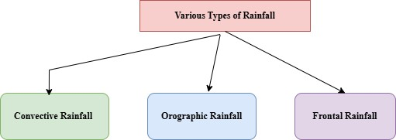

Fig.1. Types of Rainfall

Convective Rainfall: This type of rainfall occurs when the Earth's surface heats up, typically in warm regions, causing the air near the ground to warm and rise quickly. As this warm, moist air rises, it cools, and the moisture condenses to form clouds and eventually rainfall. Convective rainfall is usually intense, with short bursts of heavy rain that often lead to thunderstorms. It is common in tropical regions, especially during the summer months when temperatures are high, and the atmosphere is very humid.

Orographic Rainfall: Orographic rainfall is caused by the movement of moist air over high terrain, such as mountains. As the air ascends the mountain slopes, it cools and condenses, forming clouds and causing precipitation on the windward side of the mountain. The leeward side (the side sheltered from the wind) often receives little to no rain, resulting in a "rain
when a warm air mass encounters a cold air mass, with the warm air being forced to rise over the denser, cooler air. As the warm air rises, it cools and condenses, resulting in steady, prolonged rainfall along the boundary, or "front," between the two air masses. Frontal rainfall is common in mid-latitude regions, where weather fronts are more prevalent, such as in Europe and parts of North America. It often produces steady and widespread rainfall, which can last for several hours or even days.
Rainfall can also be classified by intensity:
- Light rain: Rain rate is between 0 to 2.5 millimetres
- Moderate rain: Rain rate is between 2.6 to 7.6 millimetres
- Heavy rain: Rain rate is more than 7.6 millimetres ML models use better approach because they integrate datasets and identify patterns within the data thereby various parameters a how they are interrelated can be identified

LITERATURE SURVEY
Parmar et al. [1] utilized ML where importance of rainfall is discussed then comparison between traditional and ML models is made where its is observed that old models tend to follow physical laws like thermodynamics, assume every variable is linearly related to each other whereas in ML models these are addressed and obtained an accuracy of 95%. Basha et al. [2] utilised both ML and DL models where a comparative analysis is made in which among ML RF has shown good performance due to its ensemble architecture whereas in DL LSTM achieved higher prediction due to its ability to form patterns between data points and obtained an accuracy of 97%.
Hussein et al. [3] made a comprehensive analysis by using ML where multiple ML models were taken into consideration and then observed that ensemble architecture has combined decision taken at multiple levels and gets corrected each time and obtained an accuracy of 98%.
Barrera et al. [4] used Both ML and DL models and gets trained on large size of data to handle this DL models performed better due to long term memory retention and pattern matching where DT which reduces error at each level and makes good decision ate the end node performed better and obtained an accuracy of 96%.
Rahman et al. [5] utilised ML to early identify rainfall related flood in urban areas so that earlier evacuation is made and appropriate suggestions are provided better feature extraction is done so these were corelated features with higher correlation rate helps in better identifying the model and obtained an accuracy of 94%.
Mohammed et al. [6] utilised multiple ML models and made a comparative analysis where initially features with higher correlation were extracted as they contain important information the model gets trained on them and obtained an accuracy of 94%.
Hernandez et al. [7] utilised DL especially information retention capabilities model which is RNN where they have a feedback mechanism through helps in capturing nonlinear relationships between input variables and rainfall underlying trend is identified and obtained an accuracy of 96%. Carmer et al. [8] made a comparative model-based analysis using ML where RF is shown better performance this is due to ensemble architecture where decision s at made each step gets corrected and moves to next step this helped in obtaining a model with low error and an accuracy of 94%. Kuamr et al. [9] utilised ML models and made data cleaning and focused on feature enhancement like identifying important features and understanding how these correlated, strong correlation between them so that models get trained on them and obtained an accuracy 98%.
Appiah et al. [10] utilised multiple models which primarily focus on ensemble architecture and focused on feature extraction where these noise removed features makes the model robust thereby reducing training tome, and obtained an accuracy of 98%.

METHODOLOGY

Dataset Details
Weather In Australia: The Weather in AUS dataset is a comprehensive collection of meteorological data from various locations across Australia, typically used for weather prediction tasks, including rainfall forecasting. The dataset contains key attributes such as temperature, humidity, wind speed, cloud cover, and pressure, along with historical rainfall measurements. Each entry includes daily weather observations, allowing machine learning models to analyse patterns in weather conditions over time. With thousands of records covering diverse regions, this dataset provides a robust foundation for predictive modelling, helping to identify factors that influence rainfall and other weather events across Australia’s varied climates.

Proposed Model
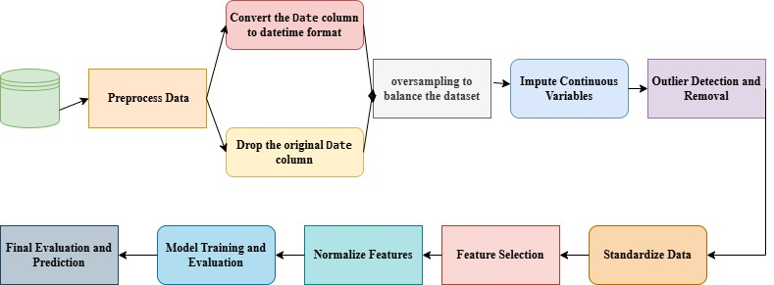
Fig.2. Proposed Model Architecture
Here’s a step-by-step explanation of each part of the process you’ve outlined for building a rainfall prediction model:
- Preprocess Data
Objective: Prepare data for model training by transforming it into a usable format.
Steps:
- Identify and handle missing values, irrelevant columns, and inconsistent formats.
- Clean the data so it contains meaningful and uniform information for every observation.

- Convert the Date Column to Datetime Format
Objective: Extract useful information from the Date column for temporal analysis.
Steps:
- Convert the Date column to a datetime format.
- Extract features like year, month, and day from the date, creating new columns.
- These extracted features might reveal patterns or trends related to seasonality.

- Drop the Original Date Column
Objective: Remove columns that no longer serve a purpose in analysis or modeling.
Steps:
- After extracting useful components from Date, drop it as it's no longer needed.
- Reducing data dimensions can speed up computation and simplify the dataset.

- Oversampling to Balance the Dataset
Objective: Address class imbalance to prevent the model from being biased toward the majority class. Steps:
- Use oversampling on the minority class (e.g., RainTomorrow = 1) so both classes have an equal count.
- Oversampling can be achieved by duplicating samples from the minority class or using techniques like SMOTE (Synthetic Minority Oversampling Technique).

- Impute Continuous Variables
Objective: Handle missing values in continuous variables without removing data points.
Steps:
- Use methods like Multiple Imputation by Chained Equations (MICE) to fill in missing values with estimates based on relationships with other variables.
- This prevents loss of data and allows for a more complete dataset for analysis.

- Outlier Detection and Removal
Objective: Remove extreme values that could skew the model's performance.
Steps:
- Calculate the Interquartile Range (IQR) for each continuous variable to identify the range of typical values.
- Define outliers as values outside 1.5 times the IQR above the 75th percentile or below the 25th percentile.
- Remove rows containing these outliers to maintain data quality.

- Standardize Data
Objective: Scale continuous features to have similar ranges, which helps many machine learning models perform better.
Steps:
- Apply scaling techniques like MinMaxScaler or StandardScaler to bring all features within a specific range, such as [0, 1].
- Standardization ensures that variables with larger ranges do not dominate the model’s calculations.

- Feature Selection
Objective: Select the most relevant features to reduce dimensionality, improving the model’s accuracy and interpretability.
Steps:
- Use statistical tests (e.g., Chi-Square for categorical features) to rank features by importance.
- Test using models like Random Forest for feature importance and select the most influential features.
- Reducing the number of features can reduce noise and improve training time.

- Normalize Features
Objective: Further scale and standardize features so they are normally distributed with a mean of 0 and a standard deviation of 1.
Steps:
- Use StandardScaler for normalization. o Normalization helps algorithms converge more quickly and can improve accuracy in distance-based models.

- Model Training and Evaluation
Objective: Train machine learning models and evaluate their performance on test data. • Steps: o Split the dataset into training and testing sets, typically using an 80/20 ratio. o Train a selected model (e.g., Decision Tree, Random Forest) using the training data. o Evaluate the model using metrics like Accuracy, ROC AUC, and Cohen’s Kappa to understand how well it’s performing.

- Final Evaluation and Prediction
Objective: Make final predictions and assess the model on unseen data.
Steps:
- Use the model to make predictions on a new test or validation dataset.
- Interpret and visualize the results (confusion matrix, ROC curve) to confirm that the model generalizes well to new data.

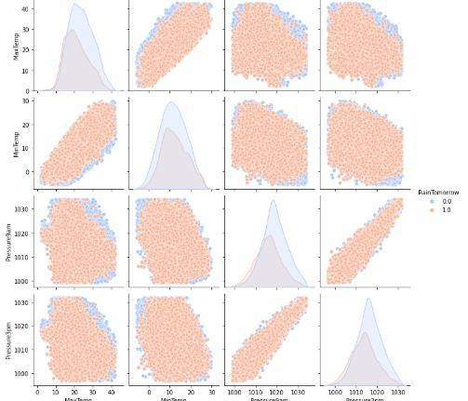

Fig.3. Probability of getting rain based on times series data

HeatMap
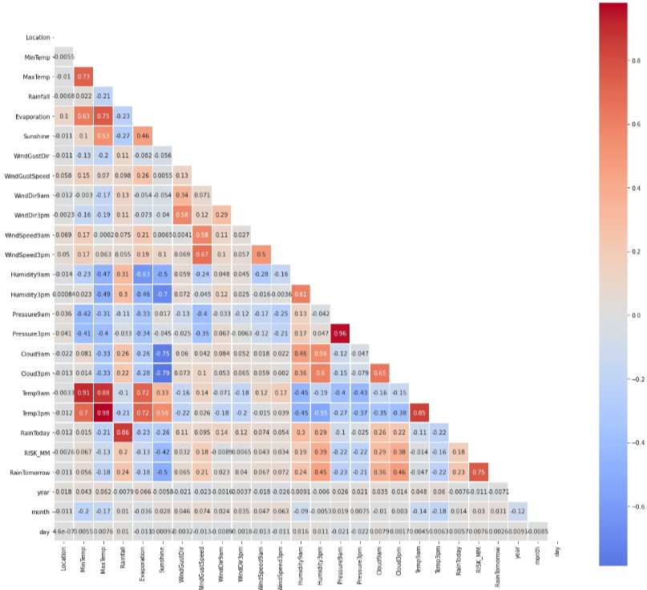
Fig.4. Heatmap correlation of various features

Advantages & Disadvantages.

S.NO | Author Name & Year | Advantages | Disadvantages
1 | Dubey, A. D. (2015) | Better feature extraction and made a comparative analysis | Data need to be generalised
2 | Dada, E. G. et al. (2021) | Better feature extraction and made a comparative analysis | Data need to be generalised
3 | Latif, S. D. et al. (2023) | Better feature extraction and made a comparative analysis | Data need to be generalised
4 | Shah, U. et al. (2018) | Better feature extraction and made a comparative analysis | Data need to be generalised
5 | Ridwan, W. M. et al. (2021) | Better feature extraction and made a comparative analysis | Data need to be generalised
6 | Refonaa, J. et al. (2019) | Better feature extraction and made a comparative analysis | Data need to be generalised
7 | Diez-Sierra, J. & Del Jesus, M. (2020) | Better feature extraction and made a comparative analysis | Data need to be generalised
8 | Salman, A. G. et al. (2015) | Good in outlier detection and model training | Data need to be generalised
9 | Sumi, S. M. et al. (2012) | Better feature extraction and made a comparative analysis | Data need to be generalised
10 | Liyew, C. M. & Melese, H. A. (2021) | Good in outlier detection and model training | Data need to be generalised
11 | Aswin, S. et al. (2018) | Good in outlier detection and model training | Data need to be generalised
12 | Hong, W. C. (2008) | Good in outlier detection and model training | Data need to be generalised
13 | Grace, R. K. & Suganya, B. (2020) | Good in outlier detection and model training | Data need to be generalised
14 | Oswal, N. (2019) | Better feature extraction and made a comparative analysis | Data need to be generalised
15 | Sarvani, K. et al. (2021) | Better feature extraction and made a comparative analysis | Data need to be generalised
16 | Aderyani, F. R. et al. (2022) | Better feature extraction and made a comparative analysis | Data need to be generalised
17 | Endalie, D. et al. (2022) | Better feature extraction and made a comparative analysis | Data need to be generalised
18 | Thirumalai, C. et al. (2017) | Better feature extraction and made a comparative analysis | Data need to be generalised
19 | Yen, M. H. et al. (2019) | Better feature extraction and made a comparative analysis | Data need to be generalised
20 | Reddy, P. C. S. et al. (2022) | Better feature extraction and made a comparative analysis | Data need to be generalised

EXPERIEMNTAL SETUP
A basic hardware setup for machine learning experiments with small datasets and simpler models could include a quad core processor (e.g., Intel i5/i7 or AMD Ryzen 5/7), 8 GB of RAM or higher, and a 256 GB SSD or larger for faster data access. For graphics, integrated graphics or a basic dedicated GPU like the NVIDIA GeForce GTX 1050 would suffice. This setup is ideal for prototyping and running smaller experiments efficiently on personal or entry-level systems.

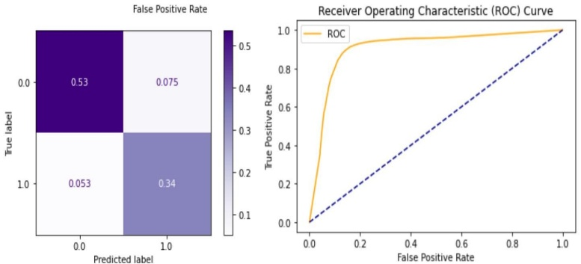
Fig.4. Results obtained using a Decision Tree classifier

RESULTS ACHEIEVD
The confusion matrix reveals the performance of the model in classifying the data. The diagonal elements (0.54 and 0.33) represent the correct classifications, indicating that the model correctly predicted 54% of the instances as class 0 and 33% as class 1. The off-diagonal elements (0.074 and 0.065) represent the misclassifications, showing that 7.4% of class 0 instances were incorrectly classified as class 1, and 6.5% of class 1 instances were incorrectly classified as class 0. While the model has some accuracy, it struggles with misclassifying instances between the two classes.

CONCLUSION &FUTURE SCOPE
Rainfall prediction using machine learning models has shown promising results in improving accuracy and lead time compared to traditional methods. By leveraging historical weather data and advanced algorithms, these models can identify complex patterns and relationships that influence rainfall patterns. This enables more accurate forecasting, aiding in disaster preparedness, water resource management, and agricultural planning. Future research directions include incorporating additional data sources like satellite imagery and soil moisture data, exploring ensemble methods for enhanced prediction reliability, and developing real-time systems for timely decision-making. Additionally, focusing on regional and localized predictions can further refine the accuracy of rainfall forecasts.

References
The template will number citations consecutively within brackets [1] Parmar, A., Mistree, K., & Sompura, M. (2017, March). Machine learning techniques for rainfall prediction: A review. In International conference on innovations in information embedded and communication systems (Vol. 3). [2] Basha, C. Z., Bhavana, N., Bhavya, P., & Sowmya, V. (2020, July). Rainfall prediction using machine learning & deep learning techniques. In 2020 international conference on electronics and sustainable communication systems (ICESC) (pp. 92-97). IEEE. [3] Hussein, E. A., Ghaziasgar, M., Thron, C., Vaccari, M., & Jafta, Y. (2022). Rainfall prediction using machine learning models: literature survey. Artificial Intelligence for Data Science in Theory and Practice, 75-108. [4] Barrera-Animas, A. Y., Oyedele, L. O., Bilal, M., Akinosho, T. D., Delgado, J. M. D., & Akanbi, L. A. (2022). Rainfall prediction: A comparative analysis of modern machine learning algorithms for time-series forecasting. Machine Learning with Applications, 7, 100204. [5] Rahman, A. U., Abbas, S., Gollapalli, M., Ahmed, R., Aftab, S., Ahmad, M., ... & Mosavi, A. (2022). Rainfall prediction system using machine learning fusion for smart cities. Sensors, 22(9), 3504. [6] Mohammed, M., Kolapalli, R., Golla, N., & Maturi, S. S. (2020). Prediction of rainfall using machine learning techniques. International Journal of Scientific and Technology Research, 9(1), 3236-3240. [7] Hernández, E., Sanchez-Anguix, V., Julian, V., Palanca, J., & Duque, N. (2016). Rainfall prediction: A deep learning approach. In Hybrid Artificial Intelligent Systems: 11th International Conference, HAIS 2016, Seville, Spain, April 18-20, 2016, Proceedings 11 (pp. 151-162). Springer International Publishing. [8] Cramer, S., Kampouridis, M., Freitas, A. A., & Alexandridis, A. K. (2017). An extensive evaluation of seven machine learning methods for rainfall prediction in weather derivatives. Expert Systems with Applications, 85, 169-181. [9] Kumar, A. S., Roshan, S. A., Dutta, A., Ray, S., Masadeh, S. R., Lakshmi, G. P., ... & Kaur, G. (2024). Rainfall prediction using machine learning. In Advancements in Climate and Smart Environment Technology (pp. 100 113). IGI Global. [10] Appiah-Badu, N. K. A., Missah, Y. M., Amekudzi, L. K., Ussiph, N., Frimpong, T., & Ahene, E. (2021). Rainfall prediction using machine learning algorithms for the various ecological zones of Ghana. IEEE Access, 10, 5069-5082. [11] Dubey, A. D. (2015). Artificial neural network models for rainfall prediction in Pondicherry. International Journal of Computer Applications, 120(3). [12] Dada, E. G., Yakubu, H. J., & Oyewola, D. O. (2021). Artificial neural network models for rainfall prediction. European Journal of Electrical Engineering and Computer Science, 5(2), 30-35. [13] Latif, S. D., Hazrin, N. A. B., Koo, C. H., Ng, J. L., Chaplot, B., Huang, Y. F., ... & Ahmed, A. N. (2023). Assessing rainfall prediction models: Exploring the advantages of machine learning and remote sensing approaches. Alexandria Engineering Journal, 82, 16-25. [14] Shah, U., Garg, S., Sisodiya, N., Dube, N., & Sharma, S. (2018, December). Rainfall prediction: Accuracy enhancement using machine learning and forecasting techniques. In 2018 Fifth International Conference on Parallel, Distributed and Grid Computing (PDGC) (pp. 776-782). IEEE. [15] Ridwan, W. M., Sapitang, M., Aziz, A., Kushiar, K. F., Ahmed, A. N., & El-Shafie, A. (2021). Rainfall forecasting model using machine learning methods: Case study Terengganu, Malaysia. Ain Shams Engineering Journal, 12(2), 1651-1663. [16] Refonaa, J., Lakshmi, M., Dhamodaran, S., Teja, S., & Pradeep, T. N. M. (2019). Machine learning techniques for rainfall prediction using neural network. Journal of Computational and Theoretical Nanoscience, 16(8), 3319-3323. [17] Diez-Sierra, J., & Del Jesus, M. (2020). Long-term rainfall prediction using atmospheric synoptic patterns in semi-arid climates with statistical and machine learning methods. Journal of Hydrology, 586, 124789. [18] Salman, A. G., Kanigoro, B., & Heryadi, Y. (2015, October). Weather forecasting using deep learning techniques. In 2015 international conference on advanced computer science and information systems (ICACSIS) (pp. 281 285). Ieee. [19] Sumi, S. M., Zaman, M. F., & Hirose, H. (2012). A rainfall forecasting method using machine learning models and its application to the Fukuoka city case. International Journal of Applied Mathematics and Computer Science, 22(4), 841-854. [20] Liyew, C. M., & Melese, H. A. (2021). Machine learning techniques to predict daily rainfall amount. Journal of Big Data, 8, 1-11. [21] Aswin, S., Geetha, P., & Vinayakumar, R. (2018, April). Deep learning models for the prediction of rainfall. In 2018 International Conference on Communication and Signal Processing (ICCSP) (pp. 0657-0661). IEEE. [22] Hong, W. C. (2008). Rainfall forecasting by technological machine learning models. Applied Mathematics and Computation, 200(1), 41-57. [23] Grace, R. K., & Suganya, B. (2020, March). Machine learning based rainfall prediction. In 2020 6th International conference on advanced computing and communication systems (ICACCS) (pp. 227-229). IEEE. [24] Oswal, N. (2019). Predicting rainfall using machine learning techniques. arXiv preprint arXiv:1910.13827. [25] Sarvani, K., Priya, Y. S., Teja, C., Lokesh, T., & Rao, E. B. B. (2021). Rainfall analysis and prediction using machine learning techniques. J Eng Sci, 12(0377-9254), 531-537. [26] Aderyani, F. R., Mousavi, S. J., & Jafari, F. (2022). Short-term rainfall forecasting using machine learning-based approaches of PSO-SVR, LSTM and CNN. Journal of Hydrology, 614, 128463. [27] Endalie, D., Haile, G., & Taye, W. (2022). Deep learning model for daily rainfall prediction: case study of Jimma, Ethiopia. Water Supply, 22(3), 3448-3461. [28] Thirumalai, C., Harsha, K. S., Deepak, M. L., & Krishna, K. C. (2017, May). Heuristic prediction of rainfall using machine learning techniques. In 2017 International Conference on Trends in Electronics and Informatics (ICEI) (pp. 1114-1117). IEEE. [29] Yen, M. H., Liu, D. W., Hsin, Y. C., Lin, C. E., & Chen, C. C. (2019). Application of the deep learning for the prediction of rainfall in Southern Taiwan. Scientific reports, 9(1), 12774. [30] Reddy, P. C. S., Yadala, S., & Goddumarri, S. N. (2022). Development of rainfall forecasting model using machine learning with singular spectrum analysis. IIUM Engineering Journal, 23(1), 172-186.

