Ensemble based Fake News Detection with Transformers and Random Forest

Piyush Vashistha
Dept. of CEA
GLA University
Mathura, India
piyush.vashistha@gla.ac.in

Jai Anand
Dept. of CEA
GLA University
Mathura, India
jai.anad_cs23@gla.ac.in

Aryan Malik
Dept. of CEA
GLA University
Mathura, India
aryan.malik_cs22@gla.ac.in

Abstract: Automatic fake news identification has become a crucial field of study due to the quick dissemination of false information via digital media channels. While more modern deep learning models are better at capturing contextual semantics, traditional machine learning techniques frequently rely on manually created textual characteristics. However, when applied to new domains, individual models can experience problems like overfitting or poor generalization. This article suggests an ensemble-based approach for detecting false news that uses a stacking meta-classifier to integrate a transformer-based deep learning model with a classical machine learning model. In the suggested system, contextual semantic representations are extracted using a DistilBERT transformer model, while statistical patterns in text are captured by a Random Forest classifier trained on TF-IDF characteristics. The final prediction is produced by combining the outputs of both models using an XGBoost meta-classifier. Two popular datasets, the ISOT Fake News Dataset and the WELFake dataset, were used for the experiments. According to the experimental results, the ensemble model outperforms individual models with an accuracy of 98.65% on the WELFake dataset. Experiments further show that models trained only on the ISOT dataset perform poorly on unexplored data sources and display overfitting, underscoring the significance of ensemble learning and dataset diversity. In order to give transparency, the suggested architecture incorporates explainable AI algorithms that identify key phrases in the news articles that influence model conclusions. When they are used practically, the results indicate that combination of transformer-based and classical models is more reliable and better in detection of fake news articles.
Keywords: Fake news detection, DistilBERT, XGBoost, Random Forest, ISOT, WELFake, ensemble learning, stacking.

- Introduction
The speed at which information is shared online has dramatically risen due to the widespread use of social media and digital news outlets. Although technology has made information more accessible, additionally, it has increased the dissemination of fake news and misleading information. The term "fake news" describes false or misleading material that is presented as authentic news and is frequently intended to sway public opinion or control social discourse. [1]. Fake news has detrimental effects on society, politics, and the economy. The manual verification of information sources by human experts is a major component of traditional fact-checking techniques. These methods are time-consuming and unable to handle the massive amount of content produced every day on web platforms, despite the fact that they can be dependable. Consequently, automated fake news detection systems have become an important research area in Machine learning and Natural language processing (NLP). Early approaches to fake news detection primarily used classical machine learning algorithms such as Naïve Bayes, Random Forest classifiers and Support Vector Machines (SVM). These methods typically rely on feature engineering techniques such as TF-IDF representations or n-gram features [2]. These models can be used to explain statistical trends in text, but they typically don't take into account the contextual links between words. The most recent developments in deep learning have produced transformer models, like BERT, which have significantly enhanced NLP systems' performance.
In order to capture contextual meanings, transformer models learn how words are related to each other as a sequence [3]. On the other hand, deep learning models generally require huge amount of training data sets or they are prone to overfitting when trained on small or unbalanced datasets. Fake news detection algorithms have to work in a diverse range of domain and need to be able to adapt with real world writing styles. Models trained on a single dataset may not perform well on unseen data. This situation, known as domain shift, can greatly lower model performance [4]. To address these issues, this work proposes to use an ensemble-based fake news detection model based on both transformer-based deep learning and standard machine learning models. The general concept is to combine the strengths of numerous models. A Random Forest classifier is used to capture statistical textual patterns, while a DistilBERT model captures semantics meaning in a sentence [5]. A stacking meta-classifier based on XGBoost is then used to merge the results of both models. The following is a summary of this work's contributions:
- A framework for spotting fake news that uses both transformer-based and traditional models.
- A stacking ensemble design uses XGBoost to make predictions more accurate.
- A comparison of two datasets to examine the effects of domain shift and dataset bias.
- Using explainable AI methods to make predictions from models easy to understand.
The experimental outcomes show that the ensemble strategy contribute greatly to prediction accuracy and reduce the constraints of the individual models.
- Related Work
The fake news detection has gained great interest recently because of the increasing spread of fake on social media platforms. A range of different approaches from cutting-edge deep learning to classic machine learning have been proposed by researchers. Supervised machine learning methods that were most often utilized the textual features from the news articles which early research was primarily focused on. Several algorithms, such as Naive Bayes, Support Vector Machines and Logistic Regression for classification, are used in conventional techniques for detecting bogus news. These algorithms translate text into numerical vectors using feature extraction methods like TF-IDF and n-gram. Though these methods work well with datasets, they might not work in real-world situations since they cannot identify the semantic relationships in the text.
Researches have tested deep learning methods to identify the false information to subdue the constraints of traditional machine learning approaches. They have used Convolutional Neural Networks (CNNs) and Recurrent Neural Networks (RNNs) to find patterns and context in text [7]. Nevertheless, the ability of these models to manage long-range relationships is restricted.
Since transformers were established, accuracy in tasks involving natural language processing has significantly improved. Models such as BERT (Bidirectional Encoder Representations from Transformers) have demonstrated unmatched performance in a variety of text classification tasks.
BERT works on a bidirectional attention mechanism, enabling it to find the relationships between words in a sentence [8]. These models have been used in numerous experiments to detect misinformation, with the results being accurate.
Transformer models are computationally expensive to run and can easily overfit when trained on datasets that are too small, repetitive or lacks diversity. Recent research has found ensemble learning methodologies as a solution for these issues. Ensemble methods use predictions from more than one model to improve the overall performance of the system [9].
Stacking is a powerful ensemble approach since it allows meta-classifiers to learn how to effectively combine the predictions from different base models [9]. While typical machine learning models concentrate more on statistical patterns, and transformer models capture the semantic meanings of words, combining the two methods can be highly helpful in identifying bogus news.
An increasingly important feature for machine learning systems is the coherence, especially when it comes to applications which require spotting of false information. SHAP (SHapley Additive exPlanations) is one of the popular explainable AI methods that has been used to identify the features that contribute to a model prediction [10].
By combining explainability, ensemble learning, transformer models, and classical machine learning into a single framework, the proposed study expands on these earlier works.
- Proposed Work
The proposed method presents an ensemble-based framework for detecting fake news that makes use of both transformer-based deep learning models and traditional machine learning models.
The framework of the system consists of three main parts:
- Random Forest, a traditional machine learning model
- DistilBERT, a transformer-based model
- XGBoost, a stacking meta-classifier

The workflow of the proposed system is illustrated in Fig 1.

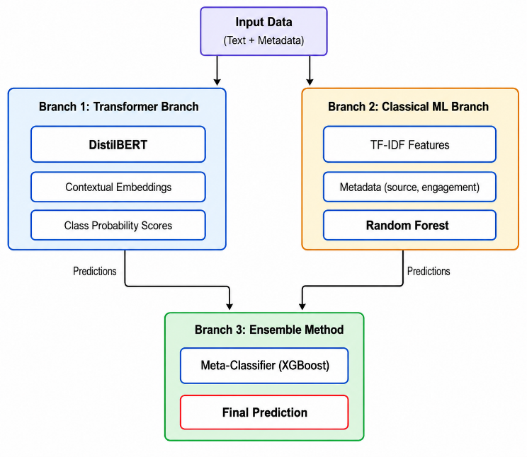
Fig 1: Proposed Framework Architecture

- Datasets and Preprocessing
In this sector, model creation and evaluation are influenced by benchmark datasets.
Two publicly available benchmark datasets namely ISOT and WELFake are used for model training [11]. The details of the dataset are illustrated in Table I.
Table I: Dataset Statistics
Dataset | Real | Fake | Total
ISOT | 21417 | 23481 | 44898
WELFake | 35028 | 37106 | 72134

The news items go through a number of preprocessing procedures to eliminate noise and normalize the input data before the models are trained.
These actions consist of:
- Elimination of punctuation and special characters
- Text is converted to lowercase.
- Stop words are eliminated.
- Normalization and tokenization
For the classical machine learning model, TF-IDF vectorization is applied to convert text into numerical feature vectors [2].

- Random Forest Classifier
Multiple decision trees serve as the foundation for the ensemble learning technique known as Random Forest.
Each tree is trained on a random subset of the training data, and the final prediction is obtained by aggregating the predictions from all trees [12]. In this work, TF-IDF features taken from the dataset are used to train the Random Forest classifier. This approach finds statistical patterns and keyword distributions that are frequently linked to fake or real news.
- Transformer Model (DistilBERT)
DistilBERT is a small transformer model based on BERT, that retains most of the language understanding capabilities while making its computation less complex [13].
The DistilBERT model was further fine-tuned on a binary classification task where the labels were using only the training dataset. The model generates contextual embeddings that capture word meaning relationships after processing input text sequences.
- Stacking Meta-Classifier (XGBoost)
The predictions from the Random Forest and DistilBERT models are taken as input features for a meta-classifier. In this work, an XGBoost classifier is used as the stacking model [14].
To provide the final forecast, the meta-classifier learns how to integrate the confidence ratings and predictions from both models.
- Hyperparameters and Model Training
- DistilBERT: Optimized with batch size 8, epochs 4, and learning rate 3e-5 using the AdamW optimizer. When optimized on the WELFake dataset, the learning rate was set to 4e-5 and the epochs were 3.
- Random Forest: Trained using n-jobs-1 and 300 estimators.
- XGBoost: trained with a subsample of 0.9, a maximum depth of 6, 800 estimators, and a learning rate of 0.02.
To enhance model performance and generalization, the training procedure is conducted in several phases. To discover fundamental patterns in news data, Random Forest and DistilBERT are initially trained on the ISOT dataset. The WELFake dataset is then used to refine DistilBERT in order to better capture contextual and varied information.
Lastly, new designed features are used to train the XGBoost meta-classifier on the WELFake dataset. It makes use of prediction probabilities from the basic models rather than raw text.
The meta-classifier use the following features:
- Random Forest's "Fake" Probability
- The Random Forest's "Real" Probability
- DistilBERT's "Fake" Probability
- DistilBERT's "Real" Probability
The ensemble provides more accurate results on combining the benefits of both models.
- Result and Analysis
- Model Performance
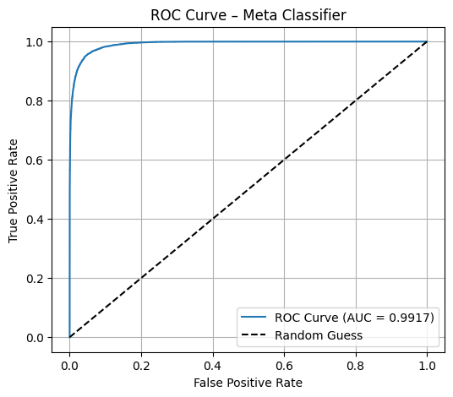
Accuracy was the main assessment criterion used to compare individual models with the ensemble framework in order to determine the effectiveness of this approach. The results are summarized in Table II.
Table II: Model Performance Comparison
Model | Feature Type | Accuracy (%)
Random Forest | TF-IDF | 97.36
DistilBERT | Contextual Embeddings | 98.15
XGBoost | Combined Features | 98.65

The results clearly show that because the DistilBERT model can capture contextual semantics, it performs better than the conventional Random Forest classifier. However, the proposed ensemble model considerably improves performance by utilizing both statistical and contextual representations. This combination lessens the drawbacks of individual models and provides better generalization of the system.
- Confusion Matrix Analysis
The confusion matrix of the ensemble model is presented in Table III.
Table III: Confusion Matrix
 | Predicted Real | Predicted Fake
Actual Real | 34470 | 538
Actual Fake | 437 | 36650

The matrix proves that the model accurately classifies majority of instances, with only few misclassifications. The low number of false positives and false negatives shows reliability of the system [15] in making difference between fake and real news.
- Evaluation Metrics
To provide a more detailed evaluation other performance metrics were calculated, as shown in Table IV.
Table IV: Evaluation Metrics of the Ensemble Model
Metric | Score (%)
Precision | 98.75
Recall | 97.08
F-1 Score | 97.91

- ROC Curve
The trade-off between the true positive rate and false positive rate is shown by the ROC curve [16]. The significant discriminative capability of the ensemble model is confirmed by the curve, which is closely aligned with the upper-left corner.

Fig 2: ROC Curve of the Ensemble Model
- Domain Shift Analysis
An important observation from the experiments is that models trained exclusively on the ISOT dataset exhibited strong performance on the training dataset but performed poorly when evaluated on external datasets. This indicates that the ISOT dataset contains patterns that lead to model overfitting.
When the DistilBERT was evaluated on an unseen news dataset, the performance decreased significantly whereas the XGBoost (Ensemble Model) demonstrated stability. This demonstrates the presence of domain shift and highlights the importance of using diverse datasets during training.
Table V: Model Performance on Unseen Dataset
Model | Accuracy (%)
DistilBERT | 32.80
XGBoost | 94.90

- Explainability Results
Explainability techniques were used to identify influential words responsible for the model’s predictions. Transformer attention scores highlight words that strongly influenced classification decisions [17], whereas for Random Forest, SHAP (SHapley Additive exPlanations) identifies the influential words.
This improves transparency and helps users understand the reasoning behind model predictions
- Conclusion
This paper presented an ensemble between transformer-based deep learning models and classical machine learning for a fake news detection system. Here we propose an ensemble approach combining a Random Forest classifier with DistilBERT transformer model powered by XGboost meta-classifier.
When compared to individual models, experimental data show that the accuracy is significantly improved using the ensemble method.
The study also shows how domain shift and dataset bias decrease model performance. Models trained on a single dataset may have poor generalization when applied to new data sources. They also offer a strong foundation for future improvements that will support the detection of multilingual fake news, better domain generalization, and integrate real-time fact-checking systems.
- References
[1] D. Mouratidis, A. Kanavos, and K. Kermanidis, “From Misinformation to Insight: Machine Learning Strategies for Fake News Detection,” Information, vol. 16, no. 3, p. 189, Feb. 2025, doi: 10.3390/info16030189.
[2] M. Narra et al., “Selective Feature Sets Based Fake News Detection for COVID-19 to Manage Infodemic,” IEEE Access, vol. 10, pp. 98724–98736, Jan. 2022, doi: 10.1109/access.2022.3206963.
[3] C. Yeh, Y. Chen, A. Wu, C. Chen, F. Viégas, and M. Wattenberg, “AttentionViz: A Global View of Transformer Attention.,” IEEE Trans. Visual. Comput. Graphics, vol. 30, no. 1, pp. 1–11, Jan. 2023, doi: 10.1109/tvcg.2023.3327163.
[4] S. Lin, C.-T. Li, and A. C. Kot, “Multi-Domain Adversarial Feature Generalization for Person Re-Identification.,” IEEE Trans. on Image Process., vol. 30, pp. 1596–1607, Jan. 2021, doi: 10.1109/tip.2020.3046864.
[5] B. G. Bokolo and Q. Liu, “Deep Learning-Based Depression Detection from Social Media: Comparative Evaluation of ML and Transformer Techniques,” Electronics, vol. 12, no. 21, p. 4396, Oct. 2023, doi: 10.3390/electronics12214396.
[6] M. Lahby, A.-S. K. Pathan, Y. Maleh, and W. M. S. Yafooz, Combating Fake News with Computational Intelligence Techniques. Springer Nature, 2021.
[7] D. Khurana, A. Koli, K. Khatter, and S. Singh, “Natural language processing: state of the art, current trends and challenges,” Multimedia Tools and Applications, vol. 82, no. 3, pp. 3713–3744, Jul. 2022, doi: 10.1007/s11042-022-13428-4.
[8] M. Wankhade, A. C. S. Rao, and C. Kulkarni, “A survey on sentiment analysis methods, applications, and challenges,” Artificial Intelligence Review, vol. 55, no. 7, pp. 5731–5780, Feb. 2022, doi: 10.1007/s10462-022-10144-1.
[9] N. Rane, S. P. Choudhary, and J. Rane, “Ensemble deep learning and machine learning: applications, opportunities, challenges, and future directions,” SMHS, vol. 1, no. 2, pp. 18–41, July 2024, doi: 10.48185/smhs.v1i2.1225.
[10] D. Korade, “Unlocking Machine Learning Model Decisions: A Comparative Analysis of LIME and SHAP for Enhanced Interpretability,” jes, vol. 20, no. 2s, pp. 598–613, Apr. 2024, doi: 10.52783/jes.1480.
[11] S. Kuntur, M. Krzywda, A. Wróblewska, M. Paprzycki, and M. Ganzha, “Comparative Analysis of Graph Neural Networks and Transformers for Robust Fake News Detection: A Verification and Reimplementation Study,” Electronics, vol. 13, no. 23, p. 4784, Dec. 2024, doi: 10.3390/electronics13234784
[12] V. Y. Kulkarni and P. K. Sinha, “Pruning of Random Forest classifiers: A survey and future directions,” Institute of Electrical Electronics Engineers, July 2012, pp. 64–68. doi: 10.1109/icdse.2012.6282329.
[13] V. Sanh, L. Debut, J. Chaumond, and T. Wolf, “DistilBERT, a distilled version of BERT: smaller, faster, cheaper and lighter,” Oct. 02, 2019. doi: 10.48550/arxiv.1910.01108.
[14] S. Rezaei, M. Kahani, B. Behkamal, and A. Jalayer, “Early multi-class ensemble-based fake news detection using content features,” Social Network Analysis and Mining, vol. 13, no. 1, Dec. 2022, doi: 10.1007/s13278-022-01019-y.
[15] Sathyanarayanan, “Confusion Matrix-Based Performance Evaluation Metrics”, African Journal of Biomedical Research·2024
[16] J. V. Carter, J. Pan, S. N. Rai, and S. Galandiuk, “ROC-ing along: Evaluation and interpretation of receiver operating characteristic curves,” Surgery, vol. 159, no. 6, pp. 1638–1645, Jun. 2016, doi: 10.1016/j.surg.2015.12.029.
[17] X. Xu, P. Yu, Z. Xu, and J. Wang, “A Hybrid Attention Framework for Fake News Detection with Large Language Models,” arXiv (Cornell University), Jan. 2025, doi: 10.48550/arxiv.2501.11967.

