A HYBRID DENSENET WITH WHITE SHARK OPTIMIZATION APPROACH FOR CROP AND SOIL MONITORING IN PRECISION AGRICULTURE

1st Sakthimani R S  Department of Computing Technologies  SRM Institute of Science and Technology, Kattankulathur Chennai, India sr8541@srmist.edu.in | 2nd RajBhalaji R S Department of Computing Technologies  SRM Institute of Science and Technology, Kattankulathur Chennai, India rb5425@srmist.edu.in | 3rd Dr. P. Rama  Department of Computing Technologies  SRM Institute of Science and Technology, Kattankulathur Chennai, India ramap@srmist.edu.in
4th Dr. J. Kalaivani Department of Computing Technologies  SRM Institute of Science and Technology, Kattankulathur Chennai, India kalaivaj@srmist.edu.in |  | 5th V. Angayarkanni Department of Computing Technologies  SRM Institute of Science and Technology, Kattankulathur Chennai, India angayarv@srmist.edu.in

Abstract - Precision agriculture requires accurate monitoring of crop health and soil conditions to improve productivity and sustainability. This work proposes a hybrid model combining DenseNet with Spatial Pyramid Pooling (SPP) and White Shark Optimization (WSO) to enhance prediction performance. Data is collected from sensors, field observations, and remote sensing sources, including parameters such as soil nutrients, moisture levels, crop type, and environmental conditions. Preprocessing techniques such as normalization, noise removal, and handling missing values are applied to ensure data quality. Feature engineering is performed to derive meaningful agricultural indicators. The DenseNet-SPP architecture extracts multi-scale spatial features, while WSO optimizes model parameters to improve convergence and accuracy. The proposed system achieves an accuracy of 96% and demonstrates better performance compared to existing models, making it suitable for intelligent crop monitoring and decision support in modern agriculture.
Keywords— Accurate crop and soil condition analysis, DenseNet- Spatial Pyramid Pooling, White Shark Optimisation, preprocessing phase, feature engineering.

Introduction
As modern agriculture continues to be challenged by the need for improved production and increased environmental stewardship, land resources are increasingly becoming limited due to the rapid growth of the global population. Thus, in order to ensure that land is used efficiently and that crops are selected appropriately, there are significant challenges associated with utilizing land well, performing accurate crop selections, and utilizing efficient agricultural practices. Traditional agricultural practices use manual observations and provide limited data, resulting in low yields and inefficient resource use. The use of land suitability analysis is an important part of determining which crops are suitable for different soil and environmental conditions, while traditional approaches often employ a combination of laboratory testing and manual data analysis, which can take a considerable amount of time to complete, and often does not incorporate the effects of the ever-changing environment. However, recent advances in information communication technologies (ICT), as well as machine learning (ML), offer opportunities for the use of data driven approaches to agriculture. Continued monitoring of soil and crop characteristics using ICT, as well as providing farmers with the necessary information to make informed decisions are just two ways in which I am using these technologies to enhance agricultural productivity. The application of machine learning (ML) based crop solution recommendation systems has demonstrated their effectiveness in assisting farmers in selecting high yielding and viable crops; however, most existing systems do not have the ability to effectively manage large-scale, high-dimensional crops due to the high dimensionality of the data to be analyzed. In contrast, deep learning (DL) models allow for the automated learning of complex relationships in the data. Nonetheless, issues related to overfitting, the high cost of computation, and limited representation in datasets are still present in many of today's DL models. In this paper, we propose a new hybrid model for crop recommendation that combines a DenseNet with a pyramidal structure to overcome these limitations and address the problems previously discussed.
Objectives for the proposed model

- To use data preprocessing methods to provide dependable, high-quality input for model testing and training.
- To use feature engineering to improve the predictive power of the model by obtaining important agricultural indicators including vegetation measurements, soil fertility indices and temporal growth features.
- To create a precision farming model that uses White Shark Optimisation and DenseNet-SPP to precisely analyse crop and soil conditions for better crop recommendation and soil management.
- To improve convergence time and classification accuracy and reach a 96% accuracy rate for crop condition assessment, the model's performance is optimised using White Shark Optimisation.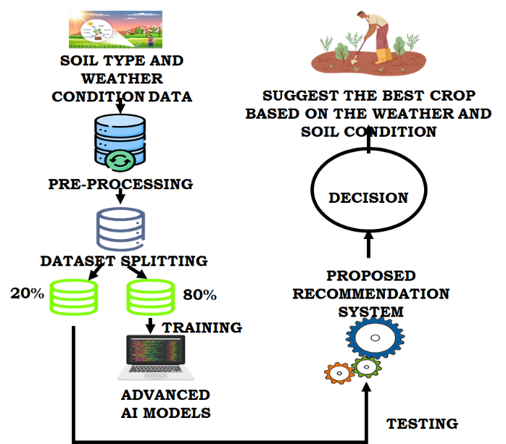

Fig. 1 General layout of soil and crop prediction model

Prior research on crop recommendation systems and soil categorization has not addressed the created neural networks. Because of this, it is challenging to evaluate the described systems' efficacy. For soil classification, the majority of previous research uses ML algorithms like SVM, K-means, and linear regression; however, this study suggests a crop recommendation system that makes use of Deep Neural Networks (DNNs) [13]. DNNs are superior to traditional neural networks like SVMs in handling huge datasets and high-dimensional input spaces and they are better suited to learning non-linear correlations over input and output. Additionally, DNNs are better at generalizing to new, unknown data since they can automatically extract valuable features from multivariate input data. However, for usage in AI and ML systems that analyses vast volumes of data, the current Indian soil data sets are too small and imbalanced. None of the studies have conducted a correlation analysis to ascertain how various characteristics affect land indexing [14]. Furthermore, none of the current research develops AI-based models using more than a few soil quality data. In particular, these models' classification accuracy compared to identify best model for this use. This study intends to aid in the creation of more effective and sustainable agricultural methods by offering a comprehensive evaluation of the suitability of various sites for crop growing [15]. Conventional crop selection techniques rely on scant knowledge of soil characteristics, which leads to less than ideal crop yields and lower financial returns. DNNs computationally costly and prone to overfitting, despite their demonstrated capacity to reliably forecast crop compatibility based on soil data [16].

Description of Proposed System
Crop data collection is the first step in the process, wherein raw agricultural data is collected, including crop characteristics, weather and soil qualities. To deal with missing values and guarantee consistency, this data is subjected to data preprocessing phase, which entails cleaning, normalisation and transformation. The most important factors influencing crop productivity are then found and kept by using visualization and feature engineering, which lowers dimensionality and boosts model effectiveness. To make model building and validation easier, the processed data is then separated into training and testing.
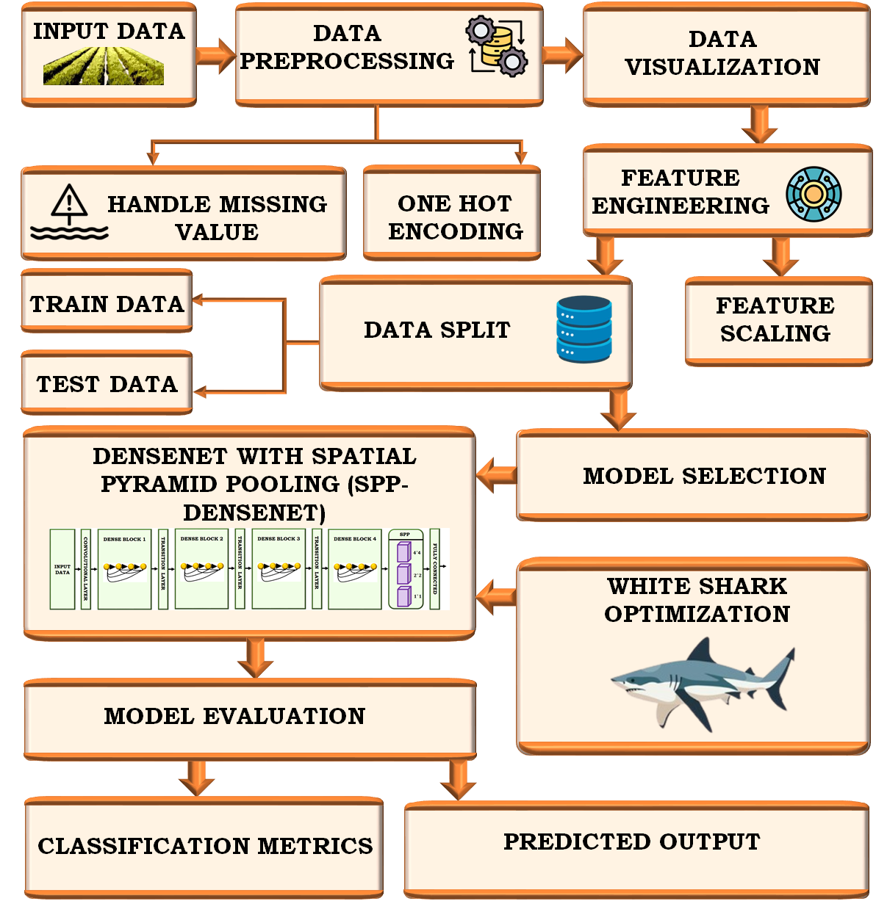

Fig. 2. Crop prediction for smart agriculture layout model

The prediction is effectively done by SPP-DenseNet, which is used for the Prediction step, it improves feature extraction by effectively capturing spatial hierarchies. The white shark optimisation algorithm, a bio-inspired metaheuristic optimisation method that enhances convergence and prediction accuracy, which optimise the hyperparameters of this model. The model is assessed using common performance indicators after training and optimisation to deliver accurate crop yield predictions.

Proposed Methodology

Preprocessing
- Handling missing values
To ensure data reliability and completeness, missing values in dataset are filled in during the preprocessing stage. Incomplete or missing entries result in biased model training or worse prediction accuracy. For preserving the consistency and integrity of the dataset, the procedure entails locating missing values across features and using the proper techniques to fill or manage them. A complete and useful dataset for efficient learning is provided to DL model when missing values are handled properly
- One hot encoding
One-hot encoding transforms dataset's categorical data into distinct binary features that indicate whether a category is present or not. By doing this, model is kept from misinterpreting categorical values as ordinal and algorithms are able to efficiently handle non-numeric input. For making categorical characteristics compatible with DL models and enhance the system's overall prediction performance, one-hot encoding standardises their representation

B. Data visualization
The purpose of data visualization is to investigate and comprehend the underlying trends, patterns and connections in the dataset. Finding feature correlations, spotting anomalies and evaluating the distribution of variables are all made simpler by the use of charts, plots and heatmaps to visually depict data. Preprocessing and feature selection are made easier with the help of this stage, which also offers intuitive insights that direct model development. The overall dependability of the predictive system is increased by appropriate interpretation of complicated agricultural datasets, which is ensured by effective visualization.

C. Feature engineering based scaling model
To improve the calibre and applicability of the input data for prediction model, feature engineering is done. In this procedure, qualities that have the greatest influence on crop yield prediction are created, transformed and chosen. By standardizing numerical variables to a common range or distribution, feature scaling is used to guarantee that each feature contributes equally to model training. Scaling increases the stability and speed of convergence of DL algorithms while avoiding features with broader numerical ranges from controlling learning process.

D. SPP-DenseNet Model
One crucial technique in computer vision is SPP, which converges local features by converting the fine-grained split of the picture data to a coarser level. Prior to neural networks became widely used, SPP is essential for classification model in agricultural applications. The spatial principle is displayed, prior to last layer of convolution (conv5), the input data is processed through a convolution operation. The feature map from this layer is then output. The pooling process of the gold tower is then completed by entering the SPP to split the feature map portions and expand it into a one-dimensional matrix before sending it to fully linked layer.

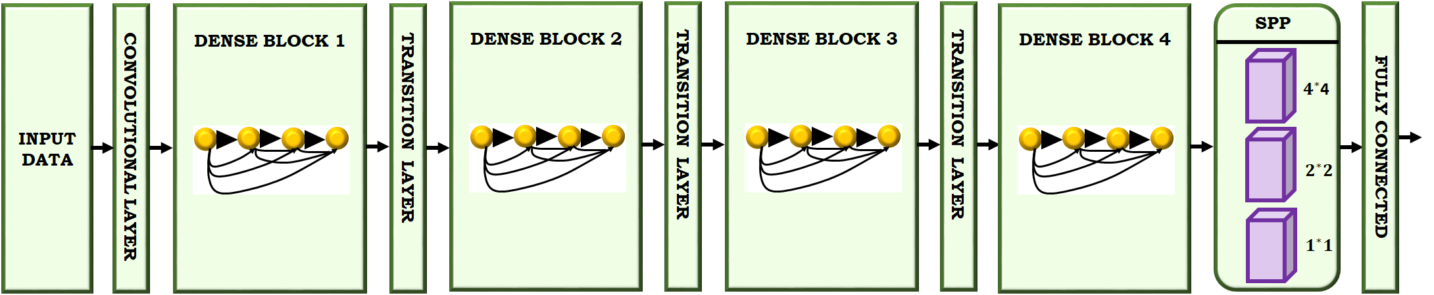

Fig.3 Structure of SPP-DenseNet model

According to experiments, training using variable size images yields considerably higher accuracy than training with fixed size data. SPP significantly improves the data’s multi-scale feature extraction by inheriting the benefits of convolutional neural network feature mapping and having the adaptability to handle varied sizes. The size of the input data is$\left(c,h_{in},w_{in}\right)$, which indicates how many channels, height and width there are. After pooling $(n,n),$ determine the matrix size using formulas Equation (1) and (2),
$\left(h+2p-f+i\right)*\left(w+2p-f+I\right)$ (1)
$\left[\frac{h+2p-f}{s}+I\right]*\left[\frac{w+2p-f+!}{s}+I\right]$ (2)
An introduced DenseNet, a novel kind of convolutional neural network, the Dense Block and Transition Layer modules make up the network structure. Each of the n identical structures that make up a dense block is a batch normalization-linear rectification unit. Layer of (Relu)-convolution (Conv). There are $L$ connection lines between the neural network layer before and the layer after, and Equation (3) states a connection relationship in tight block is$L(L2+1)$.
$x_{l}=H_{l}\left(\left[x_{0},x_{I},…,x_{l-I}\right]\right)$ (3)
Where $x_{0}$ refers first layer's input, $x_{0}$ (input) is where$H_{l}$'s input originates. $H_{2}$ Originates from an input of $x_{0}$ and$x_{I}$, per the tight block's connection relationship. Based on the DenseNet network, a fusion proposed hybrid network model is presented in this study, which combines the benefits of SPP input size flexibility and lessens over-fitting. Attach the pyramid pooling layer to the DenseNet network below the fourth Dense Block as illustrated in Figure 3.
E. White Shark Optimization
The WSO algorithm is utilized for tuning the DL model, which tune based on how white sharks hunt to help them survive in the ocean's depths. This section delivers a brief outline of the fundamentals of WSO algorithm.
WSO Updation parameters
$v=[n×rand\left(1,n\right)+1$ (4)
$P_{1}=P_{max}+(P_{max}-P_{min})×e^{-{\left(4×\frac{1}{k}\right)}^{2}}$ (5)
$P_{2}=P_{min}+(P_{max}-P_{min})×e^{-{\left(4×\frac{1}{k}\right)}^{2}}$ (6)
$μ=\frac{2}{\left|2-τ-\sqrt{τ^{2}-4τ}\right|}$ (7)
$a=sgn\left(w_{k}^{j}-u\right)>0$ (8)
$b=sgn\left(w_{k}^{j}-u\right)>0$ (9)
$w_{0}=⊕(a,b)$ (10)
$f=f_{min}+\frac{f_{max}-f_{min}}{f_{max}+f_{min}}$ (11)
$mv=\frac{1}{a_{0}+e^{\left(\frac{k}{2}-K\right)}/a_{t}}$ (12)
$S_{s}=\left|1-e^{-\left(a_{2}×\frac{1}{k}\right)}\right|$ (13)
Where $v$ specifies white sharks' index vector used to determine best site, $P_{1}$ and $P_{2}$ denotes white sharks' forces and $l$ termed as constriction factor developed by WSO. $w_{0}$ Indicates a logical vector, while $a$ and$b$ stands for the one-dimensional binary vectors. The white shark's wavy motion frequency is denoted by$f$. The movement force, represented by $mv$, which is proportional to number of iterations, while $s$ termed as the parameter that is suggested to increase the sharks' senses of sight and scent as they follow other white sharks that are near their ideal meal.
Movement speed to find prey
A white shark determine the location of its meal by listening for a halt in the waves, which indicates that prey is moving, as shown below.
$u_{k+1}^{i}=μ\left[u_{k}^{i}+p_{1}(w_{gbestk}-w_{k}^{i})×P_{2}({w_{gbest}}_{k}^{vk}-w_{k}^{i}\right]×c_{2}$ (14)
Here, $i^{th}$ shark is signified as $u_{k+1}^{i}$ for the new rapidly vector.
Best prey’s way searching movement
This scenario showed the sharks' movements as they approached fish.
$w_{k+1}^{i}=\left\{\begin{aligned}w_{k}^{i}→⨁w_{0}+u.a+l.b;rand<mv \\ w_{k}^{i}+\frac{u_{k}^{i}}{f};rand≥mv\end{aligned}\right.$(15)
Way of best shark searching movement
The white sharks' ability to stay ahead of most advantageous one that is nearer the objective is expressed in equation (16). The following formula is used to produce this phenomenon,
$w_{k+1}^{i}=w_{gbestk}+r_{1}{\vec{D}}_{w}sgn\left(r_{2}-0.5\right)r_{3}<S_{s}$ (16)
$w_{k+1}^{i}$ Refers location of improved shark,$r_{1}$, $r_{2}$ and $r_{3}$ stands for random numbers and $sgn\left(r_{2}-0.5\right)$ yields 1 or -1 to modify the search track. Both goal and shark length is indicated by${\vec{D}}_{w}$, computed as follows:
${\vec{D}}_{w}=\left|rand×\left(w_{gbest}-w_{k}^{i}\right)\right|$ (17)

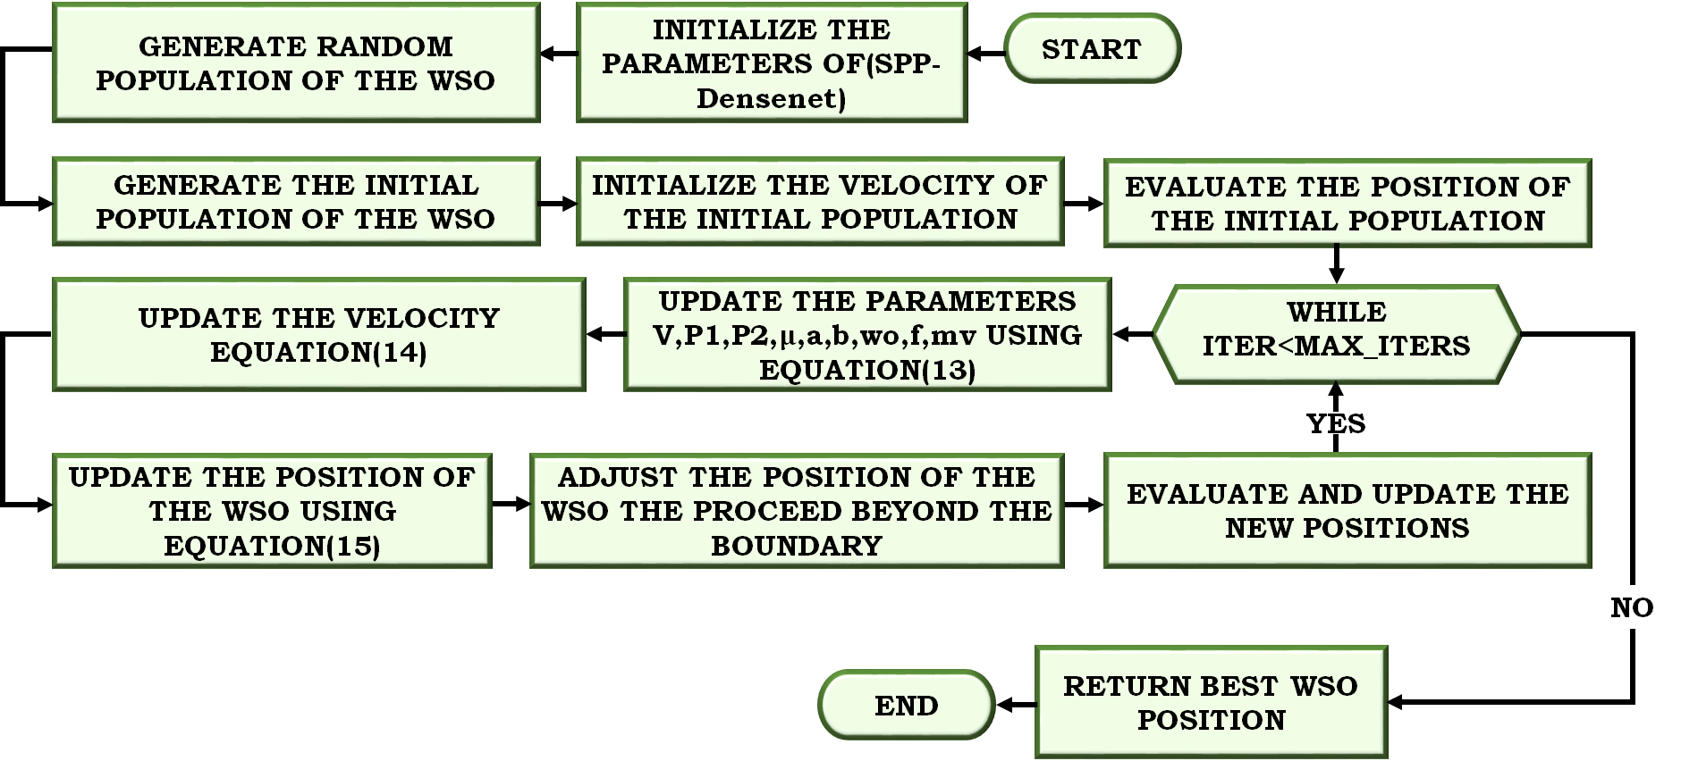

Fig.4 Tuning process using WSO

With the development of overall model, the soil and crop prediction is done with better performance for agricultural purposes.

Results and Disucssion
The Crop Recommender Dataset, which has 12 characteristics and 620 samples, employed in the investigation. Pomegranate, mango, grapes, mulberry, ragi, and potato are the six crop classes in the dataset, which also includes a dependent variable (the crop label) and 11 independent soil nutrient variables (such as nitrogen, phosphorus, and potassium). A train-test split of 80%–20% is used, with 124 samples used for testing and 496 for training. The SPP-DenseNet model, which optimised using white shark optimization, is trained on the training set and generalization is evaluated on the testing set.
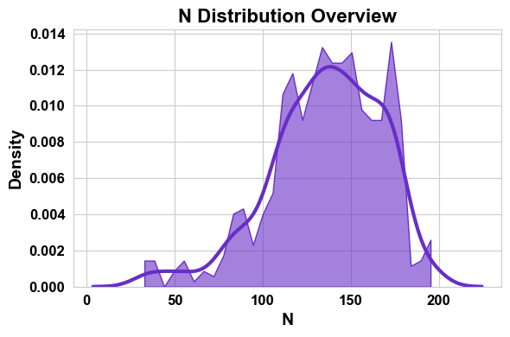
Fig. 5 N distribution overview
According to the nitrogen distribution plot in Figure 5, most soil samples have moderate to high nitrogen contents, with the mid-range values showing a density peak. A minor skew in the distribution shows that there is variation among agricultural fields. The reliability of crop prediction modelling is supported by the balanced presence of nitrogen among samples, as it is a key macronutrient controlling vegetative development.
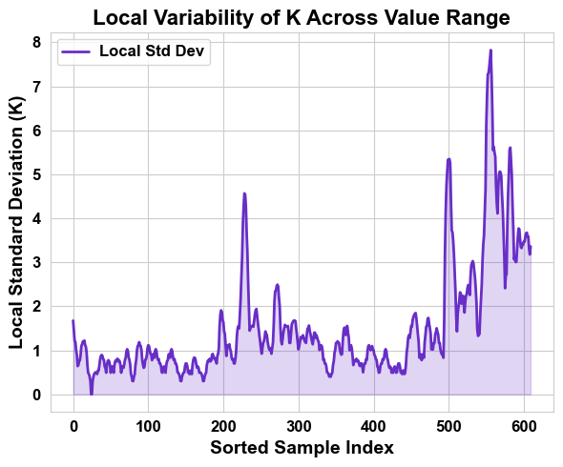
Fig. 6 Local variability of K across value range
Analysis of potassium's local standard deviation shows variations among sorted samples in Figure 6, with observable increases in some areas. These differences show that the fertility of the soil varies. High variability zones indicate a geographical nutrient imbalance, which has a major impact on the accuracy of crop yield predictions. The learning model is better able to generalize across a range of soil conditions when this variability is included.
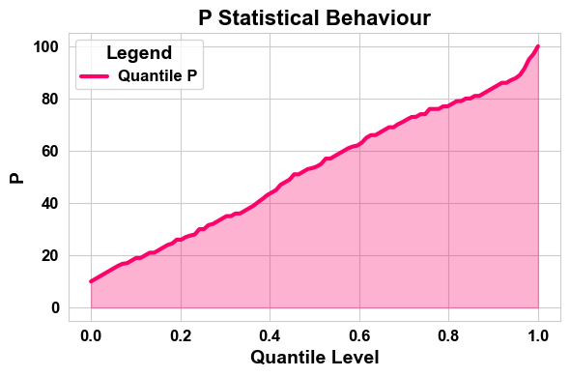
Fig. 7 P statistical behavior
The quantile-based representation of phosphorus shows a well-distributed range of phosphorus values in the sample, with a consistent and monotonic increase across percentile levels as displayed in Figure 7. This steady trend demonstrates reliable feature contribution during training and verifies the lack of severe anomalies.
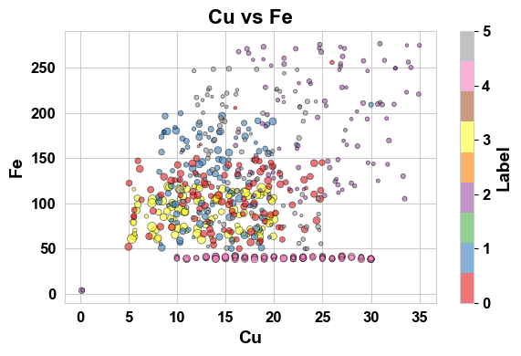
Fig.8 Cu vs Fe plot
Different crop labels correspond to clustered distributions in the scatter analysis between copper and iron is specified in Figure 8. Differential group separations imply that crop adaptability is greatly influenced by micronutrient makeup. While some crops have modest copper levels, others have higher iron contents. This distinction improves the prediction model's capacity to discriminate.

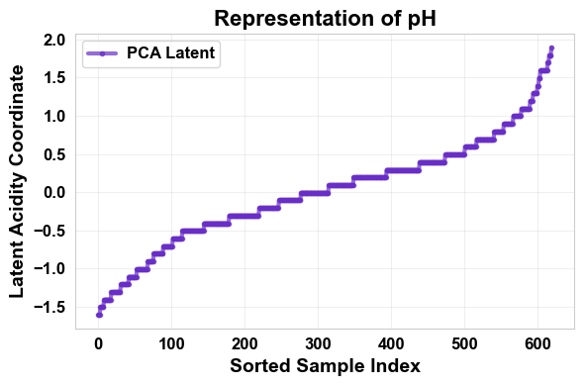
Fig.9 Representation of pH level
As specified in Figure 9, a hierarchical distribution pattern seen in the latent representation of pH values, specifying that pH adds significant variance to feature space. Effective feature embedding within the DL architecture is made possible by the progressive increase across sorted indices, which indicates that soil acidity or alkalinity levels are systematically distributed.
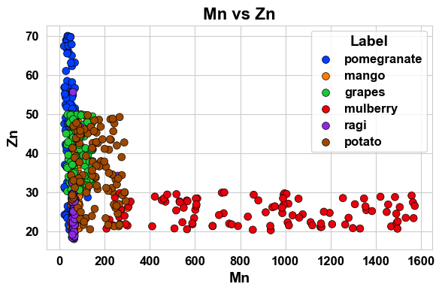
Fig. 10 Mn vs Zn plot
For various crop kinds, including pomegranates, mangos, grapes, mulberries, ragi and potatoes, the Mn versus Zn scatter plot shows clear grouping tendencies in Figure 10. While some crops group in areas with moderate zinc concentrations, others occupy areas with higher manganese concentrations. Both classification performance and the significance of micronutrient profile in crop prediction are reinforced by these separations.

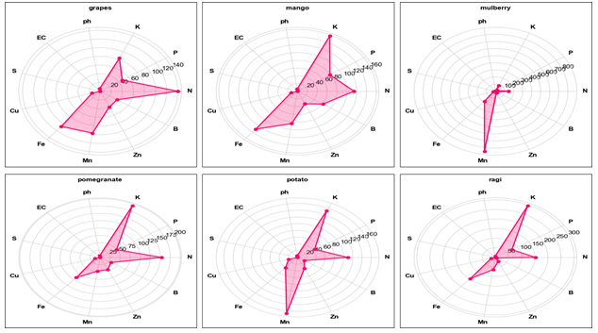

Fig. 11 Various crops model
The comparative nutrient profiles (N, P, K, pH, EC, S, Cu, Fe, Mn, Zn, etc.) for various crops are shown in Figure 11. Every crop has a different nutritional signature that indicates particular needs for the soil. Certain crops require more potassium, for instance, whilst others depend more on micronutrients or nitrogen. The requirement for a multi-feature DL model such as SPP-DenseNet for precise classification is justified by these unique nutrition patterns.
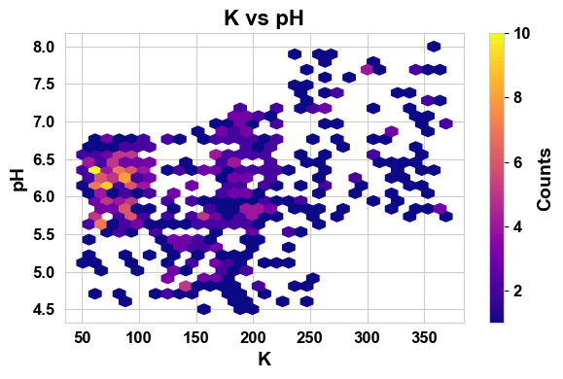
Fig. 12 K vs pH plot
As illustrated in Figure 12, the K vs pH density visualization shows that potassium levels are concentrated in mid-to-high ranges and the majority of samples fall within an ideal pH range of roughly 5.5 to 7.5. Accordingly, soil fertility conditions are generally appropriate for growing a variety of crops. Finding the dominant soil combinations affecting model predictions is made easier by the density gradient.
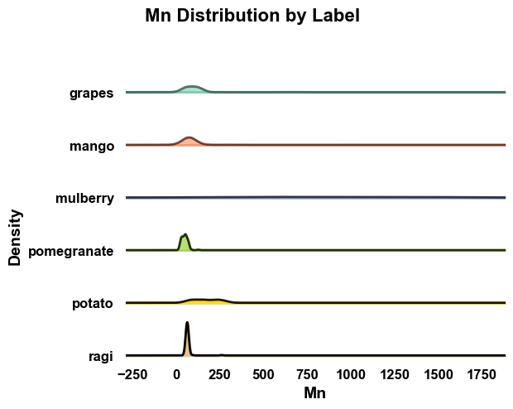
Fig.13 Mn distribution by label plot
The manganese density curves for the various crop labels display a range of distribution peaks shown in Figure 13, indicating that the concentration of manganese varies greatly among crops. While concentration ranges of some crops are restricted, those of others are more variable. This difference improves the classification model's capacity to distinguish between crops according to the makeup of micronutrients.
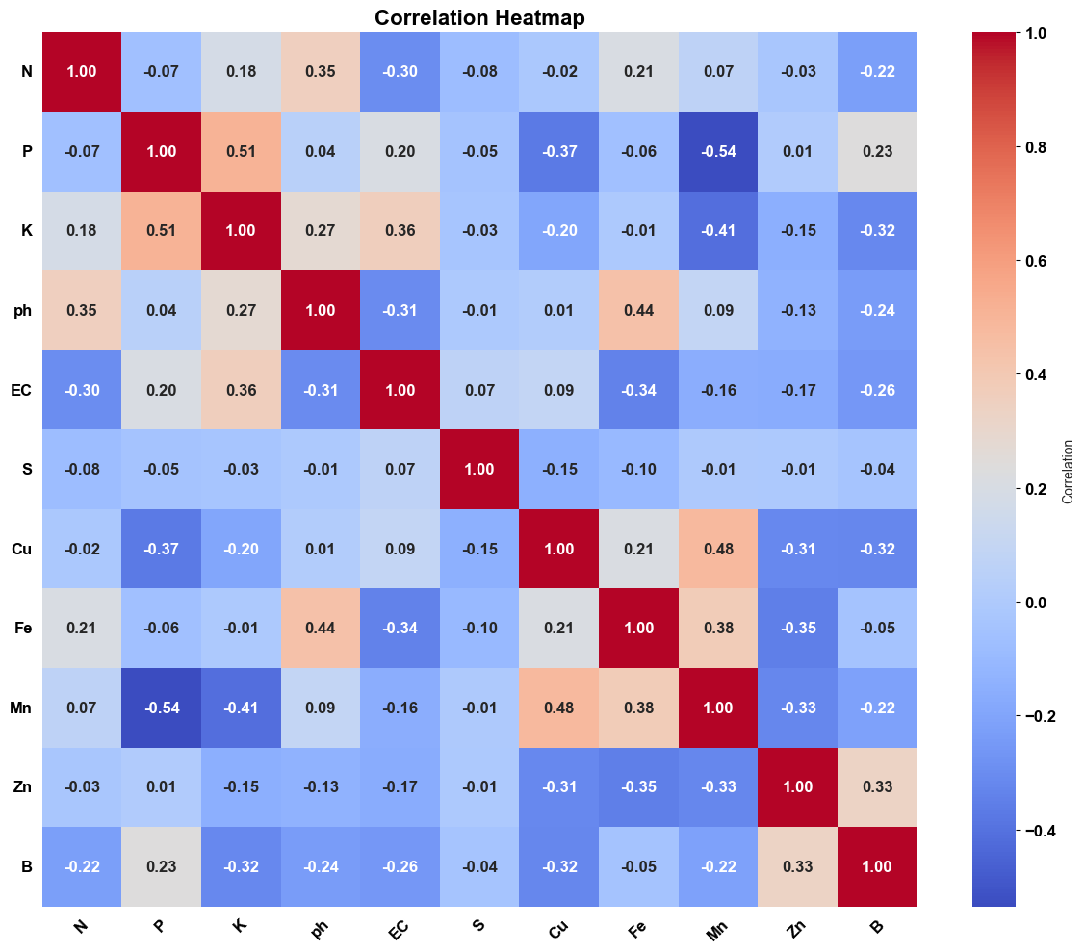
Fig.14 Correlation heatmap
The correlation heatmap in Figure 14 shows how soil nutrients and environmental factors are related to one another. Indicating feature self-correlation, strong positive correlations are shown along the diagonal (correlation coefficient = 1.0). While several micronutrients show weak to moderate relationships, some macronutrients, like potassium (K), phosphorus (P), and nitrogen (N), show moderate correlations. Minimal multicollinearity is suggested by the lack of exceptionally strong off-diagonal correlations (>0.90), indicating that the chosen characteristics independently contribute to the model's predictive accuracy.
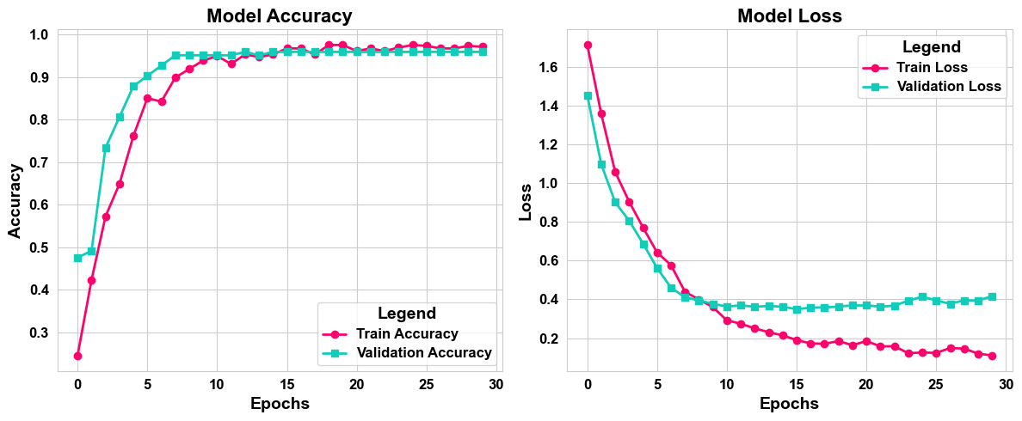
Fig.15 Plot of model accuracy and loss
Within the first epochs, the training and validation accuracy curves show quick convergence as illustrated in Figure 15. The model stabilizes at about 96% validation accuracy. Concurrently, validation loss converges around 0.15 and training loss sharply declines to less than 0.05, indicating steady learning without appreciable overfitting. The efficacy of the SPP-DenseNet model optimised with White Shark Optimisation is confirmed by the near alignment of the training and validation curves.
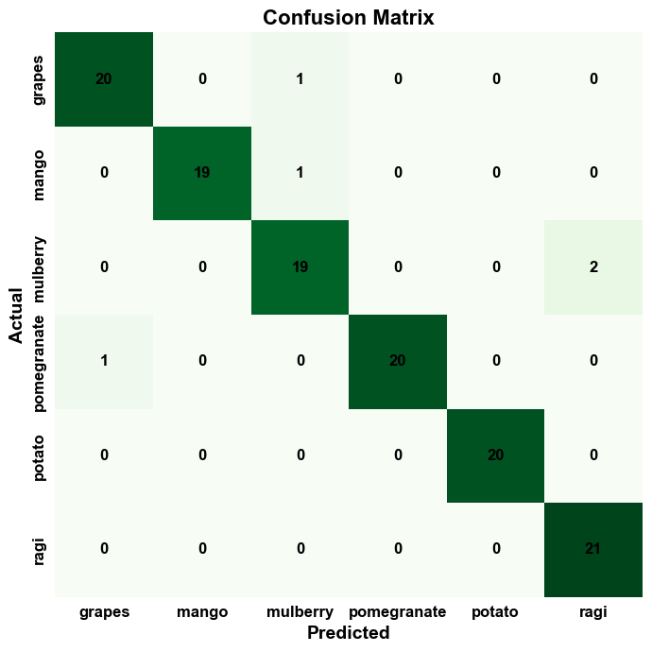
Fig.16 Confusion matrix for the proposed model
The classification performance of confusion matrix is good for all six crop classes (grapes, mango, mulberry, pomegranate, potato, and ragi). The diagonal shows the dominance of accurate predictions as specified in Figure 16. There are very few minor misclassifications (i.e., only 1-2 samples are misclassified in several categories), indicating that proposed model has a high degree of discriminative power.
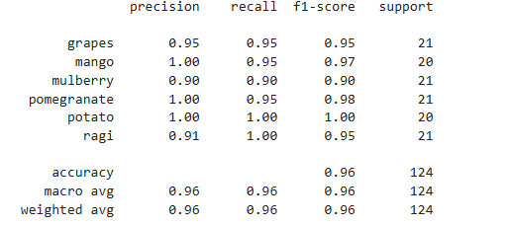
Figure 17: Performance metrics for the presented model
According to the classification report in Figure 17, all crops have strong precision, recall, and F1-scores; the overall accuracy is 96% (0.96), the macro-average precision, recall, and F1-score are all roughly 0.96, and weighted average is likewise 0.96, indicating balanced performance across all crop classes
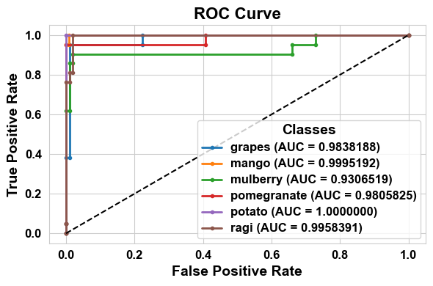
Fig.18 ROC curve for various crops
All crop classes' ROC curves show outstanding discriminative power, with Area under Curve (AUC) values near 1.0 as seen in Figure 18. The proposed SPP-DenseNet model optimised with White Shark Optimisation successfully separates crop classes with low false positive rates, as evidenced by the nearly flawless AUC values.
Table 1: Comparative analysis of accuracy and recall
Approaches | Accuracy (%) | Recall (%)
ADLF | 85.4 | 84.2
PFNL-SNM | 80.28 | 86.28
CNN | 91.34 | 92.78
Proposed | 96 | 96

The proposed SPP-DenseNet tuned WSO model is represented in Table 1, which showing that when compare to the other models, presented strategy accomplishes higher accuracy and recall value of (96%) for both, which predicted the crop and soil condition accurately than the other models.
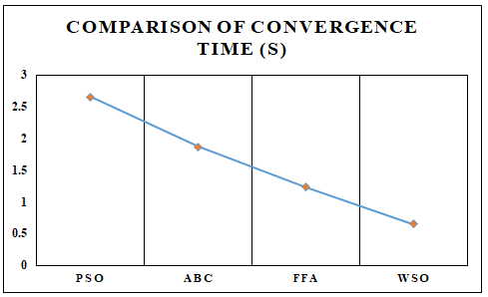
Fig.19 Comparison of convergence time
As shown in Figure 19, the proposed WSO algorithm is compared with the other recent utilized strategies for showing the predicting speed of crop and soil. The graph shown that the proposed model achieves rapid convergence speed compared to the other models.

Conclusion
This work proposes DenseNet with white shark optimization for effective precision farming and sustainable land management. The model guarantees consistency and dependability using extensive preprocessing methods. By collecting important indications like vegetation measurements, soil fertility indices and growth-stage indicators, feature engineering improves the model even more. Multi-scale spatial feature extraction is made possible by the integration of DenseNet-SPP, which preserves both local and global contextual information. The model's convergence time and classification accuracy are greatly enhanced by White Shark Optimisation, which achieves 96% accuracy in crop condition assessment. Results from the Python implementation demonstrate significant gains over current models, underscoring the promise of this strategy for more precise and sustainable crop management.

References

- Senapaty, Murali Krishna, Abhishek Ray, and Neelamadhab Padhy. "IoT-enabled soil nutrient analysis and crop recommendation model for precision agriculture." Computers 12, no. 3 (2023): 61.
- Sharafat, MD Shaifullah, Nilavro Das Kabya, Rahimul Islam Emu, Mehrab Uddin Ahmed, Jakaria Chowdhury Onik, Mohammad Aminul Islam, and Riasat Khan. "An IoT-enabled AI system for real-time crop prediction using soil and weather data in precision agriculture." Smart Agricultural Technology (2025): 101263.
- Shukla, Arvind K., V. Balaji, R. Dharani, M. Ananthi, R. Padmavathy, and Romala V. Srinivas. "Precision agriculture predictive modeling and sensor analysis for enhanced crop monitoring." Sci. Temper 14, no. 04 (2023): 1073-1078.
- Devi, Kurnool Anusha, and K. Usha Rani. "Exploring Machine Learning Algorithms in Soil Management and Precision Agriculture—A Survey." Int. J. Eng. Res 13 (2024).
- Patil, S. B., R. B. Kulkarni, S. S. Patil, and P. A. Kharade. "Machine learning based precision agriculture model for farm irrigation to optimize water usage." In IOP Conference Series: Earth and Environmental Science, vol. 1285, no. 1, p. 012026. IOP Publishing, 2024.
- Placidi, Pisana, Renato Morbidelli, Diego Fortunati, Nicola Papini, Francesco Gobbi, and Andrea Scorzoni. "Monitoring soil and ambient parameters in the iot precision agriculture scenario: An original modeling approach dedicated to low-cost soil water content sensors."
Sensors 21, no. 15 (2021): 5110.

