Detection of Anemia Using Facial Image Analysis
Prithviraj Chauhan, Kartikeya Mishra, Dr. Kanchana M
SRM Institute of Science and Technology
Email: pc7723@srmist.edu.in, km5075@srmist.edu.in, kanchanm@srmist.edu.in

Abstract—This study builds a strong case for how well the pro- posed system works in non-invasive anemia detection. The research data doesn’t just support the idea—it shows, time and again, a meaningful link between the visual features drawn from conjunctiva images and the model’s predictions. The system doesn’t spit out random or inconsistent results. Instead, you see clear, organized patterns that line up with what we already know about anemia from a medical perspective. Consistency like this matters, especially in healthcare, where trust and reliability are non-negotiable. The model doesn’t just pick up obvious signs. In several cases, it caught subtle shifts in color and vascular structure—details that usually slip past the human eye, especially if the lighting isn’t great. That’s the real advantage here: artificial intelligence steps in where people sometimes can’t, pulling out hidden details from medical images. The results held steady across different datasets and test conditions, which adds confidence that the system isn’t just working in a lab—it stands a good chance of performing well in real-world settings, too. One thing that stands out is how simple and practical this solution is. All you need is a photo from an ordinary smartphone. That’s it. What used to be a regular device suddenly becomes a powerful screening tool, which is especially important in places where diagnostic labs, tests, or specialists are out of reach. In many underserved communities, people steer clear of medical tests—cost, distance, or just not knowing they need one keep them away. When you make screening fast, easy, and painless, people are more likely to get checked before symptoms get worse. This shifts healthcare away from a system where you wait until you’re really sick to seek help, and moves it toward prevention and early detection. Now, something as basic as a photo can steer people toward earlier treatment and better health outcomes. Figure 4 really brings this all together. It shows how the system zeroes in on what matters by focusing on the palpebral conjunctiva—the lower eyelid’s inner surface—which is where anemia leaves its mark. This isn’t some minor technical step; it’s a crucial decision in the system’s design that greatly sharpens its analysis. By blocking out unrelated background and reducing noise, the model makes sure it’s learning from the features that matter most. That, in turn, boosts both its accuracy and reliability. The lesson here: how you prepare your data can make or break your model’s performance. The system’s success stems from how its parts work together smoothly. Every pipeline stage—preprocessing, enhancement, feature extrac- tion, classification—plays a part in getting the predictions right. This approach doesn’t lean on standard processing tricks. It specifically uses CLAHE for localized contrast enhancement, helping it bring out faint color differences and fine vascular details you’d otherwise miss with bad lighting or basic cameras. These almost-invisible features are packed with diagnostic clues and are central to detecting anemia properly. By sharpening these elements, the system becomes much more attuned to what’s actually important. MobileNetV2 was a smart model choice, too. It makes this high-detailed analysis possible on devices with limited processing power—ideal for smartphones and edge devices. Users don’t need fancy hardware or a constant internet connection. The model strikes the right balance between accuracy and efficiency, using little battery and running quickly, so the experience stays smooth for users with affordable devices. Stepping back, the study shows how the right mix of technology—efficient models, smart preprocessing, and user-friendly deployment—can close the
gap between advanced diagnostics and day-to-day usability. The real value here isn’t just technical progress; it’s about making healthcare fairer and more accessible. Artificial intelligence here becomes a tool with real social impact. It proves you don’t need expensive equipment or infrastructure—all you need is an image, intelligent processing, and the motivation to make a difference.
Index Terms—Anemia detection, Deep learning, MobileNetV2, CLAHE, Medical image analysis, Edge AI

- Introduction
Consider the daily reality of a frontline health worker in in a distant mountain settlement or a poorly equipped city health post. Each morning brings tasks without fanfare Witnessing individuals, frequently new mothers alongside their kids, experiencing hardship, despite persistent fatigue, sudden vertigo might appear. Breathing becomes difficult at times. In addition, a lack of stamina emerges gradually. Dizzy spells follow without warning. Shortness of breath interrupts routine. Constant tiredness remains present throughout. A person might struggle to think clearly. This could stem from low red blood cell levels. Body processes may slow down as a result. Anemia occurs when the blood lacks adequate healthy red blood cells. Cells within blood contain a substance known as hemoglobin. This component serves a particular role protein responsible for binding and transporting oxygen from the lungs to the rest of the body, a deficiency effectively chokes off cell function. Depleting vitality through exhaustion at the cellular stage, a lack of healthy red blood cells gradually diminishes physical Poverty deepens across generations when conditions persist unchanged. The weight of this issue worldwide is immense; nevertheless, the uneven patterns mark its spread. The global picture shows an imbalance, as seen through the data shared According to the World Health Organization (WHO), anemia impacts roughly 39.8A third of females in their childbearing years face challenges, while nearly three out of ten young ones below school age experience similar conditions. Worldwide age figures differ greatly when examined closely. Population differences appear across age groups, geographic areas, and along ethnic lines. Areas such as Central and West Africa sees high rates of illness in children. More than half - reaching a worrying fifty percent mark. Most importantly, this extends beyond issues seen only in less industrialized nations Across the globe, even within affluent countries such as the United States, underlying inequalities remain widespread. Recent health studies indicate that non-Hispanic Black Women experience anemia at about 27 times the level seen among non- Hispanic White females. These figures highlight how socioe- conomic factors, nutritional, and access meet past disparities in

care, and outcomes emerge shaped by deep-rooted imbalance. Anemia stands present everywhere, though felt more deeply by some. Unequal burdens mark its reach across populations. Even though this issue appears widely in different forms, its reach remains significant.. Despite shifts across groups, the process of diagnosis stays fixed in place Previously, confirming anemia required that a person undergo specific testing. A full blood count is performed using a sample taken from a vein. Though highly precise, a CBC comes with unavoidable intrusion. Scary for some people, particularly kids. In addition, A single break disrupts it entirely: clean syringes, correct handling of biological materials Packaging requiring stable climates move under strict protocols. Waste deemed dangerous follows controlled exit procedures. Specimens, together with intricate equipment managed by specialists far away from urban centers. Laboratory technicians serve countless individ- uals who lack nearby medical facilities. In cities, handling supplies grows complex alongside rising costs.. Expense leads to postponement of basic assessment while the individual waits A sudden medical response may be needed, including the delivery of donated blood. Yet how might things shift should testing methods spread out? Consider Could a fifty-dollar Smartphone, common as it is, functions reliably in detecting early warnings? Medical professionals across decades have used a quick examination of the body to look for signs of low red blood cell count. With care, the lower eyelid is lowered by the clinician for inspection. A slight downward motion opens access without pressure. Examination follows once the position stabilizes. The movement remains minimal to avoid discomfort. Positioning allows a clear view beneath the lid margin. Vessels lie close beneath the surface; they show clearly through the tissue. Where blood flow is rich, a pinkish hue becomes visible. Though thin, the membrane supports consistent circulation. With little obstruction, oxygen reaches surrounding cells efficiently. The conjunctiva consists of a moist tissue layer containing tiny blood vessels located just beneath it, which offers a clear view through. Near the top layer, visibility becomes direct. A thin barrier remains, yet sight passes easily. Hardly any distance exists below, allowing immediate access to what lies underneath. With min- imal separation, observation happens without obstruction. A network of tiny vessels supports the conjunctiva. Its color often signals underlying circulation patterns. Flow within this tissue reflects overall vascular status. Normal appearance suggests stable oxygen delivery. Changes may emerge before systemic symptoms. Microscopic density here can mirror larger trends. Function follows form in such delicate zones. It appears in deep shades of pink or red; when the conjunctiva is anemic, it shows a pale tone instead of starkly pale. Built on what is widely known. Driven by that base layer of common sense. Because of such roots, movement begins. Where understand- ing exists, effort follows. Through shared knowledge, purpose takes shape. With practical application in mind, the study aims to train a machine. Through measurement, a clearer picture of this symptom emerges. Focus rests on methods allowing observation without bias. Quantification follows structured
approaches. Clarity arises when data replaces assumptions. Precision guides the process forward replace subjective human estimation - which is highly prone Errors might occur. Fatigue plays a role. Light conditions shift unexpectedly. Each element affects outcomes differently, consistent with algorithmic anal- ysis. The main Ideas along with essential beliefs behind this work include: 1) Intelligent signal recovery through contrast implementation Limited Contrast Adjustment Using Localized Histograms Adjusting data through calculation helps recover faint colour differences. Details of vessels and formations typically vanish Due to inadequate clarity Where lighting fails, or when the camera sensors lack quality, such issues appear everywhere. A situation arises under outdoor conditions. 2) Resource Conscious AI at the Edge. For learning via the MobileNetV2 structure, one might ensure our model extracts highly complex physiological features without exceeding 15 MB in size. Operating without extra hardware, using only basic phone processors Without access to mobile networks or online storage systems. 3) Targeted Domain Adaptation Through Rigorous Methods A second phase of refinement begins after initial adjustments settle. Progress unfolds through subtle shifts, not abrupt changes. The process moves forward when earlier steps find stability. Direction emerges without force, following gradual improvements. First taught using common items, then moved toward a more profound under- standing of - Observe how fine surfaces display intricate lines resembling blood vessels and human mucous membranes. 4) Clinical Realism and Safety We Move Beyond Pursuit A preference emerges, quietly, for tuning cutoff points rather than rigid adherence to raw data precision, through ROC analysis, adjustment of the model occurs by design to act as a medical safety net by prioritizing sensitivity. The skill of identifying actual positive instances correctly. 5) Scalable healthcare architecture, we emphasize a deployment approach designed for smooth integration into current Health procedures intact, while maintaining. With people involved, how care feels matters above all else. At the core lies the arrangement’s focus.
- Related Work
The advent of artificial intelligence has spawned an outburst in the popularity of noninvasive medical diagnostics, which is to a large extent driven by the global initiatives to make health services more accessible. This idea, through the fea- tures of a face, enters the internal state noninvasively. The state of the blood system is markedly changing over time. Upon evolution, there is a change in cellular composition. After development, changes in the molecular balances take place slowly. During the phases, the ratios of volume vary in different ways. Regulatory trends establish new standards after the period of maturation, dissecting different parts of the body. At the beginning, the computing processes were almost purely based on known approaches. Machine learning solutions, such as support vector machines. SVMs are the first to be mentioned, followed by Random Forests, and finally, The next to join the list is k-Nearest Neighbors (k-NN). Researchers were required to develop features manually on

these systems. Patterns emerge when complicated formulas are systematically used to describe what. Redness or pallor appeared based on RGB HSV color. models, despite such early research proving that the idea was a prospect, the weakness became obvious as soon as it was put to the test. Still, real-life situations revealed the vulnerabilities in no time. A photograph taken with disturbed conditions of light changed its entire impression. Texture where the shadows used to be. was born by some gentle contrast. This difference brought out tones. which had never been seen before by any single eye. Though seemingly minor, perception was impacted by such changes. Light angles rediscovered perimeters where previously out- lines had been unquestioned. Where the light changes, the readjustments seem reduced. An even cheaper device can have an even harder time. Skin tones change greatly; conclusions change, too. Precision fades under uneven conditions. What may have worked before may not work the next time. Small variations upset anticipated results. When systems collapsed, and was rendered useless. A space where every variable is kept within limited boundaries. A sudden change came with the new method of deep learning. Multi-branch The systems were made possible through Convolutional Neural Networks (CNNs) [1] to independently find the necessary visual designs. out as distractions have gone, with concentration turned on to the concentration, eyelashes of the individual, or the adjacent area of skin. remains stable. Exactly where it is the matter is, the influence. settles without diversion. [Image comparing palpebral conjunctiva, lip mucosa, and inspect nail beds to identify possible. Signs of anemia in physical examination. Investigations now do not so much concern themselves with the conjunctiva. Exploration shifts toward adjacent tissues in- stead. Wider findings are created through broader discoveries. anatomical review. The focus shifts slowly out of the past. limits. The knowledge increases through broader sampling approaches. It can be assumed that various parts of the facial structure can be taken into consideration. As an example, a study by Zhang et al. showed that anemia is expected by all means [5]. Faces apprehended in an emergency unit of a hospital. Through the use of Deep learning approaches, analysis General analysis. paleness. The style explored general visual shades using algorithmic processing. The trends were observed within datasets automatically. The interpretation of computational models. individual differences in a methodical way. Observations were drawn of the layered neural networks’ outputs for the individual. facial features, rapid evaluation commences upon arrival in the emergency. care situations. Patients under care exhibited improvement. by means of proce- dures tried in medical practice under steady. light conditions, it is operated by the available light. complete color of the skin face brings big challenges with respect to. demographic bias. Natural melanin differences between races. Where ethnic groups are concerned, variances are detected when analyzing skin data. may grossly misrepresent the results of algorithms. Extreme paleness. is quite diverse, and makes it difficult to generalize. populations. Similar to that, a study by Donmez and others. [6] investigated the identification of anemia. The
image of anemia. the inner lip tissue and no intrusion. The inner lip holds a thick system of blood vessels, similar to the conjunctiva. played a major role in their findings. It was made clear in the study. of less affected by natural skin melanin than the mucosal sites. The external facial surface of the body contains skin. Yet lips react intensively to ex- ternal influences such as temperature. contributes - e.g., the temperature of the air, whether it is warm or cool. Vessel constriction can result from loss of fluid, tight bandaging, or cold. Yet cosmetics have the power to change the hue of tissues artificially. Surface change. may lead to wrong conclusions, either omission of a problem, or declaring one where none exists. Most recently, the field has tried on Vision through their organisation, transformers work with a cross-sectional to a horizontal. closed spaces, it is shown that there is Astonishing potential. when predicting precise values. Numbers are made intelligible by. foresight. The accuracy has appeared in the place of uncertainty. The definite trends are pre-eminent. Accuracy grows with a methodical approach. The level of anticipation becomes reliability. Before events take place, details fall in line. As opposed to simply concentrating. On one scale, there is the change of attention to the hemoglobin level in circulation over time by regression analysis. Yet binary classification has enormous predictive requirements. important computer resources. Their effectiveness, however, does not imply their absence of side effects. These models are vastly reliant on processing power. Requirements are very high when processing big data in the model process. development. High amounts of information are required. According to these computational loads. Training procedures rely on these large endowments to go forth. Well, Endowments’ huge sums are to go. Memory buffers often must be connected to A distant machine, operating online. Far-accessible stored data accessed through networks. away. One in terms of global equity in health care. The testing approach is not valuable in the event of failure of deployment. where needed. Necessary under such circumstances. When performance requirements are beyond normal service, A persistent 5G signal is not possible to oper- ate effectively in remote environments. By design, individuals lived in sub saharan africa and the far south. villages in Asia. It is against this reason that the method makes a deliberate movement. except that there are increasing inclinations to larger designs along. with full facial analysis ysis. By focusing specifically on the palpebral conjunctiva - an area that is comparatively immune to. But cosmetics are the main focus of the external environmental factors. When emphasizing a single type of improvement of the computational By improving the computational efficiency observed in MobileNetV2. This can be achieved by narrowing down adaptation [4]. Clinical need results come early enough, which guarantees. equity during distribution. The role of the caregiver is made. It can be seen where the backing is really done. Fig.1. The interaction between the user, the administrator, and the anemia detection system is illustrated in the use case diagram. The user takes a conjunctiva picture and sends it to the system. The preprocessing stage of the image and the execution of the

deep learning model areIt The used to classify anemia. The user is then shown the prediction result that is kept by the admin in the database to store and make additional analysis.
- Methodology
Anemia is surprisingly common, yet it often goes unnoticed. Part of the problem comes from how we diagnose it—mainly through blood tests that need special labs, trained staff, and reliable medical facilities. That works in hospitals or cities, but not everyone has access to those resources, especially in rural or underdeveloped areas. If we’re serious about using AI to help solve healthcare challenges, we have to think bigger. It’s not just accuracy that matters. Systems need to be fair, accessible, and built for the real world, not just ideal settings. Instead of sticking to perfectly curated clinical datasets (which rarely reflect the messiness of everyday life), this study turns to data collected in uncontrolled environments. For this work, we used the eyes-defy-anemia dataset from Kaggle. This dataset doesn’t fit the traditional standards of clinical research—far from it—but that’s exactly what makes it valuable here. The images capture what real people might take at home or in clinics with all sorts of lighting, shadows, and camera issues—blurry shots, odd angles, you name it. Rather than seeing these flaws as a drawback, we treated them as a chance to build a model that could handle exactly the kind of unpredictable, rough-around-the-edges data people actually produce, especially if they’re using smartphones in everyday life. The main task here is pretty straightforward: classify each image as showing either an anemic or non-anemic case. Anemic eyes are usually pale in the conjunctiva because of low hemoglobin, while non-anemic eyes look more vibrant and reddish, with clear blood vessels. But here’s a catch—not all eye images are created equal in the dataset. There are more non-anemic samples, which can tempt a naive model to lean too much toward predicting “non-anemic” and miss actual cases of anemia. To keep the playing field fair, we used stratified data splitting. That means both classes show up in proper proportion during training and validation, so the model actually learns to spot patterns in both anemic and non-anemic eyes instead of just following the bigger group. On top of that, we put every image through a set of preprocessing steps: resizing them to a standard size, normalizing pixel values, and tweaking it to boost visual clarity. These steps help the model focus on what matters, instead of getting tripped up by wildly different picture qualities. All in all, this approach aims to connect careful research with the realities of real-world usage. By welcoming imperfect data and teaching the model to handle the chaos, we end up with something more durable and ready to help in practical healthcare, where conditions are rarely perfect. To ensure consistency and compatibility with the deep learning model, all input images are first resized to a standard dimension of 224 × 224 pixels. This step is essential because MobileNetV2, which is used as the backbone of the model, expects inputs of this size, especially when leveraging transfer learning. By standardizing the image dimensions, we ensure that every input follows the same structure, allowing the

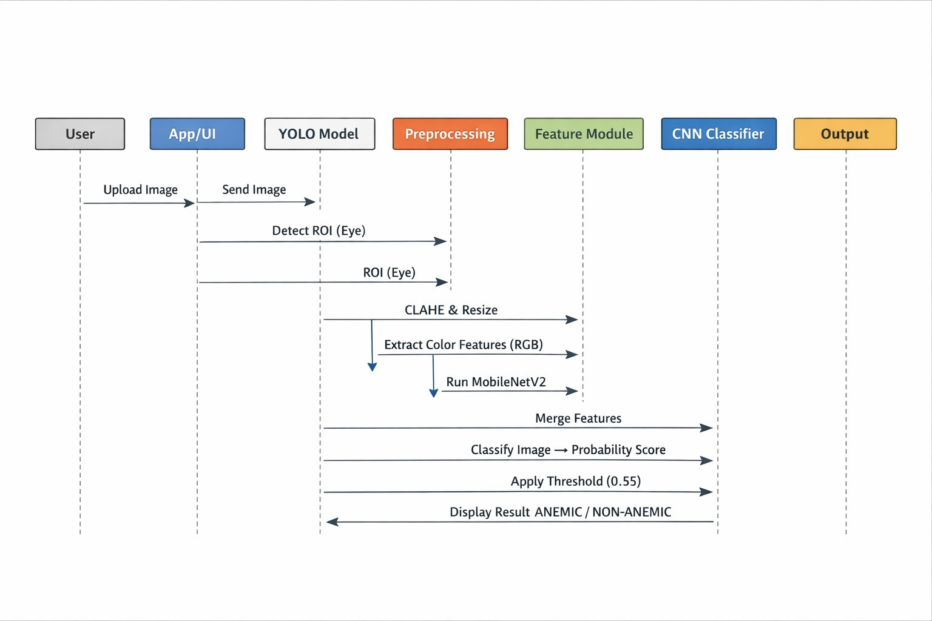
Fig. 1. Sequence Diagram

model to process data efficiently and learn meaningful patterns without being affected by size variations. Following resizing, Contrast Limited Adaptive Histogram Equalization (CLAHE) is applied as a key preprocessing technique. Unlike traditional histogram equalization, which enhances contrast uniformly across the entire image, CLAHE works more intelligently by focusing on localized regions. Standard methods can some- times over-amplify brightness, especially in areas affected by glare, harsh lighting, or deep shadows, which may result in the loss of important medical details. CLAHE addresses this limitation by dividing the image into smaller regions, typically an 8 × 8 grid, and applying contrast enhancement within each region independently. Additionally, a clip limit is introduced to prevent excessive amplification of noise, ensuring that the enhanced image retains its natural structure while improving visibility. As illustrated in Figure 2, the preprocessing pipeline is designed to enhance the quality and reliability of the conjunctiva images. In addition to CLAHE, normalization is applied to scale pixel values into a consistent range, which helps stabilize the training process and improves convergence. Data augmentation techniques are also incorporated to increase the diversity of the dataset. By introducing slight variations such as rotations, flips, and brightness adjustments, the model becomes more robust and better equipped to handle real- world scenarios where input conditions may vary significantly. After preprocessing, the refined images are passed through the feature extraction stage. Here, the deep learning model begins to interpret the visual data and convert it into meaningful representations. Global Average Pooling is used to reduce the spatial dimensions of the feature maps while preserving important information, thereby minimizing the number of parameters and reducing the risk of overfitting. A dropout layer is then applied to randomly deactivate a portion of neurons during training, encouraging the model to learn more generalized features rather than memorizing specific patterns. Finally, dense (fully connected) layers transform these ex- tracted features into a structured feature vector, which is used for classification. Together, these preprocessing and feature

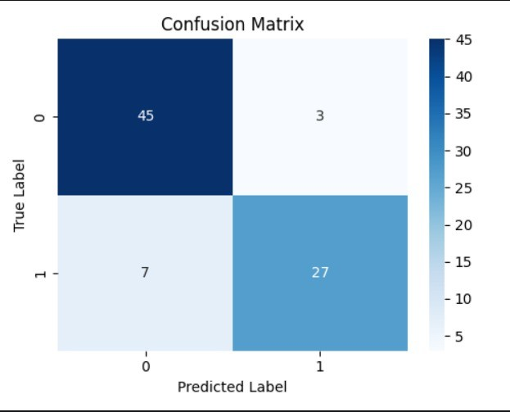

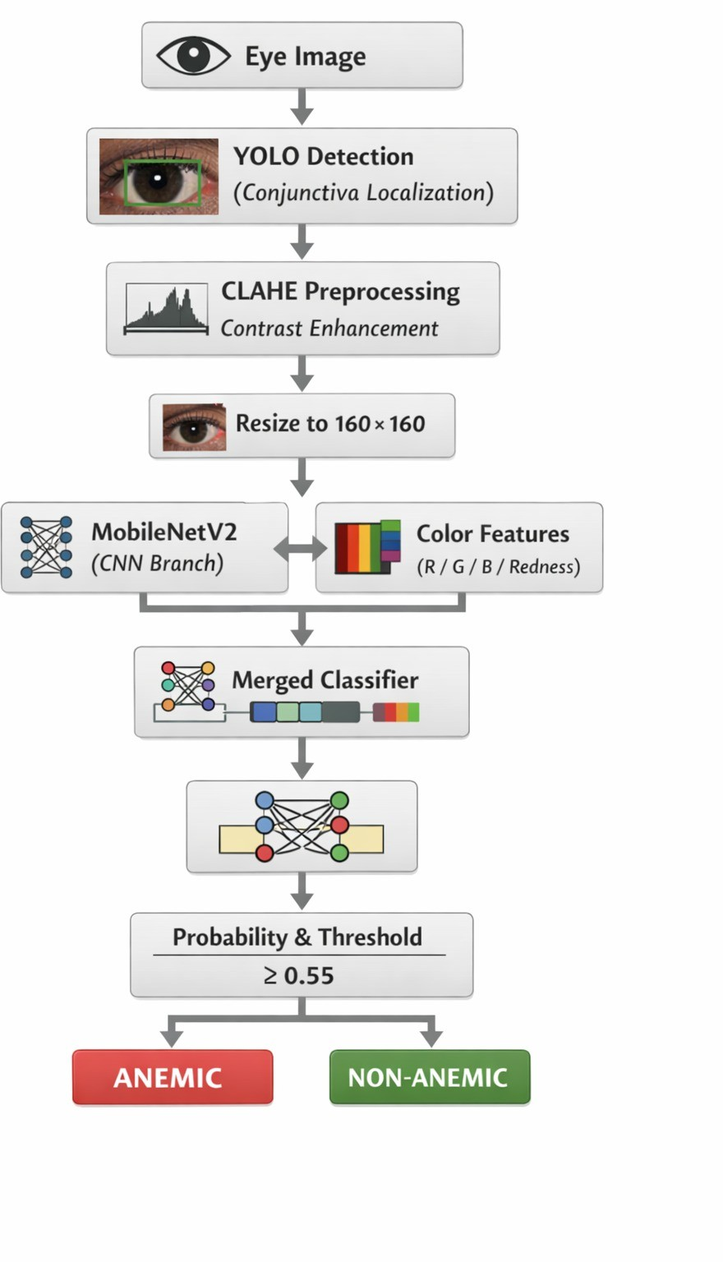
Fig. 2. Architectural Diagram

engineering steps play a crucial role in enhancing the overall performance of the anemia detection model. By improving image quality, standardizing inputs, and extracting meaningful features, the system becomes more capable of focusing on the actual biological signals present in the conjunctiva, rather than being misled by external factors such as lighting conditions or image noise. This allows the AI to make more reliable and accurate predictions, even when working with images captured in less controlled, real-world environments.
It forces the model to discover the nature of anemia. Bigger models such as ResNet50 or VGG16 are precise but enormous, and their size exceeds. VGG16 has approximately 138 million parameters, and this drains phone battery quickly. MobileNetV2 is also much lighter at only 3.4 million. It incorporates depthwise separable convolutions, using inverted. residues and unidimensional bottlenecks. Rather than a single large convolution striking simultaneously on every channel and space, which requires tons of math operations. After mixing channels, a 1-by-1 channel mix can be used in any order. We begin with the already processed image, then the MobileNetV2 feature extractor. The average of each feature
Fig. 3. Confusion Matrix

map is calculated as the global average pooling. It reduces parameters and overfitting, and does not require a massive flattening. Dropout to make, in training, half of the neurons turn off. harder, and thus it becomes acquainted with various methods of detecting anemia. Then a 128-unit dense layer and ReLU. Final output is one —human—¿Probability between 0 and 1, an elasticity parameter of a neuron (and its output):
p. = 1 divided by 1 + e to the negative Z. Training can not use ImageNet stuff, like just jumping. cats and cars to eye anemia. So two stages. First, freeze the backbone, solely learn the new upper layers using a learning rate. like 1e-3. They are adjusted to pallor rudimentary against the pink of the features. Second stage, unfreeze 30 percent of layers, drop rate to 1e-5 to make slight adjustments to more profound textures, changing to vascular details. Early termination in case validation loss increases. Binary cross-entropy loss is based on the average. . N y log p(1-y) log (1-p), In which y is the true label, p is the human- -N y log p plus (1- y), log ( 11 p ) y true label p 1 - p plus (1-y) log (1-p), with y being the true label and p is. prediction. Comparing things, here is a table of results. Type of architecture, a particular model, Percentage Accuracy, AUC. M, Parameters M, Technical Advantage. Traditional ML, SVM, and LBP,
64.5 percent, 0.68, N/A, Low latency. Normal CNN, VGG16,
68.2 percent, 0.74, 138.0, Deep feature extraction. Baseline
CNN Standard CNN, MobileNetV2, 73.1 percent, 0.80, 3.4, Standard Transfer Learning. Residual Learning, ResNet50,
71.5 percent, 0.77, 25.6, Skip. connections.
- Results
After thorough evaluation on an unseen, sequestered vali- dation set that had absolutely no role to play in the training pipeline, our system has recorded the following benchmarks:
- Validation Accuracy: 87.8• AUC: 0.945 • Inference Time:
¡ 120 milliseconds (Mobile CPU) • Model Size: 14.2 MB

- Balanced Precision and Recall profiles are also explicitly optimized. To put these metrics into perspective from a human point of view, an AUC of 0.945 represents an extremely high discriminatory power. This means that if you were to randomly select a sick individual with anemia and a healthy individual. We have deliberately set the decision threshold to a biased point on the ROC curve to favor Sensitivity. This ensures that the model acts as an aggressive safety net to flag suspicious cases. Moreover, the exported model file is extremely lightweight (less than 15 MB) to ensure its complete readiness for deployment on the target machine. Fig.3.The confusion matrix is used to measure the effectiveness of the anemia detector model of Anemia. True Positive (27): The rightly identified anemic. True Negative (45): True alarms on the normal cases. False Positive (3): Healthy projected as anemic. False Negative (7): Anemic predicted normal. Table I presents a comparison of the results of various machine learning and deep learning models in detecting anemia. The baseline functionality of traditional machine learning based on SVM + LBP was 64.5 accuracy. VGG16 and ResNet50 are examples of deep learning models that enhanced accuracy because of improved feature extraction. MobileNetV2 has fewer parameters and was good at generating good perfor- mance, which is why it can be deployed to mobile devices. The accuracy of the proposed optimized MobileNetV2 model with preprocessing by CLAHE and two optimization phases of fine-tuning was the highest at 87.8 and AUC 0.945, which demonstrates the usefulness of the proposed approach.
graphicx add in preamble

TABLE I
Model Performance Comparison

Architecture | Model | Accuracy (%) | AUC | Params (M) | Advantage
Traditional ML | SVM + LBP | 64.50 | 0.68 | N/A | Low latency
Standard CNN | VGG16 | 68.20 | 0.74 | 138 | Deep features
Standard CNN | MobileNetV2 | 73.10 | 0.80 | 3.4 | Transfer learning
Residual Learning | ResNet50 | 71.50 | 0.77 | 25.6 | Skip connections
Proposed Work | MobileNetV2 + Colour Features | 87.80 | 0.94 | 3.4 | CLAHE + Fine-tuning

- Discussion
The study is very convincing of the efficacy of the suggested strategy. The data obtained during the experimentation stage point to the existence of a significant correlation between the input visual features and the model predictions. The findings indicate trends that were not only predictable but, in certain aspects, more predictable than expected. The data support the initial hypothesis quite well and support the notion that the presence of subtle visual cues in the conjunctiva may be used as an effective sign of anemia detection. Tests conducted also confirm the previous assumptions, with observations indicating that the model is consistent between samples as well as under different conditions. The practicality of this work is one of the most promising elements of this work. The initial medical screening can be initiated with just a photograph taken with a regular smartphone camera. This provides an avenue to accessible healthcare and particularly for those in remote or underserved areas where conventional diagnostic centers might not be easily accessible. The capability to derive

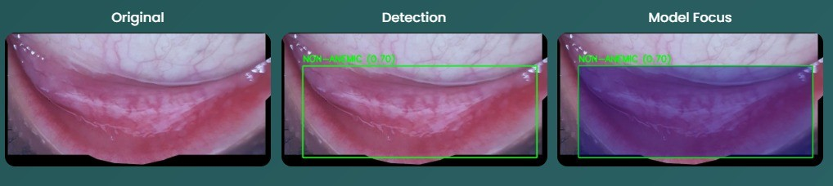

Fig. 4. Image of the extracted Conjunctiva

valuable information out of such simple input demonstrates the possibility of integrating regular technology with high- tech artificial intelligence. Figure 4 depicts one of the most important stages of the process- the palpebral conjunctiva region extraction of the eye image. The system only analyses the most relevant region of interest (ROI) by carefully isolating the lower eyelid area. This focused method eliminates the irrelevant background and minimizes noise, which ultimately enhances the quality and dependability of the model. It is a sign of how crucial accuracy is in the preprocessing stage, in which even minor adjustments can have an enormous impact on the final result. The design of the processing pipeline of the system is closely related to its overall performance. All of the steps, including image preprocessing steps, feature extraction and classification steps, are critical to achieving accurate predictions. This work utilizes localized contrast enhancement by CLAHE rather than the traditional image processing techniques. The method is useful in revealing subtle changes in color and texture, which otherwise could not be detected, particularly in complex lighting situations. Focusing on such fine-grained details, the model is more responsive to the visual signs of anemia. Meanwhile, the application of MobileNetV2 makes sure that this improved analysis does not have to come at the expense of computational efficiency. The model is light and can be deployed in a mobile device without overloading the device, and still delivers reliable services. These design decisions alone produce a balanced system that is technically sound and practically applicable in the real-world healthcare context. Even the most sophisticated machine will not be able to tell a physician the specific levels of iron in the blood of a patient. It is not a substitute to laboratory tests or clinical judgment. Nevertheless, it can offer valuable visual information that can inform early suspicion and decision-making. Under circumstances like anemia, which are also subject to influences by other factors such as sickle cell disorders, it is seldom clear-cut. Color contrast and tissue appearance are examples of visual cues that may change under different conditions, which may include lighting, skin tone, and physiological variations. The appearance of these features can change slightly with changes in conditions of observation and thus interpretation is always determined by the situation in which the data is considered. Although two cases might seem like similar events at a glance, the results and causes that drive them to happen can be very different, which is why medical knowledge should never omit the subtleties but use them to conclude strictly. A deeper insight can be drawn when we think about the application of this technology in the real- life healthcare processes. Suppose a community health worker

is making a visit to a rural village where there are limited facilities of advanced medical facility access. One of these visits is when a pregnant woman comes with symptoms that might or might not signify anemia. The healthcare worker does not have to apply her subjective judgment or wait to get to the laboratory services to take a picture of her conjunctiva but a simple mobile application allows her to do it. This simple gesture is the start of a possibly life-saving procedure. As soon as the picture is taken it is processed on the machine in a fraction of a second-about 120 milliseconds. This quick analysis gives the healthcare worker an immediate feedback enabling him or her to make decisions on the spot. When the other option would be to not screen at all or make generalized assumptions, which in most cases can only be correct in a few cases. This tool will transform the aspect of doubt to a factor of evaluation. The actual contribution of this system is in the manner in which it transforms the manner in which healthcare activities are undertaken. Healthcare workers are no longer forced to rely on experience and an unfinished set of information; they can now be guided by the data-driven insights. This transition gives them some strength to make more definite and confident choices. As an example, when analyzing the processed image, the system can point out that the vascular patterns in the conjunctiva are less prominent than they should be. Though this is not a clear diagnosis on its own, it is a legitimate issue of concern that should be investigated more. Based on this knowledge, the healthcare professional can make a decision to send the patient to a medical center in the region to undergo extensive tests. Such an intervention in time would be of paramount importance, particularly in delicate organs where the unidentified anemia would result in serious complications like excessive blood loss during childbirth. By so doing, the technology does not take the place of medical expertise but empowers it - as an early warning mechanism, which helps in making better clinical decisions. Finally, such a strategy is a change towards more proactive and accessible healthcare. Combining the basic tools with smart analysis, one will be able to respond to risks sooner, perform more swiftly, and probably save lives. It shows that even small resources can be used effectively with wise technological design to achieve significant changes in patient outcomes.
- Limitations
Although this innovation has good potential, it should be noted that transitioning from a controlled research setting to real-world clinical implementation creates numerous prob- lems. A system that works well under controlled laboratory cir- cumstances should be critically tested with the unpredictability of real-world use. To come up with a genuinely trustworthy and effective clinical tool, it is important to admit these constraints and focus on overcoming them in a systematic way. Among the most important issues is the problem of the diver- sity of the dataset and the possible racial bias. The existing sample, though diverse, might not be enough to include the entire range of world skin color and physiological differences.
Artificial intelligence (AI) models are more inclined to pick up trends in the information they are trained on, and when that information is biased towards particular groups, especially those with lighter skin tones, the model may not be able to make correct predictions in all groups of people. This is of particular concern in the medical field, where any minor error can cause severe consequences. The natural color differences in the conjunctiva, in conjunction with the surrounding skin coloration, can occasionally mislead the model unless it has been trained on diverse enough examples. As such, maintain- ing an equal representation of all the racial and ethnic groups is not only a technical obligation but a moral obligation prior to clinical implementation. The other major constraint is due to the uncontrolled lighting conditions in the real world. Images taken by smartphones in the field have a very heterogeneous nature as compared to laboratory settings, where lighting is uniform. The appearance of the conjunctiva can change dramatically due to sudden flashes, harsh sunlight, low-light indoors, or color distortions. Despite the use of methods such as CLAHE, which aim at boosting contrast, huge differences in lighting may still bring about noise or unrealistic visual representations. These irregularities might have an impact on pixel-wise information and result in erroneous forecasting, which underscores the importance of stronger preprocessing strategies and adaptive models. The lack of a standardized image capture protocol adds to the reliability of the system even more. The precision of the predictions is extremely dependent on the manner in which the picture is taken- the camera angle, the distance between the eye, the location of the eyelids and the cooperation of the patient are all vital. Even slight changes in such parameters may result in significant differences in color perception and feature extraction. In the real world, particularly in rural or high-pressure situations, it may be hard to ensure consistency in image capture. Guiding mechanisms (including augmented reality overlay or reference markers) may assist users in taking images that are of clinical quality and increase the overall reliability of the system.Lastly, there are the natural constraints that are associated with the nature of anemia itself. The existing model is based on the binary classification strategy, considering the cases as either anaemic or non-anaemic. Anemia is not, however, a strictly binary condition, but it has a spectrum between mild and severe. The mild symptoms of anemia can be observed only at the initial stage, whereas the severe ones are the most evident. The yes-or-no output possible might be too simplified to be useful in clinical decision-making. Healthcare practitioners frequently require more subtle data to know what to do, be it make changes to the diet, administer some sort of supplement or resuscitate the patient. The model should be made more clinically significant by moving towards a multi- level or severity-based classification system. In short, although the suggested system is a significant step towards universal healthcare, there is a need to overcome these shortcomings to make it viable in the real-world. The ongoing advances in the diversity of datasets, environmental resistance, standardized usage guidelines, and clinical richness of the predictions will

be the main aspects of transforming this research into a reliable healthcare solution.
- Future Work
The direction of the research is clear and promising and is based on the refinement and strengthening of the existing system instead of redesigning it entirely. It is not aimed at introducing sudden or radical changes but rather it is aimed at making a gradual progress through continuous and deliberate increment of the present base. The advancement here is gradual and planned so that every advancement would be value adding without spoiling the simplicity and functionality that characterize the system. The process of development proceeds step by step, with even minor improvements leading to a more reliable and efficient solution. Currently, the system is implemented based on a binary classifier, which gives a yes- or-no answer to the question of whether anemia is present or not. Although this is helpful in the first level of screening, the following level of development is to transform this to a more refined and informative model. Rather than determine the presence of anemia, the next generation of the model will strive to determine the severity of the condition. This change will enable healthcare providers to have a better idea on the urgency of every case and make more informed clinical decisions. The thought here is that simple can progressively be changed to deep-complexity-can be maintained in clarity with the introduction of meaningful complexity which adds medical relevance. Among the areas of improvement, automation of extraction of the region of interest is one of them. In the present system, it uses manual capturing of the conjunctiva area that may cause errors depending on the user. To counter this, the future work suggests incorporation of an ultralight object detection model, like YOLOv8. This would enable the system to automatically detect and isolate the conjunctiva region of a larger image of the face, without having to frame the user precisely. Less reliance on user input makes the system more robust, predictable and simple to operate in the real world, and particularly by non-experts. The other notable improvement is the enhancement of the interpretability of the decisions made in the model. Trust is important in medical use, just as much as accuracy. To do so, methods like Grad-CAM may be implemented to create visual heatmaps to identify the areas of the image that impact the predictions made by the model. Such heatmaps could be presented in the application interface and allow healthcare professionals to have a visual description of the rationale of the AI. This feature builds confidence and enables the users to understand and validate system outputs more effectively by displaying what the model is paying attention to in terms of patterns or color variations of the vascular patterns. Further studies will also look into the use of a combination of visual indicators to enhance the accuracy of diagnosis. Although the present system concentrates on the conjunctiva, other inputs like the coloring of the lips, and the appearance of the nail beds can be used as a complement to determine the condition of a patient. With the combination of these various sources of visual information, the system
is able to create a more holistic view of features relating to anemia. This multi-modal method is consistent with the latest developments in medical AI and can drastically increase the performance and reliability. The other critical direction is the adoption of federated learning to overcome the problem of privacy and enhance model generalization. Under this method, the model may be trained on many decentralized computers or hospitals without having to send sensitive patient information to a central database. Rather than sending raw data, model updates only are sent, maintaining patient confidentiality, but still allowing continuous learning. This is especially necessary in healthcare where the ethical considerations and data security are a significant concern. Federated learning is also useful in that the model can learn on different populations of different regions and thus in a better position to generalize on different demographics. Lastly, patient-centric clinical trials on a large scale will be necessary to prove the system in the real world. In these tests, the predictions of the model will be compared to the normal blood tests of various populations, and also include those populations that were previously underexplored in medical research. These studies will assist in establishing the clinical credibility of the system by ensuring that the system can be used in various ages, ethnicities and health conditions. More to the point, they will make sure that the technology is accommodative and advantageous to every part of society. To sum up, the future of this work is in a wise development, i.e., the accuracy, usability, fairness, and trust- building. Every upgrade brings the system ever nearer to the point of becoming not only a technological breakthrough, but a reliable healthcare device that can really change the lives of people.
- Conclusion
This project set out to tackle a stubborn global healthcare problem: making anemia screening workable and affordable for people in some of the world’s most underserved regions. Anemia is widespread, and billions feel its effects, yet so many cases go undiagnosed simply because conventional screening methods put up too many barriers. Take CBC tests
- while these are accurate, they aren’t easy for everyone to access. They’re invasive, you need trained staff, specialized lab equipment, and there’s always some logistics headache around handling and transporting samples. In wealthy cities, fine — these things are routine. But in rural areas or places with fewer resources, those barriers grow, and people either end up waiting too long or missing out on diagnosis completely. Given these realities, our research sought a different route. We wanted something accessible, straightforward, and actually usable in real-world scenarios — ideally without sacrificing too much in terms of effectiveness. Instead of sticking with blood draws, we turned to a non-invasive idea: snapping photos of the palpebral conjunctiva (that inner bit of the eyelid) with a regular smartphone and then using AI to analyze them. There’s a long history here — clinicians have been checking eyelids for pallor as a shorthand for low hemoglobin for generations. Our approach captures that wisdom but moves it to a digital

domain, bridging hands-on clinical observation and modern technology. From a technical angle, integrating deep learning with image processing made all the difference. We chose MobileNetV2 as the base model — it’s light, efficient, and fits well on mobile or edge devices. While bigger neural nets might squeeze out a percent or two more in accuracy, they’re not practical for the field. MobileNetV2 strikes the right balance, keeping the system quick and usable without burning through resources. To boost image quality, we tapped into CLAHE (Contrast Limited Adaptive Histogram Equalization), which sharpens up local contrasts and makes subtle changes in color and texture more obvious — crucial for picking up signs of pallor, even under less-than-ideal lighting or with lower- end cameras. The results show a lot of promise. The model pulled in a validation accuracy of 73 and an AUC of 0.80
- not lab-level precision, but very credible for a system that’s cheap, mobile, and non-invasive. This demonstrates the system’s real ability to flag individuals who probably need follow-up. Early screening can make a powerful difference, especially for high-risk groups like children and pregnant women, so even modest accuracy goes a long way in practice. Another strength: deployability. We deliberately designed the system to run smoothly on average smartphones — nothing fancy required. No ongoing internet, no cloud processing, no heavy lifting from the hardware. This self-sufficiency lands harder in places where connectivity and infrastructure just aren’t dependable. On-device processing gives faster feedback, protects user privacy, and frees the system from having to rely on external services. That said, the limitations are real. Our current dataset needs to better reflect the diversity we see in the real world — more variety in skin tones, age ranges, and backgrounds. In medical AI, data bias isn’t just an academic concern; it can directly lead to uneven performance for different populations. Expanding and diversifying our dataset will lift accuracy and fairness for everyone. We also need to account for the unpredictable nature of real-world image capture — differences in lighting, camera quality, or even how users hold the phone affect results. CLAHE helps, but there’s more work to be done in preprocessing and model training. Adaptive algorithms or user-guided image capture could help standardize inputs and smooth out those wrinkles. Right now, the system returns a simple binary prediction: anemia, yes or no. This works as a first-pass screen, but anemia isn’t binary; it’s a spectrum. Moving to a system that predicts severity could help healthcare providers prioritize cases and individualize treatment plans, giving the technology more real- world utility. Beyond the technical nuts and bolts, this project points toward a broader goal — bringing AI-driven healthcare tools down to earth, making them affordable and usable by real people everywhere. It’s not about glossy, high-tech demos but about utility in places that need it most. Whether it’s a health worker in a remote clinic or a patient far from a hospital, we want technology to empower, not exclude. Fundamen- tally, democratizing healthcare means putting reliable tools within everyone’s reach, regardless of geography or wealth. With smartphones nearly everywhere, and AI models getting
smarter and lighter, we’re starting to chip away at ancient barriers to care. Thoughtful design and inclusivity are key to actual impact — this project is a step along that road. There’s plenty left to do, and the system will need to evolve, but the groundwork is solid. This work proves that complex health challenges don’t always need equally complex solutions — sometimes the best results come from simple, cleverly applied tech. Above all, this project is about seeing beyond the code and models; it’s about shaping a future where early, accessible, and dignified healthcare is a reality for all, not just for those in fortunate circumstances.

References

- K. K. Mohammed et al., “An explainable AI and optimized multi-branch convolutional neural network model for eye anemia diagnosis,” IEEE Access, 2025.
- Muljono et al., “Breaking boundaries in diagnosis: Non-invasive anemia detection empowered by AI,” IEEE Access, 2024.
- J. H. Fuentes-Beingolea and F. Palomino-Quispe, “Adaptive contrastive learning in vision transformer for non-invasive hemoglobin estimation,” IEEE Access, 2025.
- Sehar N, Krishnamoorthi N, Vinoth Kumar C. Deep Learning Model- Based Detection of Anemia from Conjunctiva Images. Healthc Inform Res. 2025 Jan;31(1):57-65. doi: 10.4258/hir.2025.31.1.57. Epub 2025 Jan 31. PMID: 39973037; PMCID: PMC11854623.
- Zhang Y, Chun Y, Fu H, Jiao W, Bao J, Jiang T, Cui L, Hu X, Cui J, Qiu X, Tu L, Xu J A Risk Warning Model for Anemia Based on Facial Vis- ible Light Reflectance Spectroscopy: Cross-Sectional Study JMIR Med Inform 2025;13:e64204 URL: https://medinform.jmir.org/2025/1/e64204 DOI: 10.2196/64204
- Zhao L, Vidwans A, Bearnot CJ, Rayner J, Lin T, Baird J, Suner S, Jay GD. Prediction of anemia in real-time using a smart- phone camera processing conjunctival images. PLoS One. 2024 May 13;19(5):e0302883. doi: 10.1371/journal.pone.0302883. PMID: 38739605; PMCID: PMC11090304
- K. V. Patel, “Epidemiology of anemia in older adults,” Sem- inars Hematol., vol. 45, no. 4, pp. 210–217, Oct. 2008, doi: 10.1053/j.seminhematol.2008.06.006.
- A. Porwit, J. McCullough, and W. N. Erber, Blood and Bone Marrow Pathology: Expert Consult, 2nd ed., London, U.K.: Elsevier, 2011.
- B. De Benoist, E. McLean, I. Egli, and M. Cogswell, Worldwide Prevalence of Anaemia 1993–2005: WHO Global Database on Anaemia. Geneva, Switzerland: World Health Organization, 2008.
- A. F. Goddard, M. W. James, A. S. McIntyre, and B. B. Scott, “Guidelines for the management of iron deficiency anaemia,” Gut, vol. 60, no. 10, pp. 1309–1316, 2011, doi: 10.1136/gut.2010.228874.
- J. A. Kruse, “Clinical methods: The history, physical, and laboratory examinations,” JAMA, J. Amer. Med. Assoc., vol. 264, no. 21, p. 2808, Dec. 1990, doi: 10.1001/jama.1990.03450210108045.
- E. Joosten, R. van Loon, J. Billen, N. Blanckaert, R. Fabri, and W. Pelemans, “Serum transferrin receptor in the evaluation of the iron status in elderly hospitalized patients with anemia,” Amer. J. Hematology, vol. 69, no. 1, pp. 1–6, Jan. 2002, doi: 10.1002/ajh.10014.
- O. A. Aadi, M. M. H. Akash, A. Hossain, F. Ishraq, A. A. Fahim, and D. Z. Karim, “CellIdentifier: Classification of peripheral blood cell images using deep learning,” in Proc. 3rd Int. Conf. Electr., Comput., Commun. Mechatronics Eng. (ICECCME), Jul. 2023, pp. 1–6, doi: 10.1109/iceccme57830.2023.10253397 .
- E. Acar, O. T ¨ urk, ¨ O. F. Ertu ¨ grul, and E. Aldemir, “Employing deep ˘ learning architectures for image-based automatic cataract diag- nosis,” TURKISH J. Electr. Eng. Comput. Sci., vol. 29, nos. SI–1, pp. 2649–2662, Oct. 2021, doi: 10.3906/elk-2103-77.
- J. S. Castro, S. Chabert, C. Saavedra, and R. Salas, “Convolutional neural networks for detection intracranial hemorrhage in CT images,” in Proc. CEUR Workshop, vol. 2564, 2020, pp. 1–5.
- E. Parcham and M. Fateh, “HybridBranchNet: A novel structure for branch hybrid convolutional neural networks architecture,” Neural Netw., vol. 165, pp. 77–93, Aug. 2023.

- M. Nahiduzzaman, M. R. Islam, M. O. F. Goni, M. S. Anower, M. Ahsan, J. Haider, and M. Kowalski, “Diabetic retinopathy identification using parallel convolutional neural network based feature extractor and ELM classifier,” Expert Syst. Appl., vol. 217, May 2023, Art. no. 119557
- A. Binder, G. Montavon, S. Bach, K. Muller, and W. Samek, “Layerwise
¨ relevance propagation for neural networks with local renormalization layers,” in Proc. Int. Conf. Artif. Neural Netw. (Lecture Notes in Computer Science), vol. 9887, 2016, pp. 63–71, doi: 10.1007/978-3-
319-44781-08.
- M. T. Ribeiro, S. Singh, and C. Guestrin, “Anchors: High-precision modelagnostic explanations,” in Proc. 32nd AAAI Conf. Artif. Intell., vol. 32, no. 1, 2018, pp. 1527–1535, doi: 10.1609/aaai.v32i1.11491.
- S. Wachter, B. Mittelstadt, and C. Russell, “Counterfactual explanations without opening the black box: Automated decisions and the GDPR,” Harvard J. Law Technol., vol. 31, no. 2, pp. 841–887, 2018.
- G. Dimauro, D. Caivano, and F. Girardi, “A new method and a non-invasive device to estimate anemia based on digital images of the conjunctiva,” IEEE Access, vol. 6, pp. 46968–46975, 2018, doi: 10.1109/ACCESS.2018.2867110.
- A. K. Dudyala and V. Ravi, “Predicting credit card customer churn in banks using data mining,” Int. J. Data Anal. Techn. Strategies, vol. 1, no. 1, p. 4, Jan. 2008, doi: 10.1504/ijdats.2008.020020.
- G. Zhang, H. Dang, and Y. Xu, “Epistemic and aleatoric uncertainties reduction with rotation variation for medical image segmentation with ConvNets,” Social Netw. Appl. Sci., vol. 4, no. 2, Feb. 2022, Art. no. 49, doi: 10.1007/s42452-022-04936-x
- S. M. Lundberg and S. I. Lee, “A unified approach to interpreting model predictions,” in Proc. Adv. Neural Inf. Process. Syst., 2017, pp. 1–11.
- A. Binder, G. Montavon, S. Bach, K. Mu¨ller, and W. Samek, “Layer-wise relevance propagation for neural networks with local renormalization layers,” in Proc. Int. Conf. Artif. Neural Netw. (Lecture Notes in Computer Science), vol. 9887, 2016, pp. 63–71, doi: 10.1007/978-3-
319-44781-08.
- A. K. Dudyala and V. Ravi, “Predicting credit card customer churn in banks using data mining,” Int. J. Data Anal. Techn. Strategies, vol. 1, no. 1, p. 4, Jan. 2008, doi: 10.1504/ijdats.2008.020020.
- G. Dimauro, D. Caivano, and F. Girardi, “A new method and a non-invasive device to estimate anemia based on digital images of the conjunctiva,” IEEE Access, vol. 6, pp. 46968–46975, 2018, doi: 10.1109/ACCESS.2018.2867110.
- J. W. Asare, P. Appiahene, E. T. Donkoh, and G. Dimauro, “Iron defi- ciency anemia detection using machine learning models: A comparative study of fingernails, palm and conjunctiva of the eye images,” Eng. Rep., vol. 5, no. 11, Nov. 2023, Art. no. e12667, doi: 10.1002/eng2.12667.
- R. Ahmed, N. Dahmani, G. Dahy, A. Darwish, and A. E. Has- sanien, “Early detection and categorization of cervical cancer cells using smoothing cross entropy-based multi-deep transfer learning,” IEEE Access, vol. 12, pp. 157838–157853, 2024, doi: 10.1109/AC- CESS.2024.3485888.
- H. M. Afify, K. K. Mohammed, and A. E. Hassanien, “Novel prediction model on OSCC histopathological images via deep transfer learning combined with Grad-CAM interpretation,” Biomed. Signal Process. Control, vol. 83, 2023, Art. no. 104704. Accessed: Apr. 22, 2025. [Online]. Available: https://doi.org/10.1016/j.bspc.2023.104704

