EVOLUTION FROM SNMP TO NETCONF/YANG-BASED NETWORK MANAGEMENT

¹Dhvani Patel  Department of Computing Technologies  SRM University  dhvani16patel02@gmail.com | ¹Prince Kumar  Department of Computing Technologies  SRM University  pk0201@srmist.edu.in | ²Dr. Rajasekaran P  Department of Computing Technologies  SRM University  rajasekp2@srmist.edu.in

Abstract—The rapid evolution of large-scale, heterogeneous networks driven by cloud computing, IoT, and software-defined infrastructures has exposed fundamental limitations in the Simple Network Management Protocol (SNMP), particularly in terms of scalability, weak configuration capabilities, lack of transactional semantics, and inadequate data modeling flexibility. Despite its widespread deployment, SNMP’s polling-based architecture and reliance on rigid Management Information Bases (MIBs) hinder its effectiveness in modern, dynamic environments. This has led to the emergence of model-driven network management paradigms centered around the Network Configuration Protocol (NETCONF) and the YANG data modeling language, standardized in RFC 6241 and RFC 7950, respectively. This survey critically examines the architectural transition from SNMP to NETCONF/YANG, highlighting how features such as transactional configuration management, hierarchical data modeling, and protocol extensibility address longstanding deficiencies. Furthermore, it synthesizes empirical findings on performance, scalability, and protocol efficiency, revealing inconsistencies in benchmarking methodologies and a lack of large-scale real-world validation. The paper also analyzes emerging directions, including intent-based networking, streaming telemetry (e.g., gNMI), and AI-assisted network management, while identifying persistent challenges such as interoperability gaps, model fragmentation, and integration complexity. By consolidating both foundational standards and recent research, this survey provides a critical perspective on the shift toward model-driven network management and outlines key areas requiring further investigation.

Keywords— Network Management, SNMP, NETCONF, YANG, Model-Driven Networking, Scalability, Streaming Telemetry, Intent-Based Networking.

Introduction
Network management has become increasingly complex due to the rapid expansion of heterogeneous infrastructures, including cloud computing, Internet of Things (IoT), and software-defined networking (SDN). Traditional network management paradigms, primarily based on the Simple Network Management Protocol (SNMP), were designed for relatively static and homogeneous environments, where monitoring rather than configuration was the dominant requirement. As outlined in early foundational work by William Stallings and subsequent performance studies, SNMP provides a lightweight and widely deployable framework based on a manager–agent model and Management Information Bases (MIBs), enabling basic monitoring and control functions. However, as networks evolved in scale and dynamism, several inherent limitations of SNMP became evident, including its inefficient polling mechanisms, limited support for configuration management, lack of transactional integrity, and weak semantic data modeling [23], [24].

The increasing demand for automation, programmability, and real-time configuration management has significantly necessitated a shift toward more flexible, scalable, and expressive network management frameworks. Surveys such as [1] and [3] clearly emphasize that modern networks require not only efficient monitoring mechanisms but also fine-grained, reliable configuration capabilities along with seamless interoperability across diverse multi-vendor environments. Historical analyses (e.g., [7]) further indicate that network management has progressively transitioned from traditional protocol-centric approaches to more advanced model-driven paradigms, where data models play a central and critical role in defining network behavior, structure, and operational state in a consistent manner.

In response to these evolving challenges, the Internet Engineering Task Force (IETF) introduced the Network Configuration Protocol (NETCONF), standardized in RFC 6241, which provides a robust, efficient, and extensible mechanism for installing, manipulating, changing and deleting network device configurations. Unlike SNMP, NETCONF adopts a remote procedure call (RPC)-based architecture over secure and reliable transport layers such as SSH, enabling transactional operations, configuration validation, and rollback capabilities with improved reliability. Complementing NETCONF, the YANG data modeling language, defined in RFC 7950, introduces a structured, modular, and extensible approach to modeling configuration and state data, thereby overcoming the inherent rigidity of SNMP MIBs and enabling greater interoperability, automation, and consistency across modern network infrastructures [18].

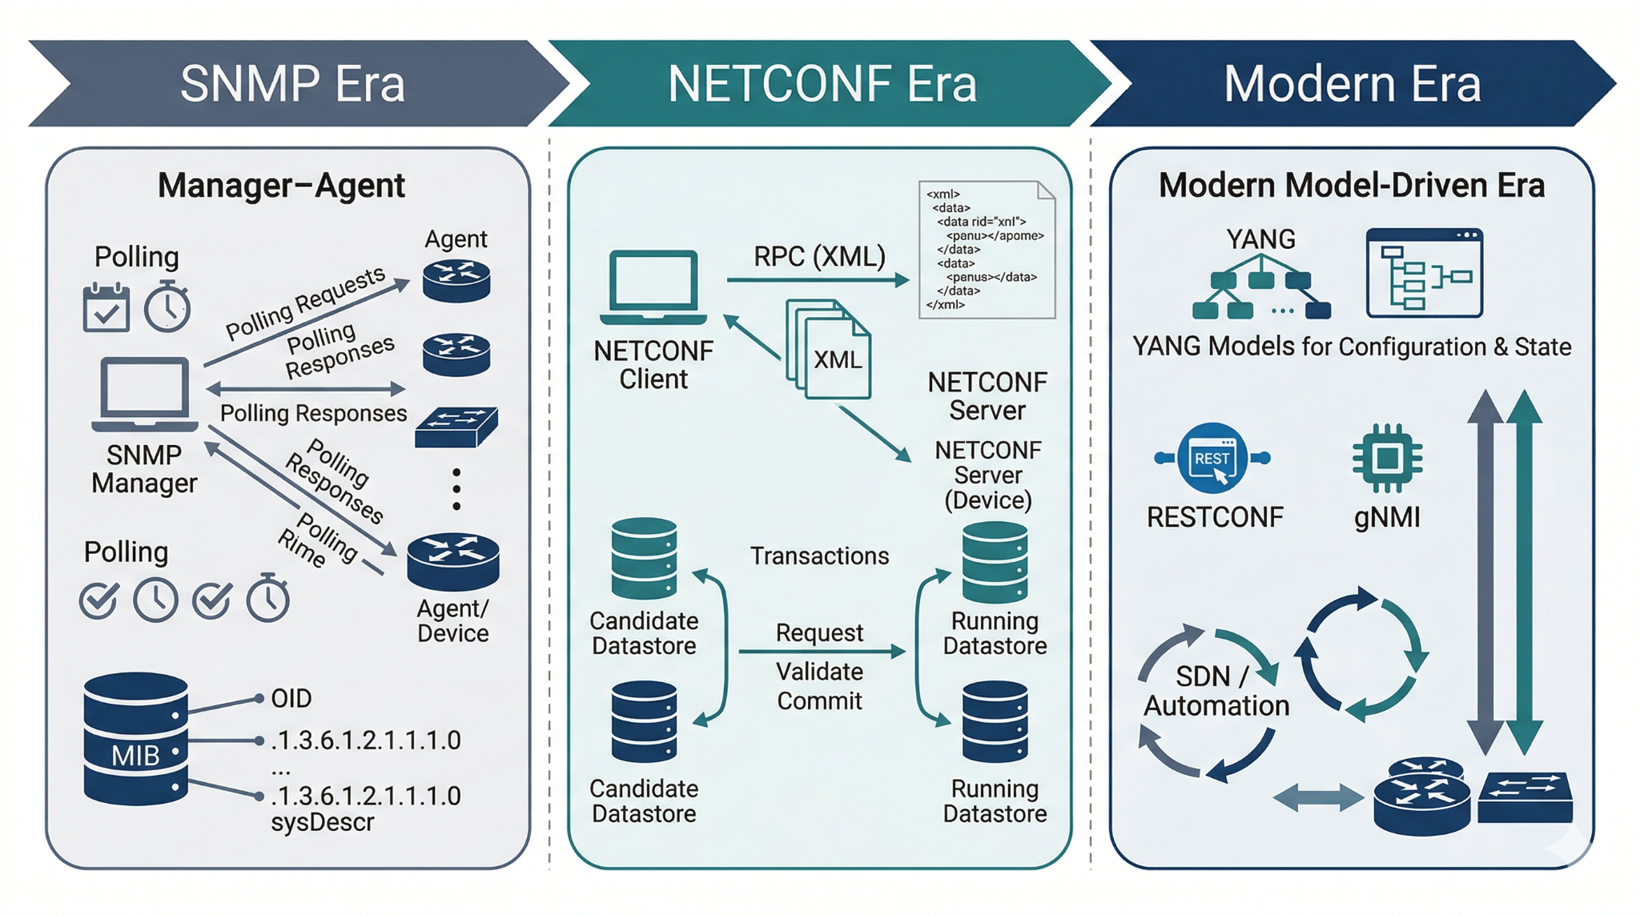
Fig. 1. Evolution of Network Management Architecture

Despite these advancements, the transition from SNMP to NETCONF/YANG is neither trivial nor complete. Comparative and empirical studies [6], [11], [21] reveal trade-offs in terms of protocol overhead, complexity, and deployment challenges. Moreover, emerging paradigms such as intent-based networking and AI-driven management introduce new requirements that extend beyond current protocol capabilities [12], [25]. These developments highlight the need for a comprehensive and critical examination of the evolution of network management protocols.

This paper aims to systematically analyze the progression from SNMP-based management to NETCONF/YANG-driven approaches by integrating insights from standardization efforts, empirical evaluations, and recent research trends. Specifically, it (i) examines the architectural and functional limitations of SNMP, (ii) analyzes the design principles and capabilities of NETCONF and YANG, (iii) provides a comparative evaluation based on performance and scalability, and (iv) identifies open challenges and future research directions in the context of increasingly automated and intelligent network environments.

Background: SNMP-Based Network Management
The Simple Network Management Protocol (SNMP) has historically served as the foundational framework for network management, standardized in early RFCs and refined through subsequent versions [23], [7]. It follows a centralized manager–agent architecture, where a Network Management System (NMS) communicates with distributed agents on network devices, accessing management data through Management Information Bases (MIBs) identified by Object Identifiers (OIDs). This design enables standardized monitoring of network parameters such as interface statistics and device status. However, SNMP was primarily designed for monitoring-centric tasks in relatively static environments, limiting its applicability in modern, dynamic, and large-scale network infrastructures [2], [4]. As networks evolve toward virtualization, cloud-native deployments, and software-defined paradigms, the limitations of SNMP’s original design become increasingly evident [3], [27].

SNMP operates using a request–response communication model, incorporating PDUs such as GET, GET-BULK, and SET, along with asynchronous TRAP and INFORM messages. While flexible, this polling-based mechanism introduces significant scalability challenges, particularly in large-scale or high-frequency monitoring environments. Studies in IoT and distributed systems demonstrate that polling generates substantial control-plane overhead, increased latency, and inefficient bandwidth utilization [1], [21], [24]. In contrast, modern approaches advocate for streaming telemetry and push-based models, which provide continuous, real-time updates with reduced overhead [26], [30], [35]. Furthermore, although SNMPv2 and SNMPv3 introduced improvements such as bulk retrieval and enhanced security, these changes remain incremental and do not address fundamental architectural limitations, particularly the absence of transactional consistency in configuration operations [11], [6].

A key limitation of SNMP lies in its data modeling approach, where MIBs defined using ASN.1 provide a rigid and low-level representation of management data. This structure lacks support for hierarchical abstraction, semantic richness, and constraint validation, limiting extensibility and interoperability in multi-vendor environments [3], [18]. Additionally, SNMP’s stateless and non-transactional configuration model results in unreliable configuration management, as changes are applied without atomicity or rollback mechanisms, increasing the risk of inconsistent states in distributed systems [6], [21]. These deficiencies become more critical in modern environments that demand programmability, automation, and real-time responsiveness, particularly in the context of intent-based networking and AI-driven management [12], [32], [33]. As summarized in Table I, SNMP’s capabilities fall short of modern network management requirements across multiple dimensions, including scalability, data modeling, validation, and automation support.

In addition to these limitations, it is important to recognize that SNMP was designed at a time when network environments were relatively simple and predictable. As a result, its architecture does not fully align with the dynamic and rapidly changing nature of modern infrastructures. Today’s networks are highly distributed, often virtualized, and continuously evolving, which requires management protocols to adapt in real time. However, SNMP’s rigid structure and dependence on predefined MIBs make it difficult to accommodate such flexibility without significant manual effort.

Table I:
SNMP vs Modern Network Management Requirements
Feature | SNMP Capability | Modern Requirement
Data Model | ASN.1-based MIB (rigid) | Rich, schema-based (e.g., YANG)
Communication Model | Polling (pull-based) | Streaming telemetry (push-based)
Configuration Management | Limited, non-transactional | Transactional, atomic updates
Scalability | Degrades with polling overhead | Scalable with event-driven updates
Validation | Minimal | Strong schema validation
Automation Support | Weak | Native programmability and automation
State Management | No clear separation | Explicit config vs operational state

In summary, while SNMP remains relevant for legacy monitoring applications due to its simplicity and widespread adoption, its architectural constraints—ranging from inefficient polling and rigid data modeling to the lack of transactional semantics and automation support—limit its effectiveness in contemporary network environments. These limitations have driven the transition toward model-driven approaches such as NETCONF and YANG, which provide structured data models, transactional capabilities, and enhanced programmability, forming the basis for modern, scalable, and intelligent network management systems [8], [18], [28], [29].

Limitations of SNMP and Need for Evolution
While SNMP has historically served as a foundational framework for network monitoring, its limitations reflect deeper architectural misalignments with modern network management requirements. These constraints are systemic rather than incremental, affecting scalability, automation, and interoperability in contemporary environments. A fundamental issue lies in SNMP’s monitoring-centric design, which inadequately supports configuration management. Although SET operations exist, they lack transactional guarantees and are rarely used in practice due to the risk of inconsistent states. Empirical studies demonstrate that SNMP-based configuration changes are executed in a non-atomic manner, where partial failures can leave devices in unstable configurations [11], [6], [19]. This limitation contrasts sharply with modern requirements for transactional integrity and consistency in large-scale and mission-critical systems.

Another major limitation is SNMP’s polling-based communication model, which introduces significant scalability and efficiency challenges. In large and dynamic networks, periodic polling generates excessive control traffic and delays state visibility, reducing responsiveness to real-time events. Studies in IoT and fog computing environments show that SNMP performance degrades as the number of managed devices increases due to cumulative polling overhead and latency [1], [21], [24]. Modern network management paradigms instead emphasize streaming telemetry and event-driven models, which provide continuous, low-latency updates and improved scalability [26], [30], [35]. Furthermore, SNMP’s data modeling approach—based on ASN.1-defined MIBs—lacks semantic richness, extensibility, and formal validation capabilities, limiting interoperability and integration with higher-level orchestration systems [3], [18], [29].

Security and integration challenges further constrain SNMP’s applicability. Although SNMPv3 introduces authentication and encryption, its deployment complexity and inconsistent adoption reduce its effectiveness in practice [23], [2]. Additionally, SNMP does not support fine-grained, role-based access control aligned with modern zero-trust models, nor does it provide native programmability for integration with software-defined and cloud-native infrastructures. Attempts to integrate SNMP with newer systems often rely on bridging mechanisms, which increase complexity without resolving core limitations [16], [27]. As modern networks increasingly depend on automation, APIs, and model-driven interfaces, SNMP’s limited extensibility becomes a critical bottleneck.

From a broader perspective, these limitations highlight the need for a paradigm shift rather than incremental improvements. Contemporary requirements—including transactional configuration, real-time telemetry, semantic data modeling, and automation—cannot be effectively addressed within SNMP’s architectural framework [6], [11], [28]. This has driven the adoption of model-driven approaches such as NETCONF and YANG, which provide structured, machine-readable data models, transactional capabilities, and improved programmability [18], [29]. Moreover, recent advances in intent-based networking and AI-driven management further emphasize the need for high-level abstractions and automated decision-making, which are fundamentally incompatible with SNMP’s design [25], [32], [33].

To provide a structured perspective, SNMP limitations can be categorized into four dimensions: architectural limitations (lack of transactional semantics and state separation), operational limitations (polling-induced scalability and latency issues), data modeling limitations (rigid and non-semantic MIB structures), and security/integration limitations (coarse access control and limited programmability). Recent studies on streaming telemetry and model-driven management consistently demonstrate that push-based mechanisms significantly outperform SNMP in terms of scalability and timeliness, while YANG-based models enable validation, automation, and interoperability not achievable with traditional approaches [26], [31], [35]. These findings reinforce the conclusion that SNMP’s limitations are structural, necessitating the transition toward model-driven, telemetry-centric, and automation-ready network management architectures.

NETCONF PROTOCOL
The limitations of SNMP in configuration management, scalability, and data modeling motivated the development of the Network Configuration Protocol (NETCONF), standardized by the IETF in RFC 6241 [28]. Unlike SNMP, which is primarily monitoring-oriented, NETCONF was explicitly designed to support transactional, programmatic, and model-driven configuration management in modern networks. Its architecture reflects a paradigm shift toward automation, structured data handling, and reliable configuration workflows, aligning with the requirements of software-defined and large-scale network environments [7], [27].

NETCONF adopts a client–server architecture, where a management application (client) communicates with network devices (servers) using Remote Procedure Calls (RPCs) encoded in XML and transported over secure protocols such as SSH. This RPC-based model enables structured and extensible interactions, allowing manipulation of complex configuration data beyond the capabilities of SNMP’s simple request–response mechanism [5], [13]. While XML encoding introduces additional overhead compared to SNMP, it enhances interoperability and facilitates integration with higher-level orchestration systems and APIs [6], [9].

A key innovation of NETCONF is its support for multiple configuration datastores, including running, candidate, and startup. This separation enables safe configuration workflows in which changes can be staged, validated, and atomically committed, directly addressing SNMP’s lack of transactional consistency [11], [18]. NETCONF further provides locking mechanisms to prevent concurrent modifications, ensuring consistency in multi-user environments.

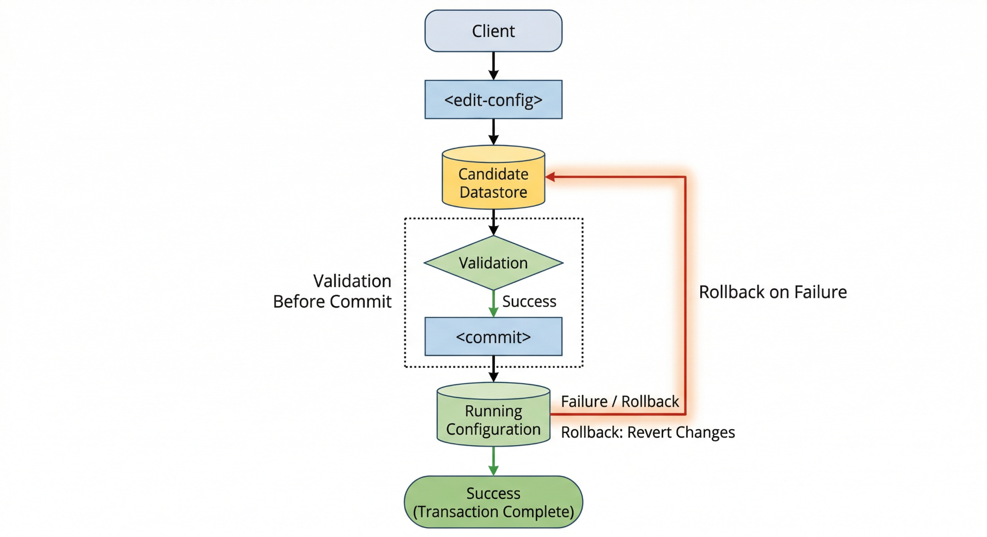
Fig. 2. NETCONF Transaction Workflow

NETCONF defines a comprehensive set of operations, including get, get-config, edit-config, copy-config, and delete-config, with the commit operation enabling atomic application of changes and rollback capabilities in case of failure. These features provide a level of reliability and control absent in SNMP-based systems [19], [22]. Additionally, NETCONF supports hierarchical and structured data representations through XML, which, when combined with YANG, enables precise schema validation, modular design, and improved interoperability across multi-vendor environments [18], [29].

Despite its advantages, NETCONF introduces trade-offs related to complexity and performance. XML-based encoding increases message size and processing overhead, which can impact efficiency in resource-constrained or high-frequency environments [5], [19]. Moreover, the protocol’s support for multiple datastores and transactional operations adds implementation complexity, requiring advanced tooling and expertise [13], [9]. Nevertheless, optimization techniques and alternative encodings (e.g., RESTCONF with JSON) partially mitigate these limitations [28], [31].

From a deployment perspective, NETCONF serves as a foundational enabler of programmable network management, supporting integration with automation frameworks, orchestration systems, and SDN controllers [27], [32]. Its extensibility and alignment with model-driven approaches position it as a critical component in evolving network architectures, including intent-based and AI-driven systems [25], [33].

Overall, NETCONF addresses the fundamental shortcomings of SNMP by providing transactional configuration management, structured data handling, and secure communication mechanisms. While it introduces additional complexity, its capabilities closely align with the demands of modern, scalable, and automated network environments, establishing it as a key protocol in the transition toward model-driven network management

The effectiveness of NETCONF as a configuration management protocol depends on the availability of a robust and expressive data modeling language, leading to the development of YANG, standardized in RFC 7950 [29]. YANG provides a formal, hierarchical, and machine-readable schema for modeling both configuration and operational state data, addressing the limitations of SNMP’s ASN.1-based MIBs [18], [3]. Together, NETCONF and YANG establish the foundation of model-driven network management, where YANG defines the structure, constraints, and semantics of data, while NETCONF provides mechanisms for its manipulation [8], [28].

YANG models are organized into modular and extensible schemas composed of constructs such as containers, lists, leaf nodes, and leaf-lists, enabling hierarchical representation of complex configurations including interfaces, routing policies, and access control rules. This structured approach contrasts with SNMP’s flat OID-based representation and enables significantly richer data abstraction and reuse [3], [18].

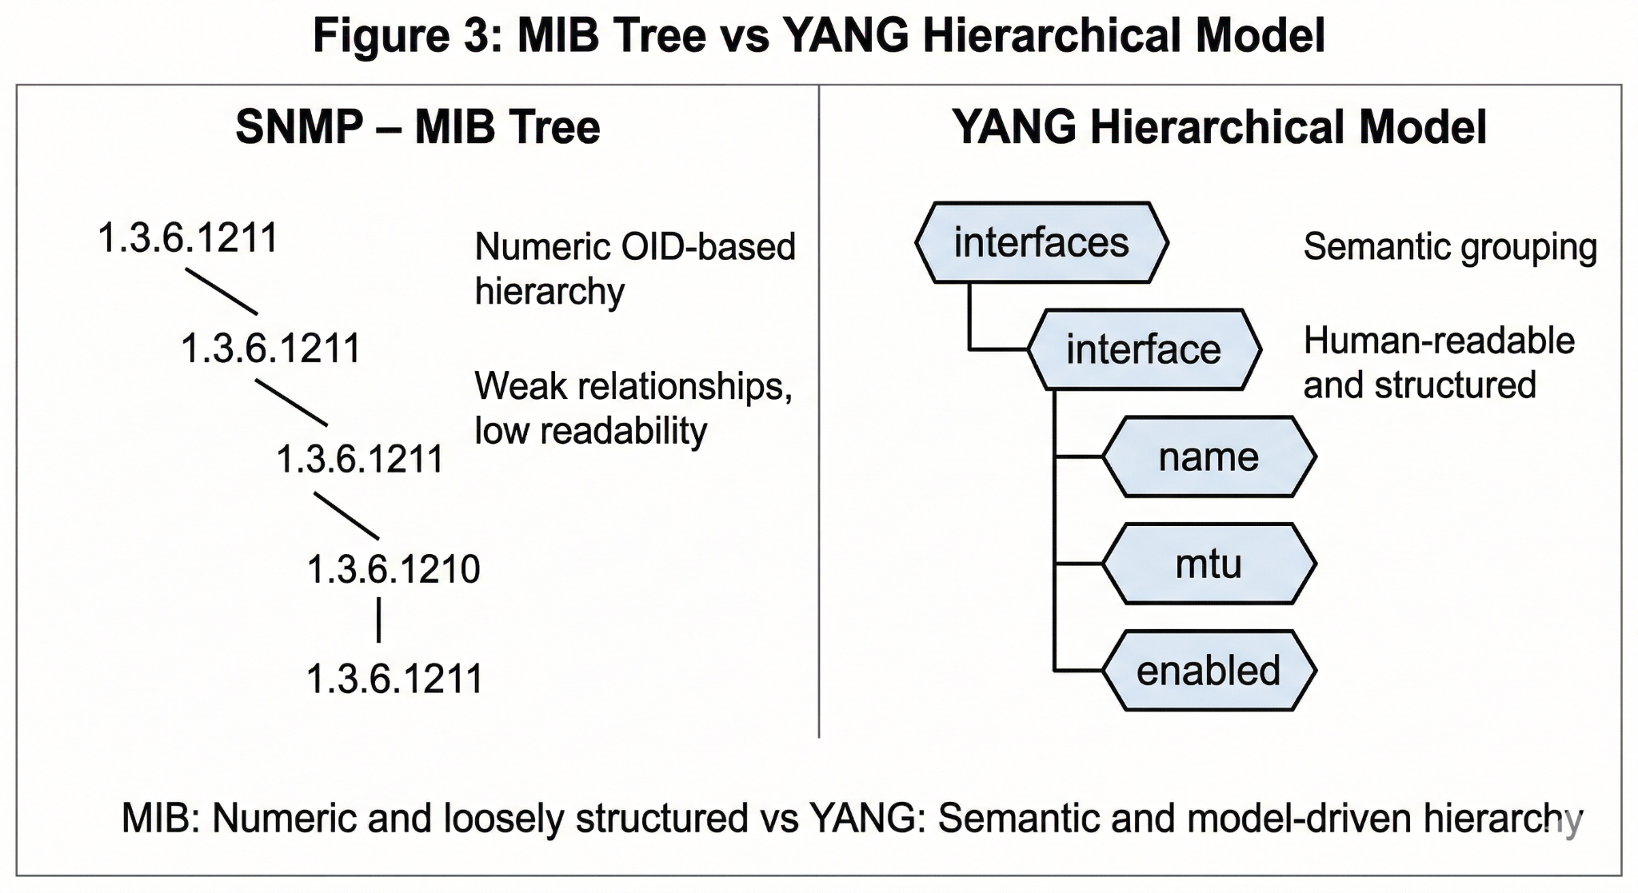
Fig. 3. MIB Tree vs YANG Hierarchical Model

A key advantage of YANG is its ability to define constraints and validation rules directly within the model. Constructs such as must, when, and range enable semantic validation of configuration data prior to deployment, significantly reducing configuration errors and improving reliability [18], [10]. YANG also supports strong typing and extensibility through mechanisms such as typedef, grouping, and module augmentation, allowing vendors and standard bodies to extend models while maintaining compatibility [29], [31]. However, this flexibility can lead to model fragmentation and inconsistencies across implementations, particularly in multi-vendor environments [12], [17].

The integration of YANG with NETCONF enables a tightly coupled model-driven architecture in which data schemas and protocol operations are cleanly separated. This approach facilitates automated validation, code generation, and integration with orchestration and automation frameworks, significantly improving operational efficiency [8], [9]. YANG models can be leveraged to generate APIs, configuration templates, and validation tools, supporting advanced use cases such as intent-based networking and AI-driven automation [25], [32], [33]. Furthermore, YANG explicitly distinguishes between configuration and operational state data, enabling more precise control and monitoring compared to traditional SNMP frameworks [18].

Despite its strengths, YANG introduces challenges related to complexity, performance, and interoperability. Designing and maintaining YANG models requires specialized expertise, and the learning curve can hinder adoption [10], [13]. Additionally, reliance on XML and JSON encodings for data exchange introduces processing overhead, particularly in large-scale or high-frequency environments [5], [19]. While emerging approaches such as model-driven telemetry and alternative encodings aim to mitigate these issues, they do not fully eliminate the associated trade-offs [26], [30], [35].

Overall, YANG represents a significant advancement over SNMP’s MIB-based modeling by providing a flexible, extensible, and semantically rich framework that enables validation, automation, and interoperability. Its integration with NETCONF forms the backbone of modern model-driven network management, although challenges related to complexity, model fragmentation, and performance must be carefully addressed to ensure scalability and consistency in real-world deployments.

Comparative Analysis: SNMP vs NETCONF/YANG
The evolution from SNMP to NETCONF/YANG represents a fundamental shift in network management paradigms, transitioning from a monitoring-centric, protocol-driven approach to a model-driven, configuration-oriented framework. This section provides a comprehensive comparative analysis across key dimensions, including architecture, data modeling, performance, scalability, security, and applicability.

Architectural Differences. SNMP follows a manager–agent architecture based on a stateless request–response model, where each operation is independent and primarily focused on retrieving or modifying individual variables. In contrast, NETCONF adopts a stateful client–server architecture using Remote Procedure Calls (RPCs), enabling structured and coordinated interactions. A key differentiator is NETCONF’s support for configuration datastores (running, candidate, startup), which allows staged and transactional configuration management. This architectural enhancement addresses SNMP’s inability to ensure consistency across multiple configuration changes, making NETCONF significantly more suitable for complex and dynamic environments.

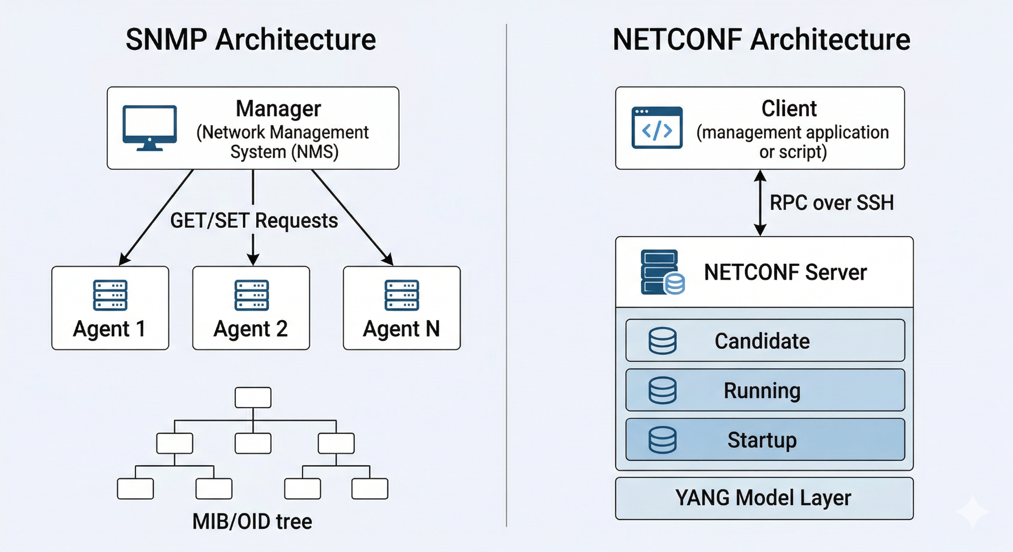
Fig. 4. SNMP vs NETCONF Architecture Comparison

Data Modeling Approach. SNMP relies on Management Information Bases (MIBs) defined using ASN.1, which provide a relatively rigid and flat representation of network data. Each managed object is identified by an Object Identifier (OID), with limited semantic relationships between objects. In contrast, YANG introduces a hierarchical, schema-driven modeling approach with rich semantics, constraints, and modular extensibility. This enables precise validation and representation of complex configurations. As discussed in [18], the combination of NETCONF and YANG allows for a tightly integrated model-driven framework, whereas SNMP lacks a formal mechanism for schema validation and structured configuration representation.

Configuration Management Capabilities. One of the most critical distinctions lies in configuration management. SNMP provides limited support through SET operations, which are non-transactional and applied on a per-variable basis. This approach can lead to inconsistent states when multiple related parameters are modified. In contrast, NETCONF supports atomic configuration changes through its commit operation, with rollback mechanisms and validation steps. Studies such as [11] demonstrate that NETCONF significantly reduces configuration errors and improves reliability in multi-parameter updates.

Communication Model and Efficiency. SNMP employs a polling-based communication model, which can lead to excessive control traffic and delayed state updates in large-scale networks. NETCONF, while still request-driven, enables more efficient interactions by supporting bulk operations and structured data retrieval. However, NETCONF’s use of XML encoding introduces additional overhead in terms of message size and parsing complexity. Empirical evaluations [5], [21] indicate that SNMP may outperform NETCONF in simple monitoring tasks due to its lightweight encoding, whereas NETCONF provides greater efficiency in complex configuration workflows by reducing the number of required interactions.

Scalability Considerations. Scalability is a critical concern in modern network environments. SNMP’s scalability is limited by its polling-based design, which does not scale well with increasing numbers of devices and managed objects. In contrast, NETCONF’s structured operations and support for batch configuration changes improve scalability in configuration management scenarios. Nevertheless, NETCONF’s performance can be affected by XML processing overhead, particularly in resource-constrained environments. Recent research suggests that combining NETCONF/YANG with streaming telemetry mechanisms (e.g., gNMI) provides a more scalable solution for real-time monitoring and analytics.

Security and Access Control. SNMPv3 introduced security features such as authentication and encryption, but its adoption remains inconsistent in practice. Furthermore, SNMP lacks fine-grained, role-based access control aligned with modern security requirements. NETCONF, on the other hand, leverages secure transport protocols such as SSH and TLS, providing stronger and more flexible security mechanisms. Additionally, NETCONF’s integration with YANG enables more granular control over configuration access, supporting modern security models.

Automation and Programmability. SNMP’s design does not inherently support automation or integration with modern orchestration systems. Its limited data modeling capabilities and lack of transactional operations hinder its use in automated workflows. In contrast, NETCONF/YANG is inherently designed for programmability, enabling integration with automation frameworks, SDN controllers, and intent-based networking systems. As highlighted in [25], YANG-based protocols facilitate intent translation and automated network configuration, making them essential for next-generation network management. With the rapid evolution of network technologies, traditional management protocols are gradually being complemented or replaced by more advanced and flexible solutions. The emergence of Software-Defined Networking (SDN) and Network Function Virtualization (NFV) has further highlighted the limitations of legacy protocols like SNMP, particularly in terms of scalability, automation, and real-time responsiveness. In this context, model-driven approaches such as NETCONF/YANG are becoming increasingly important, as they provide structured data models and support for programmability.

Moreover, the adoption of streaming telemetry and protocols like gNMI represents a significant shift from traditional polling-based monitoring to real-time, event-driven data collection. This enables more efficient network analytics, faster fault detection, and improved decision-making. As networks continue to grow in complexity, integrating NETCONF/YANG with modern telemetry systems is expected to play a key role in achieving intelligent and autonomous network management.

In conclusion, while SNMP remains useful for simple monitoring tasks due to its lightweight nature and widespread support, it is gradually being overshadowed by NETCONF/YANG in modern network environments. NETCONF offers better support for configuration management, security, and automation, making it more suitable for next-generation networks. Therefore, a hybrid approach that combines the strengths of both protocols, along with emerging technologies, can provide a balanced and efficient network management solution.

Summary Comparison. The key differences between SNMP and NETCONF/YANG are summarized in Table II.

Table II:
Comparative Analysis of SNMP and NETCONF/YANG
Dimension | SNMP | NETCONF/YANG
Architecture | Manager–Agent (stateless) | Client–Server (stateful, RPC-based)
Data Model | ASN.1 MIB (flat, limited semantics) | YANG (hierarchical, schema-driven)
Configuration Management | Non-transactional (SET operations) | Transactional (commit, rollback)
Communication Model | Polling-based | RPC-based, structured
Performance | Lightweight, efficient for monitoring | Higher overhead, efficient for config
Scalability | Limited (polling overhead) | Better for config; needs optimization
Security | SNMPv3 (limited adoption) | SSH/TLS-based, flexible
Automation | Limited | Strong (model-driven, API-enabled)
Validation | Minimal | Strong (schema-based validation)

In summary, SNMP and NETCONF/YANG are fundamentally designed for different eras and requirements of network management. While SNMP remains effective for lightweight monitoring tasks, it lacks the architectural and functional capabilities required for modern, automated, and large-scale network environments. NETCONF/YANG, despite introducing additional complexity and overhead, provides a comprehensive framework for transactional configuration management, structured data modeling, and programmability. Consequently, the transition from SNMP to NETCONF/YANG represents not merely an upgrade but a paradigm shift toward model-driven and automation-centric network management.

Performance Evaluation
The performance characteristics of network management protocols are critical in determining their suitability for large-scale and dynamic environments. While SNMP has historically been favored for its lightweight design and efficiency in monitoring tasks, NETCONF/YANG introduces additional overhead due to its structured and feature-rich architecture. This section critically evaluates the performance of SNMP and NETCONF/YANG based on metrics such as latency, bandwidth utilization, scalability, and operational efficiency, drawing from empirical studies and benchmarking analyses.
Latency and Response Time. One of the primary performance considerations is the latency associated with management operations. SNMP typically exhibits lower latency for simple retrieval tasks due to its compact message encoding using ASN.1 Basic Encoding Rules (BER). In contrast, NETCONF relies on XML-based encoding, which introduces additional parsing and serialization overhead. Empirical studies such as [5] demonstrate that NETCONF operations can incur higher response times, particularly for small, frequent queries. However, this disadvantage diminishes in scenarios involving complex configuration tasks, where NETCONF’s ability to perform batch operations reduces the number of interactions required, thereby improving overall efficiency.

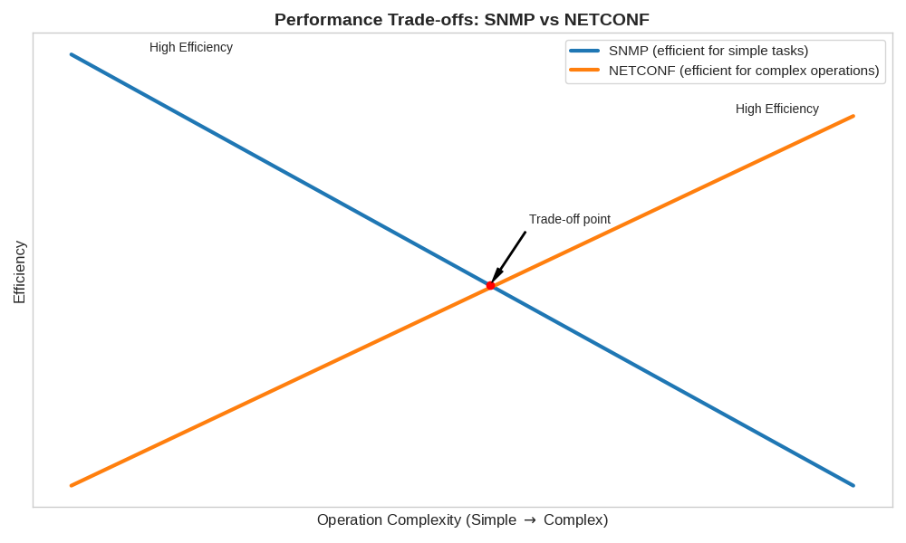
Fig. 5. Performance Trade-off Graph between SNMP and NETCONF

Bandwidth Utilization. SNMP’s lightweight message structure results in lower bandwidth consumption compared to NETCONF. The binary encoding of SNMP messages minimizes payload size, making it suitable for bandwidth-constrained environments. In contrast, NETCONF messages, encoded in verbose XML, can significantly increase bandwidth usage. Studies comparing protocol efficiencies [22] indicate that NETCONF messages may be several times larger than equivalent SNMP messages for simple operations. However, for complex configurations involving multiple parameters, NETCONF’s structured approach can reduce redundant exchanges, partially offsetting its higher per-message overhead.

Scalability and Polling Overhead. Scalability is a major limitation of SNMP, primarily due to its polling-based communication model. As the number of managed devices increases, the cumulative overhead of periodic polling can lead to network congestion and delayed data collection. Research in fog and IoT environments [21] shows that SNMP performance degrades significantly under high device density and frequent polling intervals. In contrast, NETCONF improves scalability in configuration management by supporting bulk operations and reducing the need for repeated interactions. Nevertheless, NETCONF’s scalability can be constrained by XML processing overhead and session management complexity, particularly in large deployments.

Throughput and Efficiency in Configuration Management. NETCONF demonstrates clear advantages in configuration management throughput due to its transactional capabilities. Studies such as [11] show that NETCONF can efficiently handle multi-parameter configuration updates by grouping changes into a single transaction, reducing the risk of inconsistencies and minimizing communication overhead.

SNMP, on the other hand, requires multiple SET operations for similar tasks, increasing both latency and the likelihood of partial failures. This difference becomes more pronounced in scenarios involving large-scale configuration changes, such as data center provisioning or network reconfiguration.

Performance in Virtualized and Modern Environments. In virtualized and cloud-based environments, the performance gap between SNMP and NETCONF becomes more evident. SNMP’s limitations in handling dynamic and rapidly changing configurations reduce its effectiveness, while NETCONF’s structured and transactional approach aligns better with the requirements of virtualization and orchestration systems. Experimental evaluations [11] indicate that NETCONF provides more consistent performance in virtualized router management, particularly when integrated with automation frameworks.

Comparative Observations from Literature. A synthesis of existing studies reveals that the performance trade-offs between SNMP and NETCONF are context-dependent. SNMP remains superior for lightweight monitoring tasks due to its low latency and minimal overhead. However, its performance degrades in large-scale environments due to polling inefficiencies. NETCONF, despite higher overhead, provides better performance in complex configuration scenarios by reducing interaction complexity and enabling atomic operations. Furthermore, the integration of NETCONF/YANG with modern telemetry mechanisms (e.g., streaming telemetry) further enhances its performance in real-time monitoring applications.
Summary of Performance Trade-offs. Table III summarizes the key performance characteristics of SNMP and NETCONF/YANG.

Table III:
Performance Comparison of SNMP and NETCONF/YANG
Metric | SNMP | NETCONF/YANG
Latency | Low for simple queries | Higher due to XML processing
Bandwidth Usage | Low (compact encoding) | High (verbose XML/JSON)
Scalability | Limited (polling overhead) | Better for configuration; needs tuning
Throughput | Low for multi-parameter updates | High (transactional operations)
Efficiency | High for monitoring | High for configuration workflows
Real-Time Capability | Limited | Improved with telemetry integration

In summary, SNMP and NETCONF/YANG exhibit distinct performance profiles that reflect their design priorities. SNMP is optimized for lightweight, low-overhead monitoring, making it suitable for simple and resource-constrained environments. In contrast, NETCONF/YANG prioritizes reliability, consistency, and expressiveness, resulting in higher overhead but significantly improved performance for complex configuration and automation tasks. Consequently, the choice between these protocols should be guided by the specific requirements of the network environment, with modern deployments increasingly favoring NETCONF/YANG due to its alignment with automation and scalability needs.

Challenges and Limitations
Despite the advancements of NETCONF and YANG over SNMP, several challenges continue to hinder their widespread adoption. A primary concern is the increased complexity and steep learning curve associated with model-driven management. Unlike SNMP’s simplicity, NETCONF introduces RPC mechanisms, multiple datastores, and transactional workflows, while YANG requires expertise in schema design and constraint modeling [10], [13], [18]. This complexity increases operational overhead and slows adoption, particularly in legacy environments. Additionally, model fragmentation remains a critical issue: although YANG promotes standardization, vendor-specific extensions and inconsistent implementations reduce interoperability and portability across multi-vendor networks [12], [17], [29]. These issues are further compounded by the evolving nature of standards and the lack of universally adopted modeling practices.

Performance and operational limitations also persist. NETCONF’s reliance on XML encoding introduces overhead in terms of bandwidth consumption, parsing complexity, and processing latency, which can impact scalability in large-scale or resource-constrained environments [5], [19], [22]. Furthermore, NETCONF’s request–response model limits its suitability for real-time monitoring, necessitating complementary solutions such as streaming telemetry and gNMI [26], [30], [35]. Security and access control, while improved through secure transport protocols, remain complex due to the need for fine-grained policy enforcement in automated environments. Integration with legacy SNMP-based systems adds another layer of difficulty, often requiring hybrid deployments that introduce synchronization and consistency challenges [16], [11]. Moreover, the tooling ecosystem for NETCONF/YANG, though growing, still lacks the maturity and standardization of SNMP-based tools, leading to inconsistencies in deployment and management workflows [8], [9].

From a research perspective, several open issues remain. There is a need for standardized frameworks to evaluate the performance and scalability of model-driven management systems, similar to earlier gaps identified in SNMP studies [24]. Interoperability across diverse YANG models, optimization for edge and IoT environments, and seamless integration with emerging paradigms such as intent-based networking, AI-driven automation, and autonomous systems require further investigation [25], [32], [33], [34]. In summary, while NETCONF and YANG address many limitations of SNMP, they introduce new challenges in complexity, performance, interoperability, and integration, underscoring that the evolution of network management is ongoing and demands continuous refinement to achieve fully automated, scalable, and intelligent systems.

Future Trends in Network Management
The evolution from SNMP to NETCONF/YANG marks a significant milestone; however, emerging paradigms such as Software-Defined Networking (SDN), intent-based networking (IBN), artificial intelligence (AI), and streaming telemetry are redefining modern network management. SDN introduces centralized and programmable control by decoupling control and data planes, where NETCONF/YANG serves as a key southbound interface enabling consistent configuration across heterogeneous devices. At a higher abstraction level, intent-based networking allows operators to define desired outcomes rather than low-level configurations, with YANG facilitating intent translation and validation [25]. Simultaneously, AI-driven techniques are enhancing network operations through predictive analytics, anomaly detection, and automated decision-making, with recent work demonstrating the feasibility of generating NETCONF configurations using generative models [12].

In parallel, streaming telemetry is replacing traditional polling-based monitoring by enabling real-time, push-based data collection, addressing scalability limitations of SNMP while complementing NETCONF’s configuration capabilities. The adoption of cloud-native and microservices-based architectures further accelerates this transformation, with RESTCONF enabling integration between YANG-based models and modern web-based systems. However, these advancements introduce new challenges related to orchestration, interoperability, and security. In particular, zero-trust security models are becoming essential, requiring fine-grained access control and robust authentication mechanisms within automated and dynamic environments.

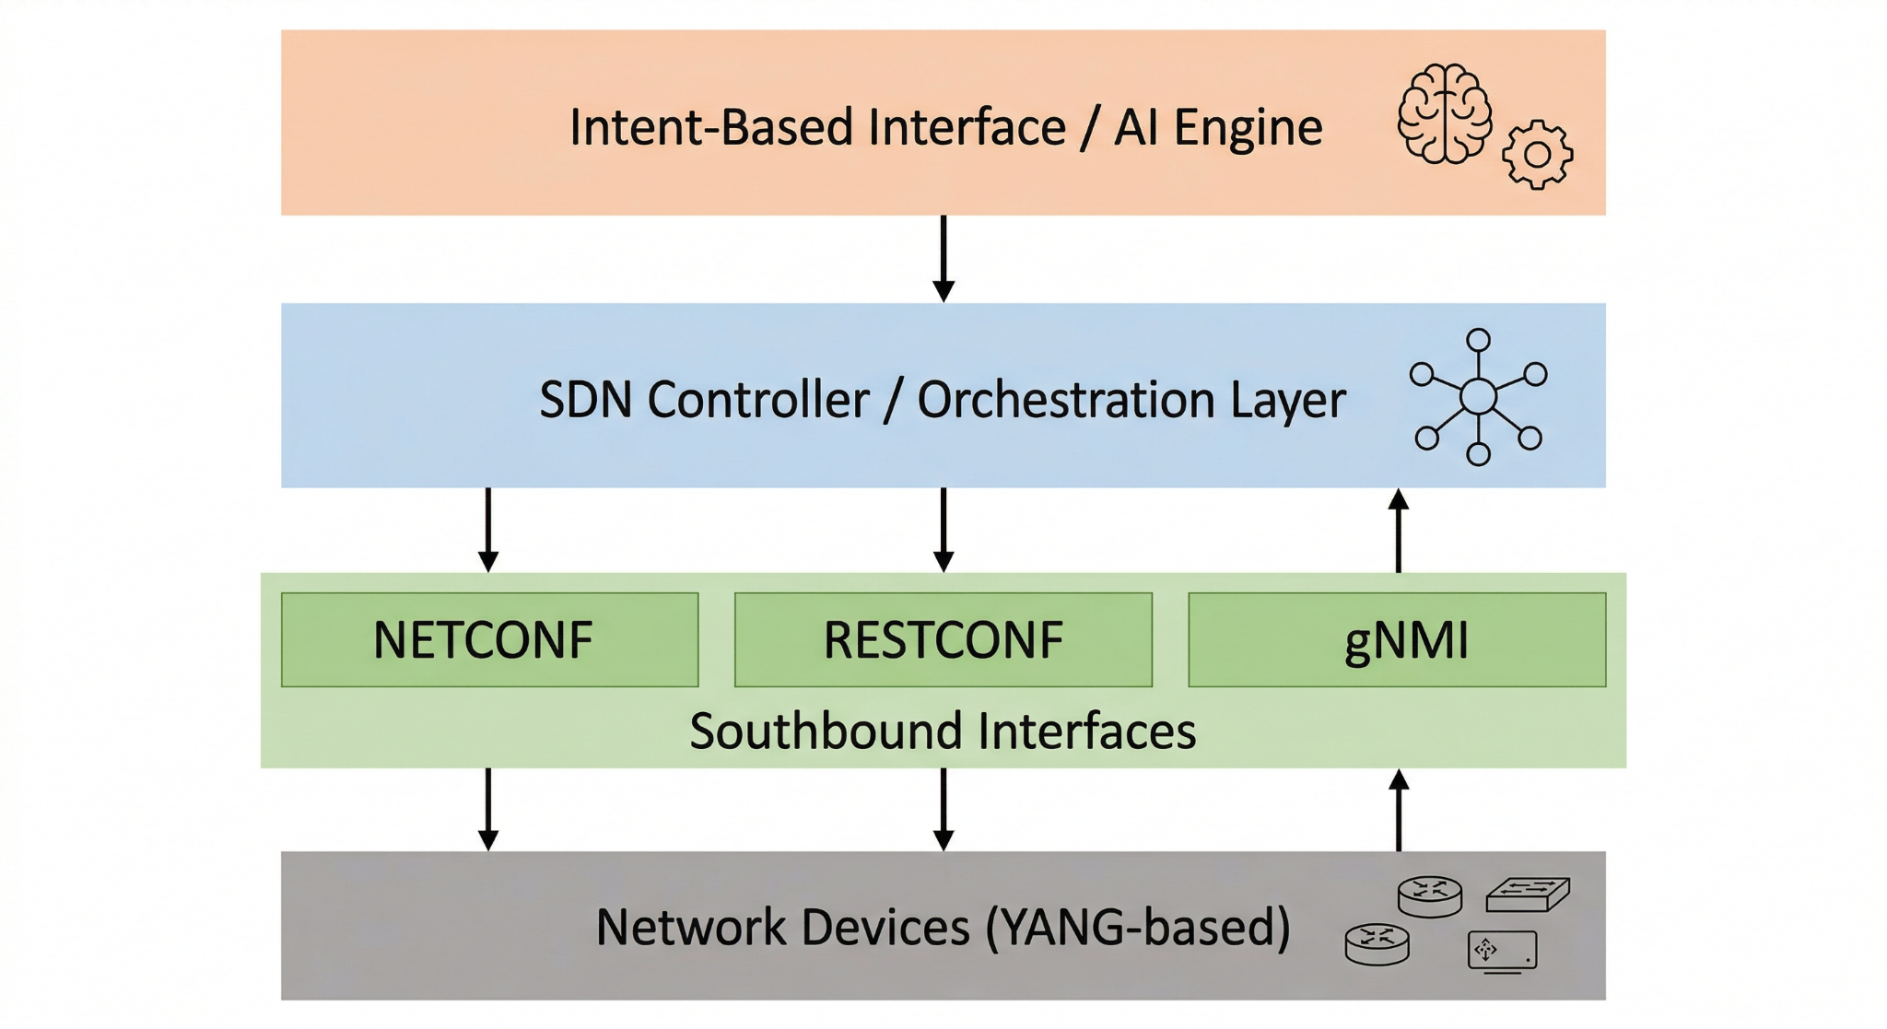
Fig. 6. Future Network Management Architecture

Conclusion
This survey critically examined the evolution of network management from SNMP to NETCONF/YANG, highlighting a fundamental shift from protocol-centric monitoring to model-driven, automation-oriented frameworks. While SNMP has played a foundational role and remains relevant for lightweight monitoring, it is constrained by inherent limitations such as its polling-based communication model, lack of transactional configuration support, and rigid MIB-based data representation. These shortcomings make it increasingly unsuitable for modern network environments characterized by scale, dynamism, and automation requirements. In contrast, NETCONF introduces transactional configuration management, structured RPC-based communication, and secure transport mechanisms, while YANG provides a hierarchical, semantically rich, and extensible data modeling framework, together forming the foundation of model-driven network management.

Despite these advancements, NETCONF/YANG introduces trade-offs, including increased complexity, performance overhead, and challenges related to interoperability and model fragmentation. Moreover, emerging requirements such as real-time telemetry, intent-based management, and AI-driven automation reveal limitations that extend beyond both SNMP and NETCONF, necessitating the integration of complementary technologies such as streaming telemetry and intent-based frameworks. The comparative and performance analyses indicate that the choice of network management approach remains context-dependent: SNMP is efficient for simple, resource-constrained monitoring tasks, whereas NETCONF/YANG offers superior scalability, consistency, and programmability for complex configuration and automation scenarios. Consequently, modern network management increasingly adopts hybrid and model-driven approaches that leverage the strengths of multiple protocols.

Finally, this survey identifies key research challenges, including improving interoperability across YANG models, optimizing performance in large-scale and resource-constrained environments, and integrating model-driven management with emerging paradigms such as autonomous networking and AI-driven decision-making. Addressing these challenges is essential for realizing fully automated, scalable, and intelligent network management systems. Overall, the transition from SNMP to NETCONF/YANG represents not merely an incremental improvement but a paradigm shift that redefines network management, with future systems expected to integrate model-driven approaches with advanced analytics, automation, and real-time telemetry.

References
[1] M. Aboubakar et al., "A review of IoT network management," 2022.
[2] S. M. Moindze and K. Konate, "Distributed network management models," 2014.
[3] T. Li et al., "Network Management for xANET," IEEE Communications Surveys & Tutorials, 2026.
[4] J. Ding, Advances in Network Management.
[5] J. Yu and I. Al Ajarmeh, "Empirical Study of NETCONF," 2010.
[6] P. Goncalves et al., "Evaluation of network management protocols," 2009.
[7] G. Pavlou, "Evolution of management approaches," 2007.
[8] S. Wallin and C. Wikstrom, "Automating using NETCONF and YANG."
[9] R. Krejci, "NETCONF-enabled systems," 2013.
[10] J. Ruohonen, "Evaluating YANG and NETCONF."
[11] P. Santos et al., "SNMP vs NETCONF," 2015.
[12] G. Hollosi et al., "AI for NETCONF," 2024.
[13] D. Valencic et al., "NETCONF implementation," 2019.
[14] K. Elbadawi et al., "Configuration management improvements," 2011.
[15] K. Sankar, "IoT Device Management with NETCONF-YANG."
[16] B. Wu and Y. Chang, "Integrating SNMP and NETCONF," 2010.
[17] D. Valencic et al., "Monitoring with NETCONF," 2025.
[18] J. Schonwalder et al., "NETCONF and YANG," IEEE Communications Magazine, 2010.
[19] M. Slabicki et al., "Performance evaluation SNMP vs NETCONF," 2015.
[20] Yoo et al., "Performance improvements for NETCONF," 2006.
[21] M. Slabicki et al., "SNMP vs NETCONF in fog," 2016.
[22] B. Hedstrom et al., "Protocol efficiencies SNMP vs NETCONF."
[23] W. Stallings, "SNMP overview," IEEE Communications Magazine, 1998.
[24] A. Lahmadi et al., "SNMP performance survey," 2009.
[25] A. Ramchandra et al., "Intent-based networking with YANG," 2025.
[26] A. Clemm et al., "Network Telemetry: Key Concepts and Open Issues," IEEE Communications Magazine, 2022.
[27] E. Haleplidis et al., "Software-Defined Networking: State of the Art and Research Challenges," IEEE Communications Surveys & Tutorials, updated perspectives 2022.
[28] R. Enns et al., "Network Configuration Protocol (NETCONF) Extensions and Usage," IETF updates, 2023.
[29] M. Bjorklund et al., "YANG Next Generation Enhancements," IETF Drafts and RFC updates, 2023–2024.
[30] Cisco Systems, "Streaming Telemetry and gNMI in Modern Networks," White Paper, 2023.
[31] Juniper Networks, "YANG and Model-Driven Telemetry," Technical Report, 2024.
[32] L. Contreras et al., "Intent-Based Networking: Concepts and Challenges," IEEE Network, 2022.
[33] H. Kim et al., "AI-Driven Network Management: A Survey," IEEE Access, 2023.

