An Interactive RAG-Enhanced Generative AI Framework for Molecular Design

Harshit Notani
Department of Computing Technologies SRM Institute of Science and Technology Kattankulathur, Chennai, India
Rishit Sharma
Department of Computing Technologies SRM Institute of Science and Technology Kattankulathur, Chennai, India
Ramkumar Jayaraman
Department of Computing Technologies SRM Institute of Science and Technology Kattankulathur, Chennai, India

Abstract — The vast size of chemical space presents a significant challenge in modern drug discovery, making efficient molecular design a critical research problem [5], [17]. While generative artificial intelligence models have shown promise in de novo molecule generation, many approaches suffer from limited chemical validity and insufficient utilization of existing chemical knowledge [1], [10]. To address these limitations, this paper presents an interactive Retrieval-Augmented Generation (RAG) enhanced generative AI framework for molecular design [18], [19].
The proposed framework integrates large-scale molecular knowledge retrieval with deep generative modeling to guide molecule synthesis [13]. A curated dataset of 196,627 PubChem molecules is used to construct a molecular knowledge base, where embeddings are indexed using FAISS to enable efficient similarity-based retrieval [12]. Retrieved molecules provide contextual seeds that improve the relevance and stability of the generative process [18]. To ensure chemically valid generation, molecular structures are represented using Self-Referencing Embedded Strings (SELFIES) [1].
Our framework evaluates LSTM, GRU, and Transformer architectures using RDKit-based metrics like QED, novelty, and Lipinski compliance. The SELFIES-LSTM model achieved 100% molecular validity with high diversity, all accessible through an interactive platform for real-time analysis.
Keywords—Retrieval-Augmented Generation, Molecular Design, Generative Artificial Intelligence, Drug Discovery, SELFIES Representation, FAISS Vector Database, Deep Learning, PubChem Dataset, Cheminformatics.

Introduction

Drug discovery is a complex process and requires substantial resources for the identification, optimization, and validation of candidate molecules that exhibit desirable biological activity and safety profiles [5], [17]. One of the challenges in drug discovery is that the chemical space is estimated to be larger than 10⁶⁰ drug-like molecules [5]. The reason why the exploration of this chemical space using traditional experimental screening and rule-based computational approaches is not feasible is that it is not possible to explore this chemical space [3].
However, recent breakthroughs in artificial intelligence have greatly impacted the computational process of drug discovery [5]. Machine learning algorithms have been extensively used in the prediction of molecular properties, activity prediction, and virtual screening [3], [9]. More recently, generative artificial intelligence has enabled the direct synthesis of novel molecular structures by learning chemical patterns from large compound databases [5] , [17]. Deep learning models like Long Short-Term Memory (LSTM) networks, Gated Recurrent Units (GRU), and transformer models have shown promising results in the generation of molecules described as sequential strings [10], [16], [8].
However, existing generative models have several drawbacks [1]. These models are mostly based on Simplified Molecular Input Line Entry System (SMILES) strings, which have strict syntactical constraints [1]. Small prediction inaccuracies can cause the generation of invalid molecules, making the process less efficient [1]. Moreover, purely parametric generative models are solely dependent on learned weights and tend to make molecules unrealistic or less drug-like [5].
To address syntactic instability, Self-Referencing Embedded Strings (SELFIES) have been introduced as a chemically robust molecular representation that guarantees valid decoding for any generated token sequence [1]. By eliminating invalid molecular outputs, SELFIES allow generative models to focus on chemical optimization rather than grammar enforcement [1], [4]. SELFIES greatly enhances stability, validity, and overall generation quality when paired with recurrent neural networks [4].
Simultaneously, it has been demonstrated that the Retrieval-Augmented Generation (RAG) paradigm is an efficient way to improve generative models by using external knowledge sources during the inference step [18], [19].Instead of relying only on the model parameters, RAG models have been demonstrated to be able to retrieve relevant context information from large databases before the generation step [13]. Although successful in natural language generation, the application of RAG in molecular design is still limited [18].
Inspired by these findings, this paper presents an interactive RAG-enhanced generative AI approach for molecular design [18], [19]. The proposed approach combines large-scale molecular retrieval from the PubChem database with deep generative modeling to support knowledge-informed molecule synthesis [3]. A filtered dataset of 196,627 PubChem molecules is employed to build a molecular knowledge base, in which molecular embeddings are indexed with Facebook AI Similarity Search (FAISS) for efficient similarity search [12].
The retrieved molecules are used as context-aware seeds to inform the generative process, ensuring that the generated molecules are well-aligned with the known chemical space, while also allowing for the discovery of new molecules [18]. The proposed approach supports and compares the use of different generative architectures, such as LSTM, GRU, Transformer, and SELFIES-based LSTM [10], [16]. The generated molecules are assessed using RDKit cheminformatics libraries according to chemical validity, uniqueness, novelty, Lipinski rule satisfaction, and quantitative estimates of drug-likeness (QED) [7], [14]. Additionally, an interactive web-based interface is designed to support real-time molecular generation, visualization, and comparison [7].
The main contributions of this research work include the combination of retrieval-augmented intelligence with molecular generation, the large-scale evaluation of different generative architectures, and the demonstration of chemically robust molecular generation using SELFIES [1], [4], [18]. The proposed framework provides a scalable and interpretable solution for early-stage drug discovery and establishes a foundation for future research in knowledge-guided molecular design [17].

Literature Survey

The use of artificial intelligence in drug discovery has experienced a substantial increase in the last decade because of the improvements in deep learning methods, the availability of large datasets of chemicals, and the improvements in computing capabilities [5], [17]. The initial approaches in computational models were mainly based on molecular descriptors and hand-engineered features, and traditional machine learning models such as support vector machines and random forests [3]. Although successful in property prediction, these models did not have the capability to design new molecular structures [5].
The development of deep generative models brought about a paradigm shift in the design of molecules [5], [15]. Recurrent Neural Networks, particularly Long Short-Term Memory (LSTM) Networks, were among the first models to be used for designing molecules in SMILES string representation [10]. These models demonstrated the capacity to learn chemical grammar and create new molecules, but because SMILES strings have a subtle grammar, they were prone to creating invalid molecules [1].Gated Recurrent Unit (GRU) networks were later introduced to accelerate training and mitigate vanishing gradient issues, although the issue of generating valid molecules remained a challenge [10].
Transformer models have recently received attention in molecular generation because of their self-attention mechanisms and capacity to model long-range dependencies [16], [8]. Transformers have been shown to increase molecular diversity and complexity in a number of studies [16], [20]. However, transformers still exhibit syntactic instability when working directly on SMILES representations, and they often require substantial amounts of computational power and training data [16].
Other molecular representations have been suggested as a solution to the shortcomings of SMILES-based generation [1]. Self-Referencing Embedded Strings (SELFIES) [1] introduced a grammar-free molecular encoding that guarantees valid molecular structures upon decoding. SELFIES has been demonstrated to dramatically increase training stability and validity rates across a range of generative architectures [4]. As a result, deep generative chemistry applications have seen a rise in the use of SELFIES-based models [1], [4].
Although graph-based techniques such as GNNs and VAEs provide direct structural modeling, they frequently encounter scalability and complexity problems when used with large datasets. Recent studies demonstrate how effectively Retrieval-Augmented Generation (RAG) can incorporate external domain knowledge to better direct the generative process.
Vector similarity search methods, particularly Facebook AI Similarity Search (FAISS), enable efficient indexing and retrieval from large datasets [12]. Retrieval-based frameworks have proven to perform well in text generation, but their use in molecular design is still rather restricted [18].
Some recent studies have investigated knowledge-guided molecule generation, where models are conditioned on known molecules or biological targets [17]. Nevertheless, most of these methods are based on predefined templates or require heavy annotations in the domain [17]. There are very few studies that combine large-scale molecular retrieval, effective chemical representation, and deep generative models in a single framework [18].
According to this review, there are three main issues with current molecular generative systems: (i) limited use of existing chemical knowledge during generation, (ii) lack of interactive tools for real-time evaluation and analysis, and (iii) inadequate chemical validity because of representation constraints [1], [18]. In order to overcome these obstacles, the current work combines SELFIES-based deep learning models with retrieval-augmented generation, allowing for chemically robust, knowledge-guided, and user-interactive molecular design [1], [18], and [19].

Problem Definition

The creation of novel drug-like compounds is inherently challenged by the sheer size of chemical space [5], [17]. Although deep generative models have demonstrated promising capabilities for the de novo generation of molecules, the current state-of-the-art models are affected by a number of open issues that make them less applicable in real-world drug discovery settings [5].
Firstly, the majority of existing generative molecular models are based on string-level SMILES representations, which come with strict grammatical and syntactic constraints [1]. Small prediction inaccuracies during the generation of molecular sequences often cause the generated molecules to be invalid, thereby drastically impairing the efficiency of molecular generation [1]. This means that a large number of generated molecules need to be rejected, thereby wasting computational resources [1].
Secondly, many generative models are purely parametric, relying solely on the learned weights of neural networks [5]. These models do not integrate external chemical knowledge during the generation phase [18]. Consequently, the produced molecules might fall beyond the established chemical space, exhibit impractical structural distributions, or lack fundamental drug-likeness criteria [5], [9]. The lack of knowledge grounding hinders both interpretability and chemical relevance [18].
Thirdly, although large-scale chemical databases such as PubChem have vast amounts of validated molecular data, current generative models hardly make use of this information dynamically during inference [3]. Without efficient retrieval systems, models cannot make use of structurally similar molecules that can help guide the generative process towards chemically significant areas [12], [13].
Moreover, some generative models have been found to focus on molecular diversity without considering chemical feasibility and pharmacological constraints [17]. This has often resulted in models generating highly novel but invalid and non-drug-like molecules, which are of limited practical use [1]. The Transformer models also bring about computational issues, as they are generally resource-intensive during training and still vulnerable to representation errors [16].
Finally, most existing systems lack interactivity and real-time evaluation capabilities [7]. Researchers encounter difficulties in comparing model outputs, assessing chemical quality during generation, and iteratively testing design hypotheses as generated molecules are often examined offline [7].
In response to these constraints, this work attempts to address the main challenge of developing a molecular generation framework that reliably generates chemically valid compounds, integrates extensive chemical knowledge during the generation process, permits comparisons across various deep learning architectures, and supports real-time evaluation and analysis of the generated molecules [1], [5], and [18].
The proposed method aims to overcome these challenges and enable knowledge-guided, chemically robust, and user-interactive molecular design by integrating retrieval-augmented generation with SELFIES-based deep learning models [1], [18], and [19].

System Design

The proposed system for molecular design integrates state-of-the-art generative artificial intelligence techniques with retrieval-augmented learning to enable reliable and knowledge-guided molecule generation [5], [18]. The framework combines deep learning–based generative models, robust molecular representations, large-scale chemical knowledge retrieval, and cheminformatics-based evaluation within a unified interactive platform [1], [7].
The system is developed using the PyTorch deep learning library and is an end-to-end system starting from the preprocessing of the dataset to the learning and generation of molecules [10]. The primary aim of the system is to generate new molecules that are chemically valid and drug-like by incorporating knowledge of chemistry during the generation phase [1], [5]. For this purpose, various deep generative models are explored and compared, including LSTM, GRU, Transformer, and SELFIES-LSTM [10], [16].
The system is composed of six major phases: dataset preparation, molecular representation, retrieval-augmented knowledge modeling, generative learning, chemical evaluation, and interactive visualization [7], [18].

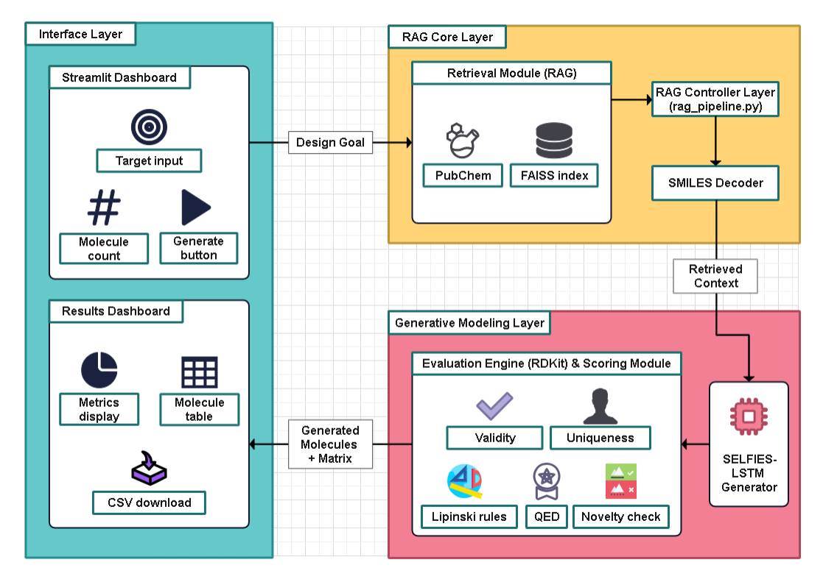
Fig. 1. Overall System Architecture.
A. Dataset And Data Preprocessing
The PubChem database provided 196,627 experimentally verified molecular data records to ensure high structural and functional diversity. An extensive RDKit-based preprocessing pipeline was used to remove anomalous valence configurations, invalid strings, and missing atomic data from the data, which was originally in SMILES format. In order to standardize the dataset, reduce noise, and speed up model convergence, structures were further improved through canonicalization and duplicate removal.
Following the cleaning process, the data is divided into training and validation subsets [10]. The preprocessed molecular data is utilized for two tasks: (i) training deep generative models to learn the distribution of molecular sequences, and (ii) building a molecular knowledge base for retrieval-augmented generation [18]. This two-fold usage allows for a seamless connection between learning from data and reasoning using knowledge [18].
B. Molecular Representation Using SELFIES
The efficiency of generative modeling is largely dependent on molecular representation [1]. Due to the strict grammatical syntax of traditional SMILES-based representations, even small prediction errors during sequence generation can lead to invalid molecular structures [1]. These restrictions have a detrimental effect on model reliability and drastically lower generation efficiency [1].
The suggested system uses Self-Referencing Embedded Strings (SELFIES) as the main molecular representation in order to solve this problem [1]. No matter the token configuration, SELSFIES' limited semantic grammar guarantees accurate molecular decoding during the encoding of chemical structures [1]. This feature guarantees that each produced SELFIES sequence corresponds to a chemically viable molecule [1].
Before training, all SMILES strings are transformed into SELFIES strings in the proposed framework [1]. The SELFIES strings are then converted into discrete tokens that are processed as sequential data for the generative models [10]. This approach enables the learning process to concentrate on significant chemical transformations as opposed to syntactic validity [1], [4].
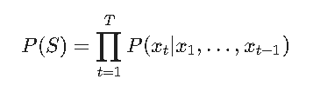
The adoption of SELFIES significantly enhances model stability, increases valid molecule generation rates, and enables consistent learning across different deep learning architectures [1], [4]. Additionally, the SELFIES representation makes decoding easier and allows for smooth integration with tools for chemical evaluation downstream [14].
C. Retrieval-Augmented Knowledge Modeling
The generative models trained on the parameters of neural networks alone tend to be unaware of the known chemical space, leading to the generation of unrealistic or chemically impossible molecules [18]. To address this shortcoming, the proposed system incorporates a Retrieval-Augmented Generation (RAG) strategy, which allows the use of external molecular knowledge during the generation process [18], [19].
Molecular embeddings are created for the entire PubChem dataset using pre-trained embedding models that learn structural and semantic relationships between molecules [11]. These embeddings are then indexed using Facebook AI Similarity Search (FAISS), which facilitates efficient and high-speed nearest-neighbor search for large molecular datasets [12], [13].
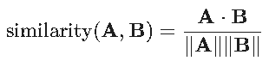
In the generation process, the system looks for similar molecules structurally within the knowledge base based on similarity scores [12]. The molecules obtained serve as context clues and are used as seed molecules for the generative model [18]. The method ensures that the generation process is grounded in the known space of chemistry while allowing the exploration of new variations of molecules [18].

Algorithm 1: RAG-Enhanced Molecular Generation
Input: Design Goal G, Knowledge Base K, Trained Model M
Output: Generated Molecule Set S
Begin
1: Convert G → embedding E_g
2: Retrieve similar molecules
seeds ← FAISS_Search(K, E_g, k)
3: For each seed ∈ seeds
4: Convert SMILES → SELFIES
5: Initialize sequence = [START] + tokens
6: Generate tokens using M.predict()
7: Convert SELFIES → SMILES
8: Evaluate using RDKit metrics
9: If molecule valid and unique → add to S
10: End For
11: Return S
End

The integration of retrieval-based context improves chemical realism a enhances drug likeness, and reduces random or unstable generation behavior [18]. By combining parametric deep learning with non-parametric knowledge retrieval, the system effectively bridges learned molecular patterns with experimentally validated chemical information [18], [19].
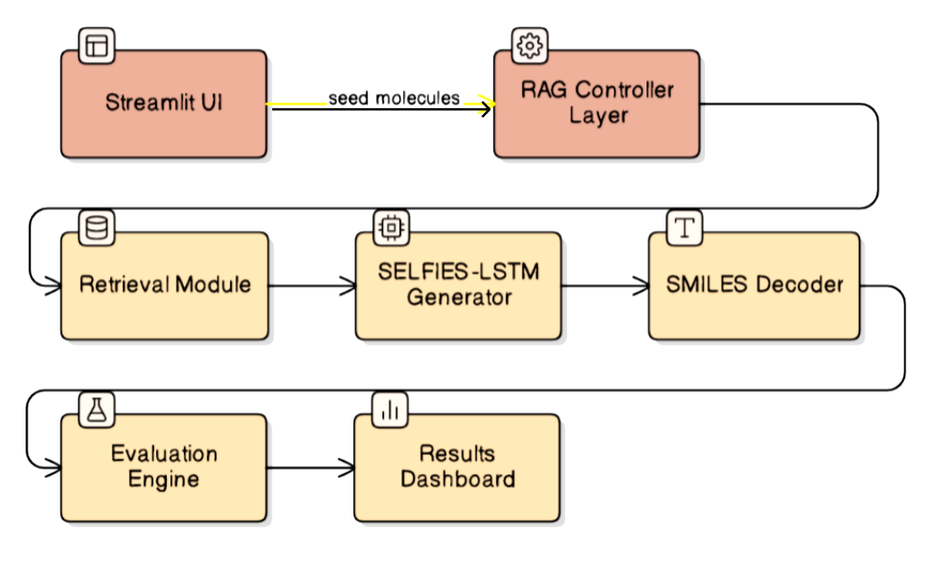
Fig. 2. Molecular Generation Pipeline.
D. Generative Model Architectures
The proposed framework combines different deep learning-based generative architectures to assess their performance in molecular sequence modelling [5, 17]. Each model uses an autoregressive approach to learn the conditional probability distribution of molecular tokens from sequential data [10], [16].
Long Short-Term Memory (LSTM) networks are used because they are able to capture long-range dependencies within molecular sequences [10]. Their gating mechanisms enable learning complex chemical patterns and also alleviate vanishing gradient problems [10].
LSTM networks can be replaced with computationally efficient Gated Recurrent Unit (GRU) models [10]. GRUs provide faster training with fewer parameters and simpler gating structures, but they may not be as capable of representing very complex molecular sequences [10].
Transformer models learn global dependencies between molecular tokens through self-attention mechanisms [16], [8]. Although transformers increase molecular diversity and parallelisation capabilities, they can be computationally expensive and require large training datasets [16], [20]. Moreover, transformer decoding is prone to syntactic errors when used with sequence-based molecular representations [16].
Chemically robust SELFIES representations and the benefits of recurrent neural networks are combined in the proposed SELFIES-LSTM architecture [1], [4]. The model consists of a fully connected output projection, stacked LSTM layers, and an embedding layer [10]. To balance structural stability and molecular diversity during generation, token sampling with temperature scaling is employed [10].

E. Model Comparison And Selection
In order to compare the best generative method, comparative experiments were conducted among the LSTM, GRU, Transformer, and SELFIES-LSTM models [10], [16]. The models were compared in the same environment and datasets [5].
The experimental results indicate that the SMILES-based LSTM and GRU models tend to generate invalid molecules due to syntax errors [1]. The Transformer models tend to have better diversity but are unstable during the decoding phase and have lower validity rates when the computational environment is limited [16].
On the other hand, the SELFIES-LSTM model tends to generate valid molecules due to the grammar-free nature of the SELFIES representation [1].Without sacrificing validity, the model typically exhibits high diversity and better stability during training epochs [4].
The SELFIES-LSTM architecture is chosen as the final generative model based on the experimental evaluation and analysis because it strikes the best possible balance between diversity, computational efficiency, and chemical validity [1], [4], and [5].

F. Interactive Visualization And Output
Using the Streamlit framework, an interactive visualisation module is developed to allow real-time exploration of generated molecules [7]. Through the interface, users can start retrieval-augmented generation, set design targets, and regulate the quantity of molecules produced [18].

The system dynamically displays evaluation metrics such as average QED values, validity percentage, uniqueness ratio, novelty score, and Lipinski compliance rate [7]. The generated molecules and computed chemical properties are shown in tabular form [14].

Users can download the generated datasets to integrate them with molecular docking pipelines or perform further analysis [6], [9]. The interactive environment enables easy comparison of different generative models, rapid hypothesis testing, and iterative experimentation [7].
By this visualisation of layer we makes the framework a useful tool for early-stage drug discovery research [5, 17].

Experiments And Results

To evaluate the model dataset of 196,627 valid molecules was acquired from PubChem dataset. The preprocessing pipeline included canonicalization, invalid structure filtering, and conversion from SMILES to SELFIES. These methods ensured stable training, decreased syntactic errors, and enhanced convergence across different architectures.
The PyTorch deep learning library was used for all of the experiments [10]. The models were trained using the Adam optimizer with a fixed learning rate, and categorical cross-entropy loss was used as the loss function for molecular token prediction [10]. Temperature-based sampling was used during inference to get a trade-off between structural diversity and chemical validity [10]. The models were trained on a CPU-based local computing environment, which shows the computational viability of the proposed approach without using any specialized hardware [10].
The experimental findings further align with prior studies demonstrating the effectiveness of deep generative modeling in capturing complex chemical distributions and supporting biologically meaningful molecular synthesis [15].
A. Training Behavior And Convergence Analysis
Although there were noticeable differences in learning consistency and convergence speed between architectures, all generative models displayed generally stable convergence trends during training [10], [16]. The SELFIES-LSTM model demonstrated the most reliable training behaviour with a steady and smooth reduction in training loss over epochs among all models[1], [4]. This stability implies efficient learning of molecular token dependencies and strong handling of long molecular sequences [10].

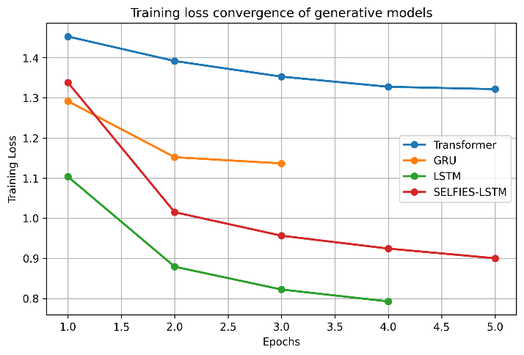
Fig. 5. Training Loss Convergence of Generative Models Across Training Epochs.

Conversely, the SMILES-based LSTM and GRU models had a fluctuating loss during training [1]. The main reason for this is the strong grammatical constraints of the SMILES representation, where small prediction errors compound over the next tokens, leading to an invalid molecule structure [1]. The invalid sequences have a negative impact on the gradient update [1].
The Transformer architecture demonstrates rapid initial loss reduction through self-attention, but when producing lengthy sequences in limited computing environments, it encounters instability and decoding errors. In contrast, the SELFIES-LSTM model achieves greater stability and convergence. By employing chemically constrained SELFIES encoding to eliminate syntactic ambiguity, the model concentrates on structural relationships rather than grammar correction, enabling effective training even on CPU-based systems.
B. Quantitative Evaluation Metrics
- Each trained model was used to produce 150 novel molecular structures under the same experimental conditions in order to quantitatively assess generation quality [7]. To guarantee a fair comparison of all molecules were sampled at the same temperature and using the same decoding technique [10].
- RDKit cheminformatics tools were used to evaluate generated compounds according to the following standards [14]:
- Molecular validity, which quantifies effective chemical parsing [1]
- Structural uniqueness, which signifies molecular diversity [7]
- Compliance with the Lipinski rule of five, which evaluates drug-likeness [5]
- Novelty, calculated by comparing it to the PubChem dataset [3].
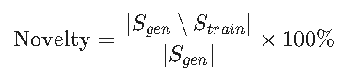
- Drug-likeness quantitative estimation (QED) [7]
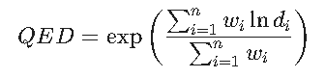

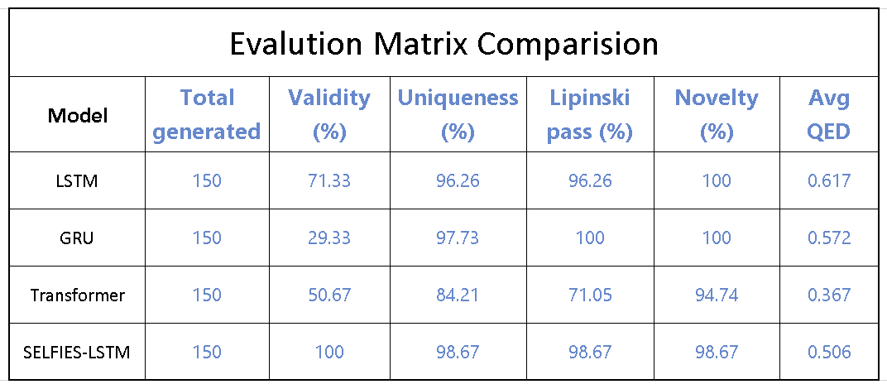
Table 1. Generative Model Performance Comparison.

The outcomes unequivocally show that the SELFIES-LSTM architecture is superior [1], [4]. It outperforms all baseline models by a significant margin and achieves 100% molecular validity [1]. Despite the transformer model's respectable diversity, its lower QED scores and relative validity suggest less chemical viability [16]. While traditional LSTM models perform moderately but inconsistently, GRU-based models exhibit poor validity because of unstable sequence decoding [10].
Overall, the quantitative analysis highlights the importance of chemically robust molecular representation in achieving reliable generative performance [1], [4].
C. Chemical Property Distribution Analysis
To analyze chemical quality and the distribution of key physicochemical properties primarily molecular weight and LogP (octanol-water partition coefficient) was investigated. These factors are critical in determining a drug's absorption, permeability, and overall bioavailability
Within the permissible range of drug-like molecular properties, the molecular weight was distributed between 200 and 500 Da [5]. Additionally, the LogP values were distributed in moderate ranges, indicating a good balance between solubility and lipophilicity and preventing potential toxicity and solubility issues [9].
The SMILES generative models, on the other hand, produced molecules with properties that are more distributed, including those with very high molecular weight or high lipophilicity [1]. These characteristics bolster the importance of context retrieval and SELFIES representation in improving the generative model [1], [18].
It is clear from the property distributions that the proposed framework can generate valid molecules with realistic physicochemical properties, which can be used for downstream drug discovery applications such as molecular docking, lead optimisation, and ADMET studies [5, 9, 17].
D. Novelty And Diversity Assessment
The novelty evaluation was performed by comparing the newly generated molecular structures with the original PubChem dataset used for training and retrieval [3]. A molecule was considered novel if its SMILES representation was not present in the reference database [2]. The SELFIES-LSTM model achieved a novelty percentage of 98.67%, which indicated its outstanding exploration capability, even in areas unexplored by known chemical molecules, while ensuring chemically valid molecules [1], [4].
In addition to the novelty, the structural diversity of the molecules was also evaluated using uniqueness scores and scaffold-based diversity analysis [7]. The high uniqueness percentages in the produced batches of molecules show that the model avoids the production of similar molecules and effectively searches different molecular scaffolds [7]. The extent of scaffold diversity found in the produced molecules shows that the molecule generation task is not only focused on modifying the searched molecules but also produces diverse molecules [17].
The novelty and retrieval distribution further supports the fact that the retrieval-augmented generation process is not limited to the reproduction of existing molecules [18]. Rather, the molecules that are retrieved serve as a set of guiding references that not only limit the generation process to the realm of realistic chemical space but also provide enough flexibility to facilitate innovation [18].
The simultaneous visualization of novelty, uniqueness, and drug-likeness scores through the interactive interface enabled the researchers to track the generative process in real time [7]. This enabled the researchers to assess the exploration and chemical feasibility trade-off during the synthesis of molecules dynamically [7].
The results mentioned above clearly show that the proposed framework provides a good trade-off between novelty and diversity, which are two important requirements for early-stage drug discovery [5], [17].

E. Retrieval-Augmented Generation Impact
To evaluate the contribution of retrieval-based contextual guidance, comparative experiments were conducted with and without retrieval augmentation [18]. In the non-retrieval setting, generative models relied solely on learned neural parameters, whereas in the retrieval-augmented configuration, structurally similar molecules were first retrieved from the FAISS-indexed PubChem knowledge base and used as seed context [12], [13].
Retrieval augmentation models continuously demonstrated higher average QED scores, decreased invalid molecule generation, and enhanced training stability [18]. The retrieval mechanism provided chemically meaningful starting points that guided sequence prediction toward feasible molecular patterns, particularly in the early stages of decoding [18].
Models often generate highly random, irrational structures in the absence of retrieval guidance. The process is successfully anchored within the known chemical space by integrating FAISS-based retrieval, which preserves novelty while preserving drug-like molecular weight and lipophilicity distributions. Deep learning and knowledge-based reasoning are combined in this hybrid parametric/non-parametric approach to stabilize generative behavior. Additionally, this impact can be directly compared using metrics like QED and Lipinski compliance thanks to the Streamlit-based interactive environment.

Conclusion

This paper introduced an interactive Retrieval-Augmented Generation (RAG) improved generative artificial intelligence framework for molecular design [18], [19]. The proposed framework combines large-scale chemical knowledge retrieval with deep generative models to tackle major challenges in de novo molecule generation, such as chemical validity, insufficient knowledge grounding, and a lack of interpretability [1], [5].
The proposed framework leverages a carefully curated dataset of 196,627 PubChem molecules and indexes molecular embeddings using FAISS to facilitate the efficient retrieval of structurally similar molecules to guide the generative process [12]. The use of Self-Referencing Embedded Strings (SELFIES) guarantees syntactically and chemically valid molecular decoding, greatly improving the stability of molecular generation for deep learning models [1].
Extensive experimental assessments were carried out using various generative models, such as LSTM, GRU, Transformer, and SELFIES-LSTM models [10], [16]. The quantitative experimental results clearly show that the SELFIES-LSTM model can guarantee 100% molecular validity while retaining high structural uniqueness, novelty, and desirable drug-likeness properties [1], [4]. The results also show that the proposed retrieval-augmented generation approach improves molecular realism, enhances chemical property distributions, and decreases the number of unstable and infeasible molecules [18].
The combination of RDKit-based cheminformatics assessment and the interactive visualization tool allows for the real-time assessment of the molecules that are being produced [7], [14]. The proposed system effectively strikes a balance between innovation and feasibility, making it an ideal candidate for early-stage drug discovery and lead identification [5], [17].
This research shows that the combination of retrieval-augmented intelligence, chemically robust representations, and deep generative models is a highly effective and scalable solution for molecular design [1], [18], [20]. The system provides a solid foundation for future research in knowledge-guided generative chemistry and illustrates the potential of generative AI in accelerating the computational drug discovery process [17].

References

[1] Krenn, M., Häse, F., Nigam, A., Friederich, P. and Aspuru-Guzik, A., 2020. Self-referencing embedded strings (SELFIES): A 100% robust molecular string representation. Machine Learning: Science and Technology, 1(4), p.045024.
[2] Polykovskiy, D., Zhebrak, A., Sanchez-Lengeling, B., Golovanov, S., Tatanov, O., Belyaev, S., Kurbanov, R., Artamonov, A., Aladinskiy, V., Veselov, M. and Kadurin, A., 2020. Molecular sets (MOSES): a benchmarking platform for molecular generation models. Frontiers in pharmacology, 11, p.565644.
[3] Dong, Y., Yang, T., Xing, Y., Du, J. and Meng, Q., 2023. Data-driven modeling methods and techniques for pharmaceutical processes. Processes, 11(7), p.2096..
[4] Nigam, A., Pollice, R., Krenn, M., dos Passos Gomes, G. and Aspuru-Guzik, A., 2021. Beyond generative models: superfast traversal, optimization, novelty, exploration and discovery (STONED) algorithm for molecules using SELFIES. Chemical science, 12(20), pp.7079-7090.
[5] Wang, M., Wang, Z., Sun, H., Wang, J., Shen, C., Weng, G., Chai, X., Li, H., Cao, D. and Hou, T., 2022. Deep learning approaches for de novo drug design: An overview. Current opinion in structural biology, 72, pp.135-144.
[6] Chi, X., Chen, R., Yang, X., He, X., Pan, Z., Yao, C., Peng, H., Yang, H., Huang, W. and Chen, Z., 2025. Discovery of Novel DDR1 Inhibitors through a Hybrid Virtual Screening Pipeline, Biological Evaluation and Molecular Dynamics Simulations. ACS Medicinal Chemistry Letters, 16(4), pp.602-610.
[7] Thomas, M., O’Boyle, N.M., Bender, A. and De Graaf, C., 2024. MolScore: a scoring, evaluation and benchmarking framework for generative models in de novo drug design. Journal of Cheminformatics, 16(1), p.64.
[8] Buehler, M.J., 2022. Multiscale modeling at the interface of molecular mechanics and natural language through attention neural networks. Accounts of Chemical Research, 55(23), pp.3387-3403.
[9] Abdelwahab, A.A., Elattar, M.A. and Fawzi, S.A., 2025. Advancing ADMET prediction for major CYP450 isoforms: graph-based models, limitations, and future directions. BioMedical Engineering OnLine, 24(1), p.93.
[10] Zou, J., Zhao, L. and Shi, S., 2023. Generation of focused drug molecule library using recurrent neural network. Journal of Molecular Modeling, 29(12), p.361.
[11] Gupta, R., 2024. Bidirectional encoders to state-of-the-art: a review of BERT and its transformative impact on natural language processing. Информатика. Экономика. Управление/Informatics. Economics. Management, 3(1), pp.0311-0320.
[12] Karthik, V., Khan, S., Singh, S., Simhadri, H.V. and Vedurada, J., 2025. BANG: Billion-Scale Approximate Nearest Neighbour Search using a Single GPU. IEEE Transactions on Big Data.
[13] Monir, S.S., Lau, I., Yang, S. and Zhao, D., 2024. VectorSearch: Enhancing document retrieval with semantic embeddings and optimized search. arXiv preprint arXiv:2409.17383.
[14] Kunnakkattu, I.R., Choudhary, P., Pravda, L., Nadzirin, N., Smart, O.S., Yuan, Q., Anyango, S., Nair, S., Varadi, M. and Velankar, S., 2023. PDBe CCDUtils: an RDKit-based toolkit for handling and analysing small molecules in the Protein Data Bank. Journal of Cheminformatics, 15(1), p.117.
[15] Choudhury, S., Moret, M., Salvy, P., Weilandt, D., Hatzimanikatis, V. and Miskovic, L., 2022. Reconstructing kinetic models for dynamical studies of metabolism using generative adversarial networks. Nature Machine Intelligence, 4(8), pp.710-719.
[16] Tan, X., 2025. A transformer based generative chemical language AI model for structural elucidation of organic compounds. Journal of cheminformatics, 17(1), p.103.
[17] Zeng, X., Wang, F., Luo, Y., Kang, S.G., Tang, J., Lightstone, F.C., Fang, E.F., Cornell, W., Nussinov, R. and Cheng, F., 2022. Deep generative molecular design reshapes drug discovery. Cell Reports Medicine, 3(12).
[18] Xian, X., Wang, G., Bi, X., Srinivasa, J., Kundu, A., Fleming, C., Hong, M. and Ding, J., 2024. On the vulnerability of applying retrieval-augmented generation within knowledge-intensive application domains. arXiv preprint arXiv:2409.17275.
[19] Zhang, Y., Zhang, Y., Gan, Y., Yao, L. and Wang, C., 2024. Causal graph discovery with retrieval-augmented generation based large language models. arXiv preprint arXiv:2402.15301.
[20] Wang, L., Song, C., Liu, Z., Rong, Y., Liu, Q. and Wu, S., 2025. Diffusion models for molecules: A survey of methods and tasks. arXiv preprint arXiv:2502.09511.

