“ MediConnect - Online Medical Appointment & Health Records System ”

Dhananjay Sharma Prof Ms. Kavita Singh
G.L Bajaj Institute of Technology and G.L Bajaj Institute of Technology and
Management Greater Noida Management Greater Noida
Uttar Pradesh, India Uttar Pradesh, India
24150cn150@glbitm.ac.in kavita.singh@glbitm.ac.in

ABSTRACT

The increasing demand for efficient healthcare services has highlighted the need for digital solutions that can simplify patient–doctor interactions and medical data management. Traditional healthcare systems often rely on manual processes for appointment booking and record keeping, which leads to long waiting times, inefficient scheduling, and difficulty in maintaining patient history. The proposed system aims to develop an Online Medical Appointment and Health Records Management System (MediConnect) that provides a centralized and user-friendly platform for patients and healthcare providers. It utilizes structured data handling and basic intelligent features to improve efficiency, accessibility, and user experience. The proposed system is expected to benefit both patients and healthcare providers by improving operational efficiency, reducing manual workload, and enhancing data accessibility. However, challenges such as data security, user adoption, and system scalability need to be addressed for successful implementation.
Keywords: Digital Healthcare, Online Appointment System, Health Records Management, Patient–Doctor Interaction, Healthcare Technology, Data Security, User Experience

Introduction
The rapid growth of digital technology has significantly transformed the way healthcare services are delivered, enabling patients to access medical facilities more conveniently through online platforms. However, traditional healthcare systems still rely heavily on manual processes for appointment booking and record management, which often leads to long waiting times, inefficient scheduling, and difficulty in maintaining patient information. Existing digital healthcare solutions provide limited functionalities and often fail to offer a fully integrated system. Many platforms focus only on appointment booking or consultation services, without effectively managing patient health records in a centralized manner. As a result, users are required to depend on multiple systems, which reduces efficiency and creates inconvenience. The proposed system, MediConnect, is designed to provide a unified platform that allows users to book appointments online and manage their health records efficiently. It aims to simplify healthcare access, reduce manual efforts, and improve communication between patients and doctors.

Current Literature
Digital healthcare systems have gained significant attention in recent years as they aim to improve the efficiency and accessibility of medical services. Various platforms have been developed to provide online appointment booking, teleconsultation, and basic health record management. Systems similar to Practo and 1mg are widely used and demonstrate the potential of technology in transforming healthcare services.
Existing systems mainly focus on features such as doctor search, appointment scheduling, and online consultations. Appointment-based systems allow patients to book slots based on doctor availability, which helps in reducing waiting time. On the other hand, electronic health record systems focus on storing patient data digitally, enabling easier access and better record management.
Some platforms also integrate telemedicine services, allowing remote consultations through video or chat. However, most of these solutions are developed independently and focus on specific functionalities rather than providing a complete integrated system.
RESEARCH GAP
Despite the advancements in digital healthcare systems, several limitations still exist:
- Most systems lack a fully integrated platform combining appointment booking and health record management.
- Inability to effectively handle complete patient history in a centralized manner.
- Limited support for real-time updates and doctor availability

The proposed system, MediConnect, aims to overcome these gaps by providing a centralized, scalable, and integrated platform that improves accessibility, enhances user experience, and ensures secure management of medical data.
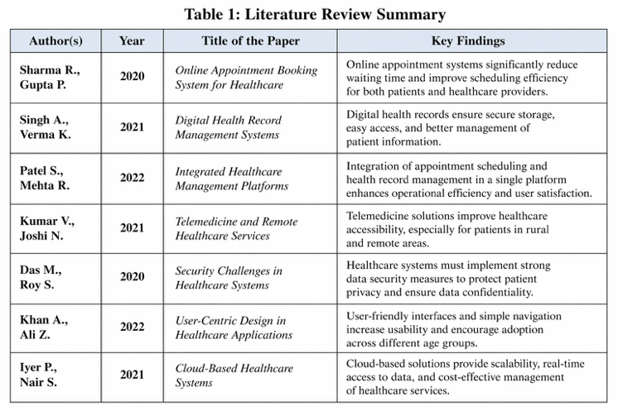
OBJECTIVES
The main aims of this study are:
- To develop an online medical appointment and health records management system (MediConnect).
- To provide a centralized platform for booking appointments and managing patient health records.
- To improve accessibility and convenience for patients in accessing healthcare services.
- To enhance communication between patients and healthcare providers.
SCOPE
The proposed system will serve to provide online medical appointment booking and health record management based on user needs and preferences.
Scope includes: Online appointment scheduling, digital health record management, integration with web-based systems. Use of healthcare technologies. Limitations: Dependence on internet connectivity, data security concerns, scalability issues with large user data.
Literature Review
With the integration of digital technologies in healthcare systems, online healthcare platforms have developed. significantly.
Appointment-Based Systems – These systems allow users to book appointments based on doctor availability. They improve scheduling efficiency but lack proper integration with medical records.
Electronic Health Record (EHR) Systems – These systems store patient data such as medical history, prescriptions, and reports. They provide better data management but are often not easily accessible across different platforms.
Telemedicine Approaches – These enable remote consultation between patients and doctors using online platforms. They improve accessibility but may face issues related to connectivity and user trust.
Integrated Healthcare Systems – These systems combine multiple features like appointment booking, record management, and consultation services.
Methodology
1. Data Collection
The first step involves collecting data from various sources such as patient details, appointment history, doctor information (specialization, availability), and user activity (bookings, preferences). The system uses this data to understand user needs and improve healthcare services.

2. Data Preprocessing
The collected data is cleaned and prepared for further processing. This involves removing duplicate records, handling missing or incomplete data, and organizing unstructured information into a proper format. Proper preprocessing ensures that the system works accurately and efficiently.
3. Feature Extraction
In this step, important features are identified from the processed data. These include user preferences such as preferred doctors or time slots, doctor details like specialization, and appointment patterns. These features help in analyzing behavior and improving system functionality.
4. User and Doctor Profiling
Profiles are created for both patients and doctors. Patient profiles are based on their appointment history and preferences, while doctor profiles are based on specialization, availability, and experience. This helps in effectively matching patients with suitable doctors.
5. System Design Approach
The system is designed using an integrated approach that combines appointment scheduling and health record management. It ensures smooth interaction between patients and doctors while maintaining proper data flow within the system.
6. System Development
The system is developed using technologies such as HTML, CSS, and JavaScript for the frontend, and Python or Node.js for the backend. A database is used to securely store patient records, appointment details, and user information.
7. Data Processing and Matching
The system processes the data to match patients with doctors based on factors such as availability, specialization, and user preferences. This improves the efficiency of appointment booking and reduces waiting time.

8. Service Generation
Based on the processed data, the system provides services such as appointment booking, viewing medical records, and receiving notifications. These services are tailored to meet user needs and improve convenience.
9. System Evaluation
The performance of the system is evaluated using factors like efficiency, usability, and reliability. This ensures that the system works properly, is easy to use, and provides accurate results.
10. Deployment (Web Integration)
Finally, the system is deployed as a web-based application using technologies like Python and Flask. Users can access the system online, book appointments, and manage their health records in real time.
Methodology Table
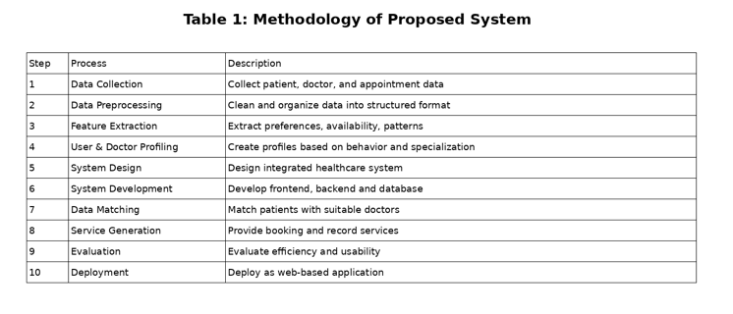
Result
The implementation of the Online Medical Appointment and Health Records Management System (MediConnect) demonstrates that the use of digital technologies can significantly improve the efficiency and accessibility of healthcare services. The system was tested based on features such as appointment scheduling, digital record management, and user interaction. It was observed that the system effectively reduces waiting time and simplifies the process of booking appointments.
The integrated approach of combining appointment booking with centralized health record management provided better usability and convenience for users. Patients were able to access their medical history easily, while doctors could manage appointments and patient data more efficiently. This resulted in improved communication and coordination between patients and healthcare providers. The performance of the system was evaluated using factors such as efficiency, usability, and reliability. The results showed noticeable improvement compared to traditional manual systems, especially in terms of time saving and data management. The notification system also helped in reducing missed appointments by providing timely reminders.
However, the results also indicate certain challenges. The system performance depends on internet availability and user familiarity with digital platforms. Issues related to data security and privacy must also be carefully managed. Additionally, adoption in rural areas may require further awareness and support.
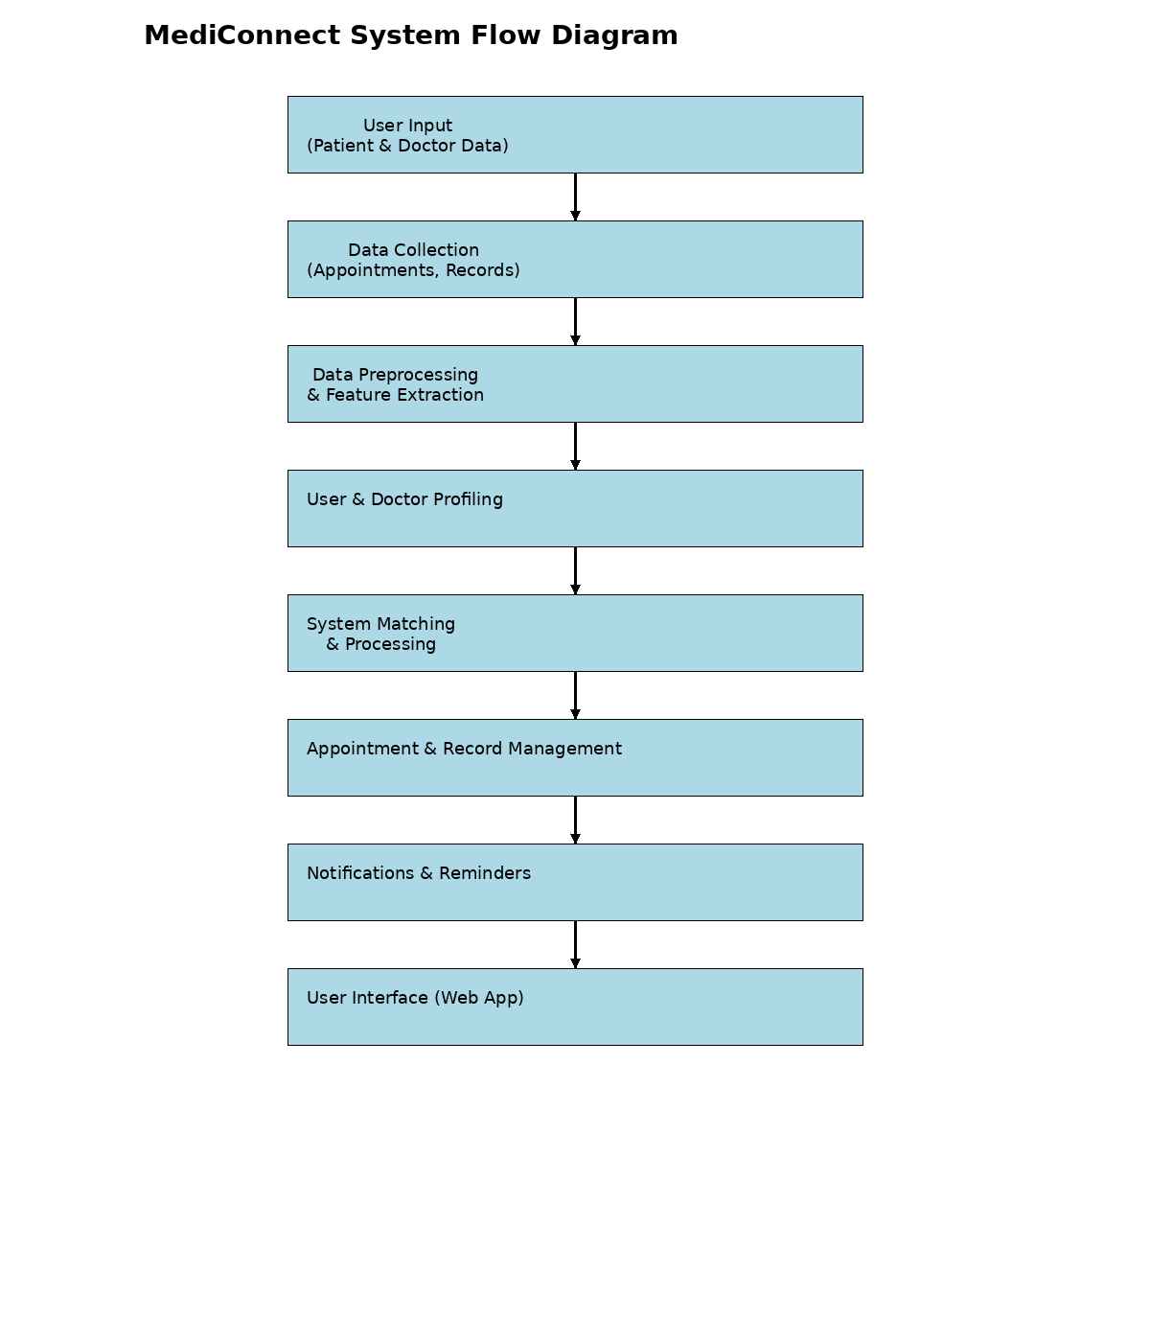
Conclusion
This study presents an Online Medical Appointment and Health Records Management System (MediConnect) designed to overcome the challenges faced in traditional healthcare systems, especially for small clinics and startups. With the increasing demand for efficient healthcare services, patients often face issues such as long waiting times, difficulty in booking appointments, and lack of proper medical record management. The proposed system effectively addresses these challenges by providing a centralized and digital platform for managing healthcare services. The system integrates appointment scheduling and digital health record management into a single platform, improving accessibility and efficiency. By utilizing user data such as appointment history and preferences, the system enhances service delivery and ensures better coordination between patients and doctors. This integration leads to improved usability, reduced manual effort, and a more organized approach to healthcare management.
The implementation demonstrates that such a digital system plays a vital role in improving healthcare experience, increasing patient satisfaction, and optimizing operational efficiency. It also supports healthcare providers in managing patient data effectively and making better decisions. For healthcare startups, the system offers a scalable and cost-effective solution without requiring highly complex infrastructure.
Certain challenges still exist, such as dependence on internet connectivity, data security and privacy concerns, and limited adoption among users unfamiliar with digital platforms. Despite these limitations, the proposed system provides a strong foundation for developing efficient and scalable healthcare solutions.

References
1 - Aggarwal, C. C. (2016). Recommender Systems: The Textbook. Springer.
2 - He, X., Liao, L., Zhang, H., Nie, L., Hu, X., & Chua, T. S. (2017).
3 - Liu, Z., et al. (2020).
4 - Kang, W. C., & McAuley, J. (2018).
5 - Covington, P., Adams, J., & Sargin, E. (2016).
6 - Hu, Y., Koren, Y., & Volinsky, C. (2008).
7 - World Health Organization. (2020).
8 - Ministry of Health and Family Welfare, Government of India. (2021).

