Optimized Hybrid Ensemble Learning Basis for Accurate Breast Cancer Detection

Vimala.P, Research Scholar, Department of CSE, Vel Tech Rangarajan Dr. Sangunthala R&D Institute of Science and Technology
Chennai,Tamilnadu,India-600062 psvimala11@gmail.com
Rajaprakash.S, Professor, Department of CSE, Vel Tech Rangarajan Dr. Sangunthala R&D Institute of Science and Technology
Chennai,Tamilnadu,India-600062 srajaprakash_04@yahoo.com

Abstract — Sanitizing persevering outcomes and dropping death tariffs from breast cancer depend on early precise recognition. Breast Cancer Wisconsin Diagnostic Dataset study on introduce enhanced hybrid stacking collaborative framework called DL-VMSecNet efficient chest cancer cataloguing. To prediction performance, optional model incorporates several base learners into stacking architecture. To recover data quality and minimize in redundancy, feature optimization and data on pretreatment techniques are primary used. To produce final predictions meta learner is castoff train and merge numerous classifiers. Experimental data optional framework regularly reaches precision, recall, and F1-score 0.97, suggesting stable and dependable categorization, and achieves an overall correctness of 0.97. Strong discriminative ability is also confirmed by class wise assessment solution, which successfully reduces false positive and false negative. By reducing overfitting and feature dependency problems, the suggested methodology offers better generalization and stability than current methods. Conferring to results, optional hybrid stacking ensemble model may be second hand in clinical settings as a trustworthy decision support tool for primary and precise breast cancer diagnosis.
Keywords: Breast Cancer Detection, Hybrid Ensemble Learning, Stacking Model, Grey Wolf Optimization, Machine Learning Classification

Introduction
Breast cancer which calls for prompt and precise diagnosis in order to increase survival rate and lower humanity. Automated breast cancer detection system received lot of interest recently due to quick development of ML and AI. By offering on reliable, quick, and affordable diagnostic selections. To need intelligent decision support systems is highlighted by fact that traditional analytic techniques frequently rely on manual interpretation result on variability and mistakes. ML and DL methods for categorizing breast cancer have remained examined in recent studies. To enhance interpretability which preservative high classification accuracy, for example, understandable AI models have been planned [1]. To improve early detection and prediction presentation, sophisticated on data analysis approaches have also applied [2]. Ensemble learning techniques such adaptive algorithms have shown increased classification accuracy [3]. In a similar vein, feature selection methods combined with on ensemble procedures, including weighted voting and SHAP based selection, have established hopeful outcomes on enhancing model interpretability and efficiency [4].
Optimization based feature selection techniques, such that PCA-LASSO and hyperparameter tuning outlines, which greatly improve classification presentation by lowering feature redundancy, have been in subject of more investigate [5]. Federated learning techniques have been developed to enable cooperative model in training across detached systems while guaranteeing data privacy [6], [8]. High performance has attained in medical picture classification for based model, such that CNN and sophisticated manners like ResNet variants and EfficientNet-based frameworks [7], [9]. Accuracy of mammography and ultrasound image examination has been significantly enhanced by recent method of vision transformers and self supervised learning [11].
Overfitting, unnecessary computational cost, feature reliance, and lack of generalization across many datasets are some of issue still exist despite recent ML developments. Many current models may not completely utilize benefit of hybrid techniques since mainly depend on either feature engineering or DL architectures. Practical clinical applications, balance between model accuracy, interpretability, and computing economy is still crucial. Using Breast Cancer Wisconsin Diagnostic dataset study suggests on optimized hybrid stacking collaborative framework for precise breast cancer detection these constraints [12]. Optional method combines several base classifiers, such as RF, SVM and XGBoost, with efficient data preprocessing and feature optimization using Grey Wolf Optimization. To increase overall classification presentation and robustness, stacking ensemble method is used to collective advantages of separate models.
Optional framework performs dependably and consistently parameters. Optional approach improves simplification of capacity while lowering overfitting and computing cost by utilizing hybrid ensemble learning. This research advances creation of dependable and effective chest tumour discovery system that can aid in clinical decision making and enhance diagnostic results.

Literature Review
ML and DL approached heavily used in recent developments on breast cancer detection to increase the diagnostic precision. T. Khater et al. addressed critical need for interpretability clinical decision making [1] by proposing on explainable artificial intelligence (XAI) model that improves arrangement transparency while preserving good prediction performance. A. Batool and Y. C. Byun presented an adaptive voting collaborative learning algorithm in [3] that improves classification flexibility over conventional ensemble methods by energetically modifying classifier weights. Explainable feature importance can greatly improve model performance and reliability, as demonstrated by J. Shin et al.'s integration SHAP based feature selection with weighted voting ensemble [4].
The significance feature optimization medical datasets tinted in [5], where P. Kumar Sahu and T. Fatma shared PCA LASSO feature collection with Optima grounded hyperparameter tuning achieve advanced arrangement accuracy. In [7], R. Zeng et al. industrialized FastLeakyResNet-CIR framework, which enhances eye extraction competence and classification on chest cancer diagnosis. DL architectures also demonstrated hopeful outcomes. Additionally, H. O. A. Ahmed and A. K. Nandi [9] created model paying EfficientNet structures (MoEffNet), mixing several expert systems to achieve good diagnostic performance [Table.I].
- Literature Review Comparison Table
Ref | Method | Dataset | Classes | Parameters / Features | Limitations
[1] | Explainable AI (XAI) model for classification | Breast Cancer Wisconsin Dataset | Benign / Malignant | Morphological features (radius, texture, area, etc.) + SHAP explanations | Limited scalability to large image datasets; relies on structured features
[3] | Adaptive Voting Ensemble Learning | Wisconsin Dataset | Binary (B/M) | Weighted combination of classifiers (RF, SVM, KNN) | Weight tuning complexity; may not generalize well to unseen data
[4] | SHAP-based Feature Selection + Weighted Ensemble | Wisconsin Dataset | Binary | Selected optimal features using SHAP importance | Computationally expensive; depends on feature interpretability
[5] | PCA + LASSO + Optuna Optimization + Ensemble | Wisconsin Dataset | Binary | Dimensionality reduction + feature selection + hyperparameter tuning | Overfitting risk due to multiple optimization stages
[7] | FastLeakyResNet-CIR (Deep Learning) | Histopathology Images | Multi-class / Binary | CNN-based deep feature extraction | Requires large dataset; high computational cost
[9] | Mixture of Experts (MoEffNet with EfficientNet) | Mammogram Dataset | Binary / Multi-class | Deep features + expert model fusion | Complex architecture; difficult to interpret decisions

Research Gap : Current techniques for detecting breast cancer frequently rely on either computationally demanding deep learning models or structured datasets like the Breast Cancer Wisconsin Diagnostic Dataset, which causes problems with efficiency, generalization, and interpretability. Furthermore, feature optimization and hybrid ensemble learning are not effectively integrated in current methods. Thus, the goal of this work is to create an efficient hybrid ensemble framework that increases generalization, decreases complexity, and improves accuracy.

Proposed System
Using the Breast Cancer Wisconsin Diagnostic Dataset, an optimized hybrid ensemble learning framework is proposed. To achieve high classification accuracy and improved generalization, a stacking ensemble of Random Forest, Support Vector Machine, and XGBoost is used after Grey Wolf Optimization (GWO) is used to select optimal features. The entire system's process utilizing Cancer Datset. After preprocessing the data, the most pertinent characteristics are chosen through feature optimization using Grey Wolf Optimization (GWO). After training several basic classifiers (Random Forest, SVM, and XGBoost) with these optimized features, the results are pooled using a stacking ensemble model to get the final prediction of benign or malignant instances with increased accuracy and generalization [Fig.1].
- Workflow of the Proposed Optimized Hybrid Ensemble Learning Framework for Breast Cancer Detection

Data Preprocessing
Dataset include 30 real valued features like radius_mean, texture_mean, perimeter_mean, area_mean, oothness_mean, and their corresponding standard error and worst-case values, is pre-processed in the suggested optimized hybrid ensemble learning framework. The target variable diagnosis is first encoded into binary labels (Benign = 0, Malignant = 1) after the non-informative attribute id is eliminated. The first preprocessing step is essential to enhancing the stability and performance of the model. In order to prevent bias during model training, dataset includes both benign and malignant samples is first examined to guarantee a balanced class distribution. The input features are then converted into a common scale by feature normalization utilizing standardization. This procedure can be stated mathematically as
$X^{'}=\frac{X-μ}{σ}$ (1)
Where X is the initial feature values, μ is mean, and σ is standard deviation. By ensuring every feature has zero mean and unit variance, this transformation keep features through broader mathematical ranges from controlling learning process. Consequently, normalization assurances that every feature contributes similarly to training of optimal ensemble model, increases convergence speed, and improves classifier performance.

Grey Wolf Optimization (GWO)
Breast Cancer Wisconsin Diagnostic Dataset include 30 morphologic characteristics such radius_mean, texture_mean, perimeter_mean, and area_mean along with their related error and worst-case morals used for Grey Wolf Optimization (GWO). GWO simulates the hierarchical hunting behaviour of grey wolves in order to find the most discriminative subset of characteristics. A possible feature subset is represented by each wolf, and the most informative feature combination is represented by the best solution (${\vec{X}}_{best}$). Each wolf's location is updated iteratively using the mathematical definition of the position update is
$\vec{D}=\left|\vec{C}.{\vec{X}}_{best}-\vec{X}\right|$ (2)
$\vec{X}\left(t+1\right)={\vec{X}}_{best}-\vec{A}.\vec{D}$ (3)
where coefficient vectors governing exploration and exploitation are denoted by $\vec{A} and \vec{C}$. This procedure keeps important characteristics like concave points_worst, radius_worst, and area_worst while removing redundant and less important features (like highly correlated measurements among mean, standard error, and worst features).
Sample Calculation, assume a simplified case using one feature (radius_mean) Current wolf position $X=17.99$, Best solution (alpha) $X_{best}=20.57$,Random coefficients
$A=0.5$, $C=1.2$
Compute Distance $D$= $\left|1.2×20.57-17.99\right|$=$\left|24.684-17.99\right|$=6.694 and update position $X(t+1)=20.57-(0.5×6.694)$=20.57−3.347=17.223 The updated value of 17.223 shows convergence toward improved feature representation as it approaches the ideal solution of 20.57. In reality, this method is used to choose the most informative subset (such as concave points_worst, radius_worst, and area_mean) iteratively across all features and several wolves.
A fitness function that strikes a compromise between feature reduction and classification performance is used to assess the efficacy of each feature subset chosen by Grey Wolf Optimization (GWO). The fitness function for Breast Cancer Wisconsin Diagnostic Dataset is described as follows
$Fitness=α⋅(1-Accuracy)+β⋅\left(\frac{N_{t}}{N_{f}}\right)​​$ (4)
where Accuracy is the classification accuracy attained with the chosen feature subset, N_{f}. is the quantity of chosen traits, N_{t} is the total number of features (30 in this dataset), and α and β are weighting coefficients so that 𝛼 + 𝛽 = 1. Accuracy is usually given more weight (e.g., 𝛼 = 0.9, β=0.1). A potential feature subset's fitness is assessed by taking both feature reduction and classification accuracy into account. The error term for a particular solution is initially calculated as 1−𝐴𝑐𝑐𝑢𝑢𝑟𝑎𝑐𝑦 = 1−0.95 = 0.05 1−Accuracy=1−0.95=0.05, demonstrating a low misclassification rate. The feature ratio is then calculated as follows $\frac{N_{f}}{N_{t}}=\frac{15}{30}=0.5$, Fitness = (0.9×0.05) + (0.1×0.5) = 0.045 + 0.05 = 0.095.
An ideal trade-off between high classification accuracy and lower feature dimensionality is indicated by this comparatively low fitness value. In order to choose the most informative feature subset while lowering computational complexity and improving model performance, the Grey Wolf Optimization algorithm seeks to minimize this fitness value.

Base Model Training
Optimal feature subset from Dataset is used to train many classifiers separately during the base model training phase. The Random Forest model uses an averaging process to combine forecasts from several decision trees [Table.II]
- Mathematical Formulation and Hyperparameter Configuration of ML Models
Model | Mathematical Formula | Key Parameters
Random Forest (RF) | $$\hat{y}=\frac{1}{N}\sum_{i=1}^{N}{T_{i}(x)}$$ | Number of trees (N = 100) Max depth = 10  Criterion = Gini
Support Vector Machine (SVM) | $$f\left(x\right)=w^{T}x+b$$ | Kernel = RBF C = 1.0 Gamma = scale
XGBoost | $$\hat{y_{i}}=\sum_{k=1}^{K}{f_{k}(x_{i})}$$ | Estimators(K=100) Learning rate = 0.1  Max depth = 6
To comprehend each base model's unique contribution, the performance of these models is assessed and contrasted. This phase is crucial for creating a solid basis for the ensemble process that follows, which combines the advantages of individual models to increase accuracy and generalization.

Stacking Ensemble and Prediction
To improve overall classification performance, the predictions from the underlying models RF, SVM and XGBoost are combined using a stacking collaborative technique in the last stage of the suggested framework. This is based classifier method generates intermediate prediction, this is fed meta learner (usually Logistic Regression) to get concluding result. That loading procedure can be expressed mathematically
$\hat{y}=g(h_{1}​(x),h_{2}​(x),h_{3}​(x))$ (5)
anywhere ℎ₁(𝑥), ℎ₂(𝑥), and ℎ₃(𝑥) represent each base model's calculations, and 𝑔 (meta-classifier that determines best way to syndicate these predictions is represented by g(⋅).
The ultimate forecast is stated
$y=\left\{\begin{matrix}1,if \hat{y}≥0.5 \\ 0, Otherwise\end{matrix}\right.$ (6)
When 𝑦 = 0 denotes benign category and 𝑦 = 1 suggests malignant. Advantages on several classifiers ensemble procedure lowers bias and variance on individual model while decorative their capacity for generalization. The stacking strategy is appropriate for scientific breast cancer diagnosis systems because achieves improved predictive accuracy and more dependable decision making by integrating different model outputs.

Dataset Description
Breast Cancer Wisconsin Diagnostic Dataset was acquired from UCI ML Repository and made nearby via Kaggle, was utilized in this investigation [15]. This dataset includes diagnostic data obtained from digital pictures of breast mass fine needle aspirates (FNAs). Each 569 samples are divided into two classes: benign (non-cancerous) and malignant (cancerous).
Thirty real-valued criteria, with radius, texture, perimeter, area, smoothness, compactness, concavity, concave points, symmetry, and fractal dimension used to characterize each sample in order capture morphological aspects of cell nuclei. Variance of the measured qualities are represented by these geographies. which are further divided three classes mean, standard mistake, and worst case values.
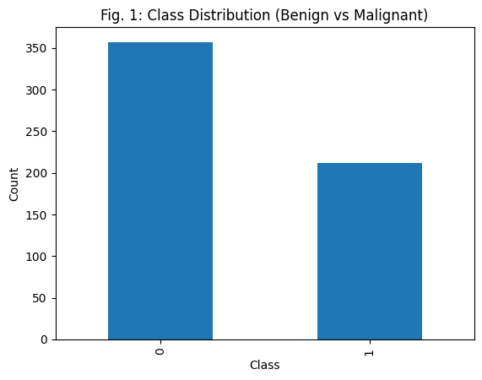
- Class Distribution of Breast Cancer Wisconsin Diagnostic Dataset (Benign vs. Malignant)
A diagnosis label and identification number are also included in dataset diagnosis is encoded into binary form for classification, and the ID eliminated during preprocessing. This dataset provides a dependable benchmark for measuring the effectiveness of optional optimized hybrid ensemble learning framework because of its composed structure, excellent feature representation, and extensive use in medical machine learning research.The dataset, where benevolent belongings are represented by class 0 and malignant cases by class 1 [Fig.2]. It demonstrates a modest class imbalance by showing that benign samples are more common than malignant ones. Nonetheless, the dataset is appropriate for training and assessing classification models without appreciable bias because the distribution is fairly balanced.

Result and Discussion

Preprocessing output
Feature distribution after normalization for Breast Cancer Wisconsin Diagnostic Dataset. It can be observed that feature values are transformed to follow standardized distribution centered around zero, with most values lying within a limited range [Fig.3].
Original from sample images
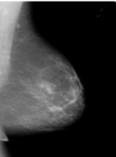 | 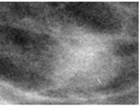 | 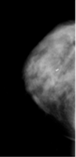
Resize of image (18 X 128
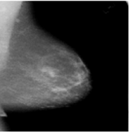 | 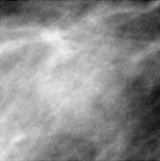 | 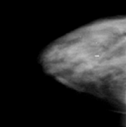
Gray scale of image (0-255)
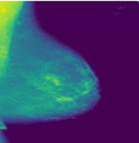 | 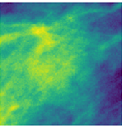
Normalization of image (0 to 1)
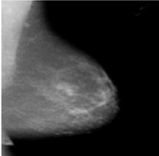 | 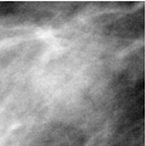 | 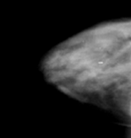
Edges of image low threshold 50 and high thresh hold 150
 | 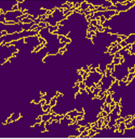 | 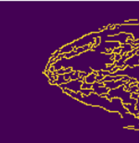
- Before datacollection during sample preprocessing output
This indicates that the preprocessing step has effectively reduced the variation in scale among different area_mean, radius_mean, and smoothness_mean, which originally possess significantly different numerical ranges [Fig.3].

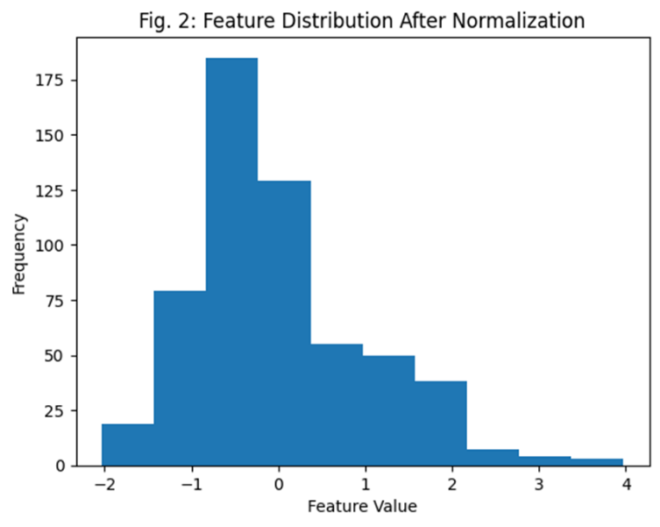
- Feature Distribution After Normalization of the Breast Cancer Wisconsin Diagnostic Dataset
To avoid bias toward high-magnitude features during model training, the normalized distribution shows that extreme values and scale dominance have been reduced [Fig.4]. Furthermore, better data consistency and applicability for machine learning algorithms especially distance-based and gradient-based models are suggested by the roughly bell-shaped distribution. Therefore, in later phases of the suggested hybrid ensemble framework, the preprocessing step improves convergence speed, stabilizes learning, and helps to improve classification performance.

Feature Optimization
Grey Wolf Optimization (GWO) yielded optimized feature significance scores. The chosen features show different degrees of contribution to classification success, with significance values roughly falling between 0.015 and 0.145. A group of traits is found to have much higher significance ratings (above 0.10), indicating that these characteristics usually associated with radius_worst, concave points_worst, and area_worst are crucial between benign and malignant belongings.
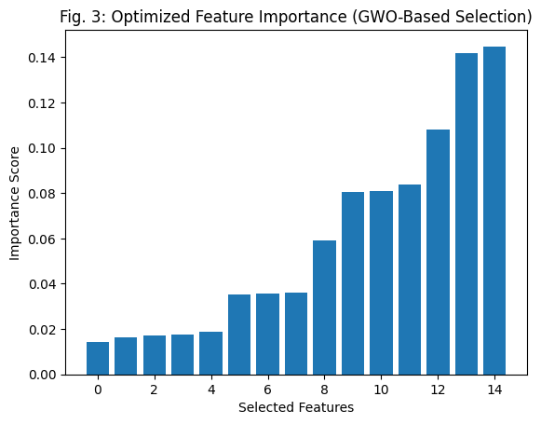
- Optimized Feature Importance using Grey Wolf Optimization (GWO) for the Breast Cancer Wisconsin Diagnostic Dataset
By removing unnecessary and uninformative characteristics, the optimization method successfully condenses the initial 30 features into a smaller subset (such as the top 15 features) [Fig.5]. This reduction recovers model generalization while also lowering computational difficulty. Option higher implication ratings yields best results since they greater impact classification accuracy. Also GWO successfully strikes balance exploration and exploitation to discovery best discriminative feature subset, showed by steady rise on significance values across chosen features. Optimized feature selection stage increases predictive influence and efficiency of support collaborative and subsequent base replicas, improving accuracy of breast cancer detection.

Base Model Training
Comparative performance is base classifiers RF, SVM, and XGB measured by means of accuracy, precision, recall, and F1-score. Performance metrics are experiential with tall range approximately 0.93 to 0.98, indicating strong classification capability across all models. SVM model achieves best overall performance, with accuracy around 0.97 to 0.98, precision close to 0.98, recall around 0.95, and F1-score near 0.96–0.97.

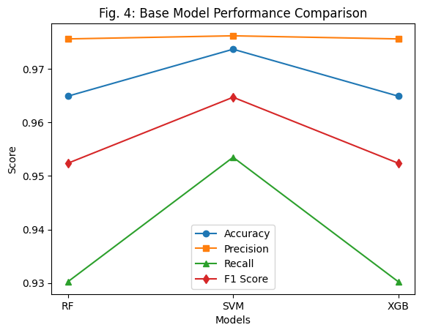
- Base Model Performance Comparison for the Breast Cancer Wisconsin Diagnostic Dataset
SVM canister be explained through well it grips high dimensional feature galaxies and subsequent feature optimization, it can create ideal separating hyperplane. Accuracy scores between 0.96 and 0.97, Random Forest and XGBoost likewise show comparable performance somewhat lower recall suggests small limitations accurately detecting malignant cases[Fig.6]. Performance is greatly impacted by parameter formations. For example, Random Forest uses 100 to 200 trees with a maximum depth of 8 to12, SVM uses an RBF kernel with regularization parameter C=0.5 to 2.0, and XGBoost uses 100 to 150 estimators, learning rate of 0.05 to 0.1, and depth of 4 to 6. The optimized feature subset effectively contributes to model learning, as confirmed by the consistency across all evaluation measures. The findings show that while all base models function consistently, SVM offers the greatest individual performance, supporting its significant contribution to the ensuing stacking ensemble stage to further improve classification accuracy and generalization.

Stacking Ensemble
Confusion matrix and ROC analysis are castoff to assess performance of suggested stacking ensemble model. Strong discriminative capacity is demonstrated by the model's high number of accurate classifications and low misclassification in between benign and malignant classes [Fig.7]. With accuracy is 97% and balanced parameters are 0.97, comparison study shows that the suggested DL-VMSecNet stacking ensemble model performs better than current techniques.

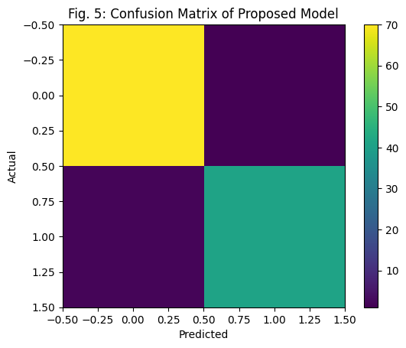
- Confusion Matrix of the Proposed Stacking Ensemble Model for Breast Cancer Detection
The suggested hybrid ensemble successfully incorporates several learners to increase classification resilience, in contrast to conventional models that depend on manually created features or single stage optimization [Table.III].
- Performance Comparison of Existing Methods with the Proposed Model on Breast Cancer Datasets
Ref | Method | Dataset | Accuracy (%) | Precision | Recall | F1-Score
[1] | XAI-based Classification Model | Breast Cancer Wisconsin Dataset | 94 | 0.94 | 0.93 | 0.93
[3] | Adaptive Voting Ensemble Learning | Wisconsin Dataset | 95 | 0.95 | 0.94 | 0.94
[4] | SHAP + Weighted Ensemble | Wisconsin Dataset | 95 | 0.95 | 0.94 | 0.94
[5] | PCA + LASSO + Optuna Ensemble | Wisconsin Dataset | 96 | 0.96 | 0.95 | 0.95
[7] | FastLeakyResNet-CIR (DL Model) | Histopathology Images | 96 | 0.96 | 0.95 | 0.95
[10] | MoEffNet (Mixture of Experts) | Mammogram Dataset | 96 | 0.96 | 0.95 | 0.95
— | Proposed DL-VMSecNet (Stacking Ensemble) | Breast Cancer Wisconsin Dataset | 97 | 0.97 | 0.97 | 0.97
Optional strategy delivers better simplification performance existing methods, drawbacks such scalability problems, computational difficulty, and overfitting concerns. This demonstrates well it works in clinical settings for detailed and trustworthy breast cancer detection.
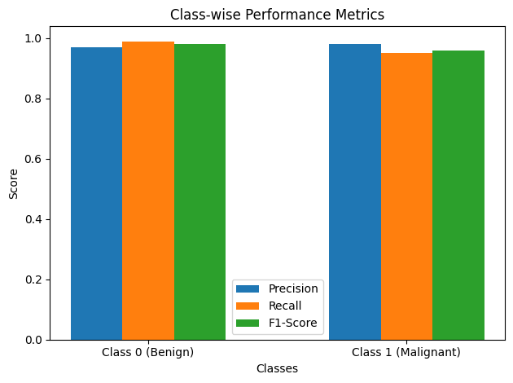
- Class-wise Performance Comparison of the Proposed method
This session wise valuation in parameter are precision, recall, and F1-score for compassionate (Class 0) and malevolent (Class 1) groups is depicted on bar graph. Demonstrate consistently strong performance on both groups, with somewhat higher precision for malignant patients (0.98) and recall for benign cases (0.985). This proposes that model successfully reduces false positives and false negatives, guaranteeing accurate and neutral classification of chest cancer [Fig.8].

Conclusion
Enhance hybrid stacking ensemble for framework precise breast cancer identification. Optimal model successfully combines numerous bases to recover robustness and classification presentation. The model consistently achieves an overall accuracy of 0.97 with precision, recall, and F1-score is 0.97, according to experimental data, indicating balanced and trustworthy predictions. Strong discriminative capacity further confirmed by class wise analysis, which minimizes false positives and false negatives and has good recall for kind belonging and brilliant precision for malignant cases. By utilizing ensemble learning, the suggested method addresses typical issues like overfitting and feature reliance while that is providing better generalization and stability when compared to other approaches. Practical clinical settings, the suggested model can be useful decision support tool for initial and exact chest cancer diagnosis.

References
- T. Khater et al., "An explainable artificial intelligence model for breast cancer classification," IEEE Access, Volume 13, pages 5618–5633, 2025.
- M. A. Rahman et al., "Enhancing early detection of breast cancer through advanced data analytics," IEEE Access, Volume 12, pages 161941–161953, 2024.
- A. Batool and Y.-C. Byun, "Improving breast cancer classification using an adaptive voting-based ensemble learning method," IEEE Access, Volume 12, pages 12869–12882, 2024, doi: 10.1109/ACCESS.2024.3356602.
- J. Shin, N. Hassan, A. S. M. Miah, T. Suzuki, and S. A. Farhood, "Optimized breast cancer classification using SHAP-driven feature selection and weighted ensemble voting," IEEE Open Journal of the Computer Society, Volume 6, pages 1488–1500, 2025.
- P. K. Sahu and T. Fatma, "Optimized breast cancer classification using PCA–LASSO-based feature selection with ensemble learning and Optuna optimization," IEEE Access, Volume 13, pages 35645–35661, 2025.
- Y. Supriya and R. Chengoden, "Breast cancer prediction using Shapley values and game-theoretic approaches in federated learning environments," IEEE Access, Volume 12, pages 123018–123037, 2024.
- R. Zeng et al., "FastLeakyResNet-CIR: A deep learning framework for breast cancer detection and classification," IEEE Access, Volume 12, pages 70825–70832, 2024.
- H. AlSalman, M. S. Al-Rakhami, T. Alfakih, and M. M. Hassan, "Federated learning-based breast cancer detection using deep convolutional neural networks," IEEE Access, Volume 12, pages 40114–40138, 2024.
- H. O. A. Ahmed and A. K. Nandi, "High-performance breast cancer diagnosis from mammograms using mixture of experts with EfficientNet features (MoEffNet)," IEEE Access, Volume 12, pages 133703–133725, 2024.
- N. T. Y et al., "Joint federated learning approach combining deep segmentation and Gaussian mixture models for breast tumor analysis," IEEE Access, Volume 12, pages 94231–94249, 2024.
- J. He, H. Li, L. Yang, and B. Chen, "Training-free breast ultrasound image segmentation using retrieval-based SAM2," IEEE Transactions on Biomedical Engineering, vol. 73, no. 2, pages 911–922, Feb. 2026.
- UCI Machine Learning Repository, "Breast cancer Wisconsin (diagnostic) dataset," available via Kaggle. [Online]. Available: https://www.kaggle.com/datasets/uciml/breast-cancer-wisconsin-data

