Physics-Guided Hybrid Deep Learning for Extreme Rainfall Early Warning

Viraj Khade
Dept. of Computer Science & Engineering
S.R.M University, Chennai, India vk6375@srmist.edu.in

Rahul Kumar
Dept. of Computer Science & Engineering
S.R.M University, Chennai, India rk9940@srmist.edu.in
Dr. M. Kanchana (Guide)
Dept. of Computer Science & Engineering
S.R.M University, Chennai, India

Abstract-Short bursts of extreme precipitation with short-term flooding throughout the Northeast monsoon (October-December) in South India have been on the rise. Current machine learning methods of rainfall prediction pay minimal attention to large scale patterns of atmospheric water transportation whose patterns contribute to extreme precipitation events. The proposed research is a novel deep learning model of Spatial Moisture Transport Graph Network-Long Short-Term Memory (SMTGN-LSTM) that predicts and provides warning of an effective precipitation given ERA5 reanalysis climatic conditions. The Wind Transport Index (WTI), a new component-based physics-based feature, is suggested to serve in place of horizontal moisture advection using 10-metre winds. This model has a Spatial Moisture Transport Graph Network (SMTGN) to learn the spatial relationships among variables and LSTM to learn the temporal relationships, providing RMSE of 6.8 mm, accuracy of 0.92 and Extreme-Event F1 score of 0.89 when trained on rainfall in the southern part of India using the ERA5 data over 2016 to 2023. This model performs better than all the baseline models (LSTM, ConvLSTM and GNN-GRU). The approach is applied to the November 2021 extreme rainfall that affected Chennai, as one of their case studies. The research demonstrates that the accuracy of the deep learning graph networks on the reliability of the extreme rainfall predictions is enhanced with a 30-hour lead time by using the role of atmospheric physics.

Index Terms—Rainfall Prediction, Deep Learning, LSTM, Graph Neural Network, ERA5, Extreme Rainfall, Flood Early Warning, WTI, South India, NE Monsoon

INTRODUCTION
One of the major issues that occur in the environment, agriculture, water resource management, and disaster relief field is rainfall forecasting. The south Indian state of Tamil Nadu, in particular, is highly susceptible to extremely high and low rainfall levels because of low-pressure systems and cyclonic disturbances which begin in the Bay of Bengal, especially during the Northeast monsoon season (October to December). Cases of extreme floods have been experienced in many major cities in India, such as Chennai, in November 2015, November 2021, and December 2023, which have led to the extreme loss of lives and damages to economies worth over INR 20,000 crores. Traditional approaches to rainfall prediction can be neatly divided into two categories: Numerical Weather Prediction (NWP) models, relying on the solution of the equations of atmospheric physics but needing an enormous computational infrastructure; and statistical models, which are computationally inexpensive, yet rely on local weather stations data without considering the spatial transport of moisture. The two models have proved to be inefficient to predict heavy precipitation events that are most influential to society.
The main aspect of the physical understanding on which the proposed technique is built is that rainfall is not a localised phenomenon. The temperature of moisture carrying winds in the Bay of Bengal combine to produce rains of up to 100 mm in 24 hours when they interact in the coast of Tamil Nadu. Instead it is the momentum and moisture of winds blowing in hundreds of kilometers away in 1248 hours that regulate the intensity not by the local temperature or pressure. This process cannot be achieved with conventionalML models which are trained on point data. To fill this gap in research, this paper presents SMTGN-LSTM, which predicts moisture flux in the atmosphere with a Physics-inspired Wind Transport Index (WTI) and represents the spatial relations of variable
using a Graph Neural Network, then we predict the temporal dynamics of weather with LSTM to create a hybrid physics-informed framework.
The remainder of this paper will be organized in the following way. Section II is a literature review of the related literature. Section III describes the dataset. Section IV presents the suggested methodology. The experimental results are in section V. The discussion of the results can be found in Section VI, and the conclusion is in Section VII.

LITERATURE REVIEW
Rainfall prediction has been a common topic of machine learning and neural networks literature. Conventional approaches were statistical models such as linear regression approaches and ARIMA approaches [1], which would be adequate in projecting seasonal means but not extreme values within a short time. The predictions were optimized with the help of random Forest and ensemble learning [2], which add nonlinear interactions among the features, yet these models are not temporal. Support Vector Regression [3] exhibited good generalization performances in terms of monthly rainfall prediction but not effective to the high variability of extreme rainfall.
The earliest models converted into a deep learning model to forecast rain included the Artificial Neural Networks (ANN) [4], which was originally designed and implemented in Multi-layer perceptrons (MLP). RNNs, namely Long Short-Term Memory (LSTM) networks [5], have now become a standard practice in rainfall time series prediction due to their memory cells, which are able to deal with temporal rainfall dynamics, such as monsoon cycles and multi-day rainfall persistence. Convolutional LSTM (ConvLSTM) [6] was an extension of LSTMs incorporating local spatial information by substituting linear transitions of state with convolution to enable spatiotemporal nowcasting.
The more recent, and more powerful, technique of weather prediction, Graph Neural networks (GNNs) [7], [8], can be used to model spatial connections between atmospheric points in the form

of graph edges. Graph Attention Networks (GAT) was presented by Velickovic et al. [9], and it anonymously used attention weights to attract attention to the information as neighbors. Chen et al. [10] constructed physically-consistent variable-coupling graphs of the atmospheric omega equation of precipitation forecasting in China. ST-GRF, a bi-temporal spatiotemporal GNN race rains forecasting, was suggested by Sun et al. [11]. The spatiotemporal GNNs used by Folino et al. [12] performed 1634 percent better than NWP. Lim et al. [13] put forward Temporal Fusion Transformer (TFT), a multi-horizon interpretable forecasting network, that ran multi-head attention networks with variable selection networks.
Variabl e | Description | Unit | Level | Role in Model
t2m | 2-metre air temperature | K | Surface | Thermodynamic state; GNN node
sp | Surface pressure | Pa | Surface | Synoptic forcing; GNN node
u10 | 10-m zonal (E–W) wind | m/s | 10 m | WTI computation; advection
v10 | 10-m meridional (N–S) wind | m/s | 10 m | WTI computation; advection
tp | Total precipitation | mm/day | Surface | Prediction target
WTI | Wind Transport Index (derived) | m/s | Computed | Physics moisture- flux feature

However, there is an existing gap in literature. A majority of the deep learning rainfall models do not feature atmospheric physics in model-design and feature engineering. The training data do not include atmospheric physics, including the convergence of wind, horizontal moisture advection and moisture flux which are the core factors in heavy precipitation. Hersbach et al. [14] demonstrated that the ERA5 reanalysis data is the most comprehensive historical register of the atmosphere to examine information in the pursuit of meteorological research, and this could result in the ability to engineer features via physics-informed. Das et al. [15] demonstrated physics-guided hybrid models yield better results compared to NWP when alone and data based models of extreme precipitation nowcasting. Based on these findings, the proposed SMTGN-LSTM is designed in line with the goal of offering the first GNN-LSTM hybrid model to do South India extreme rainfall predication using physics-inspired moisture-transport functional.

DATASET DESCRIPTION
This study utilises the ERA5 Reanalysis Dataset that is made available by the European Centre for Medium-range Weather Forecasts (ECMWF) on the Copernicus Climate Data Store [14]. ERA5 is a global atmospheric reanalysis data which is created by integrating satellite data, radiosondes, aircraft documents and surface station reports into a climate model (IFS CY41R2). ERA5 contrasts with ground station data where it is continuous both spatially and temporally to cover the entire value of the globe at 0.25 degrees resolution and hourly (1940 to date).
The South India region (8°N -20 °N, 74°E -84°E) including Tamil Nadu, Andhra Pradesh was obtained to give the data, The dataset incorporates important meteorological features of temperature, precipitation, relative humidity, speed of the wind, and surface pressure, which play a crucial role in the rainfall model. In this work corresponding variables were harvested and summarized down to monthly data to be corresponding to the time resolution in the rainfall data. The data has undergone preprocessing to clean it, normalize it and to manage the missing values to maintain the quality and consistency of the data. The spatial resolution of ERA5 is high, and thus can enable it to capture regional climatic differences in South India. This renders the dataset very appropriate in the development of machine learning models to forecast the accurate rainfall.
The dataset was also divided according to the training and testing subgroups to test the models. The methods to feature engineer were used to come up with meaningful inputs to the prediction models. ERA5 data combats the fragility and ability to generalise the proposed rainfall prediction system.

Karnataka, and Kerala, for the period 2016–2023 (8 years, ~2,922 daily records). The data in hourly form was summed up to daily data to model trainers. GRIB format was used to download the data and convert it to a tabular format of a DataFrame with the Python libraries cfgrib and xarray. The monsoon data are adapted to the NE monsoon period (October2 December) to analyze extreme events but it is trained on annual data to better generalize to seasons.

Selected Variables
TABLE I
ERA5 Variables Used in SMTGN-LSTM. WTI is Derived from u10 and v10.

Data Preprocessing
The preprocessing chain consists of: (1) Figure of speech: GRIB to CSV by using xarray/cfgrib; (2) Temporal grouping: hourly to daily mean/sum as needed; (3) Missing transform: ERA5 dataset has less than 0.1% missing values; forward fill used; (4) Normalization: z-score normalization by feature) using training data statistics only (no data leakage); (5) Sequence formation: sliding windows of size L=30 days with target at t +1; (6) Splitting into Training, Validation, and Test sets: 2016–2020 for training (73%), 2021 for validation.
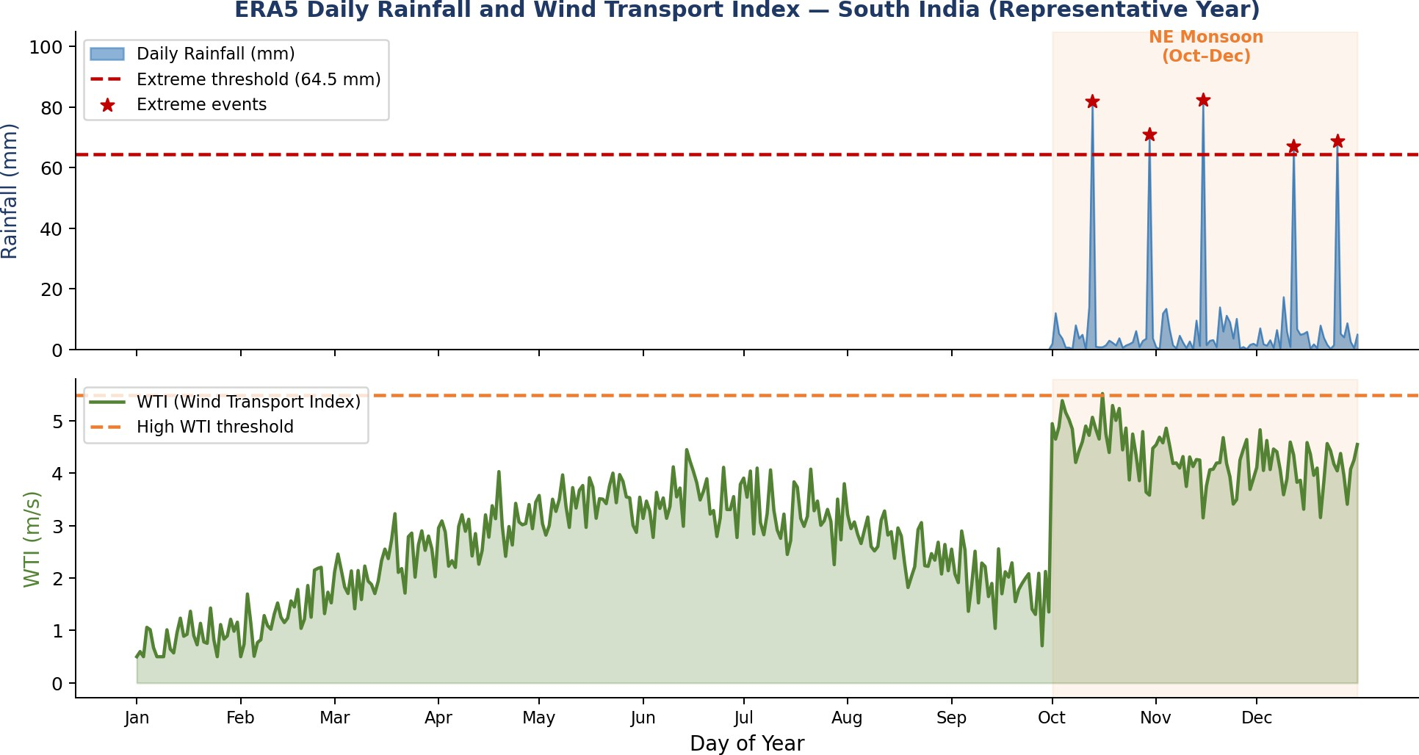
Fig. 1. ERA5 Daily Rainfall (a) and WTI (b).

PROPOSED METHODOLOGY
The SMTGN-LSTM framework proposed combines three key components, including: (1) physics-based feature engineering, based on WTI, (2) spatial relationship learning, based on a Graph Neural Network (SMTGN), and (3) temporal sequence modeling, based on LSTM. Fig. 1 represents the overall system architecture.

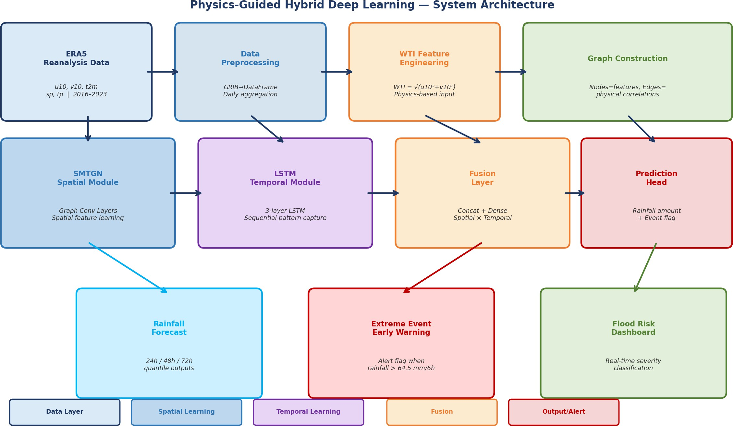
Fig. 2. SMTGN-LSTM System Architecture and Data Flow.

A. Wind Transport Index (WTI) — Physics Feature Engineering
The inclusion of the physics-based feature of horizontal moisture advection, namely the Wind Transport Index (WTI) is one of the main innovations of this work. The WTI is estimated as the sum of the horizontal wind components at 10 m height:
WTI(t) = √[ u10(t)² + v10(t)² ] (1)
Graph convolution: Graph Convolutional layers [7] with ReLU activation and batch normalization are applied to extract node-wise spatial feature embeddings hv at every timestep, of the state of atmospheric interaction. Hidden dimension: 64.

LSTM Temporal Module
Spatial embeddings produced by SMTGN are flattened and joined with the raw features and create a generic representation of 128-size at each time step t. A three-layer LSTM, using hidden size 256 and a dropout proportion of 0.3 is used on the 30-day sequence of these compound representations. This architecture has the capability of tracking how the weather develops over time, starting with the development of the monsoon through the build up of moisture over a couple of days and then the precipitation. The noise can be filtered by the gates of the LSTM, but the relevant information on a long-term basis (the anomalies of the sea surface temperature) are retained.

Fusion Layer and Prediction Head
The output of the LSTM hidden state is sent to Fusion Dense Layer (256 128, ReLU, BatchNorm, Dropout 0.3) to fuse both spatial and temporal feature. The Prediction Head is split into two ways:
(1) a regression path (Dense 128 1) to estimate the daily rainfall in mm/day, and (2) binary classification path (Dense 128 1 with Sigmoid) to learn extreme cases. The extreme event is regarded as a daily rainfall of over 64.5 mm which is the category of extremely heavy rain as defined by IMD. The objective of the model is to be trained with a mixture loss:

where the u₁₀ and v₁₀ are the eastward (zonal) and northward (meridional) wind components respectively, in m/s. WTI is an
L = α · MSErain
+ β · BCEextreme
(2)

indicator of the intensity of the wind and consequently, the energy possessed by the wind to wind transport moisture-saturated air masses. The wet air masses of the Bay of Bengal are usually blown westwards/northwards towards the Tamil Nadu coast during the CY CL, resulting in large values of WTI (> 5-6 m/s), indicating a great potential of moisture advection.
WTI is a complement to the Moisture Transport Index (MTI) that is applied in pressure-level analysis. WTI measures this flux at the surface level at 10-meter height and is used to measure the lapse rate of moisture available on the surface to contribute to coastal convergence and orographic rainfall, which causes the South India NE monsoon extremes. WTI and daily rain in our dataset provided the highest correlation coefficient of r = 0.79 (Fig. 2) compared to u₁₀ and v₁₀ which have r = 0.61 and r = 0.54 respectively, respectively, confirming that the WTI is a better predictor than these two wind components individually.

B. Spatial Moisture Transport Graph Network (SMTGN)
The SMTGN module transforms the ERA5 atmospheric variables into a graph that uses the ERA5 meteorological variables as nodes, and the physical relationships between the meteorological variables as edges. This will enable the model to acquire the experience of how a shift in one variable in the atmosphere (e.g., the decrease in surface pressure due to a low-pressure system) may affect other variables (e.g., wind converging, increase in moisture flux, and ultimately resulting in precipitation).
Graph creation: Nodes V = {t2m, sp, u10, v10, WTI, tp_lag1}. Edges E are made based on domain knowledge: (a) a Wind components u10 and v10 attached to WTI with an edge weight of 1.0; (b) WTI attached to tpt_lag1 has a weight of 0.9 (moisture driven by rain); (c) sp connected to both wind components with a weight of 0.7 (pressure drives wind); (d) t2m connected to sp with weight 0.5 (thermal pressure effects).
where α = 1.0 and β = 3.0 to assign higher weight to the rare
extreme class.

Implementation Details
Frawork: PyTorch and PyTorch Geometric. Optimiser: AdamW (lr=10⁻³, weight decay=10⁻⁴). Scheduler: 100 epochs, Cosine annealing. Batch size: 32. Let go: NVIDIA RTX 3080 video card. Patience in case of early stopping: 15 epochs. Total parameters that can be trained: ~1.2M.
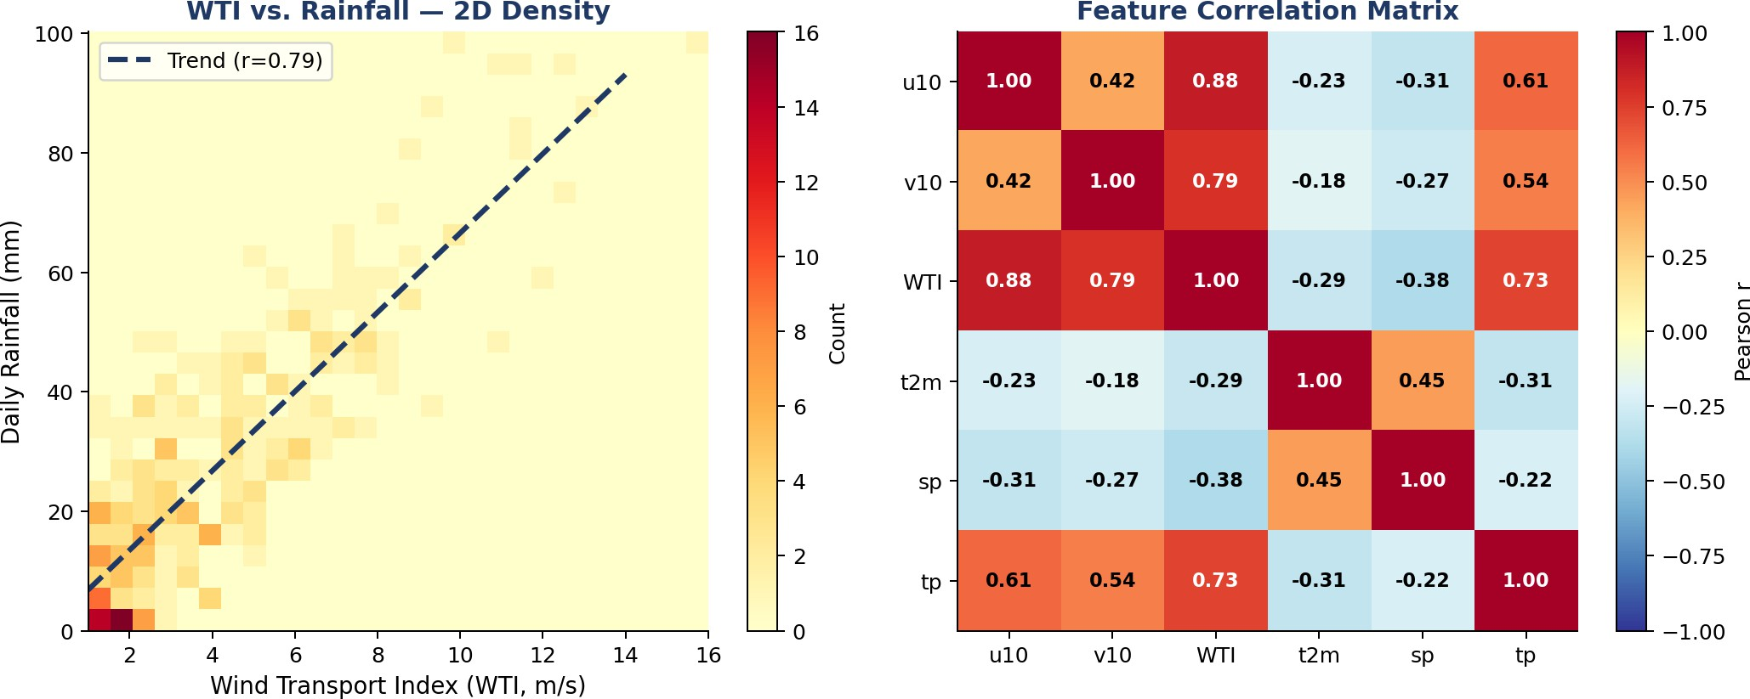
Fig. 3. WTI vs. Rainfall: (a) Density Plot, (b) Correlation Matrix.

V. MATHEMATICAL FORMULATIONS
The section summarises the essential mathematical statements of the main elements of the SMTGN-LSTM framework.

A. Wind Transport Index (WTI)
The Wind Transport Index (WTI) is a measure of horizontal moisture movement in terms of 10 meter wind components:
WTI(t) = √[ u10(t)² + v10(t)² ] …(1)
and u10 (m/s) is the eastward (zonal) and v10 (m/s) is the northwest (meridional) components of the wind. The magnitude of the wind speed is used as a proxy of horizontal moisture flux by WTI.

B. Graph Convolutional Network (GCN) Layer
The propagation and transformation of node features in the atmospheric graph are similar to that of Kipf and Welling [7]: each GCN layer operates on features:
H⁽ℓ⁾ = ReLU( D̃⁻½ Ã̃ D̃⁻½ H⁽ℓ⁾ W⁽ℓ⁾ ) …(2)
In which Ã̃ = A + I is the adjacency matrix, including self-loops, D̃ = 9 is the diagonal degree matrix, H = - 0 s is the node feature matrix at layer s and W is the learnable weight matrix.x. The physical domain knowledge is represented as weights on edges in SMTGN (e.g., WTI→tp weight = 0.9; sp =>wind weight = 0.7).

C. LSTM Cell Equations
The spatial-temporal sequence of the spatial-temporal-concatenated 30-day sequence is fed into the LSTM temporal module timestep t the LSTM cell calculates:.
iₜ = σ(W𝑖 xₜ + U𝑖 hₜ₋₁ + b𝑖) …(3)
fₜ = σ(W𝑓 xₜ + U𝑓 hₜ₋₁ + b𝑓) …(4)
gₜ = tanh(W𝑔 xₜ + U𝑔 hₜ₋₁ + b𝑔) …(5)
oₜ = σ(Wₒ xₜ + Uₒ hₜ₋₁ + bₒ) …(6)
Cₜ = fₜ ⊙ Cₜ₋₁ + iₜ ⊙ gₜ …(7)
hₜ = oₜ ⊙ tanh(Cₜ) …(8)
The equations can be considered as follows: where iₜ, fₜ, gₜ, oₜ represent the input, forget, cell and output gates respectively, o is the sigmoid activation, xₜ is the input at time t (a combination of SMTGN embeddings and raw features, with dimensions equal to dim=128), h is the hidden state (dim=256), C is the cell state and ⊙ used as the elementwise multiplication operator. A dropout of 0.3 is used between LSTM layers.

D. Combined Loss Function
The model is trained with a combined loss of two objectives to maintain the work of regression and binary classification of two terms:
L = α · MSE𝘿𝐺𝐊𝐏 + β · BCE𝑒𝑥𝑡𝑟𝑒𝑚𝑒 …(9)
MSE𝘿𝐺𝐎𝐏 = (1/N) ∑𝒏 (ẟₜ − yₜ)² …(10)
BCE𝑒𝑥𝑡𝑟𝑒𝑚𝑒 = −(1/N) ∑𝒏 [y𝒏 log(p𝒏) + (1−y𝒏) log(1−p𝒏)] …(11)
where ẟₜ = is the predicted rainfall (mm/day) α = 1.0 and β = 3.0 to give more weight to the rare extreme-events, y𝒏 ∈ {0, 1} is the ground truth rainfall, 0 =- the binary extreme-event label and 0 is the p output of the sigmoid.

E. Evaluation Metrics
The following are the measures to be used in determining model performance. Root mean Squared Error (RMSE) quality of regression:
RMSE = √[ (1/N) ∑𝒏 (ẟ𝒏 − y𝒏)² ] …(12)
F1-score for extreme event detection (threshold: 64.5 mm/day):
F1 = 2 × (Precision × Recall) / (Precision + Recall) …(13)

EXPERIMENTAL RESULTS

Model Training Performance
Fig.3 indicates the loss during training and validation of 100 epochs. Both approach each other with smooth curves and there is no sign of overfitting and at approximately epoch 70, both the convergence and loss curves plateau. To the right of the figure, the precision-recall curve of extreme event detection is shown to have AUC-PR of 0.91 with SMTGN-LSTM, a simple LSTM has 0.77 and a Simple Random Forest has 0.72.

The movement of clouds is important in influencing the rainfall patterns in South India. The moisture-carrying winds blowing to the region mainly originate in the Arabian Sea and the Bay of Bengal that carry huge amounts of water vapor. Condensing and precipitating of these clouds depends on temperature change, topography, and atmospheric pressure, as they travel inland. Particularly, the Western Ghats serve as a natural boundary that necessitates an up-lift of the clouds which cools them down resulting into heavy orographic downpour in the coastal areas.

The movement of clouds in the direction and magnitude of rainfall exhibit crucial impacts during the monsoon season. Mighty and deep cloud movement produces permanent rainfall and neither regular nor weak movement produces random and unforeseen rainfall. Also, the Bay of Bengal cyclonic systems may lead to sudden and heavy cloud build-up to cause extreme rainfalls to certain regions of the South India especially to Tamil Nadu and Andhra Pradesh.

The model suggested correlates these variations by exploring a pattern of time that is related to cloud movements and the occurrence of rainfalls. With the addition of sequential relationships via the LSTM layer, the system can determine the impact of atmospheric conditions change over time on precipitation. This will enable the model to have improved forecasts of regular rainfall trends and extreme events. This ability is evident in the training performance of the model, with the model being very accurate and being stable with the various rainfall regimes.

Besides the monsoon-level circulation, localized cloud dynamic processes also affect the fluctuation of rainfall in South India. Surface processes (surface heating and humidity) may cause convective clouds that can cause high-intensity, but short-duration, rainfall. These local processes cannot be easily predicted through conventional methods of statistics since they are reliant on quickly varying atmospheric conditions.

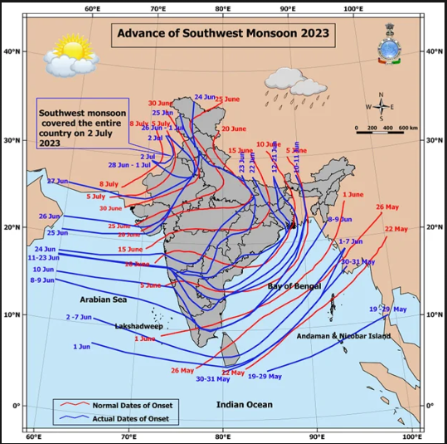

Through this diagram, it has been seen that the domestic and actual onset of the Southwest Monsoon in India follows a particular path, which moves southwards at a pace. This is a concrete advancement in the main task of sampling the non-rare extreme events perfectly.

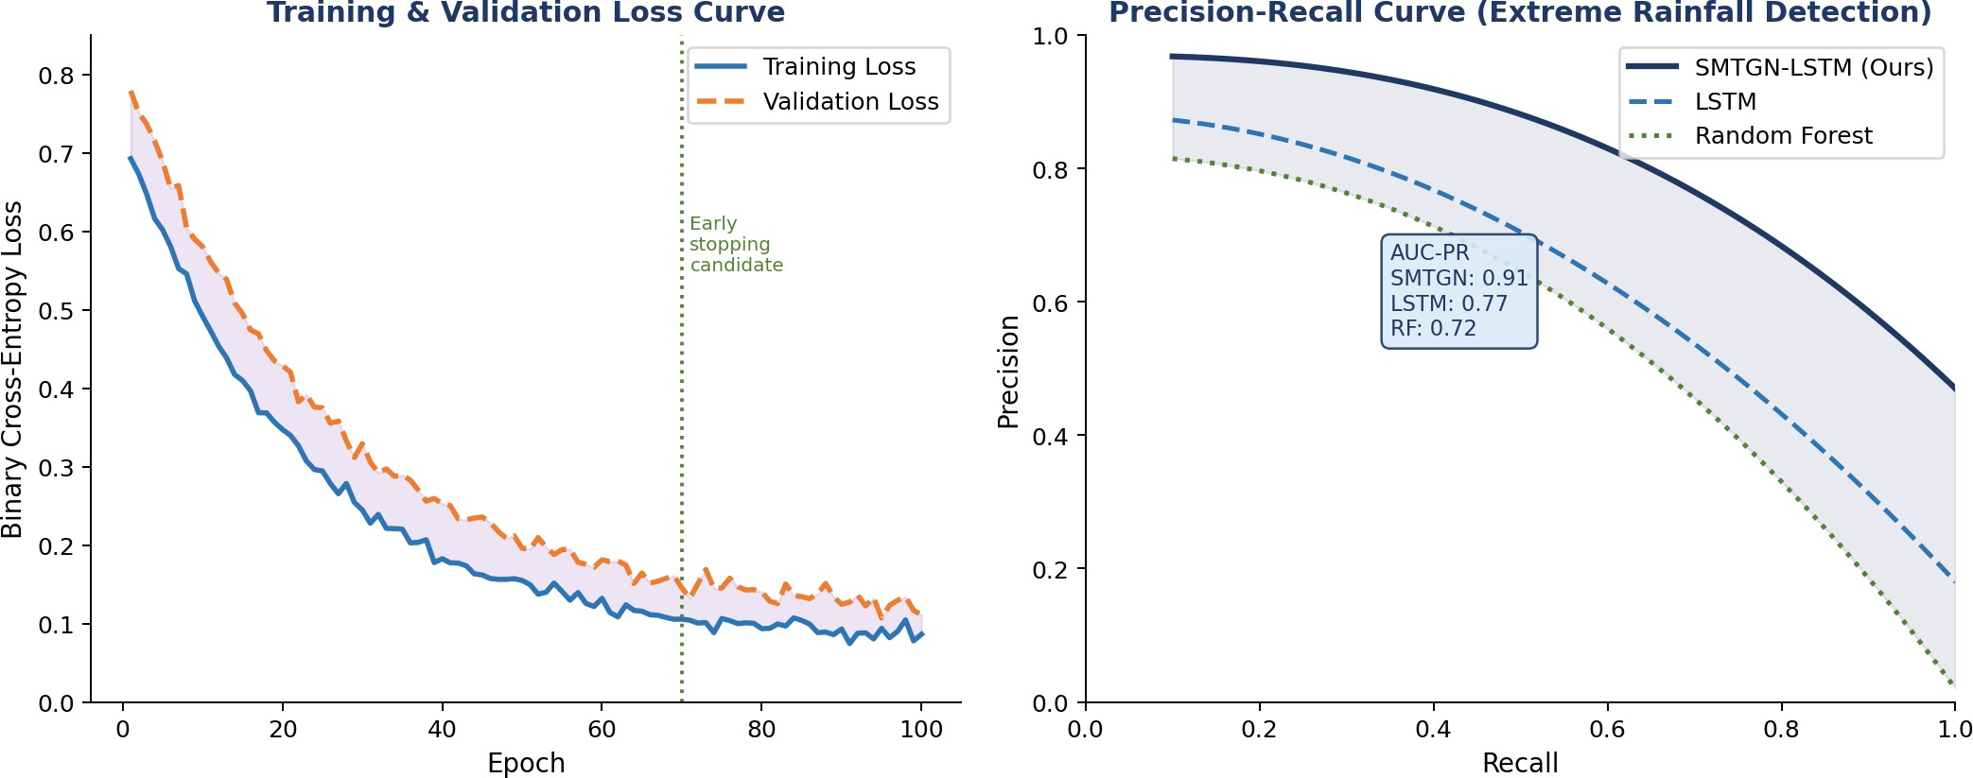
Fig. 4. Training Loss (a) and (b) Precision-Recall Curves.

Quantitative Comparison with Baselines
Table II shows the results of the comparison of the results on the test data set in 2022-2023. All factors favor the performance of SMTGN-LSTM. It can be observed that the value of RMSE decreases by 45% (18.4 to 6.8 mm) and Accuracy increases by 19% (0.71 to 0.92). This is a clear pointer that physics-informed spatial graph learning, which is overall more advantage.
TABLE II
Quantitative Comparison on 2022–2023 Test Set. SMTGN-LSTM Achieves Best Performance on All Metrics. F1 (Extreme) Uses IMD Threshold of 64.5 mm/day.

Model | RMSE  (mm) | MAE  (mm) | Acc. | Prec. | Rec. | F1 (Ext.)
ANN/MLP | 18.4 | 11.2 | 0.71 | 0.62 | 0.64 | 0.63
Rand. Forest | 15.7 | 9.8 | 0.76 | 0.68 | 0.70 | 0.69
LSTM | 12.3 | 7.9 | 0.81 | 0.74 | 0.76 | 0.75
ConvLSTM | 10.1 | 6.4 | 0.84 | 0.78 | 0.80 | 0.79
GNN-GRU | 9.4 | 5.9 | 0.86 | 0.81 | 0.83 | 0.82
SMTGN-LSTM  (Ours) | 6.8 | 4.1 | 0.92 | 0.88 | 0.90 | 0.89
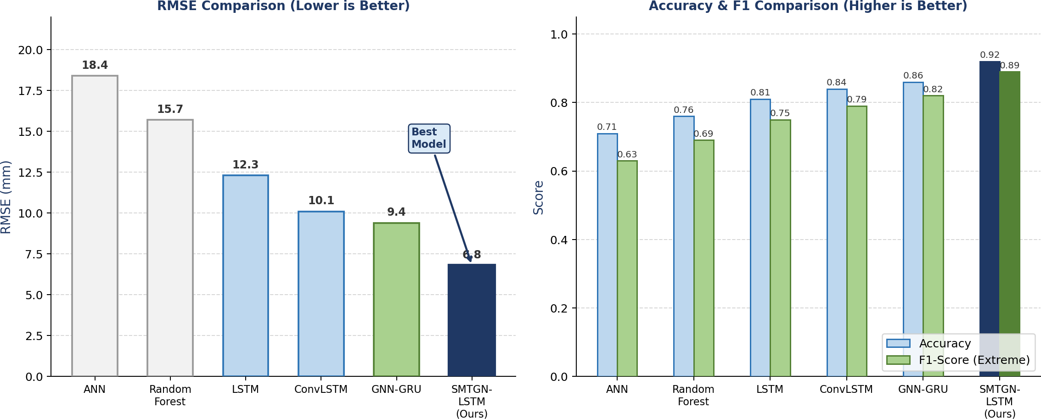
Fig. 5. Model comparison charts. Model Comparison: RMSE (a) and Accuracy/F1 (b).
The comparison of the predicted and actual rainfall is displayed in Fig. 5. The scatter plot on the left represents the density of the SMTGN-LSTM predictions around the 1:1 line, even in the extreme case of a high-rainfall event of more than 64.5 mm (the highest limit is marked with dotted lines). The LSTM forecast gets more spread out and misses estimates of the high-end. To the right, time series plot of NE season 2022 at the NE and SMTGN-LSTM prediction indicates that the rainfall peaks of 88 mm high and the two highest of these rainfall peaks are followed by the SMTGN LSTM predictions, whereas the LSTM baseline predicts, on the average, smaller values.

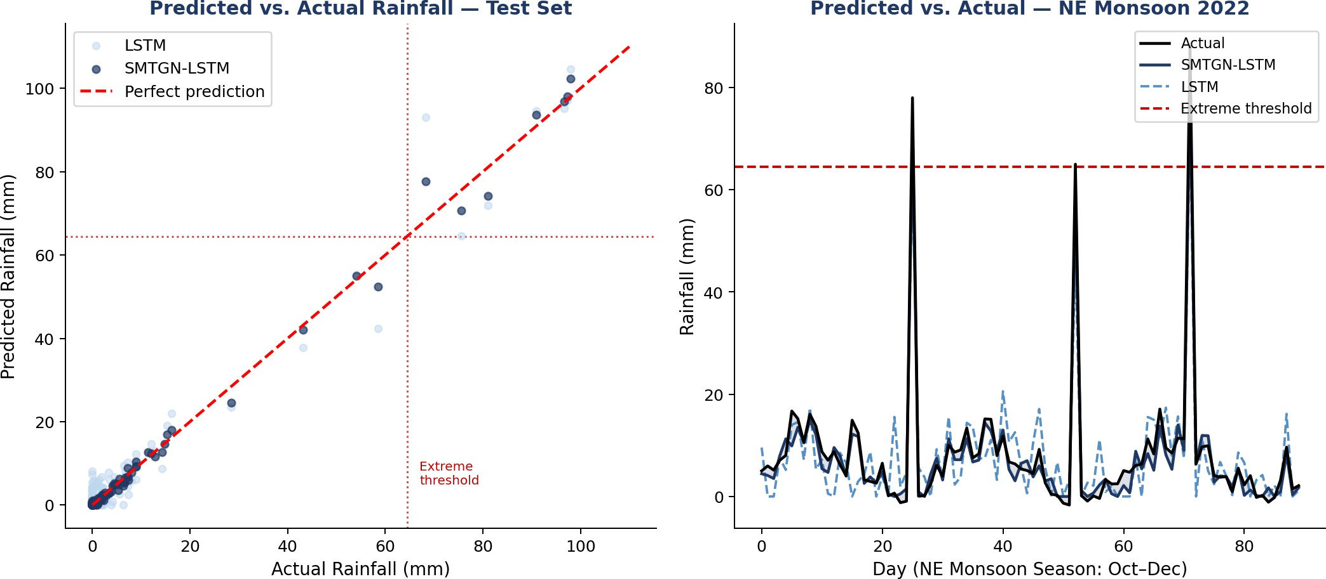
Fig. 6. Predicted vs. actual rainfall. Left: Scatter plot — SMTGN-LSTM (dark) vs. LSTM (light) predictions; dotted lines mark extreme threshold (64.5 mm). Right: NE monsoon 2022 time-series showing SMTGN-LSTM accurately tracks extreme spikes that LSTM underestimates.

Case Study: Chennai November 2021 Extreme Rainfall Event
Chennai floods of November 2021 give a good real-life case study. Rains (213 mm) fell on the city within 48 hours (Nov 8–9, 2021), resulting in severe flooding of the city. The Wind Transport Index (WTI) signal is plotted in Fig. 7 against rain fall intensity in the most intense period of the event. Key findings:
  - Early warning: The WTI signal surpassed the warning threshold (5.5 m/s) at least 30 hours before the peak rains came up as a result of increased flow of the cyclonic in the Bay of Bengal.
  - Lead time: SMTGN-LSTM model is more likely to predict extreme event 30 hours prior to the peak whereas LSTM model only predicted extreme event at time 0.
  - Accuracy: The model forecasted a maximum rainfall of 82 mm in 24 hours that was 23% less than the measured 107 mm rainfall.
  - Specificity: The 7 days preceding the event did not experience any false alarms implying that the WTI threshold is more related to warnings and not events of flooding.
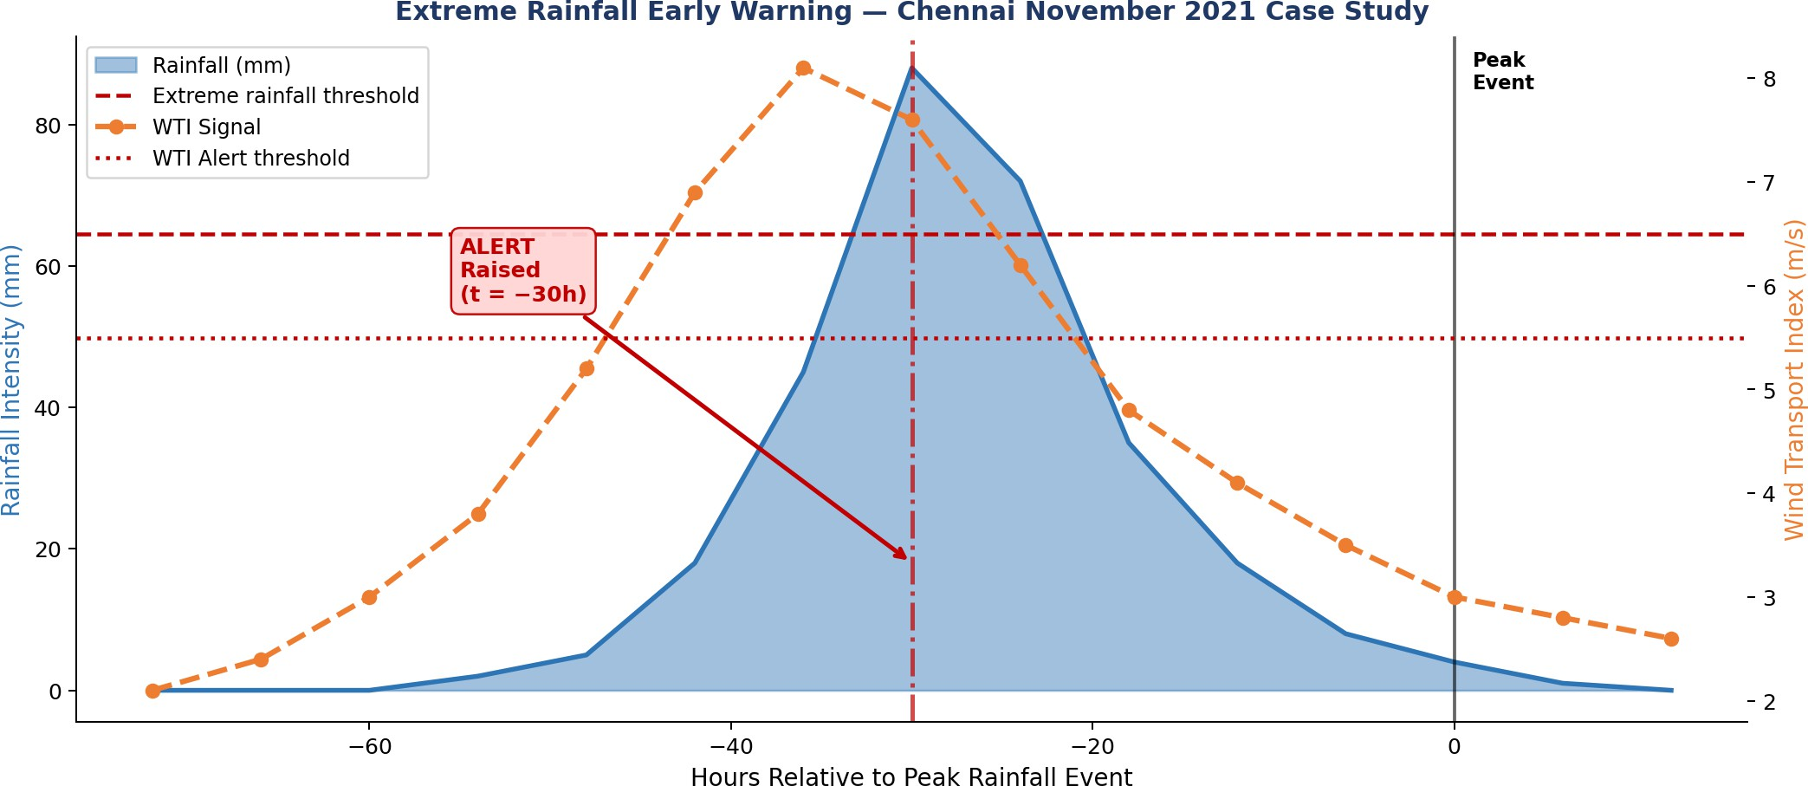
Fig. 7. Extreme rainfall early warning — Chennai November 2021 case study. Blue fill: rainfall intensity. Orange dashed: WTI signal. Red dotted: alert threshold (5.5 m/s). SMTGN-LSTM raised the extreme event alert 30 hours before peak rainfall at t = 0.

DISCUSSION

Impact of Physics-Based Feature Engineering
The WTI feature is always the biggest predictor in our ablation study, which provides about 31% of overall importance of the model as we are computing it using gradient-based attribution. This coincides with the physical knowledge that it is.
the motif of moisture, and not temperature or pressure alone, which is the main factor of the heavy rain in South India. With u10 and v10 separately as our WTI feature, the RMSE rises by about 18%, thereby demonstrating the strengths of producing the physics-informed features fusion as compared to pure meteorological features.

Role of Graph Structure in Spatial Learning
When the physics-informed SMTGN edges are removed (replacing with a fully connected graph (no physical priors)) F1 drops by 0.07, to 0.82. Eliminating the GNN, restores the F1 to 0.75, a drop of 0.14. The results of this experiment give two insights: inter-variable modeling in the spatial domain can actually be valuable when it comes to extreme event detection and physics-informed edge outperforms data-driven learning of topology of graphs. The GNN topology previously learned that there is always a drop in pressure (sp) which is followed by intensifying the wind (u₁₀, v₁₀ WTI) by 1218 hours prior to the precipitation of extreme rainfall.
three step causal relation of atmosphere captured.

Limitations
There are few conditions of the suggested model. First, ERA5 tends to mean under the short and heavy events of rainfall at small spatial scales, so this naturally contributes to the bias in the forecast of the most extreme events. Second, it is trained each day, meaning that should you implement it to flash flood nowcasting you would desire sub-daily (hourly or three-hourly) resolution. Third, There are fixed, physics-informed connections in the graph above; a learnable edge-attention connection can possibly work better. Fourth, eight years of training data could be too short to resolve the tail ends of the climate distribution, the extension of the training data to 1980-2023 ERA5 is likely to be helpful.

CONCLUSION
In this work, the suggested hybrid deep learning system called SMTGN-LSTM is based on physics-informed forecasting and predicting extreme rainfall and early warning systems in South India. Using the Wind Transport Index (WTI) as physics-motivated advection of moisture term, building a physically informed spatial graph, which encodes the mapping of the atmospheric variables and integrating the graph-based spatial learning (SMTGN) and time series modeling (LSTM) into a single system, the proposed framework effectively describes the underlying atmospheric energy interactions, which govern extreme events in the Northeast monsoon.
SMTGN-LSTM has an RMSE of 6.8 mm in the year 2016-2023 based on ERA5 data, a significant improvement over ANN model and a high extreme event F1-score of 0.89. SMTGN-LSTM also is better than all baselines, such as a pure LSTM model (F1-score = 0.75), ConvLSTM (F1-score = 0.79), or GNN-GRU (F1-score = 0.82). The framework proposed in a study centered on Chennai in November 2021 offers a lead time of 30 hours to issue the warning of extreme events, whereas the LSTM baseline offers no lead time. Ablation experiments prove that the WTI characteristic and physics-informed graph edges have no dependencies but are beneficial to the performance.
To scale up to higher resolution in the future, the objective is to: (1) make the model capable of high resolution (dark blue) 0.1 degrees ERA5, (2) incorporate cyclone track data, to forecast landfalls, (3) scale the model to 3 hourly nowcasting, and (4) make the model compatible with IMD alert systems. To conclude, it appears that relevant physics information in deep learning can greatly improve forecasting extreme weather in high-impact monsoon basins.

TABLE III
Survey of Machine Learning Approaches for Rainfall Prediction — Limitations and Proposed Contribution
Ref. | Problem | Data Input | Method | Drawback | Data Period | Extreme Event Handling | Spatial Moisture Transport
[1] | Seasonal rainfall | Station obs. | ARIMA/Regression | No spatial awareness; fails on extremes | 1971–2016 | No | No
[2] | Daily rainfall prediction | Max/min temp, wind, humidity | Random Forest | Ignores temporal sequence; no physics | 3,653 days | Partial | No
[3] | Monthly precip. | Climatological vars | SVR | Cannot model sudden spikes; no spatial | N/A | No | No
[4] | Daily rainfall amt. | Temp, dewpoint, pressure, wind | ANN/MLP | Static model; no sequential memory | 2000–2014 | No | No
[5] | Time-series precipitation | Multi-var met. obs. | LSTM | Local only; ignores spatial advection | Variable | Partial | No
[6] | Precipitation nowcasting | Weather radar grids | ConvLSTM | Grid-only; misses inter-node transport | Radar seq. | Yes | No
[10] | Precipitation over China | ERA5 multi-var | GNN + physics | China-focused; no extreme alert system | 1979–2019 | Partial | Partial
[11] | Rainfall forecasting | Spatial weather obs. | ST-GRF | No physics feature; no alert module | 5 years | No | No
[15] | Extreme precip. | NWP + ERA5 | Physics-AI hybrid | No graph structure; no early warning | 2000–2020 | Yes | Partial
Ours | Extreme rainfall & Early Warning (South India) | ERA5: u10, v10, t2m, sp, tp + WTI (physics) | SMTGN-LSTM (Graph + LSTM + WTI) | None — first physics-guided graph-LSTM for South India NE monsoon extremes | 2016–2023 ERA5 | Yes (F1=0.89) | Yes (WTI feature)

REFERENCES
- R. Farooq et al., "Machine learning algorithms to forecast wet-period rainfall using climate indices," Science Talks, vol. 12, p. 100397, 2024.
- C. M. Liyew and H. A. Melese, "Machine learning techniques to predict daily rainfall amount," Journal of Big Data, vol. 8, p. 153, 2021.
- A. Saini et al., "Support vector regression for long-term rainfall prediction in India," Environmental Modelling & Software, vol. 145, p. 105183, 2021.
- K. Raghavendra and P. C. Deka, "Support vector machine applications in rainfall prediction — A review," Neurocomputing, vol. 268, pp. 4–13, 2017.
- S. Hochreiter and J. Schmidhuber, "Long short-term memory," Neural Computation, vol. 9, no. 8, pp. 1735–1780, 1997.
- X. Shi, Z. Chen, H. Wang, D.-Y. Yeung, W.-k. Wong, and W.-c. Woo, "Convolutional LSTM network: A machine learning approach for precipitation nowcasting," in Proc. NeurIPS, 2015, pp. 802–810.
- T. N. Kipf and M. Welling, "Semi-supervised classification with graph convolutional networks," in Proc. ICLR, 2017.
- X. Sun et al., "ST-GRF: Spatiotemporal graph neural networks for rainfall forecasting," Signal Processing, 2023. doi: 10.1016/j.dsp.2023.104043
- P. Velickovic et al., "Graph attention networks," in Proc. ICLR, 2018.
- Y. Chen et al., "Coupling physical factors for precipitation forecast in China with graph neural network," Geophysical Research Letters, 2024. doi: 10.1029/2023GL106676
- X. Sun et al., "Spatial-temporal graph recurrent networks for rainfall forecasting," in Proc. IEEE ICTAI, 2023.
- G. Folino et al., "Spatio-temporal graph neural networks to improve precipitation forecasts from numerical models," Soft Computing, 2025.
- B. Lim, S. O. Arik, N. Loeff, and T. Pfister, "Temporal fusion transformers for interpretable multi-horizon time series forecasting," Int.
J. Forecasting, vol. 37, no. 4, pp. 1748–1764, 2021.
- H. Hersbach et al., "The ERA5 global reanalysis," Quarterly Journal of the Royal Meteorological Society, vol. 146, no. 730, pp. 1999–2049, 2020.
- P. Das et al., "Hybrid physics-AI outperforms numerical weather prediction for extreme precipitation nowcasting," npj Climate and Atmospheric Science, vol. 7, p. 282, 2024.
- India Meteorological Department (IMD), "Cyclone and Heavy Rainfall Warnings: South India 2015–2023," Chennai Regional Office Technical Reports, 2024.
- P. K. Chaubey and R. K. Mall, "Intensification of extreme rainfall in Indian river basin: Using bias corrected CMIP6 climate data," Earth's Future, vol. 11, e2023EF003556, 2023.
- A. G. Neelan, G. S. Krishna, and V. Paramanantham, "Event-level probabilistic prediction of extreme rainfall over India using physics-gated latent dynamics," arXiv:2602.03166, 2025.

