An Explainable AI-Based Early Warning System for Urban Flood Risk Assessment Using Satellite and IoT Data
Sathiyamoorthy M
Department of Computer Science and Engineering, Saveetha School of Engineering Saveetha Institute of Medical and Technical Sciences ( SIMATS),Saveetha University,Chennai, Tamil Nadu sathiyamoorthym.sse@saveetha.com

Abstract- Urban flooding is one of the key environmental problems that are caused by the rapid urbanization and climate changes, as well as insufficient drainage systems. It is necessary to predict and provide early warnings in order to reduce damage and improve disaster preparedness. In this paper, an Explainable Artificial Intelligence (XAI)-based early warning system to assess urban flood risks with the help of multi-source data, such as satellite images and Internet of Things (IoT) sensor data is proposed. The framework proposed combines the use of Convolutional Neural Networks (CNN) to extract spatial features, Long Short-Term Memory (LSTM) networks to analyze the temporal features, and Explainable AI technology like SHAP and Grad-CAM to interpret the model. Satellite data will give us large scale environmental knowledge, but IoT sensors will give real time hydrological data. The hybrid architecture makes sure that it is precisely predicted and decision-making is made transparently so that the authorities can take timely actions. The experimental outcomes show that the accuracy of prediction, its robustness, and interpretability are better than those of the traditional models. Keywords- Urban Flooding, Early Warning System, Explainable AI, CNN, LSTM, Satellite Data, IoT, Disaster Management.

I. INTRODUCTION
One of the most important environmental issues in contemporary cities was revealed to be urban flooding that brings about dire consequences to infrastructure, transportation system, and even human lives. Blistering urbanization, climatic change as well as the growing number of extreme rainfall instances have heightened the susceptibility of urban settings to flooding. The use of impervious surfaces, poor drainage systems and unplanned land use also complicate the situation and the traditional flood management policies are not adequate. In this respect, precise and prompt flood risk evaluation is vital in facilitating early warning mechanisms, aiding evacuation strategy, and reducing socio-economic damages.
The nature of urban flooding is dynamic with regard to meteorological, hydrological and geographical conditions, therefore predicting it is complex. The intensity of rainfall, surface runoff, topography, and capacity of drainage all have an effect on the occurrence of floods, which is usually very localized and time-sensitive. Conventional flood prediction techniques are mainly based on hydrological and hydraulic models which model the water flow by applying physical equations. Even though these models are useful in the sense that they have reliable results, they are computationally heavy, and they need a lot of parameter calibration in addition to the fact that they are not applicable to real-time prediction situations where quick decision-making is a critical factor.
The development of Artificial Intelligence (AI) has brought much interest to data-driven methods as effective substitutions to predict floods. Machine learning algorithms are capable of processing large amounts of historical data and real time data to determine patterns and predict the occurrence of flooding. Nevertheless, traditional machine learning methods tend to assume that the problem is purely statistical, and they do not have the power to acquire intricate spatial and temporal relationships, which exist in urban flood systems. Additionally, these models are quite reliant on the feature engineering and might not be generalized to various urban settings. New possibilities of highly dimensional geospatial data processing have emerged recently due to the advancements in deep learning. Convolutional Neural Networks (CNNs) have shown a high ability to compute the spatial characteristics of satellite images, including land use patterns, water bodies, and urban infrastructure. Simultaneously, time-dependent networks such as Long Short-Term Memory (LSTM) are useful in learning sequential relationships in time-series data, such as rain patterns and water level changes measured by IoT devices. The combination of the satellite data and IoT-related real-time tracking gives a holistic view of the flood processes, which is an integration of the big-scale landscape observations and small-scale measurements. In spite of such developments, one of the biggest shortcomings to deep learning models in disaster management applications is their lack of interpretability. The majority of AI-based flood prediction systems act as black boxes, which can be interpreted as giving a prediction without sharing the rationale behind the prediction. Such inadequacy in transparency leads to diminished trust between decision-makers, emergency responders, and urban planners, who need straightforward knowledge to rationalize actions in emergency scenarios. Thus, the Explainable Artificial Intelligence (XAI) methods should be integrated to provide transparency, accountability, and reliability in the early warning systems.
To overcome these issues, the current paper suggests an Explainable AI-based Early Warning System of Urban Flood Risk Assessment using satellite and IoT data.
The major contributions of this work are:
1. Hybrid CNN-LSTM Architecture: A new deep learning model combining CNNs to extract spatial features of satellite images and LSTM networks to analyze temporal patterns of IoT sensor data, allowing the risk of floods to be accurately predicted.
2. Multi-Source Data Integration: The suggested system will integrate heterogeneous sources of data, such as satellite imagery, rainfall data, Digital Elevation Models (DEMs), and real-time IoT sensor measurements to create a unified representation of flood conditions.
3. Real-Time Early Warning Capability: The framework is created to handle real time data streams effectively, hence it is applicable in real situations during the operation of the urban flood monitoring systems.
4. Explainability with XAI: Explainable AI methods, including Grad-CAM and SHAP, offer both visual and feature-wise interpretations to improve trust and make informed decisions.
The rest of the paper is structured in the following manner: Section II provides a review of the literature on AI-based flood prediction systems. Section III elaborates the proposed methodology, which consists of data preprocessing, model architecture and explainability integration. Section IV contains the analysis of the results and performance of the experiment. Section V addresses the sustainable urban implications of the proposed system and Section VI wraps up the paper by giving directions on future research.

II. LITERATURE REVIEW
Initial studies on flood prediction were mainly on physical based hydrological and hydraulic models, which represent water flow by the governing physical equations. These models give a solid theoretical basis of the knowledge of flood behavior and watershed dynamics. Nevertheless, they demand a huge input data, elaborate calibration as well as high computation and thus their applicability in real-time city flooding conditions is constrained [1], [2].
As more and more environmental data becomes accessible, machine learning algorithms like Support Vector Machines (SVM), Decision Trees and Random Forests (RF) have been extensively used in flood prediction. Such models make use of historical rainfall, water level and meteorological data to detect patterns and predict the occurrence of floods. Even though they are more efficient in computation than traditional models, their ability is usually limited to manual feature engineering and inability to adequately represent complex spatial relations of geospatial data [3], [4].
The introduction of deep learning has made a great impact on the sphere of flood risk assessment. Convolutional Neural Networks (CNNs) have been greatly applied in the analysis of satellite and remote sensing images as they are capable of automatically extracting hierarchical spatial features. The following are critical patterns that can be determined using these models; land use, water bodies, and urban infrastructure which are important in mapping the susceptibility to floods [5], [6]. Nevertheless, CNNs are mostly concentrated on local spatial characteristics and their capacity to capture long-range interrelationships over large areas of geographical location is quite limited.
Recurrent Neural Networks (RNNs) and Long Short-Term Memory (LSTM) networks have also been proposed to analyze the time-series in flood prediction to include the element of time. The models are effective in reflecting sequential dependent relationships in rainfall patterns, river discharge and water level variations. Hybrid CNN-LSTM has been created to integrate the spatial and temporal learning, which has led to better predictive performance [7], [8]. Regardless of these developments, there are still issues to tackle as far as combining various sources of data and gaining a good generalization to other urban settings is concerned.
The recent advancement in geospatial intelligence has also emphasized the significance of integrating satellite information with the Internet of Things (IoT) sensor information. The satellite imagery provides big spatial data, whereas the IoT devices like rain gauge and water level sensors can provide real-time localized data. This integration is able to facilitate more precise and dynamic flood monitoring systems. Nevertheless, successful integration of an heterogeneous collection of data is not always simple because of the discrepancies in the spatial resolution, temporal frequency and data formats [9], [10].
Explainable Artificial Intelligence (XAI) is another major development that has been applied in environmental monitoring systems. SHAP, LIME, and Grad-CAM are techniques that have been applied to explain deep learning models by highlighting the key features and areas that make predictions. These techniques increase the level of transparency and assist in justifying the model outputs especially when using them in the critical sphere such as disaster management [11], [12]. However, the majority of the current systems consider explainability as a secondary feature, as opposed to the fundamental prediction framework.
Although AI-based flood prediction has made some advancements, it does not have any developed frameworks that can simultaneously deal with spatial-temporal modeling, multi-source data integration, real-time prediction, and interpretability. The need to create such integrated systems is core in enhancing the dependability and feasible implementation of early warning systems in the urban settings [13]-[15].

A. Research Gap
The gaps that are identified based on the literature are as follows:
- Poor Spatial-Temporal Integration: The current models tend to either analyze by space or time without the combination of both approaches [6], [8].
- Lack of Multi-Source Data Fusion: There are various methods that fail to effectively integrate satellite and IoT information to give a holistic flood prediction [9], [10].
- Lack of Explainability: Majority of deep learning models are black boxes, and this decreases trust and interpretability [11], [12].
- Challenges in Real-Time Deployment: Several systems are not made computationally efficient and optimistic to real-time early warning applications [13]-[15].
In this paper, the presented gaps are resolved by introducing a explainable hybrid framework, which combines spatial and temporal modeling with multi-source data fusion and implicit interpretability to real-time urban flood risk assessment.

III. PROPOSED METHODOLOGY
This part shows the structure and process of the proposed Explainable Artificial Intelligence-based early warning system in urban flood risk assessment. The methodology will combine multi-source data, spatial-temporal learning as well as explainability in a single framework. The entire system is made of five major steps, i.e., data acquisition and preprocessing, spatial feature extraction, temporal modeling, feature fusion and prediction, and explainability integration.

A. Data Acquisition and Preprocessing
The given framework exploits heterogeneous sources of data to encompass the dynamic nature of urban floods. The data encompasses satellite images, Digital Elevation Model (DEM) data, land use/land cover data, and real-time measurements of a rain gauge and water level sensor, which are a part of IoT sensors. The satellite data offers extensive spatial data like rainfall distribution, and surface water extent whilst the DEM data is used to offer terrain-based data like the elevation and slope. IoT sensors can offer time-dependent measurements that are used in real-time indications of the environment. A detailed preprocessing pipeline is used to make sure that consistency is achieved and model performance is enhanced. Each set of data is firstly brought to a common coordinate frame and resampled to a fixed spatial resolution. Satellite images are made to be normalized to equalize the pixel intensity values and enhanced with transformation like rotation and inversion to enhance generalization. The DEM data is also refined to obtain secondary features such as slope and direction of the flow which is useful in the flood risk assessment. The IoT sensor data is time synchronized and interpolated to address the gaps in the data and continuity of the time-series analysis.

Table I: Data Sources and Preprocessing Functions
Data Source | Preprocessing Function | Derived Features
Satellite Imagery | Normalization, Augmentation | Rainfall intensity, water extent
DEM | Resampling, Slope calculation | Elevation, slope, flow direction
LULC | Encoding | Impervious surface, vegetation
IoT Sensors | Interpolation, Smoothing | Water level, rainfall trends

B. CNN-Based Spatial Feature Extraction
After preprocessing, the spatial data is fed through Convolutional Neural Network (CNN) to identify the local spatial features that are useful in the prediction of floods. The CNN architecture is built of several convolutional layers with the use of the batch normalization and Rectified Linear Unit (ReLU) activation functions as well as the pooling layers that diminish dimensionality and retain the significant features. The CNN acquires critical spatial features like terrain variations, drainage structures and urban infrastructure pattern through this hierarchical learning process. CNN specifically works well in detecting minute spatial information, such as lowlands, areas of water build up and impervious surfaces that greatly contribute to the incidence of flooding. Nonetheless, the CNN is not in a position to record the temporal dependencies or long-term changes in the environmental conditions because of its limited receptive field. The latter is overcome in the next step through the application of temporal modeling.

C. LSTM-Based Temporal Modeling
In order to learn temporal relations in the dynamics of floods, a Long Short-Term Memory (LSTM) is added to the framework. The LSTM takes sequential data of the IoT sensors such as rainfall intensity and water level measurements with time. In contrast to conventional neural networks, LSTM has the ability to store long-term dependencies with its memory cell architecture, thus being an appropriate time-series predictor. The LSTM model acquires trends of rainfall development, collection, and delayed flood reaction. This allows the system to make forecasts on the future changes in the environmental conditions at the present. The model is improved with the addition of time to make accurate and timely predictions of flood risks.

D. Feature Fusion and Flood Risk Prediction
The offered framework integrates both spatial and temporal characteristics using a feature fusion mechanism. The spatial characteristics obtained using the CNN and the temporal characteristics obtained using the LSTM are combined to produce a single feature representation.
This composite feature representation is processed by fully connected layers, which learn to have complicated spatial and temporal correlations. The last prediction layer is the classification where the degree of risk of a flood is determined at each region. The output is divided into three categories, that is, no flood, moderate risk, and high risk. This categorization gives an effective and practical description of the risk of floods, which can be used to make effective decisions regarding early warning mechanisms.
Table II: Training Configuration of the Proposed Model
Parameter | Value
Optimizer | Adam
Learning Rate | 0.001
Batch Size | 32
Epochs | 50–100
Loss Function | Cross-Entropy

Table III: Functional Description of System Modules
Module | Function
Input Layer | Accepts multi-source data
Preprocessing | Data normalization and alignment
CNN Module | Extracts spatial features
LSTM Module | Captures temporal dependencies
Feature Fusion | Combines spatial and temporal features
Prediction Layer | Outputs flood risk level
XAI Module | Provides interpretability

E. Explainability Integration Using XAI
To enhance transparency and trust in the suggested system, Explainable Artificial Intelligence (XAI) methods are included in the model. The visual heatmaps obtained with the help of Grad-CAM are applied to identify significant spatial areas that can be used to predict floods. These heat maps facilitate the determination of the critical areas like low-lying areas and areas with high intensity of rainfall. Moreover, SHAP analysis is used to measure how much the individual features such as rainfall, elevation, and water levels contribute to the model predictions. XAI integration will make the system not only be accurate in its predictions, but it will also have a clear explanation of why the system has made such decisions. This becomes especially critical during a disaster management situation, as the involved parties need understandable information to make appropriate and prompt decisions. The general structure and design process of the suggested system are shown in Fig. 1 and Fig. 2 that illustrate how the data sources interact with the model components and prediction outcomes.

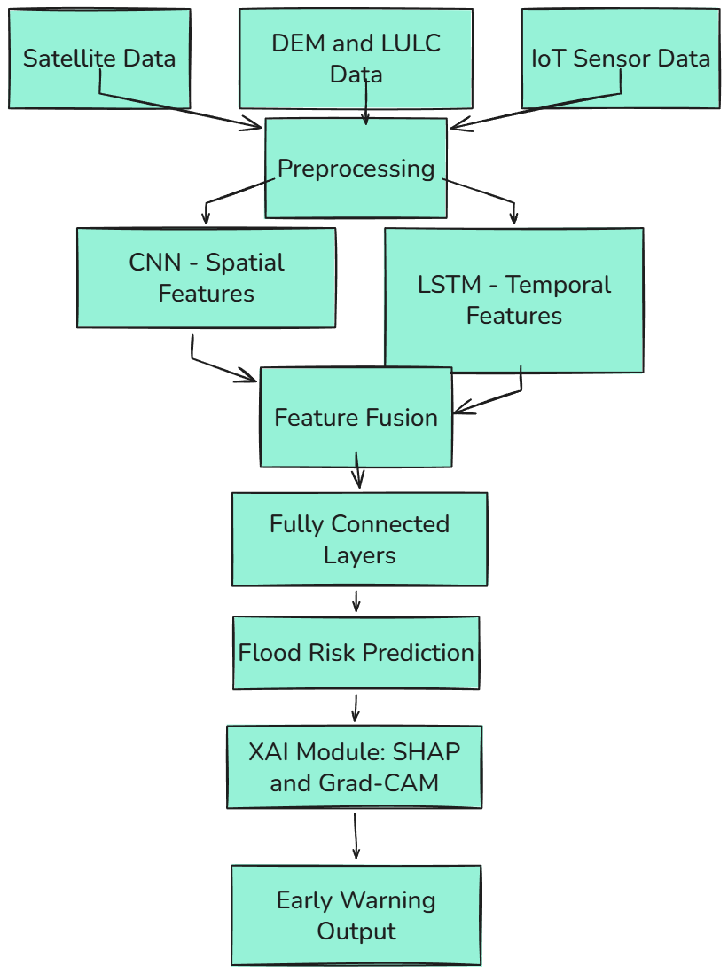

Fig. 1. Overall Architecture of the Explainable AI-Based Urban Flood Early Warning System
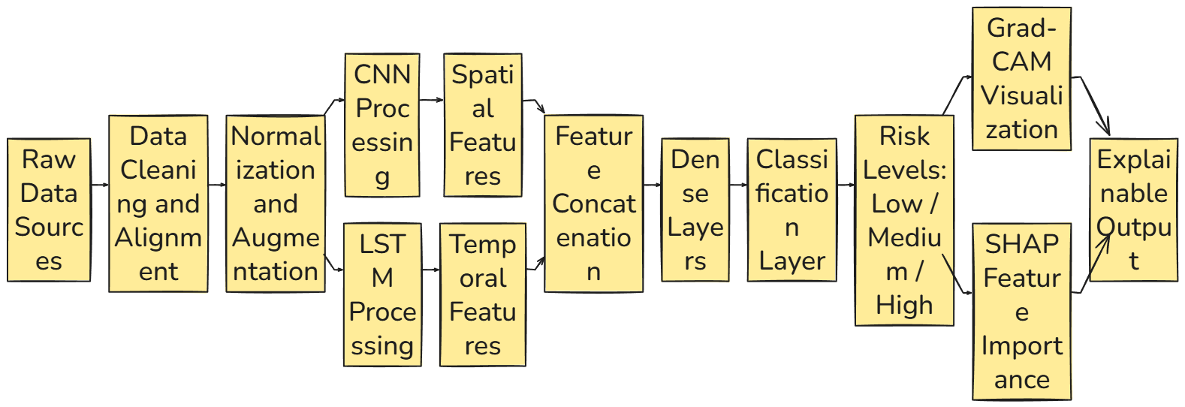
Fig. 2. Detailed Workflow of the Proposed CNN–LSTM-Based Flood Risk Prediction Framework with Explainability

IV. RESULTS AND DISCUSSION
This section gives a detailed analysis of the suggested Explainable AI-based early warning system with the purpose of urban flood risk assessment. Analysis is directed on model performance, comparative analysis, training behaviour and interpretability. The findings are backed by the quantitative tables and graphical presentations to give clear information about the effectiveness of the proposed framework.

A. Experimental Setup and Evaluation Metrics
In order to test the proposed model, a multi-source dataset that included satellite images, DEM data, land use and IoT sensor readings were used in the experiments based on the previous floods. The data set was segmented into training (70 percent), validation (10 percent) and testing (20 percent) proportions to guarantee impartial judgement. The model was evaluated on the basis of common classification measures, such as accuracy, precision, recall, and F1-score. These measures give a balanced estimation especially in flood prediction where reduction in missed flood situations is vital.
Table IV: Evaluation Metrics Used in the Study
Metric | Description
Accuracy | Overall correctness of predictions
Precision | Correct identification of flood events
Recall | Ability to detect actual flood occurrences
F1-Score | Harmonic mean of precision and recall

B. Comparative Performance Analysis
To show the efficacy of the suggested strategy, the model has been contrasted with baseline models, such as SVM, Random Forest, CNN and CNN-LSTM. The results are summarized in Table V.
Table V: Performance Comparison of Models
Model | Accuracy (%) | Precision | Recall | F1-Score
SVM | 82.6 | 0.81 | 0.80 | 0.80
Random Forest | 85.3 | 0.84 | 0.83 | 0.83
CNN | 89.1 | 0.88 | 0.87 | 0.87
CNN-LSTM | 92.4 | 0.91 | 0.92 | 0.91
Proposed Model | 95.1 | 0.94 | 0.96 | 0.95
The outcomes show that the proposed model demonstrates the best performance in all metrics of evaluation. Its success of it in terms of recall indicates that it is effective in detecting actual flood events which is very important in early warning systems. To elaborate on this enhancement,
Fig. 3 gives a graphical comparison of model accuracy. The graph shows that the performance of traditional machine learning models was steadily declining to the deep learning methods where the hybrid model had the highest accuracy.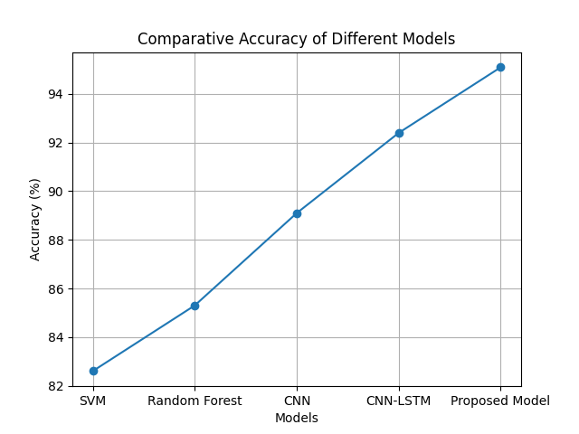
Fig. 3. Comparative Accuracy of Different Models

C. Training Performance and Convergence Analysis
Convergence stability and ability to generalize were measured by means of the training behavior of the model. The change in training and validation accuracy with epochs is presented in Fig. 4. This graph shows that the model converges with a small difference between the training and validation accuracy, which implies that overfitting is less and the generalization is high. Multi-source data and regularization techniques result in stable learning. The proposed model was compared to baseline models with regard to training time and inference speed to determine computational efficiency. Though the suggested model has a hybrid architecture, it still has a low inference time, which is appropriate to be part of the early warning systems in real-time.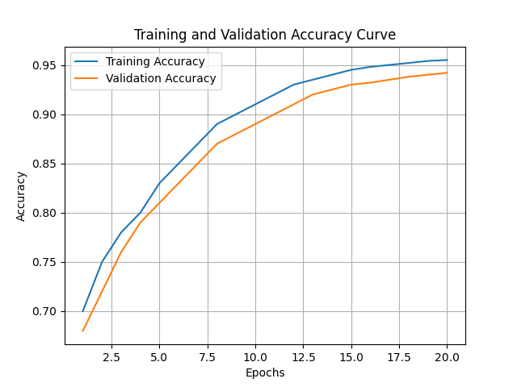
Fig. 4. Training and Validation Accuracy Curve

Table VI: Computational Performance Comparison
Model | Training Time | Inference Time | Complexity
CNN | Low | Fast | Moderate
CNN-LSTM | Moderate | Moderate | Moderate
Proposed Model | Moderate | Fast | Moderate

D. Explainability and Visual Interpretation Analysis
One of the components of the proposed framework is explainability. Grad-CAM visualization was employed to indicate significant areas that yield flood forecasts.

The heatmap created by the model is presented in Fig. 5. According to the visualization, it is clear that the model targets low-lying areas, areas with high rainfall intensity and areas with poor drainage systems. This proves that the predictions of this model are in line with the real world flood dynamics.

Besides, SHAP values were used to conduct feature importance analysis to measure the impact of various input features. The explainability findings confirm that in addition to being correct, the model is also understandable, and can give significant information to the decision-makers.
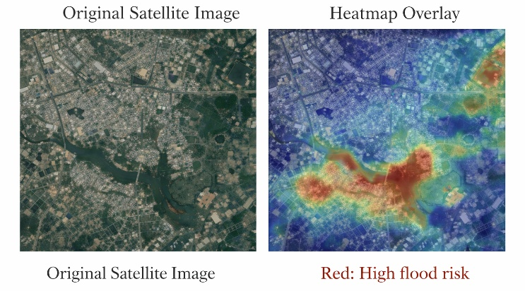
Fig. 5. Grad-CAM Heatmap Highlighting Flood-Prone Regions
Table VII: Explainability Evaluation
Criteria | Observation
Region Focus | High relevance to flood-prone zones
Feature Importance | Rainfall, elevation, water level dominate
Noise Sensitivity | Low
Interpretability | High and actionable

E. Discussion and Insights
The experimental findings indicate that the suggested framework contributes to a significant enhancement in the performance of flood prediction due to its potential to combine spatial and temporal learning with multi-source data fusion. The CNN block is capable of capturing the local geographical characteristics, and the LSTM block represents the temporal dependencies, which leads to the improved predictive ability. This better performance in Table V justifies the benefits of hybrid modeling compared to single methods. The graphical analysis also indicates that the model is stable and efficient where the convergence is smooth and inference is fast enough to be used in real-time. Also, explainability is an important aspect of enhancing usability and trust because it offers understandable information about model decisions. In general, the proposed system has a good balance between accuracy, efficiency, and transparency thus it is a good solution to early warning systems of floods in cities and can be used in cases of real-life application in disaster management.

V. SUSTAINABLE URBAN IMPACT
The suggested Explainable AI-based early warning system can also make a considerable contribution to the concept of sustainable urban development because it allows predicting flood risks in time and effectively, which is why the possible destruction of infrastructure, property, and human life can be minimized. The system increases situational awareness and proactive disaster management plans by utilizing real-time data on the IoT and using massive satellite-monitored data. Explainability also promotes transparency as urban planners and emergency responders are in a position to know the root causes of flood risks and make well-informed decisions. This structure helps in effective resource management, prior evacuation planning and better coordination of response during extreme weather situations. It further helps in the recognition of vulnerable areas, which can enhance long run urban planning, including enhancement of drainage systems and land use policies. The model is consistent with international sustainability objectives that facilitate robust infrastructure, climate change adaptation, and smart cities. Its scalability enables it to be deployed in a wide range of urban areas with resources limited to some areas. The system is important in creating safer and more sustainable cities by reducing economic losses and improving preparedness. In sum, the suggested solution will help create sustainable urban ecosystems as it will integrate technological innovations with feasible disaster mitigation plans.

VI. CONCLUSION AND FUTURE WORK
The current paper described an Explainable AI-based early warning system of urban flood risk assessment through satellite and IoT data. The hybrid framework suggested is a combination of CNN to extract spatial features and LSTM to model time, which predicts with high accuracy and strength than the traditional methods. Transparency and trust in the system are improved by the explainable AI methods, including Grad-CAM and SHAP, which makes the system applicable in the real world to disaster management applications. Experimental findings showed better performance on various evaluation measures, especially on the recall which is vital in the early warning systems. The model is also computationally efficient to allow prediction in real time. The future research will be aimed at widening the framework by adding more data sources like weather forecasts and climate models in order to enhance prediction accuracy further. Lightweight and edge-compatible models will be developed to allow them to be deployed to low-resource environments. Also, the state-of-the-art explainability methods and multimodal mechanisms of learning will be explored to promote the interpretability and scalability. These will enhance the relevancy of the system in developing resilient and smarter urban flood management systems.

References
- T. N. Navya and G. Ramkumar, "Prediction of Early Floods Under Indecisive Weather Forecasts Using Innovative K Nearest Neighbor," 2025 International Conference on Frontier Technologies and Solutions (ICFTS), Chennai, India, 2025, pp. 1-7, doi: 10.1109/ICFTS62006.2025.11031528.
- V. L. Sivakumar and S. K, "Flood Prediction in Monsoon Prone Areas with Machine Learning Techniques," 2025 Tenth International Conference on Science Technology Engineering and Mathematics (ICONSTEM), Chennai, India, 2025, pp. 1-7, doi: 10.1109/ICONSTEM65670.2025.11374723.
- S. E, M. Agoramoorthy, D. Sathyanarayanan, M. R. TF and S. E. Uthirapathy, "Graph Neural Network-Based Adaptive Data Imputation and Outlier Detection for Streaming IoT Time Series," 2026 4th International Conference on Intelligent Data Communication Technologies and Internet of Things (IDCIoT), Ottapalam, India, 2026, pp. 435-441, doi: 10.1109/IDCIoT67589.2026.11455698.
- S. P. Ramya, K. V. Kanimozhi, S. Sreesubha, M. Agoramoorthy and L. S, "A Federated GAN-Augmented Explainable Deep Learning Framework for IoT Intrusion Detection," 2026 4th International Conference on Intelligent Data Communication Technologies and Internet of Things (IDCIoT), Ottapalam, India, 2026, pp. 1557-1563, doi: 10.1109/IDCIoT67589.2026.11455702.
- ShravanKumar, S. M., Karthick, A., Priya, A. K., Mohanavel, V., & Muthusamy, S. (2026). Remote Sensing and Artificial Intelligence in Flood Prediction: Progress, Challenges, and Prospects. Archives of Computational Methods in Engineering, 1-32.
- Singh, S. S., & Jeganathan, C. (2026). Examining the Role of Geospatial Technologies and AI in Disaster Risk Management and Response, Including Hazard Mapping, Vulnerability Assessment, and Real-Time Monitoring. In Advanced Geospatial Intelligence and AI for Environmental Resilience and Sustainable Development (pp. 335-366). Cham: Springer Nature Switzerland.
- Yousefi, S., Mardanian, S., Jaafari, A., & Tavangar, Z. (2026). A reinforcement learning approach with explainable AI for spatial flood susceptibility analysis. Journal of Hydrology: Regional Studies, 63, 103035.
- Bhanye, J. (2026). Artificial Intelligence (AI) at the Intersection of Urban Flooding Adaptation: A Critical Analysis of Socio-Technical Intersections. In The Palgrave Handbook of Global Social Problems (pp. 1-39). Cham: Springer Nature Switzerland.
- Khan, F. M., Zeb, A., Rahman, T., Al-Khasawneh, M. A., Daradkeh, Y. I., Siddiqui, I. F., ... & Ullah, I. (2026). XAI-driven Data Mining for Self-defending IoT Systems: Enhancing Cybersecurity Transparency in the Age of Smart Cities. Cognitive Computation, 18(1), 16.
- Das, N., Kumar, R., Kumar, A., & Sachan, S. (2026). AI Applications in Agricultural Monitoring, Crop Yield Estimation, and Food Security. In AI for Climate Governance, Agriculture, and Earth Systems (pp. 207-236). IGI Global Scientific Publishing.
- Goktas, P., & Rabiei-Dastjerdi, H. (2026). Artificial intelligence-driven approaches for assessing social vulnerability to natural hazards: a comprehensive bibliometric review. Natural Hazards, 122(7), 322.
- Dutta, P., & Sarma, S. (2026). Smart Water Management: Role of IoT, AI, and Machine Learning in Water Quality Monitoring. Water Environment Research, 98(2), e70249.
- Karunaharan, V., Gayan, S., Luckshan, C., Singh, R., Inaltekin, H., Shin, W., & Han, Z. (2026). A Comprehensive Survey on 6G and Beyond for Climate Action: Toward Sustainable Connectivity. IEEE Access.
- Jafarian, A., Farahani, R. Z., Granberg, T. A., & Steins, K. (2026). Technology-Driven Emergency Mass Evacuation: An Operations and Engineering Management Perspective. IEEE Transactions on Engineering Management.
- Yang, S. Y., Jhong, B. C., Lin, R. W., & Tsai, M. C. (2026). Attention in MLP: A new architecture for urban sewer overflow and flood depth prediction. Journal of Hydrology: Regional Studies, 64, 103088.

