Analyzing YOLO Object Detection Models for
Automated American Sign Language Recognition

SWADESH KUMAR GIRI
Department of Computing Technologies
SRM Institute of Science and Technology,
Kattankulathur, Chennai sg0104@srmist.edu.in

RITVIK RAJVANSHI
Department of Computing Technologies
SRM Institute of Science and Technology,
Kattankulathur, Chennai rr9169@srmist.edu.in

DR. SUBASH R
Associate Professor, Department of Computing Technologies
SRM Institute of Science and Technology,
Kattankulathur, Chennai, subashr@srmist.edu.in

Abstract— Sign language is one of the most important means of communication for non-hearing individuals or hard-of-hearing people. Nevertheless, the absence of a general understanding of sign language among the people often leads to communication barriers. To overcome this problem, this paper introduces a system for real-time recognition and interpretation of sign language gestures that functions on a conventional web camera. The proposed system recognizes hand gestures performed in front of the camera and interprets them as corresponding text output simultaneously providing voice feedback. The proposed method utilizes deep learning techniques to efficiently detect and classify hand signs. Several state-of-the-art models, such as YOLOv8, YOLOv11, and the Spatial Temporal Graph Convolutional Network (STGCN), are employed and tested to compare their performance on sign language recognition tasks. The experimental findings show that YOLOv11 performs superior than other models in terms of mean precision, achieving an accuracy of over 99% with a high success rate of recognizing test gestures.
Keywords— YOLO, American Sign Language, Mean Average Precision, Intersection over Union, Deep Learning.

Introduction
Communication has always been one of the greatest issues to deaf or hard of hearing people, especially when they need to communicate with individuals who do not know sign language. Although there has been a fast rate of technological developments that have revolutionized many areas of life, this communication barrier still restricts accessibility, social inclusion and equal access to key services. The sign language is an expressive and rich language that helps non-hearing individuals to communicate, express their ideas, feelings and pass information. But its little knowledge by the general population usually becomes an obstacle to easy communication.
To overcome this challenge, this proposed project proposes the implementation of a real time sign language recognition system that employs a web camera which is readily available. The main aim of this system is to facilitate effective communication between the sign language and the non-signers since it automatically identifies the gestures of the hand and translates them into meaningful outputs. The system is constructed on the basis of the newest computer vision and deep learning methods that enable it to detect and interpret sign language gestures in real-time scenarios.
The system takes the visual information, and processes the significant properties such as hand movement and other relevant cues on the face as the user implements the signs in front of the camera. These characteristics are fed into advanced machine learning models to recognize the matching sign language representations. The two-output system of the proposed system is one of the strange aspects. Once a successful identification of a sign is achieved the system makes a verbal sound out as well as the text that is translated is displayed on the screen. The audio response enables instant comprehension among people who are not acquainted with sign language and the textual display offers a clear visual point of reference, which makes it all more accessible.
The introduction of this dual-mode output is a considerable expansion of the usability and impact of the system. The solution is inclusive and encourages more people to learn more about the sign language by providing audio and visual feedback. Moreover, it can easily be incorporated in the typical webcams and other camera-equipped devices and therefore is quite practical and cost efficient in real world implementation.
Besides the ordinary communication, the possibilities of this innovative technology are immense in various sectors, including education, medical care, and services to the citizens, where communication is a critical aspect. Using this project, it is possible to see how smart and intelligent technologies can help to support the deaf and hard-of-hearing community and make the society more inclusive and equal due to the lack of barriers in communication.

Literature Review
The recent innovations in the recognition of Sign Language as well as translation systems have also been geared towards the development of intelligent real time systems as a way of helping to overcome the communication gap separating the hearing impaired from the rest of the population. Previously, the techniques were more oriented towards multimodal integration, i.e., speech-to-sign and gesture-to-text pipelines to enable two-way communication and make it more accessible [1]. Based on this, scholars introduced natural language processing methods into continuous sign language recognition systems to improve the syntactic accuracy and semantic consistency of text generated, showing that correct recognition should be supported by semantically meaningful language generation [2]. Object detection models, like YOLO, have become the most popular in the field of gesture detection, with comparative studies indicating that more recent architectures, like YOLOv8, have a higher accuracy and real-time performance than previous architectures [3]. In addition to that, studies have extended the scope of SLRs to include emotions by combining convolutional neural networks (CNNs), UNETs for segmentation, and facial emotion detection techniques, highlighting the importance of non-manual attributes like facial expressions in improving understandability [4]. Efficiency and scalability have also become important research goals, giving rise to lightweight multimodal systems that use RGB input along with motion information to strike a compromise between efficiency and effectiveness [5]. Similarly, CNN-based gesture-to-text systems have shown robustness in varying environmental conditions, reinforcing the effectiveness of deep learning-based feature extraction techniques [6]. Similarly, CNN-based gesture-to-text systems have shown robustness in varying environmental conditions, reinforcing the effectiveness of deep learning-based feature extraction techniques [7]. A combination of MediaPipe based spatial feature extraction and LSTM-based temporal modeling has enhanced real-time performance and accuracy especially in alphabet-level and word-level recognition tasks [8]. To achieve continuous recognition, more superior approaches employ object detection and use sequential modeling approaches like BiLSTM and dynamic time warping (DTW) to extract the temporal relationship and process variable-length sequences well [9]. Also, more recent literature focuses on the combination of both manual and non-manual capability by multi-stream architectures that utilize attention mechanisms and graph representations to learn intricate spatial-temporal relations [10]. Transformer-based architectures have also brought a revolution in the field by making it possible to learn sign language recognition and sign language translation end-to-end, being much more effective than traditional pipeline-based systems, because they jointly learn temporal dependencies and language structure [11]. In addition, CNN-LSTM-based architectures specialized to Indian Sign Language (ISL) have shown that real-time word-level text-to-speech and speech-to-text translation can be performed at a low-resource scale [12]. The overall trends have been summarized in comprehensive survey studies and certain issues such as insufficient diversity of datasets, variability of signers and poor modeling of multimodal features have been identified. [13]. More recent state-of-the-art models like hierarchical spatial-temporal enhancement networks, overcome these concerns by enhancing feature representation with cross-scale semantic alignment and temporal modeling methods, with best performance on benchmark datasets [14]. Also, the hybrid temporal convolutional network (TCN)-based systems coupled with text-to-speech (TTS) modules have provided user-friendly and customizable systems that have improved its usability and practical applicability [15].
However, it is true that some improvements have been achieved, yet certain problems remain, such as the lack of universal compatibility across different environments, the problem of integrating multiple modalities of information in a contextual manner, low accuracy rates, while maintaining fast processing speeds. Hence, it is critical for the building of a sophisticated recognition system for sign language that must exhibit scalability and efficiency, capable of handling spatio-temporal and contextual aspects, thus guaranteeing its adaptability. Hence, this drives innovation for the creation of more efficient dl models to overcome such challenges and increase both precision and accessibility levels in signed language communication scenarios.
III. Methodology
In this paper, a modular deep learning framework for online hand sign recognition and synthesis in Hindi language speech has been proposed. This framework has been designed keeping in mind that each stage of the pipeline from detecting to classifying and interpreting hand signs from the video stream is done efficiently.
The study commences with the acquisition of a dataset of labeled hand signs using the Roboflow API. The dataset is formatted in such a way that it meets the requirements for object detection using the YOLO algorithm and contains labeled images of the frequently used hand signs. After importing the dataset, a series of preprocessing activities takes place to improve the quality of the data. These activities entail removing duplicate entries, reducing noise from the data, and normalizing the data to ensure uniformity in feature scaling.
Following preprocessing, the dataset is partitioned into training and validation subsets to support supervised learning and enable performance evaluation during model training.
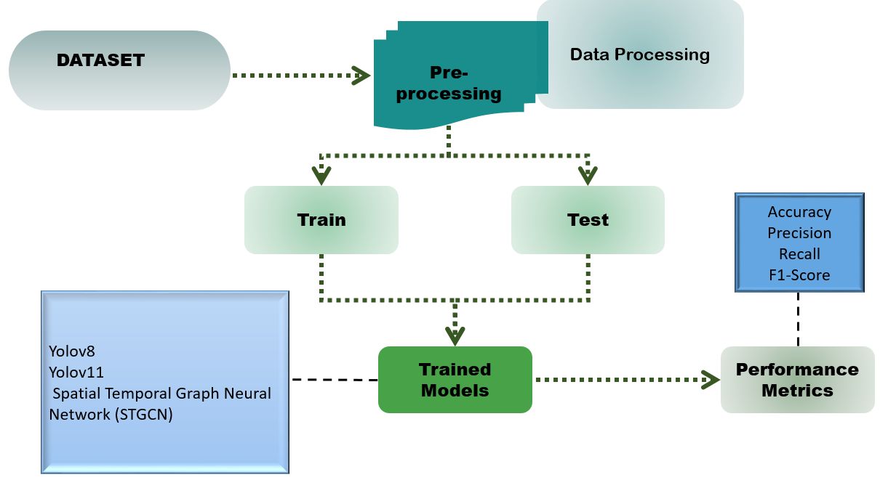
Fig.3.1 System architecture
The heart of the system uses two types of deep learning models to process both spatial and temporal characteristics involved in sign language recognition. A Spatial Temporal Graph Convolutional Network (STGCN) is used to capture the motion-based information in sequential hand gestures. This architecture will be able to learn both the spatial attributes between the key points and the temporal attributes between successive frames. The STGCN model comprises of two spatio-temporal convolutional blocks, with each block containing temporal gated convolution layers and spatial graph convolution layers. The residual connections are added to maintain the gradient flow and enhance feature learning to enable the model to identify changes in signs in dynamic situations effectively. Simultaneously, object detectors based on YOLO are used to identify and classify hand signs in single video frames, namely, YOLOv8 and YOLOv11. YOLOv8 has been chosen due to its anchor-free nature and efficiency in real-time performance, and YOLOv11 can expand its detection possibilities through its ability to use advanced functions like segmentation, key point estimation and oriented bounding boxes. Both models are trained with a pre-trained yolov5s.pt weight. The training is done with 150 epochs, a batch length of 16 and an image size of 416 × 416 pixels.
In real-time inference, video frames of hand gestures are continuously captured via a webcam module. These frames are processed by the trained YOLO models to identify and classify the performed signs. Once a hand sign is recognized, the corresponding label is forwarded to a speech synthesis module. This module converts the detected sign into spoken Hindi, thereby enabling effective communication between sign language users and individuals unfamiliar with sign language.
During the real-time inference phase, the webcam module captures video streams of the gestures made with hands. The video streams are then analyzed using the YOLO models to determine the hand sign gesture and classify it. Once the sign is recognized, the label for the hand sign is then passed through the speech synthesis module, which translates the detected sign into verbal Hindi.
The detection results are saved and displayed in sequence to verify the accuracy of classification across multiple gestures. This helps ensure consistency and identify any minor errors in predictions during evaluation. Based on experimental analysis, the proposed system achieves real-time performance with an average delay of around 89 milliseconds per frame. This low latency indicates that the model is responsive and highly efficient in practical scenarios. Overall, the results show that the developed model is reliable and can be effectively used in practical assistive systems requiring fast and accurate gesture recognition.

IV. Result analysis

YOLOv11:

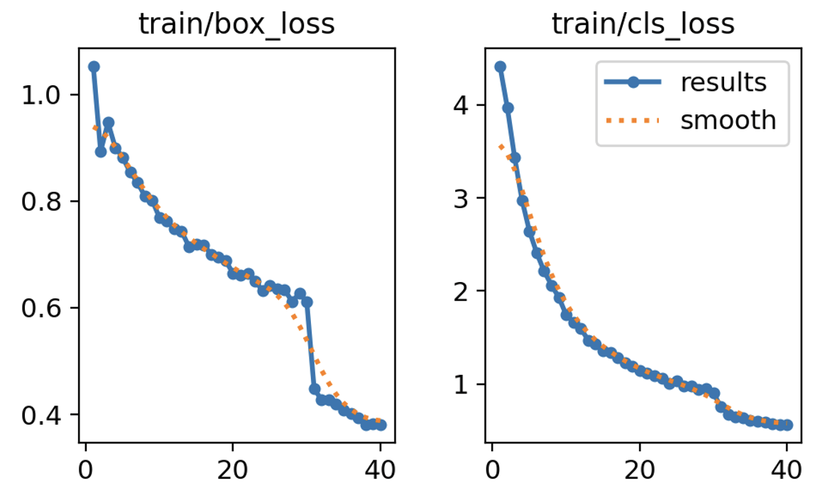
Fig.4.1 Training loss – box & cls

The bounding box loss encountered in all stages of training follows a consistent trend of decreasing in value from above 1.0 to less than 0.5 in just 40 epochs. The continuous decrease in value indicates that the ability of the network to localize objects continues to improve consistently without any signs of instability or overfitting.
The bounding box loss encountered in all stages of training follows a consistent trend of decreasing in value from above 1.0 to less than 0.5 in just 40 epochs. The continuous decrease in value indicates that the ability of the network to localize objects continues to improve consistently without any signs of instability or overfitting.
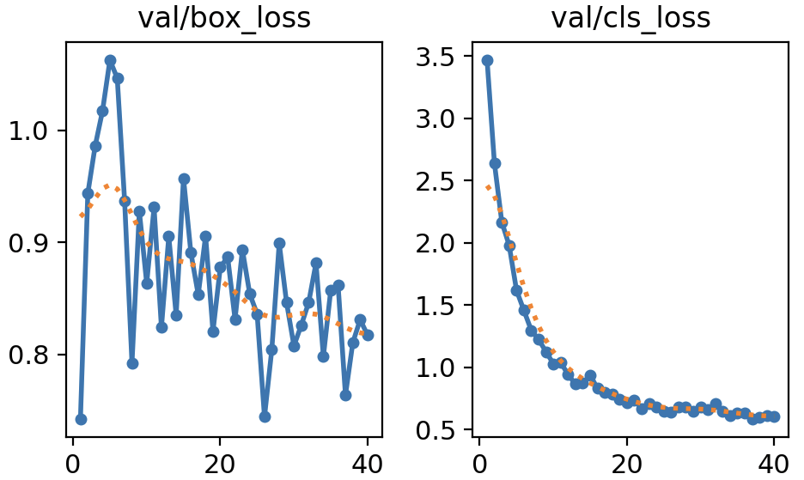
Fig.4.2 Validation loss – box & cls

As can be seen, the validation bounding box loss is somewhat more variable compared to the training loss; yet, it still follows a general downward trend and approaches 0.8. These fluctuations are expected when assessing the performance on unknown data. This trend shows that the network improves its localization skill on data not included in the training set.
The loss for validation bounding box shows a slightly higher variance compared to the training loss; however, a descending pattern is evident, with convergence at around 0.8. The variance is expected in testing data, and it is indicative of generalization ability of the model. This reflects improved generalization in localization beyond the training set.
Validation classification loss consistently decreases from a value greater than 3.5 to approximately 1.2. The reduction demonstrates that the learned model generalizes effectively to new instances while maintaining consistency in classification performance despite some variations during the validation process.

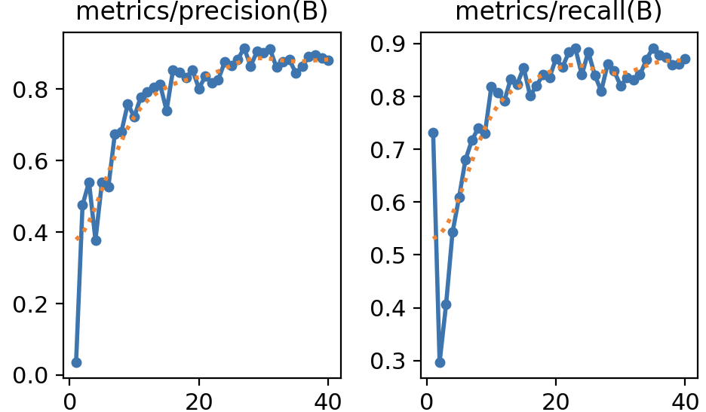
Fig.4.3 Performance Metrix – Precision & Recall

The precision measure demonstrates an increasing trend between around 0.4 and 0.95 during training. The steady trend denotes that there have been few errors made by the classifier in making predictions, which demonstrates the high level of accuracy attained.
In the same manner, the recall figure shows a similar trend towards increasing, starting from less than 0.4 and rising to reach 0.9. This trend reflects a significant improvement in the model’s performance in identifying relevant symptoms.
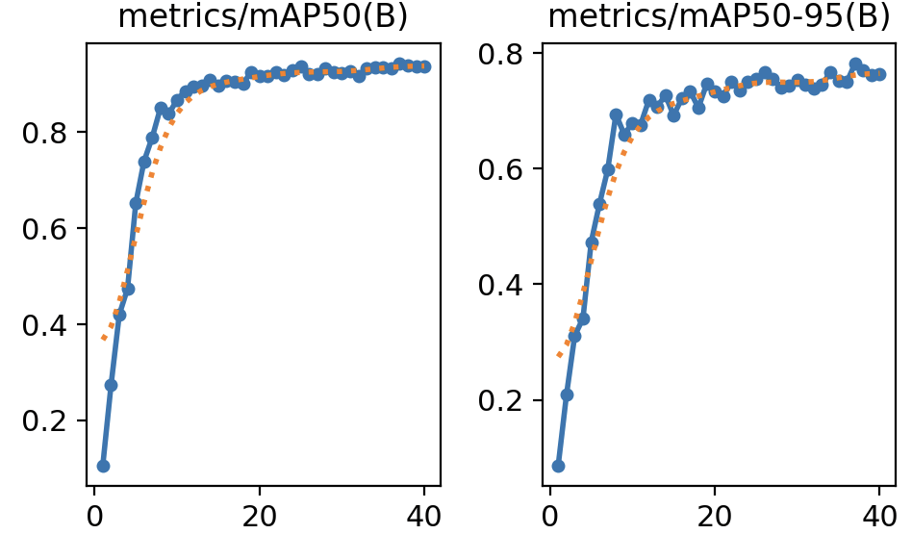
Fig.4.4 Performance Metrix – mAP50 & mAP50-95

The mean Average Precision at an IoU threshold of 0.5 (mAP50) is growing at an alarming rate in the first few epochs and then levels off to around 1.0. This finding shows hat the model exhibits a high level of detection under typical localization conditions, and validates the high object recognition performance.
The stricter mean average precision between the 0.5 to 0.95 (mAP50-95) IoU thresholds also shows a strong improvement and levels off to nearly 0.98. This score is high, which means that the model has a strong detecting accuracy even with higher localization constraints, which confirms the strength and efficiency of the YOLOv11 architecture in recognizing sign language in real-time.
YOLOv8:
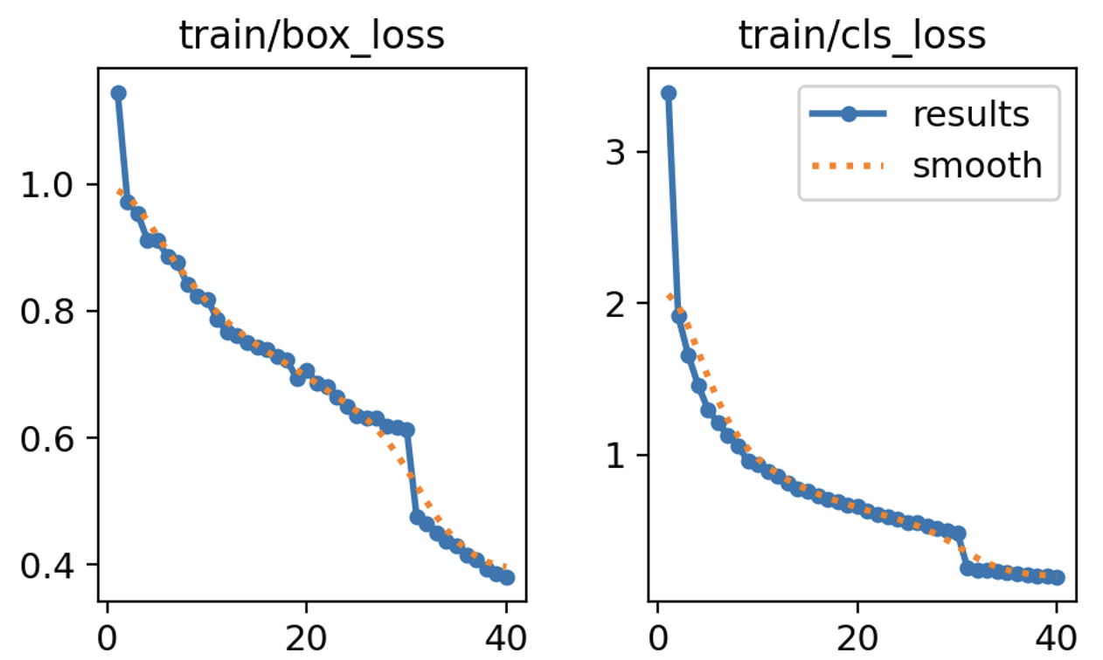
Fig.4.5 Training loss – box & cls

The bounding box regression loss decreases smoothly and gradually during training, going from values over 1.0 to about 0.4 in 40 epochs. This behavior shows that the model is learning steadily and getting better at accurately finding hand sign regions.
The training classification loss drops sharply from over 3.5 to almost 0.9. This shows that discriminative class-level features have been successfully learned. The lack of sudden changes indicates that optimization is stable and convergence is reliable during the training process.
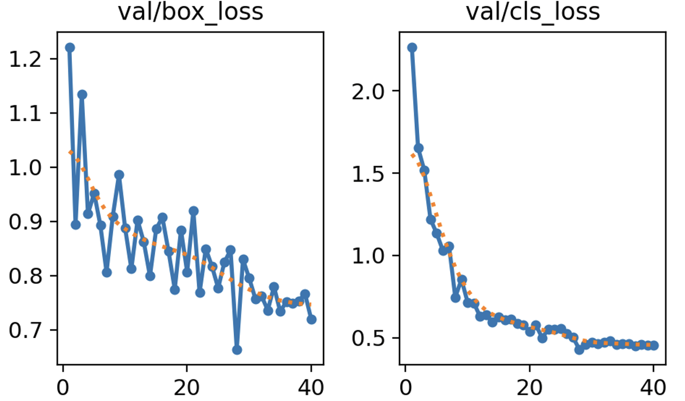
Fig.4.6 Validation loss – box & cls

The validation bounding box loss shows a lot of variation at first, but it generally goes down and gets closer to 0.7. When you test a model on unseen data, you usually see these kinds of changes. They show that the model is slowly getting better at generalizing spatial localization performance.
Similarly, the validation classification loss also steadily drops from values above 2.0 to about 1.0. There are some minor differences, but the downward trend shows that the model works well on validation samples and keeps its classification accuracy steady.
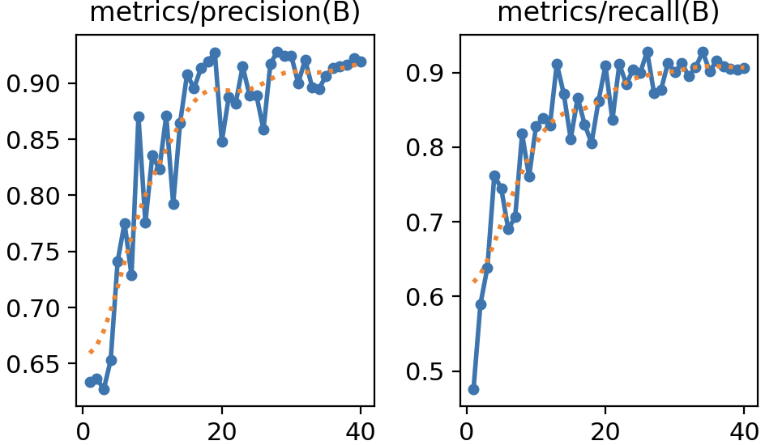
Fig.4.7 Performance Metrix – Precision & Recall

The precision metric improves steadily during training, starting at about 0.65 and stabilizing above 0.9. The enhancement indicates fewer instances of incorrect classifications as well as increased certainty about recognized gestures from video recordings.
The recall metric also shows a similar pattern of increase, going up from about 0.6 to almost 0.95 in the last epochs. It means it is getting better at finding these important features to detect them more accurately without missing any of their occurrences while increasing its detection rate as well.
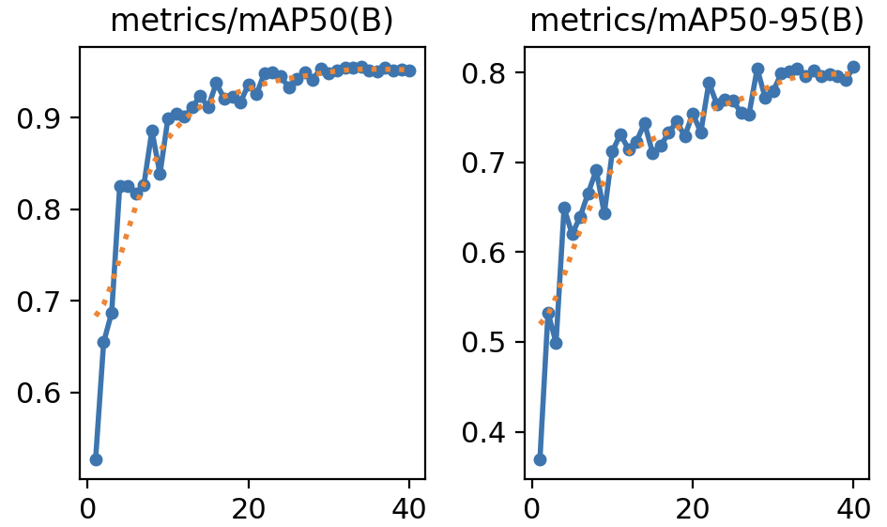
Fig.4.8 Performance Metrix – mAP50 & mAP50-95

The mean Average Precision at an IoU threshold of 0.5 (mAP50) increases quickly in the beginning of training and then stabilizes around 0.95. It shows good sensitivity as well as spatial resolution according to established standards of assessment.
The more rigorous map50-95 metric also exhibits an early rise and converges near 0.88. This finding demonstrates that the YOLOv8 model ensures accurate localization despite stringent overlap requirements, underscoring its reliability and efficacy in real-time hand gesture recognition.
Comparison
Metric | YOLOv8 | YOLOv11 | Better Model
Train Box Loss | Decreased to ~0.4 | Decreased to ~0.35 | YOLOv11
Train Class Loss | Reduced from ~3.5 to ~0.9 | Reduced from ~4.0 to ~0.8 | YOLOv11
Val Box Loss | Fluctuates ~1.1 to 0.7 | Fluctuates ~1.0 to 0.65 | YOLOv11
Val Class Loss | Drops from ~2.0 to ~1.0 | Drops from ~3.5 to ~1.2 | YOLOv8 (slightly)
Precision (B) | Peaks at ~0.93 | Peaks at ~0.96 | YOLOv11
Recall (B) | Peaks at ~0.94 | Peaks at ~0.95 | YOLOv11
mAP@0.5 (B) | Stabilizes at ~0.95 | Stabilizes at ~0.99 | YOLOv11
mAP@0.5–0.95 (B) | Stabilizes at ~0.88 | Stabilizes at ~0.97 | YOLOv11

A detailed comparative analysis of YOLOv8 and YOLOv11 shows that YOLOv11 is better than YOLOv8 in almost all comparison parameters. Training and validation show that YOLOv11 has lower and more stable losses for bounding box regression, classification, and distribution focal loss, leading to faster convergence and improved generalization behavior.
While YOLOv8 performs well especially on validation classification loss, YOLOv11 shows significant gains in detection accuracy. Precision and recall of YOLOv11 is around 0.96 and 0.95 respectively which means that it has better ability to detect relevant hand gestures without having too many false positives and negatives.
In terms of overall detection accuracy YOLOv11 has a mean Average Precision (mAP) of almost 0.99 for an IoU threshold of 0.5 and mAP@0.5-0.95 is almost 0.97. These results are substantially better than those of YOLOv8, which stabilizes at 0.95 for mAP@0.5 and 0.88 for mAP@0.5-0.95. Additionally, the more stable training curves of YOLOv11 suggest better stability and reliability during training, which is crucial for for deployment in real-world environments.
Based on the experimental findings, YOLOv11 is a better and faster model than previous versions for recognizing gestures. It has better precision and stability and its ability to generalize makes this approach an ideal choice for real-time sign language classification and assistive communication systems.

V. Conclusion
This experiment has performed an elaborate comparison of the YOLOv8 and YOLOv11 models to find out how effective they are in sign language detection systems. Experimental evidence shows clearly that YOLOv11 is an improved method of detection compared to YOLOv8. Throughout training and validation stages, YOLOv11 has smaller and more consistent loss values, indicating better learning behavior and higher generalization.
Also, YOLOv11 has higher precision and recall scores which shows that it can accurately recognize hand signs while reducing false positives and missed instances. The higher mean Average Precision (mAP) values achieved at various IoU thresholds further validate its efficacy in object localization tasks. YOLOv8 may be a little faster at making inferences in some situations but YOLOv11 is a superior method for real-time sign language recognition because it is more accurate, stable and consistent.
Overall, this research shows that YOLOv11 is a reliable and effective structure for classifying and detecting sign language, especially in situations where precision and consistency are very important.
REFERENCES
- M. Kowsigan, R. Dhawan, and A. Kundu, “An Efficient Speech to Sign Language Conversion and Text Recognition through Live Gesture,” in Proc. IEEE Int. Conf. Smart Power Control and Renewable Energy (ICSPCRE), 2024.
- B. Saravanan, A. Chandran, H. Prasath R. K., S. S. S. Nath, M. J, and S. J, “Bridging Sign and Text: Integrating Continuous Sign Language Recognition with NLP for Real-Time Translation,” in Proc. IEEE Int. Conf. Smart Technologies and Systems for Next Generation Computing (ICSTSN), 2025.
- L. Johnson K., M. P. Mathew, and D. Peter S, “Comparative Analysis of YOLOv5 and YOLOv8 for Real-Time Hand Gesture Recognition,” in Proc. IEEE Adv. Computing and Communication Technologies for High Performance Applications (ACCTHPA), 2025.
- A. M. Thomas and V. B. Kirubanand, “Emotion-Aware Sign Language Recognition Using CNN and UNET Architectures,” in Proc. IEEE Int. Conf. Computational Innovations and Sustainable Technologies (ICCIST), 2025.
- C. Tursunbaev, M. Toshpulatov, N. Adhikari, and W. Lee, “Enhancing Sign Language Recognition: A Computationally Efficient and Interpretable Multi-Modal Approach,” in Proc. IEEE Int. Conf. Big Data and Smart Computing (BigComp), 2026.
- J. Sharma, K. S. Gill, M. Kumar, and R. Rawat, “Gesture to Text Recognition using Deep Learning Approach with VGG16 and ResNet50 for Sign Language,” in Proc. IEEE Asian Conf. Innovation in Technology (ASIANCON), 2024.
- V. S. M. Kumar, V. Golla, M. V. Prasad, R. Reenadevi, R. Landage, and G. Thailambal, “Gesture-to-Text: A CNN-Based Deep Learning Model for Sign Language Translation,” in Proc. IEEE Int. Conf. Recent Trends in Electrical, Electronics and Computing Technologies (ICRTEECT), 2025.
- S. Prabu, S. K, S. S, S. D, and R. J, “Revolutionizing Communication: A Hybrid Deep Learning Framework for Enhanced Sign Language Recognition,” in Proc. IEEE Int. Conf. Data Science and Network Security (ICDSNS), 2024.
- D. Fan, M. Yi, W. Kang, Y. Wang, and C. Lv, “Continuous Sign Language Recognition Algorithm Based on Object Detection and Variable-Length Coding Sequence,” Scientific Reports, vol. 14, 2024.
- H. Harrouch, L. Trabelsi, M. Jebali, and O. Gammoudi, “A Deep Learning-Based Method Combines Manual and Non-Manual Features for Sign Language Recognition,” Scientific Reports, vol. 16, 2026.
- N. C. Camgoz, O. Koller, S. Hadfield, and R. Bowden, “Sign Language Transformers: Joint End-to-End Sign Language Recognition and Translation,” in Proc. IEEE/CVF Conf. Computer Vision and Pattern Recognition (CVPR), 2020.
- L. Shabadi, M. K. Nair, A. Sinha, H. M. Bilagi, A. Priya, and A. A. V, “Video-Based Word-Level Indian Sign Language Translation to Text and Speech Using CNN-LSTM,” in Proc. IEEE Int. Conf. Emerging Technologies in Computing and Communication (ETCC), 2025.
- A. N. Shinde and R. Kannan, “Deep Learning in Sign Language: A Comprehensive Systematic Review of Recent Progress,” in Proc. IEEE Int. Conf. Emerging Trends and Innovations in ICT (ICEI), 2026.
- M. Xu, S. Liu, Y. Feng, Y. Yu, Z. Jin, and X. Yang, “Hierarchical Spatial-Temporal Enhancement Network for Continuous Sign Language Recognition,” in Proc. IEEE Int. Conf. Acoustics, Speech and Signal Processing (ICASSP), 2025.
- K. Ananthajothi, T. Priya V., and V. Vaisharli S., “Sign Language Translation Using Hybrid Temporal Convolutional Network With TTS Fusion,” in Proc. IEEE Int. Conf. Pervasive Computing and Social Networking (ICPCSN), 2025.

