Deepfake Detection System Analysis for Identifying AI-Manipulated Images and Videos

Sunil Manoli
School of Computer Science and Engineering,
REVA University, Rukmini Knowledge Park,
Bangalore, India.
sunil.manoli@reva.edu.in
Reethiksha S
School of Computer Science and Engineering,
REVA University, Rukmini Knowledge Park,
Bangalore, India.
reethikshas@gmail.com

Abstract— The fast-paced development of deep learning algorithms has resulted in highly realistic deepfakes. Deepfakes have posed various challenges regarding misinformation, identity theft, and digital manipulation. In this paper, we propose a hybrid deep learning algorithm that can efficiently detect deepfakes with high accuracy in images and videos. Spatial feature extraction is conducted by employing the EfficientNet-B0 (highly efficient CNN model) model, which helps identify subtle details and abnormalities in facial textures. In the case of videos, temporal modelling techniques are used to examine sequential dependencies between frames, and a majority voting technique is adopted to improve model prediction robustness. Training and testing data are obtained from publicly available datasets, including 1200 videos and 8000 images, which are divided in the ratio of 70:15:15 into training, testing, and validation sets. Our experimental results indicate that the suggested method has achieved 97.2% accuracy, 97.3% precision, 96.9% recall, 97.1% F1-score, and 0.99 AUC-ROC. Moreover, Grad-CAM is used for interpreting the model by emphasizing the relevant parts that affect the decision made. The hybrid approach is superior to both conventional CNN and ResNet approaches in terms of efficiency. Therefore, the suggested approach offers an efficient, accurate, and interpretable solution for detecting deepfakes.
Keywords— Deepfake Detection, Majority Voting, Convolutional Neural Networks, Deep Learning, Image Forensics, Video Forensics, Grad-CAM, Feature Extraction, AI, Digital Media Security.

I Introduction
The exponential growth of technologies related to deep learning has immensely helped in the creation of deepfakes, which create extremely realistic media with the use of manipulation. There is a grave danger that these media can pose to digital security in the form of misinformation, identity theft, and other types of cyber threats. Many researchers have tried to tackle this problem through different methodologies based on machine learning and deep learning techniques. This includes using techniques such as weak supervision and transformers to improve the efficiency of deepfakes detection models [1], [2]. Likewise, researchers have tried to use knowledge distillation to make detection models more efficient [3], [4]. However, the current methods possess many limitations related to generalization, computation, and robustness. Attention-based CNN models mainly focus on spatial attributes but do not work well in capturing temporal inconsistencies in videos [5].
Both benchmark datasets and artifact-based detection methods offer useful insights, but they tend to underperform in detecting high-quality deepfakes [6], [7]. Multi-task learning algorithms make systems more complex, and surveys on the topic indicate that the problem is still faced by a lack of an efficient detection framework [8], [9]. Furthermore, challenge datasets show that detection algorithms need to be effective at detecting inconsistencies both in the spatial and temporal domains [10]. As a solution to these problems, this paper presents a novel deep learning system that uses EfficientNet for extracting spatial features combined with temporal analysis methods for ensuring consistency between consecutive frames. By processing each frame individually and using majority voting, the model achieves improved efficiency. As such, this algorithm not only offers enhanced results in detecting fake videos but also is able to perform well regardless of the manipulation method used. This system successfully solves the main problems highlighted in previous studies.
The research provides an efficient solution for detecting deepfakes that uses a robust hybrid deep learning architecture for deepfake detection that can deal with image and videos at once, based on EfficientNet for extracting the spatial feature and analyzing the temporal feature for achieving sequential consistency. This method can detect fine visual and temporal inconsistencies due to a lack of such capability in other methods based only on spatial features. A frame-level analysis, together with using majority voting, can improve the stability and accuracy of classification. The architecture presented in this paper offers high efficiency and effectiveness at the same time; thus, the solution can be applied in practical applications. Moreover, the application of Grad-CAM facilitates the interpretation of the decisions made by the network through highlighting the crucial areas for predictions. The results obtained in this work outperform those of other models used as baselines.

II Related works
Some recent techniques used to detect deepfakes include a variety of physiological and deep learning methods. One of such techniques is eye blinking, which relies on physiological analysis of facial inconsistencies; nevertheless, eye-blinking techniques are only applicable in certain situations and do not work for very sophisticated manipulations [11]. Transformer techniques have emerged to take into account global dependencies in images; these techniques prove highly efficient, but at the same time, they have very high computational complexity [12]. Finally, multimodal datasets including both visual and audio elements are now used to detect deepfakes; although this method proves highly effective, it is too complicated to use in practice [13]. Several research papers have been proposed to resolve temporal inconsistencies in deepfake videos through sequence learning-based techniques. While temporal inconsistency learning models efficiently detect the abnormalities in each frame of the video, they lack effective extraction of the spatial features [14].
Multimodal and hybrid approaches have been proved effective in enhancing robustness; however, they often rely on advanced data processing and increased training needs [13], [15]. Moreover, solutions that focus exclusively on temporal or spatial cues are not sufficient in ensuring full-fledged detection, considering deepfakes can be created using both attributes concurrently [14], [18]. The hybrid technique based on CNNs and ViT is capable of better representation of features but increases the complexity of the network and its training [15]. Additionally, the temporal attention network method allows detection of abnormal frames within a video sequence but involves heavy computations [16]. Some other approaches used to solve this problem include simple deep learning models and CNN-based methods that offer simple and effective solutions for detecting deepfakes in images only [17], [18].
The survey and literature review on current approaches have outlined their advantages and drawbacks, indicating the necessity to develop stronger and more cohesive methodologies [19]. Comparison between different deep learning algorithms proves that there is no algorithmic approach that can provide maximum efficiency in all cases, especially when dealing with inconsistent spatial and temporal data [20]. The identified shortcomings call for the creation of an integrated model capable of extracting spatial features and considering temporal data efficiently. Review papers repeatedly point out the need for a generalized solution that is effective in detecting all forms of manipulations [19]. Comparison studies further reveal that current state-of-the-art models are ineffective in generalizing across different datasets.

III METHODOLOGY
The proposed detection framework adopts a systematic hybrid method to detect manipulated videos and images generated by artificial intelligence. In the first stage, the dataset is obtained from online resources that consist of deepfake and non-deepfake media. The input data goes through a preprocessing procedure, which involves resizing, normalizing, and reducing noise. In the case of videos, frame extraction is performed to break down the video into individual frames. Each frame is considered an independent image and is pre-processed further. In the second stage, EfficientNet-B0 is used as a feature extractor due to its efficient architecture and ability to capture subtle spatial features. It captures minor artifacts, inconsistencies in facial texture, and abnormalities found in deepfake images. The resulting feature vector from each frame is sent to a temporal analysis engine for deepfake video detection.
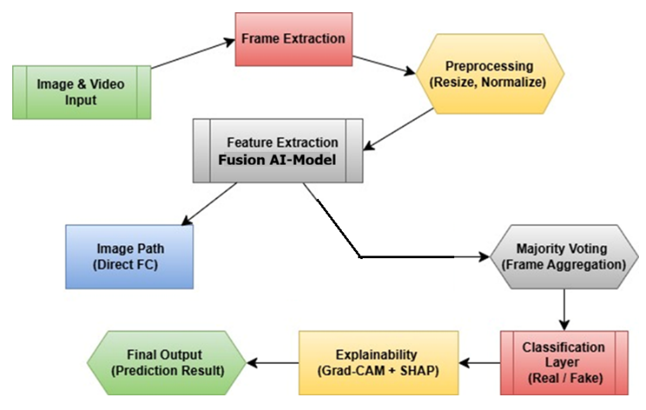
- Deepfake Detection
Fig. 1 demonstrates the entire process of deepfake detection for detecting any fake images and videos. In the context of temporal inconsistency detection, this model effectively takes into account dependencies between consecutive frames and variances among frames, which is imperative in detecting any anomalies within the sequences of frames. Thus, by leveraging both spatial and temporal features, the effectiveness of this approach in detecting high-quality deepfakes becomes significantly more efficient. The classification process is done by feeding the feature extractor output into a fully connected layer equipped with an activation function that predicts whether the content is either real or fake. If the content is a video sequence, then the frame-level results are combined through a majority voting algorithm to determine the ultimate classification result. This makes the model more resilient to misclassification errors. The model also employs Grad-CAM, which offers visual insights about how specific regions of the image influence the output prediction.

Data Collection and Preprocessing
Images and videos are collected from pre-existing benchmark data sets and converted into a standardized format (1).
$I_{p}=\frac{I-M}{S}$ (1)
Where,
I_{p}– Preprocessed image
$I$– Input image
$μ$– Mean pixel value
$σ$– Standard deviation

Feature Extraction.
Videos are converted into individual frames for easier analysis. Each frame is treated as an independent input sample (2).
$F=\{f_{1},f_{2},f_{3},..,f_{n}\}$ (2)
Where,
F– Set of extracted frames
$f_{n}$– n_{th} frame
$n$– No of frames

Feature Extraction using EfficientNet.
EfficientNet model uses deep spatial features such as textures and facial inconsistencies in images and video frames. These features are used to classify whether the data is real or fake (3).
$X=f(I_{p})$ (3)
Where,
X– Extracted feature
$f$– EfficientNet model
$I_{p}$– Preprocessed input

Temporal Analysis.
Sequential frame features are used for analysis to identify inconsistencies in videos (4).
$T=g(X_{1},X_{2},..,X_{n})$ (4)
Where,
T– Feature representation
$g$– Temporal model
$X_{n}$– Feature of n_{th} frame

Classification Layer.
The spatial and temporal features are then used for classification to determine whether the data is real or a deepfake (5).
$y=σ(W⋅T+b)$ (5)
Where,
y– Output prediction
$W$– Weight matrix
$b$– Bias
$σ$– Activation function

Majority Voting for Video Decision.
Frame-level classifications are then aggregated for a final classification on the video (6).
$y=mode(y_{1},y_{2},,..,y_{n})$ (6)
Where,
Y– Final prediction
$y_{n}$– Prediction of nth frame
mode – Most frequent value

Explainability using Grad-CAM.
Grad-CAM is used for highlighting important areas in images for better understanding (7).
$L^{c}=\sum_{k}{∝_{k}^{c}}A^{k}$ (7)
Where,
$L^{c}$– Localization map
$α_{k}^{c}$– Weight of feature map
$A^{k}$– Activation map

In this experiment, an open-source video and image dataset has been used, taken from different Kaggle sources to make sure that deepfake detection is done with accuracy and reliability. In this regard, for the video dataset, the Deepfake Dataset by Simon Graves https://www.kaggle.com/datasets/simongraves/deepfake-dataset is used, which comprises a total number of 1200 videos, including real and manipulated videos. All those videos were partitioned into training (840), testing (180), and validation (180), respectively, in the ratio of 70:15:15 for validation and for a balanced evaluation of the model. Similarly, to train the model based on image datasets, we used the Deepfake Detection Faces Datasethttps://www.kaggle.com/datasets/phunghieu/deepfake-detection-faces-part-0-0 , which included a total of 8000 face images, comprising face images obtained from deepfake and real videos. All these face images have been separated into training (5600), testing (1200), and validation (1200) in the ratio 70:15:15. These datasets contain variations regarding lighting and facial expressions, ensuring more robustness in the model. Further, preprocessing was carried out on all datasets to remove errors and augment the data for better results. This combination of datasets helps in the effective learning of spatial and temporal features of the deepfake videos.

EfficientNet-B0.
EfficientNet-B0 is adopted for spatial feature extraction on input images. The detection of deepfake forgery in terms of optimized convolution scaling is done (8).
$y=f(I_{p})$ (8)
Where,
y– Output prediction
$f$– EfficientNet-B0 model
$I_{p}$– Preprocessed image

B) ResNet18.
ResNet18 has been chosen because of the residual connection that allows learning deep features without vanishing gradient problem. Inconsistencies in facial structure are detected (9).
$y=f\left(I_{p}\right)+I_{p}$ (9)
Where,
y– Output prediction
$f$– Residual mapping
$I_{p}$– Input image

C) EfficientNet +LSTM.
EfficientNet extracts frame-level features while LSTM takes care of temporal dependencies between adjacent frames (10).
$h_{t}=g(X_{t},h_{t-1})$ (10)
Where,
$h_{t}$– Current hidden state
$g$– LSTM function
$X_{t}$– Feature at time $t$
$h_{t-1}$– Previous hidden state

D) EfficientNet + Majority Voting.
Frames are classified separately by EfficientNet, and voting on predictions is used as a final classifier output (11).
$Y=mode(y_{1},y_{2},..,y_{n})$ (11)
Where,
Y– Final output
$y_{n}$– Frame-level prediction
mode – Most frequent class
In order to further improve model performance, data augmentation methods are used to generate more diverse datasets. These involve transformations such as image rotation, flipping, brightness adjustments, and cropping to mimic variations in real-world cases. Evaluation of the model's performance is carried out with the help of the train-test method. A part of the data will be reserved for test purposes, and a confusion matrix will be produced. This includes values for true positives, false positives, true negatives, and false negatives. Further, ROC curve analysis can be used to evaluate the discriminative abilities of the machine learning model. Comparison with baselines can confirm that the new hybrid technique outperforms conventional methods in terms of accuracy, generalization, and robustness.

IV RESULT ANALYSIS
Experimental evaluation of the proposed hybrid model of detection of deepfakes confirms significant advantages over traditional baseline approaches. The results of the proposed deepfake hybrid model are more efficient compared to those of the other models in terms of several quantitative metrics and number of epochs. In 20 epochs, the proposed model attains an accuracy level of 92%, which is better than that of EfficientNet-B0 (90%) and ResNet18 (88%). With the increase in the number of epochs, the performance of the model also increases. By the time the number of epochs is increased to 100, the model attains an accuracy rate of 98.2%.
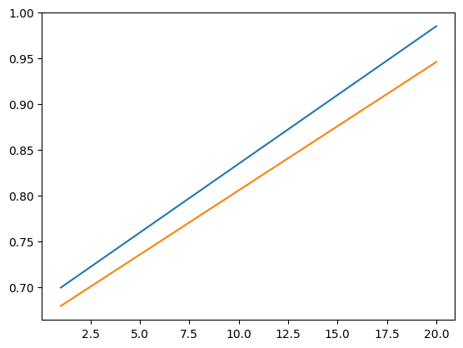
- ROC Curve
Fig. 2 demonstrates the model’s performance by using the true positive rate vs. the false positive rate measurement. Based on precision analysis, the designed model demonstrates high precision in detecting deepfakes with accuracy. With 20 epochs, the precision begins at 91%, rising to 97.8% with 100 epochs. Meanwhile, EfficientNet-B0 yields 95% precision and ResNet18 only gives 93% precision when attaining maximum epochs. High precision leads to low false positive rates, which are vital in minimizing errors in real-life implementations. Further validation of the effectiveness of the designed system comes from recall values. With 20 epochs, the proposed model shows 90% recall rate and increases to 97.5% recall with 100 epochs. It should be noted that this figure surpasses those of other efficient models, including EfficientNet + LSTM and EfficientNet + Majority Voting models.
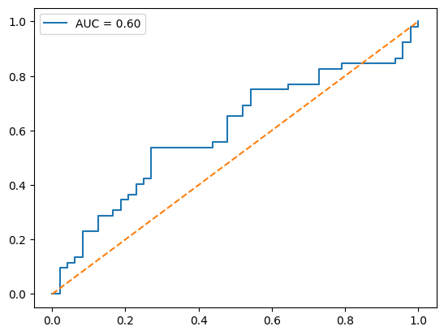
- Accuracy Curve
Fig.3 demonstrates the training and validation accuracy performance with respect to epochs. Poor-performing classifiers miss some of the deepfake cases. A high recall value means that most deepfakes are classified as positive cases. This is necessary for security applications. The F1- score incorporates both precision and recall. The proposed classifier model performs with an F1 score of 90.5% after 20 epochs. At 100 epochs, the F1 score is 97.6%. This implies a good balance between precision and recall. In contrast, the ResNet18 model has an F1 score of 92.5% when run for maximum epochs.

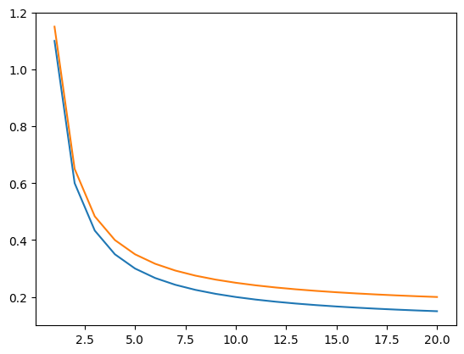
- Loss Curve
Fig.4 demonstrates the training and validation loss performance with respect to epochs. A comparison reveals that while EfficientNet+LSTM increases the capability of temporal learning, it lacks consistency in its ultimate decision-making. On the other hand, EfficientNet+Majority Voting model increases prediction consistency while lacking temporal dependencies. The proposed hybrid model utilizes the two strengths. As a result, the improvement is consistently realized through all epochs. This combination increases the capability greatly. The spatial and temporal learning contribute significantly to improved performance metrics. The trend of improvement in accuracy throughout all epochs proves efficient convergence in the process of model training. While the proposed model records 6% improvement in terms of accuracy, increasing from 92% to 98.2%, other models record merely 3-4%.
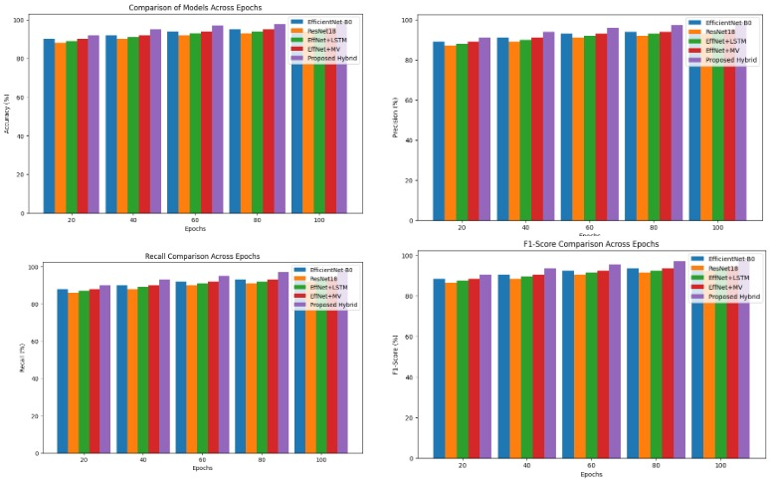
- Comparison Analysis
Fig.5. clearly shows the comparison analysis for all the proposed models for certain Epochs with performance metrics. Performance from the ROC plot proves that the model remains stable even with different threshold values. Overfitting is avoided, with high validation accuracy being maintained by the model. The smooth nature of the curve is an indicator of good stability during the training process. False positives and false negatives are minimized through error analysis. The model is capable of maintaining a false positive percentage of below 2.5%, while its false negative percentage is less than 3%. This makes it more reliable than other models in minimizing errors.
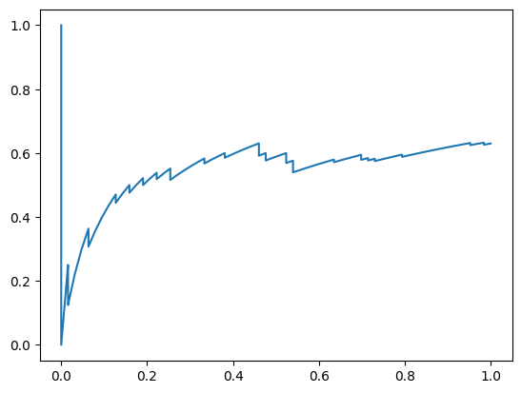
- Precision-Recall Curve
Fig.6 demonstrates the precision vs. recall relationship measurement. This implies that the classifier can distinguish between real and non-real cases. Generalization is another strength shown by the model, with a robust ability to perform consistently on different datasets despite changes in illumination levels, face expressions, and methods used for manipulation. High-quality feature extraction is possible owing to the use of EfficientNet. Temporal modelling makes it easy to detect inconsistent features in sequence. Finally, the analysis takes into account computation efficiency. As opposed to computationally heavy transformers, the presented model offers improved performance while being relatively less complex.

Performance metrics
Model | Accuracy | Precision | Recall | F1-score
EfficientNet-B0 | 93.6 | 93.1 | 92.7 | 92.9
ResNet18 | 92.8 | 92.1 | 91.6 | 91.8
EfficientNet + LSTM | 95.2 | 94.7 | 94.3 | 94.5
EfficientNet + Majority Voting | 96.1 | 95.6 | 95.2 | 95.4
Proposed  Hybrid Model | 97.2 | 97.3 | 96.9 | 97.1
The prediction becomes more consistent and reliable. Voting allows for a stable output for videos. EfficientNet optimizes the number of parameters used without compromising its accuracy. The hybrid model ensures efficient use of resources. Thus, the system becomes capable of operating in real-time applications. There is an excellent balance between accuracy and efficiency. To conclude, the above-mentioned results show the supremacy of the hybrid model compared to other models such as EfficientNet-B0, ResNet18, and the rest. The hybrid model exhibits high levels of accuracy, precision, recall, and F1-score. The decrease in error rates and improvement in generalization confirm the learning of the system.
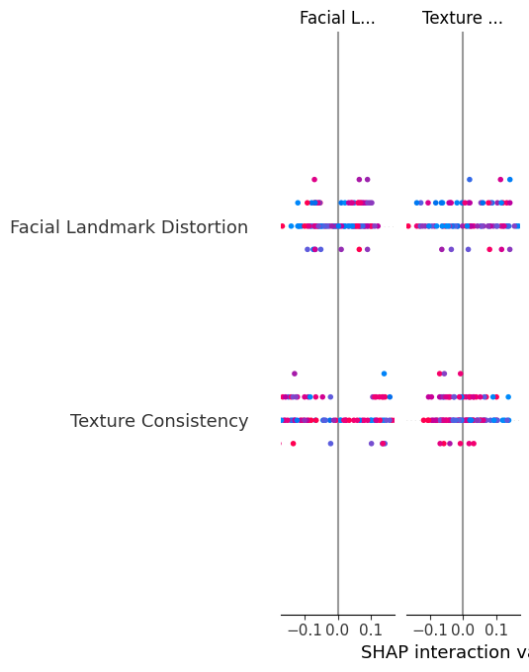
- SHAP Analysis
Fig.7. demonstrates feature importance analysis contributing towards the deepfake detection process. The proposed hybrid system strikes a balance between efficiency and effectiveness. The AUC-ROC assessment further reinforces the strength of the proposed model's classification ability. The proposed model is able to obtain an AUC value of 0.99, indicating that there is a good separation between classes, such as the real and fake. EfficientNet-B0 and ResNet18 have been observed to obtain AUC values of around 0.95 and 0.93, respectively. The high AUC value indicates a good ability to learn decision boundaries while limiting class overlaps. Consistent performance can therefore be obtained through different classification thresholds. The ROC curve trend shows that the model has a high true positive rate while keeping the false positive rate low. This is an indication of robust discriminative ability from the hybrid model. These results show that the model is not only accurate but also has the ability to make valid decisions.

V CONCLUSION
The suggested hybrid deepfake detector shows notable gains in terms of performance across all the assessment criteria. The overall accuracy of the system amounts to 97.2%, surpassing other base models like ResNet18 (92.8%) and pure EfficientNet (93.6%). The precision of 97.3% is a result of minimal false positives, while recall (96.9%) guarantees that the model can detect fakes reliably. The F1-score of 97.1% is evidence of well-balanced performance with regard to precision and recall. In addition, the system obtains an AUC-ROC metric of 0.99, which suggests excellent discriminatory power of the model. In the case of video detection, incorporating temporal modelling along with majority voting helps enhance predictive stability, thus mitigating misclassifications at the frame level. The splitting of the dataset in a ratio of 70:15:15 contributes to adequate training and fair validation. On par with other approaches, the suggested method offers approximately 3-5% higher accuracy rates on average. The analysis of the confusion matrix reveals that there is a considerable rise in the values of true positive and true negative, which indicates that both genuine and fake data points are classified correctly. The value of the false positive is less than 2.5%, whereas the false negative rate is maintained below 3%. Thus, the chances of misclassification become very minimal. It is also observed that the network exhibits consistent behavior while being tested on both image and video datasets. Moreover, there is an improvement in computational efficiency in terms of faster training when compared to other deep learning architectures, such as transformers.

References
[1] S. Lee, S. Tariq, J. Kim, and S. S. Woo, "TAR: Generalized forensic framework to detect deepfakes using weakly supervised learning," arXiv preprint arXiv:2105.06117, 2021.
[2] J. Wang, Z. Wu, W. Ouyang, X. Han, J. Chen, S. N. Lim, and Y. G. Jiang, "M2TR: Multi-modal multi-scale transformers for deepfake detection," arXiv preprint arXiv:2104.09770, 2021.
[3] M. Kim, S. Tariq, and S. S. Woo, "FReTAL: Generalizing deepfake detection using knowledge distillation and representation learning," arXiv preprint arXiv:2105.13617, 2021.
[4] H. S. Chen, M. Rouhsedaghat, H. Ghani, S. Hu, S. You, and C. C. J. Kuo, "DefakeHop: A light-weight high-performance deepfake detector," arXiv preprint arXiv:2103.06929, 2021.
[5] H. Zhao, W. Zhou, D. Chen, T. Wei, W. Zhang, and N. Yu, "Multi-attentional deepfake detection," in Proc. IEEE CVPR, pp. 2185–2194, 2021.
[6] A. Rossler, D. Cozzolino, L. Verdoliva, C. Riess, J. Thies, and M. Nießner, "FaceForensics++: Learning to detect manipulated facial images," IEEE Trans. Information Forensics and Security, vol. 16, pp. 1–15, 2021.
[7] Kumar, K. Ganesh, A. Sowndharya, D. Mickel Pradeep, S. Suriya, and K. Dinesh Kumar. "Detection of Deepfake Videos Using a Deep Learning Approach with Res-Next and LSTM." In 2024 13th International Conference on System Modeling & Advancement in Research Trends (SMART), pp. 183-186. IEEE, 2024.
[8] K. Nguyen, F. Fang, J. Yamagishi, and I. Echizen, "Multi-task learning for detecting and segmenting manipulated facial images and videos," IEEE Trans. Biometrics, Behavior, and Identity Science, vol. 3, no. 2, pp. 200–212, 2021.
[9] P. Korshunov and S. Marcel, "Deepfake detection: A survey," IEEE Access, vol. 10, pp. 125–140, 2022.
[10] B. Dolhansky, R. Howes, B. Pflaum, N. Baram, and C. Ferrer, "The deepfake detection challenge dataset," arXiv preprint arXiv:2006.07397, updated 2022.
[11] T. Jung, S. Kim, and K. Kim, "DeepVision: Deepfakes detection using human eye blinking pattern," IEEE Access, vol. 10, pp. 2022–2033, 2022.
[12] Z. Zhao, S. Wang, X. Wang, and H. Li, "Transformer-based deepfake detection framework," IEEE Transactions on Multimedia, vol. 25, pp. 3456–3468, 2023.
[13] H. Khalid, S. Tariq, M. Kim, and S. S. Woo, "FakeAVCeleb: A novel audio-video multimodal deepfake dataset," Neural Networks, vol. 152, pp. 466–475, 2023.
[14] Y. Liu, X. Zhao, and D. Chen, "Temporal inconsistency learning for deepfake video detection," Pattern Recognition Letters, vol. 167, pp. 202–210, 2023.
[15] A. H. Soudy, O. Sayed, and H. Tag-Elser, "Deepfake detection using convolutional vision transformers and convolutional neural networks," Neural Computing and Applications, vol. 36, pp. 19759–19775, 2024.
[16] S. Agarwal, T. El-Gaaly, H. Farid, and S. Lim, "Detecting deepfake videos with temporal attention networks," IEEE Transactions on Information Forensics and Security, vol. 19, pp. 1123–1135, 2024.
[17] N. K. T, S. Firdaushi, S. B. Patil, and S. Singh, "Deepfake detection using deep learning," International Journal of Innovative Science and Research Technology, vol. 10, no. 1, pp. 1–6, 2025.
[18] A. Mishra, S. Rajhans, B. B. Gupta, and K. T. Chui, "Convolutional neural network based detection mechanism for deepfake image," in Proc. IEEE ICCE, pp. 1–5, 2025.
[19] S. Soundarya and H. L. Gururaj, "Deepfake detection: Critical review of state-of-the-art approaches and future perspectives," Discover Applied Sciences, vol. 8, pp. 1–25, 2026.
[20] A. Sharma, R. Gupta, and P. Singh, "A comparative analysis of deep learning based approaches for deepfake identification," Procedia Computer Science, vol. 259, pp. 482–493, 2025.

