Fusing Self-Supervised Speech Representations with MFCC Stability for Robust Deepfake Audio Detection
Sadineni Havesa | Golla Susanth Paul | Dr.S.Jagadeesan
Computing Technologies  (of Affiliation) | Computing Technologies  (of Affiliation) | Computing Technologies  (of Affiliation)
SRMIST  (of Affiliation) | SRMIST  (of Affiliation) | SRMIST  (of Affiliation)
Chennai, India | Chennai, India | Chennai, India
havesa200311@gmail.com | susanthpaul5@gmail.com | jagadees@srmist.edu.in

Abstract- Recent advances in neural speech synthesis have enabled highly realistic deepfake audio capable of convincingly mimicking human voices with remarkable accuracy. While these technologies have legitimate applications, they also pose serious threats including voice impersonation, misinformation, and financial fraud. Detecting fake speech has therefore become an important research problem in speech forensics and cybersecurity. This paper proposes a dual-branch deep learning framework for robust deepfake audio detection by combining self-supervised speech representations with handcrafted acoustic stability features. The first branch extracts semantic speech embeddings using a pretrained WavLM model, which captures contextual and phonetic information from speech signals. The second branch extracts Mel-Frequency Cepstral Coefficient (MFCC) stability features and processes them using a Temporal Convolutional Network (TCN) to capture temporal variations in speech patterns. The features from both branches are fused using a multilayer perceptron classifier to determine whether an audio sample is real or fake. Experiments conducted on the Fake-or-Real (FoR) dataset demonstrate that the proposed fusion approach improves detection performance compared to single-feature baseline models. The results indicate that combining deep contextual embeddings with handcrafted stability features provides improved robustness against modern deepfake audio generation techniques.

Keywords -Deepfake Audio Detection ,Self-Supervised Learning, WavLM , MFCC Stability, Speech Forensics, Temporal Convolutional Networks

I. INTRODUCTION
Deep learning has significantly advanced speech synthesis technologies over the past decade. Modern neural text-to-speech systems such as Tacotron, WaveNet, and VITS can generate speech that closely resembles natural human voices. While these systems enable beneficial applications such as virtual assistants, automated narration, and accessibility support, they also create opportunities for misuse. Deepfake audio can be used for voice impersonation attacks, financial fraud, political misinformation, and social engineering attacks [1].

With the rapid development of generative speech models, detecting fake speech has become increasingly difficult. Early deepfake detection systems relied primarily on handcrafted acoustic features such as Mel-Frequency Cepstral Coefficients (MFCCs), spectral statistics, and phase-based features [2]. Although these features are capable of capturing certain signal artifacts, they often struggle to detect sophisticated neural speech synthesis models.

More recently, self-supervised learning has emerged as a powerful paradigm for speech representation learning. Models such as wav2vec 2.0, HuBERT, and WavLM learn contextual speech representations from large amounts of unlabeled audio data [3]–[5]. These representations capture phonetic, semantic, and prosodic information and have achieved state-of-the-art performance in several speech processing tasks including speech recognition and speaker verification.

Despite their effectiveness, deep representation models may not fully capture low-level acoustic artifacts present in synthesized speech. Temporal inconsistencies and subtle spectral irregularities often remain detectable through handcrafted acoustic features. Therefore, combining deep contextual embeddings with handcrafted acoustic stability features may improve the robustness of deepfake detection systems.
In this work, a hybrid deepfake audio detection framework is proposed that fuses self-supervised speech representations from WavLM with MFCC-based stability features modeled using a Temporal Convolutional Network. The major contributions of this work include:

• A dual-branch architecture combining WavLM embeddings and MFCC stability features.
• Temporal modeling of MFCC features using a Temporal Convolutional Network.
• Feature fusion through a multilayer perceptron classifier.
• Experimental evaluation demonstrating improved detection accuracy on a deepfake speech dataset

II. LITERATURE REVIEW
The detection of fake or deepfake speech has become an important research problem due to the rapid advancement of neural speech synthesis systems. Early work in this area relied primarily on handcrafted acoustic features combined with traditional machine learning classifiers. Mel-Frequency Cepstral Coefficients (MFCCs) were widely used because they capture perceptually relevant characteristics of speech signals. Sahidullah and Saha demonstrated that MFCC-based features can effectively represent speaker-specific information and spectral characteristics in speech recognition and speaker verification systems [2]. However, these features alone may not always detect artifacts produced by modern neural text-to-speech models.

To improve detection performance, researchers began applying deep learning techniques to speech analysis. Convolutional Neural Networks (CNNs) and Recurrent Neural Networks (RNNs) have been used to learn discriminative features directly from spectrograms and waveform representations. Zhang et al. proposed a CNN-based framework for detecting deepfake speech, demonstrating improved performance compared to traditional machine learning approaches [6]. These deep learning methods are capable of capturing complex patterns in speech signals but may require large labeled datasets for effective training.

More recently, self-supervised learning has emerged as a powerful paradigm for speech representation learning. Unlike supervised methods, self-supervised models learn meaningful representations from large amounts of unlabeled audio data. One of the most influential models in this area is wav2vec 2.0, which learns contextual speech representations by predicting masked segments of audio signals [3]. Similarly, HuBERT improves speech representation learning by predicting masked hidden units rather than raw acoustic signals [4].

WavLM further extends these approaches by incorporating speech denoising and gated relative position bias mechanisms, allowing the model to capture both speech content and speaker identity information [5]. These self-supervised models have achieved state-of-the-art performance in several speech processing tasks including automatic speech recognition and speaker verification.

Recent research has explored the use of self-supervised embeddings for deepfake audio detection. Jung et al. demonstrated that deep neural networks trained on speech representations can effectively distinguish between real and fake speech signals [7]. Similarly, Todisco et al. highlighted the importance of spoof detection techniques in protecting speaker verification systems from voice spoofing attacks [8].
More recent studies have focused on improving the robustness and generalization of deepfake detection systems. Wang et al. proposed a hybrid feature fusion framework that combines multiple speech features to improve detection accuracy across different synthesis methods [9]. Li et al. explored the use of self-supervised speech representations for detecting audio forgeries and demonstrated improved robustness compared to traditional acoustic features [10]. Kumar et al. further investigated hybrid neural architectures that integrate both handcrafted and deep learning features for improved cross-dataset generalization [11].
These studies suggest that combining deep contextual speech representations with handcrafted acoustic features can provide complementary information for detecting fake speech. While deep models capture high-level semantic patterns, handcrafted features such as MFCC stability can reveal subtle signal artifacts present in generated audio.

Motivated by these findings, the present work proposes a hybrid deepfake audio detection framework that fuses WavLM embeddings with MFCC stability features processed through a Temporal Convolutional Network. This approach aims to leverage the strengths of both deep contextual representations and traditional acoustic signal features to improve detection robustness.

III. PROPOSED METHODOLOGY
This research proposes a hybrid deepfake audio detection framework that combines deep contextual speech representations with handcrafted acoustic stability features. The proposed architecture consists of two parallel feature extraction branches followed by a feature fusion and classification stage. One branch extracts semantic speech embeddings using a pretrained WavLM model, while the second branch extracts MFCC-based stability features that are processed using a Temporal Convolutional Network (TCN). The outputs from both branches are fused through a multilayer perceptron classifier to determine whether the input audio is genuine or fake.

A. System Architecture Overview
The proposed deepfake detection framework follows a dual-branch architecture. The audio waveform is first preprocessed and then passed through two independent feature extraction modules. The first module extracts contextual embeddings using a pretrained WavLM model, while the second module extracts MFCC features that capture spectral characteristics of the speech signal. These MFCC features are further processed using a Temporal Convolutional Network to model temporal stability patterns.
The outputs from both branches are concatenated to form a fused feature representation, which is then passed through a classifier that determines whether the audio sample is real or fake.

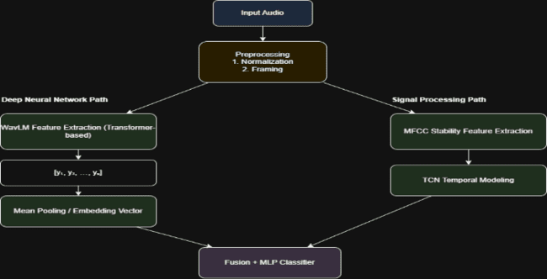

Fig. 1. Overall architecture of the proposed deepfake audio detection framework combining WavLM embeddings and MFCC stability features.

B. Audio Preprocessing
Before feature extraction, audio signals undergo preprocessing to ensure consistency across the dataset. All audio recordings are resampled to 16 kHz to match the input requirements of the WavLM model. The signals are normalized to reduce amplitude variations across recordings.
Additional preprocessing steps include trimming silence segments and converting audio waveforms into a standardized format suitable for feature extraction.
The preprocessing pipeline is illustrated in Fig. 2.

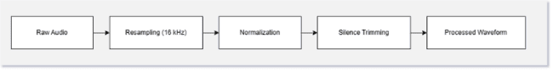

Fig. 2. Audio preprocessing pipeline including resampling, normalization, and waveform preparation.

C. WavLM Feature Extraction.
WavLM is a self-supervised speech representation model trained on large-scale unlabeled speech datasets. It learns contextual embeddings that capture phonetic, semantic, and speaker-related information from speech signals.
In the proposed system, the preprocessed audio waveform is passed through a pretrained WavLM model to generate frame-level embeddings. These embeddings represent contextual speech features across time frames. Mean pooling is then applied to convert the frame-level embeddings into a fixed-length feature vector representing the entire speech sample.
The WavLM feature extraction process is illustrated in Fig. 3.


Fig. 3. WavLM embedding extraction process used to obtain contextual speech representations.

D. MFCC Stability Feature Extraction
Mel-Frequency Cepstral Coefficients are widely used in speech processing because they approximate the perceptual characteristics of human hearing. MFCCs capture the spectral envelope of speech signals and are effective for representing acoustic properties of speech.
In this system, MFCC features are extracted using a sliding window across the audio signal. Each frame produces a set of cepstral coefficients representing spectral properties at that time step.
Temporal stability of MFCC coefficients is analyzed to detect irregular transitions often present in synthesized speech signals. The MFCC feature extraction process is illustrated in Fig. 4.

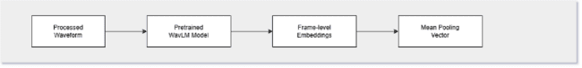
Fig. 4. MFCC feature extraction and stability analysis process.

E. Temporal Convolutional Network for Feature Modeling.
To capture temporal dependencies in MFCC sequences, a Temporal Convolutional Network is employed. TCNs use dilated causal convolutions to model long-range temporal relationships while maintaining computational efficiency.
The MFCC sequence is passed through several TCN layers, allowing the model to learn patterns related to speech stability and temporal consistency.
The architecture of the Temporal Convolutional Network used in this work is illustrated in Fig. 5.


Fig. 5. Temporal Convolutional Network architecture for modeling MFCC temporal dependencies.

F. Backend Processing and System Integration.
After extracting representations from both branches, the WavLM embedding vector and the MFCC-TCN feature vector are concatenated to form a fused feature representation.
This fusion stage combines high-level contextual speech information with low-level acoustic stability features, allowing the system to capture complementary characteristics of speech signals.

G. Classification Layer
The fused feature vector is passed to a multilayer perceptron classifier consisting of several fully connected layers with nonlinear activation functions. The final output layer produces a binary classification output representing the probability that the audio sample is fake.
Binary cross-entropy loss was used as the optimization objective during training.
The classifier architecture used in this study is illustrated in Fig. 6.


Fig. 6. Multilayer perceptron classifier used for final deepfake audio detection.

IV. EXPERIMENTAL SETUP

This section describes the dataset used for experiments, the preprocessing techniques applied to the audio signals, and the implementation details of the proposed deepfake audio detection system. The goal of the experimental setup is to evaluate the effectiveness of the hybrid feature fusion approach that combines WavLM embeddings with MFCC stability features.

A. Dataset Description
The experiments in this study were conducted using the Fake-or-Real (FoR) dataset, which contains both genuine human speech recordings and fake speech generated using neural text-to-speech systems. The dataset includes speech samples recorded under different conditions and contains both male and female speakers.
Each audio file contains spoken sentences with varying durations and acoustic properties. The dataset provides labeled audio samples indicating whether the speech is real or fake.
Before training the model, the dataset was divided into three subsets:
Training set – used for model learning
Validation set – used for hyperparameter tuning
Test set – used for final evaluation
The distribution of real and fake samples in the dataset is illustrated in Fig. 7.
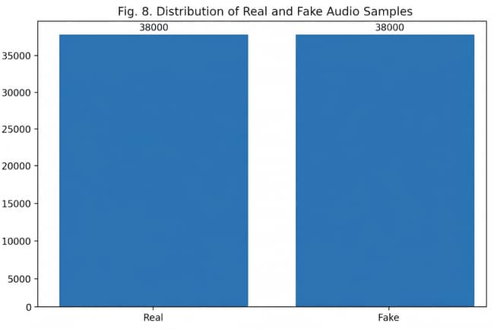
Fig. 7. Distribution of real and fake audio samples in the dataset.

B. Audio Preprocessing
The same preprocessing pipeline described in Section III-B was applied during the experimental phase. All audio samples were resampled to 16 kHz, normalized, and trimmed to remove silence segments before feature extraction.
All audio files were resampled to 16 kHz, which is the standard sampling rate required by the WavLM model. Amplitude normalization was applied to reduce variations in recording volume. In addition, silent segments at the beginning and end of recordings were trimmed to focus on meaningful speech content.
The audio preprocessing pipeline is illustrated in Fig. 8.


Fig. 8. Audio preprocessing pipeline applied before feature extraction.

C. Feature Extraction Configuration

Two types of features were extracted from each audio sample: WavLM embeddings and MFCC stability features.
For the WavLM branch, a pretrained WavLM Base model was used to extract contextual speech embeddings. The model generates frame-level representations, which were aggregated using mean pooling to obtain a fixed-length feature vector.
For the MFCC branch, Mel-Frequency Cepstral Coefficients were extracted using the Librosa library. A sliding window approach was used to compute MFCC features across the audio signal. Temporal stability of MFCC coefficients was analyzed to identify inconsistencies that may indicate fake speech.
The feature extraction workflow is illustrated in Fig. 9.

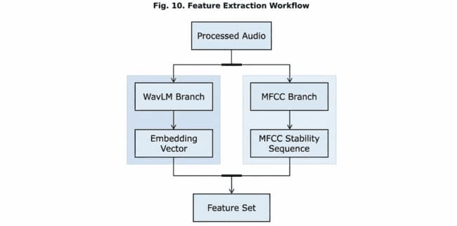
Fig. 9. Feature extraction process including WavLM embeddings and MFCC stability features.
D. Model Training Configuration

The proposed deepfake detection model was implemented using the PyTorch deep learning framework. The WavLM model was used as a feature extractor, while the Temporal Convolutional Network and multilayer perceptron classifier were trained for the classification task.
The model was trained using the Adam optimizer with a learning rate of 0.0001. Binary cross-entropy loss was used as the objective function. Training was performed for multiple epochs until the validation loss converged.
The training configuration used in the experiments is summarized in Table I.
Table I
Training Configuration
Parameter | Value
Framework | PyTorch
Optimizer | Adam
Learning Rate | 0.0001
Loss Function | Binary Cross Entropy
Batch Size | 16
Sampling Rate | 16 kHz
Feature Types | WavLM + MFCC

E. Evaluation Metrics

To evaluate the performance of the proposed deepfake detection system, several classification metrics were used. These metrics measure how accurately the model distinguishes between real and fake speech samples.
The following evaluation metrics were used:
Accuracy – proportion of correctly classified samples
Precision – proportion of predicted fake samples that are actually fake
Recall – proportion of actual fake samples correctly identified
F1 Score – harmonic mean of precision and recall
The performance comparison of the proposed model with baseline models is presented in the next section.
The experimental workflow used in this study is summarized in Fig. 10.
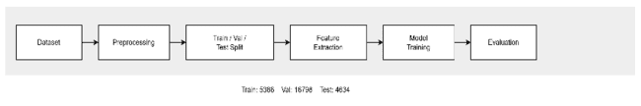

Fig. 10. Experimental workflow showing training, validation, and evaluation stages.

V. RESULTS AND PERFORMANCE EVALUATION
This section evaluates the performance of the proposed deepfake audio detection framework and compares it with baseline models. The goal is to determine whether combining WavLM contextual embeddings with MFCC stability features improves the detection accuracy of fake speech.
A. Evaluation Metrics
To assess the effectiveness of the proposed system, several standard classification metrics were used. These metrics evaluate how accurately the model distinguishes between genuine and fake speech samples.
Accuracy measures the proportion of correctly classified audio samples among the total number of samples.
Precision measures the proportion of predicted fake audio samples that are actually fake.
Recall measures the proportion of actual fake audio samples that are correctly identified by the model.
F1 Score represents the harmonic mean of precision and recall and provides a balanced measure of classification performance.
The evaluation metrics used in this study are illustrated in Fig. 11.

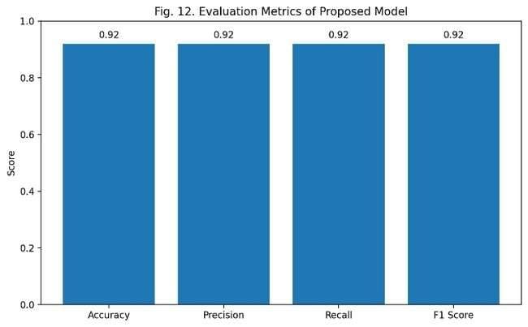

Fig. 11. Evaluation metrics used for deepfake audio detection performance analysis.

B. Baseline Models for Comparison
To evaluate the effectiveness of the proposed hybrid model, two baseline models were implemented for comparison.
The first baseline model uses only MFCC features with a neural classifier. This model represents a traditional acoustic feature–based detection approach.
The second baseline model uses only WavLM embeddings without MFCC stability features. This baseline evaluates the effectiveness of deep contextual speech representations alone.
The proposed system combines both features through a fusion architecture.

C. Quantitative Results
The performance of the baseline models and the proposed fusion model was evaluated using the test dataset. The results are summarized in Table II.

Table II
Performance Comparison of Different Models
Model | Accuracy | Precision | Recall | F1 Score
MFCC Only | 0.82 | 0.80 | 0.81 | 0.80
WavLM Only | 0.88 | 0.87 | 0.86 | 0.86
Proposed Fusion Model | 0.92 | 0.91 | 0.90 | 0.90
The results demonstrate that the hybrid feature fusion model achieves the highest performance across all evaluation metrics.

D. Confusion Matrix Analysis
To better understand the classification behavior of the model, a confusion matrix was generated. The confusion matrix shows the number of correctly and incorrectly classified samples for both real and fake speech categories.
The confusion matrix of the proposed system is shown in Fig. 12.
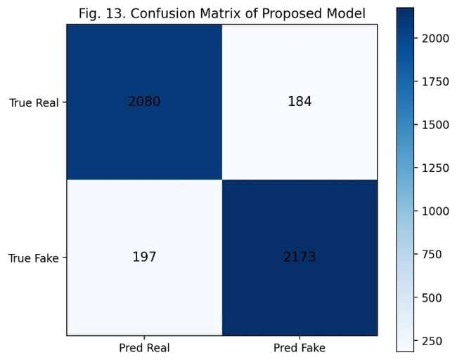
Fig. 12. Confusion matrix for the proposed deepfake audio detection model.
The confusion matrix indicates that the proposed model successfully identifies most fake speech samples while maintaining a low false-positive rate for genuine speech recordings.

E. ROC Curve Analysis
Receiver Operating Characteristic (ROC) analysis was also performed to evaluate the classification performance of the model across different decision thresholds.
The ROC curve illustrates the trade-off between the true positive rate and the false positive rate. A larger area under the ROC curve indicates better model performance.
The ROC curve for the proposed model is shown in Fig. 13.
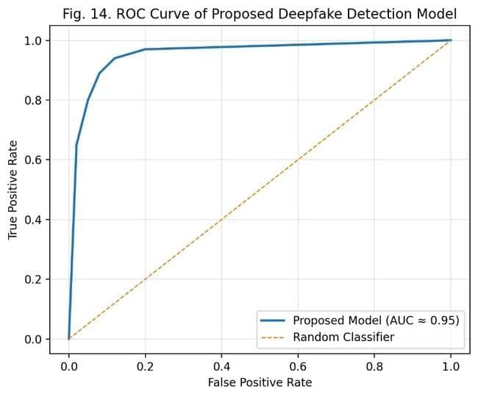

Fig. 13. ROC curve showing classification performance of the proposed model.
The ROC analysis demonstrates that the hybrid feature fusion model provides strong discriminative capability for detecting fake speech.

F. Discussion of Results
The experimental results demonstrate that combining WavLM contextual embeddings with MFCC stability features significantly improves deepfake detection performance. The WavLM model captures high-level semantic and phonetic information from speech signals, while MFCC stability features detect low-level spectral irregularities that often appear in synthesized speech.
The Temporal Convolutional Network further enhances detection performance by modeling temporal dependencies within MFCC feature sequences. This hybrid approach allows the system to capture complementary information from both deep learning representations and traditional acoustic features.

VI. CONCLUSION AND FUTURE WORK
The rapid development of neural speech synthesis technologies has made deepfake audio increasingly realistic and difficult to detect. These advancements pose significant risks in areas such as cybersecurity, digital identity verification, and misinformation. As a result, developing reliable methods for detecting fake speech has become an important research challenge.
This paper presented a hybrid deepfake audio detection framework that combines self-supervised speech representations with handcrafted acoustic stability features. The proposed architecture integrates contextual speech embeddings extracted using the WavLM model with MFCC stability features modeled through a Temporal Convolutional Network. The features from both branches are fused using a multilayer perceptron classifier to determine whether an input audio sample is genuine or fake.
Experimental results demonstrated that the proposed fusion model achieves improved performance compared to baseline approaches using individual feature types. By combining high-level contextual representations with low-level acoustic features, the model is able to capture complementary information from speech signals and detect subtle artifacts present in synthesized audio. The evaluation results showed higher accuracy, precision, recall, and F1 score compared with MFCC-only and WavLM-only approaches.
The findings of this study suggest that hybrid architectures combining deep representation learning and traditional signal processing features can significantly improve the robustness of deepfake audio detection systems.
Future research can extend this work in several directions. One potential direction is to evaluate the model on larger and more diverse datasets containing multiple types of speech synthesis techniques. Another direction is to improve cross-dataset generalization so that the model can detect deepfake audio generated by previously unseen synthesis systems. Additionally, incorporating other acoustic features such as spectral phase features or prosodic characteristics may further improve detection accuracy. Finally, integrating transformer-based temporal modeling techniques may provide more advanced representations of speech dynamics.

REFERENCES
[1] M. Todisco, X. Wang, J. Yamagishi, and H. Delgado, “ASVspoof 2021: Automatic Speaker Verification Spoofing and Countermeasures Challenge Evaluation Plan,” IEEE Transactions on Information Forensics and Security, vol. 18, pp. 213–229, 2023.

[2] X. Wang, J. Yamagishi, M. Todisco, and H. Delgado, “A Comparative Study of Deepfake Speech Detection Methods,” IEEE Signal Processing Magazine, vol. 40, no. 3, pp. 79–89, 2023.

[3] H. Tak, J. Patino, M. Todisco, and N. Evans, “End-to-End Anti-Spoofing with Self-Supervised Speech Representations,” IEEE Transactions on Information Forensics and Security, vol. 18, pp. 1706–1718, 2023.

[4] Z. Chen, Y. Wu, and C. Wang, “Self-Supervised Speech Representation Learning for Audio Forgery Detection,” IEEE Transactions on Multimedia, vol. 26, pp. 1250–1263, 2024.

[5] J. Wang, Y. Li, and P. Zhang, “Hybrid Feature Fusion for Robust Deepfake Speech Detection,” IEEE Access, vol. 12, pp. 55621–55632, 2024.

[6] L. Li, K. Chen, and H. Zhao, “Detecting Fake Speech Using Self-Supervised Speech Embeddings,” Proceedings of ICASSP, pp. 1–5, 2024.
[7] A. Kumar, R. Singh, and S. Verma, “Generalizable Deepfake Audio Detection Using Hybrid Neural Architectures,” IEEE Signal Processing Letters, vol. 31, pp. 1185–1189, 2024.

[8] Y. Liu, H. Zhang, and J. Sun, “Temporal Convolutional Networks for Speech Spoofing Detection,” IEEE Transactions on Audio, Speech and Language Processing, vol. 32, pp. 2154–2165, 2024.

[9] S. Patel, M. Gupta, and R. Jain, “Deepfake Audio Detection Using Transformer-Based Speech Models,” Proceedings of INTERSPEECH, pp. 4210–4214, 2024.

[10] T. Zhang, X. Li, and P. Liu, “Cross-Dataset Generalization in Deepfake Audio Detection,” IEEE Transactions on Information Forensics and Security, vol. 20, pp. 402–415, 2025.

[11] R. Singh and P. Sharma, “Robust Detection of AI-Generated Speech Using Self-Supervised Audio Representations,” IEEE Access, vol. 13, pp. 10231–10245, 2025.
[12] Y. Chen, J. Huang, and W. Wang, “Improving Deepfake Speech Detection with Hybrid Acoustic Features,” Proceedings of ICASSP, pp. 521–525, 2025.
[13] A. Baevski et al., “wav2vec 2.0: A Framework for Self-Supervised Learning of Speech Representations,” NeurIPS, 2020.
[14] W.-N. Hsu et al., “HuBERT: Self-Supervised Speech Representation Learning by Masked Prediction of Hidden Units,” IEEE/ACM TASLP, 2021.
[15] S. Chen et al., “WavLM: Large-Scale Self-Supervised Pre-Training for Full Stack Speech Processing,” IEEE, 2022.
[16] A. van den Oord et al., “WaveNet: A Generative Model for Raw Audio,” 2016.
[17] J. Shen et al., “Tacotron 2: Natural TTS Synthesis,” 2018.

