Impact of Techno Eustress on Innovative Performance by using Machine Learning Techniques

S. Pradeepa
School of Management
SASTRA Deemed University
Dpfi0825022303@sastra.ac.in

C Thereasa
School of Management
SASTRA Deemed University
therasa@mba.sastra.edu

Abstract— The use of digital technologies by modern businesses has raised issues linked to technostress; however, latest studies show the positive influence of techno eustress as a kind of positive stress in improving employee performance. The present paper focuses on investigating the effects of techno eustress on the innovative performance of information technology sector employees. The purpose of this study is to establish the relationship between techno eustress as an independent variable and innovative performance as a dependent variable with the help of machine learning-based HR analytics. This research involves the use of an employee data set that consists of behaviour, psychology, and performance factors including job satisfaction, involvement, experience, and demographic data. Several supervised machine learning algorithms, namely, Random Forest, XGBoost, and SVM, were used to predict innovative performance. The predictive ability of the algorithms was assessed using the following evaluation measures: Accuracy, F1 score, and ROC-AUC. The results from feature importance analysis show that techno eustress is a strong predictor of innovative performance, meaning that moderate amounts of stress caused by technology lead to innovation among employees. In the models developed, Random Forest showed higher accuracy and AUC values compared to other algorithms, followed by XGBoost, which suggests that the model has high classification abilities. The study shows the existence of a positive correlation between techno eustress and innovative performance.
Keywords— Techno Eustress; Innovative Performance; Machine Learning; HR Analytics; IT Employees; Predictive Modelling; Random Forest; XGBoost
- Introduction
In the current era of technology, companies use sophisticated technological tools for increasing efficiency, collaboration, and better decision-making in the workplace. Even though the use of technology increases efficiency and productivity in organizations, it has also created other types of stress that are commonly known as technostress. Technostress has always been seen as a factor causing negative effects on workers’ performance. However, according to the latest findings by researchers, technostress does not necessarily have negative effects; rather, techno-eustress can inspire workers for better performance (S. Tarafdar, 2019). This is especially true in the case of the IT industry, where people continuously work with changing technologies. People who face some technological challenges can benefit from increased learning, adaptation, and creativity; all these are required for innovative performance. The definition of innovative performance is the capacity of workers
to create new things and introduce and apply them effectively. It has been shown in previous studies that work environment, work load, and psychological aspects have an immense impact on the behaviour of individuals concerning innovations (Janssen, 2000). In today’s world of abundant data on workforce, HR analysts are applying machine learning algorithms to help make sense of employee data and predict their future performance and engagement. Using machine learning, an organization can analyze vast and complex datasets and detect the patterns and correlations which might not be discovered using traditional statistics techniques. Among the HR applications, machine learning algorithms including Random Forest, SVM, and XGBoost, among others, are proven successful in predicting employees’ performance, engagement, and retention levels (Jia, 2022). While the use of machine learning in HR has already become widespread, there are only a few studies which have applied machine learning to study techno eustress and its role in predicting innovative performance. Most available researches focus on the adverse results of techno stress and performance rather than innovations, leaving a gap in our knowledge on how techno eustress can positively affect employee productivity. This gap needs to be addressed to enable organizations promote a culture of continuous innovation (Singh, 2024). In this regard, the current study attempts to evaluate the effects of techno-eustress on innovative performance of IT professionals through predictive modelling techniques using machine learning methods. In this regard, the study uses a dataset that contains demographic, behavioural, and work-related variables such as job satisfaction, involvement, and experience. By testing different machine learning algorithms based on their performance measures like accuracy, F1-score, and ROC-AUC values, the research tries to determine which model performs better, highlighting the importance of techno-eustress as an independent variable. The results will help HR managers formulate innovative practices within organizations to improve overall performance (al, 2024).
- Literature Review

The impact of work-related stress in human resource management studies has always been a critical issue due to its implications for employee health, motivation, retention, and performance. One of the most widely used theoretical perspectives in the area of stress in HR research is the JD-R model, which states that high levels of job demands consume the energy of employees and may produce stress, whereas sufficient amounts of job resources protect against stressful experiences and increase motivation. It is essential because the concept of stress changes from something negative to a condition that can either result in positive or negative consequences depending on the appraisals. Another crucial finding was that not all types of stress function identically, thus establishing the ground for further research into employee performance and behavior in HR management. (Demerouti, 2007) , (M. A. Cavanaugh, 2000)[1]. A significant finding in this area is that of distinguishing between challenge stressors and hindrance stressors. While challenge stressors like workload, responsibilities, and time pressure can be difficult experiences, they can be linked with learning, achievement, and development. On the other hand, hindrance stressors such as role ambiguity, organizational politics, and bureaucratic red tape can prevent people from achieving their goals and motivate them less. Several meta-analyses have repeatedly demonstrated that hindrance stressors have a stronger link with negative work-related attitudes and withdrawal behavior compared to challenge stressors, which can show variable correlations including positive ones, even with motivation and performance. From an HRM point of view, this difference is particularly important as it allows for the assumption that some types of stress can help people develop rather than hurt their performance (J. A. LePine, 2005)[2]. With regards to work settings in digital form, stress research in general has developed into what is now called technostress, where this is defined as stress that occurs as a result of the use of information and communication technology. According to various scholarly articles published in reputable information systems journals, technostress is triggered by various forms of stressors like techno-overload, techno-complexity, techno-invasion, techno-uncertainty, and techno-insecurity. These kinds of stressors may result in increased role stress while decreasing productivity among employees as they will be stressed out by all these changes and the constant demands for technological adaptation (M. Tarafdar, 2007) , (T. S. Ragu-Nathan, 2008) , (R. Ayyagari, 2011). The notion of technostress has changed greatly in the literature on human resource management and information systems. The idea of technostress used to represent an exclusively negative concept that referred to stress caused by information and communication technologies. Today, scientists emphasize that people's reaction to technological challenges is not always negative but can be both threatening and beneficial. Accordingly, the challenges posed by technologies can be perceived either as a threat (causing technostress) or as a challenge (creating techno eustress). The latter perspective allows HR researchers to study not only negative consequences of technological changes for employees but also positive effects of technology (M. Tarafdar C. L., 2019) , (R. Ayyagari, Technostress: Technological antecedents and implications, 2011). Techno-eustress refers to the favorable psychological reaction elicited among workers when they regard technology-related stimuli as motivating, exciting, and beneficial for their development and growth. Techno-eustress results in an employee’s sense of gratification, energy, and cognitive performance, which allows him or her to efficiently address emerging challenges in terms of technological advancements. Contrary to techno-distress, which triggers exhaustion and decreased efficiency, techno-eustress helps individuals learn, become flexible, and make better decisions. In line with other stress concepts, such as challenge-hindrance stress and JD-R model, some types of stress can serve as motivating factors if accompanied by sufficient resources (al C. S.-C., vol. 18, no. 6). Several recent empirical and theoretical works have investigated the precursors of techno-eustress, which are also known as techno eustress inducers. Some examples of these factors include the usefulness of technology, its ease of use, reliability, and learning opportunities. As such, when workers perceive the usage of digital devices as liberating instead of oppressive, they are more likely to enjoy a beneficial kind of stress which will increase their productivity. It should be noted that the support systems developed by organizations (e.g., training programs, technical assistance, and digital literacy) may greatly contribute to such perceptions. Considering the HR analytics point of view, techno eustress has become one of the factors positively affecting organizational behavior. Techno eustress has a positive effect on job satisfaction, work engagement, and performance improvement of employees. Research has shown that if employees face technology-related challenges in reasonable limits and that are significant for their performance, they are motivated and proactive. Besides, techno eustress can be used to achieve innovation performance through creative activities performed by employees in digital spaces. This factor is especially important in IT-intensive businesses, which continuously experience technological changes (M. Tarafdar C. L., 2019) , (al L. N., 2024). In spite of the increasing awareness about the existence of techno-eustress, there is a lack of integration of this concept in predictive HR analytics and machine learning literature. Most studies have been concerned with either qualitative or regression-based methodologies, creating an opportunity for applying sophisticated analytical techniques in measuring and predicting the effects of techno-eustress on workers' outcomes. Moreover, the transient and situational character of techno-eustress implies the necessity to adopt longitudinal and data-oriented methods to better assess the role of techno-eustress in determining performance and innovation. By doing so, it will be possible for HR professionals to make informed decisions regarding the determination of techno-eustress levels that are conducive to worker productivity and innovation (S. Tarafdar, 2019) , (Kumar, 2024). One important tool that has gained widespread attention in human resource management is machine learning. This is because it helps organizations analyze large amounts of employee data and uncover insights that would be hard to obtain using traditional statistical analysis methods. The application of machine learning has been seen in HR areas such as recruitment, performance appraisal, retention analysis, workforce planning, and employee development. A review that has been extensively referenced on the use of machine learning in HRM indicated that the area has evolved and become applied in almost all essential HR activities, especially in relation to forecasting and decision-making tasks (S. Garg, 2021) , (M. Úbeda-García, 2025). One of the most advanced domains of application of machine learning in HR revolves around the prediction of employee turnover and retention. Some of the popular predictive techniques used in the analysis of such data include decision tree, random forest, gradient boosting algorithms, and neural networks. In recent years, researchers have found out that application of machine learning algorithms can help in improving the precision and speed of decision-making regarding employee retention and attrition by taking into account factors such as employee tenure, salary, career progress, and job role within organizations. This particular research stream is of special importance in the field of HR due to the heavy losses resulting from employee turnover (M. R. Shafie, 2024) , (H. Talebi, 2025) , (Qin, 2026). Another field where machine learning plays a significant role is human resource management in terms of talent acquisition and personnel selection. Here, machine learning techniques along with other artificial intelligence methods have applications in résumé screening, matching, interview analysis, and prediction of suitability to the role. Recently, studies have shown that machine learning algorithms and natural language processing can radically change hiring processes because of their ability to enhance the scale and consistency of these processes while increasing information processing capacity. On the other hand, scholars warn about possible risks posed by machine learning-based approaches such as perpetuation of biases if algorithms are based on poorly-governed data (N. Nawaz, 2024) , (E. D. Campion, 2024) , (A. Bujold, 2024). Another interesting research direction relates to applying machine learning in performance management and HR intelligence. The latest works have demonstrated that ML techniques could be used to predict the performance of employees, evaluate their skills, and segment their workforce based on both structured and unstructured data provided by HR information systems. As far as HR management intelligence is concerned, the latest studies have shown that machine learning could enhance the managerial decisions through improved pattern recognition and increased target-oriented interventions in HR processes. Moreover, other reviews highlight the growing importance of AI applications not only for recruiting and performance evaluation but also for increasing engagement, organizing training programs, and developing strategic plans (S. R. K. Indarapu, 2023) , (M. Madanchian, 2023) , (N. Nawaz, 2024). While there is no lack of literature on predicting techno eustress in HR management, this is a vital issue in terms of situating the current study within the context of the existing scholarship. Indeed, in most of the previous work focused on the digital stress of organizations, the negative nature of technostress was emphasized through its aspects of overload, complexity, invasion, insecurity, and uncertainty that lead to stress and poor performance. Nevertheless, in recent high-quality works, this term is now viewed as a dual concept consisting of a negative and positive dimension. It is of paramount significance for HR management as well because it implies that employees' responses to the technologies implemented by the firm do not have to be always negative since certain requirements arising from using them can be interpreted as stimulating and even motivating. Thus, predicting techno-stress/eustress becomes not about stress per se causing harm but more about understanding the conditions under which technostress/eustress occurs (M. Tarafdar C. L., 2019) , (C. B. Califf, 2020). One of the theories behind prediction is a holistic technostress process model proposed by Califf, Sarker, and Sarker. The MIS Quarterly publication of the team is considered one of the best works in this domain because of their explicit theorization of technostress as involving two subprocesses: techno-eustress and techno-distress. Through their sequential mixed methods analysis in the realm of healthcare information technologies, the authors have proven that challenge and hindrance techno stressors do not produce the same results and that positive psychological responses may lead to positive results in employees' jobs. It makes the paper important for HR studies because of its predictive power based on the theory: it is possible to predict the presence of techno-eustress through stressor appraisals and relate it to the final outcome like job satisfaction or variables related to turnover. Even though the study was not performed in a classic HRM setting, the organization is designed with employees at the center of its activities, and therefore, it could be applied to technology-based work HR analytics research. (C. B. Califf, 2020). The best empirical proof regarding the factors that predict techno-eustress is presented in the latest Information Systems Journal paper on techno-eustress generators and in other studies that build on this theory. According to this research, techno-eustress is not a stochastic phenomenon; it is predictable based on some variables such as the usefulness of technology, organizational support, and cognitive and behavioral capacities for handling digital tasks. To supplement this point, Nascimento, Correia, and Califf found that usefulness, synergic literacy, IT mindfulness, and coping flexibility were positive predictors of techno-eustress, whereas techno-eustress correlated positively with job satisfaction and work performance.

- METHODOLOGY

a. Dataset Description

The dataset used for the analysis presented below was taken from Kaggle.com (2023) and includes data on IT industry employees. Specifically, the dataset contains information about more than 1000 employees and covers all types of behaviours, psychological characteristics, and performance aspects that can be used in predicting the performance of IT specialists. Therefore, this dataset is well-structured and appropriate for further analyses. This data can be divided into three different categories to ensure that there is a complete picture regarding the characteristics of the employees. The demographic variables include age, gender, education, and experience and denote the basic profile information of the employees. On the other hand, the variables related to satisfaction are job satisfaction, work satisfaction, technology satisfaction, and environmental satisfaction, which denote the attitude of employees regarding their work and working environment. Moreover, other factors comprise techno eustress, job involvement, workload, overtime, and performance ratings, all of which pertain to the behaviour and performance of employees. Therefore, the database presents a set of employees who differ by age, level of work experience, and occupation. The use of such diverse characteristics makes it possible to identify the impact of different factors using machine learning approaches and analyse employee behaviours. In the current research, Innovative Performance serves as a dependent variable based on performance indicators of employees while Techno Eustress will be regarded as an independent one
b. Descriptive Statistics

Descriptive statistics serve to describe the dataset through numerical values and assist in comprehending the data. They give an idea of the variables' mean and variation and enable researchers to identify patterns and variations in data. In this research, descriptive statistics will be employed in examining the variables chosen for this study to give a description of the employee attributes.

Table No. I Descriptive Statistics

Variable | Mean | Minimum | Maximum
Age | 36.92 | 18 | 60
Monthly Income | 6502.9 | 1009 | 19999
Environment Satisfaction | 2.72 | 1 | 4
Job Satisfaction | 2.73 | 1 | 4
Relationship Satisfaction | 2.71 | 1 | 4
Job Involvement | 2.73 | 1 | 4
Job Level | 2.06 | 1 | 5
Total Working Years | 11.28 | 0 | 40
Performance Rating | 3.15 | 3 | 4
C. Data Preprocessing
Data preprocessing is a vital part of using machine learning algorithms because it makes sure the quality of our data set. It can help remove inconsistencies from the data, deal with missing data, and make proper changes to the variables.
• Data Cleaning:
It refers to searching for inconsistencies and errors in the data set to make sure they are corrected before proceeding further. Data cleaning plays a significant role in ensuring the data quality.
• Handling Missing Data:
Missing data is detected and addressed. The missing values in the numerical variables are filled using the average value of those variables. In this way, the data remains consistent.
• Encoding Categorical Data:
In this study, one-hot encoding technique is used to convert categorical data into numerical. Nominal data will be encoded using one-hot coding. For example, the variables "gender" and "category" have been labeled using one-hot encoding. Whereas ordinal encoding will be performed for data containing natural order, like level of education.
• Feature Scaling:
To scale the features or numerical variables, feature scaling method is used in this case.

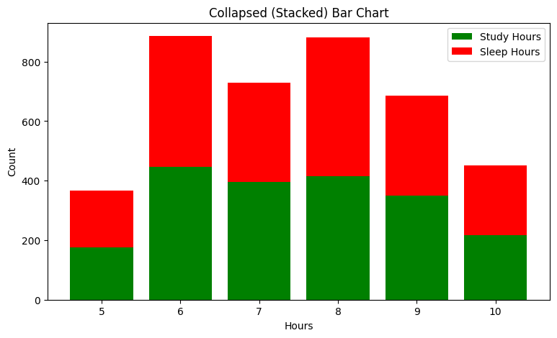
Figure 1 Stacked for Study Hours and Sleep Hours
Fig [1] Shows that the stacked bar graph depicts a balanced relationship between studying and sleeping hours at all levels. The vast majority of the observations are found within the ranges of 6 to 8 hours. Both levels exhibit one of the highest frequencies at 6 hours. The same can be said about 8 hours, which is relatively high as well. A low number of the observation is seen at 5 and 10 hours. The number of sleeping hours is slightly greater than the number of studying hours in most cases. It means that students spend a bit more time on sleeping rather than studying. The variability in numbers at each hour level is stable. Neither the relationship between sleeping and studying changes dramatically within certain ranges. Therefore, there is a relatively balanced pattern in this data set.
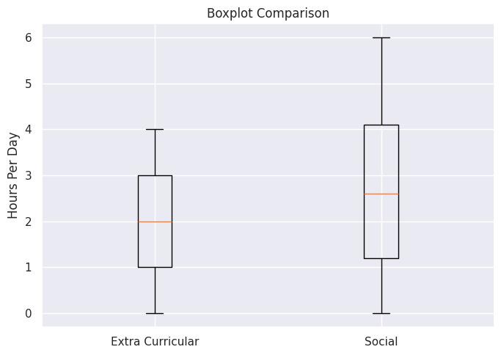

Figure 2 Boxplot for Extracurricular and Social
As Shown in Fig [2] , the boxplot, it is evident that the variable 'social activities hours' has a relatively higher median than extra curricular hours. It implies that students generally engage in social activities more often than extra curricular activities. The minimum value for both variables begins at almost zero hour per day. However, the maximum value for extra curricular activities ranges at about four hours per day. On the other hand, the value for social activities ranges up to about six hours per day. Also, extra curricular hours range are shorter and denser compared to those of social activities. In this case, students have different levels of engagement in social activities compared to extra curricular activities.
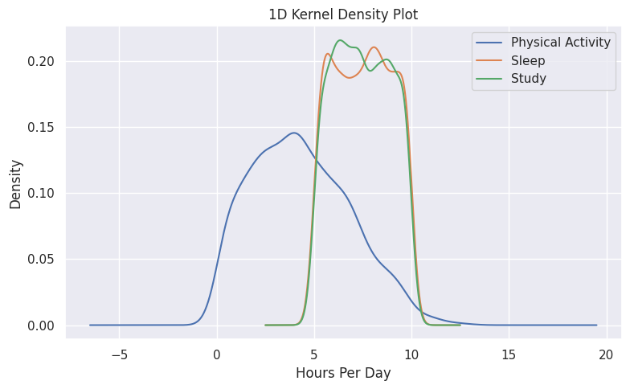

Figure 3 Kernel Density for Physical activity, sleep, and stud
As Shown in Fig [3] , The kernel density function represents the distribution of physical activities, sleeping, and studying in smooth form. The graphs representing sleeping and studying are almost parallel, showing almost complete overlap throughout the range. The density of both sleeping and studying peaks between 6 and 9 hours per day. Therefore, it can be concluded that there is an almost equal amount of time spent on both sleeping and studying by most students. The graph of physical activities differs from others and is cantered at low-hour levels. The peak of physical activity ranges between 3 to 5 hours, which is less than other distributions. The dispersion of physical activities is higher compared to others and covers a wider range. The range of sleeping and studying is shorter and has low dispersion. The overlap among sleeping and studying is higher, whereas that with physical activities is relatively lower.
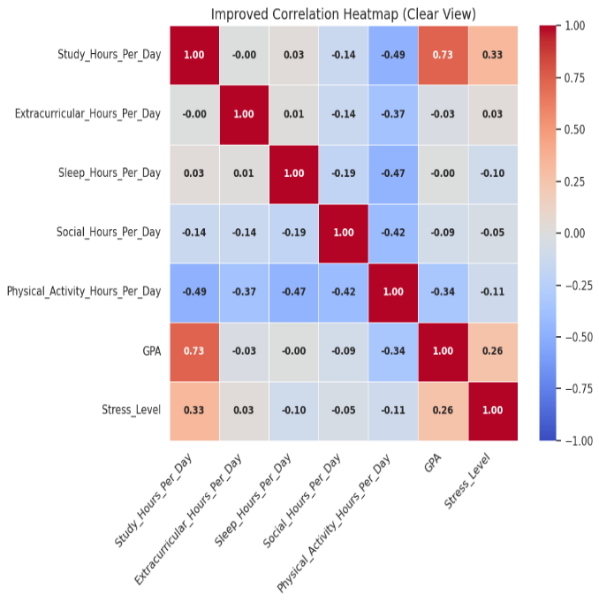

Figure 4 Correlation Matrix
As Shown in Fig [4] , From the correlation matrix, it is clear that there are both positive and negative correlations among the variables. The study variable has the strongest positive correlation with the GPA variable in the provided data set. This means that an increase in the amount of time devoted to studies increases one's GPA. There are negative correlations between physical activity and studying, sleeping, and socializing. This means that people who engage in more physical activity spend less time doing those things. There is only a weak correlation between sleeping and studying. Extracurricular activities and socializing are not correlated with any other activities strongly. GPA has a moderate negative correlation with physical activity but a weak correlation with other variables. There is a positive correlation between stress levels and study hours as well as GPA. Generally, it appears that studying is a crucial element of performance, whereas other activities are insignificant.

Table No. 2 Accuracy

Model | Accuracy Score
Random Forest | 0.7775
XGBoost | 0.7775
SVM | 0.7900

Accuracy Interpretations

The accuracy outcomes show that all three supervised machine learning algorithms showed quite a steady and equal performance with some very slight difference among them. The Support Vector Machine algorithm showed the best accuracy score value of 0.79, which means that this particular machine learning algorithm is the most effective one in terms of predicting the outcome of our study. Also, Random Forest and XGBoost algorithms demonstrated the same level of accuracy at the level of 0.7775.

It should be noted that the small difference in accuracy values proves that all three algorithms work efficiently and are able to identify the patterns of our dataset. However, as we see, there is a very slight advantage in terms of accuracy performance of the SVM algorithm, so it can be used in our further analysis of the dataset.
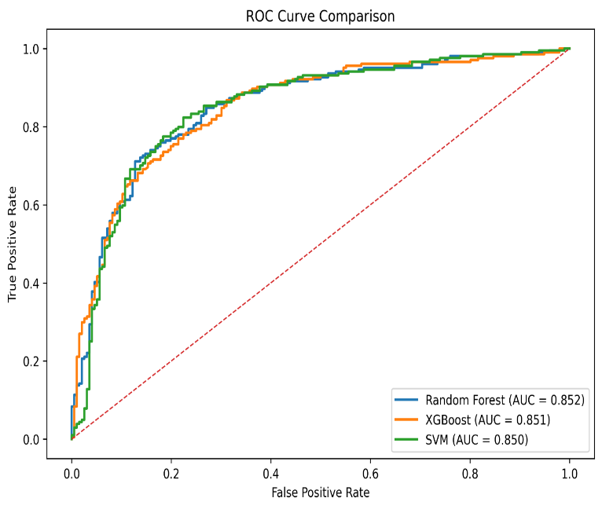
Figure 5 ROC Comparison

Analysis of ROC Curve Comparing

As Shown in Fig [5], The ROC curve depicts the classification abilities of the supervised models through the comparison of the true positive and false positive rates. All of the three models depicted the ROC curves located above the diagonal reference curve, thus demonstrating their superior performance compared to random classification and proving their effectiveness in differentiating between the classes.

In particular, Random Forest model demonstrated the highest area under the curve (AUC) – 0.852, thus demonstrating high discriminatory ability in classification of the target cases. The second highest result was shown by XGBoost classifier with AUC equal to 0.851. Finally, SVM model resulted in AUC of 0.850, also reflecting high classification capabilities.

Overall, all models showed similar levels of discrimination capability since the differences between AUC values were rather low. Despite the superiority of ROC-AUC index for Random Forest approach, it still could be claimed that all three models possess high reliability of classifications. Thus, all models were able to find hidden patterns in the data sets, whereas the most efficient one was Random Forest algorithm.
Findings

The findings from this study suggest that techno eustress positively affects innovative performance of employees. It was observed that moderate levels of stress related to technological environment help employees learn, adapt, and become creative. Further, it can be concluded from the analysis that both behavioral and work-based factors are very effective in predicting performance results.

Machine learning models showed high effectiveness in making predictions. From the different models considered, the Support Vector Machine gave the best result for accurate classification, whereas Random Forest model provided marginally better results in ROC-AUC. However, even the XGBoost performed well with consistent results. Minor variations among models imply that all three models can be used for performance prediction.

Overall, it can be stated that techno eustress positively influences employee performance. Moreover, machine learning is an effective approach to predict performance results.
Practical Applications (Recommendations)

The organization needs to keep an optimal amount of techno eustress to foster innovation among employees. The human resources manager must develop technology-related tasks that pose enough challenges but do not exceed employees' capabilities. Training programs for employees on technology-related skills must be offered regularly. Machine learning models should be used by organizations to make HR decisions and predict employee performance. An encouraging work atmosphere must be developed to promote innovation. Employee engagement initiatives need to be adopted to motivate employees. Workloads must be managed effectively to prevent stress. Data-driven HR practices must be followed by organizations for effective workforce management. Feedback systems must be continuously applied to track the employees' reactions towards technology. Human resource managers should leverage analytics solutions to determine the factors contributing to employee performance.

Conclusion

In this research, the influence of techno-eustress on the innovative performance of employees from the IT industry has been investigated using the machine learning method. As the results of this research have revealed, techno-eustress can be seen as a positive element that helps improve the innovative performance of employees in the case when its level is moderate. This research shows that technology-induced stressful situations have a positive impact on the improvement of employees' performance.

Supervised learning models used during this research helped predict performance outcomes more accurately. Out of all three models used in this research, Support Vector Machines were characterized by the best accuracy of predictions, while Random Forests showed a slightly higher discriminant capability based on the area under the curve metrics. XGBoost also delivered consistent results, which means that it is possible to use several machine learning approaches to investigate employees' behavior.
The current research makes important contributions to the field of academic literature and practice in the area of HR management as it combines the concept of techno eustress and applies machine learning techniques to its investigation. Specifically, , it draws attention to the significance of proper handling of technology-induced pressure as it fosters innovation and avoids any harm. Data analysis has proved that the use of data-based technologies is highly beneficial in making decisions related to HR processes. it draws attention to the significance of proper handling of technology-induced pressure as it fosters innovation and avoids any harm. Data analysis has proved that the use of data-based technologies is highly beneficial in making decisions related to HR processes.
Limitation:

There are several limitations associated with this study that must be taken into account while interpreting the results. First, this study makes use of a narrow scope of data set, meaning that the results may not be applicable to the entirety of the population of employees under consideration. In other words, the generalizability of results might have been constrained by the selection of a specific dataset.

The second limitation is associated with the use of proxies for measuring innovative performance and techno-eustress since the constructs themselves cannot be measured directly, and their true nature has been ignored.

Another limitation is that the machine learning techniques were used solely to work with structured data; unstructured data were not used during the analysis. It could have been interesting to use them in order to obtain more information about employee behavior.

Finally, the analysis uses cross-sectional data, which means that changes in techno eustress and innovation cannot be observed. Causal relationships cannot be established using cross-sectional data analysis.
Future Scope:

There are many prospects for further research in the sphere of applying HR analytics and machine learning tools. For instance, future research may include the analysis of datasets that are bigger and vary across various industries in order to improve the general applicability of results obtained.

The consideration of a number of additional variables such as support provided by organization, its leaders' style, digital infrastructure, etc., will contribute to the comprehension of predictors of techno eustress and innovative work environment. Thus, better predictive models will be created.

Machine learning can become even more sophisticated – the application of deep learning approaches or combination of traditional techniques will improve the quality and precision of models. Comparison of algorithms' performances can contribute to their improvement as well.

One more area for research is longitudinal datasets because the development of techno eustress can be investigated through time, and it will allow observing the dynamics of changes in employees' performance.

Finally, using machine learning in real-life HR analytics software will allow continuous monitoring of employees' performance and help foster innovation among them.

References
A. Bujold, a. c. (2024). Responsible artificial intelligence in human resources management: A review of empirical studies. AI and Ethics.
al, C. S.-C. (vol. 18, no. 6). Analyzing the evolution of technostress: A science mapping approach. International Journal of Environmental Research and Public Health, 2021.
al, L. N. (2024). Towards a bright side of technostress in organizations. Technology in Society.
al, N. Z. (2024). Unbiased employee performance evaluation using machine learning. Journal of Open Innovation, vol. 10, no. 2.
C. B. Califf, S. S. (2020). The bright and dark sides of technostress: A mixed-methods study involving healthcare IT. MIS Quarterly, vol. 44, no. 2, pp. 809–856.
Demerouti, A. B. (2007). The Job Demands–Resources model: State of the art. Journal of Managerial Psychology, vol. 22, no. 3, pp. 309–328.
E. D. Campion, A. C. (2024). Impact of machine learning on personnel selection. Organizational Dynamics.
H. Talebi, a. c. (2025). Developing a hybrid machine learning model for employee turnover prediction. Journal of Innovation & Knowledge.
J. A. LePine, N. P. (2005). A meta-analytic test of the challenge stressor–hindrance stressor framework: An explanation for inconsistent relationships among stressors and performance. Academy of Management Journal, vol. 48, no. 5, pp. 764–775.
Janssen, O. (2000). Job demands, perceptions of effort–reward fairness and innovative work behaviour. Journal of Occupational and Organizational Psychology, vol. 73, no. 3, pp. 287–302.
Jia, Y. (2022). Research on employee performance prediction based on machine learning. Journal of Business Analytics, vol. 5, no. 2, pp. 120–132.
Kumar, P. S. (2024). Technostress: A comprehensive literature review on emerging perspectives. Journal of Innovation & Knowledge.
L. Nascimento, M. F. (2025). Techno-eustress under remote work: A longitudinal study in higher education teachers. Education and Information Technologies, vol. 30, pp. 16633–16670.
M. A. Cavanaugh, W. R. (2000). An empirical examination of self-reported work stress among U.S. managers. Journal of Applied Psychology, vol. 85, no. 1, pp. 65–74.
M. Madanchian, A. T. (2023). AI-Based Human Resource Management Tools and Practices: A Systematic Literature Review. Procedia Computer Science.
M. R. Shafie, a. c. (2024). A cluster-based human resources analytics for predicting employee turnover. Decision Analytics Journal.
M. Tarafdar, C. L. (2019). The technostress trifecta—Techno eustress, techno distress and design: Theoretical directions and an agenda for research. Information Systems Journal, vol. 29, no. 1, pp. 6–42.
M. Tarafdar, J.-F. S. (2024). echno-eustress creators: Conceptualization and empirical validation. Information Systems Journal, vol. 34, no. 6, pp. 2097–2131.
M. Tarafdar, Q. T.-N.-N. (2007). The impact of technostress on role stress and productivity. Journal of Management Information Systems, vol. 24, no. 1, pp. 301–328.
M. Úbeda-García, a. c. (2025). Artificial intelligence, knowledge and human resource management: A bibliometric analysis. Journal of Innovation & Knowledge.
N. Nawaz, H. A. (2024). The adoption of artificial intelligence in human resources management practices. International Journal of Information Management Data Insights, vol. 4, no. 1, article 100208.
Q. Yuan, J. K. (2025). Understanding the effects of specific techno-stressors on strain and job performance: A meta-analysis of the empirical evidence. Information Technology & People, vol. 38, no. 2, pp. 787–826.
Qin, R. (2026). Employee turnover prediction research of human resources based on machine learning and big data. Journal of Innovation & Knowledge.
R. Ayyagari, V. G. (2011). Technostress: Technological antecedents and implications. MIS Quarterly, vol. 35, no. 4, pp. 831–858.
R. Ayyagari, V. G. (2011). Technostress: Technological antecedents and implications. MIS Quarterly, vol. 35, no. 4, pp. 831–858.
S. Garg, S. S. (2021). A review of machine learning applications in human resource management. International Journal of Productivity and Performance Management, vol. 71, no. 5, pp. 1590–1610.
S. R. K. Indarapu, S. V. (2023). Exploring human resource management intelligence practices using machine learning models. The Journal of High Technology Management Research, vol. 34, no. 2, article 100466.
S. Tarafdar, C. C. (2019). The technostress trifecta—Techno eustress, techno distress and design. Information Systems Journal, vol. 29, no. 1, pp. 6–42.
Singh, R. R. (2024). Machine learning applications in human resource management. International Journal of HR Analytics,, vol. 8, no. 1.
T. S. Ragu-Nathan, M. T.-N. (2008). The consequences of technostress for end users in organizations: Conceptual development and empirical validation. Information Systems Research, vol. 19, no. 4, pp. 417–433.
Zielonka, J. T. (2022). The impact of trust in technology on the appraisal of technostress creators in a work-related context. in Proc. 55th Hawaii International Conference on System Sciences (HICSS), pp. 5881–5890.

