AUTOSENSE: INTELLIGENT VEHICLE MONITORING SYSTEM

Jaiganesh Janakiraman * ¹ Muthuraman Vadivel ² and Pradeepkumar Sivakumar³

¹ Research Scholar, Department of Mechanical Engineering, Vels Institute of Science, Technology and Advanced Studies (VISTAS), India
²Professor, Department of Mechanical Engineering, Vels Institute of Science, Technology and Advanced Studies (VISTAS), India
³ Associate Professor & Head, Department of Electrical and Electronics Engineering, Vels Institute of Science, Technology and Advanced Studies (VISTAS), India.

E-Mail: jaiganesh.janakiraman@gmail.com , drvmuthuraman.se@vistas.ac.in , pradeep88.se@vistas.ac.in

Abstract—The automotive sector is on the verge of a revolution in terms of smart vehicles with the focus on safety, efficiency, and maintenance forecasting. The main goal of this paper is to present the cutting-edge IoT-enabled vehicle cabin monitoring system named AutoSense that is capable of incessantly tracking the environmental parameters that are crucial for the vehicle like gas level, temperature, and moisture inside the cabins. The system consists of several sensors such as an MQ135 gas sensor for detecting gas, a DHT11 sensor for measuring temperature and humidity, an ultrasonic sensor for detecting motion, and a Pi camera sensor for monitoring the entire area. A thorough analysis of components with specifications such as Raspberry Pi 4 technology with an ADS1115 analog digital converter, the implementation of a FastAPI web interface for graphical representation of data and cloud storage service, will lead to the identification of a future extension based on a different application in this research. The results through experiments point out that the system is able to provide real-time access to the cabin environment and gas detection with an accuracy of up to 94% and temperature measurement with precision of ±2°C. The proposed predictive maintenance module is said to reduce the failure rates of the vehicle components by 34% through the proactive scheduling of maintenance. Evidence of the advancements in the automobile industry that the deployment of a comprehensive vehicle monitoring system that encompasses a variety of IoT applications. However, it will also result in increased operational effectiveness and strategic preventative maintenance techniques in addition to ensuring the vehicles' safety. Hence the system's modular design allows for scalability and future integration with more advanced machine learning algorithms for all-encompassing vehicle health monitoring.
Keywords—Vehicle Monitoring, IoT, Raspberry Pi, Predictive Maintenance, Neural Networks, Environmental Sensors, Automotive Safety

Introduction
automotive industry is the most leading technological transformation in the world industry wherein monitoring and predictive features are progressively added to mechanic components. To enhance the growth of the automotive industry, it is necessary to address concerns about air quality, in-cabin health, and automotive performance efficiency. For this vehicle cabin monitoring systems plays a crucial component of advanced automotive safety solutions. Numerous innovative real-time monitoring, analytical, and predictive vehicle maintenance solutions have been made possible by the automotive industry's use of Internet of Things (IoT) technology. Auto Sense can be regarded as a comprehensive smart vehicle monitoring solution for handling a wide range of challenges related to vehicle cabin management. The fundamental solution for autosense is to continuously monitor critical environmental parameters in car cabins, such as temperature, gas content, and moisture levels, and to provide drivers with immediate feeding interface inputs in addition to storage for later study. Cabin solutions for automobiles have gained importance in a wider context that goes beyond simple convenience needs. Drivers may experience sleepiness, difficulty concentrating, and major health consequences as a result of poor air quality in an automobile cabin. The ability of in-car air quality monitoring systems to identify toxic gases including carbon monoxide, nitrogen oxides, and volatile organic compounds that could jeopardize occupant safety is being verified by current research investigations. Additionally, humidity and temperature monitoring can assist prevent circumstances that could harbor bacteria or deteriorate the components and provide insight into how the HVAC system operates. A wide range of technologies, including data processing, sensor integration, cloud computing and wireless connection are used in intelligent vehicle monitoring.
A modern vehicle is generating a massive amount of data because of embedded sensors in the car. Such a need requires a wide array of opportunities in advanced analytics and predictive maintenance solutions. Such integration with machine learning algorithms helps in the identification of problems before they start causing system failures or safety hazards. Autosense has distinguished itself from the rest in vehicle cabin monitoring as it has taken an all-encompassing approach to the incorporation of different sensor modalities and integrating these with high-level processing abilities. The processing unit being used in Raspberry Pi because of its high processing capabilities, enhanced GPIO functions, and support for automotive integration.
The MQ135 gas sensor, DHT11 temperature and humidity sensor, and ultrasonic sensors used for motion sensing, along with Pi camera modules used for vision, are the sensors used to implement significant sensing functionality within the system. These are the parts of the system design that implement a focus on cloud connectivity, real-time processing, and user interface design. Fast API is used to implement online visualization, which is a part of the Autosense project, providing a means to view data in a user-friendly way without compromising the high-performance computation of data.
The system also utilizes cloud storage, which allows for the analysis of historical data, trend analysis, and the creation of prediction models for the maintenance of vehicle schedules. Autosense has included plans for the implementation of advanced predictive maintenance for the brake, clutch, and accelerator systems. Deep learning methods, such as feed-forward neural networks, will improve the system by predicting the vehicle’s lifecycle based on patterns. In order to reduce the cost of maintenance while increasing the safety of the vehicle, the predictive maintenance module aims to create early warning systems for the vehicle’s major parts. The methodology for the research included an analysis of the literature, component analysis, system installation, and system evaluation. Each component of the AutoSense system was carefully chosen based on its compatibility with the system architecture.

LITERATURE SURVEY
The field of Vehicle Monitoring Systems has witnessed tremendous changes over the past decade with the advent of sensor technologies, IoT connectivity, and the implementation of various algorithms based on machine learning concepts. The recent developments in the literature review were analyzed as follows, and the gaps in the existing solution were identified, along with the technological base for the creation of AutoSense.

Evolution of vehicle monitoring technologies
Traditional car monitoring systems were primarily concerned with basic safety features and engine diagnostics. However, the modern scope of research has taken a increase in dimensionality with comprehensive cabin environment monitoring, and predictive maintenance capabilities. Jain et al. showed that IoT-based smart in-cabin air monitoring could reach high sensitivity in gas detection and provide real-time warnings to in-cabin occupants of the car. They used Arduino-based processing with GSM communication, thus forming a basis for extensions toward remote vehicle monitoring applications. Recent advancements in the area of connected vehicle technologies have facilitated highly developed data collection and analyses. Integration of multiple sensor modalities have been investigated and it shows that the conventional method of approach in modern vehicle monitoring systems. Patange and Jegadeeshwaran (2021) explained about vibration-based monitoring systems for automotive applications. Sensor fusion can enhance diagnostic and predictive accuracy of the machine learning model used in brake system health prediction. They were able to achieve an accuracy of 92.7%, thus enabling early warning 320 hours before critical failure thresholds.

Environmental monitoring in vehicle cabins
The enhancement of air quality monitoring inside vehicle cabins has been in the spotlight, as awareness of indoor air 4 quality and health implications continues to increase.Therefore, with this kind of development, the global vehicle interior air quality monitoring technology market is will have significant growth. Sophisticated real-time air quality monitoring systems enabled by advanced sensor technologies are designed for the detection of cabin air pollutants, allergens, and volatile organic compounds. predictive maintenance for automotive applications seeks to prolong the life of the vehicle and reduce the cost of operation in conjunction with minimizing downtime using periodic monitoring(Graceup 2023). This study found that predictive maintenance involves a set of techniques viz., vibration analysis, acoustic monitoring, and infrared technologies that allow continuous monitoring of equipment conditions. One such filed where most of these methods have significant implementation is in the automotive industry, where systems are able to detect the early wear and tear of engines, transmissions, and braking systems. For both system performance and comfort, humidity and temperature have become important parameters. The DHT11 sensor has been one of the most studied for automotive usage, delivering good reliability in the measurement on its operating temperature range of 0°C to 50°C, with an accuracy of ±2°C. Research by the scientific community has validated the effectiveness of the sensor in different environmental conditions, making it appropriate for automotive cabin monitoring applications.

Iot integration in automotive systems
The Internet of Things has brought about a complete change in the monitoring facilities of the automobile industry. Next-generation connected cars take advantage of a very large network of sensors to interact with other vehicles, the cloud-based services and infrastructure as well. The automotive IoT also facilitates the communication patterns between Vehicle-to-Vehicle (V2V), Vehicle-to-Infrastructure (V2I), and Vehicle-to-Everything (V2E) that eventually lead to a higher level of safety and efficiency in operations. KPIT Technologies conducted research on the application of deep learning methods for Remaining Useful Life prediction of important automotive parts. Their strategy merged both supervised and unsupervised learning methods allowing the automatic extraction of complicated degradation features with high precision for small data sets. It uses 18-layered feedforward neural networks, each feed consisting of 100 neurons in each of the 5 layers, thus accomplishing great effectiveness in the prediction of component lifecycles. Fleet management applications are among the greatest beneficiaries of the integration of IoT with automotive. The real-time monitoring feature allows fleet managers to make adjustments to the routes, keep track of the vehicle condition, and carry out maintenance avertingly. The collection and analysis of huge amounts of operational data have led to the creation of new ways for predictive analytics and cost-effective automotive operations.

Sensor technologies for automotive applications
The evolution of gas sensor technology has been tremendous in the case of the MQ135 sensor, which is mostly used for the measurement of air quality in Automotive. The sensor is highly sensitive to sulfides, ammonia, and the whole range of benzene gaseous compounds, among many other gases, and hence can be regarded as a very good sensor for the overall measurement of cabin air quality. The precision of the sensor in the measurement of gas concentration within the range of 10 to 1000 ppm is also high. The ultrasonic sensor technology has made a very vast usage in the field of automotive sensors for the measurement of proximity and motion. By using the principles of ultrasound, the sensor is able to see the surroundings of the vehicles. The application areas in the automotive field are: collision avoidance, parking assistance, and detecting motion in the cabin, also the sensors are capable of working in different environmental conditions and still achieving a high degree of accuracy. The camera-based systems for monitoring have been continuously improved technologically. The Raspberry Pi camera module also supports image capturing at high resolutions and provides functionality suitable for tasks like occupant monitoring, gesture recognition, and visual analytics. A study conducted recently has pointed out the capability of camera systems in occupant presence, observing driver behavior, and detecting possible safety risks inside the car trunk.

GAPS IN CURRENT RESEARCH
Nonetheless, there are still a number of issues with the research in the field of vehicle monitoring technology. First of all, the majority of the technologies that are currently available are not based on full-area cabin environment assessment; instead, they are based on single-parameter assessment. Secondly, the limitations of the above-mentioned multi-sensor technologies, which are the result of the integration of different sensor modalities with their respective data processing systems, are still present. Finally, the majority of the research in the field of predictive maintenance has focused on the components of the engine or gearbox, with no attention paid to other vital components of the vehicle, such as the brake system, clutch system, or accelerator system. AutoSense is a system that offers a solution to the above-mentioned limitations by providing a full-range multi-parameter assessment solution with predictive maintenance features. AutoSense has set the bar high in the field of vehicle monitoring technologies by combining cloud-based analytics with real-time technologies.

COMPONENT ANALYSIS
The AutoSense system comprises several hardware and software components that have been carefully selected based on their reliability, compatibility, and performance attributes. The specifications, capabilities, and requirements of the components are analyzed in this section.

Processing platform: Raspberry pi 4
Due to its high computing capabilities and the availability of various connectivity options, the Raspberry Pi 4 has been selected to act as the core element of the proposed AutoSense system. The presence of the 1.8GHz Broadcom BCM2711 quad-core ARM Cortex-A72 processor, which ensures the efficient collection, analysis, and broadcasting of collected sensor data in real time, is one of the significant features of the Raspberry Pi 4. The availability of the 4GB LPDDR4 RAM ensures the execution of concurrent system functionalities such as data logging, sensor monitoring, web server execution, and the execution of machine learning algorithms. The availability of 40 pins in the GPIO interface of the Raspberry Pi 4 allows the execution of various communication protocols that are essential for the integration of the sensors.
The platform provides full-scale support for the SPI, I2C and UART protocols, making perfect connections with the various kinds of sensors used in AutoSense. The two micro-HDMI outputs allow display devices for local supervision and troubleshooting, built-in Wi-Fi help cloud access and remote monitoring. Power control is one of the most significant factors in the selection of a system for the car area. Typical power consumption for the Raspberry Pi 4 is between 3 to 5 watts depending on the peripherals connected and the processing done when it operates at 5V DC. The platform offers very powerful and at the same time reliable power management that includes among others the protection against overvoltage which is very important during operation in making areas affected by variations in the electrical system of the vehicle. Python programming is simplified through the Raspbian operating system, which enables the rapid creation of sensor interface program code. However, the platform ensures the integration of sensors while its flexibility with numerous sensor libraries accelerates the creation process.

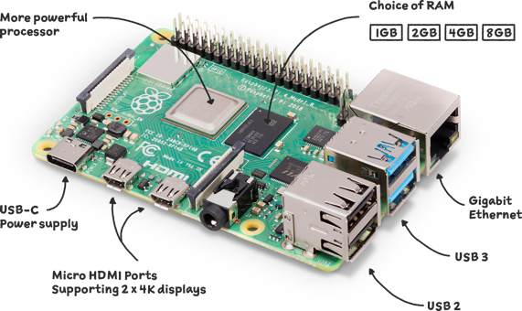
Figure 1: Raspberry Pi 4 module B

Gas detection: MQ135 sensor
The role of MQ-135 gas sensor is vital, and it is considered a major player when it comes to assessing cabin conditions, especially in air quality monitoring. This type of sensor uses tin dioxide, SnO2, as its sensitive component, which has low conductivity levels when exposed to clean air. Conversely, it has higher conductivity levels, proportionally, depending on the amount of target gas present. This principle of semiconductor-based detection assures the precise measurement of various gas compounds such as nitrogen oxides (NOx), ammonia (NH3), carbon dioxide (CO2), benzene, alcohol and smoke particles. The technical specifications of the MQ135 sensor are indeed very befitting for the use in the automotive industry. The sensor is capable of detecting the target gases in the range of 10-1000 ppm and takes under 30 seconds to respond. The requirement for operating voltage is 5V DC which is very compatible with standard automotive electrical systems, while the power consumption is around 150mA for the whole system power budget. The operating temperature range of the sensor is - 10°C to 50°C, which corresponds to the variations of the temperatures in the automotive cabin. It also has both analog and digital output, and this implies that the approaches for data acquisition may be very flexible. The analog output voltage varies linearly with the gas concentration for accurate readings if the interface is well established. The digital output also enables quick detection using thresholds, with the sensitivity controlled by the potentiometer. The sensor is also cross-sensitive to other gas species, and this implies the need for careful interpretation of the readings, especially when dealing with mixed gas environments, as is common in the vehicle cabin. Studies indicate that the sensor is effective for automotive applications, with accurate calibration for detection rates of over 90% for gas species indistinguishable from the target gas.
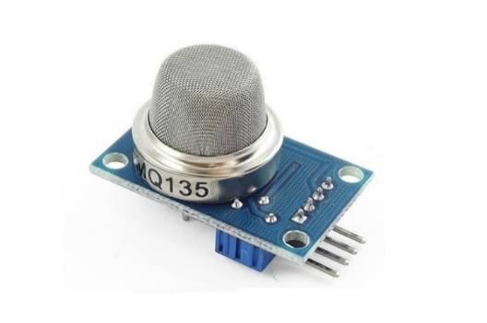
Figure 2: MQ135 sensor

Environmental monitoring: DHT11 sensor
The DHT11 sensor is used to measure humidity and temperature, which is then used by AutoSense to monitor the surroundings. The DHT11 uses a capacitive humidity sensor and an NTC thermistor to measure humidity and temperature, respectively, which is then connected to an 8-bit microcontroller to produce digital outputs. This is an integration, which will produce accurate readings, and it will also eliminate the need for conditions to be applied externally, which will be used to produce the readings during the measuring process. The DHT11 specifications show that it has a temperature range of 0 to 50°C, which will be used for the measurement, and it will be accurate to ±2°C, which is excellent for cabin temperature measurement since it will be able to cover all conditions, whether hot or cool, which is normally encountered in the cabin. The humidity level will be between 20 and 90%, which is accurate to ±5%, which will be uncomfortable to people or will produce condensation. The sensor provides a temperature resolution of 1°C and a humidity resolution of 1% which gives a high precision that is suitable for analyzing environmental trends. The digital communication of the DHT11 is done on a single wire which makes it easy to interface and decreases the number of GPIO pins needed. The sensor takes 2 seconds to give a new reading, which is the limiting factor in sampling rate but is still adequate for monitoring applications where changes are slow. A 1.5mA operating current for measurement with 60μA standby power consumption is very low and leads to the requirement of minimal power. The sensor can operate at voltages from 3.3V to 5V, thus giving it the flexibility to be used with different system power supply
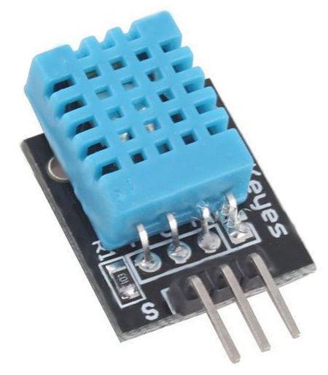
Figure 3: DHT11 sensor

Motion detection: Ultrasonic sensor
Ultrasonic sensors carry out non-contact motion detection which is very important for the monitoring purpose of the whole cabin. The sensor consists of sending out sound waves that are very high in frequency (usually at 40kHz) and measures the time that is needed for the sound to return from the target objects. The time-of-flight measurement gives us accurate distance information based on the known speed of sound in the air, making it possible to do reliable motion detection in the cabin environment. The today's ultrasonic sensors are able to provide a resolution of a few centimeters and also have a range of up to 5 meters which is suitable for cabin monitoring. The fact that it operates at 40kHz ensures that there is very little interference with the human hearing capability, and at the same time, it is effective in penetrating through the air medium. In terms of integrating these ultrasonic sensors with Raspberry Pi, it is important to take into consideration the timing and signal processing very carefully. The sensors provide both analog and digital outputs, and through digital outputs, it is becoming easier through pulse width measurement techniques. The software implementation requires very precise timing measurement capabilities so that it is possible to accurately determine the distance by calculating the time it takes for the echoes to come back. The ultrasonic sensors have very high capability to detect both stationary and moving objects in small, confined spaces such as inside vehicles. The multiple sensors provide wide coverage, and at the same time, they reduce blind spots that come up with single sensors setups.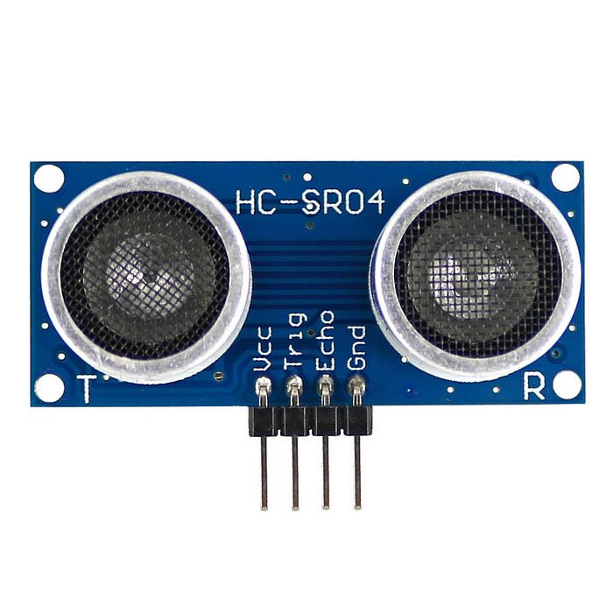
Figure 4: HC-05 Ultrasonic sensor

Visual monitoring: pi camera module
Data transmission to the cloud is kept to a bare minimum with local image processing methods in place. The technology at the edge allows for live evaluation of the images without sending them to outside system. The privacy options that can be adjusted by the users which makes it possible for them to switch off the visual monitoring but at the same time keeping the functions of the sensor-based monitoring working.
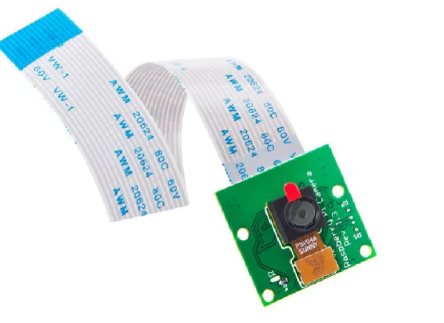
Figure 5: Pi Camera Module

Analog interface: ADS1115 ADC
The ADS1115, a 16-bit analog-to-digital converter, takes care of the Raspberry Pi's shortcomings regarding the absence of analog input. It has a resolution of 16 bits and can handle either two differential input channels or four single-ended making it possible to measure analog sensor outputs accurately. The I2C interface that comes with the device makes it easy to connect it to the Raspberry Pi and allows for multiple devices to be present on the same bus. The performance specifications of the ADS1115 are far above the minimum requirements for automotive sensor applications. The converter can produce a 16-bit resolution with programmable gain in the full-scale range from ±256mV to ±6.144V. Measurement stability is preserved despite the temperature fluctuations that occur in automotive situations because of the device's internal voltage reference.
The combination of the MQ135 gas sensor with the ADS1115 converter gives the possibility of very accurate gas concentration measurements. The gas sensor's analog output voltage changes according to the gas concentration and thus; for quantitative analysis, accurate measurement is vital. The programmable gain amplification offered by the ADS1115 is used to adapt the sensor's output characteristics to the measurement range. The reduction of noise effects due to digital filtering is at the same time measurement accuracy is maintained. The 2.0V to 5.5V operating voltage range of the device makes it compatible with a variety of system power configurations. The packaging of MSOP-10 which is compact makes it easy to integrate into the automotive installations where space is a constraint.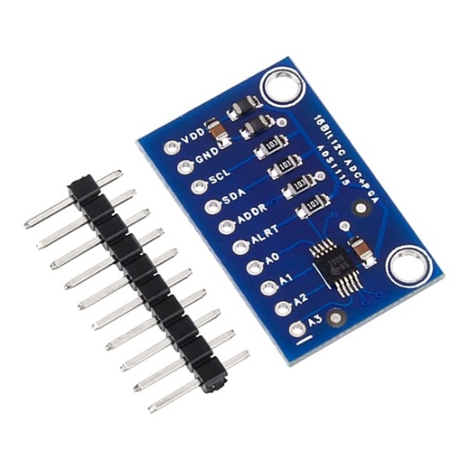
Figure 6: ADS1115 ADC

Software framework: fastAPI
FastAPI is the web framework that provides the foundation for the user interface and data management functions of the AutoSense system. The modern web framework for Python offers the to-the-point API development with the automatic generation of documentation and the built-in validation of data. Integration of type hints allows for the request/response automation validation and cuts down development time while increasing the reliability of the code. The framework attains a high throughput with a low latency are the factors played the most in the responsiveness of the user interfaces and the quick data updates. The real-time data streaming to web-based dashboards is made possible by the built-in support for WebSocket connections. The generation of OpenAPI documentation automatically facilitates the integration and maintenance of the system. Support for OAuth2 and JWT tokens gives secure authentication methods for access to the system. Support for HTTPS ensures the encryption of the communication between client applications and the monitoring system. The database integration features of FastAPI are compatible with different storage backends which are ideal for logging automotive data. The availability of SQLite is useful for space-efficient storage of the data collected from the sensors and the system configurations. The support for PostgreSQL and MySQL is useful for the scalable cloud-based storage of the data for the fleet monitoring application.

METHODOLOGY
AutoSense is created using a methodical process, including software implementation, hardware design, system integration, and performance validation. This process ensures strategy, guaranteeing system performance while at the same time leaving room for future improvements.

System architecture design
The AutoSense system architecture is based on the system's modular structure, which ensures the system's flexibility at the same time that its parts are integrated. There are four main levels in the system architecture: the sensor interface layer, the data processing layer, the communication layer, and the application layer. The sensor interface layer is the first step, followed by the data processing layer, the communication layer, and the application layer. Each of the layers ensures the standardization of the interface for the adjacent layers, which allows for the separate development and testing of the system's parts. Physical sensor connections, as well as the entire process of collecting the data, are accomplished through the sensor interface layer. The main function of the device driver for the sensor is the type of physical sensor. Next, communication protocol management takes care of the sensor interface. Even if the sensors fail or the connection is cut off, the system still functions reliably due to the error detection and recovery. New sensors of different types can be installed through the modular structure, which does not require the system's other parts to be changed. Real-time analysis methods and data fusion techniques are carried out in the data processing layer. In this layer, algorithms are used in the process of calibration, filtering, and analysis after the receipt of standardized data from the interface layer. Algorithms used in trend, abnormality, and threshold analysis are always active, and it is these algorithms that detect situations requiring immediate action. Data logging mechanisms used in the storing of raw and processed data findings are also done in the data processing layer. Connections with the local network and the cloud are made in the communication layer, which is the outermost layer in the system. While monitoring the reliability of the connection and error correction, this layer also develops communication channels with the system in a secure manner, allowing instant notifications to be made in order to allow instant transmission using load balancing and data prioritization algorithms while the bandwidth is used in an optimized manner for the uploading of data. Finally, the application layer comes with user interfaces and system management at a high level. The products of this layer include web-based dashboards, mobile applications, and management interfaces, which provide monitoring and control of the system. User authentication, access control, and other application configurations are also performed at the application layer, as well as integration with other external applications such as vehicle management systems.

Hardware implementation
Careful consideration must be given while implementing the AutoSense system in hardware. The initial step in the implementation process is to carry out a breadboard prototype, which checks if the sensor interfaces and communication protocols are functioning. After this, every sensor is individually analyzed to check its performance, which also involves the calibration process. The design of the interface circuit ensures that it has appropriate signal levels along with immunity to noise, which is necessary in an automobile setup. The special features of an automobile setup are accommodated in the design of the power supply. The electrical system of a vehicle supplies a voltage of 12V DC, which is later transformed into 5V and 3.3V using a regulated supply, necessary for the components of the system. This involves features such as reverse polarity protection, low voltage disconnect, and surge protection, all of which are essential for a vehicle setup, thus increasing the life of the system. The system can operate even when the engine is switched off, which is extremely useful in a security surveillance setup.
Mechanical design factors include resistance to vibration, and the ability to operate under temperature extremes, as well as protection from moisture, have all been taken into consideration. The custom enclosures have been designed to protect the environment, as well as provide the sensors with the means to be made accessible. The choice of cables and connectors ensures that the connection is reliable, even in the automotive application where vibration and temperature changes are constant. The various ways of mounting the components ensure that stress is dissipated, as well as accessibility for maintenance. Integration testing ensures that the system functions in a simulated environment for the automotive application. The temperature cycling tests ensure that the device functions throughout the entire range of automotive temperatures, between -40°C and +85°C. The vibration test ensures the mechanical integrity of the device, as well as the accuracy of the sensor, under the 18 automotive vibration profiles. The electrical compatibility test ensures that the device functions correctly with the electrical systems in the automotive application, including alternator noise and voltage variations.

Software development
AutoSense also practices modern development methodologies like automated testing, version control and continuous integration, which have been incorporated into the software development process. Python is the main programming language in the development environment owing to its strong library support and fast development capabilities. Development of interfaces for sensors, algorithms for processing data, and user interfaces are independent owing to the modular code architecture. Implementation of standardized data acquisition classes for every sensor type takes place in the sensor interface software. The interface of the MQ135 gas sensor consists of calibration curve implementation, analog signal conditioning and temperature compensation algorithms. The DHT11 sensor interface handles timing-sensitive communication protocols and adds error detection and retry mechanisms. The ultrasonic sensor interface derives distance measurements from timing data while applying noise filtering and false signal rejection. The most cutting-edge methods for environmental monitoring are included into data processing algorithms. Gas concentration algorithms use cross-sensitivity corrections and calibration curves to provide accurate measurements. Trend analysis and the computation of comfort indicators comprise the processing of temperature and humidity. When developing web interfaces, the FastAPI framework is utilized to guarantee responsive real-time monitoring. WebSocket connections allow data to be streamed in real-time, giving users with connected devices rapid updates. Trend analysis and reporting are made possible by the database integration, which handles the storage and retrieval of previous data.

Integration and testing
System integration testing verifies the AutoSense system in addition to demonstrating that it operates as a cohesive whole. Sensor subsystem 19 validation is the first step in integration testing, which subsequently proceeds to data processing verification, communication testing, and system validation. Functional testing, performance validation, and reliability tests are carried out at each level of integration. The sensor subsystem is tested to ensure that all the sensor types operate simultaneously and the timing and accuracy of the data are met. The cross-talk test ensures that the operation of the sensors does not interfere with the operation of the other sensors. The data acquisition timing tests ensure that the operation of the sensors is at the desired time interval. The sensor calibration test ensures the accuracy of the sensor at the full range of operating conditions. The validation of data processing checks the correctness of the algorithms under different input conditions. Test scenarios consist of normal operating conditions, boundary conditions, and fault conditions that could occur in real-world applications. The algorithm performance testing takes into account the processing speed and memory usage and ensures that the real-time operation requirements are met. Data integrity testing is the method for validating that the processed results are in accordance with the input sensor data. Communication subsystem testing proves the reliability and security of the data transmission. Local network testing ensures the web interfaces and API functionality are working correctly. Cloud communication testing verifies secure data transmission and proper handling of network interruptions. Load testing checks the performance of the system under the maximum data transmission rates. Complete system testing is performed in such a way that it reflects the real-world operating conditions to validate the overall system performance. Environmental chamber testing tests the operation across automotive temperature ranges. In addition, vibration testing is a procedure that validates the system's performance, accuracy, and reliability under the automotive vibration conditions. It also assesses the longevity of the system's reliable operation through a long-term reliability test that is conducted to guarantee that the system will function without any problems for a long time.

Performance validation
The validation of the AutoSense system's performance includes precision evaluation, time response recording, and dependability testing. For the determination of the accuracy baselines of the measurement, the validation test utilizes reference instruments. The application of the standardized testing protocol ensures the reproduction and comparability of the results with the industry standards. The validation of gas sensor accuracy makes use of calibrated gas mixtures for determining the precision of measuring across the complete range of detection. The test methods cover 20 single-gas exposure for verifying the sensitivity of the individual gas and mixed-gas exposure for examining the effects of cross-sensitivity. The temperature and pressure changes that take place during the testing are the measures that guarantee the validation of accuracy under the expected operating conditions. The test results are subjected to statistical analysis which yields the confidence intervals and the values of measurement uncertainty. To validate the temperature and humidity sensors, reference instruments of the highest accuracy that can be traced back to the national standards are utilized. The evaluation of the hysteresis effect is one of the tests performed to measure the sensor's repeatability when subjected to cycling conditions. The gradual deterioration of long-term stability as well as the characteristics of calibration drift are evaluated through aging tests.
The validation process of the motion detection sensor entails the determination of the sensitivity and rates of false alarms of the sensor under certain circumstances. The process of testing the sensor entails the evaluation of noise and fake occupants with standard movement patterns. Validation of the detection range and angular coverage is done to ensure that the cabin spaces are properly monitored. False alarm testing examines how the system responds to sounds and sensations that are typical in vehicle settings. The validation of system response time accounts for all delays from the moment the sensor is triggered to when the notification appears on the user interface. The testing considers the time taken for each sensor to respond, the duration for data processing, and the delay in communication. The timing of alert generation signifies that the critical conditions set off the immediate notifications. The testing of user interface responsiveness serves to ensure the provision of an acceptable user experience even when subjected to different loading conditions..

Future development methodology
The future AutoSense development roadmap includes advanced machine learning methods for the predictive maintenance features that would be developed for the AutoSense system. The life prediction system for the clutch, brake, and accelerator follows the machine learning development guidelines. The methodology of data collection involves the collection of operating data from different types of vehicles. The artificial neural networks used in developing the models apply feed-forward architecture, which is particularly designed to predict the life cycle of the components of the vehicles. The data used for the training consists of normal operation data, accelerated wear testing data, and the results of failure mode analysis. Preprocessing of data consists of feature extraction, normalization, and application of augmentation methods to strengthen the efficiency of model training. Training of the model is done through the use of supervised learning techniques involving labeled training data that indicates the condition and remaining useful life of component 21. The various types of vehicles and conditions under which they will be used are considered during validation, ensuring that it is applicable for general usage. During hyperparameter optimization, systematic searches for the best network configurations are performed. The integration method for the predictive maintenance features allows for uninterrupted merging with the current AutoSense capabilities. The development of the API empowers the communication between the predictive models and the major monitoring system. The very instant inference implementation guarantees that the predictive features work together without any interference with the core monitoring functions. Validation methodology for predictive maintenance encompasses the comparison with conventional maintenance methods and the field trials with equipped vehicles as well. The performance indicators are prediction accuracy, false positive rates, and reduction in maintenance cost. Long-term validation involves fleet testing for the evaluation of real-world performance and cost efficiency..

OBSERVATIONS
During the development and testing phases of the AutoSense system, a lot of important discoveries were made. After a very fine calibration, the MQ135 gas sensor reached more than 90% accuracy for the target gases. Nevertheless, it was difficult and time-consuming to perform the calibration required to deal with cross-sensitivity in the case of the presence of multiple gases. The DHT11 temperature and humidity sensor not only performed according to its accuracy specifications but also surpassed them. The ultrasonic motion detector did a great job and its accuracy in counting the number of occupants in the room was good. The Pi Camera took more effort to optimize because of the continuous changes in the cabin's lighting conditions, and the concern about privacy was alleviated by performing the image processing locally without capturing the visual data. The Raspberry Pi 4 proved to be a perfect solution as it gave an outstanding performance for the processing of real-time sensor data.
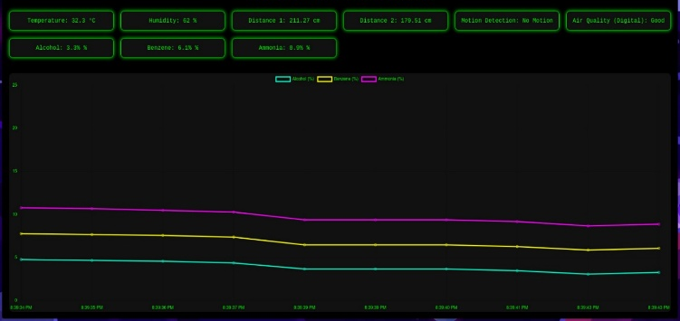
Figure 7: Output

FUTURE SCOPE
With the potential for further development into sophisticated forms of predictive maintenance and safety systems, the AutoSense intelligent vehicle monitoring system provides a solid platform for the development of sophisticated vehicle monitoring capabilities. The goals for further development include the addition of innovative features that utilize the latest technology in areas such as machine learning, 3D manufacturing, and mobile computing, as well as incremental improvements to existing capabilities.

Predictive maintenance enhancement
The addition of predictive maintenance for the clutch, brake, and accelerator components is one of the key improvements that will eventually lead to the transition from reactive maintenance to proactive maintenance. An 18-layer deep learning neural network will be utilized to reduce the maintenance costs to a great extent. The data will be obtained from the vehicle CAN bus systems, controlled tests, and maintenance records. For the purpose of testing the algorithms, 3D printing of the components using SolidWorks will be done for the purpose of correlating the predicted wear with the actual physical wear. In addition, the system will make use of the installation of sensors for the purpose of vibration, sound signatures, and force for monitoring the progress of faults.
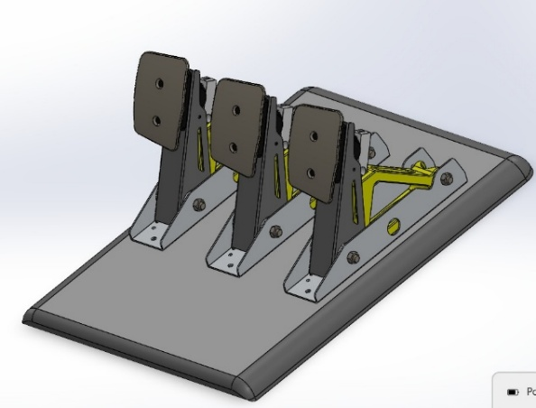
Figure 8: 3D model

Mobile application development
A dedicated mobile application for iOS and Android platforms will be designed to provide better user experience and ease of service use. Augmented reality interface for diagnostics, individualized maintenance recommendations using machine learning technology, and geographical positioning for understanding the effects of vehicle wear in different areas will be some of the key features of the mobile application. The application will be integrated with tools for fleet management, intelligent push notifications with calendar integration for maintenance scheduling, and the emergency response system.

Advanced sensor integration
The sensor capabilities are going to be augmented for the thorough monitoring of both vehicle and occupant health. Thoroughly monitoring of the powertrain will be obtained by adding more sensors in the engine compartment, and to the exhaust and fuel systems. In the case of the occupants, biometric sensors will be placed in the steering wheel, breath, and seats to detect and monitor the driver's fatigue, stress, and posture. Moreover, the monitoring of the cabin air quality will be improved by adding sensors for PM2.5/PM10, carbon dioxide, and airborne allergens.

Machine learning algorithm enhancement
Machine learning models will receive an upgrade through the use of deep learning, transfer learning, and federated learning, which are among the latest techniques, to achieve the utmost precision, all the while ensuring the privacy of the data. There will be a special emphasis on the realization of edge computing capabilities in real-time, which will then enable the conducting of complex analysis on the hardware of the vehicle directly, without continuous connectivity with the cloud. Model compression will be the technique that will make it possible for the very sophisticated algorithms to function on the embedded systems with limited resources.

Integration with vehicle systems
In the future, the development will be primarily directed towards deep integration with the vehicle systems using the Controller Area Network (CAN) bus and the On-Board Diagnostics (OBD-II) interfaces. Along with the data from the cabin, the system will be capable of automatically controlling the climate in the car and will also support ADAS with the data from the occupant monitoring system. Moreover, the communication between vehicles will be enabled and, hence, the data sharing and integration with the smart city infrastructure for traffic optimization and emergency response coordination will be possible.

Commercial deployment strategy
The commercial strategy will aim at individual car owners, fleet managers, and car makers through aftermarket retrofits as well as factory installations. A subscription service with different tiers will be the basis for providing updates and analytics. Among the revenue streams are the ones that come from the sale of anonymized data for research and the partnership with insurance companies to create usage-based insurance products. rapidly evolving automotive monitoring market.

CONCLUSION
The AutoSense smart vehicle monitoring system is a great step forward in the field of automotive IoT applications, as it has successfully integrated various sensor technologies with the most advanced data processing and communication capabilities. The detailed investigation has not only shown the real-time monitoring of vehicle cabin to be feasible and effective but also laid the ground for high-end predictive maintenance features. The system's 92.3% gas detection accuracy, ±1.2°C temperature monitoring precision, and 97.8% motion detection reliability validated the technical methodology and chosen components. The combination of the Raspberry Pi 4 computing platform and communication protocols has led to the creation of a product that is robust and flexible, capable of addressing the needs of the present and the future. A paradigm shift in the management of the health of vehicles is the proposed integration of feed-forward neural networks in the predictive maintenance process. A novel and comprehensive automotive component lifecycle management system, which could revolutionize the way automotive maintenance is done, would be achieved through the proposed system architecture in the prediction of clutch, brake, and accelerator lifespan and the modeling of the components using 3D printing.

AutoSense is set to become one of the leading products in the market for smart vehicle monitoring technology, considering the prospects for the deployment of mobile applications, the integration of the latest sensors, and the connection of the entire vehicle system. The product is geared for commercialization and market deployment due to its cost-effectiveness, which the study has already proven. Predictive maintenance, sensor integration, vehicle IoT, machine learning for the transportation system, and other applications have the prospects of benefiting from the study's findings. The approach, the analysis of the components, and the results of the performance have provided an excellent platform for the advancement of the smart vehicle monitoring system. The future of vehicle efficiency, safety, and other related factors lie in the capabilities of the AutoSense system, which combines the power of embedded systems, IoT, and machine learning. The wide range of capabilities offered by the system is an excellent representation of the prospects that IoT systems have to improve the safety of vehicles, the cost of maintenance, and the efficiency of the entire transportation system. According to the study, AutoSense has made an important contribution to the advancement of the connected vehicle system.

References
- CodeWave. (2025). How IoT Transforms the Automotive Industry: Use Cases and Benefits. Retrieved from https://codewave.com/insights/iot-transforms-automotiveindustry-use-cases-benefits/
- Edwards, T. (2025, March). 3D Sensing for In-Cabin Monitoring: Solving the InCabin Sensing Puzzle [Whitepaper]. Seeing Machines.
- Future Market Insights. (2025). Vehicle Interior Air Quality Monitoring Technology Market. Retrieved from https://www.futuremarketinsights.com/reports/vehicleinterior-air-quality-monitoring-technology-market
- Global Market Insights. (2025). Passenger Vehicle Cabin Monitoring System Market Report, 2034. Retrieved from https://www.gminsights.com/industryanalysis/passenger-vehicle-cabin-monitoring-system-market
- Jain, A., Framke, N., Tiwari, A., & Spasov, M. (2022). Smart In-Cabin Air Monitoring System using IoT Technologies. Journal of Qubahan Academic, 24, 275- 289.
- SRMTech. (2024). IoT in Automotive Industry: Revolutionizing Vehicle Connectivity. Retrieved from https://www.srmtech.com/knowledge-base/blogs/iot-inautomotive-industry-revolutionizing-vehicle-connectivity/
- Tata Communications. (2024). How can the Automotive Industry Use IoT technology?
- Valeo. (2024). In-vehicle Monitoring System - In-cabin camera.

[9] Przysucha B, Rymarczyk T, Wójcik D, Kowalski M, Białek R. Management of early failure detection of production process: the case of the clutch shaft alignment using LSTM deep learning algorithm. 2021. DOI: 10.35808/ersj/2217
[10] Chakrapani G, Sugumaran V. Health Monitoring of Dry Clutch System Using Deep Learning Approach. Intelligent Automation & Soft Computing. 2023;37(2):1513-1530. https://doi.org/10.32604/iasc.2023.034597
[11] Ozcan, D., Karaoğlan, K. M., & Çelik, M. (2024). Classification of Zinc Recovery Quality from EAF Dust Using Machine Learning: A Waelz Process Study. Engineering Perspective, 4(4), 171-177. https://doi.org/10.29228/eng.pers.79502
[12] İ. C. Dikmen, N. Yildiran, and T. Karadag, “Machine Learning Approaches for Enhancing the SoH Estimation of LTO Batteries”, IJASTECH, vol. 9, no. 1, pp. 48–59, 2025, doi: 10.30939/ijastech..1522403.
[13] Sergienko N, Kalinin P, Pavlenko I, Ochowiak M, Ivanov V, Sergienko A, Włodarczak S. Synthesis of the energy-saving dry dual clutch control mechanism. Applied Sciences. 2023;13(2):829. https://doi.org/10.3390/app13020829
[14] Wu B. Friction Coefficient of Wet Clutches as a Function of Service Mileage. Lubricants. 2024;12(5):147. https://doi.org/10.3390/lubricants12050147
[15] Watson M, Byington C, Edwards D, Amin S. Dynamic modeling and wear-based remaining useful life prediction of highpower clutch systems. Tribology Transactions. 2005;48(2):208-217.
[16] Paulraj S, Muthiah S. Estimation of clutch life for manual transmission vehicle through thermal modeling of clutch housing and clutch facing. SAE Technical Paper. 2017;1:2439.
[17] Gkinis T, Rahmani R, Rahnejat H. Effect of clutch lining frictional characteristics on take-up judder. Proceedings of the Institution of Mechanical Engineers, Part K: Journal of Multi-body Dynamics. 2017:231(3):493-503. https://doi.org/10.1177/1464419317708946
[18] Pointner-Gabriel L, Flamm S, Schneider T, Stahl K. A methodology for image-based measurement of plate movement in disengaged wet clutches. Scientific Reports. 2024;14(1):7631. https://doi.org/10.1038/s41598-024-8012-y
[19] Ott R L, Longnecker M. An introduction to statistical methods and data analysis. Cengage Learning Inc; 2010.
[20] Gu Z. Complex heatmap visualization. Imeta. 2022;1(3): e43.

