Smart Solar Panel Maintenance System for Sustainable Energy and Community Development

Vineet Bihani Department of Computing Technology
SRM Institute of Science and
Technology, Kattankulathur Tamil Nadu, India vb8917@srmist.edu.in
Samarth Agarwal Department of Computing Technology
SRM Institute of Science and
Technology, Kattankulathur Tamil Nadu, India sa0175@srmist.edu.in

Deepa R
Department of Computing Technology
SRM Institute of Science and
Technology, Kattankulathur Tamil Nadu, India deepar2@srmist.edu.in

Abstract— The objective of this project is to make solar energy installations more efficient, reliable and sustainable. This project is intended to show a smart system to maintain the solar panels. In spite of the endemization of the use of solar power as a clean and green energy source, some environmental factors such as dust deposition, temperature elevation, air pollution and physical damages have significant impacts on the performance of solar power. Regular monitoring and maintenance are also often overlooked or unperformed in many small scale and community based installations, leading to decreased energy production and reduced life span of the system. The proposed system includes several sensors to continuously monitor the operational status of the solar panel such as dust and air quality sensor, voltage, current, temperature, Arduino based control unit. Automated systems such as water sprayer and blower are triggered to restore the optimum performance in the case of anomalous conditions like overheating or excessive dusts etc. A python-based image processing module is also included to set up heavy soiling or cracks on the panel surface. Maintenance staff can receive real-time alert notifications thanks to GSM module. This is an automated and inexpensive solution that improves the energy efficiency, less energy intervention and also encourages sustainable power generation for community development.
Keywords— Smart Solar Panel Monitoring, Automated Maintenance System, Sustainable Energy Management.
- Introduction
The growing global demand for energy has created several environmental and economic problems. Accelerated industrialization and urbanization have increased the power consumption, while fossil-fuel production electricity has worsened greenhouse gas emissions and climate change. Thus, the need to adopt clean and sustainable sources of energy is growing. Solar energy is an outstanding potential renewable energy source because of its abundance, environmental sustainability, and applicability for large solar power plants as well as small-scale rooftop installations

and It plays an important part in providing essential services, such as healthcare, education, and communication in developing regions. As a result, governments and businesses are increasingly allocating resources to use solar energy in order to reduce carbon emissions and energy autonomy.
Nonetheless there is a challenge to maintain solar panel efficiency. Environmental variables such as dust collection, pollution, avian excrement and high temperatures can significantly reduce performance. A simple layer of dust is enough to block out the sun and reduce energy output, while overheating and physical damage (such as cracks) can cause long-term system degradation.
In many installations, of the scale typically made, the maintenance carried out is done manually and intermittently, causing malfunctions to go unnoticed and energy is lost. Automated monitoring solutions, although existing, are often expensive and developed for large scale solar farms.
The Smart Solar Panel Maintenance System eliminates these problems by using sensors, automation, and communication technology that monitor the states of the panels and provide alarms when there are problems with the panels. This type of methodology encourages maintenance efficiency, reduces manual labour and enhances the reliability of solar power systems.

- Related Work
Recent research in the field of renewable energy systems focus on the need for efficient monitoring and maintenance of renewable energy systems to guarantee the efficient performance of the systems in question [1], [2]. Researchers have identified that environmental factors such as dust deposition, temperature variance, humidity and pollution has a significant effect on the efficiency of solar panels [3], [17]. Several experimental studies show that accumulated dust reduces the output power, in particular in dry and polluted zones [3], [18]. As a result, researchers have been interested in developing automated cleaning and monitoring mechanisms to keep consistent energy generation [17], [18].Earlier systems were mainly based on manual inspection methods, where periodically technicians checked the conditions of panels as well as cleaning them if necessary [1]. While an easy approach, this practice results in a delay in fault detection and erratic

maintenance. To overcome these limitations some studies brought sensor based monitoring techniques like measuring of parameters such as voltage, current, and temperature [ 5], [ 6], [ 13]. These systems are used to provide real-time performance data to the user so they can detect efficiency drops quickly. However, there are many solutions which only involve da ta observation without integrating automatic corrective actions [7].
Existing advanced research has suggested the research platforms for the Internet of Things based solar monitoring, in which sensor data can be transferred to the cloud servers for remote analysis [12], [13]. These systems enable the users to have access to performance reports via mobile or web applications. Although effective, such solutions require a stable connection to the internet and have a more costly implementation resulting in them being less suitable for small-scale or rural applications [13]. Automated robotic cleaning mechanisms have also been investigated for large solar farms but such systems are often complex and costly [18].
Recent developments emphasize the use of image processing techniques on fault detection such as crack detection and analysis of heavy soils [14], [16]. The useful techniques of machine learning have provided encouraging outcomes in the detection of surface defects with high accuracy in controlled environments [14], [15]. However, combining these technologies in a low cost and community-based solution is one of the challenges [16], [17].
Based on the reviewed literature, there is a need for a cost-effective, sensor integrated and automated solar panel maintenance system comprising monitoring, fault detection and corrective action in one framework [12], [13].
Goals of the Research (EPIC Alignment)
The following EPICs outline the key research goals of the framework:

EPIC 1: Acquisition of Multi-Sensor Data
Combine electrical and environmental sensors to continuously monitor the health of solar panels.

EPIC 2: Defect Detection Driven by AI
Create a computer vision model to detect soiling and surface fissures on solar panels.

EPIC 3: Instantaneous Notification and Interaction
Use GSM-based SMS alerts to receive immediate notifications of anomalies.

EPIC 4: Decision Support and Interactive Visualization
Create a web dashboard with detection overlays, historical trends, and real-time telemetry.

EPIC 5: Automation Architecture Ready for the Future
Create a modular architecture to facilitate the integration of automated cleaning systems in the future.
- Existing System
Traditional solar panel installations normally rely on human inspection and periodic assessment for maintenance and monitoring. Technicians do visual inspections of the panels for dust accumulator, fracture, overheating, or even electrical malfunctions. Preventive methods including thermographic drone inspection for hot spot identification as well as IV curve testing for electrical performance evaluation regularly used in

operational solar facility Nonetheless, these tactics are less practical for smaller installations because of the need for specialized equipment and workers.
Electrical parameters such as voltage and current tend to be
measured only when there are expected to be performance anomalies. This approach is based, to a large extent, on planned inspections and human involvement beyond continuous monitoring. According to research, the high deposition of dust can reduce the efficiency of solar panels by 30-40%, with highest levels of dust covering solar panels by 86% power reduction. Notwithstanding these potential losses, typical monitoring is regularly passé in lots of setups.
Small scale and community-based systems may be suffering from inconsistent maintenance due to financial constraints and lack of technical help may become a reality. Investigations into IoT-enabled solar systems within tribal communities in India 's Sathyamangalam Forest region indicate that some of the problems are lengthy time to identify defects, limited monitoring capabilities and inadequate proficiency of maintenance. As a result, there are faults that may go unnoticed for a long period, which ultimately reduces energy production.
Many current modest installations do not also offer automatic cleaning
systems & real-time monitoring sensors. Despite the low cost-effectiveness of IoT-based solutions using the platforms such as ThingSpeak and ESP32 for remote monitoring, their implementation in community systems is limited. Likewise, Raspberry Pi-based monitoring systems which are able to measure voltage, current, temperature and humidity rema in neglected in rural solar installations.
The possibilities of machine learning and simulated sensor data for economic predictive maintenance are shown by recent experimental frameworks, like SolarSentinel, an AI-based decentralized monitoring system for rural Africa. Nonetheless, such solutions generally exist in the prototype phase and they have not been supported by empirical field data.
Limitations:
  - Simple design and easy implementation
  - Low initial setup cost
  - No complex hardware or software requirements
  - Minimal technical expertise needed for operation
  - Suitable for very small-scale installations

- Proposed System
The proposed Smart Solar Panel Maintenance System (SolarGuard) introduces an automated and intelligent approach to monitoring and maintaining solar installations, with a central focus on AI-powered visual inspection and multi-sensor data fusion. The system architecture integrates a microcontroller-based control unit with a dedicated computer vision module for real-time surface defect detection.

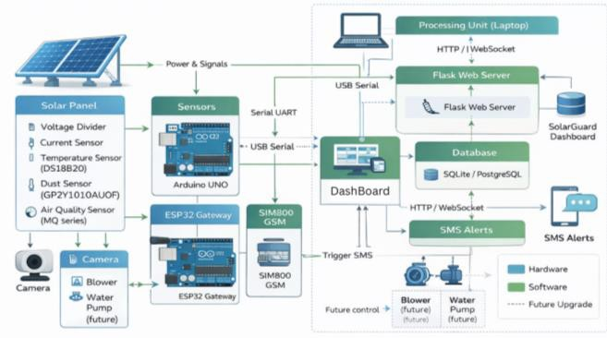

Figure 1: SolarGuard System Architecture
  - AI-Powered Vision Module
The main innovation introduced in the proposed system is the introduction of the YOLO based computer vision module for automated flaw identification. A camera located in front of the solar panel periodically collects photographs of the surface of the panel. The photos are analysed using the YOLO (You Only Look Once) object identification framework with the YOLO11m model, trained on a custom dataset to identify two types of defects - excessive soiling and cracks.
The YOLO model provides evaluation of each picture in real-time, such as drawing bounding boxes for identified faults and assigning confidence scores of these bounding boxes that is categorized as crack fault or soiled fault while encouraging optimized inference speed to be near real-time.
Upon the discovery of a problem, in excess of established criteria of confidence, two sets of actions are taken in parallel. The result of the detection or detection results in the form of bounding boxes and confidence scores is stored in the system database. A serial command in the computer is simultaneously sent to the microcontroller to start the alert and response sequence.

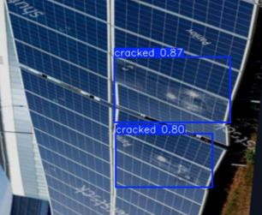
Figure 2: Yolo Detection
  - Hardware Integration and Sensor Suite
Solar Sentinel the AI vision module, the system integrates multiple sensors for comprehensive panel monitoring

Table I
Hardware Components and Specifications

The Arduino Uno, which acts as the main data acquisition controller, receives sensor inputs and YOLO detection commands via serial communication after all sensor data is gathered at regular intervals. Predefined thresholds for temperature, dust concentration, voltage, and current parameters are used by the system to coordinate responses.
Microcontroll er | Arduino UNO | Data  acquisition  and control | Digital / Analog  I/O
Communicati on Module | ESP32 | Data forwarding and GSM  control | UART /  Serial
GSM Module | SIM800 | SMS alert transmission | UART
Temperature Sensor | DS18B20 | Panel surface  temperature monitoring | 1-Wire
Current Sensor | ACS712 | Electrical current  measuremen t | Analog
Voltage Sensor | Voltage Divider | Panel voltage  measuremen t | Analog
Dust Sensor | GP2Y1010AU 0F | Particulate detection | Analog  +  Digital
Air Quality Sensor | MQ Series | Environment  al pollution monitoring | Analog
Camera | USB /  Webcam | Image capture for  defect  detection | USB

  - Data Flow and Processing Architecture
The system follows a structured dual-path data flow:
Path 1 - Sensor Data: Environmental and electrical sensors → Arduino Uno → ESP32 → Processing Unit → Database → Dashboard.
Path 2 - Vision Data: Camera → YOLO11m inference → Detection results → Serial command → Arduino → Response triggering.
Table II
Database Schema for Sensor and Detection Data
Table | Fields | Description
SensorReading | id, timestamp, temp, volt, current, dust,  airquality,  airqualitystatus, blowercount,  liquidcount, smscount | Environmental and electrical measurements

Component | Model | Function | Interfac  e

DetectionEvent | id, timestamp, class, confidence,  image_path | YOLO  detection  results
AlertLog | id, timestamp, type,  recipient, message, status | SMS alert records
User | id, username,  password_hash, role, created_at | User  authentication data

  - Alerting and Response Mechanism
The system triggers the alerting mechanism on the detection of anomalies with sensor thresholds or using Yolo based defect identification. Maintenance personnel get immediate SMS messages from either a GSM module (SIM800) wired to the ESP32 that contain the problem's details and the panel's location. For the purpose of tracking and analysis, the system maintains counters for each alert.
The architecture includes automated centres of cleaning mechanism for future scalability. Two pump motors (to turn on cooling water sprayers and as a blower to remove dust) designed to be controlled by using a dual-channel relay module. And once these motors are implemented, they can be activated depending on detection thresholds.
  - Web Dashboard and Visualization
As seen in Figures 4, all system data is displayed via a Flask-based web dashboard that includes:
    - Real-time updates from live sensor tiles.
    - Bounding box-displaying camera feed with YOLO detection overlays.
    - Trend graphs showing the history of recent sensors.
    - Summary statistics displayed in a metrics panel.
    - Time-stamped detection event logs with confidence ratings.

Figure 4.a: The SolarGuard web dashboard.
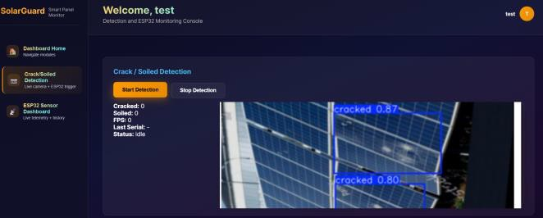
Figure 4.b: The SolarGuard camera feed with detection overlay.
  - System Advantages
The proposed SolarGuard system offers several key advantages:
    - AI-First Approach: YOLO-based vision enables automated, accurate defect detection
    - Real-Time Monitoring: Continuous sensor data
collection for immediate performance insights
    - Early Fault Detection: Proactive identification of defects before significant efficiency loss
    - Automated Alerting: Instant GSM notifications for
timely maintenance response
    - Reduced Manual Effort: Minimizes need for periodic visual inspections
    - Low-Cost Design: Affordable components suitable for
community and rural deployment
    - Future-Ready Architecture: Modular design supports automated cleaning system integration
To provide automated solar panel maintenance, this integrated system combines AI-powered visual inspection with extensive sensor-based monitoring. This ultimately improves energy efficiency, decreases downtime, and encourages sustainable power generation for community-based installations.
- RESULT AND ANAYSIS

The thorough assessment of the SolarGuard system is presented in this section, along with information on sensor data acquisition performance, YOLO-based defect detection accuracy, end-to-end system validation, and system limitation analysis. A working solar panel setup in a real-world setting was used to test the system.
- Experimental Setup
Table III
SolarGuard prototype Test Configuration
Parameter | Specification
Solar Panel | 12V, 20W polycrystalline
Microcontroller | Arduino UNO (ATmega 328P)
Communication  Module | ESP32
GSM Module | SIM800
Sensors | DS18B20, ACS712, voltage divider, GP2Y1010AU0F, MQ-135
Camera | 720p USB webcam
Processing Unit | Laptop (Intel i5, 16GB RAM, NVIDIA  Tesla T4 via cloud)
Sampling  Interval | 2 seconds
Test Duration | 72 hours continuous
Environmental  Conditions | Outdoor, temperature range 28°C–42°C,  variable dust exposure

The system was configured with the following threshold values for anomaly detection:
  - Temperature threshold: 50°C
  - Dust threshold: 100 µg/m³

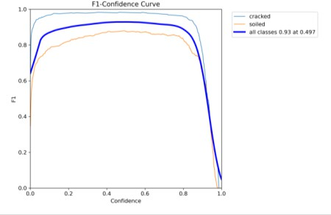
  - Voltage drop threshold: 15% below nominal
  - Current drop threshold: 15% below expected
  - Crack detection confidence threshold: 80%
  - Soiling detection confidence threshold: 75%
- Sensor Data Acquisition Results
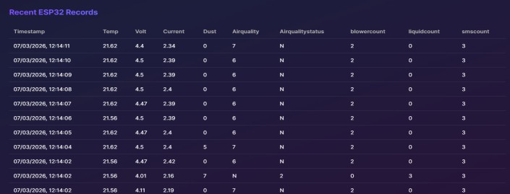
The system successfully collected and logged sensor data at 2 - second intervals throughout the test duration.

Figure 5: The SolarGuard sensor data.
Analysis of Sensor Data:
- Thermal Stability: The DS18B20 sensor registered a constant temperature of around 32.13°C, signifying consistent environmental conditions and accurate calibration.
- Voltage Fluctuations: Voltage oscillated between 2.05V and 3.47V as a result of alterations in solar irradiation and load circumstances, demonstrating the sensor’s capacity to detect real-time output variations.
- Present Measurement: The ACS712 sensor registered
2.49A under load conditions and 0A at idle, hence validating precise current measurement.
- Environmental Monitoring: Dust levels varied from 0 –5 and air quality from 0–13, with the system consistently indicating Normal (N) environmental conditions.
- System Counters: Cleaning mechanisms were not engaged (liquid and blower counts = 0), whereas one SMS notification was successfully generated during testing.
- YOLO MODEL PERFORMANCE
Figure 6: Precision-Recall curves for crack and soil detection classes.
Feature | Manual Inspecti on [1] | IoT Monitori ng [12] | Roboti c Cleani ng [18] | SolarGua rd (Propose d)
Real-time  Monitorin g | No | Yes | Yes | Yes
Automate d Defect Detection | No | No | Limited | Yes (YOLO, 93.9%  mAP50)
Crack  Detection | Visual  only | No | No | 99.4%  accuracy
Soiling  Detection | Visual  only | No | Limited | 88.3%  accuracy
GSM  Alerts | No | Optional | No | Yes
Automate d  Cleaning | No | No | Yes | Future upgrade
Hardware  Cost | Low | Medium | Very  High | Low (<  ₹4000)
Internet Dependen  cy | No | Yes | No | Minimal (SMS  fallback)

Analysis of Detection Performance:
Crack Detection: With 99.4% mAP50, 0.996 precision, and 0.969 recall, the model demonstrated extremely dependable crack identification with few false positives. Soiling Detection: With 0.896 precision and 0.861 recall, the model's mAP50 was 88.3%. Variability in the distribution, density, and patterns of dust on panel surfaces account for the somewhat reduced accuracy. Overall Performance: The YOLO11m model is highly effective at detecting solar panel defects, as evidenced by the combined mAP50 of 93.9%. Its inference speed of approximately 24.3 ms per image allows for near real-time monitoring. Error Analysis: While very thin dust layers with insufficient visual contrast were the primary cause of false negatives, some false positives were caused by shadows or reflections.
Table V
Comparative Analysis with Existing Systems

The YOLO11m object detection model was evaluated on a validation dataset of 349 images containing 453 annotated defect instances.
Table IV
YOLO11m Detection Performance on Validation Set
Class | Imag  es | Instan  ces | Precisi  on | Rec  all | mAP  50 | mAP  50-95
Crack  ed | 192 | 233 | 0.996 | 0.96  9 | 0.994 | 0.881
Soile d | 175 | 220 | 0.896 | 0.86  1 | 0.883 | 0.744
Overa  ll | 349 | 453 | 0.946 | 0.91  5 | 0.939 | 0.812

Suitable for Rural  Areas | Yes | Limited | No | Yes

- Limitations and Future Improvements
Accuracy of Soiling Detection The model achieved a low accuracy of 88.3%, which is lower than crack detection, mainly attributed to the limited range of dataset and variable soiling patterns. Subsequent efforts will supplement the dataset with photos taken in the different environmental circumstances.
Automated Sanitation: Even though it contains blower and
Water sprayer components in the system architecture, automatic cleaning is just not yet realised. Subsequent versions will include and certify the cleaning module. Reliance on GSM: The alert system relies on GSM connectivity, hence, there may be delay in receiving SMS notification in places with low cellular reception. Future designs may have Wi-Fi or LoRa to decrease reliability. Camera Positioning: YOLO paradigm-based detection requires the surface of the panel to be viewed without any obstructions, and if the positioning of the camera is limited it can affect the accuracy. The future version may use several cameras or drone inspections. Scalability and Extended Testing Falting conducted testing on the prototype with single panel configuration for 72 hours. Future research will evaluate multi-panel systems and long term performance to evaluate sensor drift and system reliability.
- Acknowledgment
The authors acknowledge the guidance of Dr. Deepa R, Assistant Professor, School of Computing Technologies, SRM Institute of Science and Technology.
- References
- B. Parida, S. Iniyan, and R. Goic, “A review of solar photovoltaic technologies,” Renewable and Sustainable Energy Reviews, vol. 15, pp. 1625–1636, 2011.
- A. Mellit and S. A. Kalogirou, “Artificial intelligence techniques for photovoltaic applications,” Progress in Energy and Combustion Science, vol. 34, 2008.
- A. Sayyah, M. N. Horenstein, and M. K. Mazumder, “Energy yield loss caused by dust deposition,” Solar Energy, vol. 107, 2014.
- Y. Tripanagnostopoulos, “Aspects and improvements of hybrid photovoltaic/thermal systems,” Solar Energy, vol. 81, 2007.
- D. Sera, R. Teodorescu, and P. Rodriguez, “PV panel model based on datasheet values,” IEEE Transactions on Industrial Electronics, 2007.
- M. Benghanem, “Measurement of meteorological data for solar installations,” Renewable Energy, 2011.
- S. Silvestre et al., “Fault detection in photovoltaic systems,”
Solar Energy, 2013.[8] K. Branker, M. J. M. Pathak, and J. M.
Pearce, “Review of solar photovoltaic levelized cost,”
Renewable and Sustainable Energy Reviews, 2011.
- International Energy Agency (IEA), Trends in Photovolta ic Applications, IEA Report, 2022.
- M. G. Villalva, J. R. Gazoli, and E. R. Filho, "Comprehensive Approach to Modeling and Simulation of Photovoltaic Arrays," IEEE Transactions on Power Electronics, vol. 24, no. 5, pp. 1198-1208, May 2009. doi: 10.1109/TPEL.2009.2013862.
- X. Li, F. Wagner, and W. Peng, "Quantifying the global impact of soiling and aerosols on photovoltaic power generation," Nature Energy, vol. 5, pp. 749–758, 2020. doi: 10.1038/s41560-020-0661-7.
- A. Mellit and S. Di Gangi, "IoT-enabled solar PV systems: real-time monitoring and efficiency optimization," Results in Optics, vol. 22, Jan. 2026, Art. no. 100949. doi: 10.1016/j.rio.2025.100949.
- S. S. S. R. K. Varma et al., "Smart monitoring of photovoltaic energy systems: An IoT-based prototype approach," Scientific African, vol. 30, Dec. 2025, Art. no. e02973. doi: 10.1016/j.sciaf.2025.e02973.
- H. Gao, S. Fan, M. He, Y. Wang, and W. Hong, "CrackNet: A transformer-based approach for detecting microcrack in photovoltaic panels based on electroluminescence images," Renewable Energy, vol. 256, Jan. 2026, Art. no. 124549. doi: 10.1016/j.renene.2025.124549.
- M. M. Rahman et al., "Effectiveness of supervised
machine learning models for electrical fault detection in solar PV systems," Scientific Reports, vol. 15, Art. no. 34919, Oct. 2025. doi: 10.1038/s41598-025-18802-4.
- S. K. Das and A. Gupta, "ResNet-based image processing approach for precise detection of cracks in photovoltaic panels," Journal of Engineering Research, 2025. [Online]. Available: DOAJ.
- M. S. Hossain and T. T. Lie, "Impact of Dust Deposition on Photovoltaic Systems and Mitigation Strategies," Technologies, vol. 14, no. 1, p. 15, Dec. 2025. doi: 10.3390/technologies14010015.
- B. Rangaswamy and R. Nithya, "Advancements in solar panel maintenance: a review of IoT-integrated automatic dust cleaning systems," Informatyka, Automatyka, Pomiary w Gospodarce i Ochronie Środowiska, vol. 15, no. 1, pp. 39 –44, Mar. 2025. doi: 10.35784/iapgos.6614.
- Y. Li et al., "Experimental investigation on the condensation characteristics and self-cleaning law of hydrophilic/super-hydrophilic dusty surfaces of bifacial photovoltaic panels," Renewable Energy, vol. 251, Oct. 2025, Art. no. 123414. doi: 10.1016/j.renene.2025.123414.
- J. A. Duffie and W. A. Beckman, Solar Engineering of Thermal Processes, Wiley, 2013.

