Automated Resume Screening Using NLP: Evaluating Fairness and Mitigating Bias.

Bedant Singhania
dept of CSE(Hons in Big Data Analytics)
Chandigarh University
Mohali, Punjab
bedantsinghania186@gmail.com
Javed Akhtar
dept of CSE(Hons in Big Data Analytics)
Chandigarh University
Mohali, Punjab
javedakhtar2665@gmail.com
Yeshika
dept of CSE(Hons in Big Data Analytics)
Chandigarh University
Mohali, Punjab
yeshikagola139@gmail.com
Manshvi Sharma
dept of CSE(Hons in Big Data Analytics)
Chandigarh University
Mohali, Punjab
manshvi.sharma@outlook.com

Gaurav Sharma
dept of CSE(Hons in Big Data Analytics)
Chandigarh University
Mohali, Punjab
gauravsharma910415344@gmail.com

Abstract—As the number of software engineering job applications grows exponentially, automated tools are getting more and more popular with organizations seeking to manage candidate pipelines at scale. Although Natural Language Processing (NLP) has given these tools more ability than the rule-based predecessors, both the complexity that makes them useful also causes them to be vulnerable to reproducing historical inequalities that are contained in the training dataset. The article presents a user-friendly dual-track NLP screening system involving classical feature engineering, i.e. TF-IDF SVM, Logistic Regression, and random forest. Machine classifiers, along with trained transformer models. (BERT and RoBERTa) to assess the suitability of candidates in software engineering roles. We put together a synthetic corpus of 1,200 annotated resumes with controlled and reproducible demographic variation by gender, age, race/ethnicity, and candidate names to explore the issue of fairness. There are three complementary metrics to measure equity; Disparate Impact Ratio (DIR), Demographic Parity Difference (DPD) and Equalizing Odds Difference (EOD).. With our RoBERTa model, classification accuracy reaches 93.2% with DIR values reaching 0.68 in the case of race/ethnicity before we perform any corrective measures. Then we implement and compare three methods of data debiasing, sample re-weighting, adversarial debiasing, and counterfactual data augmentation, showing that post-mitigation values of DIR can be boosted above 0.87 across all bias dimensions considered. The paper contextualizes these results in the wider context of AI governance using EU AI Act, EEOC guidelines, and Indian changing data protection frameworks.
Keywords— Natural Language Processing; Resume Screening; Bias Detection; Disparate Impact; BERT; TF-IDF; Adversarial Debiasing; Ethical AI.

Introduction
Large technology firms are getting hundreds of thousands of software engineering applications each year, a volume that is impractical to review manually. Automation of the screening tools has become a business need and the NLP-based systems are a new edge of this field. But as convenient as these systems are, there is an unseen cost that they are likely to encode and amplify prejudice in historical hiring information, producing discriminatory results at the scale and pace unattainable by human researchers [1].
The types of bias that take place here are many. The issue of gender bias can be seen through the linguistic cues that relate to gender between textual elements (e.g. gendered pronouns or words in the description of activities) altering the likelihood of shortlisting, but this time not depending on technical competence. The reason why there is name-based bias is that due to the possibility given by models of learning to infer cultural name patterns into ethnicity or national origin, using names is an illegitimate shortcut used by models to evaluate a candidate. There is a signal of age through graduation years and through working tenure. Even in the absence of explicit demographic fields on resumes, race and ethnicity may be determined indirectly by a web of correlated proxy factors [4][5].
These matters have practical implications. When job seekers belong to an under-represented group, their applications can be systematically placed further back in the queue as the first hiring step, a bottleneck that can determine the career trajectories before a human hiring officer has ever heard their name. To make the matter even more urgent, the regulators on several continents start to make tangible demands: the EU AI Act, and even the new AI regulation models in India start to provide expectations that automated recruiters will comply with non-discrimination rules [16].

Contributions
The following contributions can be made by this paper:
1) We design a hybrid NLP screening pipeline combining TF-IDF-based classical classifiers with fine-tuned BERT and RoBERTa transformer models for software engineering candidate assessment, reaching 93.2% classification accuracy on our synthetic benchmark.
2) We construct and release a synthetic dataset of 1,200 labeled resumes with controlled demographic diversity across four protected attribute dimensions, providing a reproducible fairness evaluation testbed.
3) We quantify bias across gender, race/ethnicity, age, and name dimensions using DIR, DPD, and EOD, exposing DIR values as low as 0.68 in unmitigated models—well below the EEOC’s four-fifths threshold.
4) We implement and benchmark three mitigation strategies—sample re-weighting, adversarial debiasing, and counterfactual data augmentation—achieving post-mitigation DIR values that consistently exceed 0.87.
5) We examine the ethical and regulatory dimensions of deploying such systems, situating our findings within global AI governance frameworks.
The continuation of the paper is the following. Section II has surveys of related work. The construction of the dataset is outlined in Section III. NLP methodology is presented in Section IV. Outcome of bias analysis are given in Section V as a pre-mitigation result. Section VI reports performance in classification. Part VII considers mitigation programs. Ethical implications are dealt with in Section VIII. Section IX is the conclusion.

RELATED WORK

Prejudice with Regard to Automated Recruitment
The issue received significant media attention when it was published that a commercial AI recruiting system developed by a large technology company replicated the gender bias of its training data, in a systematic way that docked out the resumes that included signals of female identity. Such a case made a case study to later studies. Expanding on it, Raghavan et al. [2] did a systematic audit of commercial hiring sites and discovered that fairness cannot be effectively optimized by solely targeting prediction accuracy in the absence of explicit fairness constraints, a fact which invalidated the common belief at the time that superior models would automatically be fairer models.
Resume parsing has been the subject of considerable attention in the NLP literature. Maheshwary and Misra [3] showed that Named Entity Recognition was able to pick candidate skills and qualifications with an approximation of 87 percent accuracy taking traditional pipeline techniques. In subsequent research, it was found that fine-tuned transformer models significantly outperform these classical models on resume understanding tasks, and BERT-family architectures are the standard in candidate information extraction today.

Fairness in Machine Learning
Algorithms equity concepts have migrationally developed over the last ten years. Dwork et al. [6] conjectured that fairness involves using similar individuals in a like manner, which is formalizing the concept of individual fairness. Hardt et al. [7] adopted an approach on a group level and proposed a post-processing criterion of evened odds, that limits the true and demographic false positive rates. This was complicated further when Chouldechova [8] claimed an impossibility result that many of the commonly used fairness criteria are mutually incompatible, so any use needs careful, context-sensitive metric choice. Feldman et al. [9] have made the picture full, having officially linked the concept of disparate impact doctrine in employment law to machine learning practice.
On the representation level, Bolukbasi et al. [4] demonstrated that gender stereotypes are represented through word embedding spaces with a geometrical structure, and that these stereotypes spread to any downstream task that involves word embedding space. Caliskan et al. [5] further extended this analysis to show that models trained on large corpora replicate human biases based on gender, race, and age dimensions. Their results have a direct implication on transformer-based resume screening: since BERT and RoBERTa are trained on text at a web scale, they immediately carry with them the societal biases internalized within the written record of the internet before any fine-tuning is done.

Bias Mitigation
The mitigation strategies are divided into three categories. Pre-processing techniques are applied to training data prior to a model being constructed. Kamiran and Calders [10] proposed re-weighting and resampling as a lightweight intervention, which does not reshape the model structure but equalizes the demographic representation. The methods of in-processing alter the goal of learning. Zhang et al. [11] provides a method, in which an adversary network is calibrated to infer the demographic attributes using the internal representation of the classifier, compelling the classifier to create representations resistant to demographic inference. Zafar et al. [12] proposed idea of incorporating impartiality into the loss of the model as a strong covariance condition. The third method is counterfactual data augmentation, where synthetic training pairs are delineated by replacing the references of the protected attribute to induce the model to make consistent predictions without these replacements.

DATASET CONSTRUCTION

Generating Data Synthetically
Researchers have very little access to large-scale real-world resume datasets and the ones available do not have demographic metadata that researchers can use to evaluate systematic fairness. We constructed a designed synthetic corpus of 1,200 resumes of software engineering candidates. The automation pipeline paired Python with original domain templates based on realistic software engineering career trends, both junior and senior, and spanning popular technology stacks (Python, Java, React, AWS, Docker, and Kubernetes).
Every produced resume has five standard fields: professional summary, skill set, work experience listing with company and job responsibility story, education history including name of school and year of graduation, and project/certification list. The names of the candidates were sampled based on demographic databases stratified by their cultural origin so it was possible to test the bias of names alone without considering any other information in the resume.

Labelling Methodology
Ground-truth shortlisted labels were generated using a weighted composite score that weighed all the protected attributes purposefully. These five items with respective weights were: relevant years of experience (0.30), score of skill match in connection with a reference software engineering job description (0.35), educational institution tier (0.15), rated project complexity (0.12), and certification relevancy (0.08). A composite score of 40th percentile and above was considered shortlisted, which provided 480 successful cases among 1,200. Table I gives a complete explanation of the composition of the dataset.
Table I. Synthetic Dataset Statistics
Category | Count | %
Total Resumes | 1,200 | 100%
Shortlisted | 480 | 40%
Not Shortlisted | 720 | 60%
Male Candidates | 600 | 50%
Female Candidates | 480 | 40%
Non-Binary | 120 | 10%
Age 22–30 | 420 | 35%
Age 31–40 | 480 | 40%
Age 41–55 | 300 | 25%
Western Names | 600 | 50%
South Asian Names | 360 | 30%
East Asian Names | 240 | 20%

Preprocessing pipeline
A common NLP preprocessing chain was used to clean all resume texts. We tokenized input with the en_core_web_sm model of spaCy to remove stopwords, lemmatize inputs, and normalize special characters. A Named Entity Recognition pass was then used to extract the candidate name, reference to educational institutions and mentions of companies, generating structured fields for use in downstream demographic probing. It is implemented as shown below:

import spacy
import pandas as pd

nlp = spacy.load('en_core_web_sm')

def preprocess_resume(textual content):
doc = nlp(text.lower())
tokens = [t.lemma_ for t in doc
if not t.is_stop and
not t.is_punct and t.is_alpha]
return ' '.join(tokens)

def extract_entities(textual content):
doc = nlp(textual content)
return {e.label_: e.text
for e in doc.ents}

df['processed'] = df['resume_text'].apply(
preprocess_resume)
df['entities'] = df['resume_text'].apply(
extract_entities)

METHODOLOGY

TF-IDF with ML Classifiers
The classical branch of our pipeline transforms preprocessed resume text into TF-IDF feature vectors in both unigram and bigram feature make-up. We chose a vocabulary size of 15,000, used sublinear TF scaling in order to reduce the role of high-frequency technical words, and used L2 normalization of the resulting vectors. Three classifiers were developed using an 80/20 stratified split of the dataset into training and testing sets: a Random Forest classifier consisting of 300 trees, and a Support Vector Machine employing an RBF kernel with a regularization parameter of C = 10.

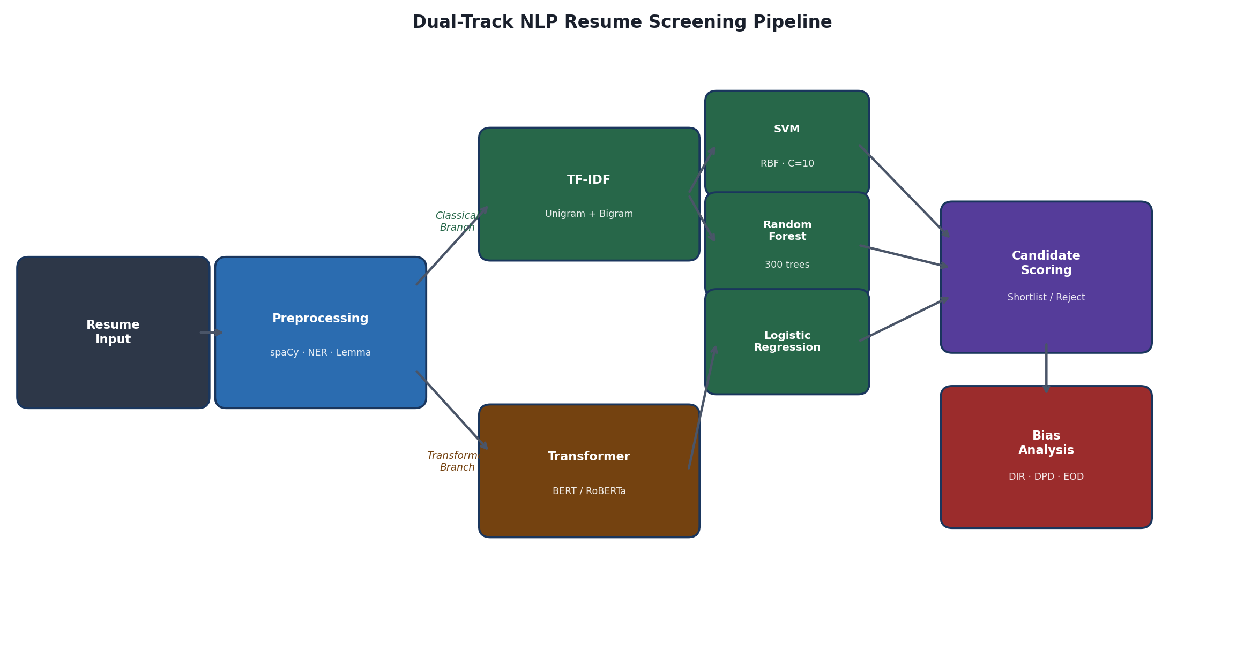
Figure 1. Dual-Track NLP Resume Screening Pipeline.

BERT and RoBERTa Fine-Tuning
The transformer branch did fine-tuning of the bert-base-uncased and roberta-base, available through the Hugging Face Transformers library, for our experiments. Texts in resumes were tokenized and cut to the 512-token input limit. For classification, the representation of the [CLS] token served as the input to a binary output layer. The entire network, including the pre-trained model, was optimized using AdamW with a learning rate of 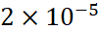. To stabilize training, a linear warmup schedule was employed during the first 10% of the steps. Additional settings included a weight decay of 0.01, a batch size of 16, and training over three epochs.

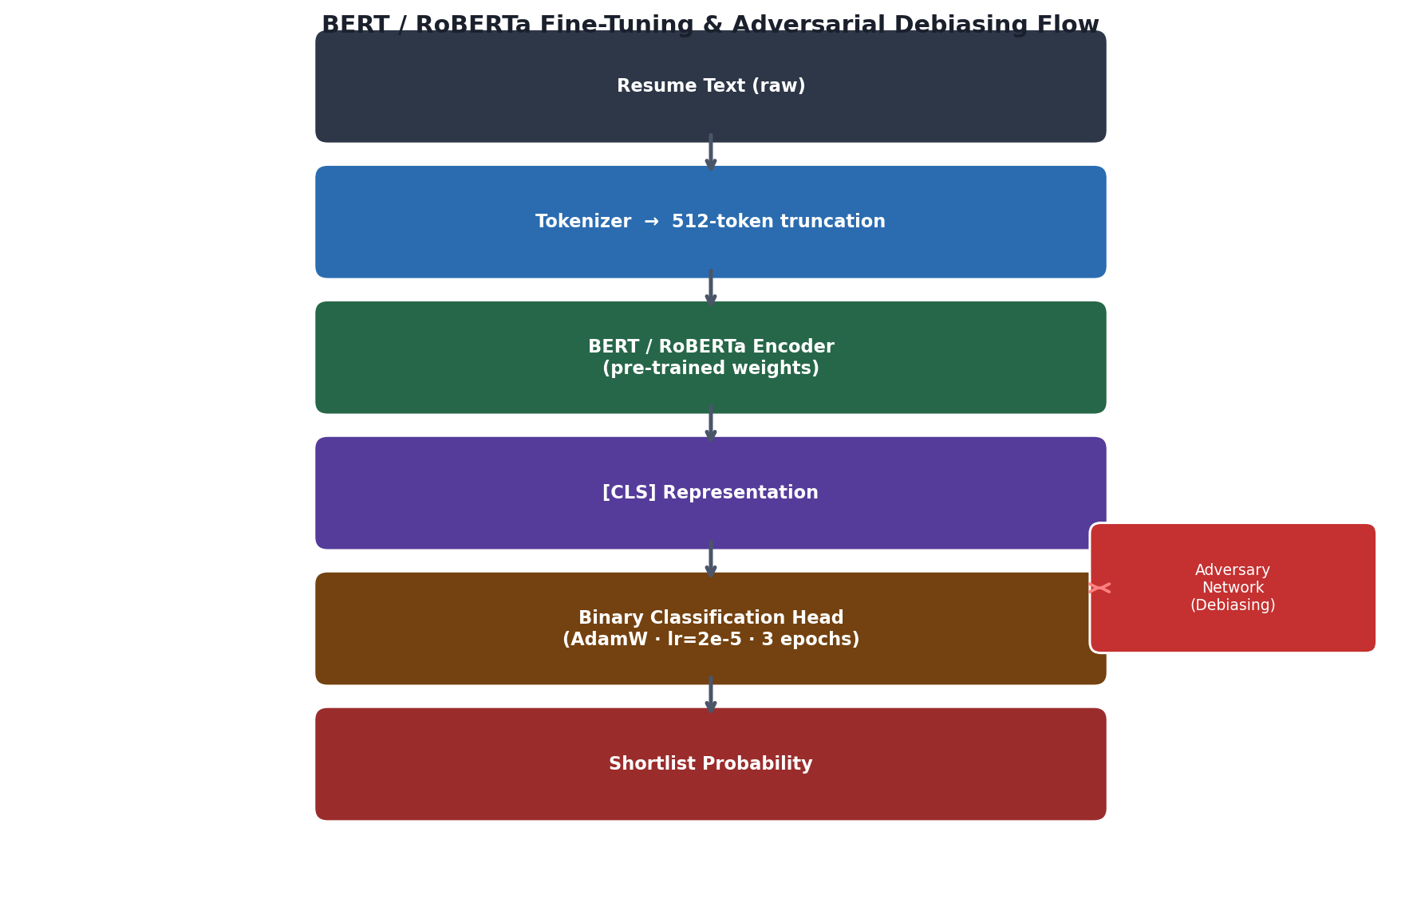
Figure 2. BERT / RoBERTa Fine-Tuning and Adversarial Debiasing Flow.

Bias Probing via Counterfactual Evaluation
In order to quantify bias not based on demographic tags built into the data, we created pairs of counterfactual resumes per test candidate by applying a systematic replacement of protected-attribute signals to hold all job-related information fixed. In gender probing, gendered role titles, pronouns, and honorifics were interchanged (e.g., he/she, Mr./Ms., chairman/chairwoman). In the name-based probing, the name of the candidates was substituted with culturally equivalent names under another demographic group whilst all other categories were held constant. Age was interrogated by sliding years of graduation and work dates to shift the suggested candidate age by either 15 years up or down. All Disparate Impact computations relied on a change in the probability of shortlisting predicted between each original resume and its counterfactual counterpart.

BIAS DETECTION AND ANALYSIS

Fairness Metric Definitions
Each protected attribute dimension was evaluated using three complementary fairness metrics.
The Disparate Impact Ratio (DIR) measures the propensity of one candidate in a minority group to be less successful than a candidate in the majority group. As per the four-fifths guideline defined by the Equal Employment Opportunity Commission, any DIR below 0.8 is legally relevant evidence of adverse impact:
DIR = P(Ŷ=1 | A=minority) / P(Ŷ=1 | A=majority)
DPD measures how much the positive prediction rates differ between groups, using the absolute difference. A zero score means that either of the two groups has an equal likelihood of shortlisting:
DPD = |P(Ŷ=1 | A=0) − P(Ŷ=1 | A=1)|
EOD basically checks the biggest gap between groups in terms of correct positive predictions and incorrect positive predictions., identifying differential model errors uncoverable by aggregate measures of accuracy:
EOD = max(|TPR₀ − TPR₁|, |FPR₀ − FPR₁|)

Pre-Mitigation Bias Results
Table II presents fairness measures of the BERT model without any debiasing intervention. All the bias dimensions correspond to DIR being below the 0.8 adverse impact threshold, reflecting statistically and legally significant discrimination. The greatest example is the race/ethnicity prejudice, wherein DIR = 0.68 and DPD = 0.22—results that one can attribute to the model’s sensitivity to ethnicity cues conveyed by names and stereotypes about institutions acquired at the pre-training stage. The second most eminent dimension is gender bias (DIR=0.71), which is mainly fueled by the consideration of gendered language when describing experiences and providing project narratives.

Table II. Fairness Metrics Before Mitigation (BERT)
Bias Type | DIR | DPD | EOD
Gender | 0.71 | 0.18 | 0.21
Race / Ethnicity | 0.68 | 0.22 | 0.25
Age (Young vs. Old) | 0.74 | 0.15 | 0.18
Name-Based | 0.72 | 0.17 | 0.20

High-confidence shortlisting decision qualitative inspection, performed on top model attention, indicated increased interest in gendered language (e.g., on maternity leave, chairman) and professionally specific and culturally relevant language. The counterfactual experiments revealed that the resumes with South Asian names are denied shortlisting chances about 28% less than textually identical resumes with Western names, which confirms that the model has learnt to use the name pattern as an invalid proxy of demographic origin.

EXPERIMENTAL RESULTS

Classification Performance
Table III gives the classification performance of each of the five model settings on the held-out 20% test subset of 240 resumes. Out of all the classical models, Random Forest performed the best with 84.1% accuracy, mainly because it works well with high-dimensional and sparse features created by TF-IDF. The transformer architectures do significantly better than this baseline: BERT has 91.7% and RoBERTa has 93.2%, a 9.1-percentage-point improvement over the largest classical model.

Table III. Model Performance Comparison
Model | Acc. | Prec. | Rec. | F1
LR + TF-IDF | 82.3% | 0.81 | 0.82 | 0.81
TF-IDF + RF | 84.1% | 0.83 | 0.84 | 0.83
SVM + TF-IDF | 83.7% | 0.82 | 0.84 | 0.83
BERT (fine-tuned) | 91.7% | 0.92 | 0.91 | 0.92
RoBERTa (fine-tuned) | 93.2% | 0.93 | 0.93 | 0.93

Transformer models possess a performance advantage due to their domain awareness of technical terminology, skill to model long-range relationships between resume sections, and exposure to software engineering language during pre-training on large web-crawled corpora. But there is an interesting result when accuracy is considered in combination with bias: the greater the accuracy of classification, the greater the bias. RoBERTa has shown a greater amplification of bias compared to the TF-IDF-based classifiers it outperforms, which matches the general trend of increasingly more capable language models acquiring societal biases more deeply during pre-training.
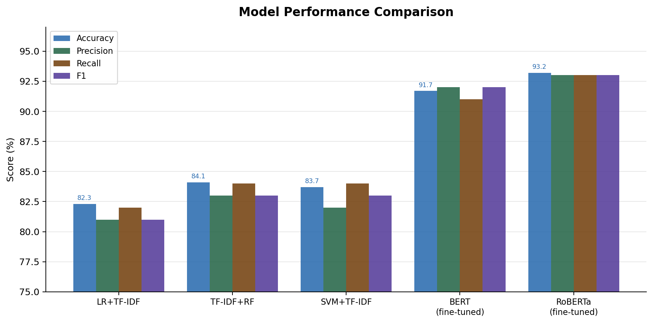
Figure 3. Model Performance Comparison across all five configurations.
B. Cross-Model Bias Comparison
On the bias as studied in model types, a definite tendency is noticed. TF-IDF-based models have a reduced bias based on name (DIR=0.81) when compared to BERT (DIR=0.72) and RoBERTa (DIR=0.70). This is unsurprising: bag-of-words representation is not as sensitive to entity-level cues as transformer models, and thus cannot respond to name-origin cues as effectively. However, the results indicate that both BERT and RoBERTa demonstrate comparatively greater gender-related bias due to a more pronounced focus on pronoun usage patterns and gendered professional titles that cannot be detected by bag-of-words models. Combined, these findings demonstrate a key accuracy-fairness dilemma: the same capabilities that accurately predict with transformer models also accurately predict the exploitation of demographic proxies.

BIAS MITIGATION TECHNIQUES
A. Sample Re-weighting (Pre-processing)
Re-weighting can deal with the underrepresentation of demographic minorities in training data by weighting their examples more heavily in optimization. The weight of each group training sample i, Wᵢ, is proportional to the inverse-frequency of the group in the training set. The merit in this technique is that it does not need any alteration to model architecture and introduces minimal computational burden. Its limitation is that it can only have a small influence on the bias of pre-trained transformer weights—it cannot reverse the learned representations acquired during pre-training on biased web corpora, although it can cause the fine-tuning objective to shift.
B. Adversarial Debiasing (In-processing)
Adversarial debiasing deals with representation-level bias by using a two-component architecture. The first component is the primary classifier, which predicts whether a candidate will be shortlisted. An adversarial component is introduced as the second part of the system, aiming to predict the protected attribute labels using the internal feature representations generated by the classifier. Through collaborative training, the classifier is rewarded for success on shortlisting predictions and demotivated when the adversary succeeds in inferring the demographic features—establishing a direct directive force on the model to produce representations that are predictive of job qualification while diminishing demographic indications. As shown in Table IV, this strategy best mitigates bias on gender and name, at the cost of making training more complex and reducing accuracy by about 1.2 to 1.8 percentage points.
C. Counterfactual Data Augmentation (CDA)
In CDA, the training set is expanded by creating a demographic counterpart of every training resume. The process replaces the markers of protected attributes—including candidate names, gendered pronouns, and age-indicating dates—with markers based on a complementary demographic category, and the resulting augmented resume retains the same shortlisting label. The model can learn, by being trained on both versions of each resume with the same labels, to predict independently of these substitutions. CDA is especially effective at mitigating age bias, with the DIR increasing to 0.91. It, in combination with re-weighting, also provides the most powerful race/ethnicity gains (DIR: 0.68→0.87).

Table IV. Fairness Metrics After Mitigation
Bias | Technique | DIR | DPD
Gender | Adversarial Debiasing | 0.71→0.89 | 0.18→0.07
Race/Eth. | Reweighting + CDA | 0.68→0.87 | 0.22→0.09
Age | Counterfactual Aug. (CDA) | 0.74→0.91 | 0.15→0.06
Name | Adversarial Debiasing | 0.72→0.88 | 0.17→0.07

Table IV results indicate that the mitigation strategies, used as indicated, increase post-intervention DIR values above the 0.80 compliance limit of the EEOC. The improvements obtained with adversarial debiasing are the most stable, and CDA fares well with name and age specifications. Combining re-weighting with CDA offers the most promising result in race/ethnicity, indicating that mitigation strategies need to be adjusted to the given mechanism that promotes each type of bias rather than being applied interchangeably.
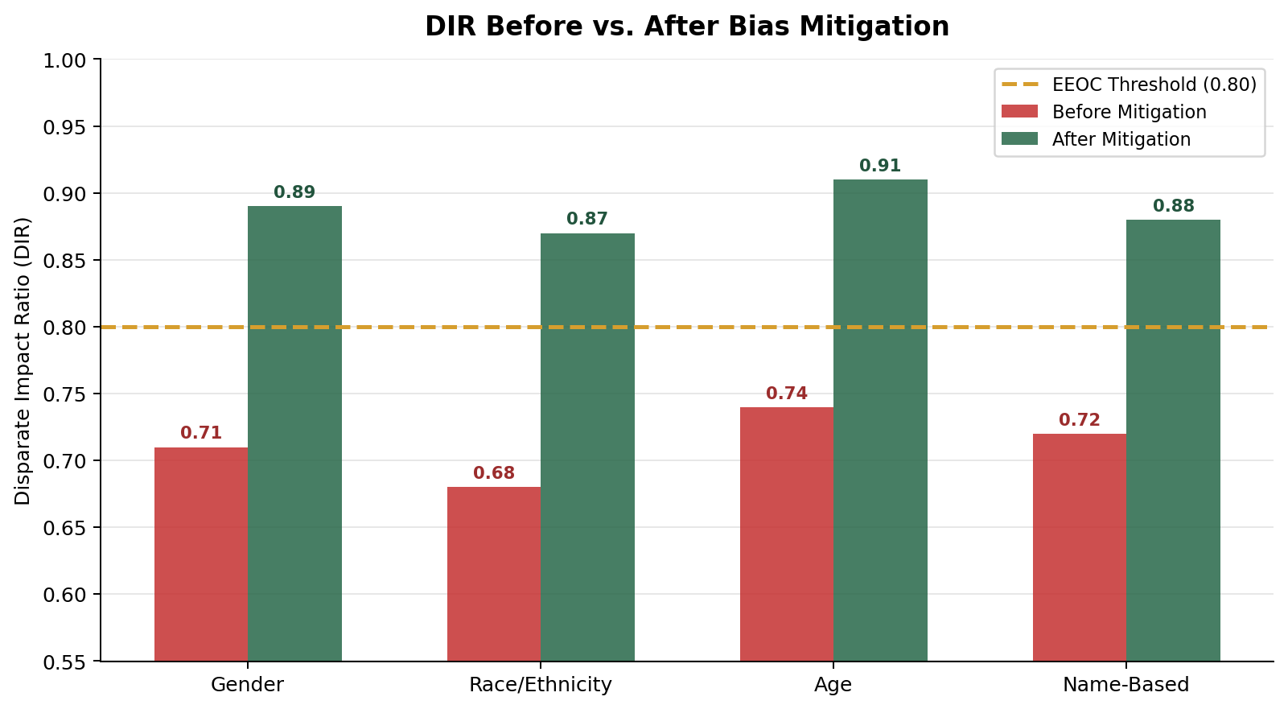
Figure 4. DIR Before vs. After Bias Mitigation across all four protected attribute dimensions.
VIII. Ethical Implications
A. Transparency and Explainability
Decisions are made by resume screening systems that directly influence the livelihood and professional path of people. A real accountability issue emerges when the underlying computation is obscured, as in the case of transformer models, from the view of decision subjects. Filtered-out candidates have a valid interest in learning how elements of their resume influenced the decision, but existing explainability systems are able to provide only biased and usually incomplete insights into complex model internals [15]. Companies implementing such systems must invest in plain-language disclosures that describe what aspects of a candidate the system takes into account, and avenues to have adverse screening results reexamined.
B. Regulatory Compliance
The legal environment surrounding automated hiring software is becoming more restrictive. In the EU AI Act, employment-related Artificial Intelligence systems are considered precarious, so they need to pass conformity checks, ensuring human oversight, and providing technical documentation prior to implementation in EU markets [16]. In the United States, automated hiring platforms must meet adverse impact criteria as mandated by EEOC guidance based on Title VII, and jurisdictional laws like Regulatory frameworks such as New York City Local Law 144 require periodic independent bias assessments. In parallel, Digital Personal Data Protection Act 2023 introduces obligations related to minimizing data usage and ensuring fairness in processing with resume data processing across the employment pipeline. To navigate this terrain, one must carefully document dataset demographics, modeling decisions, and fairness audit results, which merit to be living documents updated each time modifications are implemented in the system.
C. Proxy Discrimination
Eliminating explicit protected variables from a model cannot guarantee unbiased behavior, as machine-learning models are often powerful enough to replicate demographic signals using proxy variables that are correlated with demographics but not explicitly specified as important. The prestige of the university has a relationship with socioeconomic status and indirectly with race. Employment gaps are also gender-related, attributing to caregiving duties which disproportionately affect women. Certain sets of words used to characterize technical work can be related to a cultural background and a schooling background. Successful mitigation thus involves looking beyond single-attribute concepts of fairness and conducting intersectional analysis of model behavior across attribute groups—those protected—which reveals compounded disadvantages not detected by single-attribute approaches [8][17]. Disaggregated intersection-level model outputs should be offered to third-party auditors.
D. Human Oversight and Accountability
Automated screening must become a human judgment informer and not a replacement for human judgment. It consists of keeping human oversight over borderline instances, presenting applicants with beneficial methods of challenging algorithmic choices, and ordering routine unaffiliated bias assessments as opposed to internal validation only [18][19]. Deployment organizations shall set clear fairness boundaries that must be defined in advance and that will result in automatic human review in case of breach. They must also construct longitudinal feedback reports that compose actual hiring and retention outcomes alerting to model drift and guiding fairness improvement iteratively. Ultimately, the responsibility for discriminatory results rests not with an algorithm, but with the institutions that implement and benefit from these systems.
IX. Conclusion
This paper has provided methodological research on NLP-based automated resume screening in hiring software engineering. We demonstrated that TF-IDF classifiers with machine learning work as baselines, while fine-tuned transformer-based models, especially RoBERTa at 93.2% accuracy, offer far better classification strength. The most important discovery, however, is that classification accuracy and fairness do not improve in tandem: BERT and RoBERTa have significant bias along all four demographic dimensions—gender, race/ethnicity, age, and name-based—compared to their lower-performing TF-IDF counterparts, and pre-mitigation values of DIR are as low as 0.68, which is far below the legally significant figure.
Three debiasing interventions were compared (including sample re-weighting, adversarial debiasing, and counterfactual data augmentation) and shown to increase post-mitigation values of DIR to a minimum of 0.87 across all bias categories under evaluation. Adversarial debiasing was most generally applicable, whereas counterfactual data augmentation was most effective on age and name dimensions, and the re-weighting and CDA combination achieved the best race/ethnicity improvements. These results demonstrate that mitigation measures should be aligned to the kind of bias they are addressing.
A number of directions can be investigated in the future. Intersectional bias—the interaction occurring between two or more protected attributes—requires special consideration beyond the one-attribute analyses of this paper. The applicability of our synthetic-data results would be determined by validation on real-world resume data with measurable hiring outcomes. Last but not least, explainability mechanisms that meet legal transparency requirements and can be deployed by non-expert practitioners without advanced knowledge of AI ethics are urgently needed. With NLP-based hiring systems becoming a regular part of infrastructure, the research community bears a role not only of delivering rigorous assessment frameworks but also deployable, turn-key toolkits that organisations of different scale can leverage to keep pace with mounting ethical and legal requirements of fairness.
References
[1] J. Dastin, “Amazon scraps secret AI recruiting tool that showed bias against women,” Reuters, Oct. 2018.
[2] M. Raghavan, S. Barocas, J. Kleinberg, and K. Levy, “Mitigating bias in algorithmic hiring: Evaluating claims and practices,” in Proc. ACM FAccT, Barcelona, Spain, 2020, pp. 469–481.
[3] S. Maheshwary and S. Misra, “Matching resumes to jobs via deep learning: Applying multi-view neural networks to text classification,” in Proc. WWW, Lyon, France, 2018.
[4] T. Bolukbasi, K.-W. Chang, J. Y. Zou, V. Saligrama, and A. T. Kalai, “Man is to computer programmer as woman is to homemaker? Debiasing word embeddings,” in Proc. NeurIPS, Barcelona, Spain, 2016, pp. 4349–4357.
[5] A. Caliskan, J. J. Bryson, and A. Narayanan, “Semantics derived automatically from language corpora contain human-like biases,” Science, vol. 356, no. 6334, pp. 183–186, Apr. 2017.
[6] C. Dwork, M. Hardt, T. Pitassi, O. Reingold, and R. Zemel, “Fairness through awareness,” in Proc. ITCS, Cambridge, MA, 2012, pp. 214–226.
[7] M. Hardt, E. Price, and N. Srebro, “Equality of opportunity in supervised learning,” in Proc. NeurIPS, Barcelona, Spain, 2016, pp. 3315–3323.
[8] A. Chouldechova, “Fair prediction with disparate impact: A study of bias in recidivism prediction instruments,” Big Data, vol. 5, no. 2, pp. 153–163, Jun. 2017.
[9] M. Feldman, S. A. Friedler, J. Moeller, C. Scheidegger, and S. Venkatasubramanian, “Certifying and removing disparate impact,” in Proc. KDD, Sydney, Australia, 2015, pp. 259–268.
[10] F. Kamiran and T. Calders, “Data preprocessing techniques for classification without discrimination,” Knowl. Inf. Syst., vol. 33, no. 1, pp. 1–33, Oct. 2012.
[11] B. H. Zhang, B. Lemoine, and M. Mitchell, “Mitigating unwanted biases with adversarial learning,” in Proc. AAAI/ACM AIES, New Orleans, LA, 2018, pp. 335–340.
[12] M. B. Zafar, I. Valera, M. G. Rodriguez, and K. P. Gummadi, “Fairness beyond disparate treatment and disparate impact: Learning classification without disparate mistreatment,” in Proc. WWW, Perth, Australia, 2017, pp. 1171–1180.
[13] J. Devlin, M.-W. Chang, K. Lee, and K. Toutanova, “BERT: Pre-training of deep bidirectional transformers for language understanding,” in Proc. NAACL-HLT, Minneapolis, MN, 2019, pp. 4171–4186.
[14] Y. Liu et al., “RoBERTa: A robustly optimized BERT pretraining approach,” arXiv preprint arXiv:1907.11692, Jul. 2019.
[15] E. M. Bender, T. Gebru, A. McMillan-Major, and S. Shmitchell, “On the dangers of stochastic parrots: Can language models be too big?” in Proc. ACM FAccT, Virtual Conference, 2021, pp. 610–623.
[16] European Commission, “Proposal for a Regulation on Artificial Intelligence (EU AI Act),” COM/2021/206 final, Apr. 2021.
[17] IEEE, “Ethically Aligned Design: A Vision for Prioritizing Human Well-being with Autonomous and Intelligent Systems,” 1st ed., IEEE Standards Association, Piscataway, NJ, 2019.
[18] V. Eubanks, Automating Inequality: How High-Tech Tools Profile, Police, and Punish the Poor. New York, NY: St. Martin’s Press, 2018.
[19] S. Barocas and M. Hardt, “Fairness and machine learning: Limitations and opportunities,” fairmlbook.org, 2019. [Online]. Available: https://fairmlbook.org

