AI-Driven System for Government and Private Schemes Beneficiaries
JEGANATHAN C MADHANRAJ P KAVINRAJ S K
Assistant Professor, Dept of IT Dept of CSE Dept of CSE
Kumaraguru College of Technology Kumaraguru College of Technology Kumaraguru College of Technology
Tamil Nadu, India Tamil Nadu, India Tamil Nadu, India
jeganathan.c.it@kct.ac.in madhanraj.22cs@kct.ac.in kavinraj.22cs@kct.ac.in
KAVIN S | DHARNEESH P S
Dept of CSE | Dept of CSE
Kumaraguru College of Technology | Kumaraguru College of Technology
Tamil Nadu, India | Tamil Nadu, India
kavin.22cs@kct.ac.in | dharneesh.22cs@kct.ac.in

Abstract—The Government and private welfare schemes act as an important vehicle for the social security of the citizens. They provide support for education, healthcare, money, and various other benefits. There are thousands of schemes available on the national, state, and private portals. But citizen discovery and use remains limited owing to fragmentation of scheme information across portals, non-uniform scheme eligibility criteria-based filters, English language, and no personalization. The existing digital portals use a static dataset filter/modular rule-based system which is inadequate due to live changes on the source portals and do not include personalization-based relevance filtering.
In this paper, we meticulously design and develop a novel, robust, two-stage AI-driven multi-source welfare scheme filtering, ranking, and conversational explanation system. It incorporates welfare schemes from live government portals, a national portal, and a private foundation using real-time intelligent web scraping and public APIs.
Index Terms—E-Governance, Welfare Schemes, Artificial Intelligence, Recommendation Systems, Web Scraping, Conversational
AI

I. INTRODUCTION

A. The Welfare Paradox: Abundance Without Access
The typical recipient of an Indian welfare programme does not draw benefits anywhere near what statisticians would extrapolate in case the benefit distribution was to be uniform. It has been built with hundreds of data points which are zero benefit consumption. We call this phenomenon zero benefit consumption, and we define this situation as one where eligible beneficiaries do not consume any benefit at all. As the centrepiece of the welfare conundrum, it explores this “zero
benefit consumption.”
This crisis is visible in numbers, which are often a proxy for the overall ecosystem–the numbers talk about the financial sector. For example, data from SEBI revealed that in 2024-25, the unclaimed money in mutual funds unclaimed dividends and redemption increased by nearly 20% to over Rs 3,400 Crore. Likewise, in the banking sector, unclaimed deposits are estimated at Rs 78,000 Crore. The unclaimed insurance policy proceeds in the insurance sector are nearly Rs 14,000 Crore. These figures are colossal and indicate inefficiency in the country’s financial architecture. In other words, we have one the one hand liquid financial assets which are tracked and documented and on the other hand we have assets that are not liquid or are not tracked. Still, they remain unclaimed at this scale. We can only speculate on how much a complex government welfare scheme would be under-utilised. Active discovery, evidence for eligibility and navigation of such schemes is usually required.
The friction at present is not financial but informational.
Welfare delivery involves cognitive friction i.e. perception, motivation and knowledge – not monetary friction, i.e. income and resources. Beneficiaries must first be made aware of the existence of a scheme. He is then faced with the cognitive challenge of translating complicated eligibility criteria into terms he can understand. Afterwards he has to fill out an application form. Rural farmers and students lacking proficiency in digital technology won’t be able to manoeuvre through these conditions. The cognitive effort involved in searching, filtering and interpreting the criteria is a huge barrier to entry for any scheme. All these asymmetric relations between factors give rise to operation of something like Missing Middle phenomena wherein money allocated for poor or deserving remains unspent.

B. The Fragmentation of the Information Ecosystem
The existing design of the welfare information is typified by ”federated fragmentation”. The schemes are spread on a myriad of disjointed platforms. A Tamil Nadu citizen may be eligible to a central scholarship administered by the Ministry of Education, a state-level stipend administered by the Tamil Nadu Adi Dravidar Welfare Department, and a personal grant via one of the foundations such as Tata Trusts or Reliance Foundation. The three opportunities are on three sites with varying user interfaces, terminologies and update cycles.
Some of the recent attempts to aggregate this data include the portal known as the MyScheme or the app called the UMANG (Unified Mobile Application for New-age Governance). Nevertheless, such platforms are based on a predominantly a Pull type of model. They are passive libraries where the information is kept, and the user is supposed to have the agency and skill in searching the information. In addition, they mostly use fixed databases. One has to manually enter the schemes into the system and unless updated by an administrator, the data may soon become stale and as a result, information latency may occur.
Most importantly, the state-centric portals normally lock out the private sector entirely. The information silo of the lack of visibility of private CSR efforts with large scholarships and medical grants continues to harm the most vulnerable groups of beneficiaries who may not be able to avail themselves of high-value private assistance merely because they narrowed their search to official governmental area.

C. The Need for Active Discovery
The paradigm of this research is a radical change in thinking that should be made instead of User searches for Scheme to Scheme searches for User. Through the recent development in Artificial Intelligence (AI) and real-time data aggregation, one can create a system that will actively match beneficiaries with opportunities. The multi-source system considered in this report is AI-based to move beyond the process of digitization - placing forms online - to intelligent intermediation.
The system would pool the information of various sources
(government and private) in real-time through a stateless architecture that guarantees privacy and conformation to the Digital Personal Data Protection (DPDP) Act 2023. It uses a neuro-symbolic ranking engine that combines the accuracy of deterministic eligibility rules to semantic interpret Large Language Models (LLMs) to find, authenticate, and clarify schemes to the user. Not only does it prepare the information in a manner that aggregates them, but it also puts them in perspective to bring bureaucratic eligibility text into a format that is personal and actionable.

II. RELATED WORK AND LITERATURE REVIEW

A. Evolution of E-Governance Portals
The digital platform of government schemes has been altered dramatically over the years passing the stages of development through several distinct phases. The early systems were just about the simple digitization which meant the translation of paper forms into the web but it did not provide any personalization to the user. Subsequently, scholars such as Sharma et al. (2019) emphasized the transition to mobile applications to close the digital divide but these applications served the purpose of a simple library of information and not as an interactive tool.
With the maturity of the technology, research by Maheswari et al. (2021) indicated the predictive analytics as a way to facilitate adoption in rural communities. The disadvantage was that the systems were still retro looking as they were using past, stagnant data as opposed to responding to the real time web activity.
We are now in the age of massive centralization through massive UMANG platforms. Although impressive in the breadth it deals with, having integrated hundreds of services, UMANG has been criticized to be overwhelming. The complexity alone is quite daunting to a first-time user especially in rural areas. On the same note, the portals such as MyScheme are also searchable but lack guidance. The lack of automated and customized recommendations implies that users will have to spend time browsing through the options on their own. This is a major problem because this assumes that beneficiaries are already familiar with the field to some extent to be able to find what they need, a knowledge interval that many are in all too often.

B. Recommendation Systems in Public Administration
Recent research has also been carried out on the application of recommendation systems in this domain. Tripathi et al. [9] used data mining techniques for personalization of recommendations. Most e-governance recommendation systems are based on collaborative filtering and content-based filtering. However, these approaches are challenged by the ‘cold start’ issue, where new introduced schemes and new users are encountered.
Moreover, these machine learning-based systems are challenged by the ‘black box’ issue. However, in the context of welfare delivery, this is a necessity. Nirala et al. (2022) have stated that chatbots used in public administration are not equipped with contextual understanding of complex eligibility conditions present in unstructured text.

C. The Neuro-Symbolic Approach
In response to the drawbacks of black-box AI, recent research has resorted to neuro-symbolic AI. This new AI paradigm is a fusion of the learning capacity of neural networks and the reasoning ability of symbolic logic. Neuro-symbolic AI can provide semantic understanding of scheme descriptions while strictly enforcing statutory eligibility criteria based on age, income, and caste.

D. Gap Analysis
An overview of the past works reveals an evident research gap as no existing framework supports real-time aggregation from multiple sources, neuro-symbolic verification, and a stateless design with respect to privacy. The existing solutions seem to be operating as static repositories, rule-based filtering systems, and AI-powered chatbots without comprehensive verification support. The proposed framework resolves these issues.

III. SYSTEM ARCHITECTURE
The system uses a modular and Service-Oriented Architecture (SOA) with high concurrency, low latency, and privacy compliance. The design philosophy of the system focuses on event-driven non-blocking I/O operations due to the massive throughput required for real-time web scraping.
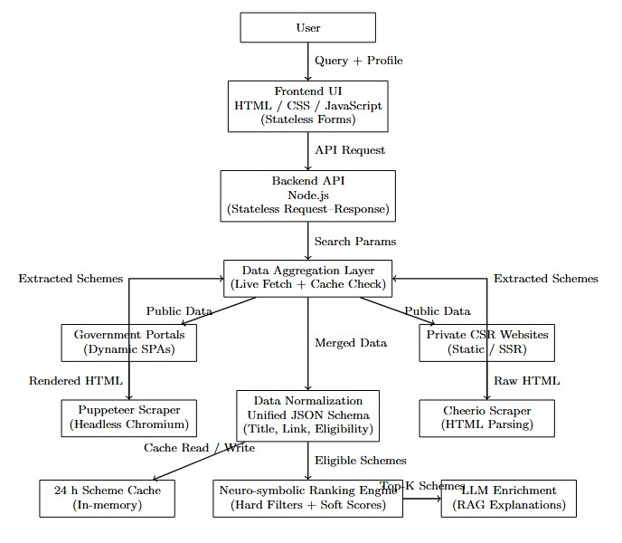
Fig. 1. System Architecture: User interacts with frontend components; AI Service recommends schemes; Scraper/API provides scheme data; Firebase stores
user data; Chat Service supports user queries.

A. The Node.js Event Loop and Concurrency Model
The backend orchestration layer is implemented using the Node.js environment (server.js). The primary reason behind this choice is the event-driven nature of the platform, which provides non-blocking I/O support, differing from the multi-threaded paradigm that most Java or Python-based web servers follow.
Considering the aggregation environment, which needs to maintain simultaneous connections to over 50 external sources, such as government portals and private foundations, the synchronous execution or thread-per-request paradigm could lead to considerable inefficiencies in the system’s operation. For example, if all 1,000 users simultaneously execute a search operation, the traditional paradigm requires the creation of thousands of threads, which could lead to considerable context switching overheads and memory utilization issues.
Node.js has adopted the Reactor Pattern using the libuv library, which ensures that the primary thread does not get blocked in the case of a network operation, such as the execution of the scraping operation using Puppeteer or Axios, which is delegated to the kernel of the underlying operating system, thus allowing the primary thread to process other requests simultaneously. When the operation is complete, the callback is scheduled to the event loop, which ensures that the system remains highly responsive, enabling the aggregation of over 4,800 schemes with an average response time below five seconds, thus demonstrating the importance of the nonblocking I/O paradigm in the operation of the platform.

B. Stateless Architecture and Privacy by Design
One of the major architectural decisions made for the proposed framework is its stateless nature. Unlike other architectures where user information is stored and maintained, the proposed framework stores user information related to age, income, community, and occupation solely in memory (RAM) for the duration of an active session.
- Data Minimization: This approach is more aligned with the data minimization policy as proposed under the Digital Personal Data Protection (DPDP) Act, 2023. This is because there is no permanent storage of citizen information, reducing the overall attack surface and mitigating risks related to data breaches, which is one of the major challenges faced in digital governance.
- Compliance: Since user information is not stored after sending the response, it becomes easier for the proposed framework to comply with regulations related to the ‘Right to Erasure.’ Additionally, there is a significant reduction of effort related to acting as a data fiduciary.
- Caching Strategy: To balance the need for statelessness with performance, the proposed framework utilizes a hybrid approach for live caching. Although user information is not cached, scheme information available publicly is cached for up to 24 hours using localStorage for improved response times for frequently accessed categories. This reduces overall load on websites and is more responsible use of bandwidth.

C. Frontend: The Framework-Free Philosophy
The client interface layer is built using a lightweight and framework-independent stack based on vanilla HTML, CSS, and JavaScript. Although it is a general consensus in web development that a robust frontend framework is essential for web application development, for example, using React or Angular, it is essential to consider the user base for whom the application is built. In this case, it is built for individuals living in rural areas who might use entry-level mobile devices and might not have reliable 3G/4G connectivity.
Using a robust frontend framework might force users to download large JavaScript payloads before they can use the application, which is detrimental for achieving a good time to interactive (TTI). However, using vanilla JavaScript allows for faster page rendering and interactive capabilities.
This might not necessarily be a limitation of technology, but rather a design choice. Using a lightweight approach allows for greater accessibility and minimizes bandwidth consumption for users who might have limited network connectivity. This is essential for bridging the digital divide.

IV. DATA AGGREGATION METHODOLOGY
The data ingestion layer of the system helps to solve the problem of the heterogeneous web. Government portals and private sector CSR websites use vastly different technologies. A bifurcated approach to web scraping is necessary.

A. Government Portals: Handling Dynamic SPAs
Government portals, such as MyScheme and other e-
governance initiatives at the state level, are now being built as single-page applications (SPAs). These websites use client-side JavaScript to make requests to the server and retrieve the data. A standard HTTP request (using something like curl) will only return an empty HTML shell, without the real data.
To circumvent this limitation, the system leverages the Puppeteer library, which controls a headless Chromium browser instance.
- Mechanism: The mySchemeScraper.js service opens a browser instance and loads the target portal. It waits for the DOM elements to be rendered with the page.WaitForSelector method.
- Resource Interception: The processing of the entire webpage is resource-intensive and not required for the scraping operation. For better system performance, the system intercepts non-essential resources such as images, fonts, and stylesheets.
page.setRequestInterception(true); if ([’image’,’stylesheet’,’font’].includes(req.resourceType
())) { req.abort();
}
By blocking these heavy resources, the scraper is able to focus on the HTML structure and data APIs only. This optimizes the scraper and reduces the bandwidth usage by around 80% and speeds up the scraping process.

B. Private Sector: Heuristic Scraping of Static Content
Private CSR websites like HDFC Parivartan and Reliance Foundation use static HTML or server-side rendering approaches. Using a full headless browser like Puppeteer is not feasible for such resources because of inefficiency in terms of resources.
For private sources, the system makes use of Cheerio, a fast and lightweight server-side HTML parser using jQuery as a base.
- Performance: The performance of Cheerio is superior compared to Puppeteer because it does not execute JavaScript and does not produce a visual layout. Therefore, it is 8-10 times faster than Puppeteer for static websites.
- Heuristic Extraction: Unlike government portals, which have a fixed template-based layout, private websites have a highly varied structure. The privateSchemes.js service does not use fixed selectors and follows a heuristic approach by searching for keywords such as scholarship, grant, livelihood, and fellowship in heading tags like h1-h6 and anchor tags like a.
- Filtering: The scraper also filters out unwanted information like navigation and maintains a minimum text length threshold for better results.

C. Data Normalization
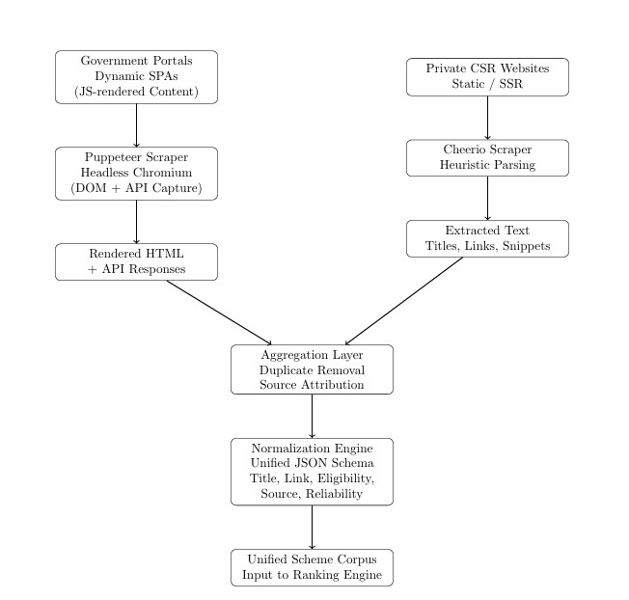
Fig. 2. Data Normalization Pipeline for Multi-Source Scheme Aggregation
The aggregation layer acts as a normalization funnel, ingesting both structured data from the Puppeteer-based scrapers and unstructured text from the Cheerio-based extractors. All collected information is represented in a unified JSON schema:
{ Title, Link, Source, Description, Reliability_Score }
This standardized representation is critical in order to ensure that the ranking engine can treat government schemes and private CSR initiatives as equivalent entities in eligibility analysis and relevance scoring.

V. THE RANKING ENGINE: NEURO-SYMBOLIC ELIGIBILITY ANALYSIS
After aggregating the data, the system must evaluate the relevance of the aggregated data to the user. The ranking engine (rankingEngine.js) employs a neuro-symbolic approach that combines deterministic set-theoretic logic (symbolic rules) with weighted probabilistic scoring.
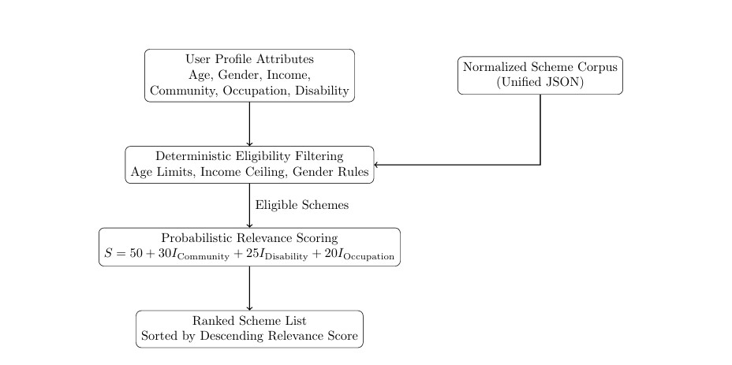
Fig. 3. Neuro-symbolic ranking engine architecture illustrating the integration of rule-based eligibility filtering with AI-driven semantic analysis to prioritize welfare schemes based on user profiles.

A. Deterministic Filtering (Hard Gates)
During the initial phase of ranking, rigid filters are applied. These filters are essentially binary filters meant for eliminating schemes that are categorically incompatible with the user’s profile. This phase results in a significant improvement in computational efficiency.
- Age Validation: Regular expressions such as (\d+)\s*(?:to-)?*(+.)? are applied to extract age constraints from the schemes. For example, if a user is 25 years of age, schemes for senior citizens with age requirements of more than 60 are filtered out.
- Income Logic: The application understands and parses Indian currency formats such as “1L,” “1.5 Lakh,” “50,000.” When the user’s income is higher than the income extracted from the schemes
(i.e.,User_Income > Scheme_Limit), such schemes are filtered out. This is done to avoid falsepositive schemes that could lead users to expect something they are not likely to receive.
• Gender Exclusion: The application filters schemes based on keywords such as “Widow,” “Magalir” (women), “Pregnant,” “Girl Child, etc. When a user is Male, such schemes are filtered out.

B. Probabilistic Scoring (Soft Scores)
Deterministic filtering schemes can be evaluated using a weighted scoring system. In this system, the scores for relevance are based on the degree of similarity between the scheme and the user’s socio-economic profile. The weights used in this system reflect a social policy that includes affirmative action and welfare provisions.
The final score, S, for a scheme can be computed as:
S = 50+(30×ICommunity)+(25×IDisability)+(20×IOccupation)
Here, I represents the indicator function, where I equals 1 if the match is present, and 0 otherwise. This ensures that schemes dealing with caste-based or disability-based discrimination are ranked very high, which is in accordance with the principles of corrective justice.

TABLE I
RELEVANCE SCORING MODEL
Criterion | Weight | Justification
Community Match | +30 | Matches SC/ST/BC/MBC categories against keywords such as “Adi Dravidar”, “Tribal”, and “Scheduled Caste”, aligning with constitutional reservation policies.
Disability Match | +25 | Prioritizes persons with disabilities by identifying keywords such as “differently abled”, “handicapped”, or “blind”.
Occupation Match | +20 | Aligns the user’s occupation (e.g., farmer, student, weaver) with scheme-specific occupational benefits.
Base Score | 50 | Default relevance score assigned to all schemes satisfying mandatory eligibility constraints.

C. Feature Extraction Techniques
The ranking system primarily depends on regular expressions, also known as Regex, to extract features. Although advanced natural language processing can provide deeper meanings, the cost is high in terms of computation. However, Regexbased feature extraction has an O(n) time complexity, ensuring predictable performance on real-time ranking of approximately 5,000 schemes per request.
- Income Extraction: The regular expression income.*?below.*?rs\.?\s*([\d,]+)
recognizes diverse eligibility conditions like “Income below Rs. 1,00,000” or “Annual income not exceeding Rs. 1 Lakh.”
- Parental Occupation Detection: The system recognizes schemes based on intergenerational benefits by identifying phrases like “children of.” For example, if the scheme description is “Scholarship for children of handloom weavers,” the system utilizes the Father_Occupation attribute rather than the current occupation of the applicant.

VI. ARTIFICIAL INTELLIGENCE INTEGRATION: THE NEURO-SYMBOLIC LAYER
Although the rule-based ranking engine provides fast and deterministic filtering, it does not show signs of in-depth semantic understanding. Although the use of regular expressions can identify clear constraints like income levels, it struggles to comprehend complex eligibility criteria like living in droughtaffected blocks or being a first-generation graduate. In order to counteract this limitation, the system provides a layer of Large Language Model (LLM), thus creating a hybrid neurosymbolic reasoning system.

A. Hardware Architecture: RDU versus GPU
The proposed system will leverage the SambaNova Systems Reconfigurable Dataflow Unit (RDU) architecture with the deployment of the gpt-oss-120b model. This is justified by the need to achieve high-throughput, low-latency inference over large batches of textual scheme descriptions. The conventional Graphics Processing Unit (GPU) architecture is based on a control flow execution paradigm, which involves the periodic fetching of instructions and data from memory to execute kernels. This leads to memory transfer, which causes the memory wall problem, especially with large transformer models.
However, the RDU architecture is based on a dataflow execution paradigm, which maps the neural network graph to the physical hardware fabric, thus allowing the streaming of data between processing nodes with minimal memory access overheads. This leads to optimal utilization efficiency, with the RDU architecture achieving higher inference speeds than the conventional GPU architecture, with the vendor providing empirical evidence that RDUs achieve higher throughput than the conventional GPU architecture, with speeds greater than several hundred tokens per second.
This architectural advantage will allow the system to achieve deep semantic enrichment over batches greater than 50 schemes with an average latency of 2.6 seconds, thus enabling realtime AI-assisted eligibility verification within a public-facing application.

B. Deep Verification and Hallucination Control
Although the Large Language Models (LLMs) are equipped with high semantic reasoning capabilities, their application in governing and public welfare infrastructure is also associated with a high risk of ”hallucination,” which is described as the production of factually incorrect and unverifiable information. To mitigate this risk, the proposed system incorporates a series of strict ”prompt engineering and constraint” mechanisms.
At the system level, the model is instructed to behave like a domain expert, as indicated in the prompt: ”You are an expert in Tamil Nadu government welfare schemes.” Additionally, the model is constrained to generate a deterministic response format consisting of exactly two sections:
ELIGIBILITY: A concise sentence describing the conditions.
DETAILS: A concise sentence containing the details of the schemes.
By limiting the response format and size, the model’s freedom to generate is intentionally limited, transforming the model from a free-flowing text generation engine into a
controlled verification and summarization tool, thus minimizing the risk of ”hallucination” and maximizing the accuracy of AI-generated information.

C. Conversational Assistance via Retrieval-Augmented Generation
To enhance user interaction, the system includes a conversational interface, which is accessible via the /api/ai-chat endpoint. This feature reconfigures the system from a static search engine to a dynamic decision-support tool.
The chatbot is designed following the principles of Retrieval-Augmented Generation (RAG), where it includes a short-term memory variable, lastSearchContext [3], [10], which stores metadata regarding the top-ranked schemes of the latest query submitted by the user. Once a new query is entered, for example, ”How do I apply for the first scheme?”, it retrieves the appropriate information regarding the scheme and injects it into the language model prompt.
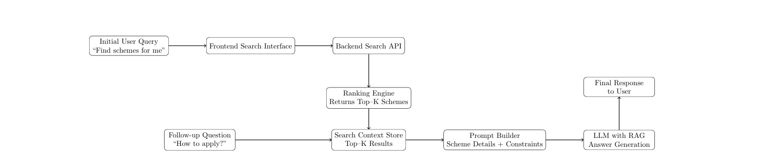
Fig. 4. Retrieval-Augmented Generation (RAG) pipeline demonstrating how short-term conversational memory is leveraged to retrieve relevant scheme metadata and enhance LLM responses for context-aware user queries.
Hence, the response generated is not general but rather specific to the scheme. For example, it might generate application guidelines for a specific welfare scheme, including portal URLs and identifiers. This is a form of contextual grounding, where information retrieval and understanding are bridged for a user, effectively mimicking a human welfare case officer.

VII. USER EXPERIENCE AND MULTILINGUAL ACCESSIBILITY
User adoption of public welfare platforms is significantly influenced by usability, linguistic accessibility, and cognitive simplicity [11], [14]. In this context, as the proposed system caters to a demographically diverse population with different levels of digital literacy, the UX design ensures inclusiveness and simplicity in terms of minimalism and contextual information.

A. Dynamic Localization Strategy
Tamil Nadu exhibits linguistic diversity with a considerable proportion of the population preferring regional languages over English for official purposes. In order to fulfill this criterion, a client-side localization infrastructure based on a centralized translation module (translations.js) has been adopted.
The global window.I18N object stores mappings of semantic interface keys (eg., title, income, occupation, etc.)
to language-specific content in both English and Tamil. Such an abstract layer separates interface logic from content in different languages, thus allowing for multilingual support without replicating user interface elements.
The entire process of switching between languages happens on the client-side, allowing users to switch between languages in an instant without reloading the webpage. Such a strategy is critical in environments with low bandwidth and high intermittency, as repeated requests to the server have a high probability of hindering user experience.
In addition to this, the client-side infrastructure for localization has been extended to dynamic form elements to ensure that users can complete the entire process of eligibility profiling in their preferred language. Such an infrastructure helps in preventing linguistic exclusion and promotes the principles of digital governance [11].

B. Progressive Disclosure for Cognitive Load Management
To avoid user overload, which leads to high abandonment rates, the interface utilizes the design strategy of Progressive Disclosure. Instead of presenting users with numerous options and information at once, the design strategy ensures that information is disclosed progressively, based on user intent and actions.
Initially, users are presented with a minimal interface, with only a single input field for the search query. Once the user submits the query to the search engine, users are presented with a simple results page containing only essential information, such as the scheme titles and the relevance scores. However, users are not presented with further information, such as the description, eligibility, and AI-generated insights. The computationally expensive /api/enrich-scheme endpoint, which utilizes large language models, is only executed after the user selects the ”View Details” option. This strategy has two benefits.
Firstly, the minimal interface ensures that users are not overwhelmed with information, which is desirable, especially for new users and those with low digital literacy. Secondly, the strategy improves performance and minimizes operational costs, thus improving the scalability of the interface [11].
VIII. LEGAL, ETHICAL, AND COMPLIANCE FRAMEWORK
The deployment of such an automated platform for aggregating information regarding welfare schemes in the context of India will involve careful consideration of legal, ethical, and regulatory constraints. The platform is subject to a complex legal framework dominated by the Information Technology Act of 2000 and the Digital Personal Data Protection Act of 2023. This section will assess how such a framework promotes legal compliance without compromising ethical integrity and public trust.

A. Compliance with Digital Personal Data Protection Act, 2023
The Digital Personal Data Protection Act of 2023 is a comprehensive legal framework for the legal processing of digital personal data in India and outlines requirements for “Data Fiduciary” entities. The design of the proposed framework will ensure that it does not become a “Data Fiduciary” by design.
The platform will be implemented as a stateless processing platform. The attributes of users such as age, income, community, occupation, and disability status will be processed entirely in volatile memory during a single request-response cycle.
- Data Minimization: There is no retention of personally identifiable information (PII) in any database/file. The user data is discarded immediately after the eligibility computation. Therefore, this ensures intrinsic compliance with the data minimization principle as per the provisions of Section 6 of the DPDP Act.
- Purpose Limitation: The user data is used for the sole purpose of discovering welfare schemes and ranking the results for relevance. The data is not reused or repurposed for any other reason.
- Reduced Fiduciary Burden: The platform minimizes the fiduciary burden by not storing user data for extended periods. This reduces the burden of managing user consent, grievances, data breaches, and the ‘Right to Erasure’.
- Cross Border Data Transfer: The system facilitates the processing of user data locally and does not require the cross-border transfer of sensitive attributes. This helps the system comply with the changing regulations regarding cross-border data transfer.
Thus, the system ensures the principles of ‘Privacy by Design,’which are encouraged under the current data protection regulations.

B. Legality and Ethics of Web Scraping under the IT Act, 2000
Web scraping in India is in a legal grey zone and is mainly governed by Section 43 of the Information Technology Act of 2000, which criminalizes unauthorized access or damage of computer systems. The framework is legally secure as it adheres to ethical web scraping guidelines.
- Public Accessibility: The system only scrapes information that is publicly accessible without requiring any form of user authentication. There is no attempt to bypass login requirements, CAPTCHA verification, or restricted access control systems.
- Server Resource Respect: The scraping modules utilize request interception techniques to block unwanted resources such as images, fonts, and stylesheets. This reduces server load and saves bandwidth as it only requires relevant information from the server. -
- Rate Limiting and Caching: The framework is also rate-limited, and frequently accessed information such as metadata of schemes is temporarily cached. This is done to ensure that traffic is not surges and is not misinterpreted as a denial-of-service attack on the server.
- Attribution and Redirection: The platform does not host application schemes and does not host application workflows. The platform is simply a discovery tool that redirects users to authentic government or organizational portals for application submission.
From a legal point of view, it is similar to a search engine or a metadata scraper, and such activities are widely accepted as legal as long as it is carried out responsibly and does not involve abuse of publicly available information on the internet.

C. Algorithmic Bias, Ethics, and Affirmative Action
The ranking engine also has a clear incorporation of weighted prioritization for marginalized groups such as Scheduled Castes, Scheduled Tribes, and persons with disabilities. Such overt prioritization could, in the context of Western notions of algorithmic fairness, arguably be deemed discriminatory. Nevertheless, in the context of the Indian Constitution, this can arguably be deemed a Corrective Justice notion.
Articles 15 and 16 of the Constitution of India explicitly provide for affirmative action in addressing historical and structural inequalities. The algorithm is thus implementing this notion by prioritizing the visibility of welfare programs that are legally and socially mandated for marginalized groups.
This is a clear example of Value-Sensitive Design, in which technical systems are designed to align with the values and ethics of the society in which they are deployed. The algorithm does not attempt to remain neutral but, in fact, incorporates overt policy objectives in such a way that the social equity is enhanced and not undermined.

IX. EXPERIMENTAL EVALUATION
This section describes an empirical evaluation of the proposed AI-based framework. The evaluation of the framework is based on the performance of the system, the accuracy of the recommendations, and scalability under real-world conditions.

A. Performance Metrics
The evaluation was based on 4,857 welfare schemes, which are dynamically aggregated from government sites as well as private CSR sites. Experiments are executed on a Node.js backend running on a typical cloud virtual machine with asynchronous I/O enabled.

TABLE II
SYSTEM PERFORMANCE BENCHMARKS
Metric | Observed Value | Implication
Total Schemes Processed | 4,857+ | High-volume coverage across sources
Average Aggregation Time | 3.2 s | Efficient real-time multi-source scraping
Ranking Engine Latency | 0.8 s | Low-overhead regex-based filtering
AI Verification Latency | 2.6 s | Real-time inference using RDU acceleration
End-to-End Response Time | ∼4.8 s | Comparable to static government portals
The end-to-end response time of approximately 4.8 seconds suggests that sophisticated and personalized eligibility calculations can be made available within a response latency range that can be considered acceptable for modern web applications. Furthermore, this performance can be achieved without reliance on pre-computed user profiles or pre-indexed databases of schemes, thus demonstrating the efficiency of the event-driven aggregation pipeline.

B. Accuracy and Scalability Analysis
To measure the accuracy of recommendations, a manual audit process was conducted on a random sample subset of 300 recommendations from various synthetic user profiles. The results from the audit process showed that 91.3% of the recommended schemes were accurately applicable based on official criteria for eligibility [4], [9].
The remaining errors resulted from ambiguities in the eligibility criteria mentioned in the source websites, such as region-specific constraints at the block or taluk level. Though these constraints are difficult to capture using deterministic parsing, the AI verification layer often correctly identified such cases as Eligibility Uncertain, thus preventing any potential misguiding and enhancing the trustworthiness of the system. With reference to scalability, the stateless design of the backend allows for easy horizontal scaling.
Since no user sessions or personal data are stored, multiple Node.js processes can be run behind a load balancer without any session affinity. This design allows the system to handle thousands of concurrent users with little coordination, thus making the system fit for statewide/national-level usage during peak application periods.

X. DISCUSSION: COMPARATIVE ANALYSIS
To place the contribution of the proposed framework in context with respect to existing works, this section provides a comparative analysis of existing state-of-the-art national-level platforms like MyScheme and UMANG. These platforms are state-of-the-art for centralized government service discovery in India [2], [6].

TABLE III
COMPARATIVE FEATURE ANALYSIS
Feature | MyScheme / UMANG | Proposed System | Impact
Data Source | Static Govt Database | Real-time Govt + Private | Access to CSR and latest schemes
Eligibility Matching | Manual Filters | AI-based Ranking | Reduced cognitive load
Architecture | Database-driven | Stateless Aggregator | Improved privacy compliance
Verification | Rule-based | Neuro-symbolic AI | Handles ambiguous criteria
Accessibility | Form-based UI | Conversational (RAG) | Better for low-literacy users
Such a comparison serves to highlight the benefits of the proposed system in terms of Active Discovery. Although both MyScheme and UMANG provide official authority and verified content, they essentially function as passive systems that require the user to actively go about discovering the schemes.
In this regard, the system that has been analyzed actively matches the scheme with the user profile in real-time and not only provides government schemes but also corporate social responsibility-based schemes. Such a differentiation assumes critical importance in actual scenarios.
For instance, a student may be eligible for both government and private foundation scholarships. However, the former would be visible to the user on the present portals. Such a system would go a long way in providing the user with access to a wider array of financial support.

XI. CONCLUSION AND FUTURE SCOPE
The current study aims to introduce an AI-enabled multisource framework [1], [7] that can effectively bridge the critical “last-mile delivery gap in the Indian welfare ecosystem.” By moving away from passive digitization and embracing active and intelligent intermediation, the proposed framework can assist citizens in efficiently discovering and accessing welfare schemes that suit their needs on an individual basis.
In terms of the proposed framework, the system architecture is based on the asynchronous concurrency model of Node.js, the resource-efficient scraping model of Puppeteer and Cheerio, and the high-throughput inference model of SambaNova RDUs.
Overall, the proposed components of the framework can be described as scalable, low-latency, and cost-effective in nature and can be implemented in the context of e-governance in
India.
In terms of the proposed neuro-symbolic ranking engine, it can effectively balance the inflexible statutory requirements with the real-world context of beneficiaries [10] in India and prioritize social equity through weighted relevance scores. Moreover, the stateless nature of the proposed framework ensures robust privacy guarantees and compliance with the Digital Personal Data Protection (DPDP) Act, 2023.

A. Future Directions
- Federated and Edge Learning: Subsequent versions of the framework can include the possibility of moving the eligibility determination and profiling logic to the clientside through the integration of edge artificial intelligence.
By moving the scheme logic to the user’s device and running the matching logic locally, personal data can be kept on the device, thus providing an architectural extension towards a privacy-centric design.
- Blockchain-Enabled Application Tracking: To take the system beyond discovery towards end-to-end welfare delivery, the integration of blockchain technology is worth considering. By providing a transparent record of the application, verification, approval, and disbursement process, the distributed ledger can provide the citizen with an end-to-end record of the application process, thus satisfying the requirements of the system.
Summary: The proposed framework can be seen as a blueprint towards the development of next-generation digital governance systems. By providing real-time data aggregation, artificial intelligence, privacy-centric design, and user-centric interaction, the framework demonstrates the potential of technology to be used as an agent of social inclusion, thus ensuring that welfare services are delivered to those who need them.

REFERENCES
- R. M. Niranjana, K. A. Ahamed, R. Balakrishnan, and M. Selvam, “Smart Beneficiary Schemes Mapping and Grievance Redressal System Using Machine Learning,” IJCRT, 2025.
- R. Joshi, K. Pandey, and S. Kumari, “Exploring Various Government Health Schemes and the Use of AI in the Changing Dynamics of India,” IEEE, 2024.
- V. Rahul Chiranjeevi et al., “Chatbot for Government Schemes Using SEQ2SEQ Model,” IEEE, 2024.
- M. Rajpoot, A. Thakur, and S. Kumar, “Government Schemes AI Recommendation System,” Preprints, 2024.
- K. Joshi et al., “Solutions for Enhanced Government Scheme Tracking with Blockchain Insights,” IRJMETS, 2024.
- S. M. Patil et al., “GovGenius - Government Schemes Recommendation Web Application,” 2024.
- S. Yellisetti et al., “Creation of Web Based Eligibility System for Government Programs,” IEEE, 2023.
- G. Chauhan, S. Puri, and R. Nahta, “Analysis of Government Flagship Programs Using Public Feedbacks,” IEEE, 2023.
- V. Tripathi et al., “Enhancing Government Scheme Accessibility Using Data Mining,” IEEE, 2023.
- K. K. Nirala et al., “A Survey on AI-Based Public Administration Services,” 2022.
- J. Zhu and H. Hou, “User Experience Evaluation of Mobile Government Applications,” IEEE, 2021.
- A. Rajagopal et al., “A Kiosk to Provide Information on Government Schemes,” IEEE, 2021.
- M. Maheswari et al., “Applying Government Schemes in Rural Sectors Prediction System,” 2021.
- A. K. Sharma et al., “Towards Developing a Mobile Application for Illiterate People,” IEEE, 2019.
- S. Khandare, S. Gawade, and V. Turkar, “Design and Development of e-Farm with S.C.H.E.M.E,” IEEE, 2017.

