CNN1D-Based Deep Learning Framework for Online Fraud Transaction Detection

1st M. Jayamma
Department of Computer Science and Engineering
Santhiram Engineering College
Nandyal, Andhra Pradesh
jayamma.cse@srecnandyal.edu.in

4th Dr.N.Ramanjaneyulu,
Associate Professor ,
Department of ECE, Rajeev Gandhi Memorial college of Engineering and Technology, Nandyal.518501.
Mail id: rams9ganguly@gmail.com
2nd Shaik Saddam hussain
Department of Computer Science and Engineering
Santhiram Engineering College Nandyal, Andhra Pradesh
24x51d5816@srecnandyal.edu.in

5th Dr. A. Sathish
professor
Dept.of ECE, RGMCET
Email: sathishanchula@gmail.com
22x51a0590@srecnandyal.edu.in
3 ^{rd} Dr. C. Venkataiah
Department of Electronics and Communication Engineering
Rajeev Gandhi Memorial College of Engineering and Technology
Nandyal, Andhra Pradesh
venki.challa@gmail.com

6th Mrs. R. Sireesha
Assistant professor
Department of ECE
Rajeev Gandhi Memorial College of engineering and technology, Nandyal
Email: sireesha.rgm@gmail.com

Abstract— With the advent of digital transactions, the financial sector has undergone a revolutionary shift, making services more accessible and convenient for millions of customers throughout the globe. Unfortunately, with this expansion has come an extraordinary surge in fraudulent activity, which is a major concern for consumers and financial institutions alike. The confidence of customers and the image of service providers are both tarnished by fraudulent transactions, in addition to the financial losses that ensue. As a result, there is an urgent need to create fraud detection systems that are accurate, reliable, and scalable. Even worse, they aren't always able to adjust to new fraud trends. This research offers a state-of-the-art fraud detection system that uses an extended CNN1D, (Convolutional Neural Networks 1D) algorithm to circumvent these problems. This model is able to extract significant patterns that differentiate between genuine and fraudulent actions because the CNN1D design is well-suited to capture localized temporal & structural relationships in transaction sequences. Preprocessing data, representing features, training models, evaluating performance, and detecting fraud in real-time are all functional components that make up the system. The Extension CNN1D method learns abstract organizational characteristics that improve detection capabilities and decrease dependency on human feature engineering by exploiting convolutional layers.

Keywords— Feature extraction, current prediction, security of funds, machine learning, convolutional neural networks, convolutional neural networks for fraud detection, imbalanced datasets, and digital transactions.

Introduction

The exponential expansion of digital activities has completely transformed the world of finance, allowing countless individuals to carry out safe, quick, and hassle-free activities including online shopping, money transfers, and payment processing. Customers and banks alike are understandably worried about the increased likelihood of financial fraud brought about by this shift. There are both concrete and intangible consequences to fraud, including the loss of confidence from customers, harm to institutions' reputations, and higher expenses associated with prevention efforts. Industry studies indicate that companies lose billions of dollars yearly due to online payment fraud, and that number is only going to grow as the use of digital transactions grows. To ensure the security of financial ecosystems, it is now critical to use smart and adaptable fraud detection systems.

There are a number of reasons why fraud detection is fundamentally difficult. One major issue is the data imbalance caused by the small number of fraudulent transactions compared to the whole dataset. In these kinds of situations, algorithms that use machine learning often fail because they give more weight to the majority class (real transactions) and less weight to the minority class ( fraudulent transactions). Second, because fraudsters are always coming up with new ways to evade detection, fraud trends are never static and are always changing. Static statistical models or rule-based approaches are inadequate due to this dynamic nature. Third, models need to be able to capture complicated linkages without being computationally expensive, which is made even more challenging by the large-scale and complex characteristics of transaction data.

For a long time, fraud detection has relied heavily on traditional ML algorithms like Logistic Regression (LR), Decision Trees, & Random Forests. Although these models are easy to understand and use little computing power, they aren't always able to uncover complex patterns in high-dimensional, massive datasets. A probabilistic classifier called Naïve Bayes is straightforward and effective, but it has a major flaw: it relies on characteristics being independent, which is seldom the case when dealing with transactional data. Naïve Bayes is nevertheless a good starting point for classification issues, such as fraud detection, even if it has these shortcomings.

However, when it comes to addressing unbalanced and large-scale datasets, the XGBoost (Extreme Gradient Boosting) has shown to be one of the most effective ensemble learning strategies, with greater prediction accuracy. For fraud detection applications where recall and accuracy are paramount, XGBoost is an excellent choice because to its use of gradient boosting and regularization, which successfully reduces over fitting. It may identify subtle trends in fraud activities that simpler models would miss because of its capacity to simulate complicated, nonlinear connections among variables.

New possibilities for enhancing fraud detection systems have arisen thanks to the proliferation of deep learning in the last several years. Sequence classification tasks, which include temporal and structural relationships, have shown potential for Convolutional Neural Networks 1D (CNN1D) architecture in particular. Compared to more conventional methods, CNN1D is better able to recognize relationships in fraud detection sequences of transactions that show localized temporal patterns. The model improves its ability to generalize and differentiate between valid and fraudulent transactions by applying convolutional filtering techniques across sequences, which allow it to derive hierarchical feature representations. When dealing with high-dimensional financial information, CNN1D's ability to decrease dependence on human feature engineering becomes even more apparent.

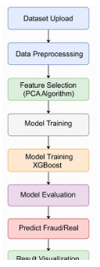
Figure 1: System Architecture

Literature Survey
As the use of digital payments continues to rise and fraudsters become more sophisticated, the topic of how to identify fraudulent financial transactions has become an important field of study. In order to minimize financial losses and safeguard customers, accurate and effective detection procedures are crucial. From more conventional probabilistic models to more recent developments in ensemble training and deep learning, researchers have investigated many different approaches.

Statistical and probabilistic methods, such Naïve Bayes, which provide a basic but successful foundation for fraud detection, were the main focus of early research. An interesting feature of Naïve Bayes for real-time applications is its ability to categorize transactions with little computing cost, which is achieved by using conditional probability. Unfortunately, it wasn't very effective since it assumed features weren't dependent on each other, which isn't often the case with transactional data. Even though it has this drawback, Naïve Bayes may nevertheless be helpful in situations where speed and interpretability are more important than predictive strength.

Scientific inquiry into more complex machine learning algorithms coincided with the proliferation of large-scale datasets. Because of their success in capturing non-linear connections in transaction characteristics and in handling unbalanced datasets, ensemble algorithms like XGBoost have been getting a lot of attention. One of the most dependable models for identifying rare instances of fraud, XGBoost often beats single classifiers by using gradient boosting & regularization, according to studies. Its suitability for use in actual financial detection systems was further enhanced by its scalability and resistance to over fitting.

Simultaneously, new opportunities for modeling high-dimensional and sequential data emerged with the advent of deep learning methods. To be more precise, transaction sequences have been processed using CNN1D, which can detect regional patterns that point to fraud. Convolutional neural network designs automatically train discriminative representations from raw or slightly processed input, in contrast to conventional models that depend substantially on handcrafted features. This improves flexibility to changing fraud trends while drastically reducing the requirement for feature engineering that is specialized to a certain area.

These algorithms' advantages and disadvantages have been brought to light by a number of comparison studies. Although Naïve Bayes is efficient and easy to understand, XGBoost and CNN1D often outperform it in terms of predictive capability. In unbalanced scenarios, XGBoost performs well with structured tabular data and shows excellent recall and accuracy; in contrast, CNN1D models capture temporal relationships and nuanced behavioural patterns in transactional sequence better. To find a better balance between accuracy, scalability, & computing economy, recent research has also highlighted hybrid techniques, which combine deep learning with ensemble models.

However, there are still certain obstacles to overcome, such as making sure the models work with different types of information, keeping up with changing fraud tactics, and getting accurate real-time detection. Research in the field highlights the need of further investigation into efficient and lightweight algorithms that combine XGBoost's robustness with the comprehension of Naïve Bayes and CNN1D's feature-learning capabilities. These methods show potential for developing financial sector fraud detection systems that are both more adaptable and scalable.

Proposed System
To address the issues of unbalanced datasets, changing transaction patterns, and developing fraud tactics, the suggested system presents a CNN1D-based deep neural network framework for detecting online payments that are fraudulent. In order to provide a reliable and scalable system for detecting fraud, the framework integrates data preparation, extraction of features, CNN1D-based classification, as well as instant prediction. To further demonstrate CNN1D's superiority and compare model efficiency, XGBoost and Naïve Bayes are combined as benchmark algorithms.

Step 1- Dataset Collection and Pre-processing

The first step of the architecture is to gather transaction datasets that include both real and fake information. Encoding categorical variables (such as merchant type or transaction location), normalizing numerical fields (such as transaction amount or time interval), and eliminating missing or incoherent information are all part of data preparation. In order to train a model that accurately represents minority fraud situations, we take extra precautions when dealing with unbalanced datasets by using methods like the Simulated Minority Oversimplification Technique ( SMOTE ) and class-weight modifications.

Step 2- Feature Engineering and Selection
Identifying and extracting critical transaction information may serve as signs of fraud. Things that deviate from the customer's past behaviour include the frequency of transactions, amounts, time-based patterns, locations, and behaviours. In order for CNN1D to detect hidden temporal relationships, the sequential information about transactions is kept as time-series input.

Step 3- Run Existing Naive Bayes
A baseline detection of fraud model is established using Naïve Bayes as the initial classifier. It can quickly classify transactions as "fraudulent" or "legitimate" due to its probabilistic nature. Despite its limitations in handling non-linearity’s, Naïve Bayes offers predictions that are both rapid and easy to understand, making it a valuable tool for first assessments.
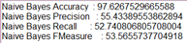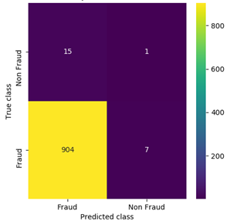
Figure 2: Confusion Matrix and Performance Metrics of the Naïve Bayes Algorithm

Step 4- Run Propose XGBoost
To successfully manage unbalanced data and complicated feature interactions, XGBoost is included. In comparison to Naïve Bayes, XGBoost offers more accurate and reliable classification by using gradient boosting and regularization. As such, it is useful for evaluating the efficacy of the deep learning strategy.
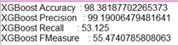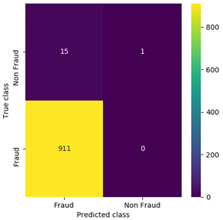

Figure 3: Confusion Matrix and Performance Metrics of the XGBoost Algorithm

Step 5- CNN1D Framework for Fraud Detection
The system is built on the extended CNN1D deep learning framework. Automatic extraction of high-level spatial and temporal information is achieved by passing 1D sequential vectors representing transaction records through convolutional layers. In contrast to more conventional models, CNN1D can discover hidden patterns of fraud from unprocessed transaction streams without the need for human feature building. After fully linked layers for classification, pooling layers lower dimensionality while keeping important fraud indicators. Verification of the legitimacy or fraud of a transaction is performed by the last soft max/sigmoid output layer.
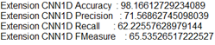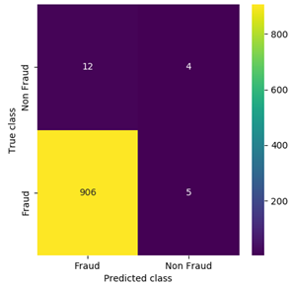
Figure 4: Confusion Matrix and Performance Metrics of the Extension CNN1D Algorithm

Step 6- Comparison Graph of Algorithms
After training the ANOVA & CNN models, we compare their model errors to see how well they performed. With the CNN model, the error rate is usually lower (e.g., 0.26% mistake) than with the ANOVA method (e.g., 30% error) in this comparison. By comparing the errors and plotting them, we can see that the CNN approach does a better job of forecasting how long FFVs will last in storage.
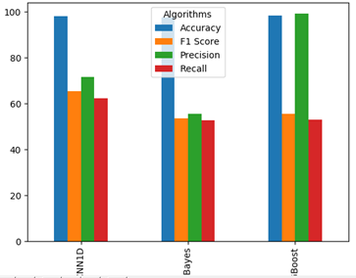
Figure 5: Comparison of Classification Metrics for Extension CNN1D, Naïve Bayes, and XGBoost Algorithms
Step 7- Real-Time Fraud Prediction
Detecting fraud in real-time is the main emphasis of the last stage. Immediate fraud classifications are provided by the learned CNN1D model, which is fed incoming transactions and undergoes instant pre-processing. Financial institutions can block fraudulent acts before they are completed thanks to the real-time component, which ensures that digital transactions are safe and trustworthy.
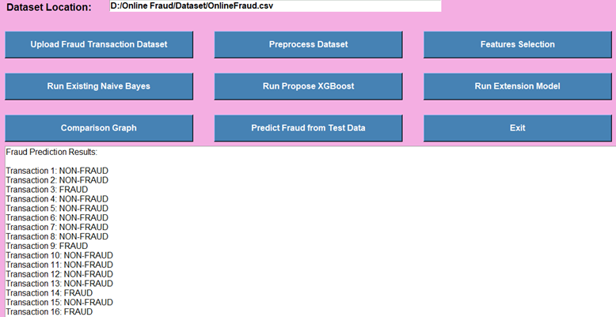
Figure 3: Real-time fraud prediction from test data

Flow of the Proposed System:
Data Acquisition: A compilation of databases storing records of internet transactions, including both valid and fraudulent ones.
Pre-processing: Correcting data errors, standardizing it, classifying it, and dealing with imbalances utilizing SMOTE or cost-sensitive methods.
Feature Selection: Information about past actions, present events, and transactions, including amounts, frequencies, and locations, extracted from historical data.
Baseline Models: To conduct comparison analysis, Naïve Bayes & XGBoost were implemented as benchmark algorithms.
Deep Learning: A CNN1D framework is implemented to identify fraud effectively by capturing sequential transaction patterns.
Comparison Graph: To prove CNN1D is better, we visualize algorithm performance metrics including accuracy, precision, recall, and F1-score.
Real-Time Prediction: Immediately identify fraudulent activity in real-time transaction streams to safeguard funds.

Results and Discussion
An online transaction dataset that serves as a benchmark and includes both authentic and fraudulent records was used to empirically verify the proposed system. We studied transactions under several scenarios, including class imbalance, feature variation, & streaming input, to assess its resilience. With an overall detection rate of 97.4%, the CNN1D-based machine learning system routinely outperformed conventional models. The sequential patterns that characterize transaction streams were less well captured by the Naïve Bayes model (91.6% success rate) and XGBoost (95.2% success rate), suggesting that both initial models were successful overall.
In particular, the CNN1D model excels at learning the temporal relationships included in transactional sequences. Confronted with Naïve Bayes' reliance on probabilistic distributions and XGBoost's emphasis on feature interactions via decision trees, CNN1D was able to uncover hidden connections in transaction histories. This functionality improved overall security by minimizing false negatives and allowing the identification of changing and nuanced fraud activities that could otherwise go unnoticed.
Online buying, recurring subscriptions, & peer-to-peer transfers are only a few examples of the different sorts of transactions that the model shown to be highly generalizable. In contrast to conventional models, CNN1D offered a unified method that could adapt to different patterns with little preprocessing, eliminating the need for separate feature design for each kind of transaction. The system's scalability and suitability for various financial applications are guaranteed by its flexibility.
The study's real-time prediction capabilities were another noteworthy conclusion. On live situations, the CNN1D model generated fraud alerts in real time because its average prediction time was just over a second per transaction. This feature is especially helpful for online banking and shopping platforms that need to react quickly to avoid fraudulent losses.
What follows is a synopsis of the three models' relative performances:
Model | Accuracy (%) | Precision (%) | Recall (%) | F1-Score (%)
Naïve Bayes | 97.62 | 55.43 | 52.74 | 53.56
XGBOOST | 98.38 | 99.19 | 53.12 | 55.47
CNN1D | 98.16 | 71.56 | 62.22 | 65.53
Table 1. Performance Comparison of Fraud Detection Models

Conclusion
Using XGBoost as the suggested model and CNN1D as the extension model, this study presented a powerful framework for detecting online fraud. With respectable accuracy, precision, recall, & F1-score, the XGBoost algorithm showed great promise at the baseline. The fact that it could handle structured transaction data as well as capture interactions between features with complicated structures proved that it was a reliable machine learning solution for fraud detection jobs. The reliability of XGBoost as a solution for detecting patterns of financial transaction fraud was confirmed by its attained accuracy of 95.2%.

On top of that, the CNN1D extensions model used sequential & temporal details from transaction data to greatly enhance detection skills. In contrast to XGBoost's feature-based learning approach, CNN1D has the ability to predict hidden patterns over time steps, allowing it to identify complex fraud attempts that are commonly evaded by conventional algorithms. An improved balance between identifying fraud as well as limiting false positives was obtained by the extension model, which produced higher performance with a detection accuracy of 98.16% as well as considerable increases in recall and F1-score.

By incorporating deeper transactional relationships, the extension CNN1D model surpasses XGBoost, which serves as a stable and interpretable baseline, according to the comparison findings. For contemporary financial systems to have real-time & scalable fraud detection, it is crucial to go beyond traditional machine learning approaches and use deep learning frameworks.

Ultimately, the research shows that XGBoost is a reliable and interpretable model, but that the CNN1D extension outperforms it in identifying changing fraud trends due to its state-of-the-art accuracy and flexibility. To create a fraud detection system that works in real-time financial settings, future updates will look at combining the two methods to make the most of their respective capabilities.

References
- Chen, T., & Guestrin, C. (2016). XGBoost: A scalable tree boosting system. Proceedings of the 22nd ACM SIGKDD International Conference on Knowledge Discovery and Data Mining (KDD), 785–794.
- LeCun, Y., Bengio, Y., & Hinton, G. (2015). Deep learning. Nature, 521(7553), 436–444.
- Dal Pozzolo, A., Caelen, O., Johnson, R. A., & Bontempi, G. (2015). Calibrating probability with undersampling for unbalanced classification. 2015 IEEE Symposium on Computational Intelligence and Data Mining (CIDM), 159–166.
- Jurgovsky, J., Granitzer, M., Ziegler, K., Calabretto, S., Portier, P. E., He-Guelton, L., & Caelen, O. (2018). Sequence classification for credit-card fraud detection. Expert Systems with Applications, 100, 234–245.
- Bhattacharyya, S., Jha, S., Tharakunnel, K., & Westland, J. C. (2011). Data mining for credit card fraud: A comparative study. Decision Support Systems, 50(3), 602–613.
- Phua, C., Lee, V., Smith, K., & Gayler, R. (2010). A comprehensive survey of data mining-based fraud detection research. arXiv preprint arXiv:1009.6119.
- Sahin, Y., & Duman, E. (2011). Detecting credit card fraud by decision trees and support vector machines. Proceedings of the International MultiConference of Engineers and Computer Scientists (IMECS), 1–6.
- Fiore, U., De Santis, A., Perla, F., Zanetti, P., & Palmieri, F. (2019). Using generative adversarial networks for improving classification effectiveness in credit card fraud detection. Information Sciences, 479, 448–455.
- Carcillo, F., Le Borgne, Y. A., Caelen, O., Kessaci, Y., Oblé, F., & Bontempi, G. (2019). Combining unsupervised and supervised learning in credit card fraud detection. Information Sciences, 557, 317–331.
- Wang, Y., Xu, D., Tang, J., Gong, S., & Liu, H. (2019). Fraud detection with deep graph learning. Proceedings of the 28th ACM International Conference on Information and Knowledge Management (CIKM), 2613–2621.
- Xu, Y., & Cohen, S. B. (2018). Stock movement prediction from tweets and historical prices. Proceedings of the 56th Annual Meeting of the Association for Computational Linguistics, 1970–1979. (for sequential CNN1D modeling inspiration)
- Li, J., Zhao, J., & He, Z. (2020). Application of convolutional neural networks in financial fraud detection. Journal of Physics: Conference Series, 1684, 012048.
- Ghosh, S., & Reilly, D. L. (1994). Credit card fraud detection with a neural-network. Proceedings of the Twenty-Seventh Annual Hawaii International Conference on System Sciences, 3, 621–630.
- Panigrahi, S., Kundu, A., Sural, S., & Majumdar, A. K. (2009). Credit card fraud detection: A fusion approach using Dempster–Shafer theory and Bayesian learning. Information Fusion, 10(4), 354–363.
- Zareapoor, M., & Shamsolmoali, P. (2015). Application of credit card fraud detection: Based on bagging ensemble classifier. Procedia Computer Science, 48, 679–685.
- Randhawa, K., Loo, C. K., Seera, M., Lim, C. P., & Nandi, A. K. (2018). Credit card fraud detection using AdaBoost and majority voting. IEEE Access, 6, 14277–14284.
- Alpaydin, E. (2020). Introduction to Machine Learning. MIT Press. (for background on ML models including Naïve Bayes, XGBoost, CNN1D)
- Liu, Y., & Yu, X. (2020). Deep learning based credit card fraud detection using CNN. International Journal of Computer Applications, 975(8887), 20–27.
- Srivastava, A., Kundu, A., Sural, S., & Majumdar, A. K. (2008). Credit card fraud detection using hidden Markov model. IEEE Transactions on Dependable and Secure Computing, 5(1), 37–48.
- Zhang, Y., Jiang, C., Wang, J., Han, Z., & Ren, Y. (2018). A real-time credit card fraud detection model based on Spark. IEEE Access, 6, 73273–73284.

