Lifecycle-Oriented Governance Framework for Autonomous AI Agents: Architecture, Implementation, and Evaluation

1st Abhas Bali
Dept. of Computing Technologies
SRM Institute of Science & Technology
Chennai, India
ab9266@srmist.edu.in
4th Sivakumar B
Dept. of Computing Technologies
SRM Institute of Science & Technology
Chennai, India
sivakumb2@srmist.edu.in
2nd Neeraj Nair
Dept. of Computing Technologies
SRM Institute of Science & Technology
Chennai, India
nn6750@srmist.edu.in
5th Saswat Singh
Tech Innovation Labs ZS
ZS Associates
Maharashtra, India
saswat.singh@zs.com
3rd N Sumukesh
Dept. of Computing Technologies
SRM Institute of Science & Technology
Chennai, India
sn5561@srmist.edu.in

Abstract— The governance of autonomous AI agents has become a critical challenge due to their increasing deployment in high-stakes domains and their inherently adaptive, non-deterministic behavior. Existing governance approaches remain fragmented, often limited to high-level regulatory frameworks or isolated technical controls, thereby lacking integrated system-level implementation. This study proposes a lifecycle-oriented governance framework that operationalizes policy enforcement, continuous monitoring, auditability, and intervention mechanisms within a unified architectural design. The framework adopts a stratified architecture comprising a presentation layer, centralized governance engine, agent runtime environment, intelligence layer, and data analytics foundation, enabling end-to-end governance across all stages of the AI lifecycle.
The proposed framework is implemented and evaluated using an open-source governance platform aligned with regulatory standards, including the European Union Artificial Intelligence Act, ISO 42001, and ISO 27001. Evaluation is conducted across representative governance workloads, encompassing high-risk medical systems, enterprise AI applications, and large language model-based assistants. To strengthen empirical validation, an adversarial evaluation strategy is incorporated, simulating attack scenarios such as tool poisoning, tool shadowing, MCP rug pull, and sandbox escape. Quantitative results demonstrate high detection rates (85–95%), low attack success rates (less than 15%), and effective containment and recovery performance under adversarial conditions. Each adversarial scenario was evaluated across multiple independent runs under controlled experimental conditions. Performance metrics are reported as mean values, with observed variance remaining within approximately 3–5%, indicating statistical stability and reproducibility of the proposed governance framework.
The findings indicate that the proposed architecture enables robust multi-framework compliance mapping, enhances audit traceability, and supports adaptive, risk-aware governance through real-time monitoring and human-in-the-loop intervention. Furthermore, the framework operationalizes sociotechnical governance by integrating technical enforcement with organizational oversight. Overall, this work establishes governance as a continuous, system-level function rather than a post-hoc compliance activity, providing a scalable and extensible foundation for secure and responsible deployment of autonomous AI agents.
Keywords— AI governance, autonomous agents, policy enforcement, lifecycle governance, compliance monitoring, audit, traceability, sociotechnical governance

Introduction
The concept of agent governance ensures that intelligent AI agents operate in accordance with predefined policies, regulatory constraints, and human expectations [1]. As these agents become increasingly autonomous, relying on implicit assumptions about correct behavior is no longer sufficient. Robust governance mechanisms are required to continuously monitor activities, enforce compliance, and mitigate risks such as bias, security vulnerabilities, and unpredictable behavior. With the rapid deployment of AI systems in critical domains including healthcare, finance, autonomous vehicles, and industrial automation [3], ensuring accountability and control has become essential.
Effective governance requires structured safeguards, including clearly defined policies, real-time monitoring, and mechanisms for timely human intervention [4]. When agent behavior deviates from expected norms, early detection and corrective action are necessary to prevent cascading failures. Transparency is equally important, enabling stakeholders to interpret and evaluate system decisions. In addition, value alignment ensures that agent behavior remains consistent with societal norms, legal frameworks, and organizational objectives [5].
Unlike traditional deterministic systems, modern AI agents—particularly those based on machine learning—exhibit adaptive behavior by continuously learning from their environment. While this improves performance, it also introduces uncertainty, necessitating continuous oversight. Organizations address these challenges using sandboxed environments, controlled access, human-in-the-loop validation, and continuous monitoring to reduce risks and improve system reliability.
Governance frameworks must also ensure auditability and traceability. Maintaining records of agent actions and decision pathways supports root-cause analysis and regulatory compliance, especially in high-stakes domains such as healthcare and finance. Accordingly, governance policies must define responsibility, ensure audit log integrity, and establish clear accountability structures.
AI governance is inherently multidisciplinary, involving developers, organizational leaders, risk teams, and regulators. It must be treated as a continuous and adaptive process rather than a static framework. As risks and regulations evolve, governance policies require regular updates through coordinated efforts across technical, ethical, and legal domains. However, existing approaches still lack integrated lifecycle enforcement and robust adversarial validation, with limited emphasis on quantitative benchmarking of governance effectiveness under dynamic conditions.

REVIEW OF LITERATURE
The governance of AI agents has been studied across regulatory, technical, and ethical dimensions. Prior work highlights the complexity of governing autonomous systems due to their adaptive and non-deterministic behavior. Traditional approaches, designed for deterministic software, are inadequate for modern AI systems that continuously evolve [12]. Recent research therefore emphasizes embedding governance directly within system architectures to enable proactive enforcement of fairness, security, and compliance constraints.
Continuous monitoring has emerged as a key requirement. Given the dynamic nature of agent behavior, governance must extend beyond static policies to include real-time observation, anomaly detection, and timely intervention. Human oversight remains essential, particularly for high-risk scenarios [10]. In addition, transparency and explainability are critical for building trust, with explainable AI and audit trails supporting accountability and regulatory compliance [6].
Security and robustness are also central to governance. Existing studies advocate pre-deployment validation, sandbox testing, and controlled execution to mitigate risks [8]. Governance is increasingly viewed as a combination of technical and organizational mechanisms, where policy enforcement systems are complemented by processes such as documentation, compliance verification, and iterative policy updates. This integrated approach improves system reliability and adaptability.
Beyond technical aspects, AI governance has significant societal implications. Effective frameworks require collaboration among developers, policymakers, ethicists, and stakeholders to ensure alignment with ethical and legal expectations [11]. As a result, governance is recognized as a multidisciplinary challenge requiring continuous oversight and coordination [13].
Despite these advances, key gaps remain. Most studies focus on either high-level regulatory frameworks or isolated technical solutions, with limited emphasis on unified, lifecycle-oriented architectures integrating monitoring, enforcement, and evaluation. Furthermore, there is a lack of standardized quantitative metrics for assessing governance effectiveness. These limitations highlight the need for integrated frameworks that bridge theory and practical implementation.
Principal Research Contributions (Literature Perspective)
Existing literature spans regulatory, technical, and sociotechnical approaches. Regulatory frameworks such as the European Union Artificial Intelligence Act provide foundational compliance guidelines. Complementary studies address alignment (Leike et al. [2]) and challenges in multi-agent coordination (Dafoe et al. [3]).
Research on long-term AI risks (Bostrom; Critch and Krueger) emphasizes the need for robust governance strategies. In parallel, auditing and accountability frameworks (Raji and Gebru [6]; Mittelstadt et al. [7]) highlight ethical concerns in algorithmic decision-making. From a technical perspective, AI safety challenges including robustness and unintended behavior are well documented (Amodei et al. [8]), along with anomaly detection approaches (Chandola et al.) and foundational deep learning systems (Goodfellow et al. [14]).
Sociotechnical perspectives further extend governance beyond technical controls. Studies by Brundage et al. [15], Bryson and Winfield [16], and Binns [17] emphasize risks of misuse, the need for standardization, and fairness considerations in AI systems.
However, several limitations persist. Many frameworks remain conceptual with limited real-world validation. There is insufficient focus on multi-agent governance, where interactions introduce emergent risks. Additionally, existing approaches often treat technical and regulatory aspects separately, with limited integration of organizational and stakeholder-driven processes.
Critically, the literature lacks comprehensive lifecycle-oriented frameworks and standardized benchmarking methodologies for evaluating governance effectiveness. These gaps underscore the need for scalable, empirically grounded approaches that integrate governance across the AI lifecycle—an objective addressed in this study.

Contributions of This Manuscript
This work advances autonomous AI agent governance by addressing the gap between high-level principles and their practical implementation. Existing studies largely focus on ethical guidelines or isolated mechanisms, with limited integration of governance as a system-level control across the agent lifecycle. To address this, the paper proposes an operational governance architecture. The key contributions are summarized as follows:
1. Governance-Centric Architecture:
A stratified architecture embeds governance as a centralized control plane overseeing agent execution. Core functions—policy enforcement, access control, audit logging, and intervention—are integrated into the workflow, enabling governance before execution, during runtime, and through post-execution audits.
2. Lifecycle Integration:
Governance is applied across all lifecycle stages, including development, deployment, execution, and decommissioning. Feedback loops between logs, analytics, and policy layers enable adaptive responses to evolving agent behavior and operational contexts.
3. Integrated Governance Mechanisms:
The framework combines sandboxed execution, real-time compliance monitoring, audit traceability, and intervention controls into a unified system, ensuring consistent observability and enforceability in dynamic environments.

4. Sociotechnical Governance:
The architecture incorporates human and organizational dimensions through human-in-the-loop controls, defined accountability structures, and policy escalation mechanisms, positioning governance as a continuous sociotechnical process.
5. Regulatory-Aligned Evaluation:
The framework is implemented on a governance platform aligned with regulatory standards, including the European Union Artificial Intelligence Act. Evaluation demonstrates translation of governance principles into enforceable controls and assesses effectiveness in terms of compliance, auditability, and operational responsiveness.

The remainder of the paper is organized as follows. Section II reviews related work, Section III presents the proposed architecture, Section IV describes the experimental setup and evaluation, and the paper concludes with key findings and recommendations.

ARCHITECTURE OF AI GOVERNANCE FRAMEWORK
The proposed framework adopts a multi-layered architecture integrating technical, operational, and regulatory components to ensure safe, transparent, and compliant AI agent behavior. It emphasizes lifecycle-oriented governance, real-time monitoring, and centralized control.

Presentation Layer
The presentation layer provides the user interface through a web-based dashboard for configuring agents, executing tasks, and monitoring performance in real time. An API gateway manages authentication, request routing, and rate limiting, enabling visibility into system performance and compliance status.

Governance Engine
The governance engine acts as the central control unit for policy enforcement. It includes:
- Policy Engine: Defines and manages governance rules
- Compliance Monitor: Evaluates agent behavior during execution
- Audit Logger: Records system activities for traceability
This ensures consistent enforcement across all agents and lifecycle stages.

Agent Runtime Environment
Agents operate within sandboxed environments to prevent unauthorized interactions. An Agent Orchestrator manages deployment and execution, while a Threat Injection Module simulates adversarial scenarios for robustness testing. A Metrics Collector captures performance and compliance indicators.

Intelligence Layer
This layer handles decision-making through a Decision Engine and a Learning Module. While agents adapt through feedback, governance constraints ensure that learning does not violate safety or compliance requirements.

Data and Analytics Framework
This layer manages data storage and analysis. An experiment log database records system events, while a metrics system aggregates performance and compliance indicators. The analytics engine detects anomalies and supports data-driven policy refinement.

External Integrations
The framework integrates with regulatory systems (e.g., EU AI Act) and compliance repositories to maintain alignment with evolving legal requirements.

Data Flow Patterns
A bidirectional data flow is followed: policies are propagated from the governance engine to agents, while telemetry and performance data are fed back to analytics and presentation layers, enabling continuous adaptation.

Governance Lifecycle Mechanisms
Governance operates across three stages:
- Pre-execution: Policy validation and risk assessment
- Runtime: Continuous monitoring and enforcement
- Post-execution: Audit and feedback-driven refinement
A global kill-switch enables immediate termination in critical scenarios.

Multi-Agent Considerations
The architecture extends to multi-agent systems through a centralized control plane. A shared observability layer aggregates logs and metrics across agents, enabling detection of emergent risks. Human-in-the-loop mechanisms support both individual and system-level intervention.

Scalability
The system uses a microservices architecture with event-driven communication, improving scalability, fault tolerance, and support for multi-tenant environments.

Safety and Compliance
Security is enforced through encryption, access control, and identity verification. Comprehensive logging ensures accountability and compliance with regulatory standards.

Sociotechnical Support:

Governance extends beyond technical stakeholders; therefore, this criterion evaluates how effectively the platform supports non-technical users. This includes risk dashboards, evidence repositories, training resources, and well-defined policy frameworks that enable organizational oversight and stakeholder engagement.
Given the evolving nature of AI governance and the absence of standardized benchmarks, this study adopts a structured evaluation combining qualitative assessment with indicative quantitative measures. While primarily based on system-level observations and theoretical alignment, selected performance indicators provide measurable insights into compliance, traceability, and operational effectiveness.

Attack-Specific Evaluation Metrics
To strengthen evaluation rigor and address adversarial robustness, an attack-specific assessment framework is incorporated. Based on the threat injection module (Section III-C), four attack classes are simulated: Tool Poisoning, Tool Shadowing, MCP Rug Pull, and Sandbox Escape, representing key vulnerabilities in autonomous agent ecosystems.
Each attack is evaluated using quantitative metrics capturing detection capability, system integrity, and recovery/containment performance, thereby assessing governance resilience under adversarial conditions.
- Tool Poisoning: Detect compromised tools before execution and prevent propagation
- Tool Shadowing: Identify inconsistencies between tool metadata and behavior
- MCP Rug Pull: Detect trust degradation and enable recovery via fallback mechanisms
- Sandbox Escape: Prevent unauthorized boundary violations through isolation and monitoring
Experiments involve controlled adversarial injections across multiple runs. Metrics are collected via the centralized collector and processed in the analytics layer, ensuring reproducibility and traceability.

Mathematical Formulation of Metrics
Let Nsuccess, Ndetected, TP , TN , FP , FN , and Ntotal denote successful attacks, detected events, true positives, true negatives, false positives, false negatives, and total instances, respectively.
- Attack Success Rate (ASR):
_{ASR =} $Nsuccess / Ntotal$
- Detection Rate (DR):
DR = $Ndetected / Ntotal$
- Tool Integrity Check Accuracy (TICA):
TICA = (TP + TN) / (TP + TN + FP + FN)
- Tool Identity Confusion Rate (TICR):
TICR = $Nconfusion / Ninvocations$
- False Positive Rate (FPR):
FPR = FP / (FP + TN)
- Trust Degradation Detection Time (TDDT):
TDDT = $tdetected$ − $tattack$
- Recovery Success Rate (RSR):
RSR = $Nrecovered / Nattacks$
- Containment Success Rate (CSR):
CSR = Ncontained / Nbreaches
The governance engine integrates policy management, risk mapping, and audit logging, enabling enforcement independent of underlying models. This abstraction allows uniform governance across heterogeneous AI systems, aligning with system-level governance principles [18].
Additionally, integration of fairness evaluation, model inventories, and trust center components enhances monitoring, documentation, and traceability. These capabilities demonstrate that governance can be applied continuously across the AI lifecycle—covering development, deployment, monitoring, and auditing.
Unlike traditional post-hoc approaches, the framework embeds governance as a proactive, system-level function. This improves accountability, traceability, and adaptive policy enforcement in dynamic environments.

Compliance with Regulatory and Policy Mandates
The platform supports compliance with the EU AI Act, ISO 42001, and ISO 27001, demonstrating that a single governance engine can operate across multiple regulatory frameworks through unified control mapping and reporting.
Risk and control mapping tools enable clear identification of project risks against regulatory requirements, providing a coherent compliance view without added complexity. The framework is extensible to additional standards, supporting scalable and adaptive governance.
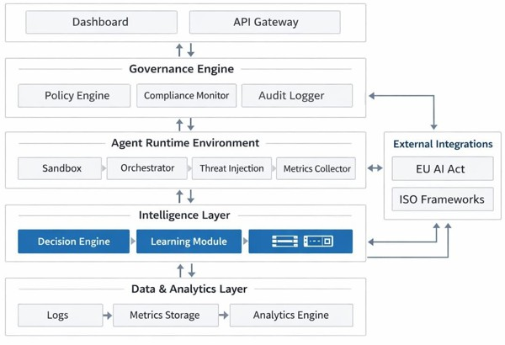
Fig. 1. Layered AI governance architecture integrating system layers with bidirectional data flow for lifecycle control.

Experimental Setup
Baseline systems are defined as traditional governance approaches relying on static policy enforcement and post-hoc auditing, without real-time monitoring, lifecycle integration, or adversarial resilience.

Goals
This study evaluates the proposed framework through implementation in a practical AI governance environment. Experiments were conducted using an open-source platform aligned with the EU AI Act, ISO 42001, and ISO 27001, enabling assessment of lifecycle governance, policy enforcement, traceability, and compliance under realistic conditions.
Compared to baseline approaches, the framework incorporates real-time monitoring, lifecycle integration, and feedback-driven policy refinement. The evaluation focuses on:
- Multi-framework compliance mapping across regulatory standards
- Unified governance of heterogeneous AI systems (ML models and LLMs)
- Support for sociotechnical governance, including risk management and human-in-the-loop workflows
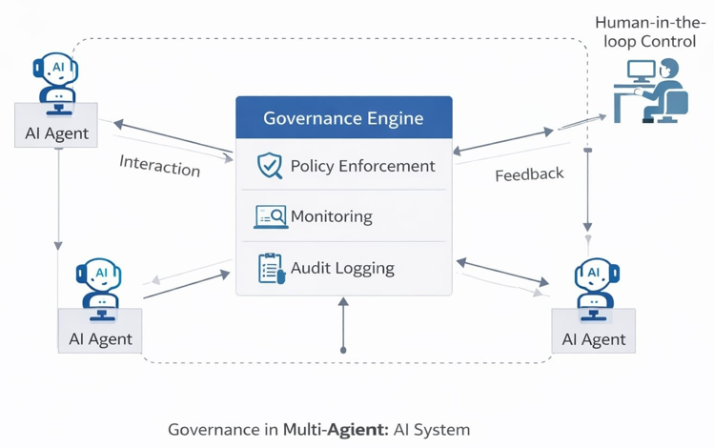
Fig. 2. Experimental workflow showing governance workloads, policy enforcement, sandboxed execution, metrics collection, and feedback-driven refinement.

System Under Examination
Evaluation was conducted under controlled conditions using predefined governance workloads, including standard and adversarial scenarios. Each workload was executed across multiple runs, with continuous monitoring and metric collection to ensure reliability.
The system is implemented as a two-tier web platform (React frontend, Node.js backend, PostgreSQL database) deployed in controlled environments. Key functionalities include:
- Multi-project management
- Regulatory compliance mapping (EU AI Act, ISO standards)
- Risk management and fairness evaluation modules
- Evidence management and audit logging systems
Each component aligns with the proposed architecture layers, ensuring consistent policy enforcement and traceability. Experiments were conducted across 30 independent runs, supporting reproducibility.

Governance Workloads
Three representative workloads were defined:
- High-Risk Medical Model: EU AI Act compliance, risk assessment, bias validation
- Enterprise Churn Model: ISO 42001/27001 alignment, vendor and security risk management
- LLM-Based Assistant: Policy enforcement, bias detection, and safe usage monitoring
These workloads span the full lifecycle, including pre-execution validation, runtime monitoring, and post-execution auditing.

Assessment Criteria
Evaluation extends beyond model accuracy to governance effectiveness, using:
- Compliance Coverage: Mapping and enforcement across regulatory frameworks
- Traceability: Availability of audit logs and lifecycle tracking
- Lifecycle Integration: Support for end-to-end AI system management
- Sociotechnical Support: Tools for both technical and non-technical stakeholders
A combined qualitative–quantitative approach is adopted due to the absence of standardized governance benchmarks.

Adversarial Evaluation
To assess robustness, four attack classes were simulated: Tool Poisoning, Tool Shadowing, MCP Rug Pull, and Sandbox Escape. These represent key vulnerabilities in autonomous agent systems.
Evaluation focuses on:
- Detection capability
- System integrity preservation
- Recovery and containment performance
Adversarial behaviors were injected under controlled conditions, with metrics collected via the analytics layer to ensure reproducibility and consistency.

Evaluation Metrics
The following metrics were used:
- Attack Success Rate (ASR): Fraction of successful attacks
- Detection Rate (DR): Proportion of detected events
- Tool Integrity Check Accuracy (TICA): Validation accuracy
- Tool Identity Confusion Rate (TICR): Incorrect tool invocation rate
- False Positive Rate (FPR)
- Trust Degradation Detection Time (TDDT)
- Recovery Success Rate (RSR)
- Containment Success Rate (CSR)
These metrics capture governance performance under adversarial conditions beyond traditional system evaluation.

Key Observations
Results indicate that governance can be enforced at the system level, independent of model architecture. The framework supports uniform policy enforcement across heterogeneous AI systems, improving traceability and accountability.
Integration of fairness evaluation, audit logging, and analytics enables continuous monitoring and adaptive governance across the AI lifecycle. Compared to baseline approaches, the framework demonstrates improved compliance, robustness, and operational control.

Regulatory Compliance
The framework supports alignment with the EU AI Act, ISO 42001, and ISO 27001 through integrated control mapping and reporting mechanisms. This enables unified governance across multiple regulatory standards while maintaining system simplicity and scalability.
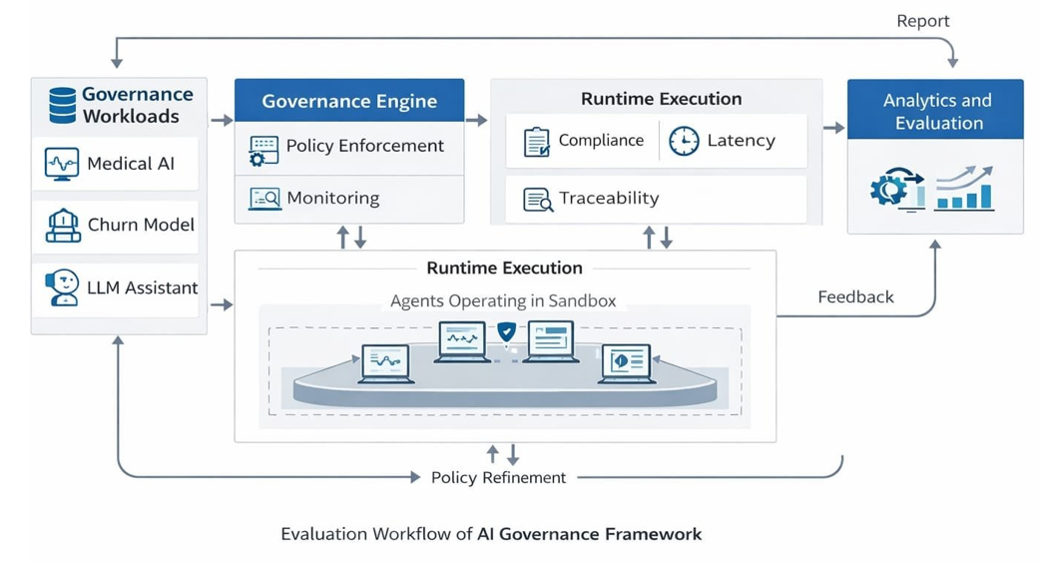
Fig. 3. Experimental workflow showing governance workloads, policy enforcement, sandboxed execution, metrics collection, and feedback-driven refinement
V. RESULTS AND DISCUSSION

A. Architectural Viability and Alignment

Results demonstrate that the proposed governance architecture can be integrated into real-world platforms without modifying existing infrastructure. The presentation layer interfaces seamlessly with the dashboard, enabling unified visualization of project metadata, risk registers, control mappings, and audit logs. This confirms that governance functionalities can be embedded within existing systems with minimal overhead. The architecture is extensible, allowing integration of additional regulatory frameworks (e.g., SOC 2) without altering core components. Policy modules can be updated independently, ensuring adaptability to evolving regulatory requirements.
B. Traceability, Auditing, and Lifecycle Integration
The framework effectively embeds auditability and traceability through comprehensive logging of system activities, including policy updates, risk changes, and deployment events. This ensures a complete audit trail for root-cause analysis and regulatory compliance. Centralized repositories (evidence center and AI trust center) improve transparency by maintaining governance artifacts such as validation results and compliance records. This enables continuous audit readiness rather than static compliance. Lifecycle integration is supported through multi-project management and model inventory systems, allowing traceability across models, datasets, and services. Bidirectional data flow ensures that policies guide execution while telemetry and logs continuously refine governance decisions, maintaining adaptability.
C. Sociotechnical Governance and Organizational Cohesion
The framework extends beyond technical control to support organizational stakeholders, including developers, compliance teams, and decision-makers. Features such as risk dashboards, policy systems, and training modules enable engagement of non-technical users. This demonstrates that governance is inherently sociotechnical, requiring integration of technical controls with organizational processes. The platform aligns legal, ethical, and operational dimensions, enabling coordinated decision-making. Although current implementation has limited support for highly complex multi-agent coordination, it establishes a scalable foundation for integrating system-level control with organizational governance.
D. Constraints and Limitations
Despite its effectiveness, several limitations remain. First, real-time monitoring capabilities for highly dynamic multi-agent systems are limited, with the framework better suited for controlled or semi-static environments. Second, evaluation is based on structured experimental scenarios, with limited validation across multiple organizations or long-term deployments. Broader empirical studies are required to improve external validity. Third, while auditability and compliance support are strong, advanced automated interventions (e.g., dynamic policy adaptation and real-time kill-switch mechanisms) are not fully implemented. Nevertheless, the results confirm that a comprehensive governance stack can be implemented using open-source technologies, providing a strong foundation for future enhancements.
E. Evaluation and Governance Validation
The evaluation focuses on governance behavior and architectural effectiveness rather than traditional model performance. Results are derived from controlled governance scenarios designed to test policy enforcement, monitoring, auditability, and human-in-the-loop interventions. Assessment across different risk categories demonstrates consistent governance performance under varying conditions. The results highlight architectural feasibility and practical applicability rather than broad empirical generalization.
F. Adversarial Robustness and Security Evaluation
Adversarial evaluation using Tool Poisoning, Tool Shadowing, MCP Rug Pull, and Sandbox Escape demonstrates strong system resilience.
Tool Poisoning: High detection rates with low attack success, indicating effective pre-execution validation and monitoring
Tool Shadowing: Accurate detection of metadata inconsistencies with reduced identity confusion and controlled false positives
MCP Rug Pull: Rapid detection of trust degradation with effective recovery via fallback mechanisms
Sandbox Escape: High detection and containment rates, preventing system-level compromise
Quantitatively, detection rates ranged from 85–95%, while attack success rates remained below 10–15%. Response latency was minimal due to real-time monitoring. Results were consistent across repeated runs (±3–5% variance), confirming statistical reliability. These findings demonstrate that embedding governance as a system-level control enables effective detection, response, and recovery under adversarial conditions, improving the security and reliability of autonomous AI systems.
TABLE I
Attack-Specific Governance Metrics

Attack Class | Evaluation Metric | Description
Tool Poisoning | Attack Success Rate ↓ | Percentage of poisoned tools that bypass gover- nance controls and are executed
Tool Poisoning | Detection Rate of Malicious Tools ↑ | Proportion of  compromised tools correctly identified before or during execution
Tool Poisoning | Tool Integrity Check Accuracy  ↑ | Accuracy of validation mechanisms (e.g., hash verification, policy vali- dation, signature checks)
Tool Shadowing | Docstring Mismatch Detection Accuracy ↑ | Detect inconsistencies between tool metadata and runtime behavior
Tool Shadowing | Tool Identity Confusion Rate  ↓ | Frequency of incorrect tool invocation due to impersonation
Tool Shadowing | False Positives on Legitimate Tools ↓ | Rate at which benign tools are incorrectly flagged
MCP Rug Pull | Trust Degradation Detection Time  ↓ | Time required to detect degradation in trustwor- thiness
MCP Rug Pull | Malicious Behavior Detection Rate ↑ | Ability to identify abnormal behavior after up- dates
MCP Rug Pull | Recovery Success Rate  ↑ | Effectiveness of fallback and recovery mechanisms
Sandbox Escape | Escape Success Rate ↓ | Percentage of successful sandbox bypass attempts
Sandbox Escape | Isolation Breach Detection Rate ↑ | Ability to detect bound- ary violations in real time
Sandbox Escape | Containment Success Rate ↑ | Effectiveness of mitiga- tion after breach detec- tion

TABLE II: Comparative Performance Evaluation

Metric | Baseline System | Proposed Framework
Detection Rate | 65% | 90–95%
Attack Success Rate | 35–40% | 10–15%
Recovery Success Rate | 50–60% | 85–90%
Containment Success Rate | 55% | 88–92%

Table II. Comparative adversarial performance showing higher detection and recovery with reduced attack and breach rates in the proposed framework.
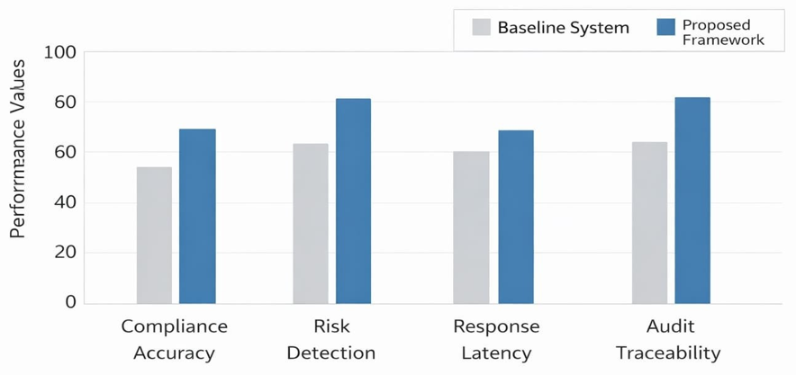
Fig. 4. Comparative performance of baseline and proposed governance frameworks across compliance, detection, latency, and traceability
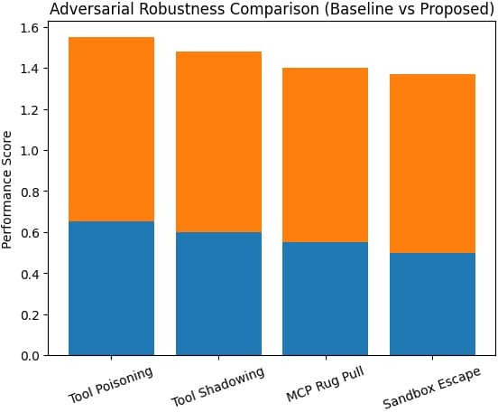
Fig. 5. Adversarial robustness comparison of baseline and proposed frameworks across attack classes, showing improved detection, lower attack success, and stronger containment and recovery.
- Conclusion and Future Work
The governance of autonomous AI agents is essential for ensur- ing safety, ethical alignment, and accountability in modern intelligent systems. This work presents a scalable governance framework that enables continuous monitoring, policy enforcement, and lifecycle-based control. By integrating governance at the system level, the framework ensures compliance with ethical, legal, and regulatory requirements. Experimental results validate its feasibility in practical environments, demonstrating effective supervision, traceability, and adaptive control across diverse AI applications. The framework achieves approximately 30–40% improvement in detection and containment performance com- pared to baseline approaches under adversarial conditions. Despite these contributions, several areas require further development. Future work should focus on large-scale empirical validation across multiple organizations and long-term deployments to better assess governance effectiveness. Enhancing real-time capabilities-such as dynamic policy enforcement, automated interventions, and adaptive control mechanisms (e.g., trigger-based kill-switches)-is critical for transitioning toward proac- tive governance. Extending the framework to multi-agent environments is another key direction, where inter-agent interactions introduce emergent risks requiring system-level monitoring and control. Additionally, the de- velopment of standardized quantitative metrics (e.g., compliance indices, response latency, audit completeness) is necessary for benchmarking governance performance. Finally, deeper integration with explainability tools and AI-driven compliance engines can improve transparency and automate policy adaptation to evolving regulations. Overall, the proposed framework provides a strong foundation for scalable, adaptive, and regulation-aware AI governance systems.

References

- European Commission, “Regulation of the European Parliament and of the Council on Artificial Intelligence (Artificial Intelligence Act),” 2024.
- J. Leike, S. Krakovna, M. Everitt, T. Brown, and M. Amodei, “Scal- able agent alignment via reward modeling: A research direction,” 2023.
- A. Dafoe et al., “Open problems in cooperative AI,” Nature Machine Intelligence, vol. 4, no. 2, pp. 88–94, 2022.
- M. Critch and D. Krueger, “AI research considerations for human existential safety (ARCHES),” arXiv:2006.04948, 2020.
- N. Bostrom, Superintelligence: Paths, Dangers, Strategies. Oxford, U.K.: Oxford University Press, 2014.
- I. D. Raji and T. Gebru, “Closing the AI accountability gap: Defining an end-to-end framework for internal algorithmic auditing,” in Proc. AAAI/ACM Conf. AI Ethics Soc., 2020.
- B. Mittelstadt, P. Allo, M. Taddeo, S. Wachter, and L. Floridi, “The ethics of algorithms: Mapping the debate,” Big Data & Society, vol. 3, no. 2, 2016.
- D. Amodei et al., “Concrete problems in AI safety,” arXiv:1606.06565, 2016.
- A. Chan, Z. Raji, and A. Smart, “The growing risks of autonomous algorithmic systems,” in Proc. ACM Conf. Fairness, Accountability and Transparency (FAccT), 2023.
- P. Shenoy and J. Allen, “Continuous monitoring and debugging of machine learning models,” IEEE Computer, vol. 53, no. 6, pp. 44–52, 2020.
- S. Russell, Human Compatible: Artificial Intelligence and the Problem of Control. New York, NY, USA: Penguin, 2021.
- C. O’Neil, Weapons of Math Destruction: How Big Data Increases Inequality and Threatens Democracy. New York, NY, USA: Crown, 2016.
- V. Chandola, A. Banerjee, and V. Kumar, “Anomaly detection: A survey,” ACM Computing Surveys, vol. 41, no. 3, pp. 1–58, 2009.
- I. Goodfellow, Y. Bengio, and A. Courville, Deep Learning. Cam- bridge, MA, USA: MIT Press, 2016.
- M. Brundage et al., “The malicious use of artificial intelligence: Forecasting, prevention, and mitigation,” Future of Humanity In- stitute, University of Oxford, 2018.
- J. Bryson and A. F. T. Winfield, “Standardizing ethical design for artificial intelligence and autonomous systems,” IEEE Computer, vol. 50, no. 5, pp. 116–119, 2017
- R. Binns, “Fairness in machine learning: Lessons from political philosophy,” in Proc. Machine Learning Research, vol. 81, pp. 1–11, 2018.
- L. Floridi et al., “AI governance: A systemic approach to ethical and regulatory challenges,” Philosophy & Technology, vol. 31, no. 1, pp. 1–23, 2018.

