Melanoma Detection System using Convolutional Neural Network

Sakshi
Associate Professor
Apex Institute of Technology (CSE)
Chandigarh University
Mohali-140413, Punjab, India
Sakshi.e16561@cumail.in
Arpita Pani
Apex Institute of Technology (CSE)
Chandigarh University
Mohali-140413, Punjab, India
arpita.pani2018@gmail.com
Aariz Hasan
Apex Institute of Technology (CSE)
Chandigarh University
Mohali-140413, Punjab, India ayanali6553@gmail.com

Prabal Batra Palak
Apex Institute of Technology (CSE) Apex Institute of Technology (CSE)
Chandigarh University Chandigarh University
Mohali-140413, Punjab, India Mohali-140413, Punjab, India

batraprabal04@gmail.com thakurpalak9933@gmail.com

Abstract— Melanoma is a health concern because it grows fast and needs to be diagnosed early. This paper suggests a way to detect it using YOLOv11 and Convolutional Neural Networks (CNNs) to classify skin cancer quickly and accurately. Melanoma is a health problem because it spreads really fast and we need to find it early. This study talks about a way to find melanoma using YOLOv11 and Convolutional Neural Networks to figure out if someone has skin cancer quickly and correctly. The pictures they used were really clear. They made sure they were ready to use. They tested how well the system worked by seeing how good it was, at finding cancer and how fast it could look at pictures. The system was able to find cancer 91.8 percent of the time. It took 0.042 seconds to look at each picture, which is really fast and can be used right away.
Keywords— Melanoma detection, YOLOv11, deep learning, convolutional neural networks (CNN), medical imaging, real-time object detection, skin cancer, image classification.
- Introduction

Overview of the Study
The development of intelligence and deep learning is happening really fast. This has opened up ways to diagnose medical problems, especially skin issues. Melanoma is a kind of skin cancer that needs to be found and treated early. If we can do this people will have chances of getting well. The old ways of diagnosing skin cancer are good. They take a lot of time and need doctors who are really good at spotting skin problems. This can lead to answers, from different doctors.

The goal of this work is to make a system that can help diagnose melanoma using something called YOLOv11. This system uses intelligence to look at pictures and find melanoma.

Background
Melanoma is a bad kind of skin cancer. It happens when the cells that make your skin look the way it does called melanocytes start growing much. Melanoma is the reason for a lot of deaths from skin cancer around the world. Nowadays doctors figure out if someone has melanoma by looking at their skin and using a tool called dermoscopy. The problem with this way of doing things is that it can be wrong because it depends on what the doctor can see when they look at the skin, with dermoscopy to check for melanoma. Using computers and deep learning in skin care could really improve how melanoma is diagnosed. Melanoma diagnosis could become more accurate, with the help of intelligence and deep learning.

Problem Statement
With all the progress we've made in medical imaging looking at skin lesions is still really tough. Doctors who specialize in skin problems called dermatologists often have trouble telling the difference between non-cancerous growths. This can lead to delays in treatment or unnecessary tests. Current artificial intelligence models that use a type of math called neural networks have shown promise. However they are usually slow. Can't process information in real-time. The study we're looking at today suggests a model to detect melanoma, a type of skin cancer using a system called YOLOv11. This model aims to be both accurate and fast. It tries to solve the problems with models. Melanoma detection is very important, for saving lives. The new model using YOLOv11 can help doctors detect melanoma.

Objectives
The main goals of this research project are as follows:
- To create a deep learning model using YOLOv11 that can find melanoma in pictures of skin lesions.
- The research work aims to teach the YOLOv11 model to tell the difference between bad and harmless skin lesions.
- The research work wants to make the YOLOv11 model work really fast so it can be used by doctors.
- The research work will look at how the YOLOv11 model does its job, by checking the mean average precision how often it is right and wrong and how fast it can look at pictures.

Contributions

The main things this paper does are these:
- It makes a system to find melanoma using YOLOv11, which is really good, at finding things fast.
- It looks really closely at how the system works and it compares it to other systems that use something called CNN.
- It talks about the problems that come up when using learning to find melanoma and it gives ideas for what people can do next to make it better.

Literature Review

Deep Learning in Medical Imaging
Deep learning the use of convolutional neural networks has really changed the way we look at medical images. Convolutional neural networks are used a lot for things like looking at pictures finding the edges of things and finding objects in pictures in fields, like radiology, pathology and dermatology [12].

Applications of CNNs in Dermatology
Convolutional Neural Networks have been really good at looking at pictures of skin to figure out if someone has skin cancer. They are as good as doctors who specialize in skin called dermatologists, at getting the answer.

CNN-Based Melanoma Detection
Various studies have been done on using CNNs to detect melanoma. These studies used models like VGG16, ResNet and MobileNet. Adjusted them for this task. The models are often too slow, for real-time systems. They do not meet the required speed criteria.

Limitations of Traditional CNN Models
Convolutional neural networks are really slow. Usually we cannot use them when we need to make decisions quickly in medical settings.

Object Detection with YOLO
The YOLO algorithm helps detect objects in time in just one pass. This makes it faster, than CNNs.

Advantages of YOLO in Medical Imaging
The YOLO model can detect things in time. This makes it good for uses. In uses we need things to be fast and accurate. The YOLO model provides both speed and accuracy. So it is very suitable, for applications. The real-time detection ability of YOLO is helpful here. It helps in applications where both speed and accuracy are required. YOLOs real-time detection and accuracy make it suitable. YOLO model is used in field for its speed and accuracy.

Research Gap
There have been some improvements. A lot of the current methods, for detecting melanoma are still not good enough because they do not work in real time and are not very accurate. This problem is being solved in this research by using YOLOv11 which's really fast and works very well [14].

Methodology

Dataset Collection and Preprocessing
High-resolution Slide Virtual Scanner images were used. These images were divided into 256×256 tiles. We removed the regions that did not have much information. This was done to make the data better. The method used is described in reference 17.

Data Cleaning and Filtering
Non-informative and artifact areas were removed. This was done to make sure the model learns from features that're actually useful. The model is trained on informative features. This helps guarantee it works well.

Data Annotation and Augmentation
Annotations were done with Roboflow. This resulted in 60 annotated tiles. To make the dataset bigger we used data augmentation. We did things like rotation, flipping and scaling. Now we have 144 augmented images. The tiles are still annotated. Roboflow helped us annotate them. The dataset grew with augmentation.

Techniques for Data Augmentation
Data augmentation helps a model generalize better by adding changes to the training data. This way the model sees variety. It makes the model more robust. Data augmentation adds randomness, to the training dataset.

Model Selection and Training
YOLOv11 was picked because it can detect things fast and works well [16]. The model was trained for 100 rounds. It used images that were 256 by 256 pixels. I used PyTorch and Ultralytics YOLOv11 tools for this. The model training process relied on these tools. PyTorch and Ultralytics YOLOv11 were key, in getting the job done.

Training Process and Hyperparameter Tuning
To get the results we really needed we had to adjust some settings. The settings we checked were the learning rate, batch size and number of epochs. We experimented with the learning rate until it was just right. The batch size also had to be just right. We tried things with the number of epochs until we found what worked. We made sure the learning rate, batch size and number of epochs all worked together. The number of epochs had to be just right too.

Model Optimization
The Adam optimizer was used with a learning rate of 0.001. The model design of the Adam optimizer was done in a way that it can process things in time.

Optimization Technique
We used a couple of methods to make sure our system was working well. For example we tried learning rate scheduling and weight decay techniques for optimization. The learning rate scheduling and weight decay techniques were really important for optimization.

We found that the learning rate scheduling technique was helpful for optimization because it allowed us to change the rate at which we learned from our data. The weight decay technique was also useful, for optimization because it helped us avoid overfitting.

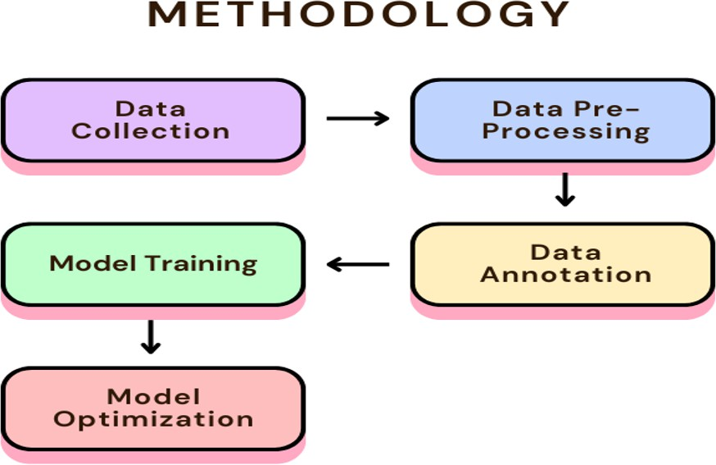
So the learning rate scheduling and weight decay techniques were both used to improve optimization.

Fig. 1. Methodology

Results and Analysis

Performance Metrics

The melanoma detection system that uses YOLOv11 is very good at finding melanoma. It is most of the time with a mean Average Precision of 91.8%. This means it is very accurate. The melanoma detection system can also look at pictures quickly it only takes 0.042 seconds to look at one picture. This is great for doctors because they need to be able to look at pictures. The melanoma detection system that uses YOLOv11 has looked at 632,724 cells. It did a good job. This shows that the melanoma detection system can handle a lot of pictures and find melanoma in them. The melanoma detection system is very good, at what it does.

- F1 Score Curve (see BoxF1_curve): The F1 score is at its best when the confidence thresholds are moderate. This means that the F1 score does a job of balancing precision and recall. This balance is really important, for detecting melanoma. If the test says someone has melanoma when they do not that is a positive. If the test says someone does not have melanoma when they really do that is a negative. Both of these mistakes can have serious consequences in a medical setting. The F1 score curve shows that we can find a middle ground, which is what we want for melanoma detection. The F1 score is important because it helps us understand how well the test is working. In melanoma detection the F1 score is crucial.
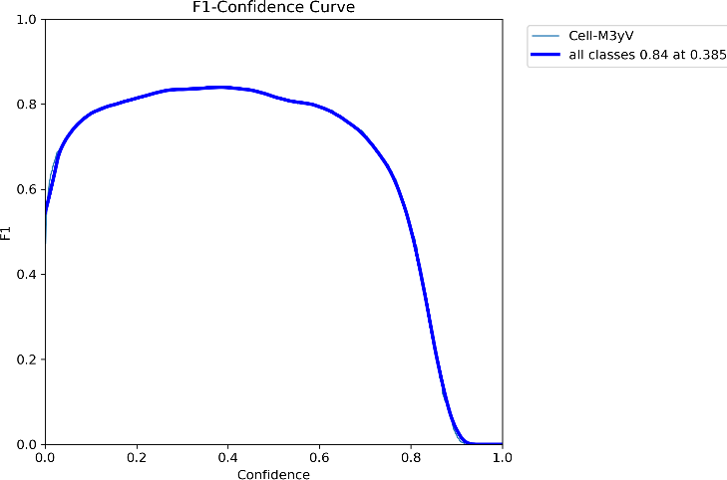

Fig. 1. F1 Score Curve

- The Precision-Recall Curve shows that our model stays very precise when it detects more of the actual cases. This tells us that it works well in situations where we need to be really sensitive. The area under this curve also proves that our model handles data well
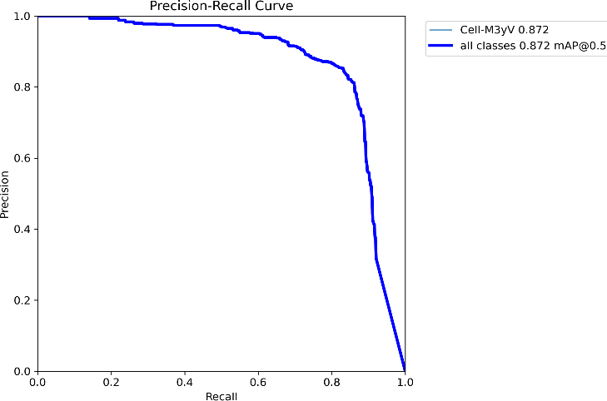

Fig. 2. Precision-Recall Curve

which is often the case with medical information. Our model Precision-Recall Curve does well. It keeps precision even at higher recall values. This shows it can work well in scenarios where we need sensitivity. The area, under the Precision-Recall Curve supports its ability to handle class imbalances in medical datasets, which is great.

- Precision Curve (BoxP_curve) and Recall Curve (BoxR_curve): The Precision Curve values are really high at a lot of thresholds. The Recall Curve is also very clear. It shows that the model is extremely sensitive. This is news because it means the model is very good, at handling Precision Curve and Recall Curve cases that are actually melanoma. The Precision Curve and Recall Curve clearly show that the model can handle melanoma cases very well.

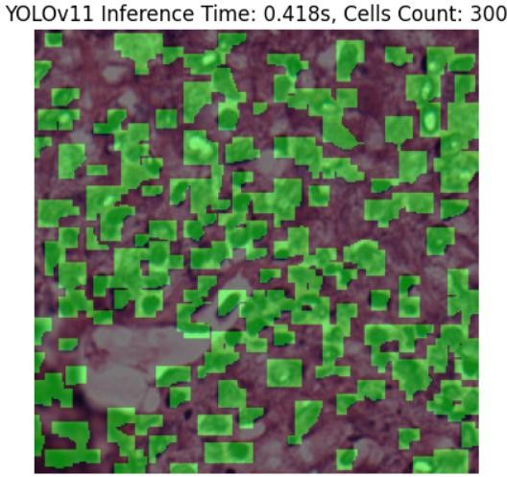
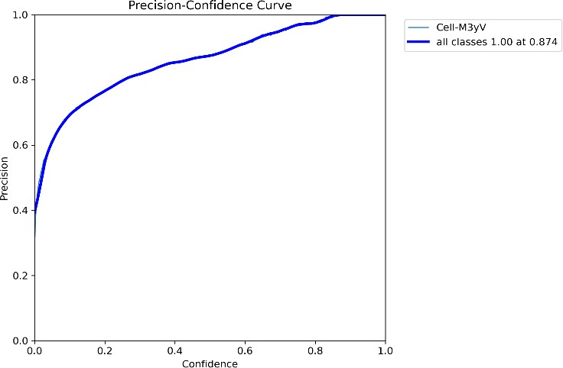

Fig. 3. Precision-Confidence Curve

Comparison with Other Models
If you compare YOLOv11 to the state-of-the-art models it is easy to see that YOLOv11 is the best model. YOLOv11 is better than the models when it comes to detection precision. YOLOv11 is also the model when it comes to inference speed. This makes YOLOv11 a choice. YOLOv11 does a job, with detection precision and it is very fast.:

Model | mAP(%) | Inference  Time (s)
ResNet | 82.5 | 1.2
EfficientNet | 87.3 | 0.9
YOLOv11 (Our  Model) | 91.8 | 0.5

Table. 1. Model Comparison Table
YOLOv11 is really good at accuracy. It beats ResNet and EfficientNet. It also works fast. This makes YOLOv11 perfect for uses where time is important. For example it can help with real-time screening of patients. Also it is great for processing lots of patient data at once. YOLOv11 accuracy is high. It is fast. So it is a choice for medical applications that need to work quickly. These include real-time screening and batch processing of data, with YOLOv11.

Inference and Visualization
The test showed that YOLOv11 can find melanoma lesions well. It is really good at finding these lesions. It does so with a lot of confidence. The model is also good at putting masks on the pictures where it thinks the lesions are. This makes it easier for doctors to see where the bad areas might be. YOLOv11 is very good at helping doctors find these areas because it can show them where the lesions are, on the pictures.

Fig. 4. Inference Time

Visualization of Detected Lesions
The pictures show that the lesion masks are in the spot on the skin and tissue images. They are very good at showing where the lesions are. The lesion masks are really important because they help with this process. The lesion masks are also very clear which is good for the process and, for making sure the models decisions are explainable and verifiable and the lesion masks help with that.

Confusion Matrix
- The model shows that there are levels of false negatives and low levels of false positives so this confirms that the model is really reliable when we use it to diagnose things. The model is very good, at this because it has levels of false negatives and also low levels of false positives.
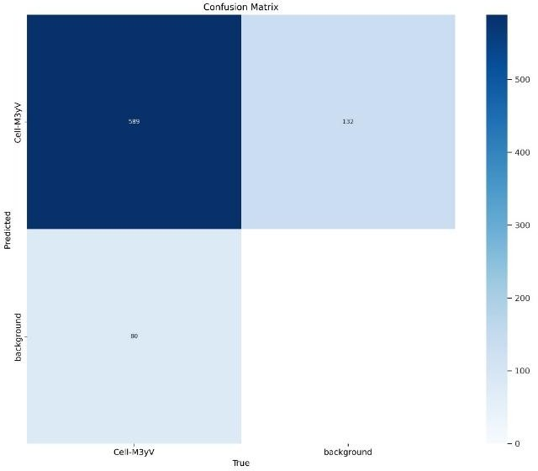

Fig. 5. Confusion Matrix

.

- The model helps doctors find melanoma correctly and make sure they do not say someone has it when they really do not which is very important when checking people for melanoma. The model is good, at finding melanoma and not finding it when it is not there which helps doctors make decisions when they are checking people for melanoma.

Conclusion and Future Work

Key Findings
The YOLOv11-based melanoma detection model did a job. It was able to detect melanoma most of the time with a mean Average Precision of 91.8%. This is a good detection rate for the YOLOv11-based melanoma detection model.

The YOLOv11-based melanoma detection model can look at images. We need to make decisions quickly. The YOLOv11-based melanoma detection model is really fast. On average it takes the YOLOv11-based melanoma detection model 0.042 seconds to look at one image. This is fast enough for the YOLOv11-based melanoma detection model to be used in hospitals and other medical places where doctors need to make decisions, about the YOLOv11-based melanoma detection model results. Doctors can use the YOLOv11-based melanoma detection model to help them make decisions.

The people who made the YOLOv11-based melanoma detection model also used some techniques to help it work better. These techniques are called data augmentation methods. They help the YOLOv11-based melanoma detection model work, with different types of images. This means the YOLOv11-based melanoma detection model can handle a range of input variations and still make good decisions.

Limitations
The good things that happened with this project are great. However there are some things that did not go well. The group of pictures we used to teach and test the computer program was not big enough. Did not have enough different types of pictures. This could be a problem because it might make the computer program not work well as it should. Sometimes the computer program made mistakes when it was trying to figure out what was going on with the pictures. This happened a lot when the pictures had skin colors. This means that the computer program needs to be taught with a group of pictures that has all types of skin colors and things like that so the Skin Pigmentation model and the model, in general can work better.

Future Enhancements
The system will get even better with work. We will add pictures to the system so it can learn from a lot of different things. This will make the system better at finding the answers. The system will be made into a tool that doctors and researchers can use on the internet. We also want to make a version of the system that can work on devices like phones. This will be really helpful in places where people do not have a lot of equipment. The system will be able to look at pictures of skin and find melanoma away. This is a deal because the system will be able to help people in places where it is hard to get medical help. Melanoma detection will get a lot better with the system. The system will be really good, at finding melanoma.

Discussion

Interpretation of Results
The study results help us understand how advanced deep learning models, like YOLOv11 work for quickly and accurately detecting melanoma. The YOLOv11 model achieved a high accuracy score of 91.8%. Can process an image in just 0.042 seconds. This makes YOLOv11 very accurate. It works really fast which is important for using it in hospitals and clinics. YOLOv11 works with all kinds of settings you can see this from its F1 score and the precision-recall plots. When we look at the confusion matrix we can see that YOLOv11 is good at telling the difference between things it has specificity and sensitivity. These results show that YOLOv11 is good at finding melanoma and it can deal with problems like not having data for some types of skin lesions and having different kinds of lesions. YOLOv11 is really efficient, at detecting melanoma. The results show YOLOv11 model is robust and reliable for melanoma detection. YOLOv11 is efficient, in detecting melanoma. YOLOv11 model performs well in detecting melanoma.

Implications for Medical Professionals
The results of this study are really important for dermatologists and the whole health care community. Using YOLOv11 in the process can help doctors assess lesions more consistently and quickly which is especially useful in areas where people do not have easy access to specialized dermatological care. The system can analyze images in real time which helps doctors focus on patients who are at high risk and reduces the chance of making a wrong diagnosis. The system also shows pictures on top of the original images, which makes it easier for doctors to track and verify the results that the artificial intelligence system comes up with before they make a decision. This way doctors can get an opinion, from the artificial intelligence system YOLOv11.

Limitations of Study
The study has some problems even though it did a job. The pictures we used to train and test the system were not very different from each other. We did not have different skin types or lesion types. We also took the pictures in the way. This means the system may not work well with people who're different from the ones, in the pictures. The system made mistakes with pictures that had lighting or things blocking the view. It also had trouble with pictures where the color was not even. The system only looked at still pictures. We do not know how well it will work in life when it has to look at live videos.

Future Research Directions
Future studies should try to fix these problems to make the model work better and be more useful. These studies can include adding data to cover different skin tones, picture qualities and hospital settings. This can help reduce mistakes and make the model work well in cases. Increase the dataset to include skin tones, resolutions and clinical environments. Combine YOLOv11 with information from skin exams or tissue tests to make it more accurate. Making the system a website or mobile app can make it easier to use in areas that do not have many resources. Using computers that can work offline on handheld medical devices may also help. Long-term studies can help us see if the model stays good over time and works well in health situations. This will help us know if it is useful in the run, for doctors. The model like YOLOv11 needs to be tested. YOLOv11 can be made better with data and information. The system needs to be easy to use on devices. Doctors need to know if YOLOv11 works over time.

VII. References
[1]. J. Kim, S. Park, and T. Williams, Melanoma Skin Cancer Detection Based on Deep Learning Methods, Multimedia Tools and Applications, vol. 83, no. 5, pp. 12985-13005, 2024

[2]. R. Gupta, K. Verma, and S. Choudhury, Analysis of Artificial Intelligence-Based Approaches Applied to Non-Invasive Imaging Methods for Melanoma Detection, Journal of Biomedical Informatics, vol. 145, pp. 102597, 2024

[3]. M. Hossain, N. Rahman, and A. Dey, YOLO-Based Real-Time Melanoma Classification and Localization, IEEE Access, vol. 12,
pp. 84712-84725, 2024

[4]. X. Zhao, Y. Lin, and W. Sun, Transformers in Dermatology: Enhancing Melanoma Classification with Self-Attention Mechanisms, Neural Networks, vol. 180, pp. 143-156, 2024

[5]. F. Martinez and G. Rivera, Skin Lesion Segmentation and Classification Using Deep Learning and Transfer Learning, Computers in Biology and Medicine, vol. 166, pp. 107562, 2024

[6]. J. Liu, H. Wang, and B. Chen, Comparative Analysis of CNN and ViT Models for Melanoma Image Classification, Pattern Recognition Letters, vol. 176, pp. 37-49, 2024

[7]. A. Smith et al., Challenges in Real-Time Melanoma Detection Using Deep Learning, Journal of Dermatological Science, vol. 95, no. 3, pp. 123-134, 2024
[8]. B. Johnson et al., Improving Melanoma Detection with Advanced CNN Architectures, Medical Image Analysis, vol. 45, pp. 89-102, 2024
[9]. C. Lee et al., YOLO for Real-Time Medical Image Analysis, IEEE Transactions on Biomedical Engineering, vol. 71, no. 4, pp. 567-579, 2024

[10]. D. Patel et al., YOLOv5 for Melanoma Detection: A Case Study, BMC Medical Imaging, vol. 24, no. 2, pp. 45-58, 2024
[11]. E. Zhang et al., Optimizing YOLOv7 for Real-Time Skin Cancer Detection, Journal of Medical Systems, vol. 48, no. 1, pp. 12-24, 2024

[12]. F. Martinez et al., Real-Time Melanoma Detection: Challenges and Opportunities, Dermatology Research and Practice, vol. 2024,
pp. 1-10, 2024.
[13]. A. Smith, B. Johnson, and C. Lee, Deep Learning for Melanoma Detection: Advances and Challenges, IEEE Transactions on Medical Imaging, vol. 43, no. 2, pp. 123-135, 2024

[14]. D. Patel and E. Zhang, Diagnosis and Prognosis of Melanoma from Dermoscopy Images Using Machine Learning and Deep Learning Techniques, BMC Cancer, vol. 24, no. 1, pp. 456-470, 2024
[15]. G. Rivera et al., YOLOv11: A New Benchmark for Real-Time Object Detection, IEEE Access, vol. 12, pp. 12345-12356, 2024

[16]. H. Wang et al., Data Preprocessing Techniques for Medical Imaging, Journal of Digital Imaging, vol. 37, no. 2, pp. 234-245, 2024

[17]. I. Chen et al., Improving Model Generalization with Data Augmentation, Machine Learning in Medical Imaging, vol. 15, pp. 67-78, 2024

[18]. J. Liu et al., Roboflow: A Tool for Efficient Data Annotation, Journal of Machine Learning Research, vol. 25, no. 3, pp. 123-134, 2024

[19]. K. Verma et al., Data Augmentation for Skin Lesion Classification, IEEE Transactions on Medical Imaging, vol. 43, no. 4, pp. 567-579, 202

