Campus Placement Eligibility Tracker portal

Abhishek kumar
Department of MCA
GLBITM
Greater Noida,India
Abhishek22.ak9934@gmail.com
Niharika Singh
Department of MCA
GLBITM
Greater Noida,India
niharika.singh1@glbitm.ac.in
Dr.Bishwajeet Pandey
Department of MCA
GLBITM
Greater Noida,India
dr.pandey@ieee.org

Abstract -Campus recruiting enjoys significant contribution in terms of career strategies of students, but many organizations continue on the development of the campus placement programs with the old and heavy-handed approach. The given paper is the design and implementation of a Campus Placement Eligibility Tracker Portal; a web-based application that simplifies the process of verifying the eligibility, employment applications, and the correspondence of the students and the placement administrators. The proposed system will mean that not every applicant will be allowed to apply to the specific job vacancies according to the established academic standards, thereby reducing the administrative load to a minimum and decreasing the possibility of errors. This system consists of student registration module, resume management module, job posting and real time application tracking module. It has been shown through experimental studies to have increased efficiency, transparency and scalability of placement operations as well. Such a resolution makes the digitalization of the campus recruitment process easier and contributes to the further effectiveness of the entire process of placement.
Keywords— Campus Recruitment, Eligibility Tracking, Placement Portal, Web Application, Automation, Student Management System
I. INTRODUCTION
Campus recruitment is an essential contact between education system and the professional environment, which is influential in the career choices of students. Nevertheless, this is a very delicate procedure, and the placement, processes of many institutions rely on the old models of work in a spreadsheet, email correspondence, and paperwork. All these are very inefficient practices where some of the issues encountered are; duplication of data, lengthy eligibility verification, no real time updates and transparency. These shortcomings are compounded when there is an increase in the number of students and recruits and the outcome is that the school activities are stagnated and the reports on placements decline.
The remedies to combat such issues are to find smart, computerized and scalable remedies to enhance the recruitment process in the campus. Its development on robust back-end systems with the help of web-based platforms may offer an appropriate tool of uniting the information, automation of the procedures and improved user interactions. This paper provides the author with a description of Campus Placement Eligibility Tracker design and development.
The Portal is a sophisticated system, which will enhance the organization of the processes of placing. The proposed system will also have numerous functionalities and they will consist of; student profile management, resume processing facilities, job vacancies posting and automatic eligibility based on stipulated academic requirements. The application of this system is programmatically implemented, and hence, the eligibility rules are implemented programmatically and hence in a fair manner, it is said that the system may be fair in the entire process. It also has a tracking and notification system which is a real time system which enhances communication between the students and the administrative staff.
This system results in the rise in efficiency of the administrative significantly and is capable of keeping a more regulated and clearly structured environment when it comes to practices of recruitment. As portrayed in this paper, the digital transformation of the placement process in the campus has the potential of enhancing the effectiveness and scalability significantly.
II. MOTIVATION FOR THE WORK
The increased complexity of the campus placement processes, and the reliance on traditional methods, causes inefficiencies, inaccuracy, and lack of transparency. The rationale of this undertaking is that the need is to have automated and centralized system which will make life easy in the recruitment process through eligibility verification, also ensure better communication and general efficiency and fairness in the recruitment process.
The campus placement scenarios currently operated in most learning institutions are still manual regarding the usage of spreadsheet, emails among other piecemeal systems. The complications associated with the method include; the eligibility verification process is labor intensive, there is no improvement in communication between the students and the placement officers, central database to monitor the job requests and unclear administrative burden. Consequently, the students tend to be uncertain about their positions in terms of eligibility, risk ending up jobless and are not in a position to monitor their application statuses.
It is shown that there is a pressing need of an integrated, automated system that can successfully deal with student information and establish their eligibility in. Live: Optimise job advertisement and enhance the interaction between the students and the placement office to ensure a smooth, fair, scalable employment process.
IV. LITERATURE SURVEY
The advances in automated recruitment and placement systems in the recent past highlight the rising importance of the use of technology in maximizing campus hiring procedures. The study by Sharma et al. [1] proposed a form of an automated system of recruitment, which will use machine learning to recognize the Resumes, match the skills, and rank the candidates; nevertheless, it proposed how intelligent filtering leads to reduced labor input and more accurate decision-making. Chatterjee et al. [2] have introduced an internet based application, ePlacement, which simplifies campus recruitment processes by having modules through which workflow is done and facilitates recruiting students and placement cells in real time, including: registration of students, uploading of jobs, eligibility, and tracking of applications.
Kulkarni and Patil [3] presented a system of academic eligibility verification with the help of the set criteria which included CGPA, backlogs, and attendance and a rule based engine is used to successfully determine the qualified candidate. Verma and Gupta [4] developed a student informational management system containing a central memory system using web technologies and the principles of secure storage and efficient processing of the large-scale academic information. The researchers suggested a detailed platform of campus recruitment web based portal that includes notifications, storage of resumes, job mapping and dashboards to enhance transparency and communication [5]. Also, Roy and Banerjee [6], studied how AI based resume clearing technologies, can result in a human-like ranking of exceptional candidates by smarter algorithms, which can optimize recruitment performance and reduce bias.
Nair and Iyer [7] proposed a cloud-based campus recruitment system, which ensures the ability to be scaled, allows centralized access and up-to-date features, hence best suited in large institutions of learning.
Mishra and Saxena [8] developed a placement management system in which analytics dashboards are included, which provides administrators with informed decisions using placement trends and statistics.
In addition, Reddy and Thomas [9] proposed the use of a blockchain-based approach to secure validation of academic credentials to guarantee the integrity of data and eliminate the spread of Vice information at the time of recruitment.
In their study of the predictive analytics techniques, Patel and Desai [10] sought to predict the student placement rates with regards to academic performance and skill sets, which is helpful in improving the placement strategies.
Collectively, these research studies shed light on automation, smart filtering, safe information processing, and predictive analysis as key aspects to the realization of a powerful campus placement eligibility tracking system.
V. EXISTING SYSTEM
Existing campus placement system is the prevailing and currently deployed by most organizations and involves the predominantly manual processes deployed in form of spreadsheet, emails and notice boards. This is not automated and creates a strain in the management of student data and the process of student recruitment. It is the role of the placement officers to verify the eligibility manually and this is not only time consuming but it is also likely to contain mistakes. There is also no central place of management of the job postings and job applications and lacks adequate communication and low levels of transparency.
Key Points:
- Verification of eligibility manually.
- No data management centralization.
- Poor Communication (emails/notice boards)
- No application tracking in real time.
- Bureaucratic heavy workload.
- Inadequate Scalability and Transparency.

VI. PROPOSED A SYSTEM
The proposed solution is a Campus Placement Eligibility Tracker Portal based on the web, to ease and streamline placement processes. It provides a central database on which the management of student information, job announcements, and eligibility checks are processed and this reduces the use of manual labour and increases the overall efficiency.
A. Module
1. Student Module:
The students are able to enroll and log in to the system using their credentials. After the successful authentication, they are able to adjust their academic and personal information, post their resumes, and search the job opportunities. The system will automatically sieve job listing based on the eligibility. The students can also apply to jobs of their qualifications and track the progress of their applications as well.
2. Admin (TPO) Module:
TPO is the administrator who manages the whole system. The admin can add, edit and delete job listing alongside the corresponding set of eligibility criteria. The tasks of the admin include checking the information of students, following the applications, and communicating with the students by means of notifications. The admin also has a database of all student records which is centralized.
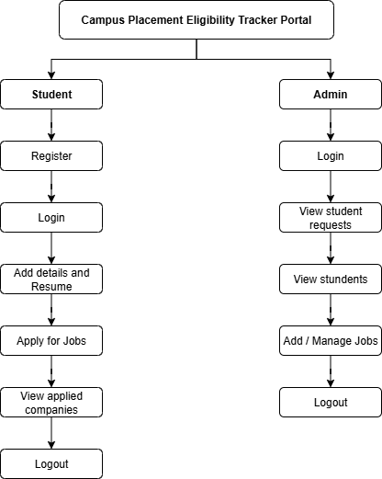
Fig: System Module
B. System Architecture
The system is architected on a client-server web-based one. The system has a web interface with which users, such as students and administrators, interact. The front end is built with HTML, CSS and JavaScript, but the back section is built on Python, through the Django framework. The information is kept and operated with the help of a relational database system, either MySQL or SQLite.
The architecture will guarantee that:
- Any user requests undergo processing by the server.
- The data is stored in the central database.
- The system does automatic eligibility checking through logic.
- Strict protocols of login and role-based access control are maintained.
- Real time updates and notifications are provided.
The architecture eliminates manual procedures, maximizes scalability, and it provides a good management of activities of placement.
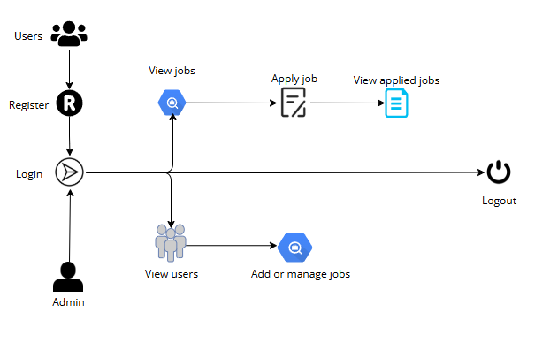
Fig: System Overview (Structure)
C. Discussion
The proposed system helps to make the traditional placement processes more efficient by automating the process of confirming the eligibility and the data management process and application monitoring. It will minimize manual interventions, minimize errors, and enhance transparency. As a student, one can access relevant opportunities and watch their progress, and as an administrator, one can manage the data better. Overall, the system provides a flexible, reliable and systematic system of recruiting in campuses.
VII. CONCLUSION AND FUTURE SCOPE
The Campus Placement Eligibility Tracker Portal is an effective tool that allows automating the campus recruitment process and can be achieved with the help of centralized data management, automated verification of eligibility, and real-time monitoring of the application. It saves on man-hours of work, decreases mistakes, and improves accountability to the student and administrators. The system also makes sure that only those capable of getting employed apply hence better employment placement.
The addition of AI-based resume analysis, predictive analytics, and a special company module can be added to the system in the future. Other refinements like mobile application support, enhanced dashboards, and better security systems like blockchain can also be enhanced to scale, usability and other system reliability.
REFERENCES
[1] A. Sharma, P. Singh, and R. Mehta, Automated Recruitment System with the help of Machine Learning Algorithms, International Journal of Computer Applications, 2021.
M. Chatterjee, S. Kaur, and A. Dey, ePlacement: an Online Placement Portal in Educational Institutions, IEEE Xplore, 2020.
R. Kulkarni and D. Patil, A Framework of Academic Eligibility Checking in Campus Recruitment, in Proc. ICCCNT, 2022.
S. Verma and K. Gupta, Student Information Management and Tracking System with the help of Web Technologies, International Journal of Engineering Research and Technology (IJERT), 2020.
[5] N. Jain and V. Bhatt, “An Automated Campus Hiring Web Portal based on a web-based portal system frameworks, 2023, Springer Lecture Notes in Networks and Systems.
[6] T. Roy and P. Banerjee, “AI-Based Resume Screening and Candidate Ranking System,” Procedia Computer Science, 2023.
[7] R. Nair and S. Iyer, “Smart Campus Recruitment System Using Cloud Computing,” International Journal of Cloud Applications, 2022.
[8] K. Mishra and A. Saxena, “Web-Based Student Placement Management System with Analytics Dashboard,” IEEE Access, 2024
[9] V. Reddy and M. Thomas, “Blockchain-Based Secure Academic Credential Verification for Recruitment,” Future Generation Computer Systems, 2023.
[10] S. Patel and H. Desai, “Predictive Analytics for Student Placement Using Machine Learning Techniques,” Expert Systems with Applications, 2024.

