BIZPULSE: FINANCIAL PERFORMANCE AND RISK PREDICTION SYSTEM

Dhananjay Sharma
Department of MCA
GLBITM
Greater Noida,India
vishu.mpsharma2020@gmail.com
Niharika Singh
Department of MCA
GLBITM
Greater Noida, India
niharika.singh1@glbitm.ac.in
Bishwajeet Pandey
Department of MCA
GLBITM
Greater Noida, India
dr.pandey@ieee.org

Abstract— In the current competitive business environment, organizations need more than simply accounting systems to be sustainable and to prosper. Traditional systems tend to record only the transactions and produce historical financial reports. These systems are lacking performance analysis and prediction capabilities. This paper describes BizPulse, a web-based intelligent business performance analytics system that can measure financial health, assess key performance indicators (KPI), predict future performance, and produce a Business Health Score. The system collects the structured financial data (e.g. revenue, expenses, inventory, employee productivity, customer growth, etc.), and produces predictions of future performance and risk level based on statistical models (e.g. moving averages and regression-based trend analysis). This system uses HTML, CSS, JavaScript for frontend development, Python Flask for backend development, MySQL for database development, and AWS cloud for deploying this system.
Keywords— Business Analytics, KPI, Financial Forecasting, Decision Support System, Web Application, Business Intelligence

I.introduction
In the contemporary digital economy, businesses are under continuous pressure due to increased competition, escalating costs and ever-changing market conditions. Many businesses still depend on old accounting systems that focus on bookkeeping and financial reporting. These systems provide historical financial records, but they do not analyze trends or predict future results.
Without monitoring and forecasting systems, a business may not notice early indicators of financial deterioration. Revenue decline, expense increase or profit margin shrinking may not be detected until a large loss has occurred.
BizPulse is a solution to this problem. It does more than just compute important financial indicators. It analyzes performance trends and predicts future revenue and profit. The system serves as a decision support system to help business owners make strategic decisions.

II. Related Work
A comprehensive overview of business intelligence and analytics systems, with special emphasis on improving decision-making through data analysis, has been given by Ramesh Sharda et al. [1][2]. Though various tools and frameworks used in business intelligence are discussed in the paper, it is mainly theoretical in nature and does not focus on implementation via a web-based integrated system. Douglas C. Montgomery et al. [3] have discussed various techniques used in time series forecasting, which are commonly used for financial predictions and trend analysis. Though these techniques are powerful, they are not presented in the context of a complete business monitoring system.
Foster Provost and Tom Fawcett [4] have emphasized the importance of data-driven decision-making in modern organizations. Though various techniques are discussed in the paper, it does not provide a structured implementation model, especially for small and medium-sized enterprises.
Wes McKinney [5] has discussed various data analysis techniques using Python, which are powerful tools for data analysis and especially for dealing with large datasets.
Jiawei Han et al. [6] have explained the concepts and techniques of data mining, which are essential for mining patterns from data. These methods support analytics but are not directly integrated into business performance systems.
Fabian Pedregosa et al. [7] have implemented machine learning models using Scikit-learn, and these models can be used for prediction and classification. However, these models have not been explored for their usage in business performance management.
Abraham Silberschatz et al. [8] have explained database management systems, and these systems are the basis for storing data. Their work provides a strong foundation but lacks integration with analytics and decision-making tools.

iii.Proposed Model
The BizPulse system is a structured web-based business performance analytics platform that transforms raw financial data into meaningful business insights. The system implements a multi-layered analytical architecture that takes user data, calculates Key Performance Indicators (KPIs), analyzes performance trends, forecasts future performance and generates an overall Business Health Score.
Diagram of Entity Relationships: A data model that conceptually or graphically depicts a database's structure is called the Entity-Relationship (ER) Model. It helps with the design or comprehension of data storage or relationships in a system. ER diagrams, which are made up of entities, attributes, and relationships.
Things or objects that exist independently within the system are called entities. BizPulse Users, Business Profile, Financial Record, KPI & Business Health Score, etc. are examples of entities. As shown in fig-1
Features of an entity are described by attributes. A financial record, for example, would include information on revenue, expenses, inventory value, employee productivity, and customer growth. Relationships explain how entities are connected to one another. One user can oversee one or more business profiles in BizPulse. A business profile may contain more than one financial record.
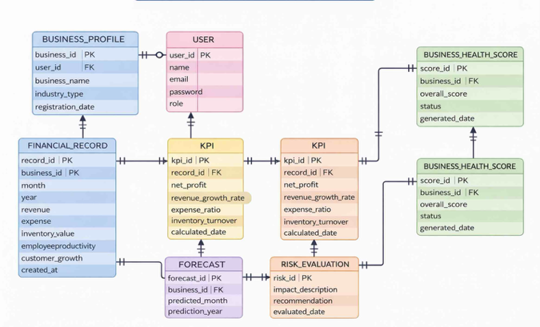
fig-1 Entity-Relationship(ER)

Data Flow Diagram
A. Level-0 Data Flow Diagram: Also referred to as the Context Diagram, this diagram depicts the BizPulse system as a single process with interactions with other entities. At this level, the system mainly communicates with: Business User Administrator: The Business User provides the system with operational and financial data. The system generates Business Health Scores, forecasting results, and KPI reports. As illustrated in Figure 2.
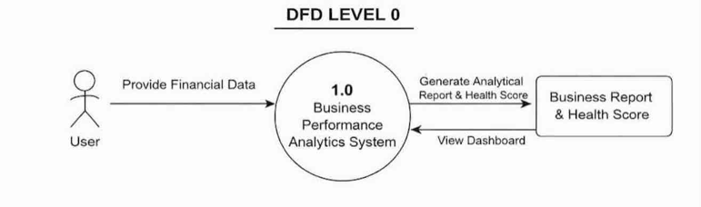
fig-2 Level 0 DFD

B. Level-1 Data flow Diagram: The flow of financial data from user-entered data to the final analytical output is shown in this diagram. This illustrates how BizPulse converts fundamental business data into strategic information and offers insight into system operations. Illustrated in Figure 3
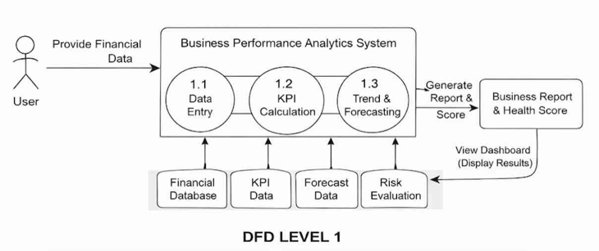

fig-3 Level 1 DFD

IV. CONCLUSION
This Application was created to revolutionize the traditional accounting system with predictive analytics and structured performance monitoring. And it does just that, converting raw financial data into actionable insights via KPI calculation and trend analysis.
BizPulse translates complex financial information into simple results by categorizing business conditions into Growing, Stable, At Risk or Critical. Business owners can also use the forecasting engine to predict future revenue and profit trends so that they can take preventative actions before financial problems arise.
it encourages data-driven decision making, increases financial visibility, and streamlines operations. So, BizPulse can be considered as an intelligent, practical business performance management solution for today’s business.
V. FUTURE SCOPE
The following is a brief description of the possible further improvements that could be made in BizPulse:
More Sophisticated Machine Learning Models Incorporation of models like Random Forest or Neural Network which can produce more accurate predictions.
Real Time Data Integration: Connecting to an ERP or Accounting System to automatically update the data in real time.
Automated Alert System: Email or SMS alerts sent when KPIs hit a certain threshold.
Industry Benchmarking: The system can compare the performance of the business to the industry.
SaaS Model: BizPulse can be developed as a multi-tenant cloud-based SaaS for use by several different organizations.
With above improvements it is possible to convert BizPulse into a very rich business intelligence ecosystem.

VI. References

- Sharda, R., Delen, D., & Turban, E. (2018). Business Intelligence and References
- Sharda, R., Delen, D., & Turban, E. (2018). Business Intelligence and Analytics: Systems for Decision Support. Pearson.
- Montgomery, D. C., Jennings, C. L., & Kulahci, M. (2015). Introduction to Time Series Analysis and Forecasting. Wiley.
- Provost, F., & Fawcett, T. (2013). Data Science for Business. O’Reilly Media.
- McInney, W. (2017). Python for Data Analysis. O’Reilly Media.
- Han, J., Kamber, M., & Pei, J. (2016). Data Mining: Concepts and Techniques. Morgan Kaufmann.
- Pedregosa, F., et al. (2011). Scikit-learn: Machine Learning in Python. Journal of Machine Learning Research.
- Silberschatz, A., Korth, H. F., & Sudarshan, S. (2020). Database System Concepts. McGraw-Hill.
- Pressman, R. S., & Maxim, B. R. (2019). Software Engineering: A Practitioner’s Approach. McGraw-Hill.M. Young, The Technical Writer’s Handbook. Mill Valley, CA: University Science, 1989.

