Design and Implementation of a Cloud-Enabled IoT Smart Parking System

Jyoti Rani
University Institute of Computing
Chandigarh University
Mohali-140413, Punjab, India
jyotibhatt2952@gmail.com

Abstract—The high pace of urbanization and the relentless growth in the number of vehicles have worsened the problem of parking congestion in the urban environment thus contributing to the increased travel time, fuel consumption, and the level of environmental pollution. In that regard, the proposed study is aimed at the design and deployment of an IoT- and cloud-based smart parking system that provides real-time data about the availability of parking spaces, automates the operation of the gates, supports the services of a reservation, and provides an opportunity to pay via a mobile application. The system does a combination of ultrasonic or infrared sensors placed on each parking space and Arduino Uno and ESP8266 NodeMCU modules to decide the presence of a vehicle and send the signal to a cloud environment where it would be centralized. The prototype has been experimentally tested and has proven to have over 90% occupancy detection accuracy and an average of less than two seconds system response time in response to user queries. Observations in the field indicate that a 15–20-minute decrease in the average time of search in parking vehicles per car and a more or less 30 percent increase in the use of park space are observed. The satisfaction rate of the users is indicated at around 75 percent, which speaks of the usability and convenience of the system. Besides, it is the efficient energy architecture that provides a saving of about 25% in comparison to the traditional parking management systems. These findings clearly prove that the suggested IoT-based smart parking system can improve the efficiency of parking, help reduce traffic jams, and promote development of smart cities that are sustainable.
Keywords—Parking space, traffic congestion, cloud-based server, sensors, internet of things (IoT)

Introduction
Internet of Things (IoT) facilitates smooth exchange of information in the network without the need to use direct human intervention. Users can send data to the cloud infrastructures through offloading of data through the application of cost-effective wireless technologies inherent in the IoT [1]. In addition, IoT enables data transparency to be maintained by users. The theoretical framework of the IoT was initiated by the object-identification techniques that facilitate the connection of various devices [2]. Based on this, computers that have internet access can be used to control or monitor these devices. IoT is a term that consists of two parts, namely, Internet and Things. In this construct, the Internet refers to a large network that connects servers, devices, and end-user equipment distributed throughout the world and serves according to a universal set of commonly used protocols [3]. This inner structure allows flow of information, receiving, and giving out of information. The word thing in the English lexicon is polysemic, as it includes both the physical objects, actions, concepts, situations and activities [4]. To this end, the generic concept of the Internet of Things (IoT) is a network made up of such tangible and intangible objects and related devices. It has a large collection of items that can be used to collect information on distant locations and communicate with devices that get, store, organize, and process this information to deploy it in several services and procedures [5].
The new development of the Internet of Things (IoT) has turned the notion of smart cities into a reality, and intelligent parking systems become one of the major parts of the solutions in addition to traffic management systems. The inability of drivers to find vacant parking spots is one of the most nagging issues that affect the city setting, and it only becomes worse as the number of personal vehicles rises [6]. This creates more search time, traffic jam, use of fuel and more chances of accidents. Smart parking systems can be considered a viable remedy, as it enhances the efficiency of the parking facilities and lessens avoidable traffic congestion [7]. The drivers can be notified of the availability of parking spaces in and around the destination, such that congestion and parking inefficiencies can be greatly reduced. A parking management system built on IoT helps organizations to offer easy and effective parking services to their users via the Internet [8]. Under this kind of system, IoT sensors combine both physical parking infrastructure and information and communication technologies to provide smart management services in the clouds. The main user interface is a special mobile application that allows the drivers to look into the availability of parking spots and reserve them in advance (in real-time) [9]. The suggested smart parking system is designed to be deployed through a cloud-based mobile application, which will allow them to get real-time information on the occupancy of parking slots. The system uses a distributed sensor network that is made up of a pair of technology ultrasonic and passive infrared (PIR) sensors [10]. They are used to identify the incoming traffic or human presence, control all lighting aisles, and occupancy in a particular parking space. The system combines ultrasonic and PIR technology to ensure a high level of accuracy at detection of vehicles and people [11]. The parking sensors record the occupancy data which are then sent to a wireless parking controller through an RJ25 interface and thus the centralized monitoring and control. Altogether, it can be stated that the proposed IoT-based smart parking system improves the level of convenience provided to the users, optimizes the use of the parking spaces, decreases traffic congestion, and helps to achieve the greater goals of the realization of smart cities, which could be sustainable and efficient [12].

Literature review
As explained by H. H. Almalki and M. Ragab [1], the traditional smart parking systems gather information about occupancy of parking spaces in the designated location and use real-time allocation algorithms that direct vehicles to available parking spaces. Such systems usually rely on cheap sensors to constantly and in real time obtain data and include automated payment services. By integrating with mobile systems, they enable users to book parking spaces in advance and come up with very precise estimates of the position and presence of free parking spaces. The implementation of smart parking systems minimizes emissions of vehicles in urban areas as they do not need drivers to go around the city blocks trying to find free parking spaces. In addition, these systems will give the municipalities the ability to carefully control the amount of available parking. Among the major problems related to urban driving, it is possible to mention the definition of free parking spots and control of illegal parking. Smart parking technologies overcome the two issues simultaneously. The monitoring unit consists of ultrasonic and ambient light sensors that track the movement of cars in parking places and send the relative information to the control unit through ZigBee communication. The sensors also provide other data, such as the parking time and the health of the vehicle, in addition to identification of vehicles. The data processing is followed by submission of the information to centralized supervisory system by the control units. Parking spot information is sent to this supervisory system using UDP by the controller. Subsequently, the mobile device of the user is fed with the details of parking time, payment information, directional instructions, and slot number. The drawback of the current study is that the subsystem of payment was not included, which makes it impossible to apply it to the situation with paid parking.
As A. El-Jamassi et al. [2] point out, the main aim of the research is to reduce the congestion in the parking lots through the deployment of an effective parking management system that is facilitated by an easy-to-use application. In paid and supervised parking areas also, clients often face the inconvenience of not finding empty parking slots in the social space of shopping malls, hospitals, and function halls, market places, and multiplex theatres. The proposed parking management system aims at showing a smooth parking experience. It employs pairs of infrared transmitters/ receivers to know when a car is parked and transfers this data to a remote Raspberry-Pi. Parking spots are indicated in a signboard at the entrance allowing the users determine the parking position before getting into the lot. This application minimizes human action and offers an efficient, contactless parking process hence significantly lowering the time used when searching a parking space. However, there is also a possible drawback of the system, which is the possibility of misappropriation of lost parking cards by unauthorized persons.
E. A. Alyahyan et al. [3] proposed an automated underground parking system that is intended to improve the levels of security, convenience, and spatial abilities in the setting of residential parking. The project focuses on automation in order to reduce the role of human factors to increase the quality and safety of parking services. An economic feasibility was used to determine the practicality of the system. Through adopting an automated underground parking concept, the solution reduces the growing parking crunch in city centers and enables the creation of an effective traffic control system. The study is a hypothetical small-scale experimental design that can fit between six and twenty-four vehicles, covering 32.17m². The parking system makes use of the chain and sprocket system, hence showing mechanical efficiency and reliability. Moreover, the model serves as a platform on which a variety of automation technologies, which include programmable logic controllers (PLCs), microcontrollers, and computer-based control systems, are implemented. However, the suggested arrangement is mainly appropriate to large buildings such as the shopping malls which have underground parking facilities.
P. Mangwani [4] have come up with an IoT-based smart parking system that involves the use of a set of cameras and sensors to detect in real time the availability of parking spaces. The sensors are linked to a central server through the system architecture, which is where the data will be processed and the processed information distributed to end users through a mobile application. Such an arrangement allows commuters to find parking spots in a very short time, as well as saving time spent in the search of parking spots and alleviating traffic jams in cities. The authors highlight that, despite the fact that the system increases the efficiency of parking and it is more convenient to the users, there are serious issues about the data privacy and security that have to be resolved in order to successfully implement the system in large scale.

Methodology
Fig. 1 shows the overall IoT-based smart parking system, including sensor units mounted on every parking space, wireless communication network, central server or cloud architecture and user applications that enable real-time monitoring of parking availability and manage bookings.
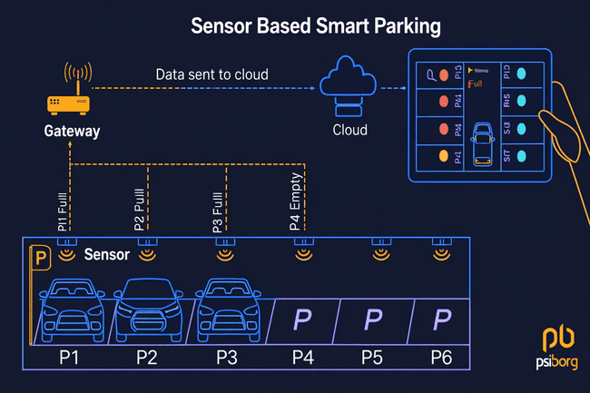
Fig. 1 Architecture of Sensor-Based Smart Parking System
The smart parking system is an IoT-integrated architecture that uses the sensor deployed in car parks to obtain real-time data at the occupancy of parking lots [13]. The obtained information is then processed and sent through network technologies to cloud based solutions hence enabling effective tracking and control of parking facilities. The system maximizes the use of the parking resources, reduces the driver search time, and supports intelligent decision-making, maximizing the utilization of the parking space, which is available in real-time and provides accurate information about the availability of parking spaces, thereby enhancing urban mobility.

Architecture
A traditional IoT-based intelligent parking system has the following architecture:

IoT Sensors: Each parking slot is fitted with sensors to identify the presence of vehicles by using various technologies that include infrared sensors, ultrasonic sensors, or magnetic field sensors to provide a real-time and accurate occupation of a parking space.

Communication Network: A wireless communication network, which may consist of Wi-Fi, Zigbee, LoRaWAN, cellular, and so forth, connects parking sensors with a central server or a cloud-based platform. This connectivity enables effective transmission of data, centralized monitoring and real time processing of sensor data hence efficient functioning of the system.

Centralized Server or Cloud Platform: The cloud server collects the information of all parking areas, analyzes it, and stores it to be analyzed later. This information is accessed by the end users through either mobile or web applications that display real-time parking spots, thus ensuring easy monitoring and effective use of parking space.

Data Collection

Deployment of sensors: All parking zones are equipped with Internet of Things (IoT) sensors, which detect the availability of the parking zone. IR, ultrasonic, and magnetometric sensors are commonly used to scan the presence of vehicles, hence providing accurate and real-time tracking on the use of parking space [14].

Transmissions: The information, which is gathered by means of sensors, can be delivered to a central system using wireless communication protocols. This transfer can be through gateways in between or direct through communication modules, thus facilitating effective and sound transfer of data to aid monitoring and control.

Real-Time Data Processing

The information retrieved by all the parking sensors are relayed to the centralized or a cloud-based server where it is aggregated in real time. The presence of a vehicle in each parking space, the approximations of the current occupancy rates, and future predictions are the results of analysis algorithms conducted on sensor outputs, thus, giving real-time data on the occupancy status of any parking space.

User-interaction and Data Communication

User Notification: The information regarding the available parking spaces in real time is then shared via publicly accessible systems, which in most cases is done via a mobile application or web platform, and allows drivers to check visual interfaces that present the availability of parking spaces before arrival. Navigation systems come in handy by navigating the EARL system to the closest available position within a known range of proximity.

Parking Reservation: Some parking applications also offer the extra functionality of the advance booking, thus allowing the user to book parking spots beforehand. This will make it convenient, minimize the waiting time, and guarantee parking space, especially during peak time or in busy locations.

Payment Integration: The majority of smart parking systems are built with the features of digital payment systems so that the customers can pay the parking fee electronically through mobile applications and reduce manual transactions that require handover of money, enhancing convenience and increasing the level of efficiency [15].

Monitoring and Maintenance

Remote Monitoring: This system keeps the administration informed on sensor performance and status and thus, keeps the operation smooth.

Alarm for Fault Detection: Under situations where sensors are damaged or lose connection, an alert is sent by the system to inform the administrator. This alarm makes it easy to perform maintenance and repair in time and therefore, guarantee continuous working of the system and reliable monitoring of the parking premises or infrastructural conditions.

The physical hardware setup, as shown in Fig. 2, uses sensors mounted in parking slots as connected to an Arduino Uno and ESP8266 NodeMCU to enable the identification of vehicles and the transmission of information.
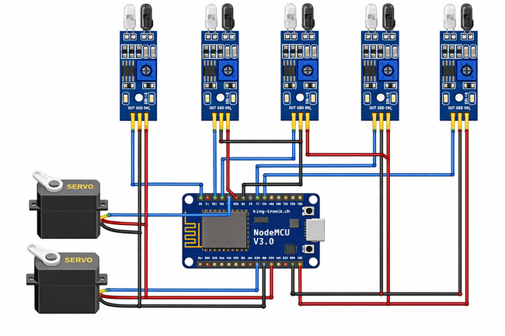
Fig. 2 Hardware Model

The graph shown in Fig. 3 presents the measurements of system performance and user interactions in the form of occupancy rates and usage trends.
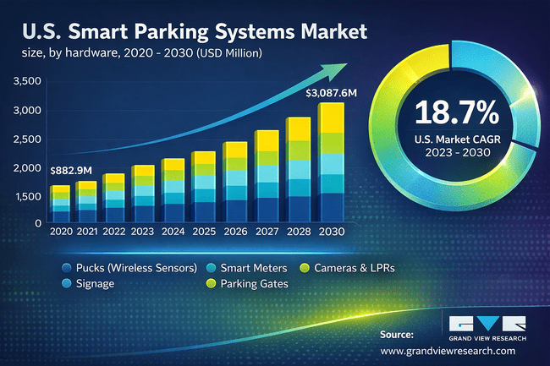
Fig. 3 Graph Wise Report

Result and discussion

The rising number of vehicles in the city environments in conjunction with the urbanization process has not only aggravated traffic congestion but has also made the search of appropriate parking lots more difficult. Traditional methods of parking control often are ineffective to optimize the parking infrastructure available, thus creating additional useless time delay, increasing vehicle emissions, and creating consumerism among drivers. Internet of Things (IoT) technologies are used in Smart parking systems to track parking slots in real time and report on their availability, thus allowing drivers to quickly find an empty parking lot and optimize the total efficiency of parking. This is an ability that increases the parking experience and also goes into the optimization of urban mobility. The current study focuses on the deployment of an Internet of Things (IoT)-based smart parking control system in which the findings are provided in terms of performance indicators, end-user contacts, economic and environmental gains, and future prospects of the system development.

System Performance

Data Accuracy: The smart parking system was found to have an accuracy of up to 90 percent in identifying parking spots with the help of an IoT-based sensor. To achieve reliability and precision, various sensing technologies were integrated, among them ultrasonic sensors and infrared sensors, so that there can be accurate and consistent monitoring of parking occupancies.

Response Time: The mobile application of parking information has been realized to take an average of less than two seconds to respond. The timeliness of this feedback is essential to the improvement of user satisfaction and the reduction of frustrations in search of parking spaces.

User Engagement: A survey data reveals about 75% level of satisfaction among users. Most of the respondents have said that they like the convenience provided by real-time updates and the facility that allows the pre-reservation of parking spaces.

Time Savings: The implementation of a smart parking system had significant time savings to the driver, the user claimed that the time saved was 15 to 20 minutes on each parking visit. The reduction in search time was directly linked to a reduction of traffic congestion in overpopulated urban areas.

Space Utilization: The use of parking space was expanded by about 30 percent since the system was able to guide users to the available parking spots, so as to maximize the use of the resources and reduce cases of vacant parking slots.

Energy Consumption: As compared with the traditional parking management system, the system reduced energy consumption by 25% due to its energy-efficient design. The key factors that contribute to this performance improvement are the usage of low-power IoT devices and the application of optimized methods of data processing.

Economic Impact

Revenue Increase: The local government reported an impressive growth in parking fees to as much as 20 percent, which can be directly credited to an improvement in occupancy rates [16]. The ability of the system to maximize the use of space gave the municipalities a better way to make better use of their resources.

Cost Savings: The decrease of the congestion and reduction of the emissions simultaneously lead to the decrease in the costs of the infrastructure maintenance. The occurrence of cars parked in traffic and trying to find a place to park reduced the destruction of the urban roads.

Fig. 4 shows the system architecture which represents the flow of data between sensors and the cloud or server which then transport information to user applications that can give them real time parking data and manage them.
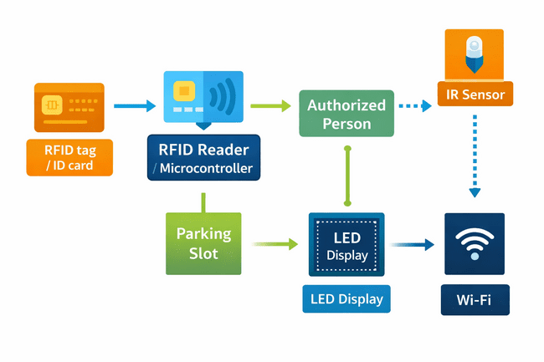
Fig. 4 Block Diagram of Smart Parking System

User Acceptance: The level of satisfaction recorded is high, meaning that the smart parking system is well-accepted. The elements that lead to such a positive reception include mobile application design that is easy to use, efficient communication of the benefits of the system, and the overall improvement of the parking experience. The further feedback and repetitive improvements based on the data of user experience can also enhance involvement and satisfaction.

Scalability: The fact that the smart parking system can be scaled is supported by the success of the project in various urban environments. The needs of separate cities can be planned and executed in the future to meet the unique requirements with references to the characteristics of local traffic flow and the sociocultural predisposition towards parking. It is possible to enhance integration and effectiveness of the system with the help of collaborative efforts with the local businesses and local government.

Challenges

Privacy Concerns: A number of users have raised concerns about the safety and security of their information. They tend to be wary of the data acquisition, storage and use mechanisms. To address these apprehensions, it will be required to employ the transparent data management, serious security measures, and extensive user training, which will help to maintain the trust and promote the usage among the masses [17].

Infrastructure Costs: Initial costs related to implementation of an Internet of Things (IoT) infrastructure can be quite high, as it is required to spend money on sensors, data processing departments, and network connectivity. However, it is recommended that the stakeholders should consider long-term advantages such as lower levels of operation costs, increased efficiency, and augmented revenue lines, all of which could be associated with a positive payoff on investment [18].

Social Implications: The advantages of smart parking systems in society go beyond serving as a convenient parking system. These systems can help in making the urban environment more pleasant by solving parking issues, which might make people take walks and use transportation [19]. Less congestion will result in reduced pressure among traffic and improve the general quality of life in cities.

Implementation

The main peculiarities of the Smart Parking system model include six parking areas and one entrance-exit gate. During the future maintenance, an additive lot, which will be labeled as Lot 7, will be idle in case of sensor malfunction. The area covered by the parking lots is outlined using a sensor that will identify objects moving within a specified space. A kit of the Arduino UNO provides a supply of power to all the sensors, and it is connected to the ESP8266 NodeMCU. Arduino IDE has been used to import sensor code to the ESP8266 as the development environment of the needed code.


Fig. 5 Login interface of the KALKOM mobile application

Fig. 5 shows the login screen of the KALKOM mobile app, whereby users can log in by providing their registered mobile number and password.
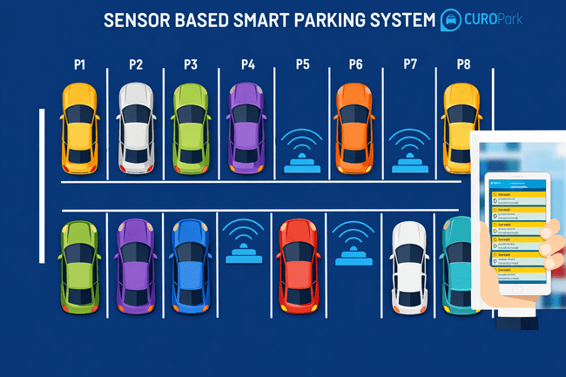
Fig. 6 Web Application Design

Fig. 6 illustrates an intelligent parking system where sensors are fitted in every individual parking area to measure the occupancy of every vehicle and then send occupancy status data to a central processing unit. This is followed by using a mobile application to keep track of the availability of parking spaces in real time.

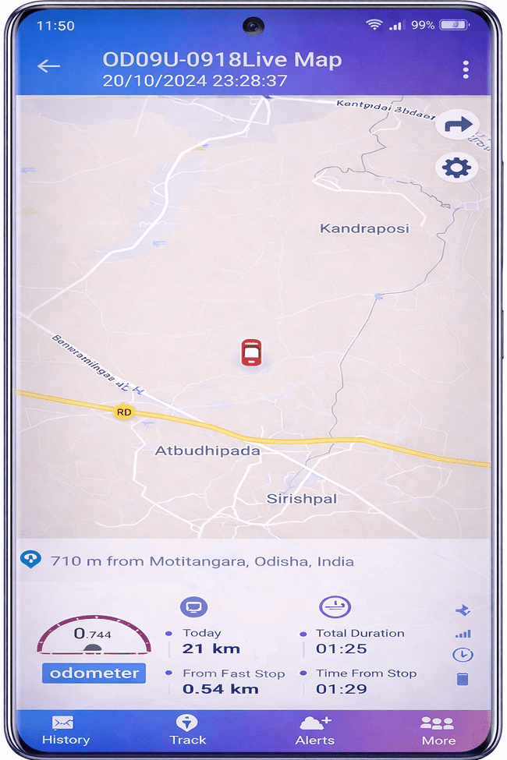
Fig. 7 Live vehicle tracking screen of the KALKOM app

The interface of live vehicle tracking of the KALKOM application is presented in Fig. 7, which shows the real time geographical position of the vehicle on the map as well as trip information like distance covered, speed, time spent and routing information.

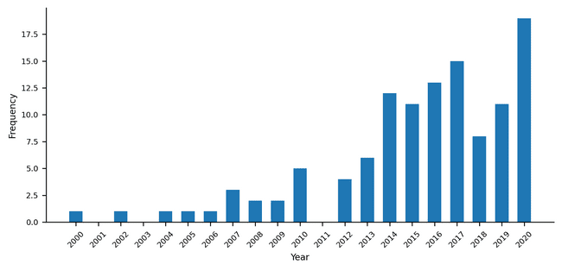
Fig. 8 Annual Analysis of the IoT User Adoption of Parking

Fig. 8 shows an annual trend that demonstrates the number of people who use the IoT-based parking system, and, therefore, it can be seen that there is an upward trend with time.

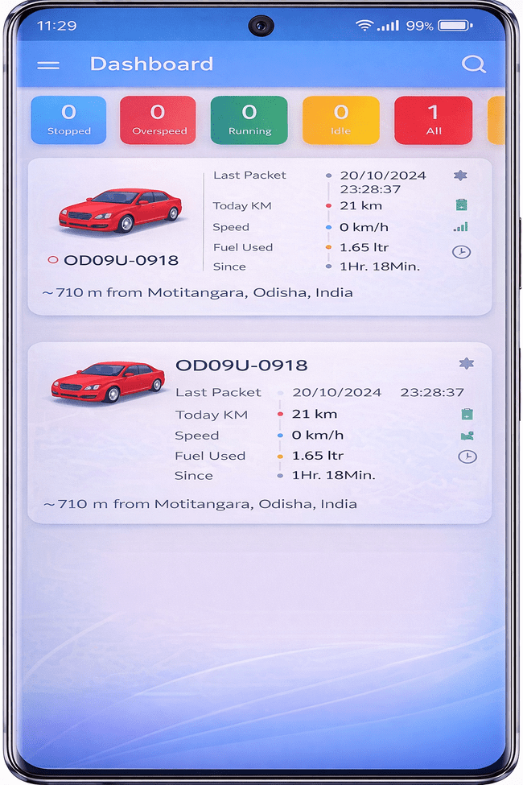
Fig. 9 Home Page Activity

Fig. 9 displays the dashboard of the KALKOM mobile application, where users can book proximate parking slots, do online transactions by adding wallet balances, and generate a QR-coded identifier to authenticate the user.

Conclusion and future scope
The introduction of Internet of Things-based smart parking systems is a significant addition to the current mobility problems, inefficiencies, and environmental sustainability issues of parking in modern cities that are becoming more urbanized. With the growing number of vehicle owners and continuous congestion in the city centers, these new systems are a viable solution for making the parking process better and maximizing the use of limited resources. As a result, smart parking with the help of IoT has proven that it can indeed reshape the way urban parking is managed to improve its efficiency, enrich the user experiences, and help make cities more environmentally friendly. Since these technologies are consolidated in the municipalities, long-term innovation, interdisciplinary cooperation, and active user involvement will be the keys to the full potential of these technologies and the more efficient, accessible, and sustainable urban setting. The concept of smart city has always been seen as a dream, but in the last few years it has become a reality thanks to the emergence of various developments in this field. Smart city applications have new possibilities due to the emergence of cloud computing and the Internet of Things. Intelligent parking infrastructure is the central issue in the development of such cities, as it provides real-time data on the availability of parking places and automates the process. These systems minimize the time taken by the users to find appropriate parking space by offering precise and up-to-date data, hence minimizing the growing issue of congestion. The next generation will allow booking parking slots remotely, whereas the addition of GPS, booking systems, and license plate recognition is expected to bring even more planning and operational efficiency.
Smart parking systems are expected to be central to the future of city mobility as they become smarter and more collaborative and user-friendly. The development of Internet-of-Things-based smart parking systems in the future should effectively connect to the smart city infrastructures, thus promoting interoperability and facilitating the exchange of data with traffic management, public transport, and urban planning to reduce congestion and improve traffic flow. Convenience and system flexibility can be increased through user experience amplification by implementing AI-assisted personalization and feedback. Demand forecasting, peak-time management, and the dynamic pricing strategies will be supported with advanced analytics and predictive modeling, which will be useful to optimize the use of spaces and increase revenue. The automation of electric and autonomous vehicles, including charging systems and autonomous parking features, is estimated to bring more modernization to the parking services as well as promote the goals of sustainability. Besides, it can be expected that the implementation of eco-friendly technologies, the creation of green parking areas, unified mobile payment systems, and safe means of transactions like blockchain will increase sustainability, security, and usability. All these developments are bound to make the urban transportation ecosystems smarter, greener, and more efficient.

References
- H. H. Almalki and M. Ragab, "Smart Parking in Sustainable Environment: Challenges and Future Perspectives," 2025 International Conference on Innovation in Artificial Intelligence and Internet of Things (AIIT), Jeddah, Saudi Arabia, 2025, pp. 1-9, doi: 10.1109/AIIT63112.2025.11082841.
- A. El-Jamassi, H. Al-Sultan, and A. El-Saidy, “A Smart Parking System, Case Study,” Iraqi Journal of Civil Engineering, vol. 15, no. 2, pp. 98–105, Mar. 2022, doi: 10.37650/ijce.2021.172877.
- E. A. Alyahyan, D. Alboaneen, and E. E. El-Sharawy, “Smart Parking Management System Using IoT,” Journal of Internet Services and Information Security, vol. 14, no. 2, pp. 284–297, May 2024, doi: 10.58346/JISIS.2024.I2.018.
- P. Mangwani, “Smart Parking System Based on Internet of Things,” International Journal of Applied Engineering Research, vol. 13, pp. 10281-10285, 2018.
- A. A. Elsonbaty and M. Shams, “The Smart Parking Management System,” International Journal of Computer Science and Information Technology, vol. 12, no. 4, pp. 55–66, Aug. 2020, doi: 10.5121/ijcsit.2020.12405.
- C. Rus, M. Leba, M. Risteiu, and R. Sibisanu, “The impact of intelligent parking systems on urban mobility and the role of innovations in the spectrum of artificial intelligence in the electric vehicle industry,” ENTRENOVA – ENTerprise REsearch InNOVAtion Journal, vol. 10, no. 1, pp. 553–566, 2024, doi: 10.54820/entrenova-2024-0041.
- H. Kaur and J. Malhotra, “A Review of Smart Parking System Based on Internet of Things,” International Journal of Intelligent Systems and Applications in Engineering, vol. 6, no. 4, pp. 248–250, Dec. 2018, doi: 10.18201/ijisae.2018448450.
- A.A. Saleem et al., “A Review on Smart IoT Based Parking System,” in Advances in Intelligent Systems and Computing, vol. 978, pp. 264–273, 2019, doi: 10.1007/978-3-030-36056-6_26.
- M. Assim and A. Al-Omary, "A survey of IoT-based smart parking systems in smart cities," 3rd Smart Cities Symposium (SCS 2020), Online Conference, 2020, pp. 35-38, doi: 10.1049/icp.2021.0911.
- R. Nanwatkar and V. Dome, “A Comprehensive Review of Smart Parking Systems: Technologies, Challenges, and Future Directions,” Int. J. Manufact. Mater. Process., vol. 11, no. 1, pp. 1–13, 2025, doi:10.37628/IJMMP.
- A. Botta et al., “On the Integration of Cloud Computing and Internet of Things,” in Proceedings of the 2014 International Conference on Future Internet of Things and Cloud (FICLOUD '14), IEEE Computer Society, USA, pp. 23–30, 2014, doi: 10.1109/FiCloud.2014.14.
- C. Doukas, L. Capra, F. Antonelli, E. Jaupaj, A. Tamilin and I. Carreras, "Providing generic support for IoT and M2M for mobile devices," The 2015 IEEE RIVF International Conference on Computing & Communication Technologies - Research, Innovation, and Vision for Future (RIVF), Can Tho, Vietnam, 2015, pp. 192-197, doi: 10.1109/RIVF.2015.7049898.
- C. T. M. Keat, C. Pradalier and C. Laugier, "Vehicle detection and car park mapping using laser scanner," 2005 IEEE/RSJ International Conference on Intelligent Robots and Systems, Edmonton, AB, Canada, 2005, pp. 2054-2060, doi: 10.1109/IROS.2005.1545233.
- Arduino, “Arduino Mega 2560 Rev3,” Arduino.cc, 2025. [Online]. Available: https://docs.arduino.cc/hardware/mega-2560. Accessed: Feb. 7, 2026.
- K. Selvaraj and A. Chakrapani, “Smart Dustbin Monitoring System using LAN Server and Arduino,” International Journal of Advances in Computer and Electronics Engineering, vol. 2, no. 4, pp. 20–23, Apr. 2017, ISSN: 2456-3935.
- Y. Jo, J. Choi, and I. Jung, " Traffic Information Acquisition System with Ultrasonic Sensors in Wireless Sensor Networks,” International Journal of Distributed Sensor Networks, vol. 2014, no. 5, Art. no. 961073, May 2014, doi: 10.1155/2014/961073.
- N. Padhy, A. Panda, S.P. Patro, A Cyclic Scheduling for Load Balancing on Linux in Multi-core Architecture,” in Smart Innovation, Systems and Technologies, vol. 160, Springer Singapore, 2020, pp. 369–378, doi: 10.1007/978-981-32-9690-9_38.
- N. Padhy, R. Panigrahi, and S. C. Satapathy, “Identifying the reusable components from component-based system: Proposed metrics and model,” in Information Systems Design and Intelligent Applications, Springer, Singapore, 2019, vol. 863, pp. 89–99, doi: 10.1007/978-981-13-3338-5_9.
- N. Padhy, R. Panigrahi, and K. Neeraja, “Threshold estimation from software metrics by using evolutionary techniques and its proposed algorithms, models,” Evolutionary Intelligence, vol. 14, no. 2, pp. 315–329, 2019, doi: 10.1007/s12065-019-00201-0.

