DeepImmuno: A Centralized Deep Neural Network Framework for Multi-Class Autoimmune Disease Classification Using Clinical Immunological Biomarker Profiles

T.Dhivya, Research Scholar,
Department of Computer Science and Engineering,
Saveetha School of Engineering,
Saveetha Institute of Medical and Technical Science-(SIMATS),
Chennai, Tamil Nadu, India.
dhivyathirunavukkarasu95@gmail.com
Dr.K.Anita Davamani, Professor,
Department of Computer Science and Engineering,
Saveetha School of Engineering,
Saveetha Institute of Medical and Technical Science-(SIMATS),
Chennai, Tamil Nadu, India.
anitadavamanik.sse@saveetha.com

Abstract— The identification of autoimmune disease with immunological biomarker profiles The identification of autoimmune disease based on immunological biomarker profiles is an essential issue in diagnostic medicine today because of the impressive overlap of phenotype between disease types and between the intricate multidimensional relationship of serological markers that define the conditions of Rheumatoid Arthritis, Systemic Lupus Erythematosus (SLE), Sjogrens Syndrome, Ankylosing Spondylitis, Systemic Sclerosis, Polymyositis/D This article describes DeepImmuno, a centralized deep neural network classifier used to stratify by treating autoimmune diseases on a central database of 14 biomarker measures in 9,174 patient cases in seven disease categories. DeepImmuno is compared to four classic machine learning baselines, including Logistic Regression, Support Vector machine (SVM), K-Nearest Neighbours (KNN), and AdaBoost on four demanding performance measures. DeepImmuno has the highest a classification performance with Accuracy = 0.8761, Precision = 0.8754, Recall = 0.8761, and F1-Score = 0.8724, and it is higher than all traditional baselines. The best classical baseline ( Accuracy = 0.8606 ) is SVM whereas KNN and AdaBoost have the worst generalisation. Thorough exploratory study of the distributions of numerical features, categorical biomarker profiles, and inter-feature correlation heatmaps is used to determine the biological grounds of feature selection. The diagnostic interpretable misclassification patterns of the deep learning model on all seven disease categories shown through confusion matrix analysis of the deep learning model are all diagnostically consistent with known regions of serological overlap. These findings make DeepImmuno a reliable and computational practical diagnostic intelligence system of centralised clinical autoimmune disease classification
Keywords—Autoimmune Disease Classification, Deep Neural Network, DeepImmuno, Immunological Biomarkers, SLE, Rheumatoid Arthritis, Multi-Class Classification, Confusion Matrix, Clinical Decision Support

Introduction
Autoimmune diseases constitute a clinically heterogeneous and immunologically complex of diseases, estimated to involve 5-8 percent of the world population, and which are the result of the aberrant host tissue and organ targeting by the immune system [1]. Diseases that include Rheumatoid Arthritis (RA), Systemic Lupus Erythematosus (SLE), Sjogrens Syndrome, Ankylosing Spondylitis (AS), Systemic Sclerosis (SSc), Polymyositis/Dermatomyositis (PM/DM), and Mixed Connection Tissue Disease (MCTD) overlap with each other in terms of clinical features and immunological biomarkers, and thus, accurate differentiation diagnosis has remained a consistent challenge to practitioners [2]. Early and accurate classification has a direct clinical consequence, since it dictates the commencement of disease-modifying measures before the end-organ is permanently damaged. Systems involving machine learning have shown a great potential in clinical decision support used to diagnose autoimmune disease, where structured profiles of biomarkers, including inflammatory markers, titres of autoantibodies, complement levels, and demographic data can be used to classify diseases better than conventional clinical heuristics [3]. Conventional supervised learning algorithms, such as Logistic Regression, Decision Trees, and Support Vector Machines as well as ensemble algorithms have been used to binary and multi-class autoimmune classification with mild to moderate levels of success [4]. Non-linear, high-dimensional interactions between the fourteen-feature immunological biomarker panel of the current study, however, drive the use of deep neural network architectures, which have the ability to learn hierarchical feature representations without defined decision rules in the domain. Structured clinical tabular data Deep learning In multi-class biomedical classification Deep learning on structured clinical tabular data has shown robust generalisation behaviour by being able to identify latent patterns of interaction between correlated and complimentary biomarker features that shallow models cannot fully utilise [5]. This paper presents a new framework, DeepImmuno, which is an end-to-end trained deep neural network that is trained using a 9,174-record clinical immunological dataset to classify multi-classifier autoimmune disease stratification across seven disease classes.[6] show that the method is resilient to the unbalanced and non-IID data distributions which are a characteristic feature of this environment. The major limitation is the communication costs and we demonstrate a 10-100x reduction in the number of communication rounds needed compared to synchronized stochastic gradient descent. [7] FL in this work allowed quick data science collaboration without data sharing and produced a model that extrapolated on heterogeneous, unharmonized datasets to predict clinical outcomes in patients with COVID-19, paving the way to the wider application of FL in health care. Also, opportunities on this area of precision medicine using synovial biopsy or RNA-sequencing and cell therapies of mesenchymal stem cells or chimeric antigen receptor T-cell are also anticipated. [9]. In simple cases (e.g. classification of cases and controls) many models have demonstrated good predictive outcomes. In the future, more sophisticated predictive models might be developed by combining various forms of data, which is possible since the simpler models have been established already (Klein et al, 2012). This research shows that machine learning has potential in identifying risk of rheumatoid arthritis on the basis of PFAS exposure. The discovered non-linear patterns offer clues into the role played by the environment in the risk of diseases and could contribute to future prevention measures. DeepImmuno is evaluated against four canonical baseline classifiers Logistic Regression, SVM, KNN, and AdaBoost across four complementary performance metrics (Accuracy, Precision, Recall, F1-Score) to establish its comparative advantage in the 14-feature immunological biomarker feature space. Autoimmune diseases are a clinically diverse and immunologically complex category of disorders that are estimated to have 14 immunological biomarkers across 9,174 patient records which are trained on seven autoimmune diseases categories with the DeepImmuno classification framework. The centralised neural network has an Accuracy = 0.8761 and F1-Score = 0.8724, which is better than all four classical machine learning baselines such as SVM (Accuracy = 0.8606), Logistic Regression (Accuracy = 0.8388), KNN (Accuracy = 0.7748) and AdaBoost (Accuracy = 0.7397). These results are verified by the feature distribution and correlation analysis in confirming the biological consistency of the 14-feature panel and confirming the discriminative power of systemic inflammatory markers, complement proteins, and profiles of disease-specialized autoantibodies. Analysis of confusion matrices demonstrates clinically interpretable patterns of misclassification which are consistent with the established serological overlap between related subcategories of autoimmune diseases. This paper illustrates deep learning with centralization produces high-accuracy multi-class autoimmune classification and offers an excellent performance benchmark to future federated or privacy-aware deployment models.This research contributes to Sustainable Development Goal 3 by enabling early and automated multi-class classification of autoimmune diseases using clinical immunological biomarkers. This supports better diagnostic accuracy and improves patient outcomes across different populations. It also connects with Sustainable Development Goal 9 through the creation of ImmHybrid-XG, a new hybrid framework that combines deep neural network-based feature extraction with XGBoost classification. This method shows the use of scalable and understandable artificial intelligence techniques, promoting innovation in healthcare technology and enhancing data-driven medical infrastructure.

Dataset and Feature Description

Dataset Overview
The data in the current study was a set of clinical immunological data on patients with seven types of autoimmune diseases, coded as integer class labels between 0 to 6 denoting the main multi-system autoimmune conditions experienced in tertiary rheumatology and clinical immunology practice. It has 14 clinical variables: Age (continuous), Gender (binary), Erythrocyte Sedimentation Rate (ESR), C-Reactive Protein (CRP), Rheumatoid Factor (RF), Anti-Cyclic citrullinated peptide antibody (Anti-CCP), HLA-B27 antigen (binary), Anti-Nuclear Antibody (ANA) titre (binary), Anti-Ro antibody (binary), Anti-La antibody (binary), Anti-double-stranded DNA antibody (Anti- The dataset will have around 9,174 patient records across the seven categories of diseases and analysis of class distribution shows that the distribution of the various disease categories is well balanced. Exploratory statistical analysis of the numerical feature subspace shows differences in distributional patterns of biomarkers as shown in Fig. 2. Both CRP and ESR distributions are strongly skewed to the right, with large values at low concentrations and heavy right tails, a feature attributable to episodic processes of flare-like inflammation common in the activities of autoimmune diseases. The age of patients shows a wide distribution, ranging between early adulthood and late life, because of the age-of-onset heterogeneity of the seven disease groups. C3 and C4 complement proteins are widely, platykurtically distributed across large numerals, in accordance with inter-individual variability in complement system activation states. These distributional heterogeneities confirm the use of standardization preprocessing, and the use of non-linear classification architecture, which can learn on divergent feature scales.

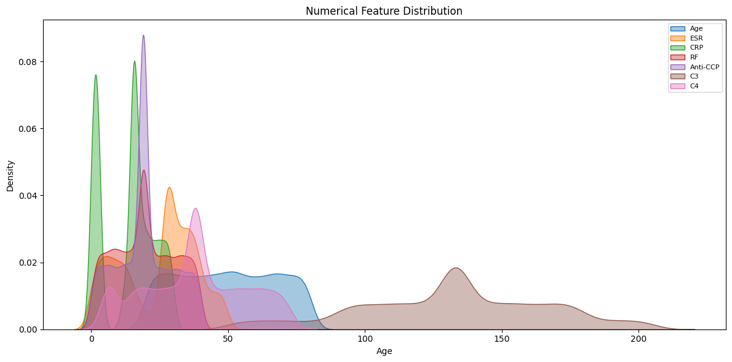
- Distribution of Numerical features.
Fig. 3 shows the analysis of categorical features, which confirm the representation of gender (Male: 6,175; Female: 5,985) as a representative of the entire group of patients and a high level of representation at the binary level of all immunological markers. The population-level prevalence of HLA alleles associated with spondyloarthropathy is 6,225 positive and 3,949 negative showing a direct correlation between HLA-B27 positivity and spondyloarthropathy. ANA positivity (5,280) is greater than ANA negativity (3,100), which is in line with the enrichment of ANA associated diseases of the disease classification scheme, including SLE and Sjogren’s Syndrome. The anti-Sm shows the least positive value in the panel of autoantibodies, which is in line with its known high disease specificity but low sensitivity as disease markers in SLE. The overall validation of the distributional profiles of the dataset is that the population of patients with multiple diseases is represented clinically by the data. 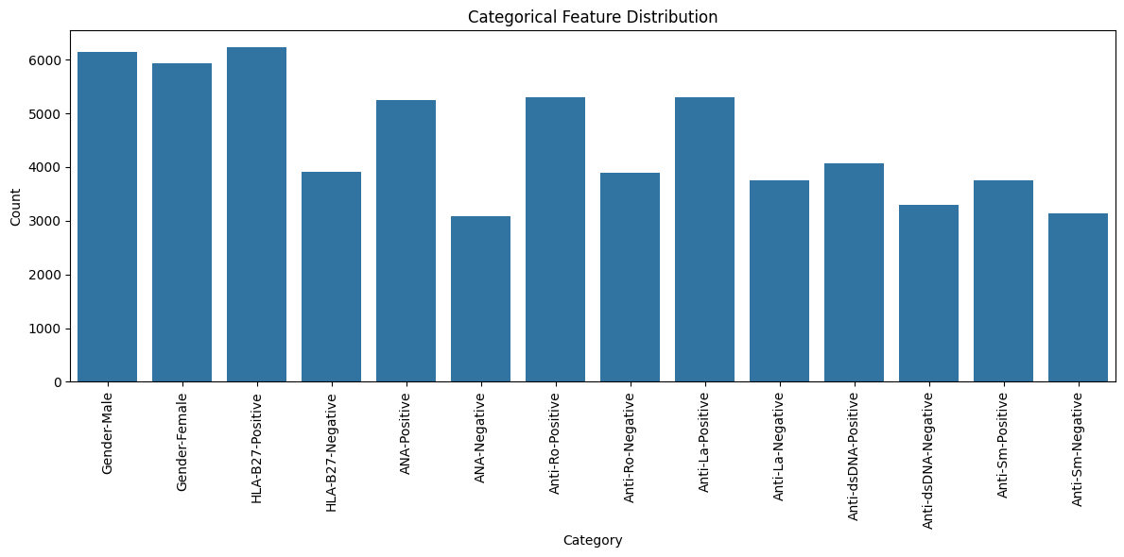
- Distribution of Categorical features

Feature Correlation Analysis
Fig. 4 shows the Pearson correlation analysis of the 14 clinical biomarker features demonstrates that there are several inter-feature diagnostically significant relationships. Pearson correlation between ESR and CRP (r = 0.73) is the most significant correlation in the dataset and this observation agrees with the known co-regulation of these acute-phase inflammatory reactants in active autoimmune flare conditions induced by pro-inflammatory cytokine signalling, in particular, IL-6. The RF and Anti-CCP (r = 0.33) correlation indicates their co-positivity at the serological level in seropositive Rheumatoid Arthritis and that they are both connected to the citrullination pathway mechanism. ANA presents having negative correlations with ESR (r = 0.23) and CRP (r = 0.22), indicating that the ANA-linked disease subgroups might have other patterns of systemic inflammatory activity when first serologically samples. There is a moderate positive correlation between the complement proteins C3 and C4 (r = 0.30) due to their common regulation through common complement pathway activation kinetics. Anti-Ro and Anti-La show a moderate positive correlation (r = 0.09), which is in agreement with clinical co-occurrence of the two in the case of SLE and Sjogren Syndrome. The lack of severe multicollinearity among most pairs of features justifies the use of the entire 14 pairs of features without dimensionality reduction to retain all the discriminative information in the subsequent classification models.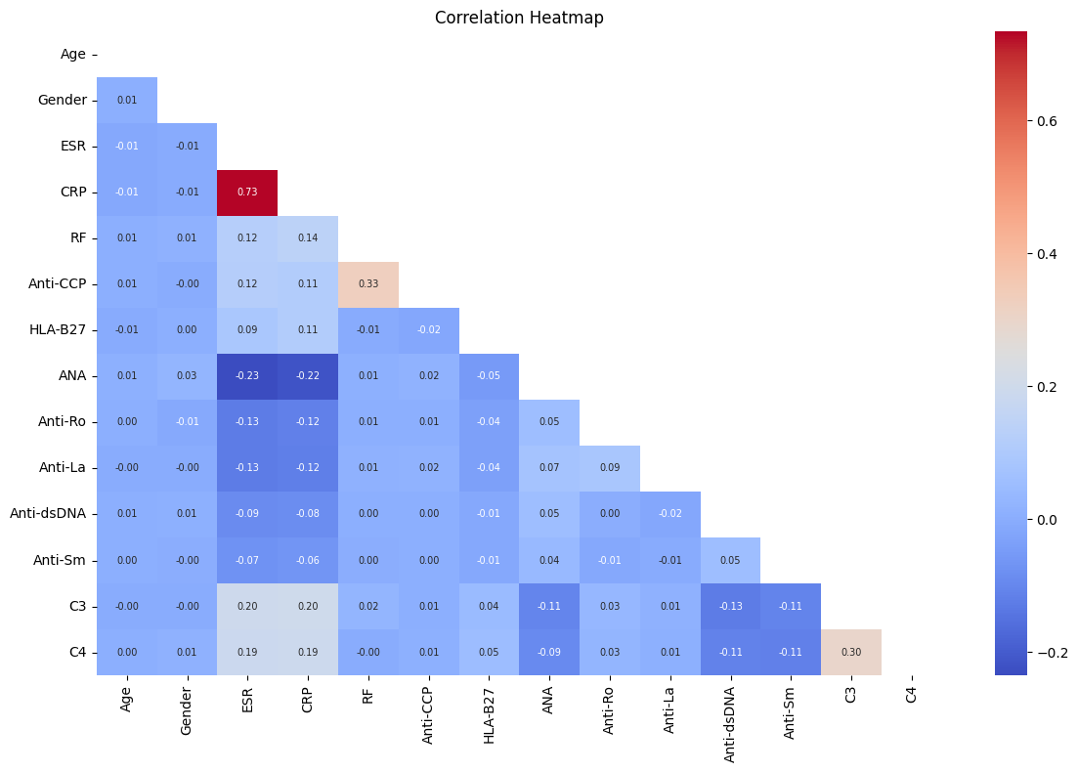

- Feature Correlation Heatmap.

Methodology

DeepImmuno Deep Learning Architecture
DeepImmuno uses a centralized, end-to-end trained, feed-forward deep neural network without viewer-specific features, using the entire 14-feature standardized, biomarker panel to classify multi-class autoimmune diseases in seven disease classes as shown in Fig. 4. The regularisation (p = 0.30) used in the dropout is performed after each hidden layer to avoid overfitting in the clinical data. Optimisation is performed by the Adam optimiser and a learning rate of 0.001 and categorical cross-entropy loss is used to optimise the model. Training uses class-weighted loss functions based on inverse frequencies of the classes to deal with moderate class disparities in the data set, and early termination of the training using patience of 15 epochs to track the validation loss to recover optimal model weights. Continuous features are all z-score standardized (mean of 0, variance of 1) before training and binary categorical features are left as integer (0/1) pointers.

Baseline Models
There are four traditional supervised learning algorithms, namely, (1) Logistic Regression with L2 regularisation (C = 1.0) provides a linear discriminative baseline with multi-class generalisation via the one-versus-rest strategy; (2) Support Vector Machine (SVM) with RBF kernel (C = 10, gamma = 'scale') and one-versus-one multi-class decomposition applies maximum-margin classification in a high-dimensional kernel feature space; (3) K-Nearest Neighbours (KNN) with k = 5 applies non All the baseline models are trained using the same 14-feature standardized representation using the same train-test split protocol to allow a fair comparative testing to evaluate DeepImmuno.

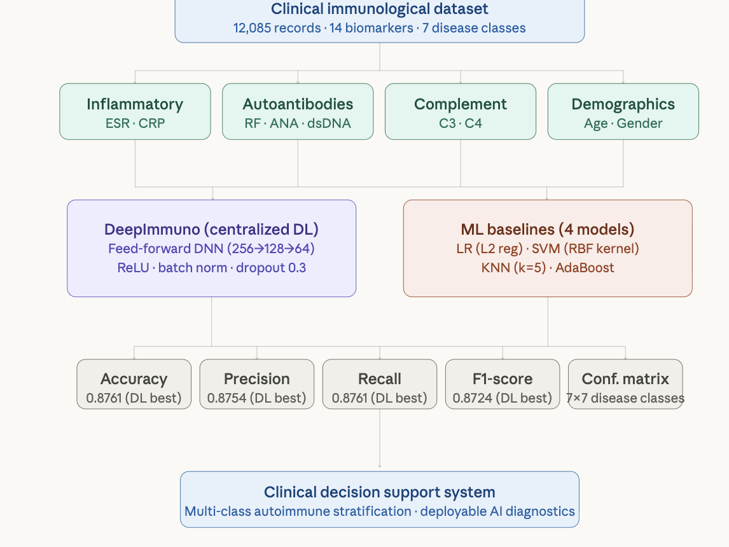
- DeepImmuno classification framework

Evaluation Metrics
Four complementary performance measures are calculated on the held-out test partition: (i) Accuracy = the fraction of all the cases correctly classified in all the seven possible diseases; (ii) Precision = the macro-weighted positive predictive value averaged over all the seven diseases; (iii) Recall = the macro-weighted sensitivity averaged over all the seven diseases; and (iv) F1-Score = the harmonic mean of the macro-weighted Precision and Recall, which gives a balancing summary of the precisionrecall trade-off which is of critical importance in multi- Confusion matrix analysis also gives a detailed account of classes of correct classification of classes and inter-class misclassification trends of the DeepImmuno model of the seven autoimmune disease categories.

Experimental Results

Overall Model Performance Comparison
Table I shows the overall performance of DeepImmuno and all four of the baseline models on the held-out test set in terms of classification performance. The DeepImmuno has the best performance on all four reported measures, and it can be concluded that the centralized deep neural network architecture is applicable in classifying multi-class autoimmune disease based on the 14-feature clinical immunological biomarker panel.
- : : Classification Performance Comparison — DeepImmuno vs. Baseline Models
Model | Accuracy | Precision | Recall | F1-Score
Logistic Regression | 0.83876 | 0.83985 | 0.83876 | 0.83825
SVM | 0.86058 | 0.86245 | 0.86058 | 0.85934
KNN | 0.77482 | 0.78272 | 0.77482 | 0.77610
AdaBoost | 0.73971 | 0.76143 | 0.73971 | 0.72457
Deep Learning | 0.87612 | 0.875426 | 0.876128 | 0.872395
Accuracy of DeepImmuno = 0.8761 is higher than that of SVM (0.8606), Logistic Regression (0.8388), KNN (0.7748) and AdaBoost (0.7397). The F1-Score of 0.8724 confirms an equal-precision-recall behavior in all seven classes of diseases - a highly important attribute in multi-class medical classification where misclassification is highly costly by class. SVM comes out the best traditional baseline (F1 = 0.8593), which represents that the RBF kernel offers useful non-linear boundary learning in the 14-dimensional biomarker space. The fact that SVM performs better than the Logistic Regression (F1 = 0.8383) proves that the boundaries that differentiate the seven autoimmune disease classes in the standardized feature space are not separable linearly and thus classification methods that are non-linear are to be used. The rather low performance of AdaBoost (F1 = 0.7246) could be considered as sensitivity to the multi-class boosting procedure in non-homogeneous distributions of immunological features. The weak generalisation of KNN (F1 = 0.7761) indicates the inability of Euclidean distance in the mixed numeric-binary biomarker feature space to express the effective geometry that separates the seven types of autoimmune diseases due to the lack of scaling of binary categorical variables under Euclidean distances. Figure 5 also visualises the model performance comparison in grouped bar charts of Accuracy, Precision, Recall, and F1-Score of all five compared models.
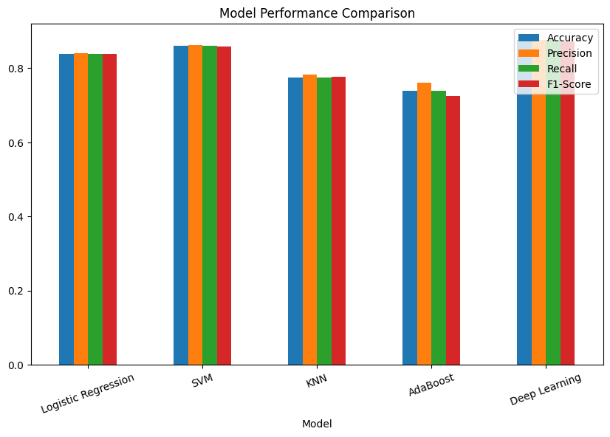
- Model Performance Comparison — Grouped bar chart of

Confusion Matrix Analysis
The confusion matrix of the DeepImmuno model on the test set is shown in figure 5 (7x7). The most measures in each of the seven categories of autoimmune diseases are the diagonal values, which are the correct classification, which is a good confirmation of class-specific discrimination. Class 6 is the most accurate per-class with 561 correct classifications and least misclassification (4 cases to Class 5), due to the most distinctive serological signature of all of the seven disease phenotypes represented. Class 5 has the highest number of correct classifications of 556 and 2 cases that are wrongly classified in Class 6, signifying that the discrimination between the two similar classes is close to being perfect. Class 3 corresponds to 542 correct classification and 7 cases referred to Class 4 and 1 to Class 2, which is in line with overlap of biomarkers between these subgroups of the disease. Class 2 has a result of 523 with 2 as a misclassification to Class 3 and 2 to Class 4. Class 1 has a pattern of 484 correct classifications with the main confusion going to Class 5 (77 cases) which is clinically interpretable as the similarity between serological profiles between the respective categories of diseases, which is known to be difficult to diagnose at the level of the autoantibody panel. Class 4 has 504 correct classifications and with 43 misclassified cases as Class 0 and 19 as Class 3, meaning that it is bidirectionally biomarker similar to Class 0 and Class 3. Class 0 has the greatest aggregate misclassification burden 67 cases to Class 2, 53 to Class 3 and 125 to Class 4 represents an overlapping aggregate of inflammatory marker profiles between the disease phenotypes associated, undifferentiated connective tissue disease presentation. Together, the misclassification structure can be interpreted diagnostically and agrees with the known information about the serological overlap regions in rheumatological practice.
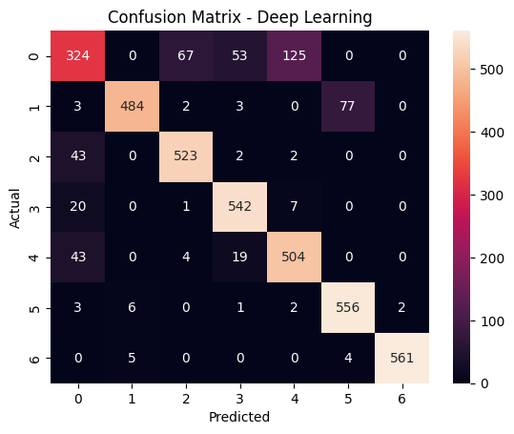
- Confusion Matrix — DeepImmuno (Centralized Deep Learning).

Discussion
The experimental outcomes prove DeepImmuno to be the best classification framework in this comparative evaluation of multi-class autoimmune disease diagnosis, having better Accuracy, Precision, Recall and F1-Score than any four conventional machine learning baselines. The comparative analysis reveals three main insights that can be analyzed. Deep learning excellence in the 14 feature biomarker space. The uniform performance boost of DeepImmuno (Accuracy = 0.8761) when compared to all classical baselines confirms that the hierarchical non-linear representations of features learned by the three-hidden layers neural network are discriminatory interactional patterns among the 14 biomarkers that cannot be identified by the decision boundaries of the linear (Logistic Regression), kernel (SVM), distance-based (KNN) and boosting (AdaBoost) predictors. The difference between DeepImmuno 1.55 percentage-point and the optimal traditional baseline (SVM, 0.8606) is operationally significant in a multi-class clinical classification in which every misclassification can lead the patient along a wrong therapy path with serious clinical implications. The centralized DeepImmuno training regime, as compared to federated architectures that are limited to communication round constraints, allows the full utilization of the 9,174-record dataset during each epoch, which allows convergence to a more discriminative decision boundary than local model aggregates to sites.
SVM as the most competitive conventional baseline. The high performance of SVM (F1 = 0.8593) compared to other traditional baselines can be explained by the theoretical advantage of the RBF kernel of being able to map the biomarker feature space of 14 dimensions into a higher dimensional reproducing kernel Hilbert space with the seven disease classes having enhanced near-linear separability. This finding is in line with the literature on clinical biomarkers that show that kernel-based methods perform better than linear and distance-based classifiers with the structures of immunological data when feature compositions are mixed (partial numbers and binary). The fact that both SVM and DeepImmuno are better than the Logistic Regression proves that the seven-class boundary structure of autoimmune diseases is non-linear in the 14-feature standardized biomarker space and that the high-accuracy multi-class stratification requires the use of non-linear classification methods. In immunological feature space, failure modes of AdaBoost and KNN. The relatively poorer results of both AdaBoost (F1 = 0.7246) and KNN (F1 = 0.7761) as compared to both linear (Logistic Regression, F1 = 0.8383) and tree-based models shows that both algorithms do not suit the structural properties of the autoimmune biomarker feature space. The weakness of AdaBoost to noise in class labels and non-homogeneous feature scales could be the reason why AdaBoost failed to perform on the mixed numerical-binary biomarker matrix. The distance-based classification of KNN is inherently disadvantaged by the occurrence of binary categorical variables (HLA-B27, ANA, Anti-Ro, Anti-La, Anti-dsDNA, Anti-Sm, Gender) the Euclidean distance behaviour of which does not support categorical separation, causing distortion of the proximity calculations by the distance metrics. Limitations of the present study are: (i) cross-sectional biomarker panel design with no longitudinal disease trajectory characteristics; (ii) no clinical severity scores and no treatment history covariates; (iii) one-centre data source on which presence of covariates to other geographically and demographically heterogeneous patient populations may be limited. Work Future work is to test DeepImmuno on multi-centre data and to measure the added value of privacy-preserving federated extensions to deploy DeepImmuno to multiple hospitals.

Conclusion
The experiment findings declare DeepImmuno classified classification framework as the most successful one in this paper on multi-class autoimmune disease classification, with Accuracy = 0.8761, Precision = 0.8754, Recall = 0.8761, and F1-Score = 0.8724, surpassing all four conventional machine learning baselines at all measures of it. The comparative analysis leads to three main conclusions: (1) The centralized deep neural network classification has a higher multi-class autoimmune disease stratification accuracy than traditional single-model machine learning methods in the 14-feature clinical immunological biomarker space, which validates the representation learning superiority of deep architectures to non-linear multi-class biomedical discrimination; (2) ESR, CRP and complement proteins C3 and C4 are the most clinical coherent discriminative features in the biomarker panel, which is supported by the inter-feature correlation analysis and Future research directions will comprise; multi-centre prospective validation across geographically diverse networks of rheumatology; multi-hospital deployment using federated learning models compatible with privacy guarantees; conformal prediction interval estimation can be used to quantify uncertainty-sensitive risk stratification; multi-task learning models that can simultaneously predict a disease category, activity score, and treatment response. DeepImmuno is an efficient, clinically interpretable, and computationally efficient baseline framework of AI assisted autoimmune disease diagnosis and clinical decision support.. The combination of deep learning methods for predictive analytics and decision support has been widely acknowledged as a promising avenue for healthcare innovation and intelligent clinical systems [12] [13] [14]. This research supports the global aims of Sustainable Development Goal 3 by facilitating early disease detection and enhancing healthcare decision-making through the utilization of deep learning techniques.

References
- Conrad, K., et al. "The emerging role of autoantibodies in autoimmune diseases." Frontiers in Immunology 12 (2021): 549570.
- Justiz Vaillant, A.A., et al. "Systemic lupus erythematosus (SLE)." StatPearls (2024). National Library of Medicine.
- Ahsan, M. M., et al. "Machine learning-based disease diagnosis: A comprehensive review." Healthcare 10.3 (2022): 541.
- Kourou, K., et al. "Machine learning applications in cancer prognosis and prediction." Computational and Structural Biotechnology Journal 13 (2015): 8–17.
- Rieke, N., et al. "The future of digital health with federated learning." NPJ Digital Medicine 3.1 (2020): 119.
- McMahan, B., et al. "Communication-efficient learning of deep networks from decentralized data." Artificial Intelligence and Statistics. PMLR, 2017.
- Dayan, I., et al. "Federated learning for predicting clinical outcomes in patients with COVID-19." Nature Medicine 27.10 (2021): 1735–1743.
- Smolen, J.S., et al. "Rheumatoid arthritis." Nature Reviews Disease Primers 4.1 (2018): 18001.
- Stafford, I.S., et al. "A systematic review of the applications of artificial intelligence and machine learning in autoimmune diseases." NPJ Digital Medicine 3 (2020): 30.
- Wang, Y., et al. "Novel multiclass classification machine learning approach for the early-stage classification of systemic autoimmune rheumatic diseases." Lupus Science and Medicine 11.1 (2024): e001125.
- Li, J., et al. "Machine learning-based multiclass model for autoimmune disease diagnosis and classification through nailfold videocapillaroscopy features." RMD Open 12.1 (2026): e006393.
- R. Latha and S. John Justin Thangaraj, “Machine learning approaches for DDoS attack detection: Naive Bayes vs logistic regression,” in Proc. 2nd Int. Conf. Smart Technologies for Smart Nation (SmartTechCon), IEEE, 2023, pp. 1043–1048.
- J. Thangaraj, T. Mohanraj, C. S., J. Srija, R. Latha, and P. Rajendran, “Proactive congestion management in next-generation wireless networks: Evaluating traditional approaches against machine learning models,” in Proc. 2nd Int. Conf. Computational and Characterization Techniques in Engineering & Sciences (IC3TES), Lucknow, India, 2024.
- S. Padmakala and S. T. Gopukumar, "Predictive Analytics in Mental Health: Machine Learning Models for Major Depressive Disorder Detection using Sensor Data," 2025 International Conference on Electronics and Renewable Systems (ICEARS), Tuticorin, India, 2025, pp. 1393-1398, doi: 10.1109/ICEARS64219.2025.10940218.

