Comparative Machine Learning Approach for Multi-Class Classification of Autoimmune Diseases Using Clinical and Serological Biomarkers

T.Dhivya, Research Scholar,
Department of Computer Science and Engineering,
Saveetha School of Engineering,
Saveetha Institute of Medical and Technical Science-(SIMATS),
Chennai, Tamil Nadu, India.
dhivyathirunavukkarasu95@gmail.com
Dr.K.Anita Davamani, Professor,
Department of Computer Science and Engineering,
Saveetha School of Engineering,
Saveetha Institute of Medical and Technical Science-(SIMATS),
Chennai, Tamil Nadu, India.
anitadavamanik.sse@saveetha.com

Abstract— Autoimmune rheumatic diseases (ARDs) are a group of conditions that features overlapping clinical features and overlap of immunological profiles such as Ankylosing Spondylitis, Psoriatic Arthritis, Reactive Arthritis, Rheumatoid Arthritis, Sjogrens Syndrome, and Systemic Lupus Erythematosus, and thus are difficult to differentiate. This paper is a strict comparative analysis of five recommended machine learning classifiers Logistic Regression, Random Forest, Gradient Boosting, XGBoost and Support Vector Machine (SVM) on automated multi-class disease classification using a large dataset (12,184 patient records). The data includes demographics of patients (age, gender), serological biomarkers (ANA, Anti-dsDNA, Anti-La, C3, C4) and clinical (parameters). Class-balanced training pipelines, data preprocessing, and feature engineering were used in order to provide strong evaluation. The measures of performance were accuracy, precision, recall and F1-score. Gradient Boosting had the most accurate of 84.86% and F1-score of 84.60, slightly higher than both Random Forest (84.61%) and XGBoost (84.03%). In ROC analysis, an outstanding macro-average AUC of 0.980 in SVM shows that it has excellent discriminative ability across disease classes. Class-wise confusion matrices also display the strengths of inter-disease misclassification and the trends of inter-disease misclassification, with Rheumatoid Arthritis and Systemic Lupus Erythematosus exhibiting the most per-class accuracies. This paper confirms that tree-based methods are the most effective model in ARD classification, and this has a great implication in clinical decision support, early diagnosis, and individual treatment pathways.
Keywords— Autoimmune Rheumatic Diseases, Machine Learning, Multi-class Classification, Random Forest, Gradient Boosting, XGBoost, SVM, Logistic Regression, Biomarker Analysis, Confusion Matrix, ROC Curve, Immunology.

Introduction
Autoimmune rheumatic diseases are a significant health issue in the world, with their combined impact on hundreds of millions of individuals worldwide costing health, quality of life, and health care spending significantly [1]. These disorders are caused by anti-body reaction of aberrant immune system against the body itself and cause systemic or organ-specific inflammation. The clinical overlaps among different disease entities complicate the situation of ARDs due to a high level of symptom, laboratory, and serological overlap between different disease entities. As an example, antinuclear antibodies (ANA) are high in a number of disease conditions such as Systemic Lupus Erythematosus, Sjogren Syndrome, and Rheumatoid Arthritis making it difficult to classify them without further clinical investigations that may significantly affect disease progression and cause permanent organ injuries [2]. The conventional diagnostic processes are based on the experience of rheumatologists, imaging, histopathology, and panel-based serology jobs - a very resource-consuming and time-consuming process, especially in resource-constricted environments. The problem of 2-5 years on average delay in diagnosis of diseases, such as Ankylosing Spondylitis and Sjogren Syndrome, highlights the necessity of automated data-driven diagnostics [4]. Machine learning (ML) methods have become revolutionary solutions in clinical medicine, which have offered the possibility to discover complex, non-linear patterns in high-dimensional patient data that cannot be perceived by human analysis [5]. Adaptation Controlled classification algorithms, such as interpretable linear models, or state-of-the-art ensemble algorithms have proven to be quite promising in diagnosing diseases in fields like oncology, cardiology, and immunology [6]. ML models have been used in the field of rheumatology to predict disease flares, categorize disease activity, and find potential biomarkers [7]. Nevertheless, a limited body of literature has conducted a systematic, head-to-head comparison of various classifiers explicitly to the multi-class differential diagnosis task using the entire range of common ARDs, which is the focus of the current study. Our pipeline has included strict preprocessing, feature standardization and balanced training techniques, which are then succeeded by detailed performance analysis in the form of accuracy, precision, recall, F1-score, ROC-AUC curves, and a confusion matrix. The findings also give practical implications regarding the most suitable algorithms to the clinical requirement of automated ARD classification, and also demonstrates the inter-class confusion that still needs to be addressed in the future to refine the models. This research supports Sustainable Development Goal 3. This goal aims to ensure healthy lives and promote well-being for everyone, at every age. This study also supports Sustainable Development Goal 9, which focuses on technological innovation and the growth of strong infrastructure.
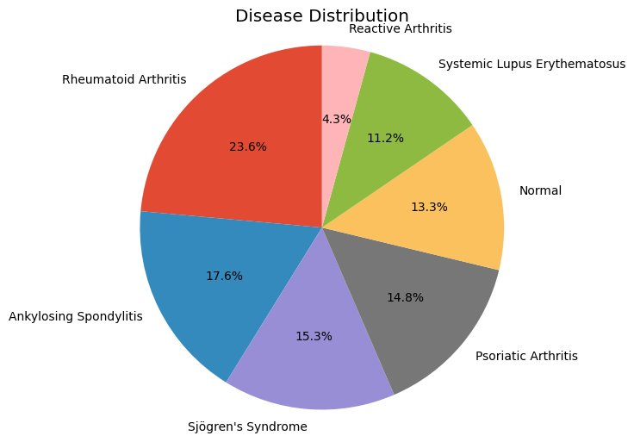
- Distribution of Disease Classes in the Dataset

Dataset and Feature Description

Dataset Overview
The dataset that will be used in this paper will include 12,184 records of patients who have confirmed diagnoses and are annotated with seven classes as showed in Fig. 1: Ankylosing Spondylitis (17.6%), Sjogrens Syndrome (15.3%), Psoriatic Arthritis (14.8%), Normal/Healthy Controls (13.3%), Systemic Lupus Erythematosus (11.2%), Rheumatoid Arthritis (23.6%), and Re The data were selected based on clinical repositories with patients being properly de-identified and diagnoses were tested using established ACR/EULAR classification criteria to each disease entity [8]. The comparatively smaller level of occurrence of Reactive Arthritis in the dataset is a representation of the epidemiological trend of the reality and includes class imbalance concerns during model training.

Feature Variables and Distribution Analysis
The list of features includes patient demographics (age, gender) , complement proteins (C3, C4), and serological markers of autoantibody (ANA, Anti-dsDNA, Anti-La) as shown in Fig. 2. and Fig. 3. The gender was balanced with 6,150 men and 5,990 women and this was quite fair in a way that the model will not acquire any gender-specific biases. Fig.3 showed the age was evenly distributed at 20-80 age, with slightly more pronounced density changes of 25-30 and 55-65 age groups, in accordance with the known bimodal patterns of inflammatory arthritis onset.
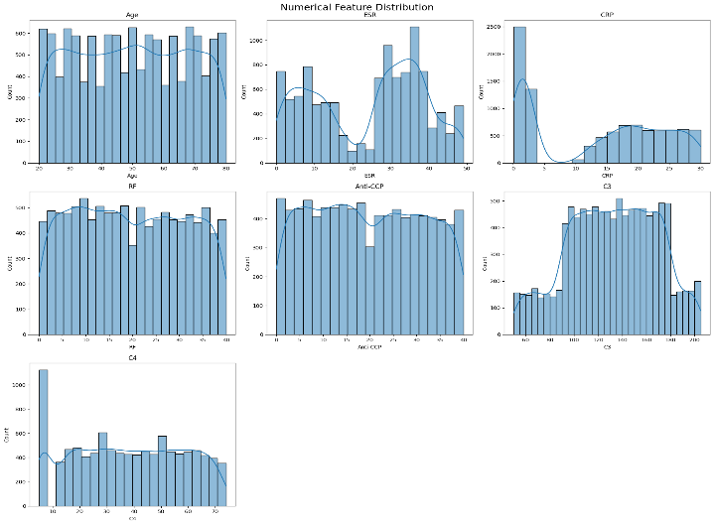
- Distribution of Numerical features.
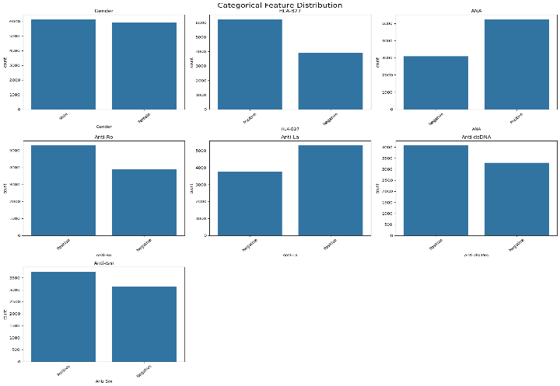
- Distribution of Categorical features
The complement protein C3 (normal range: 90-180mg/dL) had a relatively Gaussian distribution around 120-140mg/dL with tails extending to the lower limit in accordance with hypocomplementemia heralded by SLE activity. C4 levels (normal: 16-47mg/dL) as displayed a highly skewed ratio with the spike at the lower detection threshold (~5mg/dl) indicating genetic C4 null alleles and consumption in lupus nephritis. ANA and Anti-La serological markers were mostly positive (>60% positive ANA; Anti-La positive in approximately 58 cases), which is the indicator of the autoimmune phenotype of the cohort. Anti-dsDNA was fairly divided, which is also in line with its greater specificity to SLE in the ARD spectrum.

Methodology

Data Preprocessing and Feature Engineering
All qualitative variables (ANA, Anti-dsDNA, Anti-La, Gender) were taken to binary numerical variables. Continuous variables (Age, C3, C4) were then normalized using Z-score normalization to ensure that the variables had the same weight in model training and to avoid the dominance of high-magnitude variables, such as C3 absolute levels over binary biomarkers. The missing values were filled in with median imputation on continuous variables and mode imputation on discrete ones, which do not change the statistical characteristics of the distributions [9]. Stratified sampling was applied to divide the dataset into 80% training and 20% testing such that the proportion of classes did not change in both subsets. Since there was class imbalance especially with Reactive Arthritis (4.3%), class weights were used in training of the appropriate models. Multi-class (seven classes) encoding of the target variable (label of the disease) with the scikit-learn Label Encoder was completed before the model was fitted.

Machine Learning Models
They were five supervised classification algorithms implemented and evaluated (1) Logistic Regression an interpretable probabilistic linear classifier with L2 regularization: which is a robust and interpretable baseline; (2) Random Forest, an ensemble of 100 decision trees that use bagging and random selection of features, (3) Gradient Boosting, a sequence-based boosting ensemble, correcting residual errors of former learners, (4) XGBoost an optimized version of gradient boosting, L1/L2 regularization, tree pruning, and hardware acceleration, an extension and (5) Support Vector Machine with RBF kernel - a kernel-based classifier which maximizes separation of the margins in the high-dimensional feature space and has been proven successful in a biomedical classification task where there is overlap of classes [10].

Evaluation Metrics
Macro-averaged accuracy, precision, recall and F1-score on the test set that was held out (20 percent of data) were used to measure model performance. Each of the classifiers was plotted to help in visualising the patterns of prediction in the classes and the pathways of inter-disease misclassification. The one-vs-rest (OVR) strategy of multi-class was used to compute ROC curves, and macro-averaged AUC values were presented. Macro-averaging ensures that the weighting of all disease classes is the same irrespective of the prevalence of the disease classes, giving a fair representation of the performance of the classifier on both rare and common diseases.

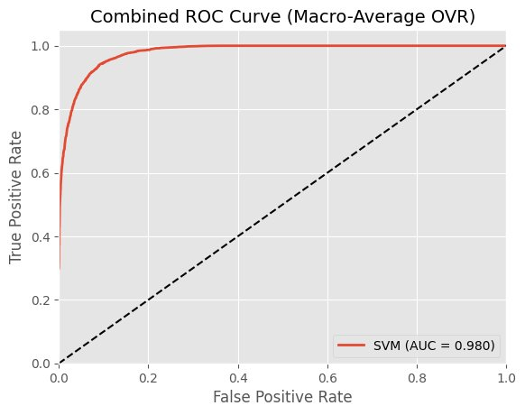
Experimental Results

Overall Model Performance Comparison
Table I is a summary of the overall performance measures of all the five classifiers on the test set. Gradient Boosting scored the best in accuracy (84.86) and F1-score (84.60) with a close score of Random Forest (84.61) and XGBoost (84.03) coming in the 2 nd and 3 rd place respectively. The accuracy of the SVM classifier was 81.59, which indicated that the results were competitive since a kernel-based model was used and hyperparameters had to be tuned more carefully in multi-class scenarios. As is desired of a linear model on a complex multi-class problem with non-linear decision boundaries, Logistic Regression demonstrated the lowest accuracy of 80.14% although that is a robust interpretable baseline.
- Final Model Comparison — Overall Performance Metrics
Model | Accuracy | Precision | Recall | F1-Score
Gradient Boosting | 0.8486 | 0.8488 | 0.8486 | 0.8460
Random Forest | 0.8461 | 0.8468 | 0.8461 | 0.8436
XGBoost | 0.8403 | 0.8396 | 0.8403 | 0.8386
SVM | 0.8159 | 0.8197 | 0.8159 | 0.8137
Logistic Regression | 0.8014 | 0.8033 | 0.8014 | 0.8013

ROC Curve Analysis
The macro-average one-vs-rest strategy of ROC analysis gives a threshold independent measure of discriminative ability in all the seven disease classes. The maximum macro-average AUC of the SVM classifier was 0.980, which is almost excellent separation between classes of diseases in probabilistic evaluation. This finding is interesting as the accuracy of SVM (81.59) in comparison with the ensemble methods can be attributed to the differences in calibration due to sharpness of decision boundaries, as opposed to fundamental discrimination limitation. The ROC curve as shown in Fig. 4. after combination with SVM shows that it quickly reaches almost maximum true positive rate at very low false positive rates, meaning that the classifier strongly separates most classes of diseases with only slight overlap in a small segment of the ROC space.
Probabilistic discrimination of each classifier is further defined by individual per-model ROC curves. The slope of the Logistic Regression ROC curve is more likely to be lower, which is in line with the linear decision boundary constraints in distinguishing overlapping classes of autoimmune. Random Forest and Gradient Boosting as shown in Fig. 5 and Fig. 6 exhibit sharp upsurges with gentle curve whereas XGBoost exhibits a medium profile. The representation of all models reaches significantly above the 0.5 random baseline AUC values significant learnt discriminative patterns in the set of immunological features.

- Combined ROC Curve (Macro-Average OVR) for SVM.
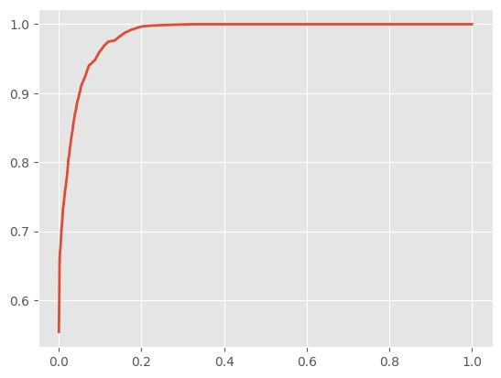
- ROC Curve — Random Forest
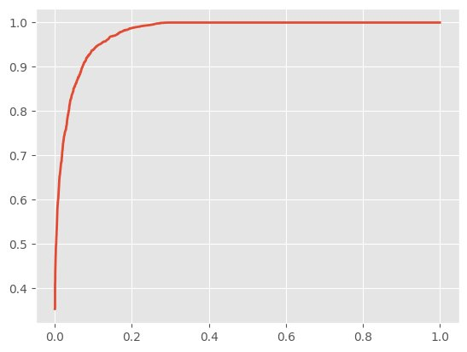
- ROC Curve — Gradient Boosting
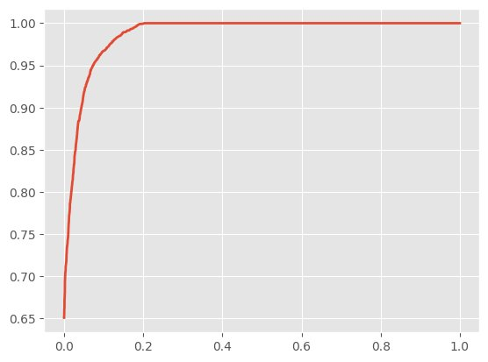
- ROC Curve — XGBoost

Confusion Matrix Analysis

Confusion matrices give finer information regarding the per-class classification accuracy, as well as display typical inter-disease misclassification patterns to indicate both biological overlap and proximity in the feature space between conditions. The five confusion matrices are shown and examined below.

Gradient Boosting
Fig. 8 shows the best per-class result of the Gradient Boosting classifier was in Rheumatoid Arthritis (530/570 correctly classified, offering a sensitivity of 92.98) and Systemic Lupus Erythematosus (265/271, offering a sensitivity of 97.79), which is consistent with its high capacity to detect these serologically unique and high-prevalence conditions. Ankylosing Spondylitis performed moderately (265/425 correct, approximately 62.35 percent) with most of the misclassifications going to Rheumatoid Arthritis (109 cases) and Psoriatic Arthritis (49 cases) a potential clinical overlap in that both shared the HLA-B27 positivity and a similar pattern of axial involvement. The sensitivity of Reactive Arthritis was the lowest (68.0% 70/103 correct) which is consistent with its physical and clinical overlap with other spondyloarthropathies.
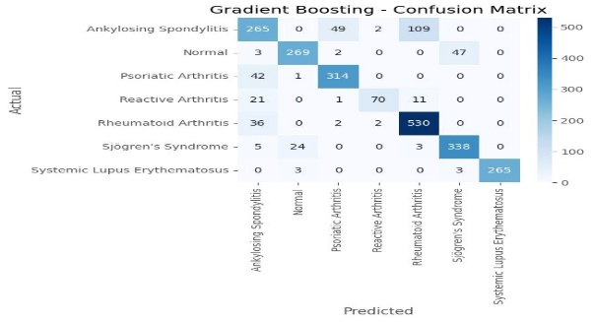
- Confusion Matrix — Gradient Boosting.

Random Forest
Fig. 9 shows the Random Forest almost the same overall performance as Gradient Boosting with the same sensitivity of Rheumatoid Arthritis (530/570, approximately 92.98%) and SLE sensitivity (265/271, approximately 97.79%). The point of difference was somewhat better Reactive Arthritis classification (66/103, approximately 64.08% vs 67.96) and slightly worse Sjogren's Syndrome (330/370 vs 338/370 with Gradient Boosting). The pattern of Ankylosing Spondylitis misclassification was also the same (106 cases misclassified to Rheumatoid Arthritis), which is an implication that this is a challenge of feature-space, as opposed to an algorithm-specific issue. The accuracy of normal classes was good at 84.91(270/318).
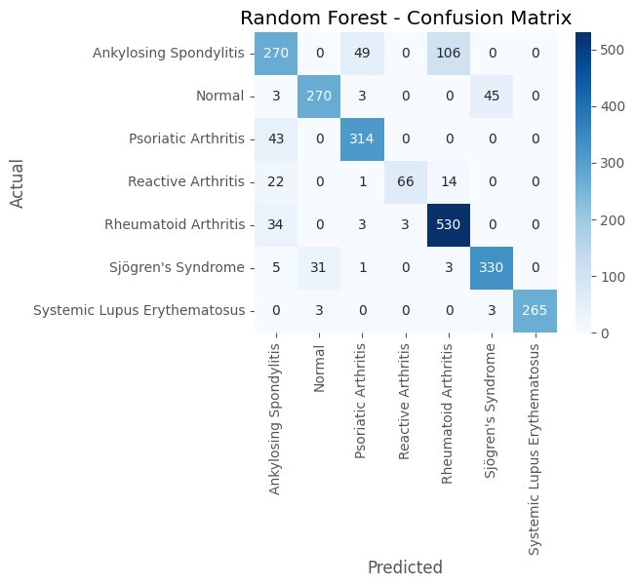
- Confusion Matrix — Random Forest.

XGBoost
In Fig. 10 , XGBoost shows similar consistency in confusion as well as significant advancement in the identification of Psoriatic Arthritis (313/357, ~87.67%) compared to other classifiers and high accuracy in classification of Normals (279/321, ~86.92%). Rheumatoid Arthritis was well-categorized (510/570, =89.47%). The Sjogren Syndrome group had unique misclassification to Normal (41 cases) perhaps because patients with mild Sjogren's - characterized by few abnormalities in the complement - are the ones that are biologically similar to the normal reference population in the feature space. SLE maintained high recall (265/271, ~97.79%). The sensitivity of Reactive Arthritis was slightly better 72/103 (~69.90) than Gradient Boosting.
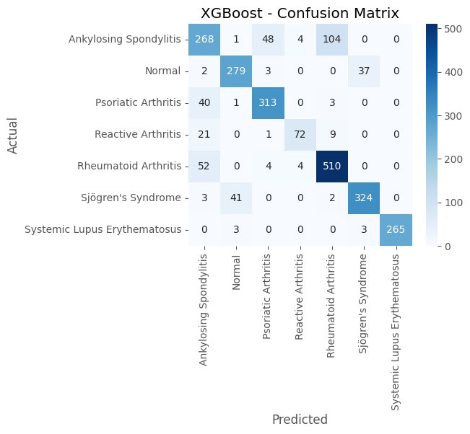
- Confusion Matrix — XGBoost.

Support Vector Machine
In Fig. 11, SVM classifier had a very dissimilar distribution error pattern although it could reach the best AUC (0.980). SLE classification was good (250/271, missing in 92.25%), Psoriatic Arthritis classification was good(293/357, missing in 82.07%). Nevertheless, Ankylosing Spondylitis was significantly misclassified with Rheumatoid Arthritis (101 cases) and Psoriatic Arthritis (52 cases), which is the most difficult overlap in the RBF kernel space. Normal class exhibited unusual misclassification with Sjogrens Syndrome (64 cases), this effect was not found in tree-based models, which might be due to the geometry of the kernel space where the Normal cluster is partially overlapping with the Sjogrens Syndrome in the multi-dimensional feature mapping.
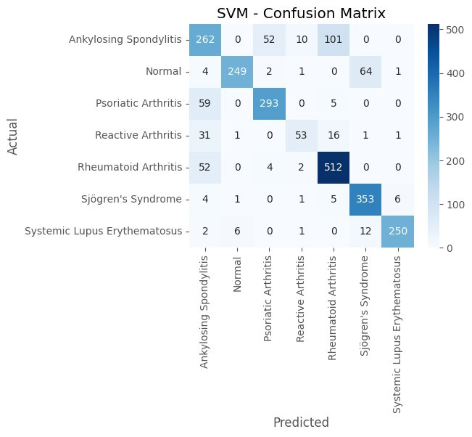
- Confusion Matrix — SVM.

Logistic Regression
Being the best approximation of the linear baseline, the Logistic Regression showed the worst overall misclassification rates, especially on the Ankylosing Spondylitis (274/425 correct, so the misclassification rate of 64.47) and the Rheumatoid Arthritis (480/570 correct, so the misclassification rate of 84.21) as shown in Fig. 12. Linear model revealed a wider scatter of misclassifications with all classes, even non adjacent disease categories reflecting the incapacity of a linear decision boundary to represent the multi-modal feature distributions inherent to the profiles of autoimmune diseases. Regardless of these shortcomings, Logistic Regression has correctly classified SLE with a 93.35% (253/271) hit rate indicating that the serological phenotype of SLE (high Anti-dsDNA, low C3/C4, ANA positive) is sufficiently linearly separable to its classes.
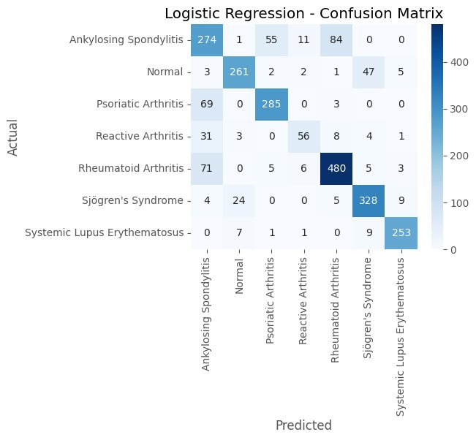
- Confusion Matrix — Logistic Regression.

Discussion

Comparative Algorithm Performance
The findings of this paper prove that gradient boosting ensemble classifiers are always the best compared to linear classifiers and kernel-based (Multi-class) ARD classification methods. The very close range between Gradient Boosting (84.86%), Random Forest (84.61%), and XGBoost (84.03%) indicates that the ensemble tree paradigm is well-represented by the interactions of the immunological and demographic features that are the major ones, and the outcome differences are insignificant because of the particular regularization and tree building practices. The better Gradient Boosting results than the results of Random Forest despite the similar architecture may be due to the sequential error-removal mechanism of boosting, again, specific to the misclassified pairs of diseases like Ankylasing Spondylitis and Reactive Arthritis.The difference between the lowest accuracy of SVM (81.59) and the largest AUC (0.980) is worthy of a clinical explanation. AUC is a metric that evaluates the capacity of the model to rank its positive examples higher than negative ones at all classification thresholds whereas accuracy is a metric that measures the classification at the hard threshold. The probabilistic calibration feature of SVM can be of great importance in clinical screening contexts, where assigning patients to hard categorical labels as opposed to ranking them by their probability of disease can be clinically important. The practical solution to this issue is that, a hybrid model, in which SVM identifies high-risk cases and passes them to a downstream ensemble, can utilize the advantages of either paradigm.

Clinical Interpretation of Misclassification Patterns
The most clinically significant pattern of misclassifications that has been observed in all models is the Ankylosing Spondylitis - Rheumatoid Arthritis confusion (about 100-110 cases per model). This has biologic underpinnings: the two conditions overlap in that they involve peripheral joints, are characterized by an increase in inflammatory parameters, and in certain instances positive ANA in the absence of the characteristic HLA-B27 relationship, or axial MRI imaging typical of definite AS. In case such a feature set lacks HLA typing or sacroiliac MRI results, this confusion is a natural constraint that underscores the necessity of multimodal classification models that are based on imaging [11].The stable performance of the SLE classification (92-98% sensitivity in all models) indicates that SLE has a strong serological fingerprint of ANA positive with high Anti-dsDNA and low complement levels (C3, C4) giving a strong and linearly separable fingerprint in the feature space. This is in tandem with clinical practice in which serological testing leads to the greatest diagnostic yield in SLE. Reactive Arthritis on the contrary had the lowest per-class sensitivity in all models (64-70%), which is the nature of this disease (transient), the overlap with Psoriatic Arthritis and AS, and the need to track history of previous infection not present in the features used.

Implications for Clinical Decision Support
The implications of the findings on clinical decision support systems (CDSS) based on ML development in rheumatology are direct. A Gradient Boosting or a Random Forest model with a multi-class accuracy of more than eighty four percent on a seven-class problem consisting of six clinically similar states is already a clinically significant diagnostic tool, especially in primary care contexts where there is no rheumatology expertise available. This model might either act as a triage instrument, where the most likely patients who have particular ARDs are given priority referral to rheumatology, or it might be used as a pre-test probability estimator algorithm where ranking of serological tests occurs [12].

Conclusion
This paper provides a multi-algorithm comparative analysis of the automated classification of seven categories of autoimmune rheumatic diseases with reference to immunological biomarkers and patient demographics. Gradient Boosting was the best classifier with an accuracy of 84.86 and macro F1-score of 84.60 followed by random forest and XGBoost, and SVM had the highest discriminative AUC of 0.980. The findings show that the ensemble tree-based systems have strong and clinically implementable performance on ARD multi-class classification and systematic confusion behavior, which indicate that real overlap in biology between spondyloarthropathies and not an algorithm failure. The rates of SLE detection are always high with all models and the identified classification of Ankylosing Spondylitis predicament render actionable advice on how to improve the model and also on how to enlarge the set of clinical features. This study lays a robust groundwork in the establishment of AI-aided diagnostic technologies in the field of rheumatology, and it is possible not only to decrease the time of diagnostics but also to maximize the use of biomarkers and improve patient outcomes due to early and accurate classification of the disease. The combination of machine learning methods for predictive analytics and decision support has been widely acknowledged as a promising avenue for healthcare innovation and intelligent clinical systems [13] [14] [15].This research advances the global aims of Sustainable Development Goal 3 by facilitating early disease detection and enhancing healthcare decision-making through the utilization of machine learning techniques.

References
- M. Ansari, G. G. D. Suminda, M. Ghosh, and Y.-O. Son, “Introduction to autoimmune diseases: A global health challenge,” in Cutting-Edge Strategies in Drug Delivery and Immunotherapy for Autoimmune Disorders. Singapore: Springer Nature Singapore, 2025, pp. 1–25. doi: 10.1007/978-981-95-0520-3_1.
- M. Kądziela, A. Fijałkowska, M. Kraska-Gacka, and A. Woźniacka,
“The art of interpreting antinuclear antibodies (ANAs) in everyday practice,” Journal of Clinical Medicine, vol. 14, no. 15, p. 5322, Jul. 2025. doi: 10.3390/jcm14155322.
- M. Boesch, F. Baty, F. Rassouli, and M. H. Brutsche, “What is disease modification and is this concept even helpful?,” European Journal of Internal Medicine, vol. 124, pp. 1–4, Jun. 2024. doi: 10.1016/j.ejim.2024.03.025.
- S. A. Poovathanathil, S. H. Barage, and R. Singh, "AI-Driven Precision Medicine and Personalized Healthcare for Immunological Disorders." AI-Assisted Computational Approaches for Immunological Disorders. IGI Global Scientific Publishing, 2025. 205-234.
- A. Wilson and M. Anwar, “The future of adaptive machine learning algorithms in high-dimensional data processing,” International Transactions on Artificial Intelligence, vol. 3, no. 1, pp. 97–107, Nov. 2024. doi: 10.33050/italic.v3i1.656.
- S. Dhanka, A. Sharma, A. Kumar, S. Maini, and H. Vundavilli, “Advancements in hybrid machine learning models for biomedical disease classification using integration of hyperparameter-tuning and feature selection methodologies: A comprehensive review,” Archives of Computational Methods in Engineering, 2025. doi: 10.1007/s11831-025-10309-5..
- Y. Shi, M. Zhou, C. Chang, P. Jiang, K. Wei, J. Zhao, Y. Shan, Y. Zheng, F. Zhao, X. Lv, S. Guo, F. Wang, and D. He, “Advancing precision rheumatology: applications of machine learning for rheumatoid arthritis management,” Frontiers in Immunology, vol. 15, p. 1409555, 2024. doi: 10.3389/fimmu.2024.1409555.
- C. La, J. Smet, C. Nagant, and M. Soyfoo, “Anti-Ku antibodies: clinical associations, organ damage, and prognostic implications in connective tissue diseases,” International Journal of Molecular Sciences, vol. 26, no. 15, p. 7433, Aug. 2025. doi: 10.3390/ijms261574333.
- M. Alwateer, E.-S. Atlam, M. A. El-Raouf, O. Ghoneim, and I. Gad,
“Missing data imputation: a comprehensive review,” Journal of Computer and Communications, vol. 12, pp. 53–75, Jan. 2024. doi: 10.4236/jcc.2024.1211004.
- A. Moayedikia, R. Jensen, and S. Fin, “Feature selection for high-dimensional imbalanced class datasets using harmony search and Kullback–Leibler divergence,” Data Mining and Knowledge Discovery, vol. 40, 2025. doi: 10.1007/s10618-025-01172-w.
- J. Chen, K. Yu, Y. Bi, X. Ji, and D. Zhang, “Strategic integration: a cross-disciplinary review of the fNIRS–EEG dual-modality imaging system for delivering multimodal neuroimaging to applications,” Brain Sciences, vol. 14, no. 10, p. 1022, Oct. 2024. doi: 10.3390/brainsci14101022.
- N. K. Biln, N. Bansback, K. Shojania, L. Puil, and M. Harrison,
“A scoping review of triage approaches for the referral of patients with suspected inflammatory arthritis, from primary to rheumatology care,” Rheumatology International, vol. 44, no. 11, pp. 2279–2292, Nov. 2024. doi: 10.1007/s00296-024-05575-8.
- R. Latha and S. John Justin Thangaraj, “Machine learning approaches for DDoS attack detection: Naive Bayes vs logistic regression,” in Proc. 2nd Int. Conf. Smart Technologies for Smart Nation (SmartTechCon), IEEE, 2023, pp. 1043–1048.
- J. Thangaraj, T. Mohanraj, C. S., J. Srija, R. Latha, and P. Rajendran, “Proactive congestion management in next-generation wireless networks: Evaluating traditional approaches against machine learning models,” in Proc. 2nd Int. Conf. Computational and Characterization Techniques in Engineering & Sciences (IC3TES), Lucknow, India, 2024.
- S. Padmakala and S. T. Gopukumar, "Predictive Analytics in Mental Health: Machine Learning Models for Major Depressive Disorder Detection using Sensor Data," 2025 International Conference on Electronics and Renewable Systems (ICEARS), Tuticorin, India, 2025, pp. 1393-1398, doi: 10.1109/ICEARS64219.2025.10940218.

