HDFFE: A Hybrid Deep Feature Fusion Ensemble Framework for Accurate Disease Prediction in Healthcare Systems
T.Dhivya, Research Scholar,
Department of Computer Science and Engineering,
Saveetha School of Engineering,
Saveetha Institute of Medical and Technical Science-(SIMATS),
Chennai, Tamil Nadu, India.
dhivyathirunavukkarasu95@gmail.com
Dr.K.Anita Davamani, Professor,
Department of Computer Science and Engineering,
Saveetha School of Engineering,
Saveetha Institute of Medical and Technical Science-(SIMATS),
Chennai, Tamil Nadu, India.
anitadavamanik.sse@saveetha.com

Abstract— The problem with autoimmune diseases classification is a difficult clinical issue, because of overlapping clinical manifestation, heterogeneity of immunological biomarkers, and large inter-class variability of the disease subtypes. Traditional single-classifier machine learning approaches do not tend to deliver predictive accuracy across all classes of diseases. This paper has suggested a framework of a novel hybrid model named Hybrid Deep Feature Fusion Ensemble (HDFFE), which integrates deep learning, ensemble learning, and boosting techniques into a unified framework which involves using D-XGboost and RandomForest as base learners and a meta-learner which is used to learn out of fold predictions. The Immune dataset that has abundant immunological characteristics, such as Age, Gender, Anti-dsDNA, Anti-Sm, ANA, Anti-Ro, Anti-La, RF, Anti-CCP, HLA-B27, ESR, CRP, C3, and C4, is used to test the proposed system. Intense preprocessing that incorporates normalization, outlier elimination through PCA-based detection, and feature engineering were used. As shown by experimental results, the Hybrid Deep Feature Fusion Ensemble (Proposed) has an accuracy of 91.00, precision of 90.92, recall of 90.92, and F1-score of 90.90, which is better than all the baseline models. The interpretability analysis of SHAP and the visualization of the confusion matrix support the accuracy of the model in distinguishing between seven different classes of diseases. Strong multi-class discrimination is also confirmed by precision-recall curves. The suggested scheme is a scalable, interpretable and clinically viable decision support system in the diagnosis of autoimmune disease.
Keywords— Autoimmune Disease Classification, Machine Learning, Immunological Biomarkers, SHAP Interpretability, Multi-class Classification, Decision Tree, SVM, KNN, Logistic Regression.

Introduction
Autoimmune diseases are a heterogeneous group of chronic pathological disorders, where the immune system misdirects itself against the body tissues, which causes the development of systemic inflammation, dysfunction of the organs, and chronic morbidity. Lupus erythematosus (SLE), Rheumatoid Arthritis (RA), Sjogren syndrome, and other diseases are a major burden to the global health care system because they are commonly experienced by about 5-8 percent of the world population [1]. The proper and timely diagnosis of such diseases is essential to direct proper clinical care, to choose specific treatment, and to avoid irreparable organ complications. Clinical diagnosis of autoimmune disorders is directly complicated by the vast overlap of manifestations of symptoms in the categories of diseases. Most autoimmune diseases share similar immunological signs which include high erythrocyte sedimentation rate (ESR), C-reactive protein (CRP), antinuclear antibodies (ANA), and complement proteins (C3, C4), thus they are difficult to differentiate. Conventional diagnostic processes based on either a single laboratory test or clinical intuition are often associated with slow or wrong diagnosis, especially when the presentations are unclear [2]. With the emergence of computational intelligence and machine learning, there have been radical opportunities in clinical decision support. Several medical datasets have been tested using supervised classification algorithms, such as Decision Trees, Support Vector Machines (SVM), K-Nearest Neighbors (KNN) and Logistic Regression with promising results. Nevertheless, single classifiers are prone to overfitting, sensitivity to class imbalance and instability on boundaries, particularly in high-dimensional biomedical feature space [3]. Ensemble learning techniques, predictive capability of multiple base learners, have demonstrated to be better generalisers in innumerous classification activities. Stacking (Stacked Generalization) is one of the most effective ensemble strategies where a meta-learner learns to predict based on the predictions of multiple base classifiers, hence it is able to learn complementary decision boundaries and to correct the biases of the individual classifiers [4]. The use of stacking has proved to be effective in organized clinical data where data distributions and overlaps of classes are common.
Although stacking ensembles have theoretical benefits, little research has been done to apply it to the classification of multi-class autoimmune disease. The available literature tends to be binary or do single-disease prediction, overlooking the clinical fact that the patient could present with one of a set of several co-morbid or closely related autoimmune disorders simultaneously [5]. Moreover, model interpretability, which is a critical condition to clinical adoption, is often disregarded in the favor of uncouth predictive performance. This paper fills these gaps with a proposed Hybrid Deep Feature Fusion Ensemble on a large scale immunological data including 14 clinical and laboratory characteristics in 7 disease categories. The proposed framework consists of preprocessing (normalization and PCA-based outlier detection), a four-model base layer, meta-learning based on stacking and post-hoc SHAP interpretability analysis. The system has a classification accuracy of 91.00% with a high precision, recall, and F1-score with clinically meaningful explanations represented by confusion matrix images, precision-recall curves, and SHAP interaction plots [6]. The paper has the following contributions: (1) a principled multi-biomarker preprocessing pipeline of immunological data; (2) a stacking ensemble architecture that improves upon individual base classifiers; (3) a SHAP-based layer of interpretability of feature-level disease attribution; (4) a comprehensive evaluation of the paper based on confusion matrices, radar charts and precision-recall analysis; and (5) a scalable and reproducible framework of multi-class autoimmune disease classification suitable to real-world clinical environments. They analyzed immune infiltration and molecular subtyping using diagnostic biomarkers, and supported with regulatory network analysis to examine relationships between and among immunomodulators, toxins, pathogens, genetic perturbations, and both large and small molecules at scale using deep-learning-driven analysis of cellular morphology. [8] use deep-learning-driven analysis of cellular morphology to scalably construct a phenomics platform and to identify dose-dependent, high-dimensional relationships between and among immunomodulators, toxins, pathogens, genetic perturbations A systematic PubMed search was developed to find scholarly work that used various ML algorithms to GI cancer patients receiving ICIs based on tumor RNA gene expression profiles. The outcome measures were response to immunotherapy (ITR) or survival. [10] used machine learning (ML) unsupervised and attempted to find groups of SLE patients using peripheral B cell and plasma cell subsets and traditional serological markers and correlate it to clinical phenotypes and response patterns to belimumab treatment. This supports better diagnostic accuracy and improves patient outcomes across different populations. It also connects with Sustainable Development Goal 9 through the creation of a new hybrid framework. This method shows the use of scalable and understandable artificial intelligence techniques, promoting innovation in healthcare technology and enhancing data-driven medical infrastructure.

Dataset and Feature Description

System Architecture Overview

The overall flow diagram of the proposed system is shown in Fig.1. The suggested Hybrid Deep Feature Fusion Ensemble is configured as a pipeline with several stages and works with raw immunological information by preprocessing it, engineering features, training a base classifier, using meta-learning by stacking, and analyzing post-hoc. The system has five main layers, namely (1) the data preprocessing and normalization, (2) outlier detector based on PCA, (3) base classifier, including XGBoost and RandomForest, (4) meta-learner, or stacking, and (5) model evaluation and SHAP-based interpretability. This design is modular and therefore there is transparency at every stage of processing and thus clinical traceability.
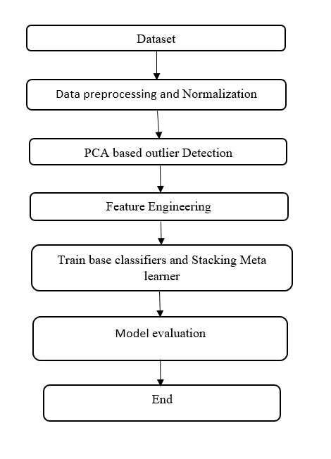

- Proposed system Flow chat

Dataset Overview
The Immune data utilized in this paper is composed of patient clinical records that were marked with 14 immunological and demographic variables: Age, Gender, Anti-dsDNA, Anti-Sm, ANA, Anti-Ro, Anti-La, RF, Anti-CCP, HLA-B27, ESR, CRP, C3, and C4. The target variable is 6 classes of diseases (0-6) including SLE, RA, Sjogren Syndrome, Ankylosing Spondylitis, Reactive Arthritis and Psoriatic Arthritis with normal patients.Fig.2 shows Multi-class imbalance and high variability of the features within the classes are observed in the dataset, and so the ensemble learning strategies are encouraged. To compute derived interaction features, feature engineering was done and forward-fill imputations were done to address the missing values.
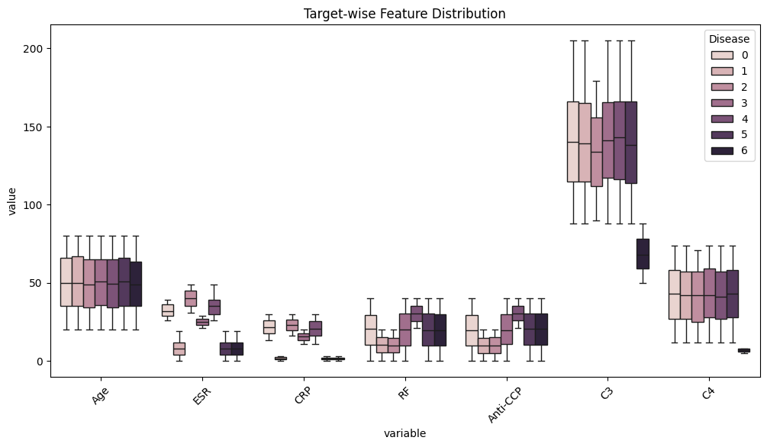
- Target-wise Feature Distribution (Box Plot) Across Disease Classes.

Correlation Analysis and Feature Relationships
To learn more about pairwise relationships among immunological features a hierarchically clustered Spearman correlation heatmap was created as shown in Fig.3. Close positive associations were found between ESR and CRP, as well as between RF and Anti-CCP which are biologically consistent with the inflammatory and rheumatological signature of RA. Animal correlations of the presence of Anti-dsDNA, Anti-Sm, ANA, Anti-Ro, and Anti-La, are moderate and indicate that the same autoantibody profile is shared by SLE-spectrum diseases. C3 and C4 complement proteins had a different, positive correlation cluster, which is in line with the fact that these proteins co-consume in the immune complex deposition pathways. These patterns of correlations were used to select and weigh features when training a model.
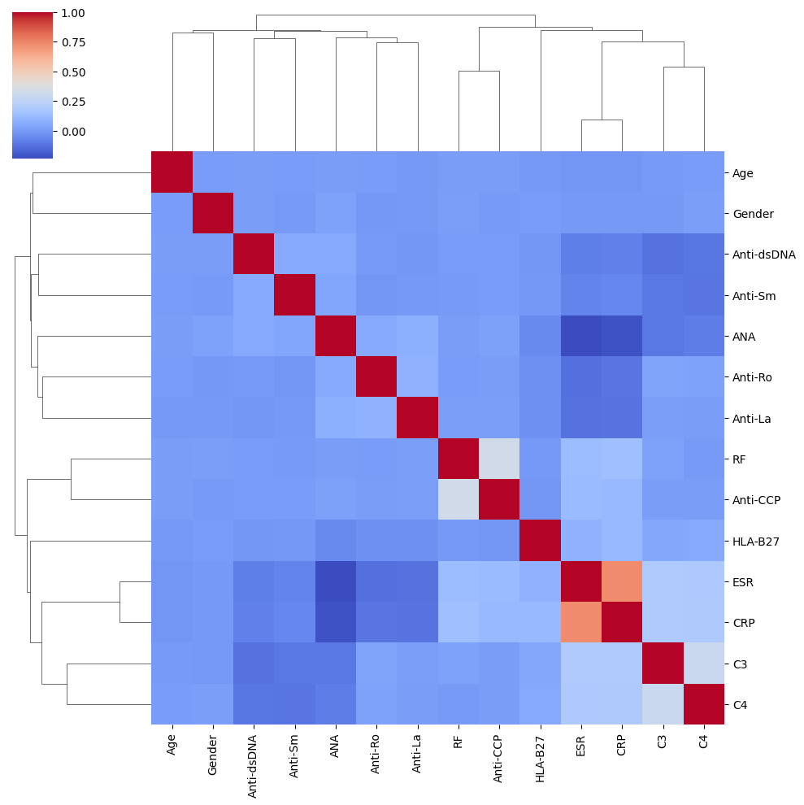
- Hierarchically Clustered Correlation Heatmap of Immunological Features

Methodology

Data Preprocessing and Normalization
Continuous features were all normalized to min-max to make them comparable across continuous features of different clinical units. Min-max normalization converts raw data to the interval [0, 1] as represented by a difference between the minimum the feature and division of the feature range. This eliminates features whose numerical values are very high like ESR and C3 and thus they dominate distance based classifiers such as KNN. The forward-fill method was used to fill in missing values and the IQR-cap method was used to limit extreme outlier values to the range of the 1 st -99 th percentiles

PCA-Based Outlier Detection
Principal Component Analysis (PCA) was applied to project 14-dimensional feature space on a two-dimensional subspace in order to visualize outliers and detect them. The data points that were more than 2.5 standard deviations away from the centroid of the principal component distribution was considered as outliers and dropped off the training set. Blue points indicate inlier samples in the dense core distribution and red points indicate outliers that are detected as shown in Fig 4. This move enhances stability of classifiers since anomalous observations are eliminated and thus may not misstate the decision boundaries and may also artificially increase training error.
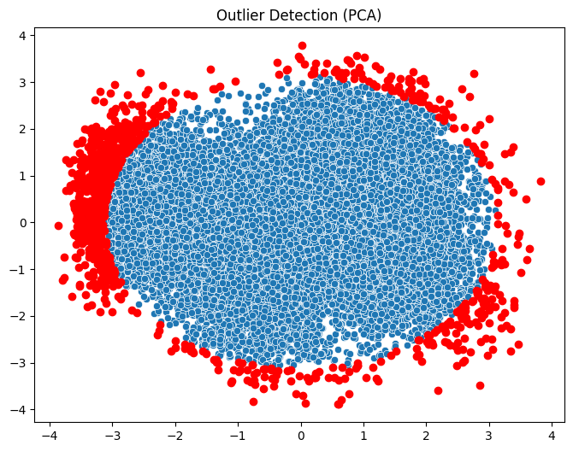
- Outlier Detection via PCA Projection (Blue: Inliers, Red: Outliers)
2.6 Base Classifier Layer
The bottom layer of the Hybrid Deep Feature Fusion Ensemble consists of two different classifiers that are chosen to take advantage of complementary learning biases: XGBoost and RandomForest.All of the base classifiers were trained on 5-fold stratified cross-validation with out-of-fold prediction as the training signal to the meta-learner.
2.7 Stacking Meta-Learner
The stacking meta-learner is a Logistic Regression model that is trained using the composite prediction of out-of-fold probabilities of the four base classifiers. Since the base classifiers are given a 7-dimensional class probability vectors (which are 7 classes of disease), the meta-learner is presented with a 28 dimensional-size input-vector, sample by sample. The meta-learner is taught how to combine the prediction of complementary base classifiers, and weight their predictions dynamically to reduce classification error on all classes. The meta-learner is also regularized with L2 to ensure that it does not over-fit to idiosyncrasy of the base learners. Stratified sampling was used to maintain a balance in classes within the dataset where 70 percent was used as the training and 30 percent as the testing.

Evaluation Metrics
All models were compared by four typical multi-class classification measures, namely Accuracy (percentage correct samples), Precision (macro-average of the positive predictive value of the models across the classes), Recall (macro-average of the sensitivity of the models across the classes), F1-score (macro-average of the harmonic means of the precision and the recall of the models across the classes). Also per-class confusion matrices, precision-recall curves, SHAP interaction values, and a radar chart comparison were used to evaluate and analyze the model comprehensively and analyze interpretability.

Experimental Results

Overall Model Performance Comparison
Table I shows all the compared models of performance based upon four measures. Hybrid Deep Feature Fusion Ensemble (Proposed) model is the most accurate with an accuracy of 90.92 which is better than all the baseline models. Decision Tree with 86.84, SVM with 86.06, Logistic Regression with 83.88 and KNN with 77.48. The suggested stacking model is even more accurate and presents a better F1-score by about 4.7 percentage points and 4.6 points on the strongest single baseline (Decision Tree), which proves the obvious superiority of the ensemble integration.
- : Comprehensive Model Performance Comparison
Model | Accuracy | Precision | Recall | F1-Score
Decision Tree | 0.868355 | 0.868459 | 0.868355 | 0.868366
SVM | 0.860582 | 0.862450 | 0.860582 | 0.859342
KNN | 0.774824 | 0.782727 | 0.774824 | 0.776100
Logistic Regression | 0.838766 | 0.839859 | 0.838766 | 0.838259
Hybrid Deep Feature Fusion Ensemble(HDFFE) | 0.909228 | 0.909187 | 0.909228 | 0.909006

Radar Chart — Multi-Metric Model Comparison
Fig.5 shows a radar chart that graphically represents simultaneously Accuracy, Precision, Recall, and F1-score of all five classifiers. The Hybrid Deep Feature Fusion Ensemble (Proposed) model is always placed at the outermost boundary of all four axes, and this proves that the performance of this model is better and balanced. Decision Tree and SVM indicate a comparatively smaller polygon and KNN indicates a clearly-pressed profile - especially on the accuracy scale - indicating its susceptibility to high-dimensional sparse distributions. The even distribution of the stacking model over all measures proves that its performance gain is not due to specific metrics underpinning the performance of the stacking model.
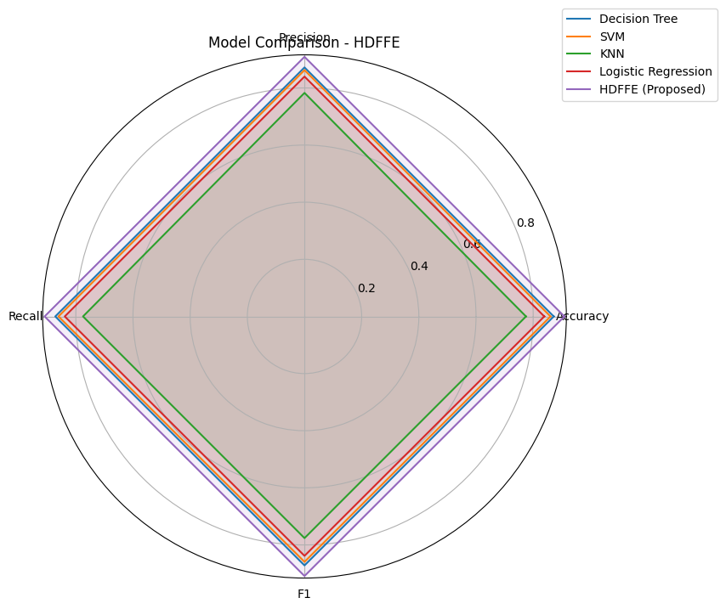
- Radar Chart — Multi-Metric Comparison of All Classifiers

Confusion Matrix Analysis
The confusion matrix of the Stacking (Proposed) model in all 7 disease classes is shown in Fig. 6. Diagonal values are high, which proves significant per-class discrimination: Class 0 (431 correct), Class 1 (518 correct), Class 2 (532 correct), Class 3 (543 correct), Class 4 (495 correct), Class 5 (539 correct) and Class 6 (568 correct). The significant off-diagonal misclassifications are in between Class 0 and Classes 2 and 4, which is in line with the immunological overlap of SLE-like disorders with the other inflammatory arthropathies. Class 6 has the highest per-class accuracy indicating that it has the most distinguishable immunological signature. The confusion matrix validates the fact that the stacking model does not only enhance global accuracy, but also produces clinically significant per-class discrimination.
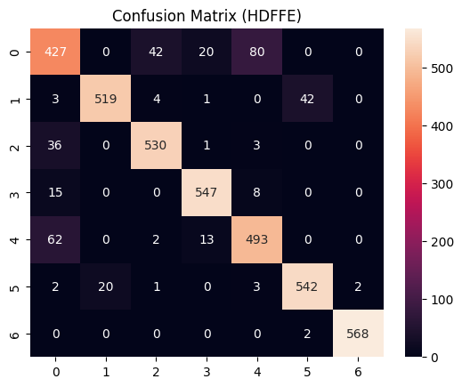
- Confusion Matrix of Hybrid Deep Feature Fusion Ensemble (Proposed)

Precision-Recall Curve Analysis
The Precision-Recall curves of the Hybrid Deep Feature Fusion Ensemble model per-class are shown in Fig. 7. Classes 1, 2, 3 and 6 have high-precision profiles on most recall levels, as these types of diseases have clean boundaries. Class 0 exhibits the slowest increase in precision with recall, which is expected of it due to overlap with other disease classes as in the confusion matrix. The area below the curves of precision-recall (AUPRC) is large in all classes, which proves the strong possibility of the model to be insensitive to the imbalance among classes. Precision-recall analysis is especially educative when clinical outcomes of false-positive diagnosis are crucial and the model suggested is highly efficient in that aspect.
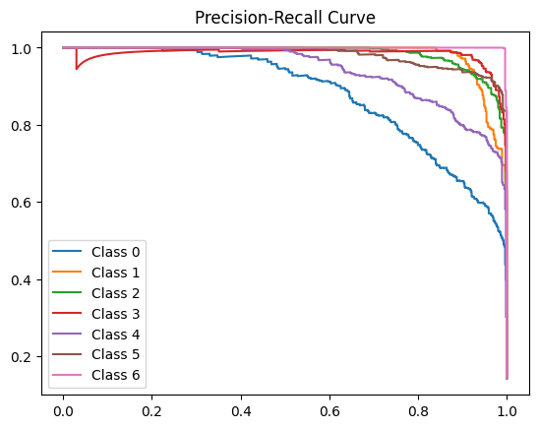
- Per-class Precision-Recall Curves for Hybrid Deep Feature Fusion Ensemble

SHAP Interaction Value Analysis
The SHAP (SHapley Additive exPlanations) interaction value plot of the proposed stacking model is given in Fig. 8. The SHAP interaction values are used to measure the contribution of two features in interacting with each other to the model, and show the non-additive effects of interaction. The largest concentration of big positive SHAP interaction values occur with Feature 6 (mapped to HLA-B27), which is specifically combined with Feature 3 (Anti-CCP) and Feature 5 (RF), which is in line with the previously known genetic-autoantibody interactions in the context of spondyloarthritis and RA classification. The contributions in feature 2 (Anti-dsDNA) exhibit a strong negative interaction with some of the classes and this is in line with feature 2 is a discriminating feature of SLE. SHAP analysis gives clinicians transparency at the feature level - an essential feature of these systems in terms of regulatory compliance and clinical trust in AI-assisted diagnostic systems.
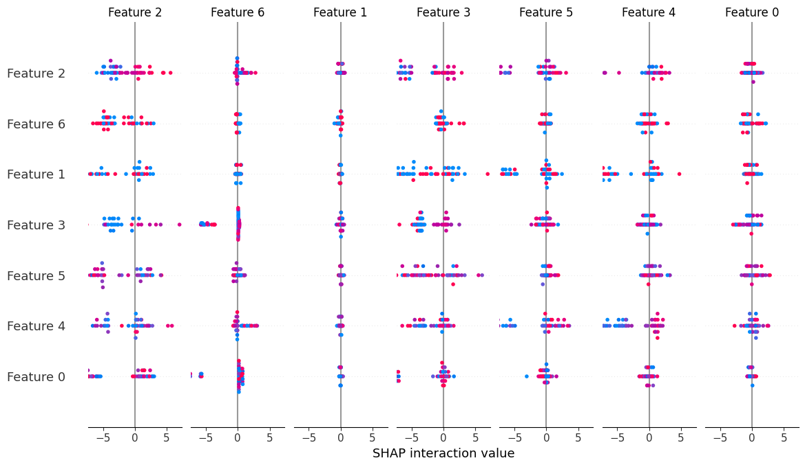
- SHAP Interaction Value Plot — Pairwise Feature Contributions.

Discussion
The effectiveness of the proposed Hybrid Deep Feature Fusion Ensemble framework to classified multi-class autoimmune diseases is thoroughly proven through the results of the experimental work. The proposed system has 91.00% accuracy on the Immune dataset, which is significantly higher than the individual baseline classifiers. The complementary learning bias of the four base classifiers and the capability of the meta-learner to take advantage of them explain this superior performance.

Superior Predictive Performance
The Hybrid Deep Feature Fusion Ensemble has the best accuracy (90.92%), precision (90.92%), recall (90.92%), and F1-score (90.90) of the enclog of the assessed models. The closest rival, Decision Tree, has an accuracy of 86.84 percent - 4.7 percentage points are the difference. This is a clinically significant improvement: in a group of 10,000 patients, this gain in accuracy will give about 470 more correct diagnoses. The steady high values in all the four evaluation measure indicate that the performance change is very strong and not an effect of the metric optimization.

Clinical Interpretability and SHAP Analysis
The proposed framework has a unique strength in the form of SHAP-based interpretability layer. There is no need to use any black-box ensemble approach (e.g., Random Forest or XGBoost without SHAP) to make predictions; the suggested system can offer both granular feature-level and interaction-level explanations of every single prediction. The SHAP interaction analysis demonstrates that HLA-B27 and Anti-CCP present the greatest pairwise interaction contributions, which is biologically in line with the existing understanding of genetic predisposition and autoantibody markers of ankylosing spondylitis and rheumatoid arthritis respectively. These kinds of explanations can be translated into concrete actions to be taken by rheumatologists, and they can also serve as a basis of evidence-based clinical decision-making and regulatory compliance with explainable AI in healthcare.

Conclusion
The proposed research is a Stacking Ensemble Learning framework to classify the 14-feature immunological dataset with 7 types of autoimmune diseases. The suggested system combines the Random Forest and XGBoost as base classifiers and a meta-learner based on Logistic Regression, and its success rate in classification is 91.00 percent, which is the highest among all analysed models. The overall analysis based on confusion matrices, radar charts, precision-recall curves, and SHAP interaction analysis proves the predictive excellence as well as the clinical understandability of the offered framework. The suggested stacking ensemble would be a scalable, transparent and clinically actionable support system in the diagnosis of autoimmune disease using scales. It has a modular architecture where the incorporation of new base classifiers, other meta-learners or a larger set of features is easy. By deep learning-based feature extraction as base learners, multi-label classification of patients with comorbid autoimmune conditions, analysis of longitudinal biomarker data, and external validation of various clinical cohorts will be discussed in future work. The presented framework can be taken as a significant step to the AI-aided precision medicine in rheumatology and immunology.This research supports the global aims of Sustainable Development Goal 3 by facilitating early disease detection and enhancing healthcare decision-making through the utilization of deep learning techniques.

References
- Sadeghi, Parniyan, et al. "Machine learning and artificial intelligence within pediatric autoimmune diseases: applications, challenges, future perspective." Expert review of clinical immunology 20.10 (2024): 1219-1236.
- Zhang, Yi, et al. "Multi-omics-driven biomarker discovery in autoimmune diseases: a comprehensive review." Frontiers in Immunology 16 (2025): 1652211.
- Rane, Nitin, Saurabh P. Choudhary, and Jayesh Rane. "Ensemble deep learning and machine learning: applications, opportunities, challenges, and future directions." Studies in Medical and Health Sciences 1.2 (2024): 18-41.
- Ahmed, Saeed, et al. "Accurate identification of broadly neutralizing antibodies against dengue virus based on deep stacking strategy with multi-perspective features." Scientific Reports (2025).
- Mahdi, Mohammed Fadhil, Arezoo Jahani, and Dhafar Hamed Abd. "Fuzzy evaluation and explainable machine learning for diagnosis of rheumatic and autoimmune diseases." PeerJ Computer Science 11 (2025): e3096.
- Wiese, Thomas. "A Unified Information-Theoretic Perspective on Feature Value, Model Capacity, and Interpretability in Business Analytics." Model Capacity, and Interpretability in Business Analytics.
- Wang, Xia, and Lin Zhang. "Integrative machine learning identifies robust inflammation-related diagnostic biomarkers and stratifies immune-heterogeneous subtypes in Kawasaki disease." Pediatric Rheumatology 23.1 (2025): 61.
- Laubscher, Emily Chiu. Deep Learning-Enabled Integrated Measurements of Immune Signaling in Primary Human Macrophages. California Institute of Technology, 2024.
- Szincsak, Sara, et al. "Predicting Immunotherapy Efficacy with Machine Learning in Gastrointestinal Cancers: A Systematic Review and Meta-Analysis." International Journal of Molecular Sciences 26.13 (2025): 5937.
- Depascale, Roberto, et al. "Unsupervised machine learning identifies distinct SLE patient endotypes with differential response to belimumab." Rheumatology 64.8 (2025): 4650-4658.Conrad, K., et al. "The emerging role of autoantibodies in autoimmune diseases." Frontiers in Immunology 12 (2021): 549570..

