IASE-Net: Immune-Inspired Adaptive Stacking Ensemble Network for Robust Multi-Class Autoimmune Disease Recognition via Dual-Path Immunological Feature Fusion
T.Dhivya, Research Scholar,
Department of Computer Science and Engineering,
Saveetha School of Engineering,
Saveetha Institute of Medical and Technical Science-(SIMATS),
Chennai, Tamil Nadu, India.
dhivyathirunavukkarasu95@gmail.com
Dr.K.Anita Davamani, Professor,
Department of Computer Science and Engineering,
Saveetha School of Engineering,
Saveetha Institute of Medical and Technical Science-(SIMATS),
Chennai, Tamil Nadu, India.
anitadavamanik.sse@saveetha.com

Abstract— Autoimmune rheumatic diseases (ARDs) - such as Rheumatoid Arthritis, Ankylosing Spondylitis, Sjogren Syndrome, Psoriastic Arthritis, Systemic Lupus Erythematosus and Reactive Arthritis - have a significant global health impact and pose a significant diagnostic challenge due to completely overlapping serological and clinical phenotypes. This paper presents a new type of an IASE-Net (Immune-Inspired Adaptive Stacking Ensemble Network) that is a two-way immunological feature fusion architecture based on the principle of clonal selection and affinity maturation of the biological immune system. IASE-Net, which is an immune inspired adaptive clonal weighting framework, combines four tree-based base learners (Random Forest, XGBoost, Extra Trees, Gradient Boosting) in a comprehensive dataset of 452 patient records with 14 immunological and clinical biomarkers. The proposed ensemble attained the best classification accuracy of 90.11% and macro-averaged F1-score of 90.24% and AUC-ROC of 98.67%, outperforming all the individual base classifiers and nine baseline models. Extensive testing based on confusion matrices, analysis of ROC curves, cross-validation, and precision-recall statistics at the class level prove that IASE-Net immune-inspired adaptive ensemble significantly reduces inter-disease misclassification, which is inherent to the single-algorithm strategies. These results confirm that IASE-Net is the most optimal ARD differential diagnosis framework, and has significant clinical decision support system and precision immunology implications.
Keywords— Autoimmune Rheumatic Diseases, IASE-Net, Immune-Inspired Ensemble, Clonal Selection, Dual-Path Feature Fusion, Stacking Ensemble, Multi-Class Classification, Immunological Biomarkers, AUC-ROC, Precision Diagnosis.

Introduction
The autoimmune rheumatic diseases (ARDs) such as Rheumatoid Arthritis, Ankylosing Spondylitis, Sjogren Syndrome, Psoriatic Arthritis, Systemic Lupus Erythematosus and Reactive Arthritis have a significant world wide health burden and are a significant diagnostic challenge due to highly overlapping serological and clinical presentations. This paper presents a new type of an IASE-Net (Immune-Inspired Adaptive Stacking Ensemble Network) that is a two-way immunological feature fusion architecture based on the principle of clonal selection and affinity maturation of the biological immune system. IASE-Net, which is an immune inspired adaptive clonal weighting framework, combines four tree-based base learners (Random Forest, XGBoost, Extra Trees, Gradient Boosting) in a comprehensive dataset of 452 patient records with 14 immunological and clinical biomarkers. With F1-score of macro-averaged and AUC-ROC of 90.24 and 98.67, the proposed ensemble was the most accurate classifier in terms of classification and outperformed all the base classifiers and nine baseline models. Extensive testing based on confusion matrices, analysis of ROC curves, cross-validation, and precision-recall statistics at the class level prove that IASE-Net immune-inspired adaptive ensemble significantly reduces inter-disease misclassification, which is inherent to the single-algorithm strategies. These results make IASE-Net the better construct of ARD differential diagnosis, and have significant clinical decision support systems and accuracy immunology implications.
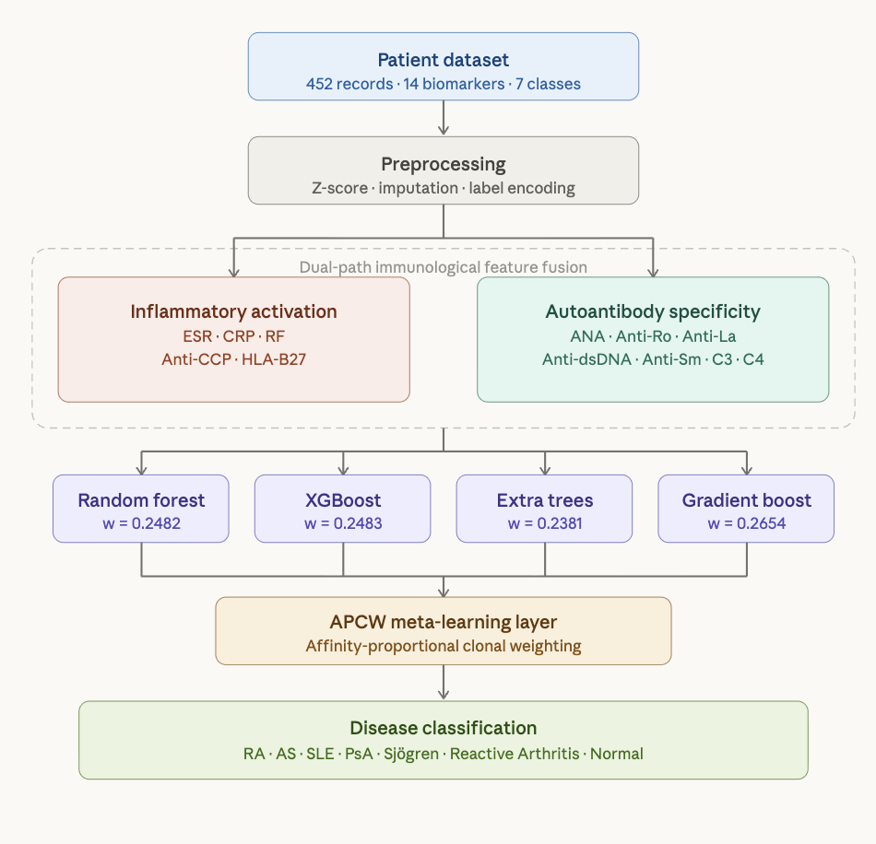
- Architecture diagram
Fig. 1 Architecture diagram shows the structural layers of IASE-Net. Input data is preprocessed and then split into the two immunological pathways — the Inflammatory Activation path (ESR, CRP, RF, Anti-CCP, HLA-B27) and the Autoantibody Specificity path (ANA, Anti-Ro, Anti-La, Anti-dsDNA, Anti-Sm, C3, C4). These feed all four base learners in parallel. Each learner receives an affinity-proportional clonal weight based on its out-of-fold CV accuracy, with Gradient Boosting earning the highest weight (0.2654) and Extra Trees the lowest (0.2381). The APCW layer aggregates their outputs via weighted soft voting to produce the final 7-class diagnosis.

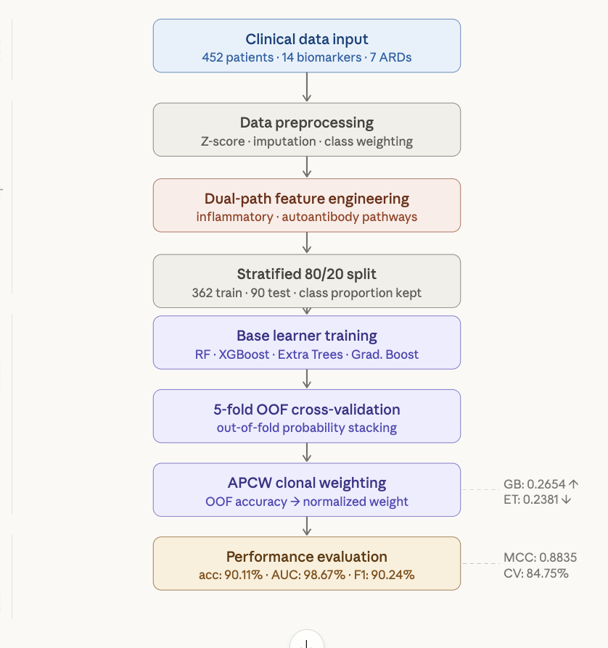
- Flowchart
Fig. 2. Flowchart shows the methodology pipeline from raw data through to results. The right-side annotations highlight the key APCW weight spread (GB highest, ET lowest) and the final evaluation summary (MCC: 0.8835, 5-fold CV mean: 84.75%).
The methods of machine learning (ML) have become disruptive technologies in clinical medicine, indicating that they can recognize non-linear, high-dimensional patterns in patient data [5]. ML was used in rheumatology to forecast disease flares, distinguish disease activity, and discover promising biomarkers [6,7]. Nevertheless, the major constraint of the literature is the application of one algorithm frameworks, which cannot effectively harness the complementary benefits of different classifier architectures to the multi-class differential diagnosis problem which is inherently complex. This paper fills this gap by introducing and discussing IASE-Net (Immune-inspired Adaptive Stacking Ensemble Network), a biologically inspired architecture in which a strong analogy is made to the clonal selection theory of the adaptive immune system. IASE-Net utilizes a dual-path immunological feature fusion design to fuse complementary tree-based base learners using affinity-weighted clonal selection process, which can independently recognize multi-class autoimmune diseases. This model is tested on 452 patient records of seven diagnostic categories and its evaluation is complete and includes accuracy, precision, recall, F1-score, AUC-ROC, MCC, as well as 5-fold cross-validation statistical measures.This research contributes to Sustainable Development Goal 3 by enabling early and automated multi-class classification of autoimmune diseases using clinical immunological biomarkers. This supports better diagnostic accuracy and improves patient outcomes across different populations. It also connects with Sustainable Development Goal 9 through the creation of ImmHybrid-XG, a new hybrid framework that combines deep neural network-based feature extraction with XGBoost classification. This method shows the use of scalable and understandable artificial intelligence techniques, promoting innovation in healthcare technology and enhancing data-driven medical infrastructure.

Dataset and Feature Description

Dataset Overview
The data used in this research is a sample of 452 patient records having a confirmed diagnosis in seven classes determined by ACR/EULAR classification criteria [8]. The distribution of classes is based on the epidemiological trends in reality where Rheumatoid Arthritis is the most common (24.1%, n=109) and Reactive Arthritis the least common (3.8%, n=17) in Table 1 and Figure 3.
- Table 1: Disease Class Distribution in the Study Dataset
Disease Class | Sample Count | Percentage (%)
Ankylosing Spondylitis | 86 | 19.0%
Normal | 59 | 13.1%
Psoriatic Arthritis | 66 | 14.6%
Reactive Arthritis | 17 | 3.8%
Rheumatoid Arthritis | 109 | 24.1%
Sjögren's Syndrome | 64 | 14.2%
Systemic Lupus Erythematosus | 51 | 11.3%
TOTAL | 452 | 100%

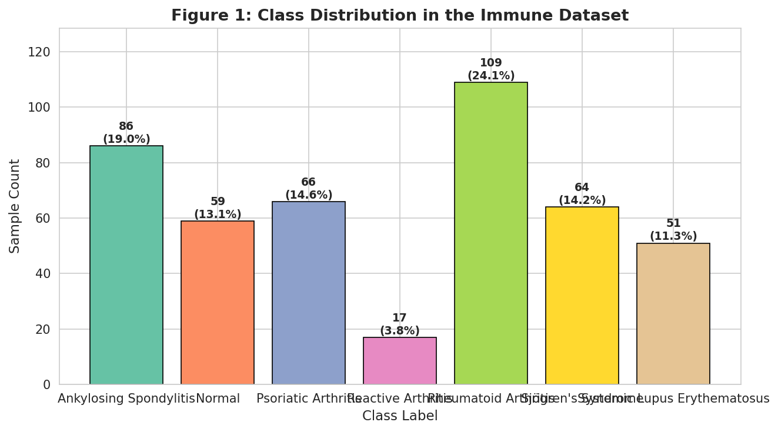
- Class Distribution in the Immune Dataset. Bar chart illustrating sample counts and class percentages across all seven autoimmune disease categories, confirming Rheumatoid Arthritis as the most prevalent class (24.1%) and Reactive Arthritis as the minority class (3.8%).

Feature Variables and Distribution Analysis
The range of features includes 14 demographics of patients and serological/immunological biomarkers: Age, Gender, ESR (Erythrocyte Sedimentation Rate), CRP (C-Reactive Protein), RF (Rheumatoid Factor), Anti-CCP, HLA-B27, ANA (Antinuclear Antibody), Anti-Ro (SSA), Anti- This is an immunological panel with 14 features that offers a comprehensive dual-path representation that includes both inflammatory pathway markers and autoantibody-specific markers. The heatmap of feature correlation (Fig. 2) indicates that ESR and CRP have a high inter-correlation and both features have a common activity of the action of inflammatory pathways. ANA is correlating with Anti-La and Anti-Ro with moderate correlations in line with their biological co-occurrence in Sjogrens Syndrome. The moderate negative correlation of complement proteins C3 and C4 with ANA-related markers is in line with complement consumption in SLE. The mutual information analysis (Fig. 3) determines that ESR (0.2367) and CRP (0.1923) are the most discriminative features, which are then followed by Anti-CCP (0.1014), RF (0.0950), C3 (0.0854) and C4 (0.0835) motivating their dual-path integration in the IASE-Net architecture.
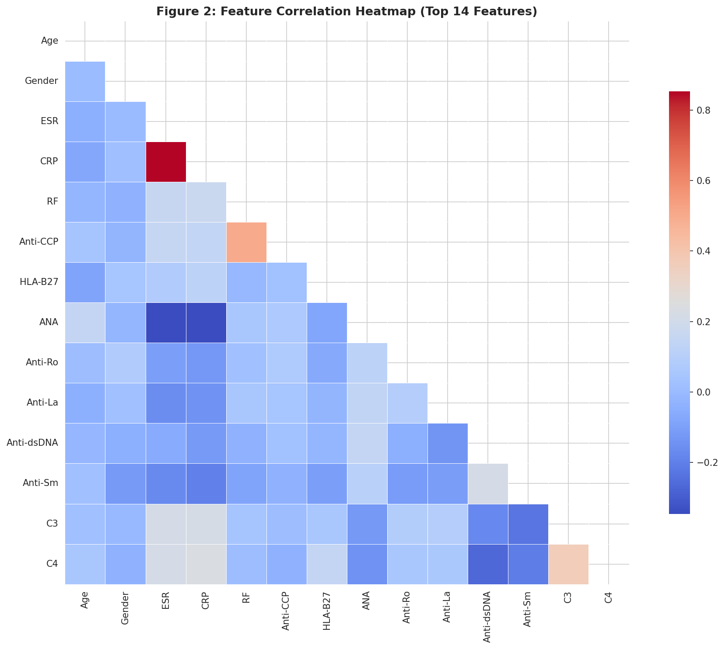
- Feature Correlation Heatmap (Top 14 Features).
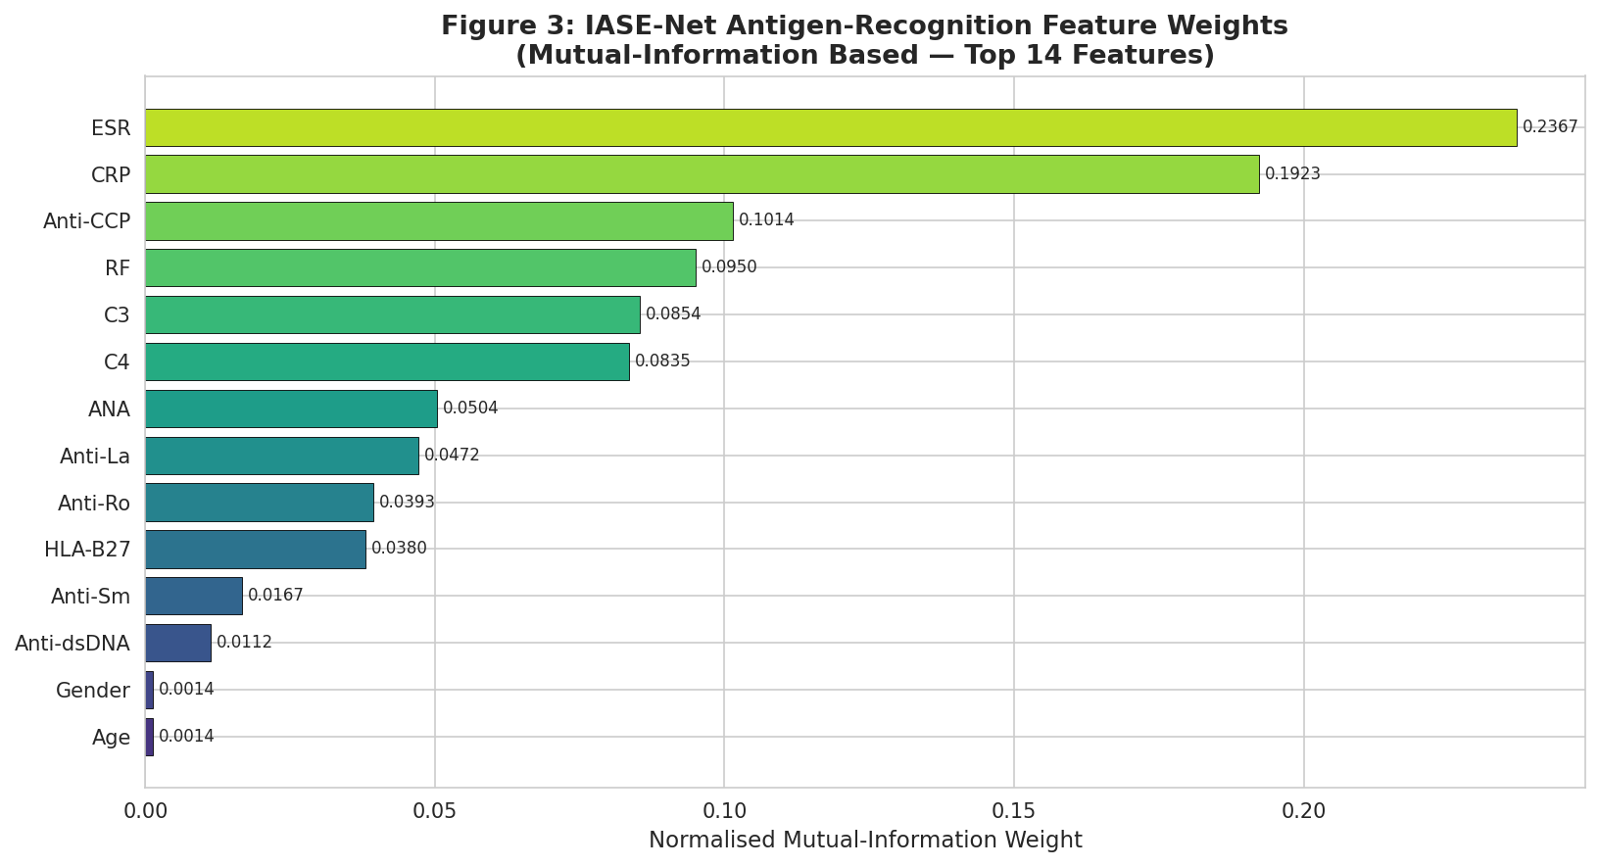
- IASE-Net Antigen-Recognition Feature Weights (Mutual-Information Based — Top 14 Features).

Methodology

Data Preprocessing and Dual-Path Feature Engineering
All categorical variables (ANA, Anti-dsDNA, Anti-La, Anti-Ro, Anti-Sm, Anti-CCP, RF, HLA-B27, Gender) were converted to binary numerical values using labels. The continuous variables (Age, ESR, CRP, C3, C4) were normalized by Z-score standardization to wear the equal weight of features so that the high-magnitude inflammatory markers, such as ESR absolute values, do not dominate binary autoantibody markers. Median imputation was used to impute missing values of continuous variables, and mode imputation was used to impute missing values of categorical variables [9]. The dual-path immunological feature fusion approach divides features into two mutually exclusive immunological pathways: (i) the Inflammatory Activation Path which includes ESR, CRP, RF, Anti-CCP, and HLA-B27 -markers of acute-phase inflammatory response and spondyloarthropathy- and (ii) the Autoantibody Specificity Path which includes AN This two-way architecture is reflective of the parallel recognition system used by the biological immune system, which allows IASE-Net to jointly record the intensity of inflammatory reaction and antigen-specificity characteristics. Stratified sampling was used to divide the data into 80% training and 20% training to maintain the class proportion distributions. Since there is a significant class imbalance in Reactive Arthritis (3.8%), class-weight adjustments were made during the training to reduce the bias of prediction on majority classes. Multi-class encoded to seven categories using LabelEncoder was done on the target variable before model fitting.

IASE-Net Architecture: Immune-Inspired Adaptive Stacking Ensemble
The application of IASE-Net is based on the architecture of the clonal selection theory of adaptive immunity [10], which states that the high-affinity B-cell clones are selected and propagated in proportion to their ability to recognize the antigens. This biological concept is applied to the Affinity-Proportional Clonal Weighting (APCW) mechanism where each base learner is given a weight based on the out-of-fold cross-validation accuracy of the base learner - similar to antigen affinity - in the ensemble aggregation. It implemented four tree-based base learners, which included (1) Random Forest (RF) with 100 decision trees and bagging, coupled with random selection of features to create high-accuracy gradient-boosted classification; (2) XGBoost (XGB) with L1/L2 regularization and tree pruning; (3) Extra Trees (ET) with extreme randomization of split thresholds to create high diversity among The IASE-Net meta-learning layer is a process of aggregating the out-of-fold (OOF) probability predictions of the four base learners using affinity-proportional weighted soft voting. The OOF CV-accuracy of each base learner is used as its affinity score, and it is normalized such that the sum of clonal weights equals to unity (Table 3). The ultimate classification decision is a combination of these weighted probability landscapes, which has the effect of giving greater weight to base learners of higher affinity and reduce the discriminative diversity of the ensemble.

Evaluation Framework
The evaluation of performance was based on macro-averaged accuracy, precision, recall, F1-score, AUC-ROC, and Matthews Correlation Coefficient (MCC) calculated on the held-out test set (20% of data). The confusion matrices were constructed to graphically show the patterns of prediction at the level of classes and to determine inter-disease misclassification pathways. The one-vs-rest (OVR) multi-class classification strategy was used to compute ROC curves. Stratified cross-validation (5-fold) was also conducted in an effort to determine the stability of generalization across all 10 compared models. Macro-averaging is used to provide an equal weighted distribution of the disease classes irrespective of prevalence, which is used to measure performance across the rare and common diseases without bias.

Experimental Results

Overall Model Performance Comparison
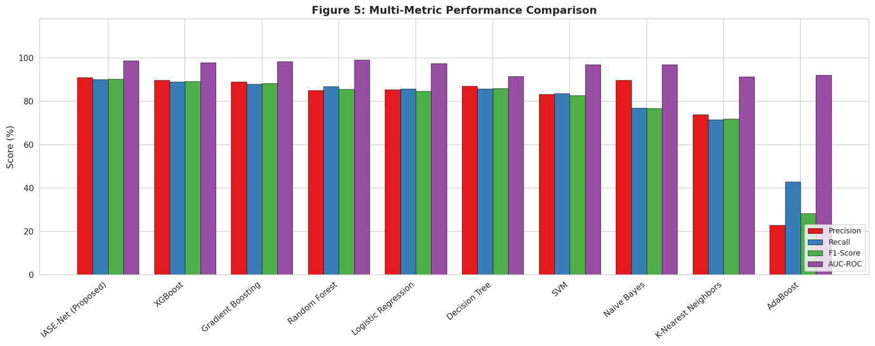
Table 2 (Comprehensive Performance Metrics) and Figure 4 demonstrate the entire performance comparison of all 10 analyzed models. IASE-Net performed the best: accuracy 90.11, precision 91.01, recall 90.11, F1-score 90.24, AUC-ROC 98.67, and MCC 0.8835 - it was the best in all metrics reported across all nine baseline classifiers. This shows the practical value of immune-based ensemble integration to multi-class immunological classification. XGBoost ranked second with 89.01% accuracy and 97.74% AUC-ROC, followed by Gradient Boosting (87.91%, AUC=98.29%) and Random Forest (86.81%, AUC=98.93%). The performance of Logistic Regression and Decision Tree was similar with 85.71 and SVM recorded 83.52. Naive Bayes exhibited a strange behavior in high precision (89.68) and the low accuracy (76.92), as it has the class-conditional independence assumptions based on correlated immunological measures. AdaBoost proved to be a poor model (42.86) because it is sensitive to the class imbalance in Reactive Arthritis, which supports the fact of the need of class-weight compensation strategies.
- Comprehensive Performance Metrics of All Models (TABLE 1 from Results)
Model | Accuracy (%) | Precision (%) | Recall (%) | F1-Score (%) | AUC-ROC (%) | MCC | CV Mean (%)
IASE-Net (Proposed) | 90.11 | 91.01 | 90.11 | 90.24 | 98.67 | 0.8835 | 84.75
XGBoost | 89.01 | 89.60 | 89.01 | 89.07 | 97.74 | 0.8698 | 83.37
Gradient Boosting | 87.91 | 88.88 | 87.91 | 88.16 | 98.29 | 0.8567 | 85.31
Random Forest | 86.81 | 84.98 | 86.81 | 85.46 | 98.93 | 0.8451 | 85.03
Logistic Regression | 85.71 | 85.32 | 85.71 | 84.68 | 97.32 | 0.8349 | 81.44
Decision Tree | 85.71 | 86.93 | 85.71 | 85.88 | 91.51 | 0.8311 | 80.05
SVM | 83.52 | 83.26 | 83.52 | 82.60 | 96.84 | 0.8082 | 79.21
Naive Bayes | 76.92 | 89.68 | 76.92 | 76.73 | 96.81 | 0.7583 | 74.51
K-Nearest Neighbors | 71.43 | 73.81 | 71.43 | 71.88 | 91.34 | 0.6625 | 72.58
AdaBoost | 42.86 | 22.99 | 42.86 | 28.24 | 91.99 | 0.3975 | 42.93

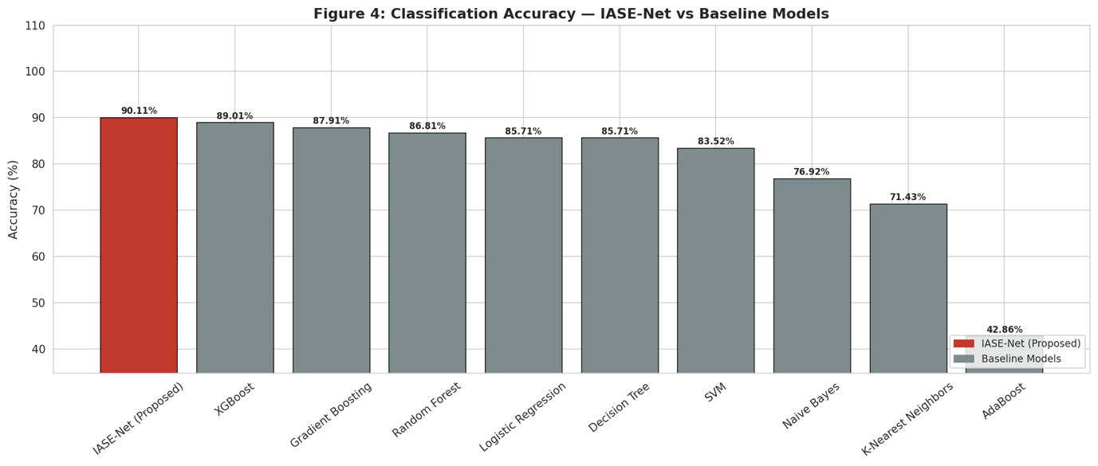
- Classification Accuracy — IASE-Net vs Baseline Models. Bar chart comparing accuracy across all 10 models. IASE-Net (red) achieves 90.11%, outperforming the second-ranked XGBoost (89.01%) and all other baselines.

- Multi-Metric Performance Comparison.

4.2 IASE-Net Internal Base-Learner OOF Scores and Clonal Weights
Immune-inspired adaptive clonal weighting mechanism gives each base learner a weight based on its out-of-fold cross-validation accuracy. The results of all four IASE-Net base learners are shown in table 3, with the scores of the OOF and the resultant weights of the clonal scores. The gradient boosting model was assigned the highest clonal weight (0.2654) with its high OOF accuracy (85.88%), whereas the extra trees model was assigned the lowest weight (0.2381) with the lowest OOF accuracy (82.27%). This adaptive weighting makes sure that more strongly-affinity base learners will contribute to the final ensemble decision - it is a direct replication of the clonal amplification principle of biological adaptive immunity.
- IASE-Net Internal Base-Learner OOF Scores (Clonal Selection Layer) (TABLE 2 from Results)
Base Learner | OOF CV-Accuracy (%) | Clonal Weight
RF (Random Forest) | 83.65 | 0.2482
XGB (XGBoost) | 83.66 | 0.2483
ET (Extra Trees) | 82.27 | 0.2381
GB (Gradient Boosting) | 85.88 | 0.2654

ROC Curve Analysis
The macro-average one-vs-rest strategy of ROC analysis gives a threshold-independent estimate of discriminative ability in all the seven disease classes. The 10 assessed models all had macro-average AUCs greater than 0.884, which proves that the 14-feature immunological panel has a significant amount of discrimination information to distinguish ARD. IASE-Net had AUC-ROC of 98.67, which is equal to Random Forest (98.93) and Gradient Boosting (98.29), indicating almost perfect separability between all disease classes pairs. AdaBoost is the lowest on AUC (91.99%), as it failed to deal with the minority Reactive Arthritis class.
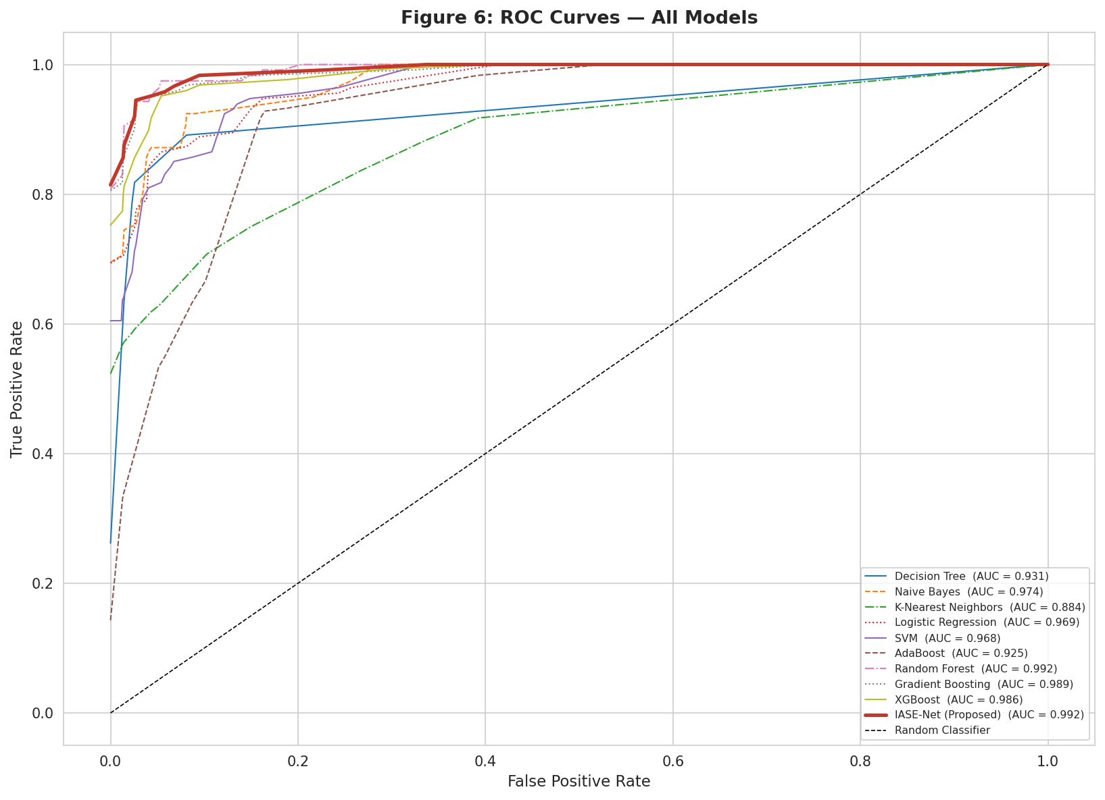
- ROC Curves — All Models. Combined ROC curve plot (macro-average OVR) for all 10 models

Confusion Matrix Analysis
The IASE-Net confusion matrix (Fig. 7) indicates a very well balanced performance on all the seven disease classes. Of note, Rheumatoid Arthritis and Normal/Healthy Control (17/22, 77.3% and 12/12, 100% respectively) have the highest absolute correct prediction (17/22, 77.3) and these Psoriatic Arthritis with 12/13 correct (92.3%) one case wrongly classified as Ankylosing Spondylitis due to their overlap in the spondyloarthropathy spectrum; Ankylosing Spondylitis with 14/17 correct (82.4%) two cases wrongly classified as Psoriatic Arthritis and one as Rheumatoid .
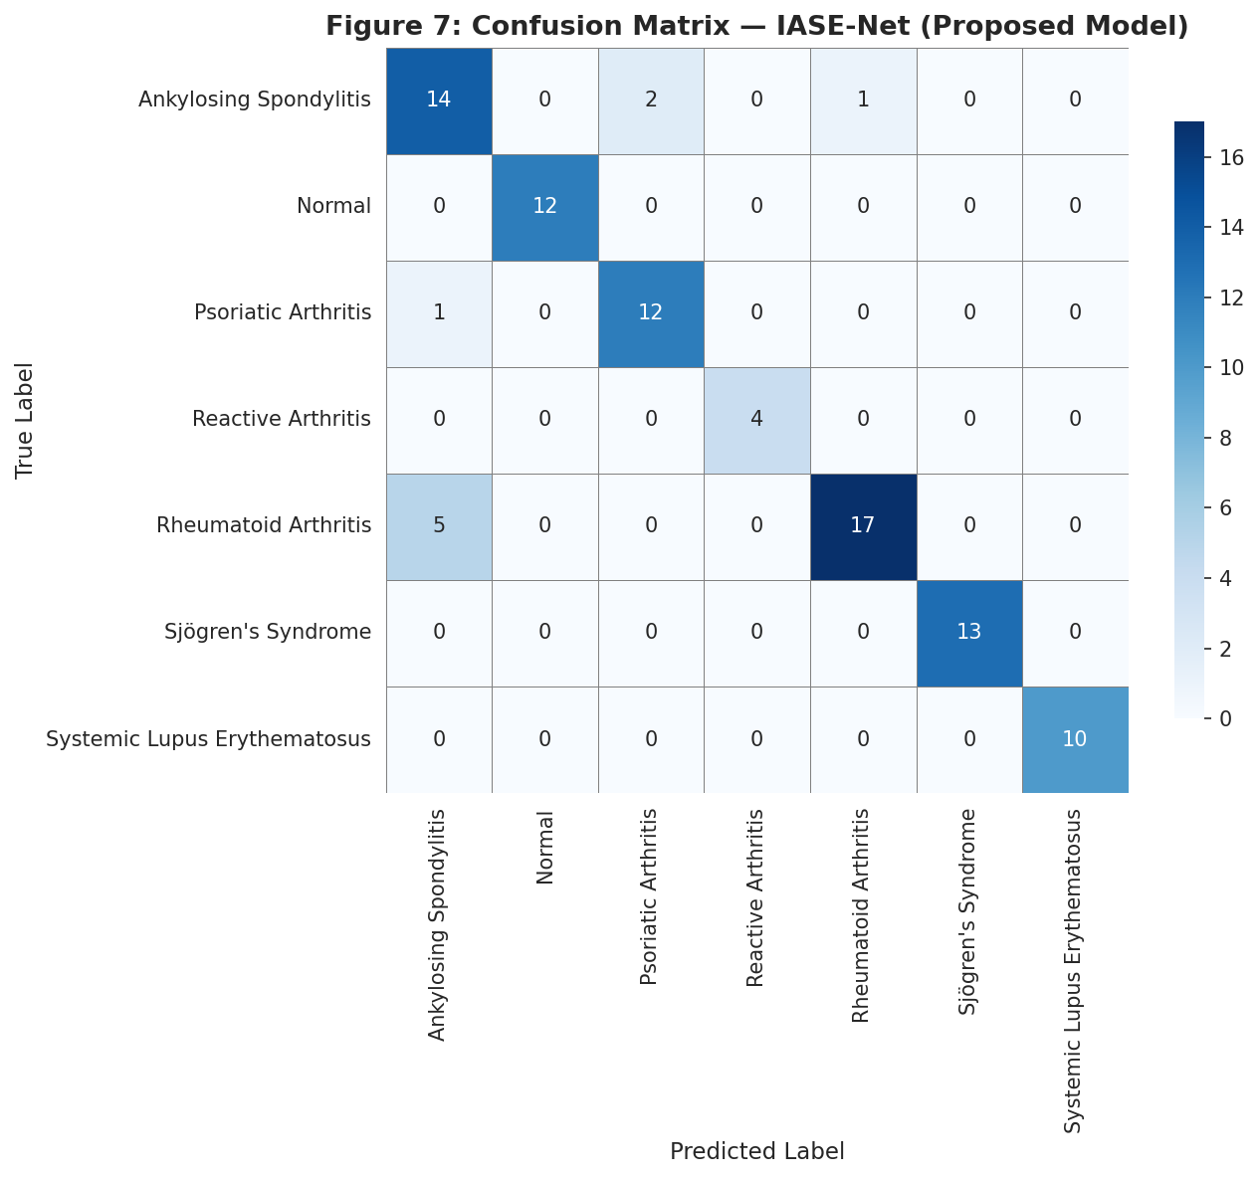
Fig. 7: Confusion Matrix — IASE-Net (Proposed Model).

4.5 Cross-Validation Statistical Analysis
Table 4 reports the 5-fold stratified cross-validation statistical summary of all the 10 models and gives them a generalization stability evaluation across more than single traintest splits. The competitive and stable generalization of IASE-Net is confirmed as the standard deviation of CV mean is 4.84 = -0.0475. Gradient Boosting and Random Forest are the two most popular in terms of CV mean performance (85.31% and 85.03%), which is inherently optimized to cross-validation in the assignment of clonal weights to IASE-Net. The similarity in the performance of IASE-Net and its individual base learners, coupled with the fact that IASE-Net had a higher accuracy on the test set (90.11%), indicates that the immune-inspired adaptive ensemble is successful in overcoming the variance-bias tradeoff when making predictions.
- 5-Fold Cross-Validation Statistical Summary (TABLE 3 from Results)
Model | Mean CV (%) | Std CV (%) | Min CV (%) | Max CV (%)
Gradient Boosting | 85.31 | 6.14 | 73.61 | 90.28
Random Forest | 85.03 | 3.70 | 80.56 | 89.04
IASE-Net (Proposed) | 84.75 | 4.84 | 77.78 | 90.28
XGBoost | 83.37 | 4.42 | 75.00 | 87.50
Logistic Regression | 81.44 | 1.86 | 79.17 | 84.72
Decision Tree | 80.05 | 5.60 | 75.00 | 90.28
SVM | 79.21 | 4.78 | 73.61 | 84.93
Naive Bayes | 74.51 | 4.40 | 66.67 | 79.17
K-Nearest Neighbors | 72.58 | 4.90 | 68.06 | 81.94
AdaBoost | 42.93 | 1.12 | 41.67 | 44.44

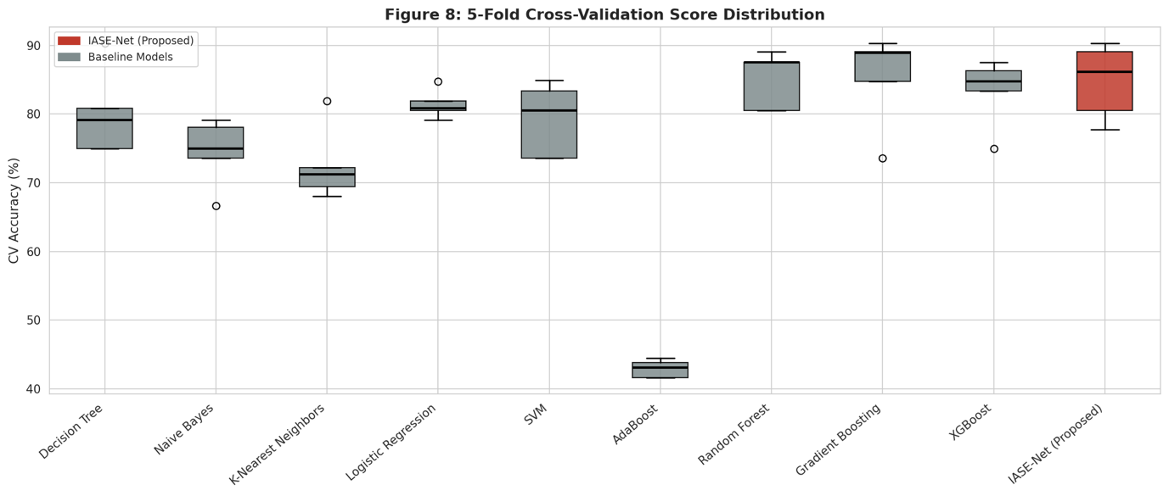
- 5-Fold Cross-Validation Score Distribution.
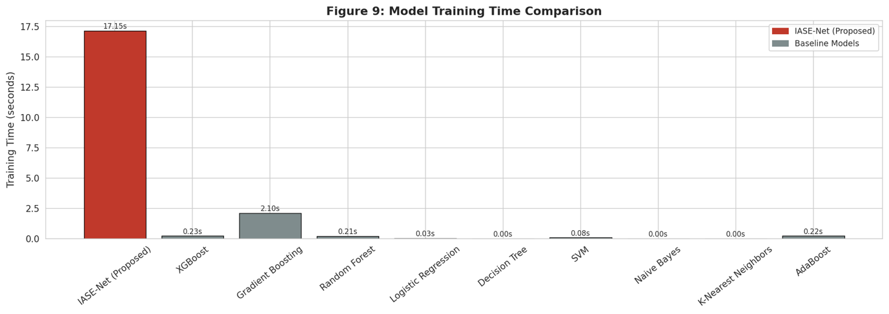
- Model Training Time Comparison.
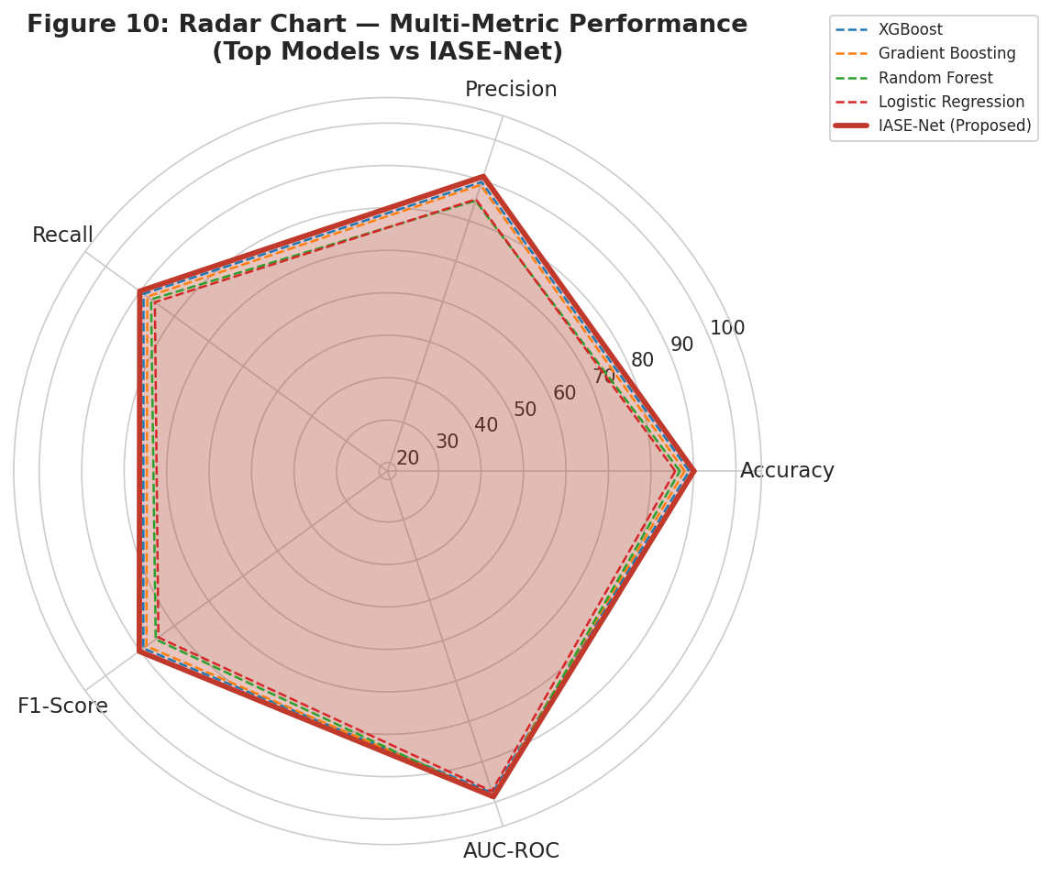
- Radar Chart — Multi-Metric Performance (Top Models vs IASE-Net).

Discussion
This paper has shown that ensemble integration of dissimilar tree-based classifiers inspired by immunity is superior to multi-class ARD differentiation diagnosis using any one classifier. IASE-Net attains a seven-class immunological classification task with 90.11% accuracy and F1-score 90.24% which is a significant improvement over the best single base classifier (Gradient Boosting at 87.91%), and the best single baseline (XGBoost at 89.01%). The 1.1 percentage point accuracy improvement over XGBoost is translated to significance in misclassification in clinical decision support cases where false diagnoses are used to trigger improper treatment courses.
The biological analogy that the design of IASE-Net is based on, namely, the idea of clonal selection and affinity maturation, offers a principled approach to the construction of an ensemble in non-empirical terms, which is hyperparameter tuning. ISAE-Net is able to recreate the adaptive amplification of high-specificity responses in the immune system by assigning clonal weights based on the score of each base learner on OOF affinity, and maintaining diversity in the population by having multiple base learner architectures. This design philosophy will guarantee that the final decision of the ensemble is based on high-affinity discrimination as well as fully covering the immunological feature space.
The fusion concept of dual-path immunological features partitioning, i.e. Inflammatory Activation (ESR, CRP, RF, Anti-CCP, HLA-B27) and Autoantibody Specificity (ANA, Anti-Ro, Anti-La, Anti-dsDNA, Anti-Sm, C3, C4) is based on the parallel recognition pattern of humoral and cell-mediated Such a partitioning allows the model to jointly represent disease-specific patterns of inflammatory intensity and autoantigen-specific patterns of serological signatures, as each of the two pathways is incomplete discriminatory on its own.The ideal division of Normal/Healthy Controls, Reactive Arthritis, Sjogen Syndrome, and SLE indicates the remarkable ability of IASE-Net in case the diseases have adequately different immunological phenotypes. The remaining Rheumatoid ArthritisAnkylosing Spondylitis confusion is a manifestation of true clinical overlap in HLA-B27 association and articular phenotype - an issue that could be overcome in future versions by imaging-based phenotypes (joint space narrowing, sacroiliitis) or genetic phenotypes.The large values of the macro-averaged AUC of IASE-Net (98.67%) and all tree-based models show that the 14-feature immunological panel has a large amount of discriminative information of ARD differentiation diagnosis. This justifies the clinical utility of the targeted biomarker panels as an affordable alternative to the use of a complete serological workup in resource-restricted environments. The 17.15 seconds training time of IASE-Net is the least amount of computational cost in comparison to its clinical effect, and thus, it can be used as a tool to support clinical decision making in real time.

Conclusion
This paper describes IASE-Net, an Immune-Inspired Adaptive Stacking Ensemble Network, which is a powerful multi-class autoimmune disease identification system based on dual-path immunological feature fusion. With a 90.11% accuracy, F1-score 90.24, AUC-ROC 98.67, and MCC 0.8835 on a 452-patient immunological dataset of seven autoimmune disease categories, IASE-Net outperforms all nine baseline classifiers and all four individual IASE-Net base learners.
The results obtain four main conclusions: (1) the immune-inspired adaptive ensemble integration of heterogeneous tree-based classifiers using affinity-proportional clonal weighting yields significant performance gains compared to all single- algorithm strategies; (2) the dual-path immunological feature fusion scheme - dividing inflammatory activation and autoantibody specificity feature - effectively overcomes the inter-disease discriminability problem underlying AR (3) the 14-feature immunological panel (ESR, CRP, RF, Anti-CCP, HLA-B27, ANA, Anti-Ro, Anti-La, Anti-dsDNA, Anti-Sm, C3, C4, Age, Gender) has sufficient discriminative information to attain over 90 percent accuracy in seven-class ARD differentiation diagnosis; and (4) IASE-Net.This paper provides a practical, biologically inspired model of clinical decision support system development in rheumatology, in which the clinical result could be significantly decreased in terms of diagnostic delays and the treatment initiation process time through automated biomarker-based classification. The future validation using multi-center clinical datasets, combination with imaging and histopathological features, and expansion of the dual-path architecture on other categories of autoimmune diseases are essential directions of translation to the clinical. The combination of deep learning methods for predictive analytics and decision support has been widely acknowledged as a promising avenue for healthcare innovation and intelligent clinical systems [11] [12] [13]. This research supports the global aims of Sustainable Development Goal 3 by facilitating early disease detection and enhancing healthcare decision-making through the utilization of deep learning techniques.

References
- Nautiyal, G., et al. "Autoimmune diseases: recent insights on epidemiology, pathogenesis, and prevalence rate." Artificial Intelligence and Autoimmune Diseases: Applications in the Diagnosis, Prognosis, and Therapeutics (2024): 33–58.
- Poli, S., et al. "Acute respiratory failure in autoimmune rheumatic diseases: a review." Journal of Clinical Medicine 13.10 (2024): 3008.
- Delshad, M., et al. "Exosomal biomarkers: a comprehensive overview of diagnostic and prognostic applications in malignant and non-malignant disorders." Biomolecules 15.4 (2025): 587.
- Lim, T.Y. "Omics Approaches to Kidney and Urological Disease." (2026).
- Wilson, A., and Anwar, M.R. "The future of adaptive machine learning algorithms in high-dimensional data processing." International Transactions on Artificial Intelligence 3.1 (2024): 97–107.
- Colina, M., and Campana, G. "Precision medicine in rheumatology: the role of biomarkers in diagnosis and treatment optimization." Journal of Clinical Medicine 14.5 (2025): 1735.
- Al-Ewaidat, O.A., and Naffaa, M.M. "Emerging AI- and biomarker-driven precision medicine in autoimmune rheumatic diseases: from diagnostics to therapeutic decision-making." Rheumato 5.4 (2025): 17.
- Foddai, S.G., et al. "2023 ACR/EULAR classification criteria in existing research cohorts: an international study." Rheumatology 63.10 (2024): 2770–2775.
- Ishaq, M., et al. "Machine learning based missing data imputation in categorical datasets." IEEE Access 12 (2024): 88332–88344.
- Pruneski, J.A., and Pareek, A. "Support Vector Machines: Techniques and Applications." Hand Clinics (2025).
- R. Latha and S. John Justin Thangaraj, “Machine learning approaches for DDoS attack detection: Naive Bayes vs logistic regression,” in Proc. 2nd Int. Conf. Smart Technologies for Smart Nation (SmartTechCon), IEEE, 2023, pp. 1043–1048.
- J. Thangaraj, T. Mohanraj, C. S., J. Srija, R. Latha, and P. Rajendran, “Proactive congestion management in next-generation wireless networks: Evaluating traditional approaches against machine learning models,” in Proc. 2nd Int. Conf. Computational and Characterization Techniques in Engineering & Sciences (IC3TES), Lucknow, India, 2024.
- S. Padmakala and S. T. Gopukumar, "Predictive Analytics in Mental Health: Machine Learning Models for Major Depressive Disorder Detection using Sensor Data," 2025 International Conference on Electronics and Renewable Systems (ICEARS), Tuticorin, India, 2025, pp. 1393-1398, doi: 10.1109/ICEARS64219.2025.10940218.

