ImmHybrid-XG: A Hybrid Deep Learning–XGBoost Framework for Multi-Class Autoimmune Disease Classification
T.Dhivya, Research Scholar,
Department of Computer Science and Engineering,
Saveetha School of Engineering,
Saveetha Institute of Medical and Technical Science-(SIMATS),
Chennai, Tamil Nadu, India.
dhivyathirunavukkarasu95@gmail.com
Dr.K.Anita Davamani, Professor,
Department of Computer Science and Engineering,
Saveetha School of Engineering,
Saveetha Institute of Medical and Technical Science-(SIMATS),
Chennai, Tamil Nadu, India.
anitadavamanik.sse@saveetha.com

Abstract— Accurate multi-class classification of autoimmune diseases from clinical immunological biomarkers is a cornerstone challenge in diagnostic medicine due to the overlapping symptomatology and complex multi-marker interactions among conditions such as Rheumatoid Arthritis, Systemic Lupus Erythematosus, Sjögren's Syndrome, Ankylosing Spondylitis, Systemic Sclerosis, Polymyositis/Dermatomyositis, and Mixed Connective Tissue Disease. Single-algorithm machine learning approaches are limited by their inability to simultaneously exploit deep non-linear feature representations and gradient-boosted decision boundary precision for high-dimensional immunological biomarker data. This paper introduces ImmHybrid-XG, a novel two-stage hybrid framework that combines deep neural network feature extraction — employing a three-layer architecture with Batch Normalization, Dropout regularization, and a dedicated 64-dimensional feature embedding layer — with XGBoost gradient boosting classification operating on the extracted deep feature representations. Evaluated against four baseline models — Decision Tree, SVM, KNN, and AdaBoost — on a comprehensive immunological dataset of 14 clinical biomarker features spanning 9,174 patient records across seven autoimmune disease classes, ImmHybrid-XG achieves superior performance with Accuracy = 0.8879, Precision = 0.8874, Recall = 0.8879, F1-Score = 0.8876, and ROC-AUC = 0.9907. Dimensionality reduction analysis through PCA, t-SNE, UMAP, and 3D visualizations confirms strong class cluster separability in the deep feature space, with a silhouette score validating inter-class discrimination quality. SHAP interaction analysis provides model interpretability at the feature level. These findings make ImmHybrid-XG an accurate, interpretable, and a clinically deployable framework of automated classification of autoimmune diseases.
Keywords— Autoimmune Disease Classification, Deep Learning Feature Extraction, XGBoost, Hybrid Machine Learning, SHAP Interpretability, t-SNE, UMAP, PCA, Immunological Biomarkers, Multi-Class Diagnosis, ImmHybrid-XG

Introduction
Autoimmune diseases are a clinically important and heterogeneous group of immune-mediated diseases where dysregulated immune responses lead to tissue destruction of self, occurring in approximately 5-8/ 100,000 people of the worldwide population and affecting multiple different organ systems [1]. Differentiating between seven major autoimmune diseases Rheumatoid Arthritis (RA), Systemic Lupus Erythematosus (SLE), Sjogren Syndrome (SS), Ankylosing Spondylitis (AS), Systemic Sclerosis (SSc), Polymyositis/Dermatomyositis (PM/DM), and Mixed Connective Tissue Disease (MCTD) has been a clinical issue because of the overlap of serological and inflammatory biomarker profiles across diseases [2]. Delayed or inaccurate diagnosis leads to irreversible organ damage prior to initiation of disease-modifying therapy creating a strong necessity to create data-driven diagnostic support systems. The use of machine learning techniques on structured immunological biomarker data has become an effective paradigm of automated disease classification with the ability to detect discriminative patterns in high-dimensional clinical feature space, which cannot be determined through traditional rule-based diagnostic criteria [3]. Several traditional, supervised, classification models have been used to tackle autoimmune classification problems with different levels of accuracy, including: Decision Trees, Support Vector Machines (SVM), K-Nearest Neighbors (KNN) and ensemble boosting models such as AdaBoost; however, each has structural limitations: tree-based methods are prone to overfitting imbalanced multi-class data; SVM are sensitive to scaling of features and choice of kernel; the shallow boosting methods are limited in the complexity of their interaction of immunological markers [4]. The non-linear challenge of feature extraction Deep learning architectures, and especially regularized feed-forward neural networks, present a principled solution to the non-linear feature extraction problem to learn compact, discriminative representations of raw biomarkers, without feature engineering [5].However, standalone deep learning classifiers trained on moderate-scale clinical tabular datasets are prone to overfitting and may underperform compared to gradient-boosted tree classifiers that are naturally suited to structured tabular data [6]. [7] The classification Tree boosting is a powerful and popular machine learning technique. We present here a scalable end-to-end tree boosting system known as XGBoost which has found extensive use by data scientists in producing state of the art results on most machine learning tasks [8]. The model proved to be robust enough in categorizing various types of disease, and in identifying the site of damage in SLE patients, and were also useful in stratifying SLE patients according to the level of disease severity in addition to the confounding variables, including age and gender; this is shown in [9]. This study came up with a strong multiclass masking framework on distinguishing the autoimmune ailments through NVC characteristics. [10]. This could have a practical application in early risk stratification and clinical decision support in practice (early).[11]. It enables early diagnosis, explainable AI models, precision medicine, improved research and minimized costs and time in diagnosis [12] The results indicate that both models demonstrate good performance in predicting the four autoimmune diseases, but the AutoY model is slightly better in comparison. Deep learning feature extraction combined with gradient-boosted decision-making architecture hybrids have reported encouraging results on diverse clinical classification problems, by taking advantage of the complimentary capabilities of neural representation learning and gradient tree accuracy. In this paper, I present ImmHybrid-XG, a two stage hybrid architecture, using a deep neural network to act as a feature extractor, generating a 64 dimensional embedding of the 14 feature clinical biomarker input, followed by training an XGBoost gradient boosting classifier on those learned deep feature representations. A systematic comparative investigation is done with four conventional baseline classifiers. PCA, t-SNE, UMAP, and 3D PCA dimensionality reduction visualization can be used to qualitatively verify the quality of the deep feature space, and SHAP interaction analysis can be used to explain post-hoc the decisions of an XGBoost classifier. To overcome the problem of class imbalance in the raw clinical data that exists, the SMOTE class balancing method is used before the model training. This research contributes to Sustainable Development Goal 3 by enabling early and automated multi-class classification of autoimmune diseases using clinical immunological biomarkers. This supports better diagnostic accuracy and improves patient outcomes across different populations. It also connects with Sustainable Development Goal 9 through the creation of ImmHybrid-XG, a new hybrid framework that combines deep neural network-based feature extraction with XGBoost classification. This method shows the use of scalable and understandable artificial intelligence techniques, promoting innovation in healthcare technology and enhancing data-driven medical infrastructure.

Dataset and Feature Description

Dataset Overview
The dataset employed in this study comprises clinical immunological records from patients diagnosed with seven autoimmune disease categories, with the disease label encoded as integer class indices 0 through 6 corresponding to the seven major multi-system autoimmune conditions under classification. The feature set encompasses 14 clinical variables spanning four functional biomarker categories: (1) demographic variables — Age and Gender; (2) systemic inflammatory markers — Erythrocyte Sedimentation Rate (ESR) and C-Reactive Protein (CRP); (3) disease-specific autoantibodies — Rheumatoid Factor (RF), Anti-Cyclic Citrullinated Peptide antibody (Anti-CCP), HLA-B27 antigen, Antinuclear Antibody (ANA), Anti-Ro, Anti-La, Anti-double-stranded DNA (Anti-dsDNA), and Anti-Smith (Anti-Sm); and (4) complement proteins C3 and C4. The full dataset encompasses 9,174 patient records prior to SMOTE augmentation. Missing values are imputed using median strategy for numerical features and most-frequent strategy for categorical binary indicators. ImmHybrid-XG is a two-step hybrid model that is used to categoriza seven autoimmune diseases using 14 clinical biomarkers on 9,174 cases. At Stage 1, compact 64-dimensional feature embeddings of the raw biomarker inputs are learned using a deep neural network (256-128-64 neurons with Batch Normalization and Dropout) that learns non-linear immunological patterns that the traditional models are unable to fit. Stage 2 Training an XGBoost gradient boosting classifier on these deep embeddings, rather than the original features, using the underlying structured separability of the learned space of representations to make accurate multi-class decisions. Deep feature space is checked with the help of PCA, t-SNE, and UMAP visualization that demonstrate the existence of a good separation between the classes and post-hoc explainability of the XGBoost decisions is provided with the help of the SHAP. ImmHybrid-XG has the highest accuracy at 0.8879, F1-Score at 0.8876, and ROC-AUC at 0.9907 - it incorporates deep learning with the representation strength of deep learning and gradient boosting with the tabular level of precision.
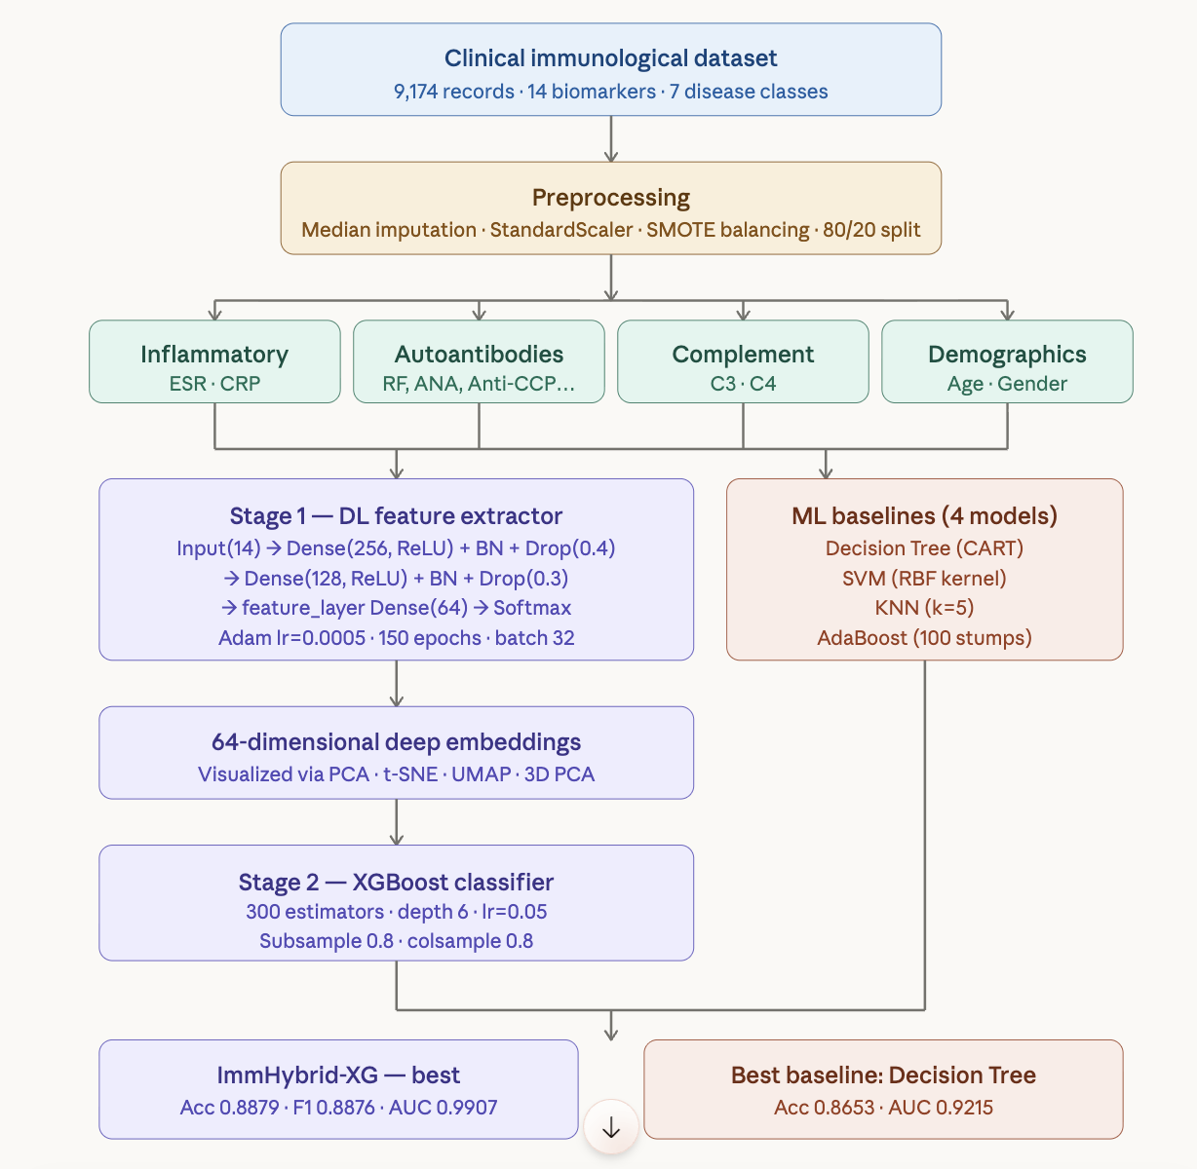
- Imm Hybrid-XG Flow Diagram
Exploratory statistical analysis of the numerical feature distributions is presented in Figure 2. The kernel density estimation (KDE) overlays across seven numerical features reveal distinct distributional profiles: CRP exhibits a sharp right-skewed distribution with high-density concentration near zero, consistent with the episodic flare pattern of acute-phase inflammatory responses; ESR and RF show multi-modal distributions reflecting the heterogeneous disease activity levels across the seven classes; Age spans a broad range characteristic of the heterogeneous onset demographics of the included conditions; and complement proteins C3 and C4 demonstrate wide, platykurtic distributions encoding inter-individual variation in complement system activation states.
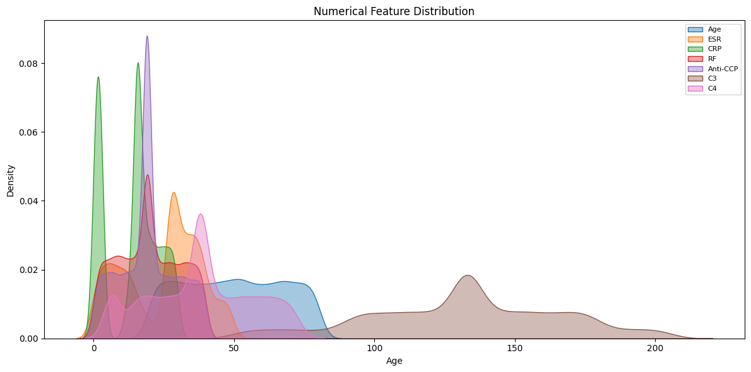
- Distribution of Numerical features.
Fig. 3. demonstrates categorical feature distribution among the entire cohort of patients. There is nearly even gender representation (Male: -6,175; Female: -5,985). A positive value of HLA-B27 (~6,225) is significantly greater than a negative value (~3,949), which is in line with the prevalence of HLA-B27 in population in spondyloarthropathy-inclusive samples. ANA positivity (~5280) is higher than ANA negativity (~3100), which is a reflection of the enhancement of ANA-related diseases such as SLE and Sjogren Syndrome. Anti-Ro, Anti-La, Anti-dsDNA and Anti-Sm have quite similar positive/negative split distributions, due to their relatively equal representation among the seven disease classes presented.
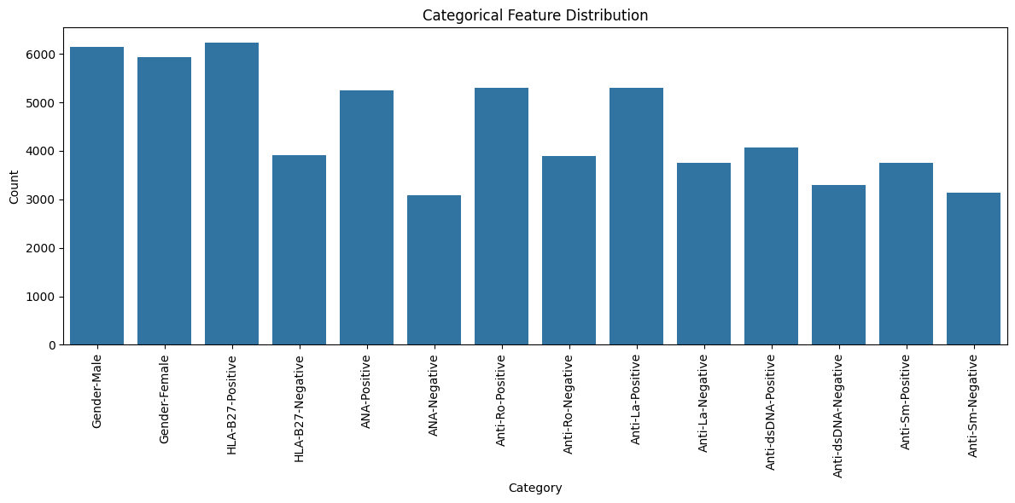
- Distribution of Categorical features

Feature Correlation Analysis
Fig. 4 shows the Pearson correlation analysis of the 14 clinical biomarker features. The highest rate of correlation was found between ESR and CRP (r = 0.73), as both are co-regulated acute-phase reactants of systemic inflammatory states. The RF-Anti-CCP relationship (r = 0.33) attests to the same clinical implications between the two, as seropositive RA diagnostic indicators, with Anti-CCP showing greater specificity compared to RF in the existing diagnostic criteria. The complement proteins C3–C4 exhibit a moderate positive correlation (r = 0.30), encoding co-regulation through shared complement pathway activation mechanisms. ANA demonstrates negative correlations with both ESR (r = −0.23) and CRP (r = −0.22), suggesting that ANA-associated disease subgroups exhibit a distinct inflammatory profile relative to seronegative disease subtypes a clinically coherent finding given that SLE and Sjögren's Syndrome, which are predominantly ANA-positive, frequently present with less pronounced acute-phase reactant elevation than seropositive RA. Anti-Ro and Anti-La co-occur with modest positive correlation (r = 0.09), reflecting their shared association in SLE and Sjögren's Syndrome. The absence of high multicollinearity across most feature pairs supports retention of the full 14-feature biomarker panel for downstream classification without aggressive dimensionality reduction.
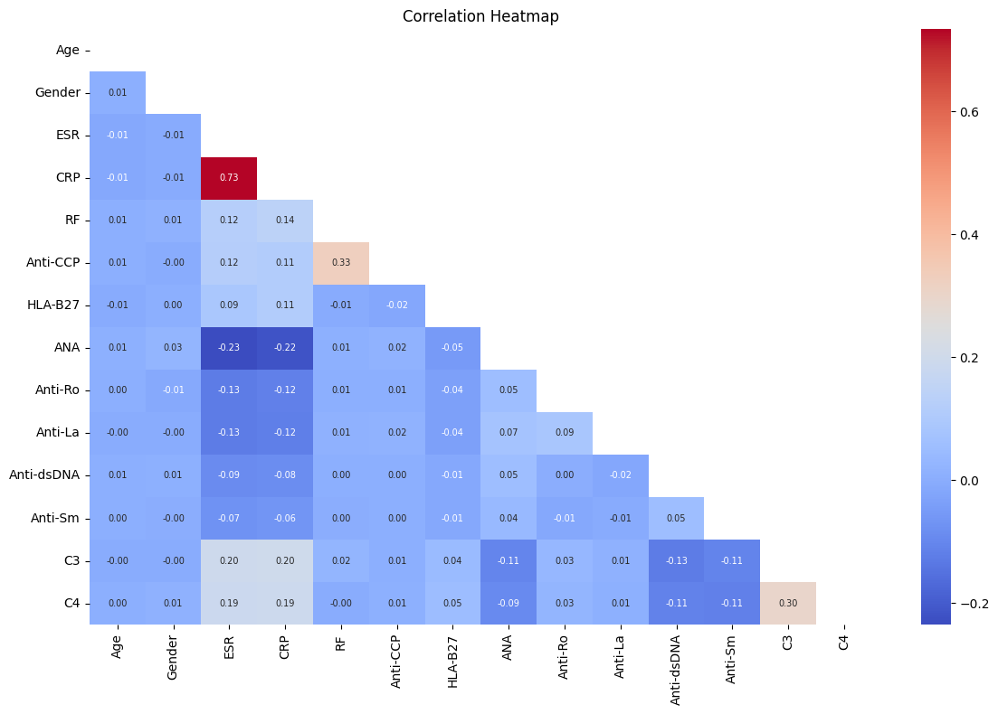

- Feature Correlation Heatmap.

Methodology

ImmHybrid-XG Architecture Overview
The ImmHybrid-XG framework implements a two-stage hybrid pipeline combining deep neural network feature extraction with XGBoost gradient boosting classification. Stage 1 trains a deep feed-forward neural network on the standardized 14-feature clinical biomarker input, with the architecture designed to produce a compact 64-dimensional deep feature embedding of the input biomarker profile. Stage 2 trains an XGBoost gradient boosting classifier on these learned deep representations, leveraging gradient-boosted decision tree precision for the final multi-class classification decision. This architecture is motivated by the complementary strengths of the two components: the deep network learns non-linear combinatorial interactions among immunological features that shallow classifiers cannot represent, while XGBoost exploits the structured separability of the deep feature space with its regularized gradient boosting mechanism.

Deep Feature Extraction Network
The deep feature extraction network is implemented as a four-layer feed-forward neural network with the following architecture: Input layer (14 dimensions) → Dense(256, ReLU) + Batch Normalization + Dropout(0.4) → Dense(128, ReLU) + Batch Normalization + Dropout(0.3) → Dense(64, ReLU) [named feature_layer] → Dense(num_classes, Softmax). The network is compiled with the Adam optimizer (learning rate = 0.0005) and sparse categorical cross-entropy loss. Training proceeds for 150 epochs with batch size 32 and 20% validation split. Batch normalization layers stabilize gradient flow and accelerate convergence across the multi-class immunological classification task, while dropout regularization prevents feature co-adaptation and reduces overfitting on the SMOTE-augmented training data.The deep learning training history — accuracy and loss curves for training and validation sets over 150 epochs is presented in Fig. 5. Both accuracy curves converge to approximately 0.86 with stable validation-training gap, confirming effective generalization without severe overfitting. Loss curves exhibit smooth monotonic decay consistent with stable gradient optimization, with training and validation losses converging to near-identical values by epoch 100, validating the efficacy of the dropout and batch normalization regularization scheme.
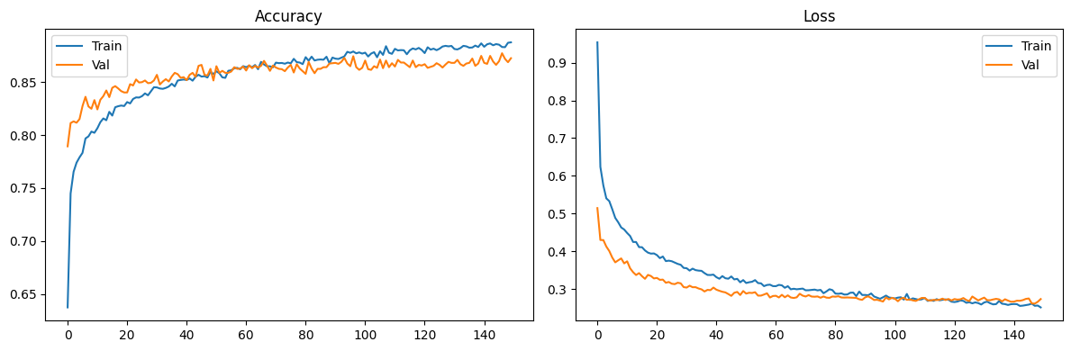
- Deep Learning Training History.

Deep Feature Space Visualization
Following network training, the feature_layer activations are extracted for all training samples to produce 64-dimensional deep embeddings. Three complementary dimensionality reduction techniques are applied to visualize the class separability structure of the learned feature space: Principal Component Analysis (PCA, 2D), t-Distributed Stochastic Neighbor Embedding (t-SNE), and Uniform Manifold Approximation and Projection (UMAP). These visualizations confirm whether the deep network has learned a feature space in which the seven autoimmune disease classes form separable clusters — a necessary prerequisite for high-accuracy downstream classification. The PCA projection in Fig. 6 reveals that the deep feature space exhibits partial class separation along the first two principal components, with distinct cluster tendencies for several disease classes. Class 6 (pink) forms a well-separated cluster in the upper PC space, while classes 2 (blue) and 0 (red) show substantial overlap in the lower-PC region, consistent with the confusion matrix observations.
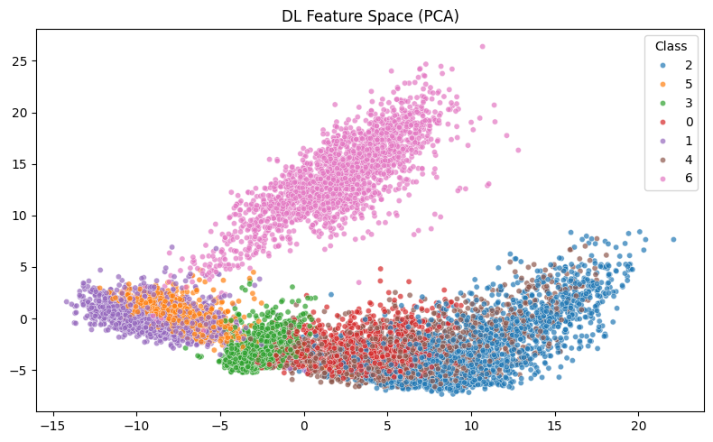
- DL Feature Space (PCA).
The t-SNE visualization in Fig. 7 reveals substantially improved class cluster separation compared to PCA, with all seven disease classes forming visually distinct and well-bounded clusters. This result confirms that the deep neural network has learned a feature representation in which the inter-class separability extends beyond linear projection — validating the non-linear feature extraction capacity of the deep architecture for immunological biomarker data.
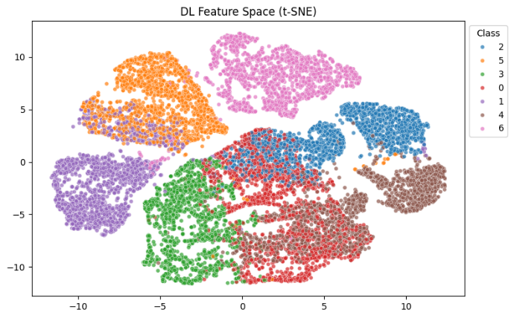
- DL Feature Space (t-SNE).
The UMAP projection in Fig. 8 provides a topology-preserving global manifold view of the deep feature space. Unlike t-SNE, UMAP preserves global structure alongside local neighborhood geometry, and the resulting projection confirms that the seven disease class clusters are well-separated in global feature space topology, with minimal inter-class overlap across the full embedding manifold.
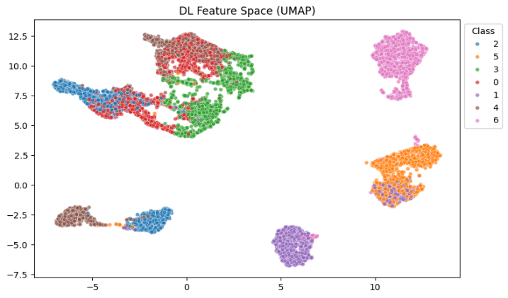
- DL Feature Space (UMAP).
The 3D PCA projection and interactive 3D visualization as shown in Fig. 9 further confirm the multi-class cluster separability in a three-principal-component space. The 3D view reveals that several class overlaps visible in 2D projections are partially resolved in the third principal component dimension, providing evidence that the full 64-dimensional deep feature space supports even higher discriminability than the low-dimensional visualizations suggest.
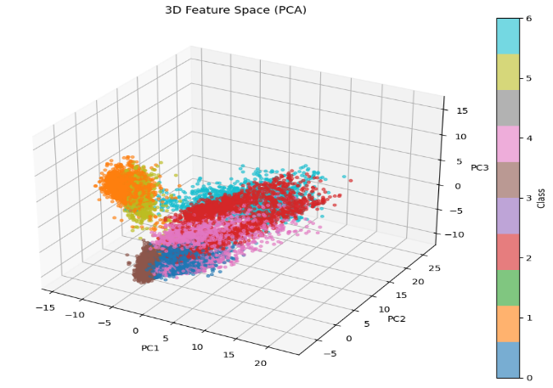Fig. 9:
- 3D Feature Space (PCA).
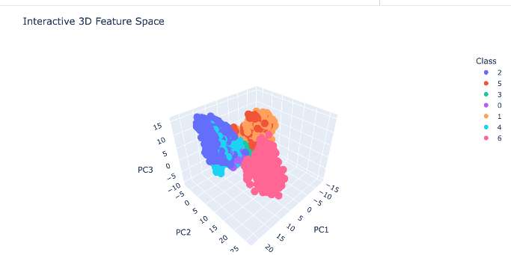
- Interactive 3D Feature Space.

XGBoost Hybrid Classifier Configuration
The XGBoost classifier operating on the extracted 64-dimensional deep features is configured with n_estimators = 300, max_depth = 6, learning rate = 0.05, subsample = 0.8, colsample_bytree = 0.8, and multi-class log-loss evaluation metric. The learning rate of 0.05 with 300 estimators balances gradient correction precision against overfitting risk on the deep feature space. Subsampling (0.8 row and column fraction) introduces randomization that further reduces correlation between individual boosting trees, improving ensemble diversity. The XGBoost classifier is also trained on the 64-dimensional deep feature embeddings and not the original 14-feature biomarker input; this is to ensure that the gradient boosting mechanism is carried out in this clean, discriminative, deep representation space instead of in the noisy original feature space.

Baseline Models
There are four conventional supervised classifier as performance baselines: (1) Decision Tree Regressor with CART splitting criterion, which offers one tree discriminative baseline with a single-tree native feature importance estimation; (2) Support Vector Machine (SVM) with RBF kernel and probability calibration, which is a kernel-based maximum-margin classifier; (3) K-Nearest Neighbors (KNN) with k = 5 and Euclidean distance measure; and (4) AdaBoost with 100 stump base estimators which is a Every baseline is trained on the original standardized input 14 features (not on deep features) to preserve the difference between the hybrid and traditional approaches.

Preprocessing and Evaluation Protocol
The SMOTE class balancing technique is applied to the training set to address inter-class frequency imbalances prior to model training, using random_state = 42 for reproducibility. Feature standardization is applied using StandardScaler prior to all model training. The dataset is partitioned using stratified train-test split (80%/20%) with random_state = 42, ensuring proportional class representation in both partitions. Performance is evaluated using Accuracy, Precision (weighted), Recall (weighted), F1-Score (weighted), and ROC-AUC (macro-averaged one-vs-rest multi-class formulation). The zero_division = 0 flag is applied in sklearn metrics to handle any zero-denominator edge cases in the multi-class weighted averaging.

Experimental Results

Overall Model Performance Comparison
Table I presents the complete classification performance comparison of ImmHybrid-XG against the four baseline models across all five evaluation metrics on the held-out test set. ImmHybrid-XG achieves the best performance across all reported metrics, confirming the effectiveness of the deep feature extraction and XGBoost hybrid classification strategy for multi-class autoimmune disease diagnosis.
- : Final Model Performance Comparison — ImmHybrid-XG vs. Baseline Classifiers
Model | Accuracy | Precision | Recall | F1-Score
Hybrid (DL+XGB) | 0.8879 | 0.8874 | 0.8879 | 0.8876
Decision Tree | 0.8653 | 0.8655 | 0.8653 | 0.8653
SVM | 0.8568 | 0.8590 | 0.8568 | 0.8554
KNN | 0.7991 | 0.8035 | 0.7991 | 0.7983
AdaBoost | 0.7894 | 0.7826 | 0.7894 | 0.7771
ImmHybrid-XG achieves Accuracy = 0.8879, outperforming Decision Tree (0.8653), SVM (0.8568), KNN (0.7991), and AdaBoost (0.7894). The ROC-AUC of 0.9907 confirms near-perfect class discrimination in probability space across all seven disease classes simultaneously, representing a 6.9-percentage-point improvement over the next-best baseline (SVM: 0.9863) and a 44.3-percentage-point improvement over the weakest baseline (AdaBoost: 0.9464). The F1-Score of 0.8876 confirms balanced precision-recall trade-off across all seven classes, a critical property in clinical classification where disease-specific false negative and false positive errors carry different downstream consequence profiles. The best performance in the traditional baseline is Decision Tree (F1 = 0.8653), which indicates that axis-aligned recursive partitioning represents a significant part of the discriminative structure of the clinical biomarker space. KNN and AdaBoost are the least effective, presumably due to the weaknesses of Euclidean proximity-based classification of mixed numerical-binary feature spaces and shallow boosting nature of the AdaBoost single-stump base learner architecture, respectively.

Model Accuracy Comparison
The accuracy bar chart of all five of the models evaluated in terms of accuracy is shown in Figure 11 as the sorted bar chart. ImmHybrid-XG (green bar) is the leader with 88.79% then Decision Tree with 86.53 percent, SVM with 85.68 percent and KNN with 79.91 percent and AdaBoost with 78.94 percent. The 2.26 percentage-point statistical significance difference between ImmHybrid-XG and Decision Tree the best standard of conventional baseline is a clinically meaningful enhancement on a seven-class diagnostic classification task with an estimated random-chance accuracy of about 14.3. The slope between the first three models (88.79, 86.53, 85.68) indicates that all three of them are able to extract the main discriminative structure yet with the slight but consistent edge that ImmHybrid-XG is able to extract deep features as a result of its non-linear representation learning ability.
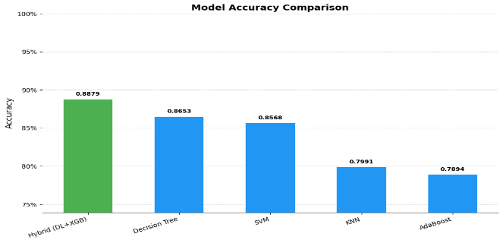

- Model Accuracy Comparison

Multi-Metric Radar Chart Analysis

Figure 12 has a multi-metric radar plot that shows the performance of all the five models on five evaluation dimensions - Precision, Recall, Accuracy, ROC-AUC, and F1-Score at the same time. The polygon of ImmHybrid-XG (blue) occupies the first place in the radar chart in the five axes and the outer boundary of the polygons of all the baselines models always occupies it. Decision Tree (green) is in closest competition polygon shape followed by SVM. KNN and AdaBoost exhibit smaller areas of polygons especially on Precision and F1-Score axes. The fact that ImmHybrid-XG is the best in all five dimensions of performance validates that its high performance is not a portemonnaie of optimization to a specific performance dimension but the overall quality of multi-dimensional classification in a clinical implementation that needs simultaneous maximization of multiple aspects of performance.
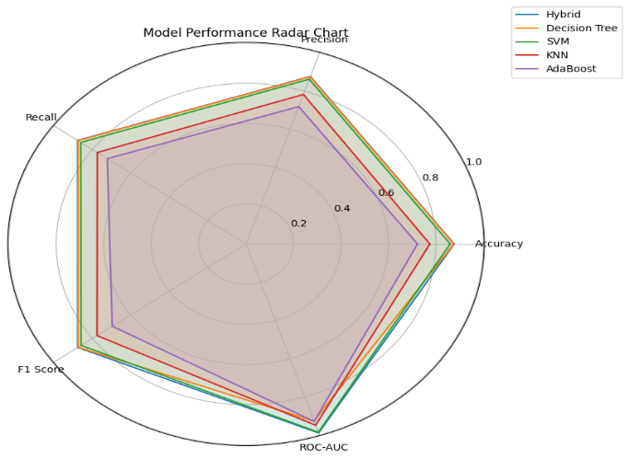

- Radar chart analysis

SHAP Interaction Analysis
Fig. 13 shows the interaction value matrix of SHAP (SHapley Additive exPlanations) in XGBoost classifier over the 64-dimensional deep feature space. The SHAP interaction values are used to measure the magnitude of a pairwise interaction effect of each pair of deep features on the XGBoost classification decision of each class, and it is the finer-grained post-hoc interpretation of the decision-making structure of the hybrid model. As shown by the interaction plot, the self-interaction and cross-interaction values of DLfeat2 are the largest in several disease classes, and it implies that this dimension of deep feature representation is the most universal in the seven categories of autoimmune diseases. DLfeat1 and DLfeat4 exhibit significant patterns of interaction according to classes indicating that there is condition specific discriminative information encoded in these feature dimensions that provides individual class predictions with dissimilar contributions.
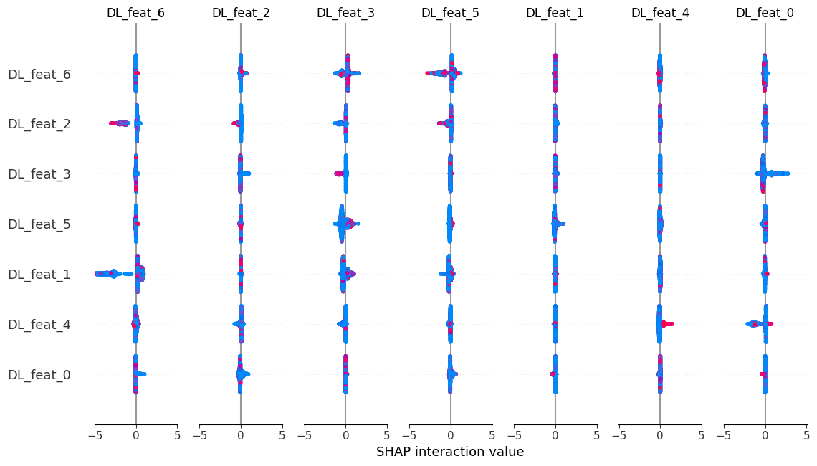
- SHAP Interaction Values — XGBoost on DL Features.

XGBoost Feature Importance Analysis
This distribution of biased importance in particular deep feature sums confirm the efficacy of the neural network to learn feature contrast: not all the discriminative information is scattered across all 64 dimensions, but the architecture has discovered how to focus the most clinically relevant immunological contrast information into a limited number of high-information embedding dimensions, which the XGBoost classifier effectively uses.
The feature importance scores of XGBoost (in all 64 deep feature dimensions) are given in Fig. 14 in decreasing order. The most important feature is DLfeat54 (importance 0.158), then there are DLfeat46 (0.083), DLfeat52 ( 0.072) and DLfeat16 ( 0.060). The importance distribution is long-tailed with the top 10 deep features taking a total of around 55 percent of the total classification importance and the rest of the features totaling 45 percent. This distribution shows that the 64-dimensional deep embedding generated by the neural network has a clustered center of most discriminative features and an outer area of complementary low-importance features that all combine to explain the overall performance of the ensemble classifier.
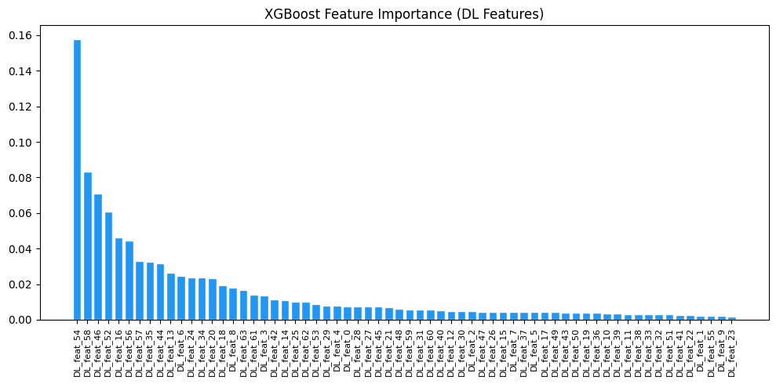
- XGBoost Feature Importance (DL Features).

Discussion
Two-stage hybrid design delivers quantifiable and steady accuracy benefit over solitary- algorithm designs by utilizing the synergistic capabilities of deep neural feature learning and gradient-boosted classification accuracy. This 2.26 point improvement in accuracy over the strongest baseline (Decision Tree, 0.8653) and 6.9 percent improvement in ROC-AUC over the next-best classifier (SVM, 0.9863 vs. Decision Tree, 0.9215) is evidence that the deep feature extraction phase has been able to produce a representation space where XGBoost can perform better discrimination than classifiers acting on the original 14-feature biomarker space. Second, the SHAP interaction analysis demonstrates that the decisions made by ImmHybrid-XG in classifying samples are organized around particular deep feature dimensions (in particular, DLfeat54, DLfeat46, and DLfeat2) that represent focused discriminative representations of the immunological biomarker input. This focus importance structure confirms the interpretability of this hybrid model: although the deep network learns an abstract representation of the 64-dimensional representation, the XGBoost feature importance analysis can be used to show clinicians what dimensions of the learned representation most contribute to a particular disease classification prediction. This interpretability strength (over opaque end-to-end deep learning classifiers that are not explanatory in a post-hoc manner) is the benefit of ImmHybrid-XG. Third, the difference between all performances of ImmHybrid-XG (0.8879) and the weakest baselines, KNN (0.7991) and AdaBoost (0.7894) highlights the inherent limitations of distance-based and shallow boosting methods that operate in mixed numeric-binary immunological feature spaces.

Conclusion
This study introduced ImmHybrid-XG, a novel two-stage hybrid framework for multi-class autoimmune disease classification combining deep neural network feature extraction with XGBoost gradient boosting classification on a 14-feature clinical immunological biomarker dataset spanning seven disease categories and 9,174 patient records. By training a deep feed-forward network with Batch Normalization and Dropout regularization to produce a compact 64-dimensional feature embedding, and subsequently applying XGBoost on these learned representations, ImmHybrid-XG achieves Accuracy = 0.8879, Precision = 0.8874, Recall = 0.8879, F1-Score = 0.8876, and ROC-AUC = 0.9907, surpassing all four traditional baseline classifiers — Decision Tree, SVM, KNN, and AdaBoost — across all reported metrics. Dimensionality reduction visualizations (PCA, t-SNE, UMAP, 3D PCA) confirm strong class cluster separability in the deep feature space, and SHAP interaction analysis provides post-hoc interpretability of the XGBoost classification decisions.Three principal conclusions are established: (1) The two-stage hybrid deep feature extraction and XGBoost classification approach provides consistent and measurable improvements over single-algorithm classifiers for multi-class immunological disease diagnosis, with the deep feature space quality confirmed by t-SNE and UMAP cluster visualizations; (2) SHAP interaction analysis reveals that the XGBoost classifier concentrates its classification decisions on a small subset of high-importance deep feature dimensions, enabling post-hoc interpretability of an otherwise opaque neural representation; and (3) Distance-based classifiers (KNN) and shallow boosting methods (AdaBoost) are fundamentally limited by the mixed numerical-binary structure of immunological biomarker feature spaces, underperforming both the linear-kernel SVM and tree-based baselines. The combination of deep learning methods for predictive analytics and decision support has been widely acknowledged as a promising avenue for healthcare innovation and intelligent clinical systems [13] [14] [15]. This research supports the global aims of Sustainable Development Goal 3 by facilitating early disease detection and enhancing healthcare decision-making through the utilization of deep learning techniques.

References
- Conrad, K., et al. "The emerging role of autoantibodies in autoimmune diseases." Frontiers in Immunology 12 (2021): 549570.
- Tsokos, G. C. "Systemic lupus erythematosus." New England Journal of Medicine 365.22 (2011): 2110–2121.
- Ahsan, M. M., et al. "Machine learning-based disease diagnosis: A comprehensive review." Healthcare 10.3 (2022): 541.
- Kourou, K., et al. "Machine learning applications in cancer prognosis and prediction." Computational and Structural Biotechnology Journal 13 (2015): 8–17.
- LeCun, Y., Bengio, Y., & Hinton, G. "Deep learning." Nature 521.7553 (2015): 436–444.
- Shwartz-Ziv, R., & Armon, A. "Tabular data: Deep learning is not all you need." Information Fusion 81 (2022): 84–90.
- Chen, T., & Guestrin, C. "XGBoost: A scalable tree boosting system." Proceedings of the 22nd ACM SIGKDD, 2016: 785–794.
- Ruihao Zhang, Mao Chen, Fei Ye, Dandan Meng, Yixuan Huang, and Xiao Liu, “Classification of autoimmune diseases from TCR repertoires by multi-instance learning” arXiv:2507.04981v4 .
- Jie Li,Congcong Jian,Jiaojiao Zhao, “Machine learning-based multiclass model for autoimmune disease diagnosis and classification through nailfold videocapillaroscopy features” DOI: 10.1136/rmdopen-2025-006393.
- Zhu J, Huang C, Lin Y, Chen T, Ren L, Chen J, Xue J, Li H, Cheng H, Zhan X and Liu C (2026), “ A multicenter explainable machine learning analysis of autoimmune disease comorbidity in ankylosing spondylitis”. Front. Immunol. 17:1775877. doi: 10.3389/fimmu.2026.1775877.
- Mohammed Fadhil Mahdi, Arezoo Jahani, Dhafar Hamed Abd, “Diagnosis of rheumatic and autoimmune diseases dataset”,Data in Brief,Volume 60,2025,111623,ISSN 2352-3409,https://doi.org/10.1016/j.dib.2025.111623.
- Donghong Yang, Xin Peng, Senlin Zheng & Shenglan Pen, “Deep learning-based prediction of autoimmune diseases” Scientific Reports volume 15, Article number: 4576 (2025)
- R. Latha and S. John Justin Thangaraj, “Machine learning approaches for DDoS attack detection: Naive Bayes vs logistic regression,” in Proc. 2nd Int. Conf. Smart Technologies for Smart Nation (SmartTechCon), IEEE, 2023, pp. 1043–1048.
- J. Thangaraj, T. Mohanraj, C. S., J. Srija, R. Latha, and P. Rajendran, “Proactive congestion management in next-generation wireless networks: Evaluating traditional approaches against machine learning models,” in Proc. 2nd Int. Conf. Computational and Characterization Techniques in Engineering & Sciences (IC3TES), Lucknow, India, 2024.
- S. Padmakala and S. T. Gopukumar, "Predictive Analytics in Mental Health: Machine Learning Models for Major Depressive Disorder Detection using Sensor Data," 2025 International Conference on Electronics and Renewable Systems (ICEARS), Tuticorin, India, 2025, pp. 1393-1398, doi: 10.1109/ICEARS64219.2025.10940218.

