PREDICTIVE ANALYTICS FOR CUSTOMER CHURN IN SUBSCRIPTION BASED SERVICES BY USING MACHINE LEARNING TECHNIQUES
1st Solanki Teja
PG Student (MCA), Dept. of Computer Application
Mohan Babu University
Tirupathi, Andhra Pradesh, India
Solankiteja2004@gmail.com
2nd P M D Ali Khan
Assistant Professor, School of Computing
Mohan Babu University
Tirupathi, Andhra Pradesh, India
Alikhan.tpty@gmail.com

Abstract— Retention of subscribers has emerged as one of the more urgent challenges of subscription-based businesses in the present day as far as customer retention attempts have a direct impact on the maintenance of revenue. The present paper discusses Churn IQ, a machine learning platform that was developed aiming that using the records on what identify customers have done previously, customers who are more likely to cancel can be identified.. These data rely on the facts concerning their previous behavior, such as how often they use the service, how many support calls they make, how they pay, which kind of subscription plan they use, etc. The data is cleaned and categorical fields are labeled before being subjected to SMOTE to correct the unequal representation of churners and non-churners. We compared Three types of classifiers models, namely Logistic Regression, Random Forest, and XG Boost and tested at quality accuracy, precision, recall, and AUC-ROC scores of 81% accuracy, 82.32% as well as precision and AUC-ROC rating of 87.42. There is also a Customer Lifetime Value (CLV) module present in the system that will allow the designed to help businesses to be aimed of which at-risk clients are financially worth their first place. Overall, the findings show that the ensemble classifier plus attentive data preparation seems much more effective to identify churn detection than simpler ones, and the Flask-based interface means that the system can be utilized in the actual business environment without necessarily having to install much additional infrastructure.
Keywords: Customer churn, Machine learning, Random Forest, SMOTE, AUC-ROC, Subscription services, Customer Lifetime Value, Predictive analytics.

I. Introduction
The process users repay for services has changed better. In comparison to one-time purchases, providers, streaming platforms, cloud based programs, and e-commerce retailers. Now providers are largely rely on ongoing subscriptions, which make the payment model essentially repeated.
A specific problem has emerged up as a consequence for this modifications: people are able to leave at any situation, and their earnings is immediately lost. One of the more costly operational and money troubles that subscription business look at churn, or the independent dismissal of a subscriber [1].
In some sectors based on this system has annual churn rates usually down at approximately 30% per year. A single percentage point of user loss may result in millions of money in lost regular earnings [2]. Along with to economic damage, high customer losses a company’s standing, disturb investors, and encourage managements to running pursuing in recruiting new clients with the aim in marketing. Any requirement that can constantly finding at-risk customers before they leave has original, measurable value when operating margins per user are already less, as far as it does not require expensive buildings to work [3]

A majority of industry studies accept that maintaining existing clients is far less cost than gaining new ideas, and a period of time even slight rises in retention rates may end in significant differences in revenue [2]. This has pushed many organizations to think again how they allocate their customer management costs, concentrating more on early intervention for users displaying warning signs with fewer on purchasing. Companies had a window of chance to reply to these indications before a customer actually cancels; if done at the right moment, a targeted discount, a service improvements, or direct outreach may frequently converted the situation around [3]. For instance, rule-based churn detection, that sets a threshold on moments of inactivity, commonly fails to recognize
Customer behavior is rarely that simple, and patterns that precede cancellation are often buried across multiple variables interacting with each other. Machine learning techniques are better alternatives to the others in this context and due to their capability to simultaneously examine numerous characteristics and identify non-obvious combinations that have a strong results [4]. This paper describes a system that runs three classification models to predict which customers are at risk of churning. A total of four main goals are represented of this system : early detection of high-risk customers, budget examination of retention materials to users with the top financial value, prediction of churn-related revenue results based on Customer Lifetime Value, and the supplying of sufficiently visual outputs to be used for routine business decision-making [5].

II. Related Work
Churn prediction has been approached from many sides and in different industries, such as banking, software-as-a-service and media. Early work used the CHAMP framework, which examined cancellation patterns through historical usage logs and was one of the first structured approaches to the problem [1]. Logistic regression became a go-to method for a while — it is straightforward to interpret and gives out probability scores that translate naturally into churn risk rankings [2]. Random Forest methods later gained in popularity due to their ability to reduce high risk naturally present in single decision trees; by combining the results of many trees, the technique shows a greater validity of irrelevant data and more relevant common to unseen data [3].
XG Boost is one way of enhancing the performance of prediction of developing decision trees, whereby each tree displays the errors of the previous trees [4]. Another issue in churn data is the imbalance in the classes: churners are in lower grade and non-churners in the high grade: a majority of classifiers will predict no churn. This imbalance is notified in SMOTE by generating new instances of minority classes sample instead of cloning existing instances in a bid to achieve a superior recall on the difficult to detect instances of churn occurrence [5]. The practical uses also of feature selection are that correlation examination and data gain can be applied to eliminate noise and refocus the attention to variables that actually have predictive power, i.e. tenure, monthly charges and support call history [6]. Similar tests have continuously identified group to be superior to this category of classifiers with specific models, particularly following resampling [7].
Later studies have experimented with LSTM networks and sequence of transformer-based models to predict churn, and thus customer interactions are treated as time sequences [12]. The kind of buildings are analytical in the sense that they aim at inviting less in the temporal method that is omitted in a static feature format table. As a matter of fact, however, they require much more labelled data, run more slowly, and are significantly more difficult to interpret with a business stakeholder than a Random Forest feature importance chart. The difficulty of the new advanced models like deep learning that are included in the size of datasets that often characterize subscription processing often have less and additional accuracy to warrant the effort. That perfectly explains the reason why classical types of approaches-combined with sound data preprocessing-continue to be the standard in the industry of doing actual retention job [7].

II. III. Methodology
Churn System is developed as a pipeline sequence of pipelines accepting the data of raw data to data cleaning, feature selection, model testing and lastly a financial evaluation process. One stage leads to another and the system has been designed such that one may drop in a new dataset without having to refactor the entire flow. Figure 1 has demonstrated a relationship between these stages.
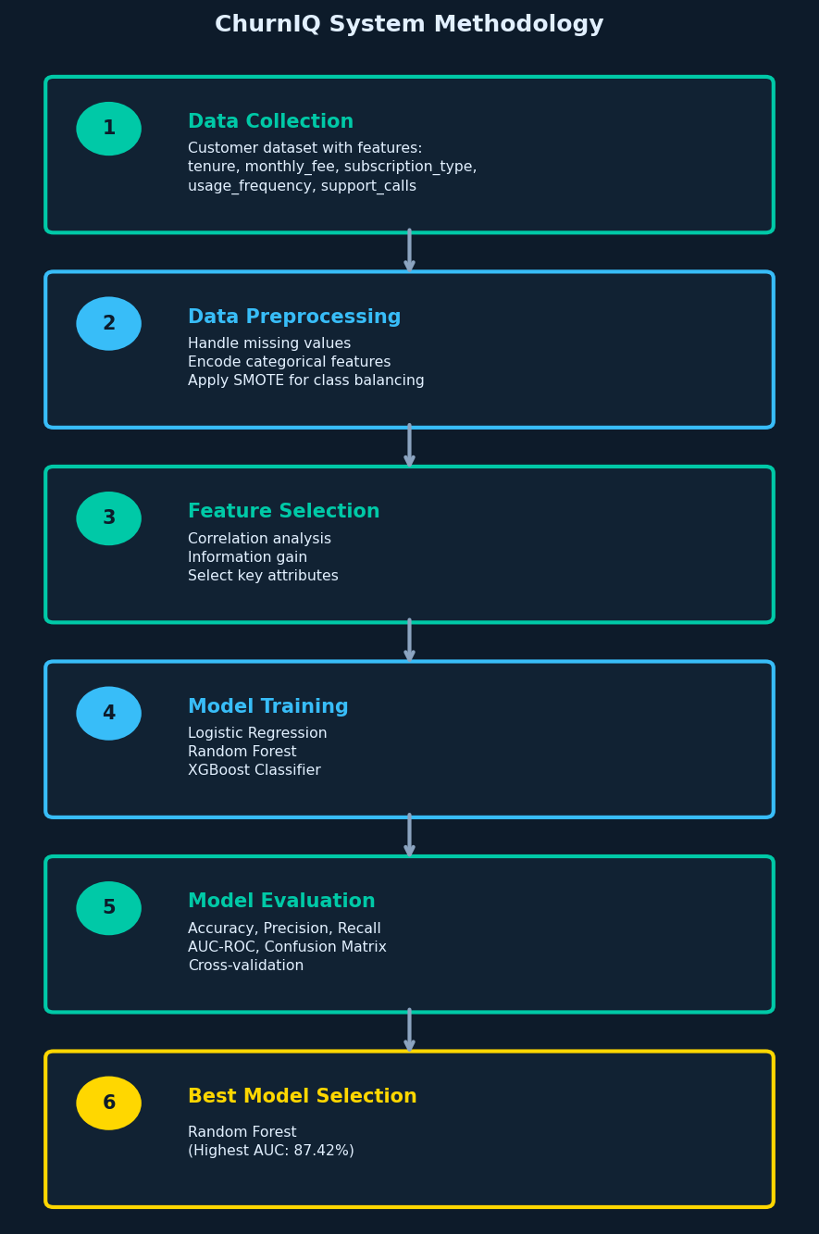
- Fig. 1. ChurnIQ System Methodology Workflow

A. Data Collection
The data adopted in this project is comprised of the details of customer with several fields: customer ID, number of months of service, monthly payment, subscription level, frequency of customer usage of service, number of support calls, mode of payment, type of contract and churn label which is a binary variable which indicates the customer left or not. These fields combined formed a snapshot of the length of time that particular individuals have been a subscriber, their unavailability, the payment that they make, the support they engaged in, and the type of contract they have a contractually reasonable picture of churn. Table 1 elaborates on each of the features [8].

B B. Data Preprocessing
To begin with, we begin cleaning up the information or the incomplete records. Such safe high quality information, verification rather untrustworthy through decreasing the performance of the model. Label encoding is done to convert categorical columns such as subscription type, payment method and contract type into integers to enable the classifiers deal with them. The churn datasets nearly always contain very many non-churners than churners and training on the imbalance is likely to create models that are good at predicting the majority class but fail to capture many of the real cases of churn. The solution to this problem offered by SMOTE is that they create artificial instances of minority class rather than merely replicating real instances [9]. In the case of Logistic Regression, the numerical features are also standardized with the help of a standard scaler, as the concerned model is susceptible to variations in the magnitude of the features.

C C. Feature Selection and Model Training
The correlation analysis was performed at the first stage to reduce the number of features to be actually used and eliminate those that had minimal correlation with the churn label. The remaining features were then ranked in terms of information gain and gain ratio with respect to the extent of predictive signal each one of them has. The characteristics which manifested on the top were tenure, monthly fee, frequency of use, support calls and type of contract [6]. The clean and homogenous data set was being trained on triples, i.e. Logistic Regression as a baseline model, Random Forest as a primary collection model, and XG Boost as an Evaluation process. The data was split 80/20 into training set and testing set and each model was tested against the identical test held-out to ensure that the comparison is fair.Boost for Evaluation process. The data was divided 80/20 between training and testing, and every model was evaluated against the same held-out test set to keep the comparison fair.

D D. Evaluation Metrics
There were 4 performance metrics used to evaluate model performance. Precision delivers all the amount of precise value forecasts. Precision provides the answer to the question: among all the customers being considered as churners, what was the number of the churners? Recall Flips that: out of the total number of customers that actually churned, what number did the model pick up? AUC-ROC is the capability of the model to differentiate between churner and non-churners at the different level of confidence - a value nearer to 1.0 means that the model has more capability of ranking real churners over the non-churners.. The estimated CLV of a particular customer is monthly fee times predicted remaining lifetime which will provide a financial weight to each prediction and will allow prioritizing the customers who will receive retention attention most [10].

III. IV. Implementation
Churn IQ is the application that is a Flask web application written in Python and consists of 4 stages, including loading data, validating data, training models, testing and presenting models. The following table (Table 1) contains the expected fields in the dataset of the system.
- TABLE I. Dataset Feature Description
Feature | Type | Description
tenure | Numerical | Months subscribed
monthly_fee | Numerical | Monthly charge amount
subscription_type | Categorical | Plan tier selected
usage_frequency | Numerical | Service logins per month
support_calls | Numerical | Help desk contacts made
payment_method | Categorical | Billing method used
contract_type | Categorical | Agreement duration
churn | Binary (0/1) | Target: 1 = churned

When we upload a CSV, our system instantly finds it against the given format. It frequently rejects any rows with missing values, duplicates, or incorrect designing to ensure only clean, accurate information data is imported. Categorical columns are then encoded and SMOTE is applied to balance the classes before training begins. All the models have been executed on the same partition of the examine data after preprocessing. Once the process has trained, the models are saved by using pickle type model. This allows the system to instantly load them and make more predictions on advanced information without needing to reevaluate from scratch. The CLV module computes a financial value score for each and every flagged customer, which is used by the dashboard to prioritize them. The primary libraries used behind the system include Pandas and NumPy libraries for data handling, Scikit-learn library is used for the models and evaluation of the model, imbalanced-learn library used for SMOTE, Matplotlib for charts prepared, and Flask is used for the develops web layer [11].

IV. V. Results and Discussion
All three models were evaluated using the same preprocessed test partition. Table II indicates how each one performed across the four metrics.

- TABLE II. Model Performance Comparison
Model | Acc% | Prec% | Rec% | AUC%
Logistic Reg. | 77.50 | 75.62 | 78.76 | 84.64
Random Forest * | 81.00 | 82.32 | 77.20 | 87.42
XGBoost | 75.25 | 74.48 | 74.09 | 85.36
- * Best performing model
The confusion matrix of Random Forest on the test set suggests confusion as shown in figure 2.Figure 2 indicates the confusion matrix of Random Forest on the test set. It accurately sorted 175 non-churners and 149 real churners. The false positives were 32 0 customers who were predicted to churn but did not and the false negatives were 44 0 customers who were predicted to churn but were not. The significance of the false negative number is more critical here in terms of marketing: a lost churner goes out the door without any work by the retention team, and this is lost direct revenue.
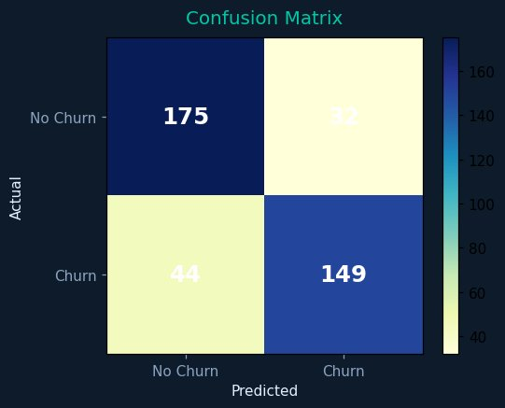
- Fig. 2. Confusion Matrix – Random Forest Classifier
Figure 3 presents the ROC curve attribute for Random Forest. An AUC of 0.874 defines the model is working a good job of discriminating the users from non-users the curve heads highly toward the top left corner, which illustrates the model is catching a good percentage of the real churners, but it is not making too many needless alarm or worry. This is helpful in practice because it means that approach can be adjusted based on what the business is more interested in: decreasing missed churners, or minimizing wasted retention offers to customers refuse to go away [9].
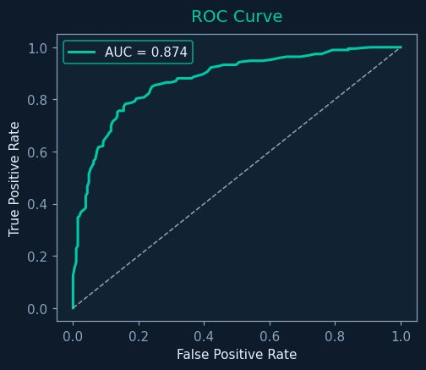
- Fig. 3. ROC Curve – Random Forest (AUC = 0.874)
Figure 4 compares all models underside based on accuracy, precision, recall etc. the best on accuracy and contains AUC and Logistic Regression has it spot on recall - it clicks a bit higher degree of real churners which is material when you are most concerned with recall. Overall, XG Boost in this experiment was slightly inferior, but it does not disqualify it, as it can be trained on larger datasets faster than Random Forest, and probably would bridge the gap with additional records. The resumption of all three models on raw data, i.e. unrefined data, showed a considerable drop in the results across the board, which is a confirmation that refined - and most importantly SMOTE and encoding - does not omit the process in this pipeline [8]..
Based on the scores of the feature importance scores of the Random Forest model, the most predictive variables were by far contract type and tenure. The next in line was monthly fee and number of support calls. The practical implication of this is that a customer with a month-to-month contract who has just signed up and called the support a few times is a high-risk case - no matter how frequently they log in. Usage frequency, although intuitively connected with the engagement, was less ranked when the contract type and tenure were already included in the model. This approach is in line with the findings of prior studies on attenuation to subscription: conceptual adjustability and repetition support is the simplest to identify as a precursor to a person leaving [6]. In terms of retention there are a number of reasons why such scores can be of utmost significance to businesses: - the scores give a build starting point - the most - priority targets are of the humanity with short period and multiple support interactions and the spot is warranting the first mediate regardless of its overall activity levels.

V. VI. Conclusion
This paper represented Churn model, a churn prediction system build for subscription-based services using three machine learning techniques. Random Forest was found to came out ahead with an 81% accuracy, 82.32% precision, 77.20% recall, and an 87.42% of AUC-ROC Using SMOTE to balance data and correlation-based feature selection proved essential for increasing model accuracy. Without these retrained steps, working performance dropped significantly, finding that this work is not just additionally overhead, but difficult to success. first testing and using interconnection-based feature selection made a clear difference — models starts to run without these steps performed mentioned worse, which tested to confirms that the pretrained work is not just overhead but actually drives the accuracy gains.
Beyond flagging churners, Churn system calculates a CLV score for each at-risk customer so that retention resources can be directed where they have the most financial impact rather than spread evenly. The Flask model interface suggests that the system can be position into a conventional web environment without any specific infrastructure and building requirements, which will reduce the barrier to entry for smaller teams to use such an interface. Moving forward, it would be interesting an investigation on whether an machine learning model such LSTM and transformer models can provide better recalling on time period behavioral data, and if they could provide a near-time scoring pipeline that comes from streaming logs of data, it can enable the system to react more quickly to the onset of churn (as it is developing)

VI. VII. REFERENCES
[1] A. E. Eiben, A. E. Koidijs, and F. Slisser, “Genetic modelling of customer retention,” Lecture Notes in Computer Science, vol. 1391, pp. 178–186, 1988.
[2] N. Saini, Monika, and K. Garg, “Churn prediction in telecommunication industry using decision tree,” International Journal of Engineering Research and Technology, vol. 6, no. 4, Apr. 2017.
[3] A. Liaw and M. Wiener, “Classification and regression by Random Forest,” The Newsletter of the R Project, vol. 2, no. 3, pp. 18–22, 2002.
[4] G. Piatetsky, “CRISP-DM, still the top methodology for analytics, data mining, or data science projects,” KDD News, 2014.
[5] W. Y. Ying, N. Lin, and L. I. Xiu, “The unbalanced dataset analysis algorithm in customer churn prediction,” System Engineering, vol. 26, no. 11, pp. 99–104, 2008.
[6] W. Verbeke, D. Martens, C. Mues, and B. Baesens, “Building comprehensible customer churn prediction models with advanced rule induction techniques,” Expert Systems with Applications, vol. 38, pp. 2354–2364, 2011.
[7] K. Coussement, S. Lessmann, and G. Verstraeten, “Comparative analysis of data preparation algorithms for customer churn prediction: A case study in the telecommunication industry,” Decision Support Systems, vol. 95, 2017.
[8] N. V. Chawla, “Data mining for imbalanced datasets: An overview,” in Data Mining and Knowledge Discovery Handbook. New York, NY, USA: Springer, 2005, pp. 853–867.
[9] B. Zoric, “Predicting customer churn in banking industry using neural networks,” Interdisciplinary Description of Complex Systems, vol. 14, no. 2, pp. 116–124, 2016.
[10] Y. Xie, X. Li, E. W. T. Ngai, and W. Ying, “Customer churn prediction using improved balanced Random Forest,” Expert Systems with Applications, vol. 36, no. 3, pp. 5445–5449, 2009.
[11] U. Lu, “Predicting customer churn in the telecommunications industry: An application of survival analysis modeling using SAS,” in Proc. Data Mining Techniques, M. J. A. Berry, E.
[12] Y. LeCun, Y. Bengio, and G. Hinton, “Deep learning,” Nature, vol. 521, pp. 436–444, May 2

