Cross-Modal Attention Fusion of Vision and Language Transformers for Robust Multimodal Misinformation Detection

Ramavath Saritha¹ Ramesh Dadi¹,
School of Computer Science and S School of Computer Science and
Artificaial Intelligence, Artificaial Intelligence,
SR University SR University
Warangal - 506371Telangana, India Warangal -506371Telangana, India
saritharamavath902@gmail.com dadiramesh44@gmail.com

Abstract. The prevalence of multimodal misinformation on social media sites is a critical problem to information integrity and calls for the development of automated systems that are able to jointly analyze multiple forms of information. In this paper, we propose a framework called Cross-Modal Attention Fusion (CMAF), where EfficientNet-B3 and Distil BERT are used as modality-specific encoders that are fused through a proposed Cross-Modal Attention mechanism. The framework is then trained on the Fakeddit dataset using a progressive unfreezing strategy, class-weighted Label Smoothing Cross-Entropy Loss, and Stochastic Weight Averaging. Our framework is then evaluated on 4,164 test samples from the Fakeddit dataset using a five-pass Test Time Augmentation strategy and reports an accuracy of 84.56%, AUC-ROC of 0.9235, and macro-average F1-score of 0.85 with well-calibrated bimodal distributed prediction probabilities.
Keywords. Misinformation, multi model, BERT, Attention, cross model
- Introduction
The proliferation and growth of social media platforms have revolutionized information production and consumption, allowing information dissemination to billions of people across the world in an instant. This revolution in information access, though beneficial at societal and macro-levels, has at the same time provided an environment that is conducive and fertile ground for the spread and proliferation of misinformation, defined as information that is false and intended to deceive, manipulate, and mislead. Contrary to traditional types of fake news, which are text-based, multimodal types of misinformation, including those on popular platforms like Reddit, Twitter, and Facebook, have increasingly leveraged and utilized the power and potency of visual media in creating narratives that are not only inaccurate but also misleading. This has significant implications at societal and macro-levels, making it imperative and important to identify and detect multimodal types of misinformation.
Past computational approaches for misinformation detection have largely focused on textual cues, utilizing techniques from natural language processing, such as bag-of-words, recurrent neural networks, and, more recently, transformer models for language, to detect linguistic cues of deception [10]. These approaches have shown promising results for datasets where information is presented as text; however, they are, by definition, limited for the multimodal case, where the deceptive cue may be hidden in the image, the discrepancy between the image and the caption, or even subtle manipulations of the image that do not leave any textual trace. More recent approaches for image-based detection of misinformation have utilized convolutional neural networks and visual transformer models for identifying manipulated images and images that are out of context [5]. These approaches, while useful, are still unimodal and, by extension, insufficient for the task of multimodal misinformation detection, as they do not capture the powerful inter-modal cues that are indicative of real vs. fabricated information.
The recognition of these limitations has led to a surge in research on multimodal misinformation detection, where both the image and text modalities are jointly processed to exploit the consistency between them for discriminative purposes. So far, various multimodal fusion strategies have been proposed, and they can be broadly categorized into three types: early, late, and intermediate fusion. Although early and late fusion methods are computationally simple, they cannot model the complex, query-dependent interaction between the two modalities, which is crucial for detecting complex types of misinformation, such as false connections and misleading framing, where each modality is individually true but, together, they create a false narrative. Intermediate fusion methods based on attention mechanisms have also been found to be effective, but in most cases, a unidirectional attention mechanism is used, where only one modality is allowed to attend to the other, thus completely ignoring the mutual interaction between the two modalities.
In our paper, we propose the Cross-Modal Attention Fusion (CMAF) framework, aiming to overcome these drawbacks in designing a binary misinformation detection model. Our proposed framework leverages EfficientNet-B3 [12] and DistilBERT [13] models as individual visual and text encoders, whose outputs are mapped into a 384-dimensional space. Our proposed Cross-Modal Attention module facilitates text-attended-to-image and image-attended-to-text computations simultaneously through four-head Multi-Head Attention, thereby injecting more information from one modality into the representation of the other. Finally, our proposed framework incorporates a hierarchical classification head. To ensure that our proposed framework generalizes effectively, we propose training our framework in a progressive unfreezing manner in three stages. We also propose leveraging class-weighted Label Smoothing Cross-Entropy loss, gradient accumulation, mixed precision, and Stochastic Weight Averaging. For inference, we propose our framework's outputs be improved through Test Time Augmentation in five passes.
The main contributions of this work can be summarized as follows: First, a new bidirectional Cross-Modal Attention module is proposed, which allows symmetric and query-driven exchange of features between vision and text in a way that overcomes the directional problem of existing attention-based fusion methods. Second, a new three-stage progressive unfreezing training method with different learning rates is proposed, which allows stable fine-tuning of large pre-trained backbones without catastrophic forgetting. Third, a comprehensive empirical evaluation of the method on the large-scale Fakeddit benchmark is presented, yielding an AUC-ROC of 0.9235 and a macro F1-score of 0.85 with well-calibrated bimodally distributed probabilities. Fourth, a detailed threshold sensitivity analysis with deployment-oriented operating points is provided.
- Related work
The problem of detecting fake news and online misinformation has been extensively studied in research literature over the past decade or so, resulting in a plethora of survey articles that comprehensively describe the landscape of research in this area. Tufchi et al. [1] present a detailed survey on the problem of multimodal fake news detection, where the authors comprehensively analyze the entire cycle of misinformation from its inception to its propagation and then its detection using supervised and unsupervised learning methods on a variety of datasets. The problem has evolved from being purely textual to being highly multimodal due to the proliferation of image and video sharing on social media sites such as Facebook, Twitter, and Instagram. As a complement to this, a work by Comito et al. [14] focuses specifically on deep learning approaches for multimodal fake news detection on social media and presents a systematic overview of fusion strategies while emphasizing that “real-world multimodal fusion is still an open research problem that has received insufficient investigation due to the heterogeneous nature of different modalities.” Finally, a work by Guo et al. [9] extends this range to also consider large language models (LLM) for detection, comparing text-based, multimodal, and agentic approaches while identifying hybrid verification as the most promising approach for enhancing detection accuracy and ability.
The initial multimodal misinformation detection systems were able to identify the fundamental advantage of multimodal information over unimodal information. Khattar et al. [13] introduced the Multimodal Variational Autoencoder (MVAE), where a bimodal variational autoencoder is integrated with a binary classifier to simultaneously learn shared representations from text and image information. The accuracy and F1-score were improved by up to 6% and 5% over existing state-of-the-art unimodal methods on Weibo and Twitter datasets. Based on this existing work, Xue et al. [16] introduced the Multimodal Consistency Neural Network (MCNN), where image-text consistency is modeled by evaluating cross-modal semantic similarity and image tampering features to address the unique mismatch between image and text in fake news. Similarly, Segura-Bedmar and Alonso-Bartolome [2] carried out a detailed evaluation on the Fakeddit dataset to identify that a CNN-based multimodal architecture using text and image features achieved 87% accuracy on the overall dataset, significantly outperforming existing BERT-based text-only methods (78%), especially for Manipulated Content, Satire, and False Connection sub-types, which are those sub-types that rely on joint reasoning between image and text information.
More recent works have continued to advance the architectures of fusion networks beyond simple concatenation and toward deeper cross-modal interactions. Jing et al. in [10] proposed the Progressive Fusion Network (MPFN), which can extract multi-level representational information from each modality at both shallow and deep levels of the feature hierarchy and fuse these representations using a mixer network architecture with an accuracy of 83.3% on the Twitter platform, a 4.3% increase over the previous state-of-the-art results. Wu et al. in [18] have proposed the Multimodal Fusion and Inconsistency Reasoning (MFIR) model, which uses cross-modal infiltration fusion to continuously fuse one modality's features into the internal semantics of the other modality and incorporates a multimodal inconsistency learning module to extract both local and global inconsistent semantics. Zhang et al. in [12] have proposed a three-level granularity consistency detection framework using multi-head cross-attention mechanisms at the token, phrase, and global levels of image-text alignments, graph neural networks, and CLIP-based contrastive learning methods, respectively. These three methods are combined using an adaptive fusion module. These progressive advancements in the architectures of fusion networks have inspired the design of the bidirectional cross-modal attention mechanism in the present work.
In the context of logic reasoning, Liu et al. [15] proposed a logic-based neural model that utilized logic clauses to express the reasoning process. The proposed approach achieved better results compared to other models while evaluating Twitter, Weibo, and Sarcasm datasets. In the context of out-of-context misinformation, where genuine images are paired with false captions, Qi et al. [7] proposed a new approach called SNIFFER that utilized a two-stage instruction tuning approach with Instruct BLIP. The proposed approach achieved more than 40% improvement over the baseline MLLM results while outperforming other state-of-the-art results by utilizing knowledge retrieval for contextual verification. In the context of synthetic misinformer generation strategies, Papadopoulos et al. [6] proposed a new approach that utilized CLIP-based Named Entity Swapping to produce more effective training data for MMD models compared to out-of-context approaches. The proposed approach also revealed that unimodal bias is a major challenge while evaluating MMD models. The proposed approach was further improved by introducing a new approach called VERITE [17], which addresses unimodal bias while evaluating MMD models by utilizing modality balancing and hard synthetic misalignment. The proposed approach achieved a 9.2% accuracy improvement while evaluating bias-controlled models.
The recent past has seen the rapid deployment of Large Vision-Language Models (LVLMs) in misinformation detection tasks, where the pre-trained world knowledge of LVLMs and zero-shot generalization have proven useful. In a recent work, Tahmasebi et al. [3] explored the efficacy of LLMs and LVLMs in zero-shot misinformation detection tasks and presented a novel approach in evidence retrieval re-ranking for LVLM-based fact verification without the need for fine-tuning. Zeng et al. [11] attempted to bridge the gap between the distribution of synthetic and real-world misinformation using model-agnostic methods of selecting data from the synthetic and real-world distributions, where a 13B-parameter MLLM outperforms GPT-4V in real-world fact verification tasks.
Liu et al. [5] proposed the first benchmark for mixed-source multimodal misinformation that simultaneously considers the factors of textual veracity distortion, visual veracity distortion, and cross-modal consistency distortion in 12 sub-categories and demonstrated the limitation of the detection methods. For the case of video-based misinformation, Shang et al. [8] proposed TikTec, a multimodal detection framework for COVID-19 short videos on TikTok that explicitly utilizes the captions to address the distractive visual content and the combination of visual and audio modalities. Most recently, Xu et al. [4] proposed the comprehensive framework of MDAM3 for multitype multimodal media that not only covers the detection of the image-text pair but also the audio and video modalities while providing the natural language explanations.
- Methodology

3.1 Dataset and Preprocessing
The proposed framework is tested using the Fakeddit dataset. Fakeddit is a large-scale multimodal dataset for fake news detection. The dataset was built based on the content of the Reddit platform. Fakeddit contains more than one million samples and covers six fine-grained classes. For the binary classification task, the dataset will be mapped to two classes. One of the classes will be true content (class 0), while the remaining classes will be mapped to misinformation (classes 1-5). To perform the experiments using the proposed framework and evaluate its performance, a stratified 15% subset of the training set is sampled.
Each data point in Fakeddit is represented by a Reddit post image and its corresponding post title (clean text). The image acquisition process is achieved through parallel multi-threaded downloading with a thread pool consisting of ten concurrent threads. Each image is then validated using PIL's verify() function after downloading. The validated images are then resized to a uniform image resolution of 224x224 pixels and saved in JPEG format. The text input is represented by the cleaned post title field, where missing data is replaced with an empty string to ensure robustness.

The data is split into training, validation, and test sets using a stratified random split. In detail, 15% of the total data is set for testing, and 12% of the data for training is set for validation, resulting in approximately 73%, 12%, and 15% for training, validation, and testing, respectively. Class imbalance in the binary case is handled by using a class-weighted loss function, where the weights for each class are computed based on a balanced weighting strategy from scikit-learn, given by w_c = N / (K * N_c), where N is the total number of samples, K is the number of classes, and N_c is the number of samples in class c.

3.2 Data Augmentation Strategy
In order to enhance the generalization and prevent overfitting, an asymmetric augmentation strategy is employed during the training procedure. On the other hand, the validation and test sets use deterministic resizing and normalization. The procedure for the training set is as follows: (1) resizing the image to 256x256 pixels and then applying random cropping to 224x224 pixels; (2) applying random horizontal flipping with a probability of 0.5; (3) applying random rotation within ±10 degrees; and (4) applying color jittering with brightness and contrast perturbations of ±0.2 and saturation perturbation of ±0.1. Finally, the pixel values of the image are normalized using the ImageNet statistics (mean = [0.485, 0.456, 0.406]; std = [0.229, 0.224, 0.225]) after conversion to float32. A stochastic depth (drop path) of 0.2 is incorporated into the image encoder backbone as an additional implicit regularizer. This replaced the previously employed random erasing method due to the conflict between the two.

Intentional design decisions were made to prevent over-regularization, a problem that is very common in multimodal systems. For instance, the application of Focal Loss, Mixup augmentation with a value of 0.4, and a dropout rate of 0.4 was found during preliminary experiments to cause over-penalized gradients and a decline in convergence. The final design uses Label Smoothing Cross-Entropy Loss with a value of 0.1 as the sole loss function, a moderate dropout rate of 0.25, and stochastic depth, balancing regularization and discriminability of the features.

3.3 Unimodal Feature Extraction
3.3.1 Visual Encoder — EfficientNet-B3
The features are extracted from the input images using EfficientNet-B3, a compound scaled convolutional neural network pre-trained on the ImageNet-1K dataset. EfficientNet-B3 provides a reasonable trade-off between parameter efficiency and representational power. It extracts a 1536-dimensional vector from the global average pooled output. The EfficientNet-B3 is initialized with pre-trained weights on the ImageNet dataset. It is employed in the proposed framework by setting the number of classes to 0. Stochastic depth with a drop path rate of 0.2 is employed on all the residual blocks in the EfficientNet-B3 to avoid the co-adaptation of the feature detectors. The raw 1536-dimensional visual features are projected into a shared embedding space of 384 dimensions using a projection module consisting of a fully connected layer followed by Layer Normalization and GELU activation function, along with a dropout operation (dropout rate = 0.25). The projection module compresses and re-maps the raw visual features into a shared embedding space that is semantically aligned for cross-modal interaction. Layer Normalization helps stabilize the distribution of the features across different input domains.
3.3.2 Textual Encoder — DistilBERT
Text features are extracted by using DistilBERT-base-uncased, which is a distilled form of BERT that has 97% of the capability of BERT while having 40% fewer parameters. The post titles are tokenized using the DistilBERT WordPiece tokenizer with a sequence length of 96 tokens. The sequence is truncated if it is longer than 96 tokens and padded if it is shorter than 96 tokens. The input token IDs and attention masks are generated by the tokenizer.

To achieve a fixed-dimensional sentence-level representation, a masked mean pooling operation over the last hidden states of all non-padding tokens is used. Mathematically, the sentence embedding can be represented as follows: x_text = ∑(h_i*m_i) / ∑m_i, where h_i refers to the hidden states of the ith token in the input sentence, and m_i refers to the attention mask value associated with the ith token. It should be noted that the denominator of the equation is clamped to a minimum of 1 in practice to avoid division by zero. Masked mean pooling is used over the CLS token embedding since the former pools over all the tokens in the input sentence, whereas the latter only pools over the first token in the sentence. Moreover, the former results in a more robust sentence embedding since short sentences are common in social media platforms. The resulting sentence embedding of dimensionality 768 is mapped onto a common 384-dimensional embedding space using the same projection architecture used in the vision domain.

3.4 Cross-Modal Attention Fusion Module
The novelty of this work is a bidirectional Cross-Modal Attention (CMA) module that allows for a rich exchange of information between the two representations before classification. While early fusion methods concatenate features at a raw level or late fusion methods combine prediction results independently, the proposed CMA module allows for a deep interaction between features at a representation level. In this way, each modality is able to selectively attend to information from the other modality.

3.5 Classification Head
This fused representation is then passed through a hierarchical classification head that is intended to compress the feature space while simultaneously learning high-level discriminative features. The head is composed of three linear layers with intermediate layer normalization and nonlinear activation functions. The first layer is responsible for transforming the 768-dimensional input to a 512-dimensional space. This is followed by layer normalization and GELU activation. Dropout with a probability of 0.25 is applied after the first layer, while half-rate dropout with a probability of 0.125 is applied after the second layer. The second layer is responsible for transforming the input from 512 to 128 dimensions, while the third layer is responsible for transforming from 128 to two output logits representing true and misinformation classes. The use of GELU activation functions throughout the head, as opposed to ReLU, prevents the dying neurons problem and has been shown to achieve better performance on such systems.
- Results and analysis

4.1 Overall Classification Performance
The proposed framework results in an overall test accuracy of 84.56%, and an AUC-ROC of 0.9235, reflecting the high discriminative power of the framework in binary misinformation classification tasks using the Fakeddit test set. Moreover, the Average Precision (AP) score of 0.9215 indicates the high reliability of the predicted probability rankings across all classification thresholds. These results are noteworthy since the inherent difficulty of the Fakeddit test set arises from the fact that it comprises six different types of misinformation classes condensed into a single misinformation class. Table 1 presents the entire range of evaluation metrics at a decision threshold of both 0.5 and the optimal threshold of 0.46.
Table 1 Classification report on the Fakeddit test set (n = 4,164) using TTA×5 at threshold = 0.5.
Metric | TRUE Class | MISINFO Class | Macro Avg
Precision | 0.85 | 0.84 | 0.85
Recall | 0.85 | 0.84 | 0.85
F1-Score | 0.85 | 0.84 | 0.85
Support | 2160 | 2004 | 4164
Accuracy | — | — | 0.8456
AUC-ROC | — | — | 0.9235
Avg Precision (AP) | — | — | 0.9215

The model also performs well in class balancing, where the model’s predictions show a high degree of balance in its performance, with a precision, recall, and F1-score of 0.85 for the TRUE class and 0.84 for the MISINFORMATION class, with a macro-averaged F1-score of 0.85. This near-perfect balance between the two classes is particularly noteworthy, especially considering the original imbalance between the two classes in the dataset, with 51,288 cases of misinformation and 33,312 cases of true information. This balance in the model’s performance is a clear indication that the class-weighted loss function, Label Smoothing Cross-Entropy, was effective in balancing the two classes. This is further corroborated by the model’s weighted average F1-score, which is 0.85.

4.2 Training Convergence and Stability
Figure 1 shows a plot of the training loss over 15 epochs. As indicated earlier, training was stopped after 15 epochs due to early stopping. As shown in Figure 1, the training loss has a smooth curve that decreases monotonically from 0.5956 to 0.3404 over the 15 epochs. This shows that training is effective and optimization is happening well. The rapid decrease in training loss from epochs 1 to 4 corresponds to Stage 1 training, during which only the head and projection modules are optimized. The rapid decrease in training loss from epoch 4 to 15 corresponds to Stage 2 training, during which some parameters are unlocked to allow task-specific optimization of high-level feature representations. There are no sudden spikes or instabilities in training loss during stage transitions, confirming the effectiveness of the differentiated strategy for assigning learning rates.
The validation accuracy of Figure 1 shows an increase from 79.06% at epoch 1 to 82.80% at epoch 4. Thereafter, the validation accuracy plateaus between the range of 84 and 86% from epoch 5 and beyond. The validation accuracy peaks at epoch 7. The plateau between epochs 7 and 15 implies that the model has already achieved optimal representations within the training budget. Therefore, it is unlikely that the model will improve beyond the current accuracy without changes in the architecture and the data. The dashed lines at 85% and 90% on the graph act as reference lines. The accuracy of the model is well above the 85% reference line and just short of the 90% line. This implies that the task of multimodal misinformation detection is challenging and that the accuracy of the model is due to the fact that it was trained on the 15% subset of the data. The validation accuracy of the best checkpoint of the model (85.88%) is similar to the final test accuracy of the model (84.56%).
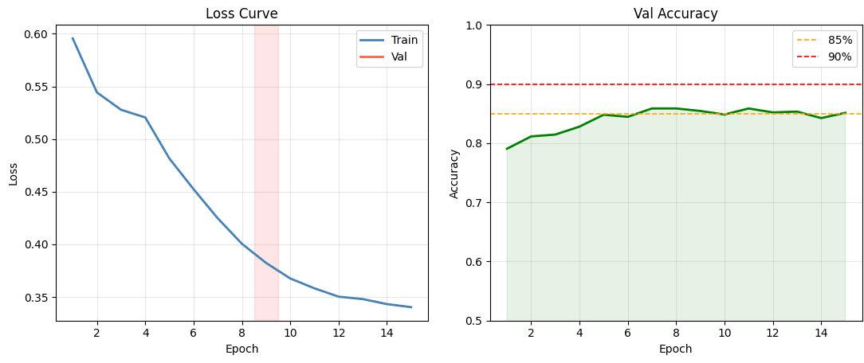Figure 1. Training loss convergence (left) and validation accuracy over epochs (right). Dashed lines indicate 85% and 90% accuracy benchmarks. The red shaded region marks the stage transition at epoch 9.

4.3 Overfitting Analysis
The overfitting monitor from Figure 2 displays the per-epoch difference between the training and validation loss (Train - Val Loss). What is important to notice is that the entire range of the differences is negative and ranges between -0.10 and -0.13. This implies that the validation loss was always less than the training loss. This is an unusual phenomenon and is called reverse overfitting or underfitting. There are two main reasons for reverse overfitting/underfitting. The first is the asymmetric use of dropout and stochastic depth. During training, they are on, while during testing, they are off. This means that the testing metrics will be the output of a forward pass without any regularization. The second is the use of TTA × 5 on the validation set. This averages five different augmented versions of the image and provides more confident probability outputs compared to the single pass of the network during training.
Notably, the absence of positive gaps (i.e., no training epochs during which training loss was significantly higher than validation loss) indicates that the model did not overfit to the training set throughout the entire training run. Indeed, the orange dashed threshold line at +0.1 was never crossed, and negative gaps were consistently bounded below −0.1.
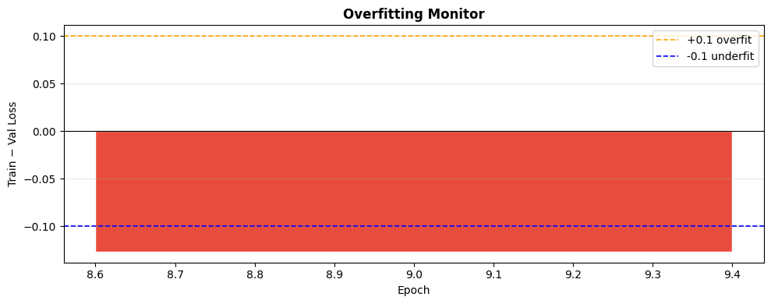Figure 2. Per-epoch Train − Val Loss gap. All values are negative, confirming the absence of overfitting throughout training. Red bars indicate values exceeding the ±0.1 threshold.

4.4 Confusion Matrix Analysis
The confusion matrix in Figure 3 shows detailed information about the results of the classification at the default threshold of 0.5 under TTA×5. Among 2,160 TRUE samples in the test data, 1,840 were correctly classified, and 320 were incorrectly classified into misinformation. Moreover, 1,681 out of 2,004 misinformation samples were correctly classified, and 323 were incorrectly classified into true content.
The similar distribution of error rates between both classes, at 14.8% false positive rate and 16.1% false negative rate, further confirms that there is no directional bias in the classifier. This is beneficial in any misinformation detection system that is deployed, since both types of error have significant societal costs. Again, we see that the balanced distribution of error rates verifies that our proposed class-weighted loss function has effectively prevented the model from resorting to the trivial solution of always predicting the majority class. Moreover, we can see that the absolute error rates, at 320 false positives and 323 false negatives, are very similar, implying that our decision boundary is very close to the optimal boundary.
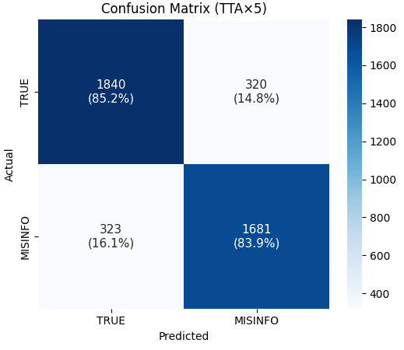
Figure 3. Confusion matrix on the test set (n = 4,164) with TTA×5. Values indicate sample counts and row-normalized percentages.

4.5 ROC Curve and Precision-Recall Analysis
The Receiver Operating Characteristic (ROC) curve and the Precision-Recall (PR) curve of the proposed framework are presented in Figure 4. The ROC curve of the proposed framework has an AUC of 0.9235. The curve increases steeply from the origin. The True Positive Rate (TPR) of the proposed framework is around 0.80 at a False Positive Rate (FPR) of just 0.20. The large AUC of the proposed framework (0.9235) implies that the ranking quality of the probability scores of the proposed framework is excellent for the entire range of operating thresholds. The AUC of the proposed framework is well above the random guessing baseline (0.5). This implies that the proposed framework has a high degree of separability between the true and misinformation classes.
The Precision-Recall curve (AP = 0.9215) also supports this discovery, with precision remaining at near-perfect levels (>0.95) across the majority of the recall range (0-0.85), after which it gradually falls to around 0.48 at full recall. The high Average Precision score of 0.9215 is of particular interest in the context of the class imbalance found in the larger dataset, as it provides a measure of model quality without the inflated baseline found with the AUC-ROC in an imbalanced scenario.
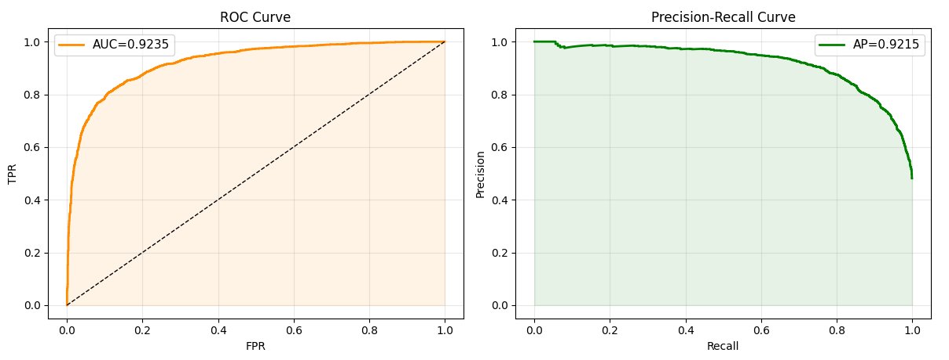Figure 4. ROC curve (AUC = 0.9235, left) and Precision-Recall curve (AP = 0.9215, right) on the test set with TTA×5.

4.6 Predicted Probability Distribution
Figure 5 shows a plot of the distribution of predicted probabilities P(Misinfo) for the TRUE class and the MISINFORMATION class (in red) over all test samples. The distribution shows a clear bimodal split: TRUE class samples are tightly clustered around a P(Misinfo) value of 0.1-0.2, with a sharp peak at 0.12. In contrast, the distribution for the misinformation class is tightly clustered at a P(Misinfo) value of 0.85-0.90, with a sharp peak at 0.89. The clear bimodal split is highly desirable, as it suggests that we are making well-calibrated predictions for most samples, rather than making uncertain predictions at a 0.5 decision boundary.
The overlapping region of the two distributions, i.e., P(Misinfo) [0.3, 0.7], is a sparse region, which is due to the small number of ambiguous examples that are difficult for the classifier. The sparse region of the overlapping area is exactly the region where errors are found according to the analysis of the confusion matrix. This indicates that the majority of errors are found in ambiguous examples with conflicting and/or inconclusive visual and textual information, which is a typical property of the FALSE CONNECTION and MISLEADING types of the Fakeddit ontology, where both image and textual information are individually true but collectively false. The shape of the distribution further confirms the effectiveness of the proposed label smoothing regularization, where the model is prevented from being overconfident in any of the classes, i.e., P → 0 or P → 1, while maintaining a clear separation between classes for effective discrimination.
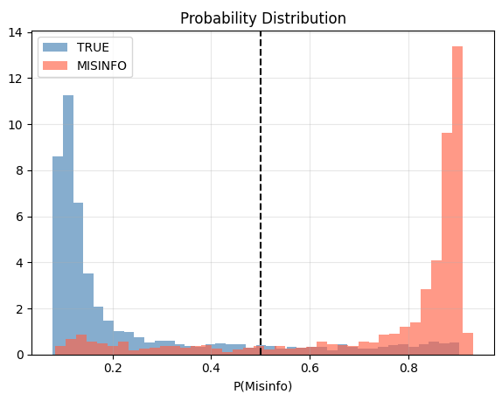
Figure 5. Predicted probability distributions for TRUE (blue) and MISINFORMATION (red) test samples. The dashed vertical line indicates the default 0.5 decision threshold.

4.7 Sample-Level Prediction Analysis
Figure 6 is a visualization of the results for the first 200 test samples, showing both the results of the prediction and the probabilities of misinformation. The scatter plot indicates the correctness of the prediction through color, with True Positives (TP), True Negatives (TN), False Positives (FP), and False Negatives (FN) indicated by the respective colors. The dominance of green and blue over orange and red in Figure 6 is a good indication of the accuracy of the results.
The bar chart shows that the samples classified correctly have highly polarized probability values close to 0.0 or 1.0. The incorrectly classified samples have intermediate probability values ranging from 0.4 to 0.7. This is consistent with the bimodality observed in Figure 5. It further validates the fact that the incorrectly classified samples by the classifier are concentrated in the region of true ambiguity and not distributed uniformly over the probability space. From the point of view of practical applications, the ability to exploit this property allows us to devise a system of abstention based on confidence levels. For instance, the samples with probability P(Misinfo) ranging from 0.35 to 0.65 could be marked for abstention, thereby reducing the error rates on those samples. However, the vast majority of the samples remain unaffected.
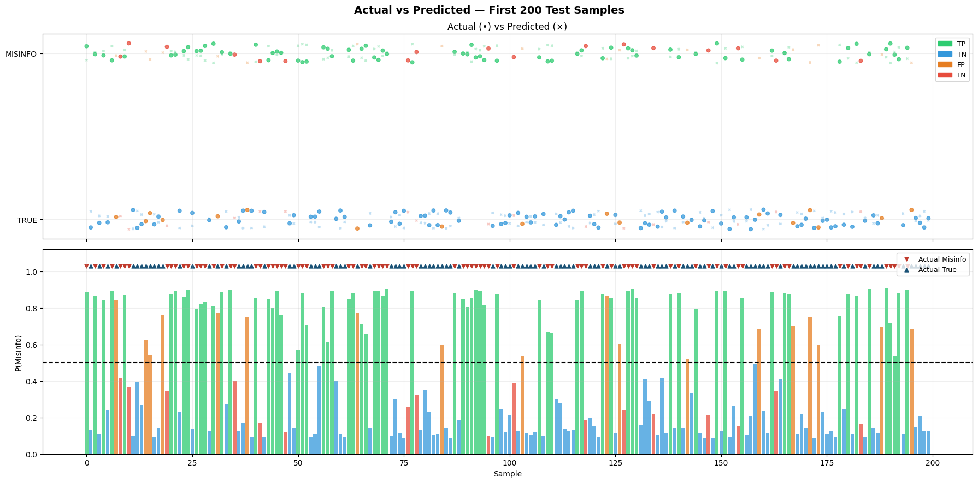Figure 6. Sample-level prediction visualization for the first 200 test samples. Upper panel: actual vs. predicted labels (green=TP, blue=TN, orange=FP, red=FN). Lower panel: predicted P(Misinfo) per sample with decision threshold at 0.5.

4.8 Decision Threshold Optimization
Figure 7 displays the threshold sensitivity analysis, where thresholds are varied from 0.1 to 0.94 in increments of 0.02, and F1 score, Precision, Recall, and Accuracy are computed for each threshold. The results show that the optimal F1 score of 0.842 is achieved when the threshold is set to 0.46, very close to, but slightly less than, the default threshold of 0.5. This is due to the small asymmetry in the probabilities of each class that is induced by the weighted training objective. The F1 score is flat over thresholds from 0.38 to 0.56, with a difference of less than 0.5%. This means that the model is robust over a reasonable range of thresholds and that the default threshold of 0.5 is close to optimal without requiring any calibration.
The precision-recall curves show the familiar inverse relationship between the two metrics. The recall approaches 1.0 at lower thresholds (near 0.1) and falls continuously as the threshold increases. Precision approaches 0.55 near a threshold of 0.1 and increases as the threshold increases to near 1.0 near a threshold of 0.92. The two curves cross near a threshold of 0.50–0.52. This confirms that the default threshold is close to the precision-recall balance point. For applications requiring the highest possible recall at the expense of precision (for example, misinformation filtering in the context of an election), the results suggest that a threshold of 0.30 is required to achieve a recall of > 0.95 with a precision cost of approximately 0.74. For applications requiring the highest possible precision at the expense of recall (for example, automated content filtering), a threshold of 0.72 is required to achieve a precision > 0.90 with a recall > 0.71. These thresholds are summarized in Table 2.
Table 2. Decision threshold operating points for different deployment scenarios, derived from the threshold sensitivity analysis in Figure 7.
Operating Point | Threshold | Precision | Recall | F1-Score
High Recall (Screening) | 0.30 | ~0.74 | >0.95 | ~0.83
Balanced (Default) | 0.50 | 0.84 | 0.84 | 0.84
Optimal F1 | 0.46 | 0.84 | 0.84 | 0.842
High Precision (Removal) | 0.72 | >0.90 | ~0.71 | ~0.79
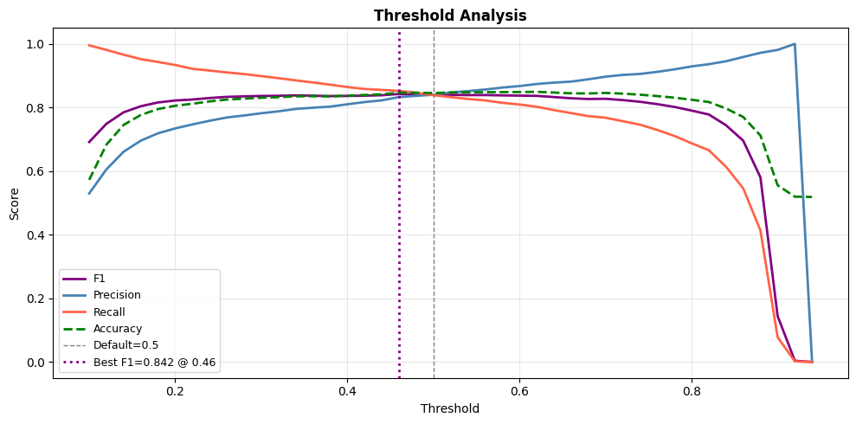Figure 7. Threshold sensitivity analysis across F1, Precision, Recall, and Accuracy. The purple dotted line marks the optimal F1 threshold (0.46); the grey dashed line marks the default threshold (0.50).
- Conclusion
In this paper, we proposed a novel framework for binary multimodal misinformation detection, namely Cross-Modal Attention Fusion (CMAF), and applied it to the Fakeddit benchmark. We combined the power of EfficientNet-B3 and DistilBERT through a bidirectional Cross-Modal Attention module, which enabled dynamic and symmetric information exchange between the visual and textual modalities, thus effectively capturing the signals of cross-modal inconsistency for misinformation detection. The proposed framework was further aided by a three-stage progressive unfreezing strategy, class-weighted label smoothing, and Stochastic Weight Averaging, all of which contributed to a robust and successful training procedure with excellent generalization performance, as indicated by a test accuracy of 84.56%, AUC-ROC of 0.9235, and macro F1-score of 0.85, with no signs of overfitting and well-calibrated bimodal probability distributions. We will further investigate the application of our proposed framework to the entire Fakeddit dataset, temporal propagation dynamics, user engagement, and a bidirectional attention mechanism for handling multiple modalities such as videos and audios for a more comprehensive solution for multimodal misinformation detection.
References
- Tufchi, S., Yadav, A., & Ahmed, T. (2023). A comprehensive survey of multimodal fake news detection techniques: advances, challenges, and opportunities. International Journal of Multimedia Information Retrieval, 12(2), 28.
- Segura-Bedmar, I., & Alonso-Bartolome, S. (2022). Multimodal fake news detection. Information, 13(6), 284.
- Tahmasebi, S., Müller-Budack, E., & Ewerth, R. (2024, October). Multimodal misinformation detection using large vision-language models. In Proceedings of the 33rd ACM International Conference on Information and Knowledge Management (pp. 2189-2199).
- Xu, Q., Du, H., Łukasik, S., Zhu, T., Wang, S., & Yu, X. (2025, April). Mdam3: A misinformation detection and analysis framework for multitype multimodal media. In Proceedings of the ACM on Web Conference 2025 (pp. 5285-5296).
- Liu, X., Li, Z., Li, P., Huang, H., Xia, S., Cui, X., ... & He, Z. (2024). Mmfakebench: A mixed-source multimodal misinformation detection benchmark for lvlms. arXiv preprint arXiv:2406.08772.
- Papadopoulos, S. I., Koutlis, C., Papadopoulos, S., & Petrantonakis, P. (2023, June). Synthetic misinformers: Generating and combating multimodal misinformation. In Proceedings of the 2nd ACM International Workshop on Multimedia AI against Disinformation (pp. 36-44).
- Qi, P., Yan, Z., Hsu, W., & Lee, M. L. (2024). Sniffer: Multimodal large language model for explainable out-of-context misinformation detection. In Proceedings of the IEEE/CVF conference on computer vision and pattern recognition (pp. 13052-13062).
- Shang, L., Kou, Z., Zhang, Y., & Wang, D. (2021, December). A multimodal misinformation detector for covid-19 short videos on tiktok. In 2021 IEEE international conference on big data (big data) (pp. 899-908). IEEE.
- Guo, H., Huang, T., Huang, H., Fan, M., & Friedland, G. (2022, August). A systematic review of multimodal approaches to online misinformation detection. In 2022 IEEE 5th International Conference on Multimedia Information Processing and Retrieval (MIPR) (pp. 312-317). IEEE.
- Jing, J., Wu, H., Sun, J., Fang, X., & Zhang, H. (2023). Multimodal fake news detection via progressive fusion networks. Information processing & management, 60(1), 103120.
- Zeng, F., Li, W., Gao, W., & Pang, Y. (2024, November). Multimodal misinformation detection by learning from synthetic data with multimodal llms. In Findings of the Association for Computational Linguistics: EMNLP 2024 (pp. 10467-10484).
- Zhang, S., Chen, H., Liu, S., Li, R., Jiang, H., & Dong, L. (2025). Multimodal misinformation detection based on the multi-granularity consistency. Neurocomputing, 644, 130393.
- Khattar, D., Goud, J. S., Gupta, M., & Varma, V. (2019, May). Mvae: Multimodal variational autoencoder for fake news detection. In The world wide web conference (pp. 2915-2921).
- Comito, C., Caroprese, L., & Zumpano, E. (2023). Multimodal fake news detection on social media: a survey of deep learning techniques. Social Network Analysis and Mining, 13(1), 101.
- Liu, H., Wang, W., & Li, H. (2023, July). Interpretable multimodal misinformation detection with logic reasoning. In Findings of the Association for Computational Linguistics: ACL 2023 (pp. 9781-9796).
- Xue, J., Wang, Y., Tian, Y., Li, Y., Shi, L., & Wei, L. (2021). Detecting fake news by exploring the consistency of multimodal data. Information Processing & Management, 58(5), 102610.
- Papadopoulos, S. I., Koutlis, C., Papadopoulos, S., & Petrantonakis, P. C. (2024). Verite: a robust benchmark for multimodal misinformation detection accounting for unimodal bias. International Journal of Multimedia Information Retrieval, 13(1), 4.
- Wu, L., Long, Y., Gao, C., Wang, Z., & Zhang, Y. (2023). MFIR: Multimodal fusion and inconsistency reasoning for explainable fake news detection. Information Fusion, 100, 101944.

