Multimodal Knowledge Alignment for Social Bot Detection: Integrating Vision-Language Understanding with Behavioral Feature Fusion via Attention-Guided LSTM

Mallepally Kavitha¹ Ramesh Dadi¹,
School of Computer Science and S School of Computer Science and
Artificaial Intelligence, Artificaial Intelligence,
SR University SR University
Warangal - 506371Telangana, India Warangal -506371Telangana, India
mallepallykavitha1103@gmail.com dadiramesh44@gmail.com

Abstract. The emergence of automated bot accounts on social media has created substantial threats to the integrity of information, democracy, and trust. Current solutions for detecting social bots primarily use either textual metadata or network features individually, which are not effective against the evolving sophistication of bot attacks. This paper presents MKA-BotNet, a multimodal knowledge alignment framework for detecting social bots on social media, which combines the power of vision-language understanding and behavioral feature fusion with an attention-guided Bidirectional Long Short-Term Memory (BiLSTM) network. MKA-BotNet uses a frozen CLIP ViT-B/32 encoder to encode user profile images and textual metadata, followed by the use of the BiLSTM network with Bahdanau attention to encode the contextual information, and finally combines the contextual information with 31 engineered behavioral metadata features using a late fusion classifier. MKA-BotNet has been tested on the Twitter Human-Bots dataset and has achieved an accuracy of 84.59%, AUC ROC of 0.9239, and Average Precision of 0.9260 with F1-scores of 0.85 for both classes.
Keywords: Social bot detection, multimodal learning, vision-language alignment, CLIP, BiLSTM, attention mechanism, behavioral feature fusion, Twitter.
- Introduction
The unprecedented rise and proliferation of online social media platforms have changed the manner in which information is produced, disseminated, and consumed on a global level. Twitter, which has been renamed to X, has millions of daily active users and has emerged as the most prominent channel for the dissemination and consumption of news, political discourse, and commercial activities. However, along with these significant contributions to society, these platforms have also emerged as a hub for the proliferation of bot accounts, which are artificial entities programmed to behave and act like humans. Bot accounts have been identified with the systematic dissemination of misinformation, artificial promotion of trending topics, mass dissemination of spam and phishing content, interference with electoral processes, and artificial inflation of metrics for commercial and political gains. The proliferation and sophistication of bot accounts require the implementation of effective and automated detection mechanisms.
Previous methods of automated bot account detection were based on rule-based heuristics and threshold-based filtering techniques that utilized basic observable anomalies such as unusually high posting rates, consistent content formats, and/or a lack of profile photo usage [5, 6]. Although these methods are computationally efficient, they are easily evaded even with minor adversarial modifications. Recent work on bot account detection has focused on utilizing machine learning techniques that incorporate a broader range of features based on account metadata, such as follower/following ratios, account age, verification status, and tweet activity statistics, and shallow classifiers such as Random Forests, Support Vector Machines, and Gradient Boosting. These tabular-based methods have shown significantly higher accuracy, and several key behavioral characteristics, such as statuses sent daily, friends/followers ratio, and numeric characters in screen names, were established as reliable bot account discriminators [15].
The development of deep learning took the field a step further by allowing for the automated detection of hidden representations from raw content in accounts. The use of recurrent neural networks, particularly Long Short-Term Memory (LSTM), was used to account for the sequential posting of content by accounts. The use of LSTM networks allowed for dependencies in tweet streams to be captured, which could not be done using previous models. The use of transformer-based natural language processing models for analyzing user-generated content, such as account descriptions, tweets, and hashtags, allowed for the detection of lexical and semantic anomalies associated with automated content generation. However, most of the existing deep learning models for bot detection treat it as a unimodal classification problem, which does not use discriminative information from multiple input modalities at once [16, 17].
Contrastive Language-Image Pre-Training (CLIP), which is the most prominent among these, has opened up a whole new avenue for the analysis of social media data by providing semantically aligned representations for both images and text data. In the context of bot detection, this is particularly relevant because, for normal user accounts, there is usually semantic consistency between the description and image provided for the user’s profile, whereas for bot accounts, there are often inconsistencies, such as the use of stock images or AI-generated images alongside text descriptions that are either vague or stuffed with keywords.
Inspired by these insights, in this work, we propose MKA-BotNet: Multimodal Knowledge Alignment Bot Detection Network, which leverages three types of complementary information for social bot detection. Specifically, user profile description information is encoded into 512-dimensional semantic text representations via the CLIP text encoder. On the other hand, user profile image information is encoded into 512-dimensional geometrically compatible visual representations via the CLIP image encoder. These two representations are combined into a two-stage sequence and fed into a Bidirectional LSTM with Bahdanau attention to capture cross-modal interactions and adaptively combine the importance of each type of representation for each input sample. Lastly, 31 hand-crafted user behavior and metadata features, including log-scale activity count statistics, follower ratio statistics, account age derivatives, and text-based screen name features, are processed through a separate Multi-Layer Perceptron branch. Finally, the output of the LSTM-attention branch and the output of the MLP branch are concatenated and fed into a classification head to generate the final probability of botness.
The proposed approach makes four main contributions to the social bot detection literature. First, it proposes a multimodal knowledge alignment framework that utilizes vision-language pre-training and behavioral metadata in an end-to-end manner. Second, it shows that the Bahdanau attention mechanism used over CLIP representations enables interpretable and adaptive modality weighting for focusing on the most informative modality for each individual account. Third, it performs a thorough feature engineering analysis and identifies 31 behavioral features. Finally, it presents gradient-based attribution analysis to quantify the relative importance of each feature. Lastly, it presents a comprehensive evaluation of the proposed approach on the Twitter Human-Bots Dataset with an AUC-ROC of 0.9239 and Average Precision of 0.9260.
- Related work
Hybrid fusion of heterogeneous input modalities has emerged as an essential paradigm in modern intelligent systems. Thorne [1] introduced a hybrid cross-attention and feature alignment architecture for human-robot interaction using multimodal input modalities, including visual, auditory, and textual modalities, using a unified transformer-based encoder. The system showed that the fusion of multimodal input modalities significantly enhances the accuracy of intent recognition compared to unimodal input modalities in real-world service scenarios. Furthermore, Zhang et al. [8] introduced a three-layer embodied intelligence system, called Dynamic Perception-Task Adaptation (DP-TA), which includes multimodal perception, world modeling, and adaptive decision-making using Feature-Conditioned Modal Alignment (F-CMA), establishing a comprehensive cross-modal fusion paradigm.
Yadav et al. in reference [2] proved the effectiveness of soft attention in an image captioning model that utilized a combination of spatial features from VGG-16 and an LSTM decoder, where the attention module allowed the model to concentrate on important image areas during caption generation, achieving competitive results in BLEU scores on the Flickr8k dataset. In social media multimodal analysis, ANTU et al. in reference [7] proposed an attention-guided fusion model for Bengali meme sentiment classification that dynamically fused ResNet-18 spatial features with a BiLSTM-BiGRU text processing pipeline, achieving state-of-the-art results compared to vision-language model baselines such as ViT and BanglaBERT, achieving 86% accuracy and a macro F1 of 0.88. Cao et al. in reference [11] also proved the effectiveness of the attention paradigm in weakly supervised whole slide image classification, where a dual-stream attention-guided framework generated multi-scale pseudo labels and improved focus on diagnostically relevant areas.
In the work of Xu et al. [10], the evolution of cross-modal image-text retrieval in the context of remote sensing has been reviewed, and the main paradigm shift has been the appearance of vision-language pre-training (VLP) models, which has shifted the focus of the task from global representation learning to fine-grained semantic alignment. Yang et al. [13] presented a survey on the use of vision-language models for multimodal federated learning, and the models such as CLIP, BLIP, and ViLT were recognized as state-of-the-art VLMs with strong capabilities in the task of visual-text alignment, which could be exploited for tasks such as cross-modal content generation, visual question answering, and multimodal sentiment analysis. Biswal and Baliarsingh [3] developed a multimodal video anomaly detection framework based on the Hierarchical Multi-scale Temporal Network (H-MSTN) and the Multimodal Attention-Based Fusion Transformer (MA
Shao et al. [14] have addressed the issue of multimodal deception detection using a Spatio-Temporal Representation Disentanglement (STRD) approach using dual encoders for spatial and temporal features, a Constrained Self-Attention Block for local facial region focus, and a Cross-Modal Correlation Fusion Block for temporal correlation between vision and audio modalities. The survey paper by Noghre et al. [9] has also presented deep learning-based video anomaly detection scenarios, which are human-centric, vehicle-centric, and environment-centric, and have emphasized transformer and attention-based architectures. Shao et al. [4] have presented the DR-IAL approach using dual pathways in motion perception and spatiotemporal decoupling-recoupling to recognize egocentric actions, which has shown significant improvement using bidirectional sequence modeling over unidirectional modeling. Hang et al. [12] have presented MSG-GCN using textual semantic alignment in graph convolutional networks for human action recognition in maritime drones, which has shown superior performance using lightweight hierarchical structures on NTU60 and NTU120 benchmarks.
- Methodology
3.1 Overall Framework
The proposed framework, which will be henceforth referred to as MKA-BotNet (Multimodal Knowledge Alignment Bot Detection Network), is a three-branch late fusion architecture that processes all input modalities in parallel before fusing them into a unified decision space. The system is built upon three distinct information channels: (i) user descriptions represented by a vision language pre-trained model, (ii) user images represented by the same pre-trained vision encoder, and (iii) a wide range of handcrafted behavioral and metadata features extracted from account-level statistics. The output of all branches is fused at the decision level to produce a final decision of bot or human using the collective strength of all input modalities.
3.2 Dataset and Preprocessing
These experiments are performed on a dataset called the Twitter Human-Bots Dataset, which is a publicly available dataset of Twitter account information that is categorized into two classes: bot and human. Each account in this dataset is provided with a textual description of the user, a profile image path, and various numerical and categorical metadata about the account itself. Because of this inherent class imbalance in the dataset, where there are significantly more human accounts than bot accounts, random under-sampling is applied to the majority class, i.e., human accounts, to create a balanced dataset that is comprised of equal numbers of bot and human accounts.
All input text descriptions are processed to replace missing values with an empty string, which is necessary for consistency with the next step of tokenizing. The path of the profile image is converted to its full path on the file system, and it is decoded, resized to 224x224, and converted to the RGB color space. If images are missing, corrupted, or in an unsupported format (such as PNG in palette color mode), they are replaced with a white image of the same size. This approach guarantees full functionality of the image modality branch despite incomplete and erroneous data in the profile.
3.3 Vision-Language Embedding via CLIP
To encode both the text description and profile image into semantically aligned embedding spaces, we utilize a Contrastive Language-Image Pre-Training (CLIP) model with a ViT-B/32 vision transformer backbone, as introduced in Radford et al. (2021). We find that this model is especially suitable for our problem since it is pre-trained to align image and text embeddings in a 512-dimensional space such that the cosine similarity is maximized for matched pairs and minimized for mismatched pairs. This is especially useful in capturing rich semantic information, such as whether a user's profile description matches their profile image—a useful signal in detecting user authenticity.
For each of the samples, the text description is tokenized using the text tokenizer of the CLIP model with a maximum sequence length of 77 tokens and is then encoded through the text encoder to generate a 512-dimensional text embedding vector. Likewise, the profile image is encoded through the image encoder of the CLIP model to generate a 512-dimensional image embedding vector. Both of these vectors are L2-normalized before further processing to ensure that the geometric properties of the vectors do not impact the attention mechanism between the two. All weights of the CLIP model are frozen during training since it is believed that the pre-trained representations are sufficiently generic and overfitting is likely to occur with the limited size of the dataset.
3.4 Behavioral and Metadata Feature Engineering
In tandem with this vision-language pipeline, we also develop a specialized branch of features tailored to tabular data, which captures behavioral signals not readily available from text and image-based data. We derive a total of 31 features from the raw data available in the metadata of each account, which fall into four major groups: raw counts, log-transformed counts, ratio-based behavioral features, and text-based characteristics of each account. The raw counts are followers_count, friends_count, favourites_count, statuses_count, average_tweets_per_day, and account_age_days. These features are directly indicative of the level of activity within each account but are highly skewed due to power-law distributions often observed in social networks. We therefore also derive log1p-transformed versions of each of these features, which compress the range and make them more suitable for gradient-based optimization.
Nine ratio features are derived to describe relative behavioral patterns that are scale-invariant. The followers-to-friends ratio and its reciprocal describe network reciprocity of an account, and extreme values in this dimension are indicative of bot activity. The engagement ratio, which is calculated as favourites-to-statuses, captures content engagement relative to posting activity. Other ratio features are tweets-per-follower, followers-per-day, friends-per-day, statuses-per-day, and account age-per-follower, which capture various behavioral patterns over time, all of which are indicative of bot activity.
Boolean indicator features such as verified default_profile, default_profile_image, and geo_enabled are also included. The use of default profile images and the lack of geographic information are well-known indicators of automated account creation. The text-derived features are the length of the description in terms of both characters and words, the presence of a location field, the length of the screen name, the number of numeric digits in the screen name, and the digit fraction of the length of the screen name. Bot-generated accounts often have numerically suffixed screen names and lack or have sparse profile descriptions, so these features are very informative.
3.5 Attention-Guided Bidirectional LSTM for Multimodal Sequence Encoding
The two embedding vectors obtained from the text and image encoders are combined along the sequence dimension to obtain a two-step input sequence with dimensions (2, 512), where the first time step represents the text embedding and the second time step represents the image embedding. This sequence representation is suitable for passing through a recurrent neural network to learn the interaction and dependency between the two input modalities, which are treated as simultaneous representations of the account identity.
This sequence is then passed through a two-layer Bi-LSTM network with a hidden size of 256 units for each direction. The bidirectional LSTM architecture is used to incorporate the information from both the text-image and image-text paths, which is more comprehensive than using a simple LSTM model. A dropout operation is used with a dropout rate of 0.4 between the two LSTM layers to prevent overfitting and reduce the co-adaptation of the hidden units. The output sequence from the Bi-LSTM is (2, 512), which are two hidden states corresponding to each input modality after cross-modal interaction.
To adaptively weight the contribution of text and image modalities, we utilize a Bahdanau additive attention mechanism over the LSTM output sequence. Specifically, the attention module computes a scalar relevance value for each modality by first applying a learned linear projection followed by tanh nonlinearity and then a scalar-valued linear layer. We then normalize these values using a softmax function to obtain weights that sum to 1 over the two possible modality positions. Finally, we compute a weighted sum of the LSTM hidden states to produce the context vector. We then pass this vector through a linear layer with LayerNorm and a ReLU nonlinearity to produce a 256-dimensional CLIP branch.
3.6 Tabular Feature MLP Branch
The standardized tabular feature vector then passes through the three-layer fully connected Multi-Layer Perceptron (MLP) network. The first two fully connected layers transform the input vector with a hidden layer of 128 dimensions, followed by Batch Normalization and ReLU activation. The third layer transforms the vector to an output vector with 128 dimensions, Batch Normalization, and ReLU activation. Dropout with a rate of 0.2 is used after each of the first two ReLU activation functions to independently regularize the tabular branch, unlike the CLIP branch. Batch Normalization has been used instead of Layer Normalization in the MLP for the tabular feature vector because the feature vector has significant variation in its dimensions, with 31 dimensions in the input vector. Batch Normalization has been found to be more effective in stabilizing the training process in such cases.
- Results analysis
4.1 Training Convergence and Learning Dynamics
Figure 1 displays the plot for the validation loss, validation accuracy, training loss, and training accuracy for 11 epochs, at which point early stopping occurred due to the lack of improvement in validation accuracy over six epochs consecutively. The training process has been consistently convergent. This is evident from the fact that the training loss decreases monotonically from 0.4749 at epoch 1 to 0.3479 at epoch 11, indicating steady optimization of the model’s parameters by the AdamW optimizer and the cosine annealing scheduler. At the same time, the training accuracy increases from 80.04% to 87.31%, proving that the model has learned discriminative representations for all three input modalities.
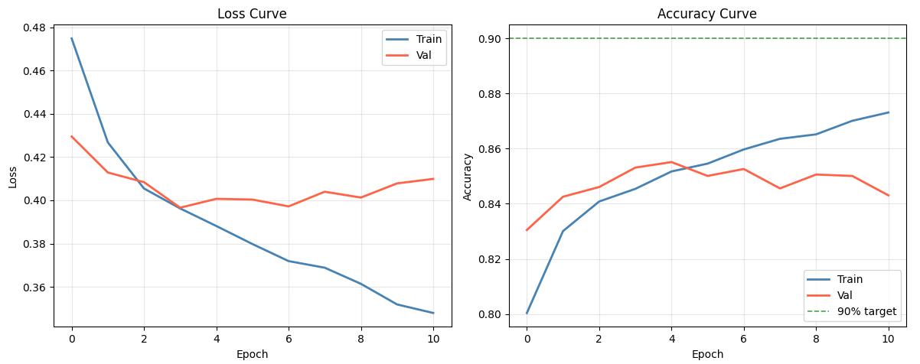
Figure 1 learning curves of proposed model
Validation loss has a sharper initial drop from 0.4295 to its lowest value of 0.3966 at epoch 4. It then maintains a plateau from 0.39 to 0.41 from epoch 6 onwards. Validation accuracy of 85.51% is recorded at epoch 5. There is a slight indication of overfitting from epoch 6 onwards, as evidenced by a noticeable gap between training and validation accuracy. While training accuracy increases with each epoch, validation accuracy maintains its peak at 85.51%. The early stopping criterion is effective in controlling overfitting to some extent by retaining only the best-performing model on the validation set to be used on the test set. It is interesting to observe that accuracy on the validation set is well above 50% at all times during training. This is an indication of the discriminative ability of the multimodal model from as early as epoch 1. The 90% accuracy target line on the figure indicates that although accuracy on the validation set is close to 90%, it is not fully realized on this dataset.
4.2 Overall Classification Performance
Table 1 presents a summary of the key performance metrics that are attained on a held-out test set consisting of 4,970 samples, of which 2,485 are bot and 2,485 are human accounts. The proposed MKA-BotNet model attains a test accuracy of 84.59%, AUC-ROC of 0.9239, and AP of 0.9260. The similarity in performance on both classes, Bot F1 = 0.85 and Human F1 = 0.85, validates that the model is able to generalize equally to both classes and that there is no class bias in this model, which is a significant requirement since a balanced evaluation is conducted.
Table 1: Summary of MKA-BotNet Performance Metrics on the Test Set
Metric | Value | Interpretation
Test Accuracy | 84.59% | Overall correct classifications
AUC-ROC | 0.9239 | Excellent discriminative ability
Average Precision (AP) | 0.9260 | Strong precision across thresholds
Bot Precision | 84% | Bot predictions highly reliable
Bot Recall | 85% | 85% of bots correctly caught
Bot F1-Score | 0.85 | Balanced bot detection
Human Precision | 85% | Human predictions reliable
Human Recall | 84% | 84% of humans correctly identified
Human F1-Score | 0.85 | Balanced human identification
True Positives (TP) | 2106 | Bots correctly identified
True Negatives (TN) | 2098 | Humans correctly identified
False Positives (FP) | 387 | Humans misclassified as bot
False Negatives (FN) | 379 | Bots missed by model
The high AUC-ROC value of 0.9239 and AP value of 0.9260 are particularly noteworthy. These are threshold-independent measures that test the ranking ability of a model over a wide range of thresholds. The high AUC-ROC value of 0.9239 indicates that the model is able to rank a randomly chosen bot account above a randomly chosen human account in over 92% of cases, which is a high figure and speaks to the discriminative ability of the multimodal knowledge alignment approach beyond what is captured by simple accuracy. The high AP value of 0.9260 further supports this by indicating that high precision is maintained over a broad range of recall, which is particularly relevant for a bot detection scenario.
4.3 Confusion Matrix Analysis
Figure 2 displays the confusion matrix for the test set. In this regard, there are 2,106 bot accounts that are correctly classified (true positives), and there are also 2,098 human accounts that are correctly classified (true negatives). In other words, the model has symmetric detection rates, which is an indication that there is balanced generalization performance. In terms of false positives, which are the human accounts that are incorrectly classified as bot accounts, there are 387. In terms of false negatives, which are the bot accounts that are incorrectly classified, there are 379. The similarity between false positives and false negatives is also an indication that the model does not favor either false positives or false negatives, as shown by the balanced precision and recall values.
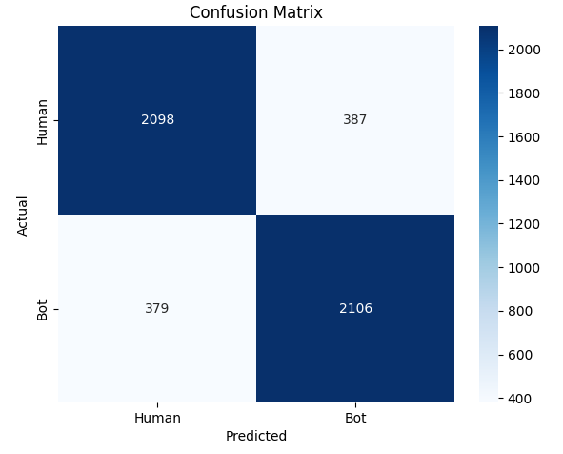
Figure 2 confusion matrix of proposed model
The division of the number of correctly classified samples by total samples per class results in per-class accuracy values of approximately 84.42% for the human class (2,098 / 2,485) and 84.71% for the bot class (2,106 / 2,485). The slight edge for bot recall over human recall (84.71% vs. 84.42%) suggests that the model is slightly more sensitive to bot-specific patterns than to human-specific patterns, which is beneficial for security-oriented applications where bot detection is the focus.
4.4 ROC Curve and Precision-Recall Analysis
Figure 3 displays the Receiver Operating Characteristic Curve and Precision-Recall Curve. From Figure 3, it is evident that there is a steeply rising curve on the Receiver Operating Characteristic Curve with low False Positive Rate values. At the same time, it is able to attain a True Positive Rate of over 0.8 with a False Positive Rate of less than 0.2. Such behavior is indicative of a well-calibrated classifier with good early retrieval capability. It is also evident from Figure 3 that the area under the curve is substantially higher at 0.9239 compared to a random classifier with an area of 0.50.
The Precision-Recall curve extends the ROC curve analysis to the trade-off between precision and recall in the absence of true negatives, making the analysis more appropriate when the cost of false positives is high. The PR curve retains high precision, i.e., close to unity, for recall levels ranging from 0 to 0.70 or 0.75, which indicates the model’s capability to retrieve the majority of the botnet accounts with few false positive predictions. The AP, i.e., 0.9260, obtained as the area under the PR curve, further supports the high precision levels over a wide range of operating thresholds. The smooth degradation of precision levels at high recall levels, i.e., greater than 0.85, is expected, considering the difficulty of detecting the highly camouflaged botnet accounts without incurring additional false positive costs. Overall, the high AUC ROC and AP values obtained in the analysis establish the strong ranking capability of the MKA-BotNet model and its potential for real-world usage.
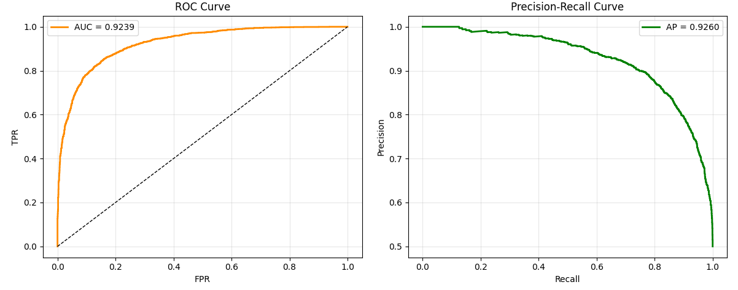
Figure 3 ROC and PR curve of proposed model
4.5 Predicted Probability Distribution
Figure 4 presents the kernel smoothed density histograms for the predicted probabilities P(Bot) for the human and bot classes, with the decision threshold set at 0.5, indicated by the vertical dashed line. Both the human and bot class probability distributions are clearly bimodal and well separated, with the human class probability distribution being sharply peaked around P(Bot) ≈ 0.0, with the majority of the human class having low probabilities, and the bot class being sharply peaked around P(Bot) ≈ 1.0 with a sharp upswing at the high end of the probability range.
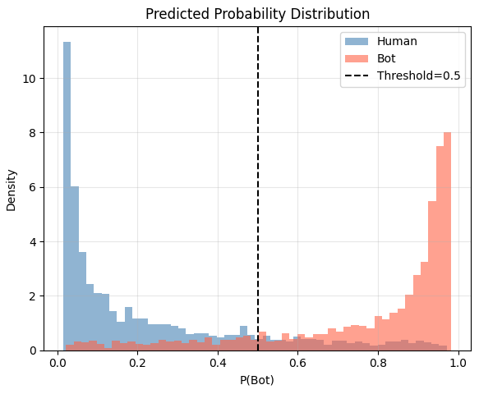
Figure 4 Predicted probability distribution with proposed model
This bimodal separation is a defining feature of a well-calibrated classifier with high confidence in its output. The low overlap between the two distributions in the intermediate region (P(Bot) ∈ [0.2, 0.8]) is where the indeterminate samples lie that contribute to the false positives and false negatives identified in the analysis of the confusion matrix. The low probability density of both distributions in this overlap region further supports the argument that the model is making confident and well-separated decisions for most of the test samples, with only a low percentage of accounts existing in this indeterminate region. Finally, the sharpness of the peaks at 0.0 and 1.0 supports that the model is not making any indeterminate decisions and is well-calibrated, validating the effectiveness of the label smoothing regularization used during training.
4.6 Actual versus Predicted Sample-Level Visualization
Figure 5 shows a detailed view of the model prediction over the first 200 test data samples. The top plot is based on color-coded scatter plots to differentiate between four types of prediction outcomes: True Positive (TP: Bot→Bot), True Negative (TN: Human→Human), False Positive (FP: Human→Bot,), and False Negative (FN: Bot→Human), which are represented along with actual labels and prediction indicators. The lower plot shows the corresponding prediction probability P(Bot) as a color-coded bar chart, and actual class membership is represented as inverted triangles above each bar.
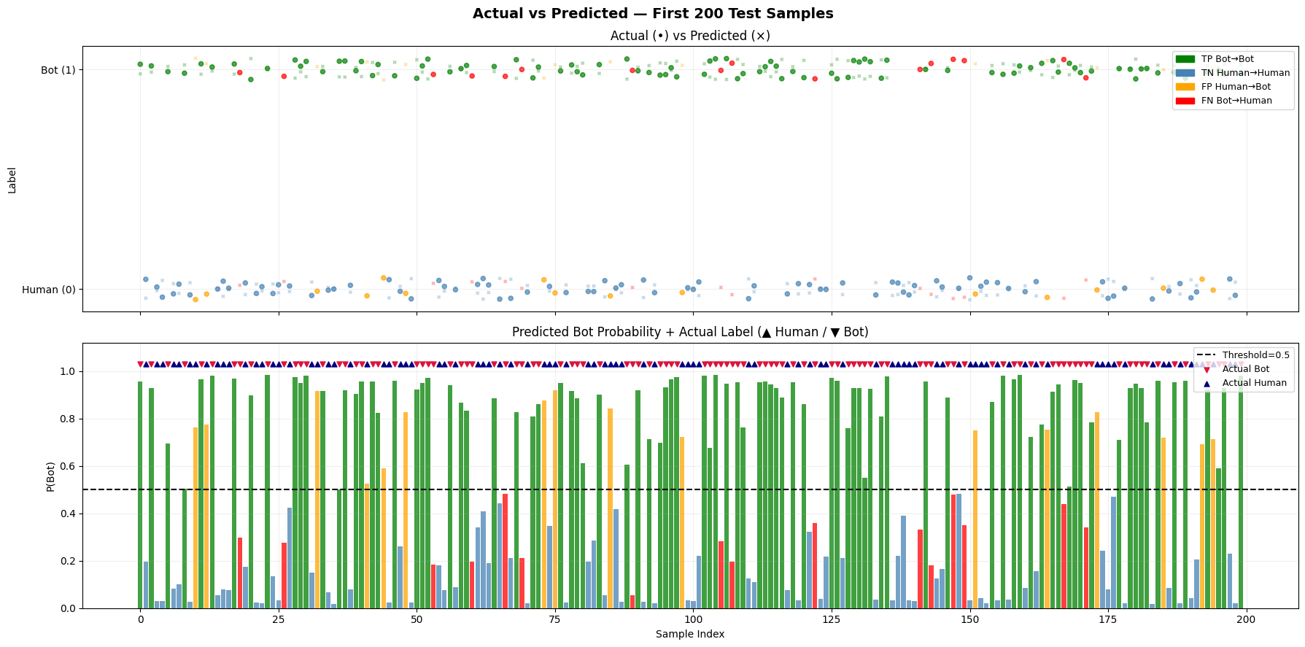
Figure 5 actual and predicted samples of test data
The visualization also supports the quantitative results of the confusion matrix, which indicated the dominance of TP and TN, with the FP and FN instances being relatively sparse and appearing throughout the distribution. The misclassifications seem to be coming from the more ambiguous instances, as the FP instances tend to cluster at the higher probability levels, with their P(Bot) values being only slightly above the threshold of 0.5, and the FN instances tend to cluster at the lower probability levels, also just slightly above the threshold. There are several FP instances with probabilities between 0.5 and 0.7, which correspond to the human instances with unusual behavioral profiles, and several FN instances with probabilities between 0.3 and 0.5, which correspond to the bot instances with unusual human profiles. This analysis indicates that the model's errors are clustered in the hard-to-classify region and could be improved with the appropriate choice of decision threshold.
4.7 Attention Weight Analysis by Prediction Outcome
Figure 6 is a grouped bar chart of the Bahdanau weights of the text and image modalities, each of the four prediction outcome categories: TP - Bot→Bot, TN - Human→Human, FP - Human→Bot, FN - Bot→Human. It offers direct interpretability of what kind of input modality is used by the model.
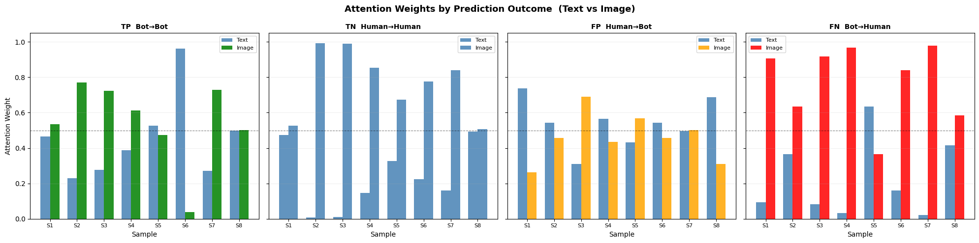
Figure 6 attention weights analysis
For the TP bot samples, the attention weights are generally balanced between the text and image modalities, with a slight bias towards the image modality in some of the samples (image modality weight up to 0.75–0.95). This indicates the strong presence of bot-indicative information in the image modality, which is typical for bot profiles, such as the use of generic or computer-generated image content, such as the profile picture. The text modality also provides additional contextual information to confirm the presence of the bot. For the TN human samples, the text modality has a higher attention weight, which indicates the typical human user behavior of providing rich and personalized text content as strong human authenticity indicators.
The attention patterns for these misclassified samples are particularly insightful. For FP samples, i.e., human accounts misclassified as bot, the model mostly attends to the image modality, implying that these human accounts have profile images that are visually atypical, mimicking bot-visual patterns to some extent, thereby overshadowing textual cues of human authenticity. For FN samples, i.e., bot accounts evading detection, there is an overwhelming high attention weight for the image modality (red bars close to 1.0 for several samples), while attention to text is suppressed to 0. This implies that these bot accounts may have visually appealing profile images, such as stolen or AI-generated photos of real people, leading the attention mechanism to incorrectly assign low bot probability to these samples, despite textual cues of bot-ness.
- Conclusion
This paper has introduced MKA-BotNet, a multimodal knowledge alignment bot detection framework using CLIP-based vision-language embeddings and 31 behavioral metadata features via an attention-guided Bidirectional LSTM and late-fusion classification head. The efficacy of this framework is validated using the Twitter Human-Bots Dataset, yielding an accuracy of 84.59%, AUC-ROC of 0.9239, and Average Precision of 0.9260 on the test set, along with symmetric F1-scores of 0.85 for bot and human classification. The Bahdanau-based attention mechanism has shown interpretable modality weights, indicating adaptive usage of image features to detect bot accounts and textual features to detect human users. The probability distribution has shown high separability between bot and human classes, and the confusion matrix has shown symmetric classification performance between bot and human users. The efficacy of this work has shown MKA-BotNet as a strong baseline in bot detection using multimodal features. The future direction of this work is to explore more behavioral features, adversarial training, and GAN-detection to make it more robust against visually sophisticated bot accounts.
References
- Thorne, E. (2025). Multimodal Perception and Fusion for Robust Human-Robot Interaction in Indoor Environments. Transactions on Computational and Scientific Methods, 5(7).
- Yadav, A., Verma, A., & Gupta, S. (2025). Lightweight Attention-Guided CNN–LSTM for Image Captioning. Journal of Kathmandu BernHardt College, 7, 248-265.
- Biswal, M. R., & Baliarsingh, S. K. (2026). Integrating Vision and Language: An Improved VAD Model. Journal of Applied Science and Technology Trends, 7(1), 137-156.
- Shao, J., Zou, X., Zhao, X., & Zhang, Y. (2025). DR-IAL: Decoupling-to-recoupling guided interaction-aware learning for egocentric action recognition. Pattern Recognition, 112731.
- Anuar, M. F. A. M. S., Zaman, F. H. K., Abdullah, S. A. B. C., Ng, K. M., Vijyakumar, K. N., & Ng, S. K. (2026). Transformer Architectures for Distracted Driving Behavior Detection: A Comprehensive Review of Vision-Based Approaches. IEEE Open Journal of Intelligent Transportation Systems, 7, 233-267.
- Wang, Z. (2025). Cultural Heritage-Inspired Deep Framework forSports Action Recognition and Competition BehaviorAnalysis.
- ANTU, S. R. R., MUNNA, A. I., KHALIL, M. I., ABYAD, S. M., SIFAT, N. M., DHRUBO, A. F. H., ... & SAJJAD, M. (2026). Multimodal Sentiment Classification of Bengali Memes on MemoSen with Custom Fusion Models.
- Zhang, Y., Tian, J., & Xiong, Q. (2025). A review of embodied intelligence systems: a three-layer framework integrating multimodal perception, world modeling, and structured strategies. Frontiers in Robotics and AI, 12, 1668910.
- Noghre, G. A., Pazho, A. D., & Tabkhi, H. (2025). A survey on video anomaly detection via deep learning: Human, vehicle, and environment. arXiv preprint arXiv:2508.14203.
- Xu, L., Wang, L., Zhang, J., Ha, D., & Zhang, H. (2025). A Review of Cross-Modal Image–Text Retrieval in Remote Sensing. Remote Sensing, 17(24), 3995.
- Cao, D., Cheng, H., Li, Y., Zhou, R., Zhang, X., Li, X., ... & Wu, Y. (2025). DSAGL: Dual-Stream Attention-Guided Learning for Weakly Supervised Whole Slide Image Classification. arXiv preprint arXiv:2505.23341.
- Hang, R., He, G., & Dong, L. (2025). MSG-GCN: Multi-Semantic Guided Graph Convolutional Network for Human Overboard Behavior Recognition in Maritime Drone Systems. Drones, 9(11), 768.
- Yang, S., Chen, Z., Lin, Y., Chen, X., Cai, G., Yu, H., ... & Yang, Q. (2025). A Survey on Vision-Language Models for Multimodal Federated Learning Tasks. Authorea Preprints.
- Shao, Z., Yang, H., Zhu, H., Yao, R., Zou, L., Li, M., & Sheng, B. (2026). Spatio-Temporal Disentanglement and Constrained Self-Attention for Multi-Modal Deception Detection. ACM Transactions on Multimedia Computing, Communications and Applications, 22(2), 1-20.
- Saket, O., Aicha, A. B., & Fathallah, H. (2025). Deep learning applied for abnormal human behavior recognition in video surveillance systems: A systematic review. Applied Intelligence, 55(13), 904.
- Xu, Z., Tang, Z., Lou, J., Yao, Z., Xie, X., Wang, T., ... & Jia, W. (2026). EAT: QoS-Aware Edge-Collaborative AIGC Task Scheduling via Attention-Guided Diffusion Reinforcement Learning. IEEE Transactions on Mobile Computing.
- Lande, R. S., Bhagat, A. P., & Khodke, P. A. Current Challenges and Open Issues for Multimodal Visual Memes Content Analysis.
- Huang, Y. (2025). Explainable AI-Driven Co
- ntent Optimization for 2D Character Merchandise Marketing: A Causal Feature Attribution and Attention-Guided Framework. INNO-PRESS: Journal of Emerging Applied AI, 1(2).

