Securing Social Media Platforms Using Face Recognition and Liveness Detection

G Kartheek
Department of
Computer Application
PG Student (MCA)
Mohan Babu University
Tirupathi, Andhra Pradesh, India
karthikgude73784@gmail.com

P M D Ali khan
School of Computing
Assistant Professor
Mohan Babu University
Tirupathi, Andhra Pradesh, India
Alikhan.tpty@gmail.com

Undela sireesha
Department of
Computer Application
PG Student (MCA)
Mohan Babu University
Tirupathi, Andhra Pradesh, India
sirireddy830960@gmail.com

ABSTRACT
The rapid growth of social media platforms has led to a significant rise in fake and duplicate accounts, which are often exploited for malicious activities such as spamming, phishing, and cyberbullying. Traditional authentication mechanisms, including passwords, email verification, and one-time passwords (OTPs), are increasingly vulnerable to security breaches. This paper proposes a lightweight and efficient face-based authentication system that integrates multi-frame verification and duplicate face prevention to enhance security. The system utilizes the Haar Cascade algorithm for real-time face detection and the Local Binary Pattern Histogram (LBPH) method for facial recognition. To ensure robustness against spoofing attacks, a multi-frame liveness detection mechanism is incorporated, where multiple frames are analyzed to confirm user authenticity. Additionally, duplicate account creation is prevented by validating both username and facial identity during registration. The system is evaluated using a real-time dataset collected from users under varying conditions, with an 80:20 training and testing split. Experimental results demonstrate that the proposed approach achieves an authentication accuracy of 90.3%, with reduced False Acceptance Rate (FAR) of 4.8% and False Rejection Rate (FRR) of 3.1%, while maintaining low computational complexity suitable for real-time applications. The proposed system effectively enhances authentication security and provides a practical solution for preventing unauthorized access and fake account creation in social media platforms.
Keywords
Face Recognition, Liveness Detection, Social Media Security, Spoof Detection, MultiFrame Verification, Duplicate Detection
I. INTRODUCTION
Social media platforms have become an integral part of modern communication, enabling users to interact with large audiences in real time. However, the proliferation of fake and duplicate accounts, along with increasing incidents of unauthorized access, has raised serious privacy and security concerns. Traditional authentication mechanisms, such as username-password combinations, are no longer sufficient to address the growing sophistication of cyber threats. To overcome these limitations, biometric-based authentication — particularly face recognition — has emerged as a robust and user-friendly alternative for securing online accounts.
Face recognition leverages the unique physiological features of the human face to verify user identity. Unlike passwords, facial features cannot be easily shared or stolen, making face-based authentication inherently more secure. This paper proposes a face-based authentication system for social media platforms that integrates the Haar Cascade algorithm for real-time face detection and the Local Binary Pattern Histogram (LBPH) method for facial recognition. The system incorporates a multi-frame liveness detection mechanism to effectively distinguish live users from spoofing attempts using photographs or recorded videos.
Recent advances in computer vision and machine learning have significantly improved the accuracy and speed of face detection and recognition systems. Classical approaches such as Viola-Jones detection and LBP-based recognition remain relevant due to their computational efficiency, making them well-suited for deployment in resource-constrained environments such as web-based social media platforms. The system proposed in this paper builds upon these established techniques, enhancing them with multi-frame liveness verification and duplicate-face detection to prevent unauthorized account creation and access.

II. EXISTING AUTHENTICATION METHODS
Several authentication models are currently used to secure social media accounts. These traditional mechanisms are primarily based on credentials or token-based verification. Users are required to provide correct credentials along with an authentication token to gain access to their accounts. However, these approaches have proven increasingly insufficient against modern security threats. The two most widely adopted methods are described below.
1. Email Authentication
Some social media platforms use email-based authentication to verify user identity. Upon providing correct credentials, the platform sends a one-time verification code to the registered email address. The user must enter this code to complete the login process successfully.
2.Mobile OTP authentication
In OTP-based authentication, the platform sends a numeric verification code to the registered mobile number of the user. The user must enter this code within a specified time window to authenticate successfully.
III. LIMITATIONS OF EXISTING AUTHENTICATION MODELS
There were some limitations found in the previous models of authentication with respect to computation and accessibility .
Email-based authentication presents accessibility challenges, as users must have access to their registered email account at all times. In remote areas with limited internet connectivity, this requirement becomes a significant barrier. Similarly, mobile OTP authentication is unreliable in regions with poor network coverage. Furthermore, both methods are vulnerable to credential theft — any attacker who obtains a user’s login credentials can gain unauthorized access without any physical verification, enabling account misuse and fraudulent activities. These limitations underscore the need for a biometric-based authentication approach that is both secure and resilient to spoofing.
IV. PROPOSED SYSTEM
The proposed system aims to enhance the security of social media platforms by implementing a face-based authentication mechanism integrated with liveness detection. Traditional authentication techniques such as passwords, email verification, and OTPs can be bypassed through phishing, credential theft, or SIM swapping. The proposed approach ensures that each registered account is uniquely associated with the owner’s facial identity, preventing unauthorized access and duplicate account creation.
During the login phase, the system verifies users through facial biometrics. In addition to face recognition, a liveness detection module is incorporated to prevent spoofing attacks using printed photographs or recorded videos. The overall architecture is designed to be lightweight, efficient, and suitable for real-time applications without requiring high computational resources.

1. User Registration Phase
During the registration phase, the user is required to capture facial images from multiple angles using a webcam. These images are processed to extract reliable facial features that uniquely represent the user. Multiple images are collected under varying lighting conditions and facial expressions to improve robustness. The extracted facial features are then securely stored in the database as feature templates for future verification.
2. Face Detection
Face detection is performed using the Haar Cascade classifier, which is based on the Viola–Jones framework. This algorithm is computationally efficient and provides reliable face localization in real-time video streams. The face detection process involves converting the input image or video frame into grayscale, followed by scanning at multiple scales to detect and localize facial regions while eliminating noise.
3. Face Recognition
Face recognition is implemented using the Local Binary Pattern Histogram (LBPH) algorithm. LBPH features are extracted from the detected face region, generating a histogram representation that is compared against stored feature templates using Euclidean distance. A match is confirmed when the computed distance falls below a predefined threshold.

V. METHODOLOGY
The methodology is designed to ensure accurate user authentication while preventing spoofing attacks, using lightweight and computationally efficient algorithms. The complete process is divided into sequential algorithmic stages, as described below.

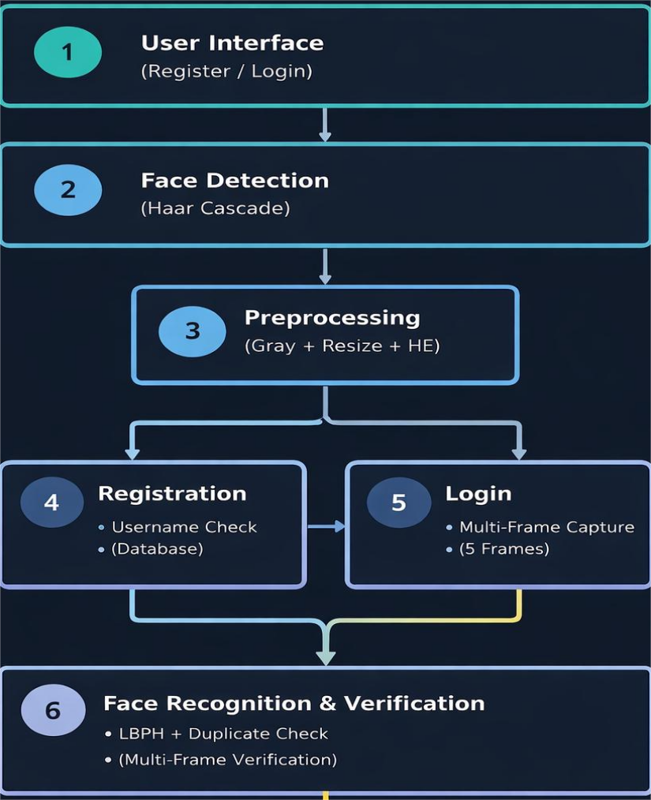
A. Face Detection Using Haar Cascade Algorithm
Face detection is the first and most critical step in the authentication pipeline. The system employs the Haar Cascade classifier to locate facial regions in the input frame.The classifier offers a favourable balance between detection accuracy and processing speed, making it well-suited for real-time authentication.
Key advantages of the Haar Cascade algorithm include:
1. High face detection accuracy under varying illumination.
2. Low false positive rate in controlled environments.

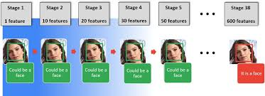

B. Image Preprocessing
Image preprocessing is applied to improve consistency and recognition accuracy by reducing variations caused by lighting, pose, scale, and image quality. The cropped face image is resized to a fixed resolution, pixel values are normalized, and contrast is enhanced through histogram equalization.

C.Face Recognition
Facial recognition is performed using the Local Binary Pattern Histogram (LBPH) algorithm, which extracts texture-based features from the face image. The preprocessed face is divided into smaller non-overlapping grids. Each pixel is compared with its neighbouring pixels to produce a binary pattern, which is then converted to a decimal value. Histograms are computed for each grid cell, and the concatenation of all grid histograms forms the final facial feature vector used for identity matching.
D. Feature Matching Using Euclidean Distance
To verify the identity of the user, the extracted LBPH feature vector is compared with stored feature templates. Euclidean distance provides a simple and efficient method to measure similarity between facial feature vectors.
E. Multi-Frame Verification
The multi-frame verification method serves dual purposes: liveness detection and spoofing prevention. During the login phase, the system captures multiple consecutive frames from the webcam and verifies consistency of facial features across frames to confirm that the input originates from a live user rather than a static image or replay video. A total of five frames are analysed, and authentication is granted only if at least 60% of the frames yield a successful match, thereby providing robustness against presentation attacks.

Datasets
The dataset used in this study is a real-time, self-collected facial image dataset captured through a webcam during user registration. Each user provides approximately 10 facial images under varying poses, expressions, and lighting conditions to ensure robustness. The captured images are preprocessed using face detection, grayscale conversion, histogram equalization, and resizing to a fixed resolution of 200 × 200 pixels.
For performance evaluation, the dataset is divided into 80% for training and 20% for testing. The use of a real-time dataset enables the system to operate under practical conditions and improves its adaptability for real-world face authentication applications.
VI. RESULTS AND DISCUSSION
The proposed face authentication system was evaluated using a real-time dataset collected from multiple users through a webcam interface. Each user contributed facial samples under varying orientations, expressions, and illumination conditions to ensure robustness. The dataset was divided into 80% for training and 20% for testing, ensuring unbiased evaluation.To address spoofing vulnerabilities, a multi-frame liveness detection mechanism was integrated. The system captures multiple frames during login and validates consistency across frames, ensuring that the input originates from a live user.
Face recognition Accuracy of Different Methods
Method | Accuracy (%) | FAR (%) | FRR (%) | Time (ms)
Password Only | 100 (logic) | High | Low | ~5
Face Only (Single Frame) | 78.5 | 12.3 | 9.2 | 120
Face + Blink Detection | 86.7 | 8.1 | 5.2 | 180
Proposed Multi-frame Method | 90.3 | 4.8 | 3.1 | 220

Compared with traditional authentication methods such as passwords and OTPs, the proposed system offers significantly improved resilience against phishing, spoofing, and fake account creation. The average authentication time is approximately 2.2 seconds, which is acceptable for real-time social media applications. Overall, the proposed face authentication system with liveness detection provides enhanced security and user convenience, making it an effective solution for improving trust and safety on modern social media platforms.

VII. CONCLUSION
This paper presented a face-based authentication framework for securing social media accounts by integrating face detection, face recognition, and liveness verification. The proposed system employed the Haar Cascade algorithm for efficient real-time face detection and the Local Binary Pattern Histogram (LBPH) method for robust facial feature extraction and recognition. To address spoofing threats, a dual-layer liveness detection mechanism based on eye-blink analysis and LBP texture features was incorporated, effectively distinguishing live users from photo and video replay attacks.
Experimental evaluation demonstrated that the proposed multi-frame face authentication system achieved an authentication accuracy of 90.3%, with a False Acceptance Rate (FAR) of 4.8% and a False Rejection Rate (FRR) of 3.1%, while maintaining low computational overhead and an average authentication response time of approximately 220 ms, which is suitable for real-time social media applications. These results confirm that the proposed system outperforms single-frame and blink-detection-based approaches in both accuracy and spoofing resistance.

References
[1] X. Zhang, K. Jing, Y. Dai, and X. Xu, "Face Biometric Identity Authentication System," in Proc. IEEE 4th Int. Conf. on Computer and Communications (ICCC), Chengdu, China, Dec. 2018, pp. 2338–2342.
[2] M. Zulfiqar, F. Syed, M. J. Khan, and K. Khurshid, "Deep Face Recognition for Biometric Authentication," in Proc. 1st Int. Conf. on Electrical, Communication and Computer Engineering (ICECCE), Swat, Pakistan, Jul. 2019, pp. 1–6.
[3] U. Ahmad et al., "Enhancing the Authentication Mechanism of Social Media Websites using Face Detection," in Proc. IEEE Int. Conf. on Innovative Computing (ICIC), Lahore, Pakistan, Nov. 2019, pp. 1–8.
[4] B. M. H. Alhafidh, R. M. Hagem, and A. I. Daood, "Face Detection and Recognition Techniques Analysis," in Proc. 2022 Int. Conf. on Computer Science and Software Engineering (CSASE), Duhok, Iraq, Mar. 2022, pp. 185–191.
[5] L. Kurnianggoro and K.-H. Jo, "Towards an Integrated Method of Detection and Description for Face Authentication System," in Proc. IEEE 15th Int. Conf. on Ubiquitous Robots (UR), Hawaii, USA, Jun. 2018, pp. 697–701.
[6] V. Shevchuk and I. Kots, "Improve the Security of Social Media Accounts," in Proc. IEEE 14th Int. Conf. on Computer Sciences and Information Technologies (CSIT), Lviv, Ukraine, Sep. 2019, pp. 67–70.
[7] P. Viola and M. J. Jones, "Robust Real-Time Face Detection," International Journal of Computer Vision, vol. 57, no. 2, pp. 137–154, May 2004.
[8] F. S. Samaria and A. C. Harter, "Parameterisation of a Stochastic Model for Human Face Identification," in Proc. IEEE Workshop on Applications of Computer Vision, Sarasota, FL, USA, Dec. 1994, pp. 138–142.
[9] Z. Zhang et al., "A Face Antispoofing Database with Diverse Attacks," in Proc. IEEE Int. Conf. on Biometrics (ICB), New Delhi, India, Mar. 2012, pp. 26–31.
[10] G. Pan, L. Sun, Z. Wu, and S. Lao, "Eyeblink-based Anti-Spoofing in Face Recognition from a Generic Webcamera," in Proc. IEEE Int. Conf. on Computer Vision (ICCV), Rio de Janeiro, Brazil, Oct. 2007, pp. 1–8.
[11] Y. Liu, A. Jourabloo, and X. Liu, "Learning Deep Models for Face Anti-Spoofing: Binary or Auxiliary Supervision," in Proc. IEEE/CVF Conf. on Computer Vision and Pattern Recognition (CVPR), Salt Lake City, UT, USA, Jun. 2018, pp. 389–398.
[12] A. Rehman et al., "Face Liveness Detection: Comprehensive Study, Deep Learning Models, Dataset, and Challenges," Sensors, vol. 21, no. 19, p. 6354, Sep. 2021.
[13] A. George and S. Marcel, "Deep Pixel-wise Binary Supervision for Face Presentation Attack Detection," in Proc. IEEE Int. Conf. on Biometrics (ICB), Rome, Italy, Sep. 2019, pp. 1–8.
[14] S. Bhattacharyya et al., "Face Detection and Recognition Using Local Binary Pattern," in Proc. Int. Conf. on Signal and Image Processing, Hubli, India, Dec. 2009, pp. 308–312.

