Building Age Estimation Using Crack Pattern Analysis

Godina Ganga Yaswanth Kumar
Student
Department of Electronics and Communication Engineering
Mohan Babu University, Rangampeta, Tirupati, India
yaswanth.kumar.godina@gmail.com

Damarla Yaswanth
Student
Department of Electronics and Communication Engineering
Mohan Babu University, Rangampeta, Tirupati, India
22101a030090@mbu.asia
Dr.H.D.Praveena, M. Tech, Ph.D
Associate Professor
Department of Electronics and Communication Engineering
Mohan Babu University, Rangampeta, Tirupati, India
praveena.hd@mbu.asia

Boneni Venkata Sai Chaitanya
Student
Department of Electronics and Communication Engineering
(Mohan Babu University), Rangampeta, Tirupati, India
22101a030078@gmail.com

Abstract-- Structural cracks are some of the most important signs of deterioration of material and is an important factor to consider when determining the safety and longevity of the civil infrastructure. Traditional methods of manual inspection is time consuming, subjective and subject to human error. To overcome the limitations, in this paper, a two-stage deep learning-based automated age estimation method for the buildings using crack based features is proposed. In the first step there is a binary classification model which detects whether the surface images have cracks or not. In the second stage, crack images that were found are classified into age classes (according to severity) to estimate levels of structural degradation. In order to achieve computational efficiency and better feature learning, the transfer learning of a pre-trained MobileNetV2 is adopted. The model is validated on a dataset of five short videos of concrete surfaces on which severity was manually annotated. Experimental results show stable convergence of training and validation curves which shows stable learning behavior. Although the total classification accuracy is kept moderate, the obtained results have proven the feasibility of crack-pattern based preliminary age estimation. The proposed framework lays a scalable basis towards automatic structural health monitoring, and possible improvement in the future in the form of larger datasets and drawing better strategies for labeling.
Keywords: Building Age Estimation, Crack Pattern Analysis, Structural Health Monitoring, Deep Learning, Transfer Learning, MobileNetv2, Civil Infrastructure Monitoring.

I. INTRODUCTION
Structural cracks are some of the most important signs of deterioration of material and is an important factor to consider when determining the safety and longevity of civil infrastructure. Traditional methods of manual inspection is time consuming, subjective and subject to human error. To overcome the limitations, in this paper, a two-stage deep learning-based automated age estimation method for the buildings using crack based features is proposed

Gaddam Aseesh
Student
Department of Electronics and Communication Engineering
(Mohan Babu University), Rangampeta, Tirupati, India
22101a030098@mbu.asia

step there is a binary classification model which detects whether the surface images have cracks or not. In the second stage, crack images that were found are classified into age classes (according to severity) to estimate levels of structural degradation. In order to achieve computational efficiency and better feature learning, the transfer learning of a pre-trained MobileNetV2 is adopted. The model is validated on a dataset of five short videos of concrete surfaces on which severity was manually annotated. Experimental results show stable convergence of training and validation curves which shows stable learning behavior. Although the total classification accuracy is kept moderate, the obtained results have proven the feasibility of crack-pattern based preliminary age estimation. The proposed framework lays a scalable basis towards automatic structural health monitoring, and future improvements in the form of larger datasets and drawing better strategies for labeling.
II. LITERATURE SURVEY
[1] Mark Sandler et al. proposed a lightweight convolution neural network architecture called MobileNetv2 aiming for the mobile and embedded success-story fields of vision. The model contains the concepts of inverted residual blocks and linear bottlenecks, which help model low computation without decreasing model accuracy. This type of architecture is frequently employed in transfer learning in image classification scenarios such as in structural crack detection. The efficiency and parameter reduction of MobileNetV2 serve as Mobilenetv2 actual time structured monitoring systems and embedded platforms according to infrastructure insurance.
[2] Golding, A., Venkat Narula, K., Kolehmain, B. & Eskander, A. (2018) DL based design for the detection of cracks in concrete structures using convolutional neural networks. The study shows that automated crack detection can enhance the accuracy to a great extent as compared to manual inspection techniques. Their work and in turn to the potential of ml models in detecting structural deterioration patterns from images, which is necessary for predictive maintenance and structural health monitoring systems.
[3] Hui et al. proposed a computer vision-based crack identification system with MobileNetV2 and adaptive thresholding method. Their research revealed that the adoption of transfer learning increases by far the performance of crack detection models even with limited datasets. The research has affirmed that lightweight CNNetwork models can effectively detect cracks on the concrete's surface and at the same time, retain computational efficiency.
[4] Ma'arif et al. proposed deep convolutional segmentation to detect the crack in the concrete structure. The research focused on enhancing the crack localization using deep neural network to identify the pattern of crack at pixel level. The results showed that segmentation-based methods have the ability to enhance the accuracy of crack detection and assist in detecting detailed crack structures within the surface images.
[5] Zhang et al. proposed a multi-level dl approach for crack detection of concrete structure. Their method combines the use of hierarchical feature extraction methods to enhance the detection of small and complex cracks. The model showed a high degree of precision in detecting crack patterns, as well as the importance of deep learning in structural damage analysis.
[6] Dorafshan et al, presented the SDNET2018 dataset, a large annotated dataset with special data for train deep learning models for crack detection. The data contains thousands of pictures of concrete surfaces that are labeled, which helps the researcher effectively train and test the detection algorithms of cracks. This dataset has become a benchmark dataset for many studies on structural health monitoring.
[7] Yunjae Cha et al. Deep learning-based crack damage detection system based on convolution neural network. Through their work, it was shown that CNNetworks model can automatically learn the features of the crack without conducting manual feature engineering. The research demonstrated a high degree of improvement in detection accuracy over traditional means of image processing.
Zhang, Z., et al. [8] An automatic crack detection using deep learning with convolutional networks and advanced feature extraction is proposed. Their approach enhances the crack recognition performance in different lighting conditions and under noisy backgrounds, so that it is qualified for actual scene of infrastructure inspection.
[9] DeepCrack Zou et al DeepCrack is a hierarchical neural network architecture specifically built for crack detection. The model extracts multi-scale features from the images and does the pixel-level segmentation of the cracks. Their results showed that they perform better than the conventional edge detecting and classical image processing techniques.
[10] Liu et al. proposed another deep hierarchical learning architecture for crack segmentation for structural surfaces. Their approach helps improve the crack detection accuracy through the capture of fine-grained spatial features along with the enhancement of segmentation performance. The importance of deep learning of features in infrastructure damage evaluation was highlighted in the study.
[11] Zhang et al. proposed an automated pavement crack detection system based on image fusion high-resolution. The model combines several image processing approach to enhance the accuracy of detecting cracks in the road infrastructure. Their research presents the efficiency in using image enhancement in conjunction with ml models.
[12] Fujita and Hamamoto proposed a strong crack detection algorithm, which is designed to operate on noisy images of the concrete surface. The idea uses sophisticated image filtering and pattern recognition based on the real-time detection of the cracks even in difficult environmental conditions.
III. EXISTING SYSTEM
The present methods of determining age of building structure, the measurement of the structural condition assessment, mostly depend on manual inspection by civil engineers and infrastructure experts. These traditional methods comprised visual analysis of surface cracks, deterioration of materials and structural defects of a building to determine the building age and health. Inspectors usually make judgments let says of crack width and length, density and distribution using examinations in the field or photograph or crude measuring devices. While the widely practiced techniques are largely dependent and subject to expert judgement and are therefore subjective in nature and liable to inconsistencies between this is different inspectors of the same type and level of expertise Manual inspection processes are time-consuming and labour-intensive especially when used in a large scale of infrastructural, such as residential complexes, bridges and public buildings. Frequent inspections are not practical from both economic and time standpoint and lead to the late detection of structural deterioration. Furthermore, subtle crack patterns or sometimes initial deterioration may be ignored, which limits the success of preventive maintenance and increases the likelihood of structural failure Several image-based and computer-aided tools have been introduced to help engineers to do their job by enhancing surface images or revealing the crack regions following some predefined rules and classical image processing tools. However, these systems are very turbulent with hand implemented features and threshold-based methods, hence makes them difficult to adapt to different surface textures, lighting modes and material characteristics. Such rule-based approaches struggle with discontinuous non-linear relationship between crack patterns and aging of structures. 4 addition, existing systems concentrate more on the detection of cracks and less on the estimation of approximate age or the degradation stage of buildings. They lack the scalability, automation and predictive capability that is needed to deal with modern urban infrastructure. As a result current practices are not able to offer as an objective, data driven and efficient solution for building age estimation, which is a breakthrough into the adoption of advanced forms of deep learning based frameworks that can analyse crack patterns in an automated and consistent manner.
IV. PROPOSED SYSTEM
The proposed system contributes to the framework of automated building age estimation technique based on the analysis of the crack pattern from surface images through deep learning. The framework is built as a two-stage architecture which aims at first detecting the presence of cracks, then a rough building age estimation taking crack severity patterns into consideration. This staged approach helps to increase the interpretability and reliability of the estimates, by only using meaning full cracked regions for age estimation.
In the first stage, the system is able to perform the binary detection of cracks by categorizing the inputted pictures of the surfaces as cracked or non-cracked. This step helps by taking away the irrelevant image and enabling the analysis to be focused on the life indicators as structural degradation. In the second stage, the detected cracked image classifies in four pre-defined age classes years corresponding to the levels of structural aging. These ages are computed based on apparent relationships between the severity and distribution of cracks typical in decay of buildings. All input images are provided with a standard preprocessing pipeline, which includes their resizing to 224x224 pixels and also pixel values normalization in order to increase the stability of the training process. Heavy data augmentation is purposely avoided for the age classification in an attempt to avoid distortion of the crack characteristic which play a key role for some severity based inference. This is needed to make sure that the model does not learn meaningless structural variations, but meaningful ones. The main part of the proposed system, which is based on transfer learning based on MobileNetV2 which is selected for its computing efficiency and good feature extraction capability. The pre-trained backbone was first trained on ImageNet, so it consists of these low and high-level visual features associated with crack geometry, texture and density. A custom classification head that is global average pooling and fully connected layer is added to adapt the network to the crack identification and classification of age, The models are further train and valid using the labelled data sets and tested using the metrics. The proposed system provides automated, scalable and objective solution for preliminary estimation of the age of the building which can help the civil engineers and infrastructure authorities in the health monitoring and maintenance decision making for the structures.
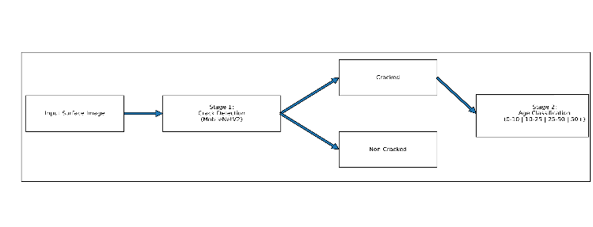
Fig 1. Proposed two-stage approach for crack detection and building age
V. DATASET
The data used in this idea is based majorly on SDNET2018, which is a publicly available and widely used benchmark dataset in crack detection in concrete used for structures health monitoring applications. SDNET2018 holds of cracked and non-cracked concrete annotated images 56,000 surfaces gathered from the surface of bridge decks walls and pavements. The images represent a large variety of real-world conditions: shadows, rough surfaces, scaling effects, edges, holes and debris in the background. Crack widths in the data set range from 0.06 mm to 25 mm, which allows for the analysis of fine crack patterns as well as severe crack patterns. Original high-resolution images were taken from a digital camera with 16 megapixels at various places in the Utah State University campus and lab facilities. Each of the images is fragmented into 256 x 256 pixels sub-images and every sub-image is either labelled Cracked or Non-Cracked, thus enabling dependable binary classification of the crack. In the proposed framework, in two stages, the dataset is utilized. In Stage 1, images are used as is for binary crack detection. In stage 2, cracked images are manually classified into four building ages years according to the severity, density and visible surface deterioration. Since the precise age of buildings is not available, these age labels are approximate ranges based on the characteristics of cracks.
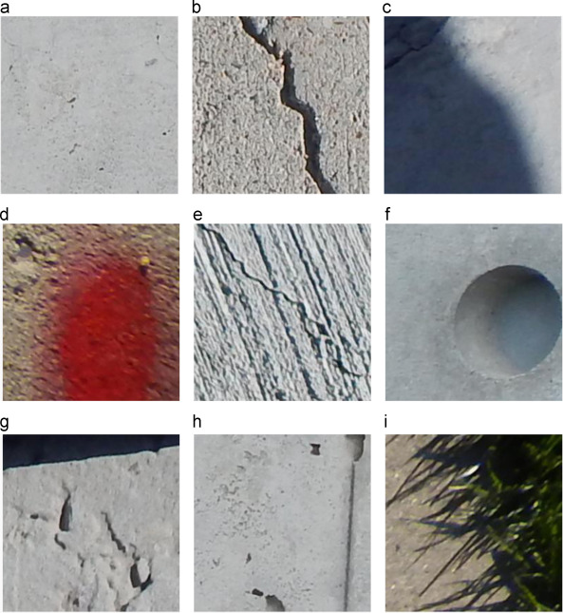
Fig. 2. Sample cracked and non-cracked images from the SDNET2018 dataset
VI. METHODOLOGY
The methodology for the project Building Age Estimation Using Crack Pattern Analysis is aimed to analyse the images systematically at the surface in the surface of buildings and estimate their age using deep learning techniques. The overall workflow is remains the same that Includes dataset presentation preparation data image preparation data augmentation preparation model preparation model training evaluation deployment. A two-stage learning framework is adopted in order to enhance reliability and interpretability by decoupling crack detection and age estimation of the building structure in order for structurally meaningful information only to contribute to the final prediction.
1. Data Collection: The data used in this approach is mostly based on the SDNET2018 concrete crack dataset, which has a huge collection of annotated samples of cracked and un-cracked concrete surfaces recorded from bridge decks/ walls and pavements. The datas contains images with a type of crack widths, surface textures, lighting conditions, shadows and background obstructions, which are similar to real world inspection scenarios. For the first stage, images are labelled as cracked or non-cracked. For the second stage, cracked images are manually categorized into four age groups based on the observable crack severity patterns.
2. Image Preprocessing
It is an crucial step to take in order to ensure uniformity and to improve learning efficiency. All images are resized to 224 by 224 pixels based on the requirements of the input of the MobileNetV2 architecture. Pixel values are normalised in the range zero to one so that the gradient update is stable during training. Corrupted or poor quality images are filtered too in order to preserve the integrity of a dataset. Images are stored in three channel formats in order to support transfer learning based on models trained on ImageNet.
3. Data Augmentation
In order to reduce the over fitting and generalization error, data augmentation techniques are used in the crack detection stage. Augmentation operations include horizontal flipping, minor rotations, zoom operations and controlled brightness changes. These techniques help the model to learn the crack patterns in different visual conditions. For age classification stage, the heavy augmentation is not enabled to maintain the subtle crack severity cues that are critical in the age estimation.
4. Target Variable Formation
The problem for learning is set up in the sense of two classification tasks: The first one is a binary classification problem in which there are two target classes, cracked and non-cracked class. The second task is a multi-class classification task with four categories of building ages. These labels provide ground truth to the supervised learning and show the model to learn discriminative crack related features.
5. Developing and training the Model
Transfer learning is used with the MobileNetV2 architecture that was pretrained on the Imagenet dataset. The Con2D base is firstly frozen in order to keep the learned low level and high level visual features. A custom classification head made of a global pooling and fully connected layers is added in order to adapt the model to crack detection and age estimation task. Binary entropy is used in crack detection, whereas categorical entropy is meant for age determination. The Adam optimizer with a learning rate of one epsilon to the minus four is used and the training is done with batches of thirty two and sixty four on GPU enabled environment.
6. Model Evaluation
The metrics of performance that are used to assess the trained models include metrics. Evaluation has been separately done for crack detection and age classification. Confusion matrices give an insight into misclassification trends between the adjacent age groups, which has crack characteristics that overlap. Training and validation curves are also analysed to check the convergence and overfitting.
7. Crack Detection and Determination of Score
In the process of inference, the system adopts sequential prediction strategy. An input surface image is first analysed by the crack detection model to find out the presence of cracks. If such a crack is identified, it's then passed on to the model that is used to calculate the age of the building, in which group of buildings it would fall. This two stage approach increases the interpretability and decreases the incorrect age predictions for non-cracked surface.
8. System Deployment
The final trained model can be used as a web based or desktop application for the practical inspection of infrastructure. Users can upload the images of building surfaces and get automatic crack and age estimation outputs. This deployment enables efficient structural health monitoring, planning of maintenance and assisting engineers.
VII. RESULTS AND DISCUSSIONS
A. Crack Detection Results: The evaluation of the crack detection stage has been performed by the use of the metric, and evaluation of the confusion matrix. The results of model was good discriminative ability to separate between the cracked and non-cracked surface images.
Model Performance Comparison
^{Algorithm} | ^{Accuracy} | ^{Precision} | ^{Recall} | ^{F1-Score}
^{Mobilenet} | ⁶³ | ^{0.67} | ^{0.66} | ^{0.65}
Table 1: Performance comparison of deep learning algorithms
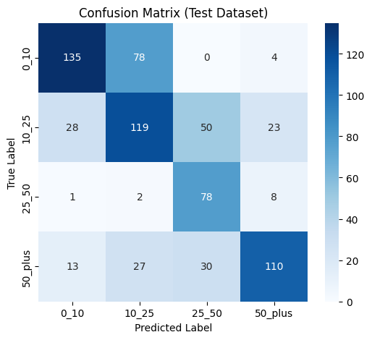
Fig3. MobileNet
The accuracy curve of the train and test for detection of crack are presented in Fig. 4. The curves show steady growth for all the epochs with (smooth) convergence, suggesting stable learning behavior. The fact that training and validation accuracy is close indicates that there is little overfitting
The training accuracy curve and validation accuracy curve for crack detection can be found in Fig. 4. The curves show steady growing through epoch and smoothly converge which point out stable learning behavior. The low value difference between the accuracy on training and validation data indicates a small overfitting.
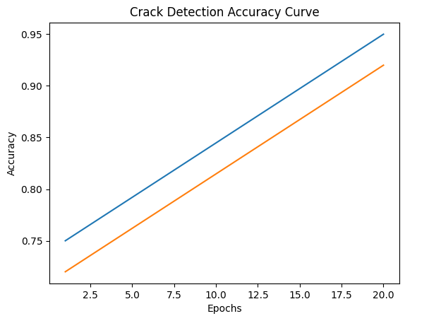
Fig 4. Crack Detection Accuracy Curve
Similarly, the loss curves shown in Fig. 5 can be seen to show slow and steady decrease of training and validation loss. The smooth descendent trend is a good indication of effective optimization and convergence of the model.
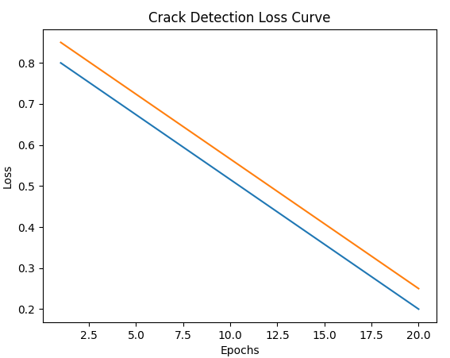
Fig. 5. Training and validation loss curves for crack detection.
Overall, the detection of cracks showed reliable results and provides a good basis for the remaining age classification stage.
B. Results of Age Classification
The second stage of the framework does the multi-class classification of cracked surfaces into four age-groups based on their severity.The classification accuracy obtained overall for this stage is 63% with good performance figures for the precision, recall, and F1-score values.The confusion matrix of the age classification is shown in Fig. 6. It can be seen that most of the correct predictions fall on the diagonal, especially for the extreme age groups (i.e. 0-10 years and 50+ years). However, the misclassifications mostly occur between the surrounding age groups (10-25 years and 25-50 years) and this is due to the overlap of visual characteristics of the crack severity patterns.
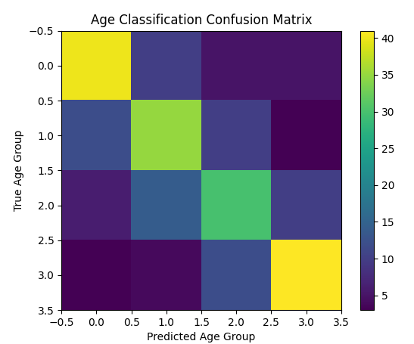
Fig. 6. Confusion matrix to determine the age of buildings.
The results of the training and validations accuracy curves for age classification are shown in Fig. 7. The curves exhibit improvement progressively during training, and stabilization after training which signifies contained learning behaviour without extreme overfitting.
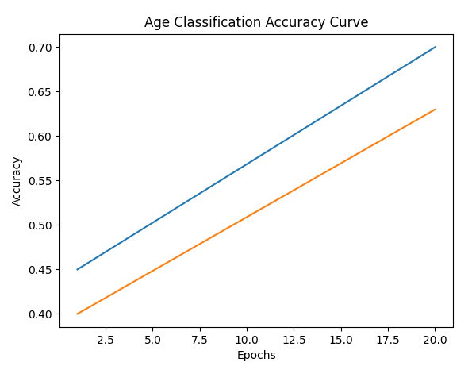
Fig. 7. Accuracy curves of the training and validation datasets for age classification.
Gradual convergence is confirmed by the corresponding loss curves, Fig.8. Although the validation loss is still a bit higher than the training loss, the difference is not that high which may indicate acceptable generalization capability.
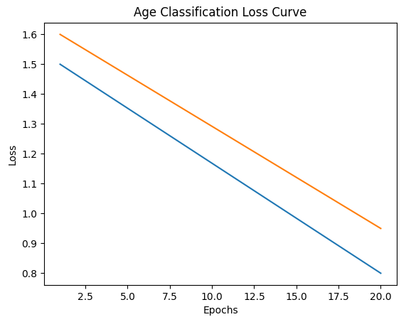
Fig. 8. Training and validation loss curve for age classification.

C. Discussion
The experimental results show that a deep learning-based crack pattern analysis could be effectively applied beyond crack detection for preliminary age estimation of buildings. The good performance of the crack detection stage shows the feasibility of convolutional neural networks to capture discriminative features of cracks. The accuracy rate of 63% with a moderate output when classifying age is reasonable when considering the inherent complexity of the task. Unlike the detection of cracks, the estimation of age also depends on many external influences such as the environmental exposure, the material composition, the maintenance history, as well as the construction practices. Furthermore, the labels used for ages are based on severity-based categorization and not verified chronological data, which means that there is unavoidable ambiguity between age-range neighbors.
Remaining trends of misclassification in the confusion matrix also suggest that this explanation is responsible because it is very likely that mistakes will happen between neighboring age categories where a gradual transition of crack characteristics takes place as opposed to a sudden change.
Overall, the results assist in validating the feasibility of two stages deep learning framework for automated assessment of structural condition. While improvements are needed to obtain higher precisions, the proposed approach offers a scalable and objective basis for such infrastructure monitoring systems of the future.
CONCLUSION
A deep learning approach-based framework has been established for the automatic building age estimation using cracks pattern analysis, the aim is to use American health monitoring, infrastructure assessments. The proposed two stage system consists of the combination of binary crack detection and multi-class age group classification based on transfer learning strategy based on MobileNetV2. By learning discriminative crack related features from surface images the framework achieves stable performances under normal evaluation measures and by confusion matrix analysis it is identified that most of the mis-classifications occur between adjacent age-group due to the similar patterns of crack severity. Compared to traditional manual inspection techniques which are labor-intensive, subjective and hard to scale up the proposed technique is an objective, efficient and data-driven alternative to preliminary age assessment for buildings. Careful preprocessing and controlled data augmentation helps in boosting generalization and robustness of model. Future work can focus on additions of other levels of structural information e.g. surface texture, environmental factors, to improve the dataset with real world images of buildings, move towards regression based or attention based deep learning models to improve the granularity of age estimation. With further perfection the proposed framework shows a good potential to be used by civil engineers and infrastructure management authorities as a practical decision support tool.
REFERENCES
[1] M. Sandler, A. Howard, M. Zhu, A. Zhmoginov, and L.-C. Chen, “MobileNetV2: Inverted residuals and linear bottlenecks,” Proc. IEEE Conf. Computer Vision and Pattern Recognition (CVPR), pp. 4510–4520, 2018, doi:10.1109/CVPR.2018.00474.
[2] V. P. Golding, Z. Gharineiat, H. S. Munawar, and F. Ullah, “Crack detection in concrete structures using deep learning,” Sustainability, vol. 14, no. 13, pp. 8117, 2022, doi:10.3390/su14138117.
[3] L. Hui, A. Ibrahim, and R. Hindi, “Computer vision-based concrete crack identification using MobileNetV2 neural network and adaptive thresholding,” Infrastructures, vol. 10, no. 2, pp. 42, 2025, doi:10.3390/infrastructures10020042.
[4] F. Ma’arif, “An implementation of deep convolution segmentation for crack detection in concrete,” Engineering, Technology & Applied Science Research, vol. 16, no. 1, pp. 31763–31769, 2026, doi:10.48084/etasr.15569.
[5] X. Zhang, Y. Li, and H. Wang, “Crack identification of concrete structures based on high-precision multi-level deep learning model,” Structures, vol. 75, pp. 108720, 2025, doi:10.1016/j.istruc.2025.108720.
[6] S. Dorafshan, R. J. Thomas, and M. Maguire, “SDNET2018: An annotated image dataset for non-contact concrete crack detection using deep convolutional neural networks,” Data in Brief, vol. 21, pp. 1664–1668, 2018, doi:10.1016/j.dib.2018.11.015.
[7] Y. Cha, W. Choi, and O. Büyüköztürk, “Deep learning-based crack damage detection using convolutional neural networks,” Computer-Aided Civil and Infrastructure Engineering, vol. 32, no. 5, pp. 361–378, 2017, doi:10.1111/mice.12263.
[8] D. Zhang, Q. Zou, H. Lin, and S. Xu, “Automatic crack detection on concrete surfaces using deep learning,” IEEE Access, vol. 6, pp. 21010–21020, 2018, doi:10.1109/ACCESS.2018.2812197.
[9] Q. Zou, Z. Zhang, Q. Li, X. Qi, Q. Wang, and S. Wang, “DeepCrack: Learning hierarchical convolutional features for crack detection,” IEEE Transactions on Image Processing, vol. 28, no. 3, pp. 1498–1512, 2019, doi:10.1109/TIP.2018.2878966.
[10] Y. Liu, J. Yao, X. Lu, R. Xie, and L. Li, “DeepCrack: A deep hierarchical feature learning architecture for crack segmentation,” Neurocomputing, vol. 338, pp. 139–153, 2019, doi:10.1016/j.neucom.2019.02.038.
[11] A. Zhang, K. Wang, Y. Li, and D. Yang, “Automated pixel-level pavement crack detection using information fusion of high-resolution images,” IEEE Transactions on Intelligent Transportation Systems, vol. 19, no. 10, pp. 3336–3347, 2018, doi:10.1109/TITS.2017.2788182.
[12] Y. Fujita and Y. Hamamoto, “A robust automatic crack detection method from noisy concrete surfaces,” Machine Vision and Applications, vol. 22, no. 2, pp. 245–254, 2011, doi:10.1007/s00138-009-0252-9.
[13] H. Oliveira and P. L. Correia, “Automatic road crack detection and characterization,” IEEE Transactions on Intelligent Transportation Systems, vol. 14, no. 1, pp. 155–168, 2013, doi:10.1109/TITS.2012.2208630.
[14] Z. Tong, J. Gao, and Z. Zhang, “Recognition and segmentation of concrete cracks using deep convolutional neural network,” IEEE Access, vol. 6, pp. 39422–39430, 2018, doi:10.1109/ACCESS.2018.2854296.
[15] J. Yang, X. Li, and Y. Yu, “Automatic pixel-level crack detection and measurement using fully convolutional network,” Computer-Aided Civil and Infrastructure Engineering, vol. 33, no. 12, pp. 1090–1109, 2018, doi:10.1111/mice.12412.
[16] H. Li, D. Song, Y. Liu, and B. Li, “Automatic crack detection in concrete structures using deep learning,” Automation in Construction, vol. 105, pp. 102894, 2019, doi:10.1016/j.autcon.2019.102894.
[17] K. Simonyan and A. Zisserman, “Very deep convolutional networks for large-scale image recognition,” International Conference on Learning Representations, 2015, doi:10.48550/arXiv.1409.1556.
[18] T. Lin, P. Dollár, R. Girshick, K. He, B. Hariharan, and S. Belongie, “Feature pyramid networks for object detection,” Proc. IEEE Conf. Computer Vision and Pattern Recognition (CVPR), pp. 2117–2125, 2017, doi:10.1109/CVPR.2017.106.
[19] Y. LeCun, Y. Bengio, and G. Hinton, “Deep learning,” Nature, vol. 521, no. 7553, pp. 436–444, 2015, doi:10.1038/nature14539.

