Performance Analysis of Machine Learning Techniques for Heart Disease Diagnosis

Vishav Pratap Singh
Department of Computer Science And Engineering
UIE, Chandigarh University
Mohali-140413, Punjab, India
pratapvishav92@gmail.com
Natali Singla
Department of Computer Science And Engineering
UIE, Chandigarh University
Mohali-140413, Punjab, India
Singlanatali52@gmail.com
Amrita Chaudhary
Department of Computer Science And Engineering
UIE, Chandigarh University
Mohali-140413, Punjab, India
amrita.january@gmail.com
Nongmeikapam Thoiba Singh
Department of Computer Science And Engineering
UIE, Chandigarh University
Mohali-140413, Punjab, India
nthoiba12@gmail.com
Kamal Kumar
Department of Computer Science And Engineering
UIE, Chandigarh University
Mohali-140413, Punjab, India
Kamalkumar2661987@gmail.com

Abstract—Heart disease remains one of the leading causes of deaths all over the world, and the need to have accurate and timely diagnostic support methods is quite categorical. In this paper, a comparative analysis of some machine-learning methods in identifying heart disease using clinical and lifestyle features is reported. The dataset comprised of 918 records with 12 demographic and clinical characteristics of patients, and it was preprocessed with categorical encoding, feature scaling, and missing-value imputation. Five trained learning models, i.e., the Logistic Regression, the Random Forest, the Support Vector Machine, the K-Nearest Neighbors, and the Gradient Boosting were instantiated and their performances measured by means of accuracy, precision, recall, and F1-score. Based on the empirical data, ensemble-based techniques are better than traditional classifiers. The best overall performance was shown by the Random Forest model that achieved the accuracy of 88.04% and the balanced performance measures precision, recall, and F1 -score of 89.72. The next step was the hyperparameter optimisation through the Grid Search CV that gave a slight improvement with the accuracy being 88.59. Gradient Boosting achieved the most accuracy with 92.00 which means that it has increased chances of positive-class prediction. These results highlight the effectiveness and robustness of ensemble-based learning procedures in predicting heart diseases and indicate their future implementation as reliable decision-support tools in the early diagnoses and preventive medicine.
Keywords- heart disease prediction, machine learning, gradient boosting, medical diagnosis, feature selection, hyperparameter tuning.

Introduction
The albumin causes of death world over are heart failure, stroke, coronary artery disease and other cardiovascular diseases (CVDs). The world health organization reports that the number of people killed by heart disease alone is over 17.9 million annually, which is nearly 32% of the total deaths across the world. The growing prevalence of CVDs underscores effectiveness of early detection and preventive interventions in reducing mortality and the overall patient outcome [1]. The primary elements of the current standard diagnosis of heart disease are the electrocardiogram (ECG), echocardiography, clinical assessment, and medical information assessed by the judgement of a medical worker. Though used extensively, such a diagnosis may be highly time-consuming and prone to human error, depending on the opinion of the medical practitioner because of its subjective nature. Docoscassation would also create inconsistencies in identification and risk assessment of diseases because doctors have a different opinion on the interpretation of diagnostic test results. These disadvantages underscore the importance of more accurate, effective and scaleable predictors of heart disease.
Over the last few years, machine learning (ML) and artificial intelligence (AI) have transformed predictive analytics in the healthcare business through application of data-informed approaches to risk evaluation and sickness identification. The ML algorithms will be able to examine large volumes of health-related patient data, and it will identify minute patterns and relationships that would otherwise be undiscovered in a conventional approach [2]. This paper explores how various machine learning models predict cardiovascular disease, with the application of key patient vital indicators of cardiovascular diseases, age, glycemic, blood pressure, lipid profiles and other cardiovascular risk factors.
Five machine learning models, which include KNN, Random Forest, SVM, Convolutional Neural Networks (CNN) and Gradient Boosting, are evaluated in this research. The ability of the models to foresee a heart disease is evaluated based on such vital assessment criteria as accuracy, precision, recall, F1-score, and ROC-AUC. The paper compares the models in trying to establish the best initial diagnostic tool that may promote patient care and allow healthcare providers to make sound decisions.
The results of the study may be vital towards enhancing early detection techniques of heart diseases thus reducing the burden on the health care systems and in the end lead to better patient outcome. The paper also highlights the importance of machine learning that is increasingly significant in healthcare diagnostics and how the latter can be applied to develop helpful healthcare solutions. Through AI-driven technologies, healthcare providers have an opportunity to be closer to applying more proactive and personalized treatment plans at low risk and timely intervention of patients at risk of cardiovascular illnesses.

Literature review
A research work by S. Mohan et al. [3] presents an introduction of a hybrid random forest with linear model (HRFLM) to predict cardiac disease with a high accuracy of 88.7 accompanied by a given enhancement over the traditional methods.. The HRFLM algorithm improved the prediction performance as compared to Decision Tree, Random Forest, and Linear Model techniques with the help of all 13 available characteristics, which in other studies were limited in their feature selection. In predicting the cardiac illness Rohit Bharti et al. [4] found a deep learning strategy beating machine learning models with a maximum accuracy of 94.2%. After the selection of features and normalisation of data, K-Nearest Neighbours (KNN) algorithm was used and the result was the accuracy of 83.29. In order to maximise the performance of the model, the authors have highlighted the importance of the phases of data preparation stages which include normalisation, outlier detection through Isolation Forest, as part of their approach. Vijeta Sharma et al. [5] have fully considered cardiac disease prediction using various machine-learning algorithms. Their results showed that a Random Forest classifier had a spectacular 99 -percent accuracy, which was higher than any other algorithm. SVM came in second with 98 % and then Naive bayes and Decision Tree with 90 and 85 % respectively. Their analysis revealed that different algorithms performed differently depending on the features of the patients and thus they have highlighted the importance of feature selection and preprocessing in ensuring high predictive accuracy.
M. Kavitha et al. [6] have suggested a hybrid of machine-learning to predict heart disease, combining the use of Random Forest and Decision Tree classifiers. The model thus obtained gained an accuracy of 88.7, which is quite high compared to the similar methods found in the literature. Additionally, the authors presented a new user-interface application which allows entering personal information and using the hybrid model to stratify risks. The main goal of such user-friendly design was to support the convenient implementation in real life situations, providing clinicians with a stable tool facilitating the initial diagnosis and making well-informed decisions. With an F1 score of 90.56%, 88.89% recall, 92.31% precision and 91.67% accuracy, the SVM model was better than the others, according to C. Boukhatem et al. [7]. Their research proved the utility of machine learning algorithms for inferring complex relationships between disorders and symptoms, which can be valuable in other fields of medicine. Harshit Jindal et al. have demonstrated that a combination of number of data mining methods like KNN, Random Forest and Logistic Regression have shown the accuracy to be improved to 87.5% [8]. KNN was the most effective of these with an accuracy rate of 88.52%. When it came to categorizing cases of heart illness, Jyoti Soni et. al [9] found that the Naive Bayes method was better than Decision Trees, K-NN, and Neural Network. Furthermore, by optimizing the use of the attributes with a genetic approach, the accuracy of the Decision Tree and the Bayesian Classification models was increased. Asmit Srivastava et al. [10] have proposed a machine learning model to predict the heart disease occurrence using dataset of 14 heart related factors. Their general aim was to build a model that would aid medical practitioners in their broadcasting about the heart disease diagnosis. By supporting early diagnosis and intervention, this technology is meant to assist physicians with well-informed decisions based on predictive analytics that could help to improve patient outcomes. In a thorough experimental analysis of artificial intelligence heart disease predictions, D Rohan et al. [11] found out that XGBoost model works better than the other models and it reaches the highest standards with 97.3% accuracy, 97% precision, 98% sensitivity, 98% specificity, 98% F1 score and 98% area under curve (AUC). According to their research, the best results to predict heart disease have been achieved by hyperparameter tuning the XGBoost model without the use of feature selection. The proposed XGBoost model is a strong competitor among other algorithms with respect to increase the predictive performance for the identification of heart disease.

Methodology

Datasets
The dataset has 918 instances with 12 features, including demographic, clinical, and diagnostic attributes required for heart disease prediction. To increase the model's performance, a combination of numerical and categorical variables must be pre-processed with label encoding for categorical variables and scaling for numerical variables. The fundamental attributes, which are taken into account in the current analysis, include age (28-77 years), sex (male/female), chest -pain type (ATA, NAP, ASY, TA), rest blood-pressure (0-200 mm Hg), serum cholesterol (0-603 mg/dL), fasting blood-glucose level (≥126 mg/dL or <126 mg/dL), resting ECG result (Normal, ST, left ventricular hypertrophy), maximal heart rate (60-202 bpm), exercise-induced angina (Yes/No), Oldpeak (-2.6 to 6.2), and ST segment slope (Up, Flat, Down) [12]. These traits provide valuable insight into a patient's cardiovascular state and are often utilized in clinical assessments to diagnose heart disease. The response variable, HeartDisease (0 or 1), indicates the prevalence of heart disease in the patient, making this a binary classification problem [13]. The data exhibits potential missing or anomalous values for features like RestingBP and Cholesterol, which may require cleaning or imputation. Additionally, features like Oldpeak and ST_Slope, indicating the results of the stress test, are extremely important for risk prediction. By applying machine learning algorithms to data analysis, we can explore risk variables, uncover hidden trends and enhance early identification of cardiac disease, which provides a good ground to develop predictive modeling algorithms. The results of this investigation can improve the patient and use them in decision making when deciding on the type of therapy.
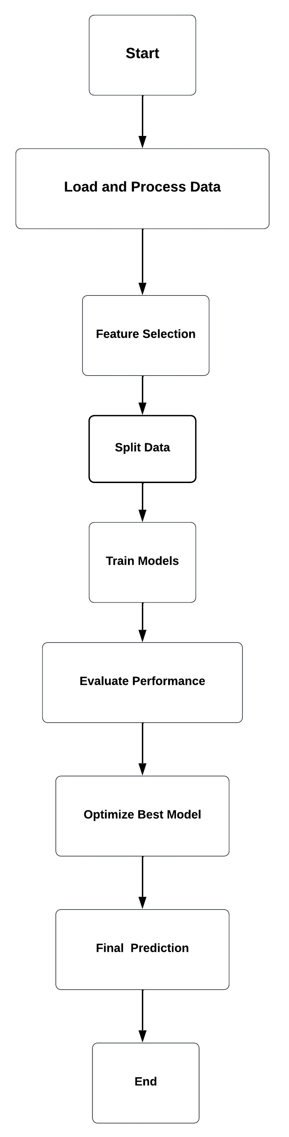
Fig. 1 Block Diagram of Proposed Model

Fig. 1 shows the systematic procedure used for the development of the machine learning-based method for cardiovascular disease detection. The process is initiated with the data loading and preprocessing that is performed to clean, standardize and process categorical variables, in raw dataset. The most important traits that influence the risk of having heart disease are then identified through feature selection which ensures that the model only looks at the most relevant data. This data is then split into training and testing sets so that they can be used to train the model and test them. The predictive models are realized based on a library of machine learning algorithms used on the training set. Their performance is then tested in terms of parameters such as accuracy, precision, recall and other such metrics. To make it more accurate and robust, Hyperparameters are adjusted for the best performing model. The model is called as final prediction after optimization, and it provides us with information of possible risks of heart disease. An effective and trusted machine-learning framework for medical decision-making and early detection of disease is guaranteed by this methodical methodology.

Methods

This work is based on machine learning to make some systematic predictions about cardiac illness. The methodology involves the model selection, evaluation, hyperparameter tuning, data pre-processing, and exploratory data analysis (EDA). A detailed description of each step is given below.

Data Preprocessing

Dealing with Categorical Variables: In case of machine learning techniques, the categorical variables in a dataset such as the type of sex, kind of chest pain, resting ECG, exercise angina, and ST + slope must be transformed into a number. Each of the categories has been assigned a different integer value using the process of label encoding.

Handling Missing Values: Data integrity was ensured by finding out the missing and correcting the missing values. Depending on the characteristic missing values were either removed if necessary or imputed using statistical measures (mean, median or mode).

Feature Scaling: Standard Scaler was applied to the numerical features for the scaling of these features since these features have different scales. This transformation reduces the bias effects due to different magnitudes by ensuring that all the numerical values have a mean of zero and a standard deviation of one [13].

Exploratory Data Analysis (EDA)

Histogram Analysis: The histogram analysis of the numerical variables was carried out in the form of histograms which were helpful in determining skewness, outliers, and inconsistent data.

Correlation Heatmap: In order to understand the correlations between variables, a correlation heatmap was generated. Features with high correlations were then further analyzed as to their usefulness in heart disease prediction.

Model Selection and Training: Five supervised machine learning algorithms were compared in terms of expected performances.

Logistic Regression: For a binary classification task, a statistical model which utilizes a sigmoid function to determine a likelihood of heart disease.

Random Forest Classifier: Ensemble learning methods combine output from various decision trees for better prediction and decrease the over-fitting [14].

Support Vector Machine (SVM): It is a classification technique that defines an optimum hyperplane for separating the data points into two classes. In this investigation, a linear kernel was used.

K-Nearest Neighbors (KNN): In the current system, the labeling of classes is done with assistance of distance-based classifiers. A total of five neighbours (K) were chosen.

Gradient Boosting Classifier: This is an iterative learning approach defined to enhance weak model by reducing errors of previous iterations which effectively finds complex patterns [15].

Model Evaluation: The metrics that were used to assess the performance of each classifier were as follows:

Accuracy: The general accuracy is found by dividing the number of accurate predictions against the total number of predictions.

Confusion Matrix: Demonstrates the corresponding false positive (FP), true negative (TN), true positive (TP) and false negative (FN).

Precision: Determines the proportion of all optimistic forecasts that come true.

Recall: Evaluates how well the model can identify actual positive cases.

F1-Score: A harmonic mean of recall and precision serves as a balanced evaluation metric.
To assess each model's capacity for generalization, an independent test set comprising 20% of the data was used.

Hyperparameter Tuning Using Grid Search: The optimization of the performance of the Random Forest classifier was performed by grid search cross-validation, which is systematic hyperparameter search. The optimal set of hyperparameters is methodically found using this approach, which includes:
- Estimator count (number of trees in the forest)
- The tree's greatest depth
- Samples needed to separate a node at minimum
- A leaf node's minimum sample requirements.
The model that performed the best was chosen based on cross-validation's highest accuracy and F1-score.

Model Comparison: The performance of each model after being trained and evaluated was measured using accuracy, precision, recall, and F1 -score. The model that performed the best overall was chosen to be the best model for predicting heart disease.

Results and discussions
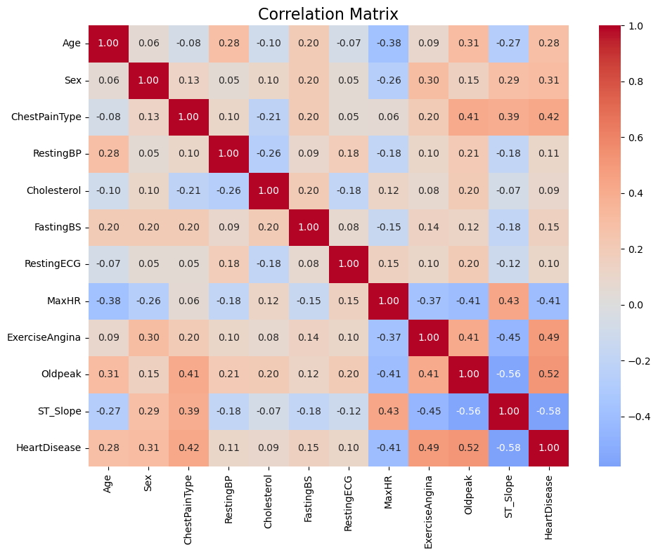
Fig. 2 Result Analysis
The association between various characteristics in a dataset used to predict heart disease is shown in Fig. 2. It displays relationships using color coding, with dark blue denoting high negative correlations and dark red denoting strong positive correlations. The salient results show strong relationships between exercise angina ( 0.49), old peak (0.40), and ST slope ( 0.56) and the presence of heart disease, which support the position of these variables as key predictive variables. In addition, the correlations between chest pain type ( 0.39), maximum heart rate ( -0.40), age (0.28), and sex (0.31) are significant, meaning that they make significant contributions to the evaluation of cardiovascular risk.
The heatmap identifies the most relevant predictors, thus, simplifying the process of selecting features to be used in machine learning models. Model accuracy can be improved by examining features that have strong connections, such as Oldpeak and ST Slope. Weaker correlations, on the other hand, imply that certain features might not be as important to prediction accuracy and might be eliminated for optimization. this graphic helps to understand the relationship between heart disease and various health measures which can guide the formulation and examination of efficient models. Table 1 presents the performance indicators on a number of classification models including Gradient Boosting, Random Forest, SVM, KNN, and Logistic Regression.
TABLE I PERFORMANCE COMPARISION OF MODELS
Techniques | Accuracy (%) | Precision (%) | Recall (%) | F1 Score (%)
Logistic Regression | 84.78 | 90.72 | 82.24 | 86.27
Random Forest | 88.04 | 89.72 | 89.72 | 89.72
SVM | 83.69 | 88.89 | 82.24 | 85.43
KNN | 84.78 | 90.72 | 82.24 | 86.27
Gradient Boosting | 87.50 | 92.00 | 85.98 | 88.89

After tuning of hyperparameters, the Random forest model performed better as compared to other models with an 88.59% accuracy. Its ability to handle non-linearity and categorical data and mitigate overfitting is attributed with the improvement. Other alternatives such as SVM and Logistic Regression were good with less complex feature combinations. From Fig. 3, it can be seen that the Random Forest model has the best balance and consistency in all evaluation indicators, the overall accuracy is the highest (88.04%), and the precision, recall, and F1-score are unanimous (89.72%). The Gradient Boosting model gives the best score for precision (92.00%) which shows the best reliability in the positive class prediction at a balanced level with the accuracy and F1 score. In contrast, the Logistic Regression and KNN prove the same tendency as a moderate accuracy and F1-score with relatively low recall, hence a reduced sensitivity in terms of positive instance identification. The SVM model cannot be considered as the one with the lowest recorded accuracy score which is 83.69% even though its precision value is relatively high. Overall, Fig. 3 makes it quite clear to see the superior effectiveness and stability of ensemble based methods, especially Random Forest and Gradient Boosting, when compared to traditional machine learning classifiers.
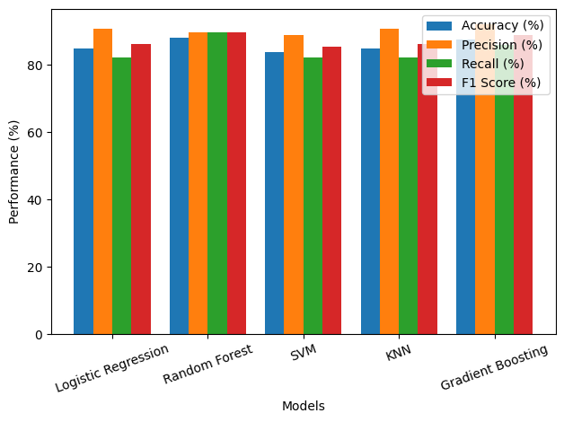
Fig. 3 Comparative analysis of the classification performance for different machine learning models.
Several factors affected the model performance. Feature selection played an important role with better models depending on features with higher correlation. Imbalanced data for certain categorical variables influenced the classification accuracy of the model, providing a need for methodologies such as resampling. By maximizing the number of estimators as well as the depth of the tree, hyperparameter tuning significantly improved the performance ability of the Random Forest model. Finally, the complexity of models affected results as simpler models such as Logistic Regression performed well, but struggled with non-linearity in the data.

Conclusion and future scope
With an accuracy level of 88.59%, according to this study it can be said that the Random Forest model is the most successful in predicting heart disease after hyperparameter tuning. The ability of the model to handle non-linear and categorical data and decreasing overfitting enables it to be a good candidate for medical diagnosis. Important features which are crucial to prediction are Exercise Angina, Oldpeak, ST Slope and MaxHR indicating the importance of features. Simpler models such as Logistic Regression worked well on the other hand but had difficulty capturing complex relationships. Future research will focus on feature engineering to create more predictive variables and ensemble learning to make models more accurate. Handling class imbalance by experts with techniques such as SMote or class weighting will further improve the predictions. Additionally, it is a good idea to explore deep learning models and test them with larger datasets gained with real-world data, which will make the model reliable. These developments will add to the development of a more exact and comprehensible clinically useful system to predict cardiac disease.

References
- Shah, D., Patel, S. & Bharti, S.K., “Heart Disease Prediction using Machine Learning Techniques,” SN Computer Science, vol. 1, p. 345, 2020.
- Wankhede, J. P., Palaniappan, S., & Magesh Kumar, S., "Heart Disease Prediction Using Hybrid Random Forest Model Integrated with Linear Model," in Advances in Parallel Computing Technologies and Applications, D.J. Hemanth et al., Eds. IOS Press, 2021, pp. 370 - 376.
- S. Mohan, C. Thirumalai and G. Srivastava, "Effective Heart Disease Prediction Using Hybrid Machine Learning Techniques," in IEEE Access, vol. 7, pp. 81542-81554, 2019.
- Bharti, Rohit, Khamparia, Aditya, Shabaz, Mohammad, Dhiman, Gaurav, Pande, Sagar, Singh, Parneet, “Prediction of Heart Disease Using a Combination of Machine Learning and Deep Learning,” Computational Intelligence and Neuroscience, vol. 2021, 8387680, 11 pages, 2021.
- V. Sharma, S. Yadav and M. Gupta, "Heart Disease Prediction using Machine Learning Techniques," 2020 2nd International Conference on Advances in Computing, Communication Control and Networking (ICACCCN), Greater Noida, India, 2020, pp. 177-181.
- M. Kavitha, G. Gnaneswar, R. Dinesh, Y. R. Sai and R. S. Suraj, "Heart Disease Prediction using Hybrid machine Learning Model," 2021 6th International Conference on Inventive Computation Technologies (ICICT), Coimbatore, India, 2021, pp. 1329-1333.
- C. Boukhatem, H. Y. Youssef and A. B. Nassif, "Heart Disease Prediction Using Machine Learning," 2022 Advances in Science and Engineering Technology International Conferences (ASET), Dubai, United Arab Emirates, 2022, pp. 1-6.
- H. Jindal, S. Agrawal, R. Khera, R. Jain and P. Nagrath, “Heart Disease Prediction Using Machine Learning Algorithms,” IOP Conference Series: Materials Science and Engineering, vol. 1022, pp. 120-126, 2021.
- Jyoti Soni, Ujma Ansari, Dipesh Sharma, and Sunita Soni , “ Predictive Data Mining for Medical Diagnosis: An Overview of Heart Disease Prediction,” International Journal of Computer Applications, vol. 17, pp. 43- 48, 2011.
- A. Srivastava and A. k. Singh, "Heart Disease Prediction using Machine Learning," 2022 2nd International Conference on Advance Computing and Innovative Technologies in Engineering (ICACITE), Greater Noida, India, 2022, pp. 2633-2635.
- Rohan, D., Reddy, G.P., Kumar, Y.V.P. et al., “An extensive experimental analysis for heart disease prediction using artificial intelligence techniques,” Scientific Reports, vol. 15, Article No. 6132, 2025.
- D. Dua and C. Graff, “UCI Machine Learning Repository,” University of California, Irvine, 2019.
- R. Alizadehsani et al., “A data mining approach for diagnosis of coronary artery disease,” Computer Methods and Programs in Biomedicine, vol. 111, no. 1, pp. 52–61, 2013..
- Andhare C.V., Ingle D., “Adaptive local binary descriptor statistics: A novel feature set for heart disease diagnosis,” Concurrency and Computation: Practice and Experience, vol. 34, pp. e7339, 2022.
- Kumar, R. S., Reddy, M.S. & Fatima, S. S., "Heart Disease Prediction Using ANN Based Ensemble Framework (ANNEF) Approach," Journal of Artificial Intelligence Research & Advances, vol. 9, pp. 38-45, 2023.

