Leveraging Transformer-Based Contextual Embedding with Attention Mechanism for Depression Detection on Text-Based Behavioral Data

P. Priyadarshini
Department of Computer Science and Application,
Jeppiaar University,
Chennai, Tamil Nadu-600119.
priyadharshinikumaran.lp@gmail.com

Dr V.Janani
Department of Computer Science and Application,
Jeppiaar University,
Chennai, Tamil Nadu-600119.
jananiv91@gmail.com

Abstract— Depression is a type of emotion that adversely affects people's day-to-day lives. Many people suffer from long-term emotions, and it can be improved annually throughout the world. Several psychologists find it difficult to diagnose the occurrence of mental disorders or harmful emotions earlier to give more effective treatments before they reach a decisive stage. Research workers have implemented the Natural Language Processing (NLP) methods to assess the text contents and uploaded them on social networking websites to support the development of models for identifying depression. With the progress of ML and the accessibility of sample data appropriate to depression, there is the prospect of advancing a timely depression diagnostic method that is important to decrease the number of affected individuals. This study presents a Transformer-Based Contextual Embedding with Attention Mechanism for Automated Depression Detection (TCEAM-ADD) approach using social media platforms. The goal of the proposed model is to detect depression using NLP techniques, analyzing emotional and contextual cues in the text to reliably assess users’ mental health status. To accomplish this, the proposed model begins with preprocessing, which includes lowercasing, tag removal, punctuation removal, special character handling, and tokenization to clean and standardize the input text. Besides, DeBERTa is used to generate meaningful embeddings from text, capturing context and semantics for further analysis. For depression detection, an Attention-based Bidirectional Recurrent Network (Att-BiRNet) model captures both sequential and contextual information from social media text, enabling it to understand relationships between words in both directions. Finally, AdamP optimization is utilized to efficiently update model parameters while improving the model’s generalization. The experimental result analysis of the TCEAM-ADD technique is inspected on the benchmark dataset. The simulation outcomes reported the supremacy of the TCEAM-ADD technique under different measures.
Keywords— Depression Detection; Natural Language Preprocessing; Deep Learning; AdamP Optimization; Behavioral Data Analysis.

Introduction
The rapid growth of the internet and communication technologies, particularly the online media platforms, has transformed the way people communicate electronically [1]. The social media platforms like Instagram, Facebook, and Twitter are used to host written and multimedia content and also allow users to share their thoughts, opinions, and emotions in an extensive online platform [2]. Primarily, this is well-suited for users on social media websites to easily and openly engage with and respond to all subjects online [3]. Secondarily, it can create opportunities for persons working in the medical field to gain insight into what must occur with the mental health condition of someone who responds to an issue in a particular form [4]. To deliver the insights, the machine learning (ML) methods must be provided with the unique features that may support inspecting the unique hidden patterns in online communication platforms and process them to show the mental conditions like anxiety, sadness, anger, happiness, and depression amongst social media users [5]. Also, there is an increasing form of research to overcome the part of social networking sites under the architecture of social relations, like breakup relationships, mental disorders, namely anxiety, depression, bipolar, drinking and smoking relapse, suicide ideation, and sexual harassment [6].
This technique is mainly based on one-on-one reviews and must be diagnosed the depression as a psychological condition. The inspection of informal texts suggested by consumers with questionnaire- or interview- based depression prediction [7]. Earlier medical psychological investigations have discovered that the connection between a dialectical user and text is important and may give rise to prospects in the future. Online data and records are growing into a more extensively identified as a feasible source for clinical decision-making [8]. The Artificial Intelligence (AI) and Natural Language Processing (NLP) methods support ML to recognize depression from emotions or sentiments. Within the various techniques, ML is broadly employed to evaluate the mental and physical conditions of humans from different data sources [9]. The main issue is the illogical AI decisions and inadequate interpretability of the behavior of models. The ML and deep learning (DL) techniques have established their efficiency in analyzing and identifying the various diseases, which are related to psychological health conditions [10]. According to the complex and multifaceted features of depression, it depends on the ML or DL approaches cannot be sufficient for the accurate identification of depression medical indications. In order to exceed the limitations of ML and DL methods, one efficient method is to combine the robustness of numerous techniques by demonstrating the Ensemble model [11].
This study presents a Transformer-Based Contextual Embedding with Attention Mechanism for Automated Depression Detection (TCEAM-ADD) approach using social media platforms. The proposed model is intended to detect depression utilizing NLP models, analyzing emotional and contextual information in the text. Initially, the proposed model performs preprocessing that includes lowercasing, tag and punctuation removal, special character handling, and tokenization to standardize the input. Along with that, DeBERTa is used to generate embeddings that capture contextual and semantic information. Moreover, an Attention-based Bidirectional Recurrent Network (Att-BiRNet) learns sequential and contextual information to understand word relationships for depression detection. At last, the AdamP optimizes model parameters for efficient training and better generalization. The performance analysis of the TCEAM-ADD model is conducted on a benchmark dataset (Depression Detection using Sentiment Analysis dataset), and the results are analyzed under multiple aspects.

Literature Survey
This section presents a brief review of prior studies on depression detection. Bahmani [12] developed an innovative method to Persian text SA by integrating statistical and stylistic (surface-level) features with standard text-based features like TF-IDF. In contrast with prior works that depend on the TF-IDF or DL architecture, this technique incorporates statistical and stylistic indications to gain the expressive nuances in simple Persian text. Moreover, the Support Vector Machine (SVM) model is enhanced by employing the RandomizedSearchCV to increase the outcomes. This method employs both textual and statistical features to enhance the classification accuracy. Alsahafi et al. [13] proposed the sentiments about the Riyadh Season in Saudi Arabia, an entertainment activity. Tweets are considered as neutral, negative, and positive sentiments by employing SA methods, thus permitting an all-inclusive perception and emotions. Ayebare et al. [14] implemented a real-world SA technique devoted to a social media network, precisely from Twitter, employing DL techniques in an edge-cloud context. The recommendation model is designed to achieve the classification of textual data leveraging a hybrid deep representation, which comprises the CNN and LSTM models. Initially, a large-scale data collection method was conducted to retrieve tweets data about various fields, with an emphasis on real-time, noisy datasets and higher volume.
Najib [15] developed an advanced, comprehensive product rating reliant on various satisfaction factors like speed, quality, and utilization to significantly and exactly support customers in buying products that depend on their exact priorities. Also, the SA must be used as stated by the projected comprehensive rating. Real Amazon product analysis datasets have been employed. This method of comprehensive rating is allocated to datasets that rely on evaluating the text reviews. Diverse baseline models must be employed to ensure model strength and generalization of the developed comprehensive rating approach. Kusal et al. [16] presented that the usage of emojis must be attributed to the automatic identification of emotions in text data, with highlights in online social media platforms. The emoji-aware hybrid DL method for multimodal emotion identification. This architecture utilizes the feature-level fusion of emoji and textual representations, integrating the standard and recurrent neural networks (RNNs), to obtain the fused modalities. Almufareh et al. [17] implemented a unique architecture that combines SA with ML methods to improve the identification of cyberbullying under media platforms. SA discovers the emotional and linguistic features of cyberbullying data that support the architecture to recognize significant sentiment indicators that distinguish destructive interactions. Also, it can offer a more optimal text preprocessing phase that can be ordered in a method to increase the text quality for cyberbullying identification.

Proposed Methodology
This study follows a comprehensive pipeline for depression detection by using NLP models. The complete workflow of research methodology is depicted in Fig. 1. Primarily, the model preprocesses the text by lowercasing, removing tags and punctuation, handling special characters, and performing tokenization to standardize the input. After preprocessing, DeBERTa is employed to generate embeddings that encode both contextual and semantic information. In addition, Att-BiRNet leverages sequential and contextual information to effectively capture relationships between words for detecting depression. In addition, the AdamP optimizer is used for effectively updating the model parameters.

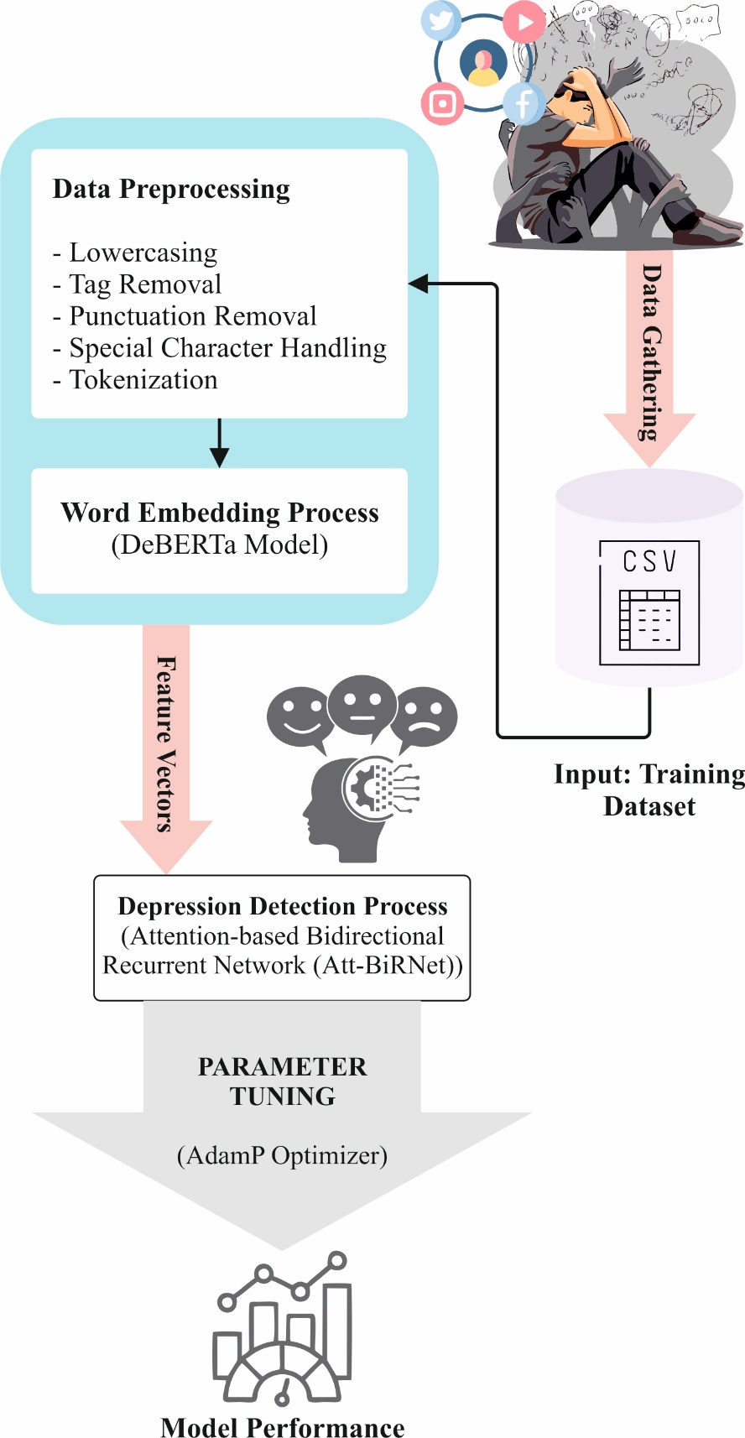

Fig. 1. Complete workflow of the proposed model

Text Preprocessing
The proposed model starts with preprocessing that involves lowercasing, tag removal, punctuation removal, handling special characters, and tokenizing the text.
Lowercasing: The text conversion method transforms every character in the dataset into lowercase, instead of maintaining capitalization for proper nouns, initials, or sentence beginnings [18]. Capitalization is intricate in Twitter due to the users' preference to stop the use of capital letters. Thus, converting each text to lowercase is considered the most practical and consistent approach.
Tag Removal: Social networking website’s text often comprises hashtags, HTML or XML tags, and user mentions that cannot contribute to the semantic meaning of the post for depression identification. Tag removal includes recognizing and eliminating these components to clear the texts, while maintaining the meaningful content. This stage decreases the noise and prevents the model from learning unrelated patterns connected with formatting tags or usernames.
Removal of punctuation: Removing the punctuation prior to performing the SA is most prevalent in the conditions. Although a few punctuation types are linked to emoticons that can show the sentiment, their elimination can diminish the classification performance. Certainly, the punctuation sequences like :), :D, ;), or <3 They are referred to as emoticons that convey sentiments. The conversion of the emoticons into words firstly removes the punctuation and then executes with the emoticons. Alternative research suggests a similar method to improve the evaluation and increase the performance.
Special Character Handling: The SMS spam information often comprises promotional codes, phone numbers, URLs, and currency symbols. This method can include eliminating, masking, or substituting these basics with placeholder tokens. Appropriate processing confirms that informative patterns, like the existence of monetary values or URLs, can be maintained with no redundant noise.
Tokenization: In general, the text data is a collection of letters in the initial phase. Every individual operation in the text analysis phase requires the words in the dataset. The necessities of the parser are the tokenization of documents. Tokenization is the separation of raw text data into numerous individual tokens that have been signified as a character or word.

DeBERTa-based Contextual Embedding
DeBERTa is employed to generate embeddings that encode both contextual and semantic information. It is an advanced transformation of the RoBERTa and BERT systems, superior within adversarial settings following pre‐training methods for language models [19]. A separated element of the attention layer is combined with DeBERTa. Word sense disambiguation (WSD) is mainly reliant on disentangling AM of DeBERTa. In contrast to conventional self‐attention mechanisms (SAM), demonstrated by BERT and RoBERTa, DeBERTa splits dual significant depictions, namely Position Embedding and Content Embeddings, by employing the disentangled attention.
The DeBERTa presents dual unique techniques: disentangled attention and an improved masked decoder. It interprets an additional decoder‐centric form of BERT with disentangled attention. It specifies the requirement of text removal at the position of the word. This technique improves the RoBERTa and BERT by implementing the disentangled AM that can be self-reliantly encoded to represent the word contents and positional data, thus resulting in a greater outcome in WSD assessments. The AM works with dual categories of embeddings in DeBERta, where the parameter $c_{i}$ refers to the content embeds, and $p_{i}$ indicates the positional embeds in the word sequences. The attention score for word $i$ and $j$ can be determined by employing this mathematical form,
$$Attention\left(i,j\right)=\frac{(W_{Q_{c_{i}}+W_{Qp_{i}}^{P}})(WK_{c_{j}}+W_{K_{P_{j}}}^{p})^{T}}{\sqrt{d_{k}}} (1)$$

Attention-based DL Classification
An Att-BiRNet is developed for depression detection from social media posts. The bidirectional layer examines the forward and backward dependencies in text, incorporating hidden states to denote nuanced semantic and emotional features [20]. The attention layer allocates the learnable weights to keywords and phrases, dynamically highlighting significant content for precise multi-class mental health classification.
Bi‐LSTM Layer: An LSTM comprises an input, output, and hidden layers (HLs), with the HL acting as the memory cell. This can include the memory cell $C_{t}$, input gate $i_{t}$, forget gate $f_{t}$, and output gate $O_{t}$. Based on the time $t$, the mathematical representation of $X_{t}$ remains the input; this term $C_{t-1}$refers to the previous cell state, and the mathematical term $h_{t-1}$represents the preceding HL. The input gate handles the data updates $C_{t}$, the forget gate $f_{t}$ controls the maintenance, and the output gate $O_{t}$ calculates the term $h_{t}$, the existing output. This method permits the LSTM to gain the long-term dependency in sequential data.
The Bi-LSTM is an expansion of standard LSTM that gains the bidirectional dependency in time series by handling the data both backward and forward. This can be utilized as a forward LSTM and a reverse LSTM to gain the HL from opposite directions that must be integrated to generate the output. This bidirectional method permits the model to obtain both causal and feedback impacts in the sequences. The reverse LSTM processes the input in the reverse direction, with its computations symmetrical to the forward LSTM, whereas alternative methods are used to follow the typical LSTM training procedure.
$$f_{\overset{⃖}{t}}=σ\left(W_{\overset{⃖}{f}}. \left[h_{\overset{⃖}{t}+1^{'}}x_{t}\right]+b_{\overset{⃖}{f}}\right) (2)$$
$${\tilde{C}}_{\overset{⃖}{f}}=tanh\left(W_{\overset{⃖}{c}}⋅\left[h_{t+1},x_{f}\right]+b_{C}\right) (3)$$
$$\tilde{C_{\overset{⃖}{t}}}←=f_{\overset{⃖}{f}}+⨀\tilde{C_{\overset{⃖}{t+1}}}+i_{\overset{⃖}{t}}⨀C_{\overset{⃖}{t}} (4)$$
$$o_{t}=σ\left(W_{0} \left[h_{t+1^{'}}←x_{t}\right]+b_{O}←\right) (5)$$
$$h_{t}=0_{t}⨀tanh\left(C_{\overset{⃖}{t}}\right) (6)$$
Here, the parameter $W_{*}$ refers to the backward LSTM weighted matrix, $b_{*}$ indicates the biased term, the symbol $⨀$ represents the Hadamard multiplication, the notation $σ$ indicates the Sigmoid activation function, $C_{f+1}$ means the cell layer at the following moment, and $h_{f+1}$ represents the outcome value at the further moment $t+1.$
Attention Layer: It is designed and utilizes the Key‐Value‐Query model to accomplish dynamic reconstructive features in which the main operation is to reinforce the contributions of significant aspects to the prediction targets by applying a learnable weight AM. Precisely, the HL sequences $(H=\{h_{1}^{bi},h_{2}^{bi}, …,h_{T}^{bi}\})$ output is obtained from the Bi‐LSTM, which can be employed as input; here, the vectorized features $h_{t}^{bi}∈R^{d}$ in every individual time step comprise the backward and forward time‐series data. The method of computing the attention weights has been represented by,
Feature mapping: In order to produce the value vectors $V_{t}$, key vectors $K_{t}$, and query vectors $Q_{t}$ through linear transformation,
$$Q_{f}=VV_{Q}⋅h_{f}^{bi}, K_{f}=VV_{K}⋅h_{f}^{bi}, V_{f}=VV_{V}⋅h_{f}^{bi} (7)$$
Now, the parameters $V_{Q},$ $VV_{K}$, and $VV_{V}$ describe the matrix of training parameters.
Similarity measure: the scaled dot product is applied for the calculation of the relationship
among the key and query vectors corresponding to every individual time step,
$$score\left(Q_{t^{'}}K_{i}\right)=\frac{Q_{f}^{T}K_{i}}{\sqrt{d}},i∈\left[1, T\right] (8)$$
Weighted normalization: producing the attention distribution by the softmax function,
$$α_{f,i}=\frac{\exp\left(score\left(Q_{f;}K_{i}\right)\right)}{Σ_{j=1}^{T}\exp\left(score\left(Q_{t},K_{j}\right)\right)} (9)$$
Context vector: a system of weighted combined value vectors has been acquired by this mathematical form.
$$c_{f}=\sum_{i=1}^{T}{α_{f,i}}V_{i} (10)$$

Parameter Tuning
The AdamP optimizes model parameters for efficient training and better generalization. The AdamP method is the Projected Gradient Normalization. It is employed to exactly overcome the suboptimum optimization in layers in which the functionality relies mainly on the parameter direction instead of magnitude [21]. To compute the adaptive learning rate (ALR) parameters, the AdamP projects the raw gradient vector onto the direction orthogonal to the existing vectorized parameters. The important mathematical expression is given below,
$$g_{perp}=g_{t}-\frac{g_{t}*θ_{t}}{‖θ_{t}‖^{2}}*θ_{t^{'}} (11)$$
Here, the parameter $g_{t}$ refers to the raw gradient, and $θ_{t}$ represents the vectorized parameters. $g_{erp}$ indicates the gradient perpendicular to $θ_{t}.$ The mathematical representation of $\frac{(g_{t}*θ_{t})}{‖θ_{t}||^{2}}*θ_{t}$ signifies the estimation of the gradient as $θ_{t}$. AdamP applies the term $g_{perp}$ to upgrade Adam’s 1st moment $m_{t}$ and 2nd moment $v_{t}$ estimations. The parameter updates of the AdamW module are specified,
$$θ_{t+1}=θ_{t}-η*\frac{{\hat{m}}_{t}}{\sqrt{{\hat{v}}_{t}+ϵ}}-η*λ*θ_{t} (12)$$
Among these mechanisms, the adaptive update representation $\frac{{\hat{m}}_{t}}{\sqrt{\hat{v_{t}}+e}}$, which is motivated by $g_{perp},$ completely enhances the direction of the parameter. Thus, $η*λ*θ_{t}$ refers to the weight decay term that can be self-reliantly controlled to control the magnitude of the parameter.

Performance Validation
The empirical evaluation of the TCEAM-ADD method was conducted using the Depression Detection using Sentiment Analysis dataset [22]. This data is gathered from the mental health states, collected for original statements revealed by patients. To bring together and refine information from several resources, it offers a high and consistent foundation for emerging chatbots and investigating SA. The object is to provide useful insights and generate tools that could best comprehend and respond to mental health requirements. Table 1 displays that the dataset contains a total of 53,043 samples across different classes, Fig 2 exemplifies the class distribution, and Table 2 presents sample texts from the different classes.

TABLE I
DETAILS OF DATASETS
Classes | Samples
Anxiety | 3888
Normal | 16351
Depression | 15404
Suicidal | 10653
Stress | 2669
Bipolar | 2877
Personality disorder | 1201
Total | 53043

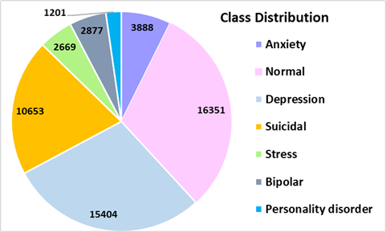

Fig. 2. Class distribution

TABLE II
SAMPLE TEXTS
S.no | Sample Statement | Status
1 | Have you ever felt nervous but didn't know why? | Anxiety
2 | A person will be with the person he loves. And you will be with the people you love. | Normal
3 | I am so scared of everything, when will it stop? Scared | Depression
4 | It does not matter how hard I work or how much time I invest, it's never enough. I might do it in a few days at this rate. There is no point. | Suicidal
5 | There became two sides of me I battled within myself. On one hand, I wanted us to build a life together, to experience that love and the relationship. I did most days. On the other, I wanted to absolve myself. I obsessed with it. | Stress
6 | Social media Have any of yall started a social media account solely to share about your mental battle? | Bipolar
7 | Any hobbies? If you're comfortable sharing, does anyone here have any hobbies/activities that they enjoy? | Personality disorder
Fig. 3 shows the confusion matrices generated by the TCEAM-ADD method for the 70:30 splits of TRAP/TESP. The results indicate that the TCEAM-ADD technique accurately identifies and classifies all classes.
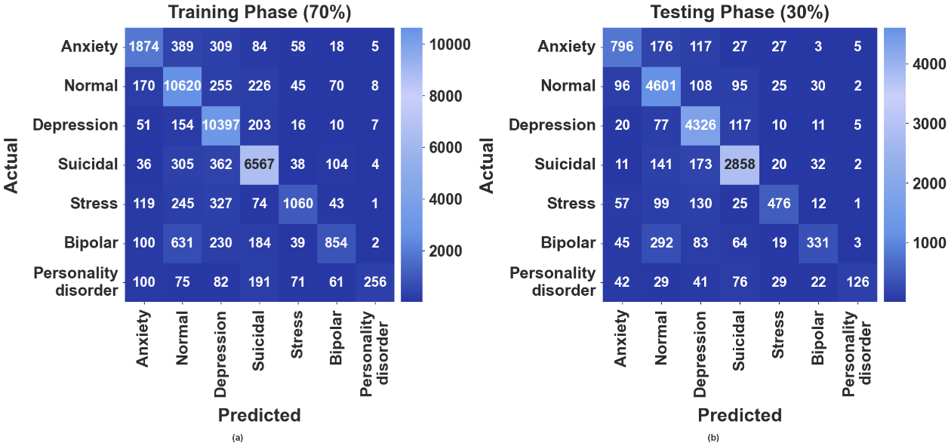
Fig. 3. Confusion matrices of the TCEAM-ADD method with (a-b) 70:30 of TRAP/TESP
Table 3 and Fig. 4 signify the depression detection outcomes of the TCEAM-ADD method on 70:30. The outcome implied that the TCEAM-ADD system accurately classified the instances. On 70% TRAP, the TCEAM-ADD approach achieves average value with $acc{ur}_{y}$ of 95.77%, $preci_{n}$ of 82.87%, $recal_{l}$ of 67.91%, ${F1}_{score}$ of 72.29% and $AUC_{Score}$ of 82.56%, respectively. For the meantime, on 30% TESP, the TCEAM-ADD technique reaches an average value with $acc{ur}_{y}$ of 95.69%, $preci_{n}$ of 82.17%, $recal_{l}$ of 68.37%, ${F1}_{score}$ of 72.59% and $AUC_{Score}$of 82.76%, respectively.
TABLE III
DEPRESSION DETECTION RESULT OF THE TCEAM-ADD METHOD WITH 70:30
Class Labels | $$Accur_{y}$$ | $$Preci_{n}$$ | $$Recal_{l}$$ | $$F1_{score}$$ | $$AUC_{score}$$
TRAP (70%)
Anxiety | 96.12 | 76.49 | 68.47 | 72.26 | 83.40
Normal | 93.07 | 85.51 | 93.21 | 89.19 | 93.11
Depression | 94.60 | 86.92 | 95.93 | 91.20 | 94.99
Suicidal | 95.12 | 87.22 | 88.55 | 87.88 | 92.66
Stress | 97.10 | 79.88 | 56.71 | 66.33 | 77.98
Bipolar | 95.98 | 73.62 | 41.86 | 53.37 | 70.50
Personality disorder | 98.37 | 90.46 | 30.62 | 45.76 | 65.27
Average | 95.77 | 82.87 | 67.91 | 72.29 | 82.56
TESP (30%)
Anxiety | 96.07 | 74.60 | 69.16 | 71.78 | 83.66
Normal | 92.65 | 84.97 | 92.82 | 88.72 | 92.69
Depression | 94.39 | 86.90 | 94.74 | 90.65 | 94.50
Suicidal | 95.08 | 87.61 | 88.29 | 87.95 | 92.55
Stress | 97.15 | 78.55 | 59.50 | 67.71 | 79.32
Bipolar | 96.13 | 75.06 | 39.55 | 51.80 | 69.41
Personality disorder | 98.38 | 87.50 | 34.52 | 49.51 | 67.20
Average | 95.69 | 82.17 | 68.37 | 72.59 | 82.76

Fig. 5 presents the ROC examination of the TCEAM-ADD method on the training and testing process. The outcome implied that the TCEAM-ADD method has achieved higher outcomes on the testing dataset than the other methods.

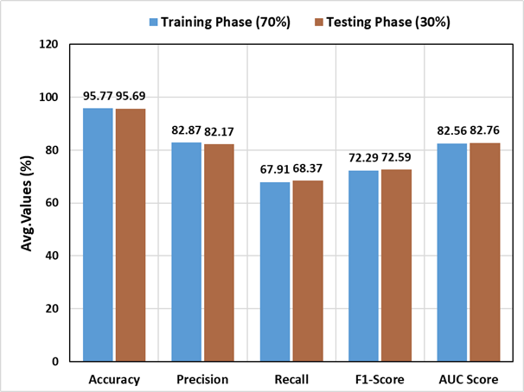
Fig. 4. Average value of the TCEAM-ADD approach with 70:30
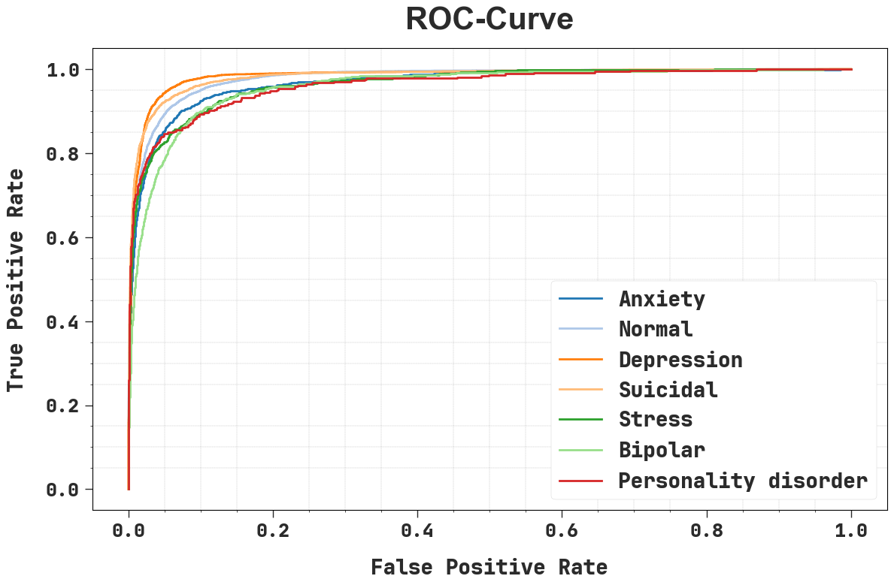
Fig. 5. ROC-curve of the TCEAM-ADD system

Table 4 and Fig. 6 represent the comparison outcomes of the TCEAM-ADD technique with other methodologies with several measure [23, 24]. The result specified that the LSTM attention, BERT+Ensemble, and SBERT+BiGRU models have exhibited the least performance, while the Multi-nominal NB, Bi-LSTM, Multi-Channel pooling CNN, and Lib-Linear methods have obtained slightly higher and reasonable outcomes.

TABLE IV
COMPARATIVE STUDY OF THE TCEAM-ADD METHOD WITH EXISTING TECHNIQUES
Algorithms | $$Accur_{y}$$ | $$Preci_{n}$$ | $$Recal_{l}$$ | $$F1_{score}$$
BERT+Ensemble | 66.00 | 68.00 | 66.00 | 64.00
SBERT+BiGRU | 61.00 | 63.00 | 61.00 | 62.00
Multi-nominal NB | 83.00 | 83.60 | 60.13 | 83.20
Bi-LSTM | 80.51 | 80.51 | 62.89 | 80.03
Multi-Chanel pooling CNN | 82.46 | 80.87 | 65.00 | 81.51
Lib-Linear | 87.50 | 87.60 | 60.45 | 87.50
LSTM attention | 60.45 | 54.00 | 35.00 | 42.00
TCEAM-ADD | 95.77 | 82.87 | 67.91 | 72.29
Moreover, the TCEAM-ADD method has achieved superior performance with $acc{ur}_{y}$ of 95.77%, $preci_{n}$ of 82.87%, $recal_{l}$ of 67.91%, ${F1}_{score}$ of 72.29%. The detailed evaluation confirms that the TCEAM-ADD model consistently attains greater performance than other existing methods.
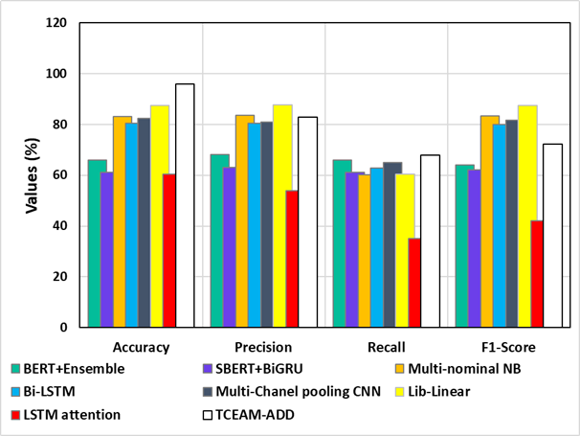
Fig. 6. Comparison result of the TCEAM-ADD approach with metrics

Conclusion
This study has developed a TCEAM-ADD model using social media platforms. The objective of the proposed model is to identify depression utilizing NLP systems, analyzing emotional and contextual information in the text to precisely assess users' mental health status. Initially, the proposed model begins with preprocessing, which comprises lowercasing, tag removal, punctuation removal, special character handling, and tokenization to clean and standardize the input text. Moreover, DeBERTa is applied to generate meaningful embeddings from text, acquiring context and semantics for further analysis. For depression detection, an Att-BiRNet model attains both sequential and contextual information from social media text, allowing it to understand relationships among words in both directions. Eventually, the AdamP optimizer is used to effectively update model parameters while enhancing the model’s generalization. The experimental result analysis of the TCEAM-ADD approach is conducted and the outcomes are analyzed under various aspects. The simulation analysis stated the improvement of the TCEAM-ADD approach with an accuracy of 95.77% over the recent state-of-the-art models. Future work will focus on the design of advanced multimodal fusion approaches by the combination of EEG signals with questionnaire-based psychological assessment for capturing neurophysiological and behavioral indicators of depression. The incorporation of real-time EEG monitoring with adaptive, context-aware questionnaires allows personalized and continuous mental health evaluation.

References
Fisher, H., Jaffe, N.M., Pidvirny, K., Tierney, A.O., Vaidean, M.S., Dongre, P., and Webb, C.A., 2026. Language-based detection of depression with machine learning: systematic review and meta-analysis. npj Digital Medicine.
More, P. and Mane, K., 2026. Machine learning-based prediction and recommendation system for anxiety and depression. In Smart Technologies and Intelligent Computing (pp. 319-327). CRC Press.
Taoussi, C., Lyaqini, S., Metrane, A., and Hafidi, I., 2025. Enhancing machine learning and deep learning models for depression detection: A focus on smote, roberta, and cnn-lstm. Informatica, 49(14).
Khan, S. and Alqahtani, S., 2024. Hybrid machine learning models to detect signs of depression. Multimedia Tools and Applications, 83(13), pp.38819-38837.
Sharma, A., Saxena, A., Kumar, A. and Singh, D., 2024, March. Depression detection using multimodal analysis with chatbot support. In 2024, the 2nd International Conference on Disruptive Technologies (ICDT) (pp. 328-334). IEEE.
Prasad, T.R. and Kumar, P., 2026. A review of multimodal depression detection methods using smartphone usage and audio-visual clues. Iran Journal of Computer Science, 9(1), p.15.
Kumar, G.U., Sharmasth, V.Y. and Shakkeera, L., 2026. Exploring depression detection through acoustic speech features: A comprehensive review. Artificial Intelligence and Sustainable Innovation, pp.72-78.
Li, Y., Kumbale, S., Chen, Y., Surana, T., Chng, E.S. and Guan, C., 2025. Automated depression detection from text and audio: A systematic review. IEEE Journal of Biomedical and Health Informatics.
Wei, Y., Qin, S., Liu, F., Liu, R., Zhou, Y., Chen, Y., Xiong, X., Zheng, W., Ji, G., Meng, Y. and Wang, F., 2025. Acoustic-based machine learning approaches for depression detection in Chinese university students. Frontiers in Public Health, 13, p.1561332.
Choudhary, D.K., Gupta, A., Singh, S., Abhinav, T., and Agrawal, T., 2024, May. Sentiment analysis for depression detection using artificial intelligence. In 2024, the 3rd International Conference on Artificial Intelligence for Internet of Things (AIIoT) (pp. 1-5). IEEE.
Gadzama, W.A., Gabi, D., Argungu, M.S., and Suru, H.U., 2024. The use of machine learning and deep learning models in detecting depression on social media: A systematic literature review. Personalized Medicine in Psychiatry, 45, p.100125.
Bahmani, A., 2026. Fusion of Statistical and Stylistic Text Features with SVM for Persian Sentiment Analysis. Journal of Future Artificial Intelligence and Technologies, 2(4), pp.534-548.
Alsahafi, S., Alshutayri, A. and Alahdal, S., 2026. Sentiment Analysis of Tweets During the Riyadh Season Using Deep Learning. Engineering, Technology & Applied Science Research, 16(1), pp.32327-32335.
Ayebare, M., Mugisha, S. and Julius, A., 2026. Real-Time Sentiment Analysis Over Social Network Streams Using Deep Learning Models in Edge-Cloud Architectures. Babylonian Journal of Networking, 2026, pp.1-10.
Najib, F.M., 2026. A new detailed rating strategy for enhancing online products recommendation using machine learning and sentiment analysis. Social Network Analysis and Mining.
Kusal, S., Patil, S. and Kotecha, K., 2025. Multimodal text-emoji fusion using deep neural networks for text-based emotion detection in online communication. Journal of Big Data, 12(1), p.32.
Almufareh, M.F., Jhanjhi, N.Z., Humayun, M., Alwakid, G.N., Javed, D. and Almuayqil, S.N., 2025. Integrating sentiment analysis with machine learning for cyberbullying detection on social media. IEEE Access.
Palomino, M.A. and Aider, F., 2022. Evaluating the effectiveness of text pre-processing in sentiment analysis. Applied Sciences, 12(17), p.8765.
Masethe, H.D., Masethe, M.A., Ojo, S.O., Owolawi, P.A. and Giunchiglia, F., 2025. Hybrid transformer-based large language models for word sense disambiguation in the low-resource Sesotho sa Leboa language. Applied Sciences, 15(7), p.3608.
Zhao, X., Dong, S., Rao, H. and Ming, W., 2025. Water flow forecasting model based on bidirectionallong-and short-term memory and attention mechanism. Water, 17(14), p.2118.
Liu, X., Qi, H., Jia, S., Guo, Y. and Liu, Y., 2025. Recent advances in optimization methods for machine learning: a systematic review. Mathematics, 13(13), p.2210.
https://www.kaggle.com/datasets/szegeelim/mental-health/data
Ogunleye, B., Sharma, H. and Shobayo, O., 2024. Sentiment informed sentence bert-ensemble algorithm for depression detection. Big Data and Cognitive Computing, 8(9), p.112.
Kumar, A. and Beniwal, S., 2024. Depression Sentiment Analysis using Machine Learning Techniques: A Review. INTERNATIONAL JOURNAL, 11(1).

