A Multiscale Attention-Driven ConvNeXt with Graph-Enhanced Autoencoder for Morphology-Aware Brain Tumor Classification on MRI Scans

R. Hemavathy
Department of Computer Science and Application,
Jeppiaar University,
Chennai, Tamil Nadu-600119.
hemavathyrajenderan@gmail.com
Dr.V.Janani
Department of Computer Science and Application,
Jeppiaar University,
Chennai, Tamil Nadu-600119.
jananiv91@gmail.com

Abstract— A brain tumor is an abnormal proliferation of cells found within or surrounding the brain. Early disease detection and treatment plans improve patients’ life expectancy and quality of life. Magnetic Resonance Imaging (MRI) scans are the most widely applied technique for brain cancer detection. Recently, deep learning (DL) has evolved as a key method in machine learning (ML), gaining broad acceptance across numerous applications and exhibiting robust performance in addressing complex issues. This study presents a Graph-Enhanced Autoencoder-based framework for high-precision brain tumor classification (GEAE-HPBTC). The proposed GEAE-HPBTC framework aims to accurately detect and classify brain tumors into three classes, namely glioma, meningioma, and pituitary using MRI imaging data. Initially, MRI images are preprocessed through normalization and contrast enhancement to improve image quality and facilitate effective feature learning. Following preprocessing, feature extraction is carried out using the ConvNeXt-Tiny model integrated with a dual attention mechanism. Besides, the brain tumor classification is performed using graph convolutional autoencoder. Furthermore, the classification performance of the model is improved using the AdaBelief optimization. The model is morphology-aware as it derives both local structural features and global spatial relationships via ConvNeXt-based feature extraction, attention-driven region focus, and graph-based relational modeling. To verify the efficacy of the proposed GEAE-HPBTC model, comprehensive experiments were conducted on a publicly available MRI-based brain tumor classification dataset. The dataset encompasses multiple classes of brain tumors, enabling comprehensive evaluation of the model. Experimental results demonstrate that the proposed model outperforms state-of-the-art techniques, achieving an accuracy of 95.98%.
Keywords— Brain Tumor Classification; Tumor Heterogeneity; ConvNeXt-Tiny; Magnetic Resonance Imaging; Deep Learning; Multiscale Feature Learning

Introduction
Brain tumor is an irregular buildup of tissue inside the skull that may be cancerous and noncancerous. The cancerous tumors can rapidly spread to other brain tissues and result in deterioration of the patient's health. Although old or damaged cells are replaced by new ones [1]. If this removal process fails, it may impact tissue function. The accumulation of abnormal cells frequently leads to tissue mass development known as a tumor. Brain tumor identification is the most complex and intricate because of the size, location, shape, and kind of brain tumor [2]. Detecting brain tumors in the initial phase is complex because lower-resolution images frequently prevent accurate measurement of the tumor’s size and boundaries. At the same time, prompt diagnosis and intervention enhance the patient’s likelihood of a positive outcome [3]. Thus, efficient tumor treatment is built upon diagnosing the tumor in a timely manner. The diagnosis is frequently made using medical analysis, with magnetic resonance imaging (MRI) and computer tomography scans [4]. MRI is a non-invasive model, which offers higher-resolution images of the brain and is considered one of the most significant tools for diagnosis and evaluation.
In recent times, the developments of artificial intelligence (AI) in radiology have made considerable evolution in automatically identifying and recognizing several characteristics in medical images [5]. AI models provide superior automatic detection of intricate patterns in image data. Many applications that advance the field quickly could be found in this approach [6]. MRI is the most general approach for brain tumor identification and is also applied in medical images to show anomalous body tissues [7]. While various models have been established for brain tumor image classification and segmentation, this field remains an active research area because achieving higher precision remains a significant challenge [8]. Annually, the development of image segmentation addresses the limits of the prior approach. The segmentation and classification that depend on the DL approach are a good approach for detection and MRI image feature extraction [9]. Artificial neural networks (ANNs) and convolutional neural network (CNN) are excellent efficacy in image classification tasks [10].
This paper presents a Graph-Enhanced Autoencoder-based framework for high-precision brain tumor classification (GEAE-HPBTC) to effectively detect and classify brain tumors into three classes from MRI images. Initially, MRI images are preprocessed using normalization and contrast enhancement to enhance image quality. Feature extraction is then performed through the ConvNeXt-Tiny model integrated with a dual attention mechanism, namely the convolutional block attention module (CBAM) and the multi-scale attention module (MSAM). The extracted features are subsequently passed into a graph convolutional autoencoder (GCAE) for classification. Furthermore, the model performance is enhanced using the AdaBelief optimization algorithm. To assess the effectiveness of the GEAE-HPBTC system, extensive experiments are carried out on a publicly available MRI-based tumor classification dataset.

Literature Review
This section briefly reviews the existing work on brain tumor classification. Shahin et al. [11] introduced a severe multi-model analytical structure that methodically contrasts recurrent, transformer, and convolutional-based learning methods with pre-process, train, and evaluate states by inspecting the global, spatial, and sequential features for brain tumor detection. Particularly, ViTs, CNNs, LSTMs, and hybrid structures are assessed inside a combined experimental condition. Ye et al. [12] introduced BTD-YOLO, an improved approach that depends on the YOLOv8 structure. First, an identification head is proposed to improve multi-scale cancer localization, thus enhancing precision in difficult medical image situations. In addition, an innovative Channel-Mixed Sliding Transformer (CMST) mechanism is combined. It incorporates sliding-window self-attention with the hierarchical framework of the Swin Transformer, efficiently decreasing missed identification in MRI-driven tumor classifications. Rong et al. [13] presented an optimizer DL structure intended for achieving the real-world outcomes whereas maintaining higher precision. Particularly, design the A2C2f-Mona mechanisms that improve medium and local-range feature perspective via residual connections and multi-scale depth-wise convolution; propose the C2PSA-DyT mechanism that substitutes conventional standardized layers with element-wise normalizations to improve training steadiness and feature distribution constancy.
Singh and Singh [14] proposed a domain-accepted object detection structure for brain-tumor detection, YOLOv8-Med, especially optimized for healthcare applications. The growth of CNN techniques combines attention-based mechanisms, depthwise separable convolutions, and clinical-domain specific feature extractions to improve the precision of detection without speed compromise. Sankari et al. [15] presented an innovative ViT structure that integrates a new hierarchical multi-scale attention (HMSA) model for automatic recognition of brain tumors through 4 different classes. The method shows the various significant models, including a multi-resolution patch embedded approach, allowing a feature extractor via diverse spatial scales, a computation transformer structure associated with traditional ViT executions, and improves predictive confidence for decision-making applications. Rajesh et al. [16] suggested an innovative approach that depends on Neural Architecture Search (NAS)by designing the optimum 3D encoder-decoder CNNs for improving the brain tumor identification system though concurrently decreasing the size of the network. The complete search space is intended with several block architectures that include squeeze-and-excitation mechanisms, efficientNet blocks, and transformers, together with several activation functions and normalized layers, with vital training parameters.

Proposed Method
In this section, the overall workflow of the proposed model is given, which encompasses the overall architecture, preprocessing, feature extraction, classification, and optimization stages.

Overall Architecture
Fig. 1 portrays the overall architecture of the proposed GEAE-HPBTC system for brain tumor classification. The process commences with MRI images taken from the tumor classification dataset, which are provided as input for training. These images are first preprocessed using normalization and contrast enhancement to enrich their quality. The preprocessed images are then passed to the feature extraction stage, where ConvNeXt-Tiny with a dual attention mechanism is utilized for extracting meaningful features. The extracted attributes are then passed into a GCAE for classification. Lastly, the model classifies the images into three categories: glioma, meningioma, and pituitary. The overall model performance is further improved using the AdaBelief optimization technique.

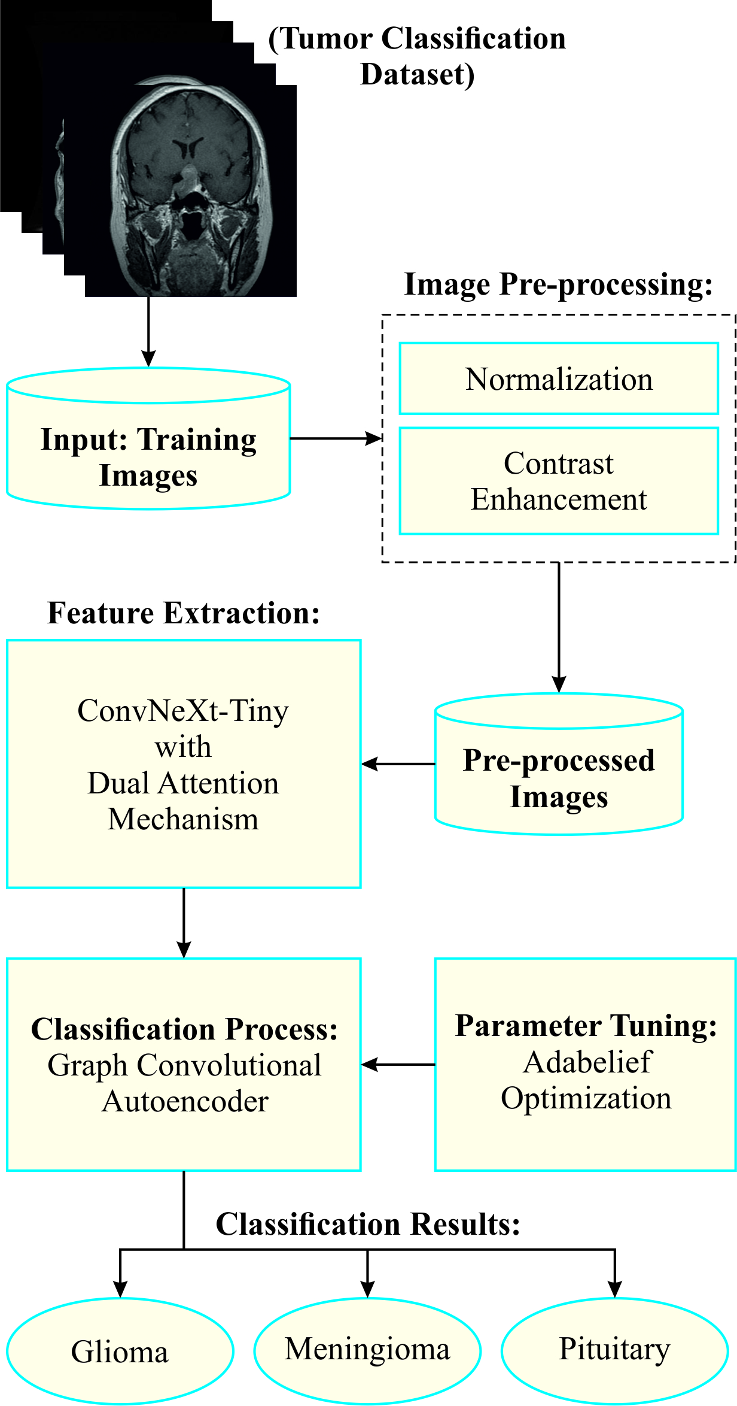

Fig. 1. Overall architecture of the proposed GEAE-HPBTC system

MRI Preprocessing
The preprocessing stage is an essential first step in preparing a dataset for effective analysis. The contrast enhancement and min-max normalization models are used on the MRI brain tumor images in this research [17]. Min-max depends on the minimal and maximal values of the unstandardized information applied in the rescaling. This normalization technique linearly rescales the data into a fixed range, usually zero to one. The computation of min-max normalization is represented as Eq. (1):
$$x_{i,n}^{'}=\frac{x_{i,n}-\left(x_{i}\right)}{\left(x_{i}\right)-\left(x_{i}\right)}\left(nmax-nmin\right)+nmin (1)$$
Here, $max$denotes the maximized value and $min$ implies the minimized value of $the i$th feature, correspondingly. Likewise, the lesser and higher restrictions of the data are provided as $nmax$ and $nmin$. This reduces the difference and maintains data relations, although it lessens unrelated pixels. Afterward, contrast enhancement is then used to enhance image quality. Histogram equalization enhances image contrast by spreading out the most frequent pixel intensity values. The standardized histogram of the imaging $M×N$ is described as shown in Eq. (2):
$$N_{HE}=\frac{h}{Σ_{i=0}^{L-1}h(i)}=\frac{h}{M×N} (2)$$
In this formula, $h$ represents the statistical histogram, and $i$ denotes the $i$th level intensity for the standardized image $x_{i,n}^{'}.$ The transformation operation $T(l)$ is computed as given in Eqs. (3) and (4).
$$T\left(l\right)=\left(L-1\right)\sum_{k=0}^{l}{N_{HE}}\left(k\right) (3)$$
$$T\left(l\right)=\frac{L-1}{M×N}\sum_{k=0}^{l}{h}\left(k\right) (4)$$
Here, $l=0,1,2,…,L-1$ represents the intensity levels. Histogram equalization maps input intensities through a transformation function, refining overall contrast and assisting better distinction between tumor classes.

Feature Extraction using Attention-Driven ConvNeXt-Tiny
The ConvNeXt-Tiny model integrated with a dual attention mechanism, namely CBAM and MSAM, is employed for feature extraction.

ConvNeXt‐Tiny
The ConvNeXt‐Tiny plays a significant role in extracting hierarchical and discriminative features [18]. ConvNeXt, a CNN that integrates a ResNet‐style framework with concepts from ViT. Rather than batch normalizes, this approach utilizes the activation function of GELU, layer normalizes, and higher convolutional kernels. It attains a better mix among precision and speed that creates it higher for looking at MRI brain imaging, while speed is very critical, particularly in computer-assisted diagnosis models. The feature extraction has been achieved throughout a series of ConvNeXt blocks as provided in Eq. (5)."
$$F=ϕ_{ConvNeXt}\left(X\right)∈R^{h×w×C} (5)$$
Now, $ϕ_{ConvNeXt}$ signifies the series of depth-wise convolution functions, and $C$ represent the output channel.

Dual Attention Mechanisms: CBAM and MSAM
The CBAM and MSAM support the method that concentrates on medically relevant characteristics. CBAM leverages attention in spatial and channel dimensions. Spatial attention then classifies the main areas in every map. Channel attention applies global max and average pooling to emphasize significant feature maps. Simultaneously, these mechanisms decrease background noise and highlight tumor regions in MRI imaging.
CBAM utilizes sequential and spatial channel focus on a feature mapping $F$. As shown in Eq. (6), the channel attention mechanism uses the max pooling (GMP) and global average pooling (GAP) approach by finding a description.
$$M_{c}=σ\left(MLP\left(GAP\left(F\right)\right)+MLP\left(GMP\left(F\right)\right)\right) (6)$$
Let $σ$ signify the activation of the sigmoid, and MLP$(∙)$ implies the shared multilayer perceptron. The attention‐weights feature is given in Eq. (7):
$$F^{'}=M_{c}⊙F (7)$$
Then, spatial attention calculates:
$$M_{s}=σ\left(f^{7×7}\left(\left[AvgPool\left(F^{'}\right);MaxPool\left(F^{'}\right)\right]\right)\right) (8)$$
Here, $f^{7×7}$implies the convolutional layer with $7×7$ kernel, and the output is expressed in Eq. (9):
$$F^{''}=M_{s}⊙F^{'} (9)$$
Moreover, the MSAM has been formed by enhancing the feature extraction. The input to MSAM represents the improved feature mapping $F^{''}∈R^{h×w×C}$. It calculates global max and average pooling characteristics, combines them, and utilizes a $1×1$ convolution to create attention weights through scales. MSAM allows the method for recording characteristics of altering granularity that is crucial in the analysis of brain tumors, since tumors can pose as refined variations in texture, intensity, or size. Where $g_{avg},g_{max}∈R^{C}$ denotes the global description attained by using GMP and GAP throughout the spatial dimensions of $F^{''}$. These vectors are added point‐wise and resized to $R^{1×1×C}$. MSAM calculates:
$$M_{ms}=σ\left(Conv_{1×1}\left(Reshape\left(g_{avg}+g_{mαx}\right)\right)\right) (10)$$
Then, $M_{ms}∈R^{1×1×C}$ represent the broadcast‐multiple with $F^{''}$ to attain the final attention tensor $F^{*}$ as revealed in Eq. (11):
$$F^{*}=M_{ms}⊙F^{''} (11)$$
This integration enhances attention through global features and local structure modifications, which are usual in brain tumor areas. CBAM confirms the method classifies where and what to focus on, even though MSAM assures it deliberates both low and high tumor patterns throughout scales. Concurrently, these two attention mechanisms improve the capability of networks to help precise and consistent brain tumor detection.

GCAE-based Classification
Brain tumor classification is carried out using the GCAE architecture. GCAE contains a multilayer GCN that captures graph representations of feature embedded and edges to take correlations among feature nodes [19]. Especially, $X$ represents the input feature matrix that the mapped feature extraction from ConvNeXt-Tiny, which implies an $N×F$ matrix. Therefore, the feature vector $x_{i}$ linked to the node $ith$ is comprised of the values of the $ith$ characteristic vector in the spatial feature extraction of length $F$. For adjacent matrix $A$, the $\left(i , j\right)$ entry is measured as the resemblance computed among characteristic vectors of the $ith$ and $jth$nodes in the feature graph construction. The GCN layer is separated into encoded and decoded, follows the AE structure, while the encoding aims to rebuild the real input precisely. With respect to graph layer, the outcome $H_{e}^{\left(l + 1\right)}$of the $l$th layer of encoding, $H_{e}^{\left(l\right)}$ represents the preceding layer of outcome, and $A$ denotes the adjacency matrix as expressed in Eq. (12):
$$H_{e}^{(l+1)}=f\left(H_{e}^{\left(l\right)}, A\right)=σ\left(D^{\frac{1}{2}}\hat{A}D^{\frac{1}{2}}H_{e}^{\left(l\right)}W_{e}^{\left(l\right)}\right) (12)$$
Here, $W_{e}^{(l)}$ denotes layer’s trainable matrix weight and $σ$ signifies the activation function of ReLu. To assume the encoded wishes $L_{e}$ layers, by obtaining $H_{e}^{(0)}=X$ and $H_{e}^{(L_{e})}=H$, whereas $H$ implies the $N×K$ matrix that signifies a dense feature matrix of input $(K<F)$, then following the encoding phase. Rather than directly reconstructing the original feature space, the decoding stage follows a mirrored structure, as given in Eq. (13).
$$H_{d}^{(l+1)}=f\left(H_{d}^{\left(l\right)}, A\right)=σ\left(D^{\frac{1}{2}}\hat{A}D^{\frac{1}{2}}H_{d}^{\left(l\right)}W_{d}^{\left(l\right)}\right) (13)$$
In this equation, the subscript $d$ is used to differentiate the decoded matrix, supposing the layers $L_{d}$, it attained $H_{d}^{\left(0\right)}=H$and $H^{\left(L_{d}\right)}=X^{'}$, while $X^{'}$implies the reconstructed feature matrix of input $X$. Moreover, for AEs, the reconstructed error $L =∥X^{'}-X∥_{F}^{2}$ is reduced under training using the BP model.
The GCAE is trained by reconstructing the deep feature extractions regarding brain tumor features. Afterwards, gaining the reconstruction feature embeds, the compressed representation $H$ is used for multi-class brain tumor detection that depends on the learned hidden feature representations.

Optimization using AdaBelief
The AdaBelief optimizer is utilized to enhance model performance and ensure stable training. As a derivative of ADAM, AdaBelief intends to combine the rapid convergence of adptive methods with the superior generalization of SGD [20]. In the AdaBelief, the update direction is $m_{t}/\sqrt{s_{t}}$, whereas the term $s_{t}$ is the EMA of $(g_{T}-m_{τ})^{2}$. Therefore, the computational form of updating of AdaBelief is specified by,
$$s_{t}=β_{2}s_{t-1}+(1-β_{2})(g_{t}-m_{t})^{2}+∈ (14)$$
$$\hat{s}=\frac{s_{t}}{\left(1-β_{2}^{t}\right)} (15)$$
$$θ_{t+1}=θ_{t}-\frac{η}{\sqrt{\hat{s}}+∈}⋅{\hat{m}}_{t} (16)$$
AdaBelief dynamically measures the step size through the variance amongst the forecasted and measured slopes. In this study, AdaBelief is employed as the primary optimization technique to accomplish faster convergence, better generalization, and stable training for the proposed DL model for brain tumor classification.
Table 1 summarizes the key hyperparameters used in the model. It includes the learning rate (0.001) for optimizer updates, a batch size of 32, and 3 GCN with 64 hidden layers and a latent dimension of 32. Regularizes is used through a dropout rate of 0.3 and weight decay of 0.0001. The method utilizes ReLU activation in hidden states, cross-entropy loss for classifying, and is trained for 100 epochs.

Experimental Results and Analysis
The experimental evaluation of the proposed GEAE-HPBTC method was performed using the Brain Tumor MRI dataset [21]. The dataset is a gathering of labeled brain tumor imaging for ML tasks. It involves samples from diverse tumor classes to train and evaluate the classifiers techniques. Researchers utilize it to advance and benchmark DL models for tumor classification and detection. Table 2 depict the dataset includes 1,050 samples, with 350 samples in each of the three classes: glioma, meningioma, and pituitary. Fig. 2 represents the sample MRI images from the tumor classification dataset representing glioma, meningioma, and pituitary classes.

TABLE I
PARAMETER SETTING
Hyperparameter | Description | Parameter Value
Learning Rate | Step size used by the optimizer for updating model weights | 0.001
Batch Size | Number of samples processed per training iteration | 32
Number of GCN Layers | Depth of graph convolution layers in encoder/decoder | 3
Hidden Dimension | Number of neurons in hidden graph layers | 64
Latent Dimension | Size of compressed graph representation | 32
Dropout Rate | Regularization parameter to prevent overfitting | 0.3
Activation Function | Non-linear function used in hidden layers | ReLU
Weight Decay | Regularization applied during optimization | 0.0001
Loss Function | Objective function used for classification | Cross-Entropy
Training Epochs | Number of complete passes through the dataset | 100

TABLE II
DETAILS OF DATASETS
Classes | No. of Images
Glioma | 350
Meningioma | 350
Pituitary | 350
Total Images | 1050

Fig. 3 displays the confusion matrix produced by the GEAE-HPBTC method, indicating its stronger capability in precisely identified the 3 classes.
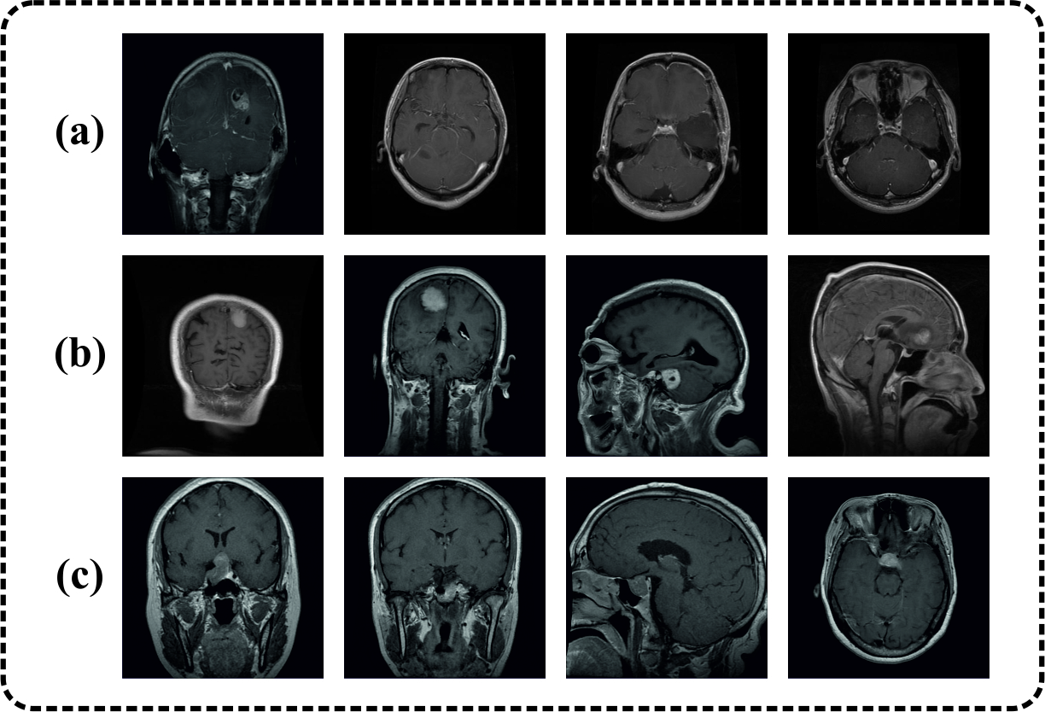

Fig. 2. Sample MRI images showing (a) glioma, (b) meningioma, and (c) pituitary classes
Table 3 present the brain tumor classification outcomes of the GEAE-HPBTC approach on 70:30. The outcome implied that the GEAE-HPBTC method exactly identified the various classes. Under 70% TRAP, the GEAE-HPBTC system reaches average result with $acc{ur}_{y}$ of 93.47%, $preci_{n}$ of 90.17%, $recal_{l}$ of 90.12%, $F_{measure}$ of 90.06% and MCC of 85.29%, respectively. For the meantime, under 30% TESP, the GEAE-HPBTC model attains average result with $acc{ur}_{y}$ of 95.98%, $preci_{n}$ of 93.95%, $recal_{l}$ of 94.05%, $F_{measure}$ of 93.97% and MCC of 90.98%, respectively.

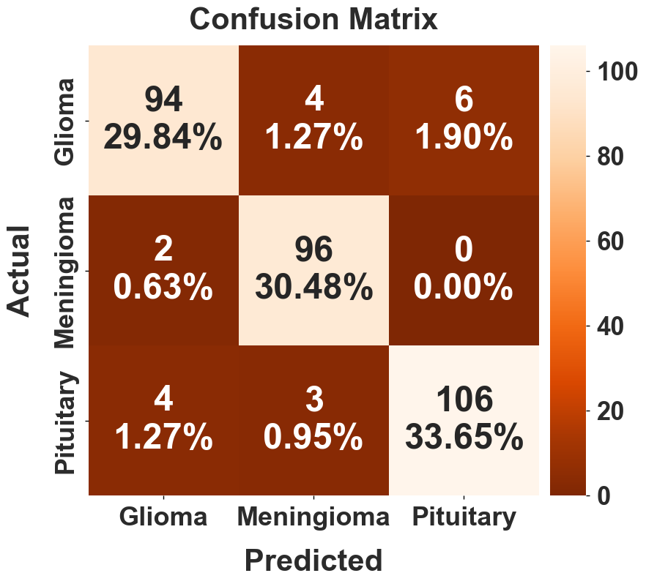
Fig. 3. Confusion matrix of the GEAE-HPBTC approach

TABLE III
BRAIN TUMOR CLASSIFIER RESULT OF THE GEAE-HPBTC METHOD WITH 70:30
Classes | $$Accur_{y}$$ | $$Preci_{n}$$ | $$Recal_{l}$$ | $$F_{measure}$$ | MCC
TRAP (70%)
Glioma | 91.29 | 89.57 | 83.74 | 86.55 | 80.23
Meningioma | 95.92 | 90.81 | 98.02 | 94.27 | 91.27
Pituitary | 93.20 | 90.13 | 88.61 | 89.36 | 84.37
Average | 93.47 | 90.17 | 90.12 | 90.06 | 85.29
TESP (30%)
Glioma | 94.92 | 94.00 | 90.38 | 92.16 | 88.44
Meningioma | 97.14 | 93.20 | 97.96 | 95.52 | 93.49
Pituitary | 95.87 | 94.64 | 93.81 | 94.22 | 91.01
Average | 95.98 | 93.95 | 94.05 | 93.97 | 90.98

Fig. 4 presents the training (TRAING) and validation (VALIDN) $accur_{y}$ curves of the GEAE-HPBTC technique. The TRAING $accur_{y}$ is prolonged continually and it represents faster learning ability and proper convergence of the system. The VALIDN $accur_{y}$ is closely followed the training curve with a minor gap, thereby suggesting lower overfitting and higher generalizes outcomes.

Fig. 5 exemplifies the TRAING and VALIDN loss curves of the GEAE-HPBTC method. The losses curves are declined significantly in the initial epochs and after gradually constant, which shows the successful convergence and learning. The lesser gap among TRAING and VALIDN loss are validated the greater generality and slighter overfitting.
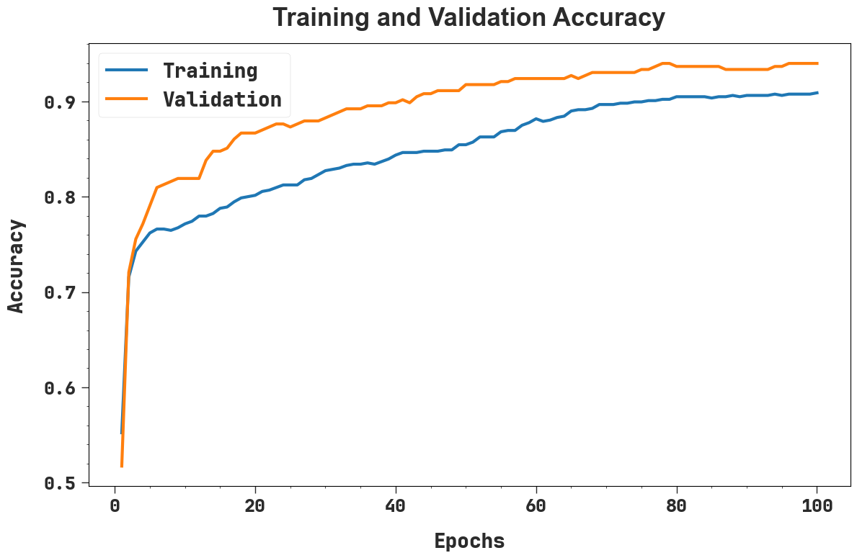
Fig. 4. $Accur_{y}$ curve of the GEAE-HPBTC method

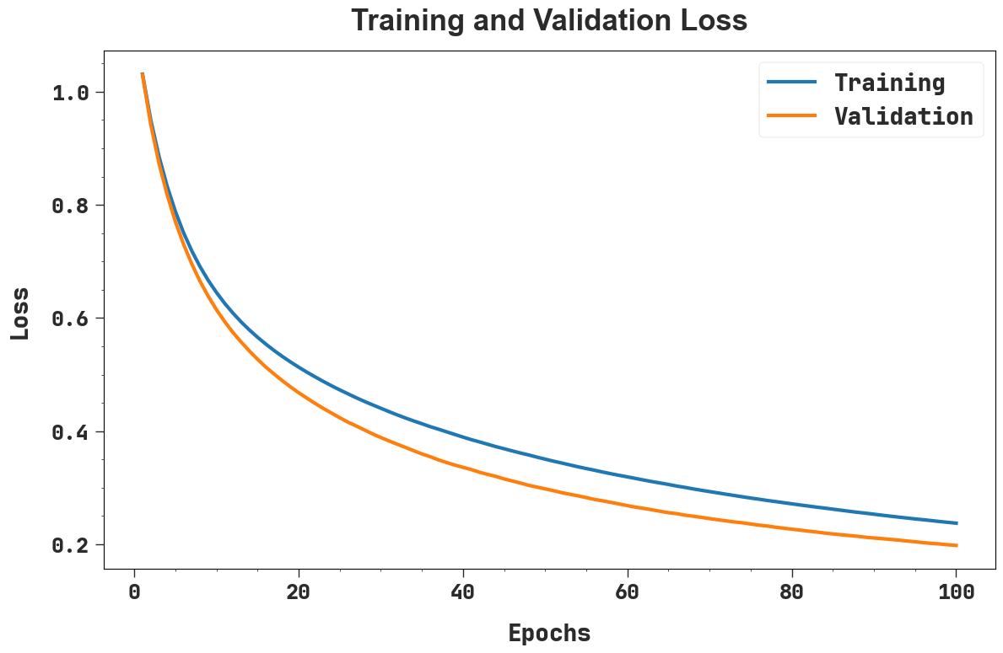
Fig. 5. Loss curve of the GEAE-HPBTC technique

Fig. 6 depicts the ROC curves for the GEAE-HPBTC technique, showing robust performance through each class. The higher ROC values specify the method’s capability of efficiently differentiating the various class. The constant outcomes through classes highlight the model’s efficiency and steadiness.

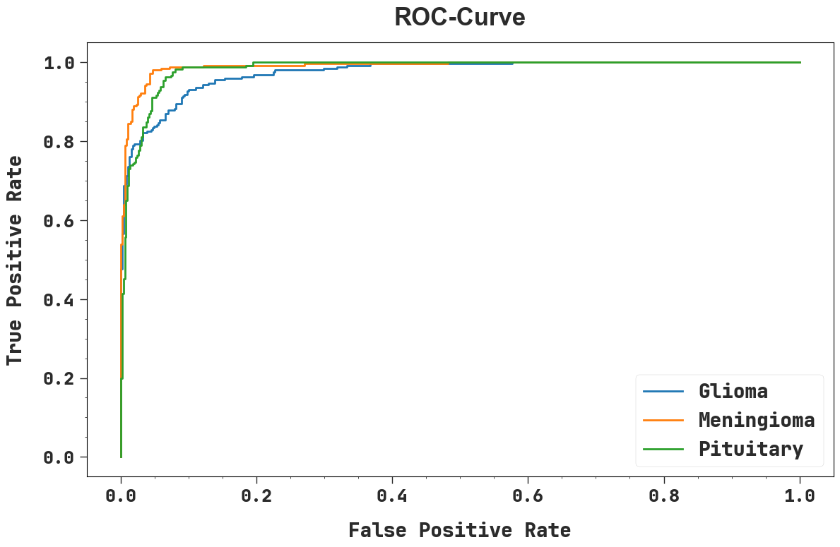
Fig. 6. Loss curve of the GEAE-HPBTC system

Table 4 present the comparison outcomes of the GEAE-HPBTC system with existing models across various performance metrics [22, 23]. The findings shown that the VGG16 model has attained the lowest value with $acc{ur}_{y}$ of 90.60%, $preci_{n}$ of 90.49%, $recal_{l}$ of 89.11%, and $F_{measure}$ of 92.88%. Also, the MobileNetV2, InceptionV3, DenseNet121, ResNet50, VGG16-AB, and VGG16-SGD methods have got slightly higher outcomes. At last, the GEAE-HPBTC approach has exhibited maximal performance with $acc{ur}_{y}$ of 95.98%, $preci_{n}$ of 93.95%, $recal_{l}$ of 94.05%, and $F_{measure}$ of 93.97%. The comprehensive results indicate that the GEAE-HPBTC model provides robust and reliable performance, surpassing other existing methods.

TABLE IV
COMPARATIVE RESULT OF THE GEAE-HPBTC METHOD WITH EXISTING TECHNIQUES
Models | $$Accur_{y}$$ | $$Preci_{n}$$ | $$Recal_{l}$$ | $$F_{measure}$$
MobileNetV2 | 94.51 | 92.76 | 89.11 | 90.66
InceptionV3 | 94.51 | 88.60 | 92.82 | 92.34
DenseNet121 | 92.85 | 91.47 | 90.22 | 91.16
ResNet50 | 90.62 | 92.44 | 90.77 | 91.79
VGG16-AB | 94.02 | 88.64 | 89.72 | 92.68
VGG16 | 90.60 | 90.49 | 89.11 | 92.88
VGG16-SGD | 93.59 | 88.11 | 90.46 | 92.95
GEAE-HPBTC | 95.98 | 93.95 | 94.05 | 93.97

Conclusion
In this manuscript, the GEAE-HPBTC approach has been presented for precisely detecting and classifying brain tumors into three classes such as glioma, meningioma, and pituitary using MRI imaging data. At the initial stage, MRI images were processed using normalization and contrast enhancement to enhance their quality and support effective feature extraction. After preprocessing, features were obtained using the ConvNeXt-Tiny architecture combined with a dual-attention mechanism, including the CBAM and the MSAM. The extracted features were then passed to a GCAE model for the classification task. In addition, the overall performance of the model was further improved by using the AdaBelief optimization algorithm. To evaluate the efficiency of the GEAE-HPBTC methodology, extensive experiments were carried out on a publicly available MRI-based brain tumor classification dataset. The results pointed out that the GEAE-HPBTC model attained better performance with an accuracy of 95.98% over existing models, highlighting accuracy and reliability.

References
Hareesh, D., Riyaz, S. and Reddy, Y.S., 2025, May. Brain Tumor Detection Using Deep Learning Techniques. In 2025 2nd International Conference on Research Methodologies in Knowledge Management, Artificial Intelligence and Telecommunication Engineering (RMKMATE) (pp. 1-6). IEEE.
Dogan, Y., 2026. A novel pruning-enhanced hybrid approach for efficient and accurate brain tumor diagnosis. Biomedical Signal Processing and Control, 112, p.108466.
Wekalao, J., Ali, Y.A.A., Saidani, T., Patel, S.K., Almawgani, A.H. and Alabsi, B.A., 2025. A graphene-based surface plasmon resonance metasurfaces terahertz sensor for early brain tumor detection with machine learning optimization. Plasmonics, pp.1-17.
Jordhana, P.D. and Krishna, G.V., 2025, February. Detection of Brain Tumors from MRI Images using Novel Deep CNN. In 2025 3rd International Conference on Intelligent Systems, Advanced Computing and Communication (ISACC) (pp. 293-298). IEEE.
Buabeng, S.A., Agyeman, A.Y., Tetteh, S.G. and Azupwah, L., 2024. Detection of brain tumor using medical images: A comparative study of machine learning algorithms–A systematic literature review. International Journal of Latest Technology in Engineering, Management & Applied Science, 13(9), pp.77-85.
Rajesh, V., Babu, B.R., Ahammad, S.H. and Elsayed, E.E., 2026. A Foundational Approach to Biomedical Image Enhancement for Brain Tumor Detection. International Journal of Neurology, 60, pp.232-232.
Berghout, T., 2024. The neural frontier of future medical imaging: A review of deep learning for brain tumor detection. Journal of imaging, 11(1), p.2.
Musthafa, N., Memon, Q.A. and Masud, M.M., 2025. Advancing brain tumor analysis: current trends, key challenges, and perspectives in deep learning-based brain MRI tumor diagnosis. Eng, 6(5), p.82.
Sadeghzadeh, N., Correia, J.A., Holdsworth, S.J., Nielsen, P.M. and Abbasi, H., 2026. Artificial intelligence-driven advances in automatic segmentation of meningioma brain tumors: a systematic review. Brain Network Disorders.
Bhagyalaxmi, K., Dwarakanath, B. and Reddy, P.V.P., 2024. Deep learning for multi-grade brain tumor detection and classification: a prospective survey. Multimedia Tools and Applications, 83(25), pp.65889-65911.
Shahin, I., Bader, M., Hassan, A., Nassif, A.B. and Werghi, N., 2026. An Advanced Deep Learning Approach for Medical Image Analytics in Brain Tumor Diagnosis. Healthcare Analytics, p.100456.
Ye, W., Chen, Z., Sun, X. and Chen, S., 2026. High-accuracy brain tumor detection method based on deep learning. Scientific Reports.
Rong, M., Qi, H., Hu, F. and Guo, X., 2026. BTD-YOLO: Brain Tumor Detection in Medical Images Using Improved YOLOv8. Engineering Letters, 34(1).
Singh, K. and Singh, P., 2025. A State-of-the-Art Perspective on Brain Tumor Detection Using Deep Learning in Medical Imaging. Journal of Scientific Innovation and Advanced Research (JSIAR), 1(3), pp.250-254.
Sankari, C., Jamuna, V. and Kavitha, A.R., 2025. Hierarchical multi-scale vision transformer model for accurate detection and classification of brain tumors in MRI-based medical imaging. Scientific Reports, 15(1), p.38275.
Rajesh, C., Sadam, R. and Kumar, S., 2025. A modified genetic algorithm based encoder-decoder network for brain tumor detection in 3D medical images. ACM Transactions on Evolutionary Learning.
Pratap Joshi, K., Gowda, V.B., Bidare Divakarachari, P., Siddappa Parameshwarappa, P. and Patra, R.K., 2025. VSA-GCNN: attention guided graph neural networks for brain tumor segmentation and classification. Big Data and Cognitive Computing, 9(2), p.29.
Parathanath, A.J. and A, M., 2025. CBMNet: a dual-attention enhanced ConvNeXt model for accurate GV Black type I–III classification in intraoral periapical radiographs. Scientific Reports, 15(1), p.39287.
Escorcia-Gutierrez, J., Torres-Torres, M., Soto-Diaz, R. and Soto, C., 2025. Blockchain-based decentralized smart healthcare using improved wild horse optimizer with Graph Convolutional Autoencoder in IoT environment. International Journal of Cognitive Computing in Engineering.
Nurdiati, S., Najib, M.K., Bukhari, F., Revina, R. and Salsabila, F.N., 2022. Performance Comparison Of Gradient-Based Convolutional Neural Network Optimizers for Facial Expression Recognition. BAREKENG: Journal of Mathematics and Its Applications, 16(3), pp.927-938.
https://www.kaggle.com/datasets/masoudnickparvar/brain-tumor-mri-dataset
Disci, R., Gurcan, F. and Soylu, A., 2025. Advanced brain tumor classification in MR images using transfer learning and pre-trained deep CNN models. Cancers, 17(1), p.121.
Velpula, V.K., Reddy, K.R., Prakash, K.N., Jasmine, K.P. and Jyothi Sri, V., 2025. Optimizing Brain Tumor Classification: Integrating Deep Learning and Machine Learning with Hyperparameter Tuning. Engineering Proceedings, 87(1), p.64.

