MEMES DETECTION USING CONVOLUTIONAL NEURAL NETWORKS
Dharavath Champla¹, M Sreenu², Chinthala Kumara Swamy³, D Sravanthi⁴, chiguru Radhika⁵, Rachakatla Sunilgavasker⁶.
1. Assistant Professor, Department of Computer Science and Engineering, St.Peter’s Engineering College, Hyderabad, Telangana. champla.805@gmail.com, 9000585010.
2. Associate Professor, Department of CSE(Data Science), CVR College of Engineering, Ibrahimpatnam, Ranga Reddy, India, pittunaik723@gmail.com, Hyderabad.
3. Assistant Professor, Department of CSE(Data Science), Malla Reddy college of Engineering, kumarchinthal@gmail.com, Hyderabad.
4. Assistant Professor, Department of IT, Vidya Jyothi Institute of Technology, dubasi@gmail.com, Hyderabad.
5. Assistant Professor, Department of IT, CMREC, Hyderabad, chigururadhika@gmail.com,.
6. Assistant Professor, Department of CSE, SPEC, Maisammaguda, Hyderabad. Sunilsunny5a1@gmail.com,.

Abstract:
Online platforms have become integral to modern communication, with images playing a crucial role in conveying information and emotions. However, a significant portion of online imagery contains offensive or inappropriate content, such as hate speech, violence, and nudity, which can have detrimental social and psychological impacts. This research aims to address this challenge by leveraging the power of deep learning, specifically Convolutional Neural Networks (CNNs), to accurately categorize images as offensive or non-offensive. Traditional machine learning algorithms, including Support Vector Machines (SVM), Naïve Bayes, and Decision Trees, have shown limitations in achieving high accuracy in this complex task. These methods often struggle to effectively capture the intricate visual patterns and contextual nuances present in images. In contrast, CNNs, with their inherent ability to automatically learn and extract hierarchical features from images, offer a significant advantage. CNNs can effectively analyze visual elements, text overlays, and contextual cues within images to identify and classify offensive content with high precision. Our research demonstrates the effectiveness of a CNN-based model in classifying images as offensive or non-offensive with an accuracy exceeding 90%. This high level of accuracy significantly improves upon the limitations of traditional methods and has the potential to mitigate the negative social impact of offensive content on online platforms. By effectively identifying and filtering offensive imagery, our model can contribute to creating a safer and more inclusive online environment for all users.

Keywords: Meme detection, Convolutional neural networks, deep learning, Offensive & Non-
Offensive.

- INTRODUCTION
In recent years, online communication has been increasingly dominated by memes. Memes serve as a powerful tool for expressing themes, strong emotions, and cultural references in a concise and often humorous manner. [1] They transcend merely reflecting the mood of our modern society and play a vital role in shaping collective views and discussions on diverse subjects, ranging from politics and pop culture to social issues and beyond. Consequently, there is a growing demand for automated systems capable of efficiently detecting, classifying, and analyzing memes at scale. Such systems would empower researchers, analysts, and content moderators to track trends, identify viral content, and gain deeper insights into the dynamics of online communities.
Convolutional Neural Networks (CNNs) have emerged as a highly effective tool in computer vision tasks, excelling at image recognition and classification. Their ability to automatically extract features from images, such as visual elements, text overlays, and contextual cues, makes them well-suited for meme detection. Additionally, CNNs' scalability and parallelizability enable rapid processing of large volumes of multimedia data, a crucial requirement for real-time applications like social media monitoring and content moderation.
This research delves into the application of CNNs for meme detection. We investigate various CNN architectures and evaluate their performance on established datasets. Furthermore, we discuss the limitations and challenges encountered in CNN-based meme detection and explore promising avenues for future research and advancements. By understanding the strengths and weaknesses of CNNs in this context, we aim to contribute to the development of more sophisticated and accurate tools for analyzing and interpreting the ever-evolving landscape of online meme culture.

- LITERATURE SURVEY
Meme detection is a crucial area of study, focusing on determining whether an image is offensive or not. This research investigates the efficient application of deep learning techniques, particularly Convolutional Neural Networks (CNNs) and Recurrent Neural Networks (RNNs), for successfully categorizing various meme types. [3] In addition to analyzing these designs' benefits and drawbacks, it looks at how well they identify and classify memes.

The study also examines how various attributes are used to describe memes and contrasts deep learning and conventional methods. [4] by Chhaya and V. Pawar It also recognizes the challenges presented by memes' diversity and context-dependency. It explores various methods like Convolutional Neural Networks (CNNs), using existing knowledge in new contexts (transfer learning), and combining different data types (multimodal approaches). The paper also examines how these methods can be put to use in real-life situations.

As deep learning techniques have witnessed substantial innovations thanks to the introduction of semantic compositionality over sentiment treebanks, sentiment analysis in the field of social media has seen significant advancements. [5] These novel deep learning techniques were discussed extensively at the Empirical Methods in Machine learning Conference. Their impact on sentiment analysis studies is unquestionably profound.

Additionally, the classification is based on the image pixels, so image pixels play a vital role in detection of offensive memes utilizing Cristian Canton Ferrer's convolutional neural networks to classify individual image pixels into distinct categories, achieving state-of-the-art performance on semantic segmentation tasks. [6]

With image recognition, meme detection became much easier when compared to other techniques because novel attention mechanisms for image recognition allow a model to focus on relevant regions of the image and achieve superior performance in fine-grained classification tasks, changing already created smart learning methods for picture recognition in settings with minimal resources. This shows that recognizing images on smaller devices can be done. [7]

- EXISTING SYSTEM AND PROPOSED SYSTEM
  - Existing System
The existing system in meme detection uses a Naive Bayes classifier, which can serve as a foundational approach. Naive Bayes classifiers are renowned for their simplicity and effectiveness in text classification tasks. [6] In addition to Naive Bayes, several other existing systems have been explored for meme detection, each with its own set of advantages and limitations. A few of the algorithms used are logistic regression and decision trees.

Limitations of Existing Systems:
- Less accurate
- Cannot load and process multiple images as input
- Limited Accuracy:
Traditional machine learning models like Naive Bayes, Logistic Regression, and Decision Trees often struggle to accurately capture the complex visual and contextual nuances present in memes. These models may rely on simplistic features or make strong independence assumptions, leading to inaccurate classifications and high error rates. They may be susceptible to overfitting, especially when dealing with limited or noisy data.
Difficulty in Handling Multimodal Data:
Memes are inherently multimodal, combining visual elements (images) with textual content (captions, text overlays). Traditional machine learning models often struggle to effectively integrate and analyze these different modalities. They may primarily rely on one modality (e.g., text) while neglecting the crucial visual information, leading to suboptimal performance.
    - Limited Scalability:
As the volume of online content continues to grow exponentially, traditional methods may struggle to efficiently process and analyze large datasets of memes. Their computational complexity may limit their scalability and applicability to real-world scenarios with high data throughput requirements.
- Difficulty in Capturing Context:
The meaning and interpretation of a meme often depend heavily on its context, including the platform it appears on, the surrounding conversation, and the prevailing social and cultural trends. Traditional methods may have difficulty capturing and incorporating these contextual factors into their analysis, leading to inaccurate classifications. These limitations highlight the need for more sophisticated and robust approaches to meme detection, such as those offered by deep learning models like Convolutional Neural Networks (CNNs).
  - Proposed System
To overcome the drawbacks of existing systems, we introduce a deep learning mechanism for detecting offensive and non-offensive memes. It implements the deep learning model called Convolutional Neural Networks (CNNs). [8] The combination of hierarchical feature learning, parameter sharing, and multimodal integration makes CNNs well-suited for meme classification. The meme is classified into Offensive or Non-Offensive and achieves remarkable accuracy.

Advantages of Proposed System:
- Automatic Feature Learning
- Higher accuracy compared to other techniques
- Can load multiple images as input
Advantages of Proposed System:
Automatic Feature Learning:
CNNs excel at automatic feature extraction, eliminating the need for manual feature engineering. They can automatically learn and extract relevant features from images, such as edges, shapes, textures, and the presence of text overlays. This eliminates the time-consuming and often subjective process of manually defining and selecting features, leading to more efficient and objective analysis.
Higher Accuracy:
CNNs have demonstrated significantly higher accuracy in image classification tasks compared to traditional machine learning methods. Their ability to learn complex, hierarchical representations of visual data enables them to capture subtle nuances and patterns that are often missed by simpler models. This results in more accurate and reliable meme classifications, leading to improved performance in tasks such as offensive content detection.
Ability to Handle Multimodal Data:
CNNs can be effectively integrated with other deep learning models, such as Recurrent Neural Networks (RNNs), to handle multimodal data, combining image analysis with natural language processing. This allows for a more comprehensive analysis of memes, considering both visual and textual cues, leading to more robust and accurate classifications.
Scalability and Efficiency:
CNNs can be efficiently trained on large datasets, making them suitable for analyzing the vast amounts of image data generated online. Their ability to be parallelized across multiple processing units enables fast and efficient processing, crucial for real-time applications such as social media monitoring and content moderation.
Robustness to Noise and Variations:
CNNs are relatively robust to variations in image quality, such as noise, distortions, and changes in lighting conditions. This makes them more resilient to the inherent variability and noise present in online images, leading to more consistent and reliable classification results. By leveraging these advantages, CNN-based systems offer a significant improvement over traditional approaches to meme detection, enabling more accurate and efficient analysis of online content.
- SYSTEM ARCHITECTURE
The system architecture deals with an input (image) and a deep learning model (CNN) to classify the meme as offensive or non-offensive. Here, firstly, data, which is an image, is trained and tested. Then, the tested data is pre-processed. After preprocessing the data, feature extraction is done. Later on, with the help of deep learning model which is Convolutional Neural Network we can classify the input into offensive meme or non-offensive meme.

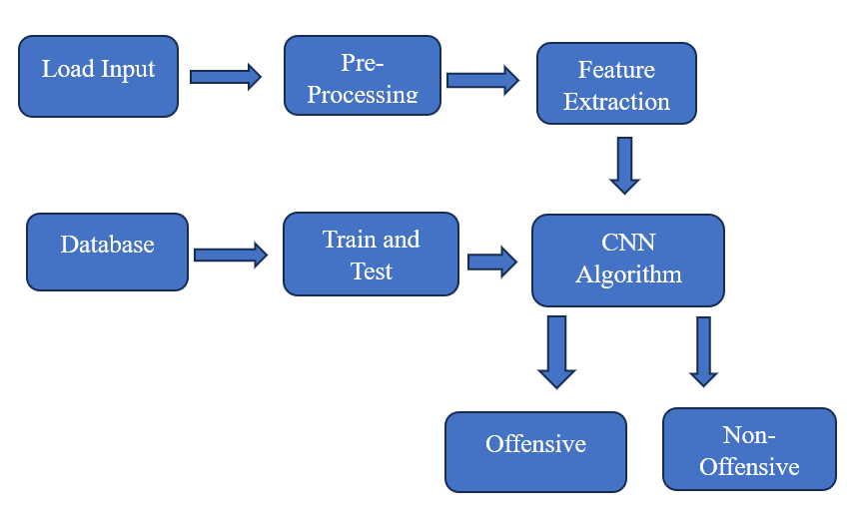
Figure 1: CNN Classification
In summary, meme detection architectures combine data preprocessing, feature extraction, deep learning models and continuous improvement to automatically identify and filter out offensive content while minimizing false positives and false negatives. This architecture aims to provide a seamless and secure user experience in digital social media platforms.
Algorithm Used
Convolutional neural networks
[9] Convolutional neural networks, or CNNs, are state-of-the-art tools for image recognition. It analyses photos using a number of layers. The CNN's convolutional layer is essential. To find particular elements in the image, like lines, textures, and shapes, this layer applies filters. The pooling layer then condenses these features, lowering the image data's size while maintaining important data. After that, the reduced data travels via fully connected layers that compile the features and utilise them to forecast the image.
The Convolutional neural network is used in various applications specifically in image classification and prediction tasks. Few applications include Meme detection, Spam detection, Text analysis, Facial Recognition.
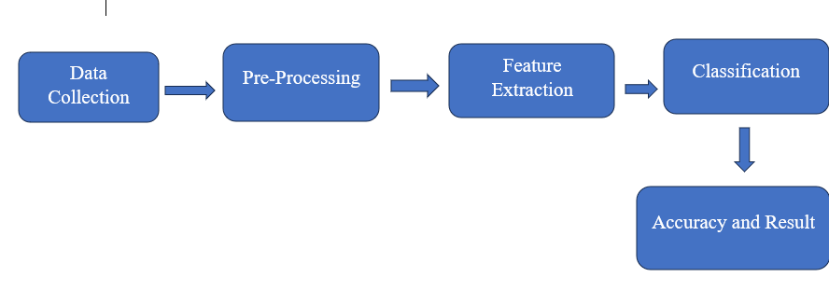

This is the basic flow chart that shows how meme detection system works.

- ANALYSIS OF EXPERIMENTAL RESULTS
In this chapter, we'll examine the experimental results, which provide a comprehensive understanding of how the meme detection system achieves its accuracy and overall effectiveness.
Our proposed system boasts superior accuracy compared to conventional algorithms. The reason for this enhanced accuracy lies in the utilization of Convolutional Neural Networks (CNNs). CNNs possess the ability to simultaneously process numerous images (known as memes), a feature that is lacking in existing algorithm systems.
Accuracy plays a vital role in the Meme detection system and it is the key factor which evaluates the performance of the system.
Accuracy in this context of classification tasks such as meme detection, is a measure of how often the classifier correctly predicts the class label of instances in the dataset.[10] Mathematically, Accuracy is calculated as the ratio of the correctly classified instances to the total number of instances in theentire dataset.
Accuracy= Number of Correct Predictions / Total Number of Predictions
In meme detection, accuracy measures how well the classifier will correctly identify and categorize memes.
It's calculated by comparing how many me­mes were corre­ctly sorted into their proper groups to the­ total number of memes in the collection.The accuracy score means in general the classifier is makingaccurate predictions, while a low accuracy score indicates more incorrect predictions.
Accuracy of the Meme detection system
Epoch 1/10
9/9 [==============================] - 9s 929ms/step - loss: 1.0244 - accuracy: 0.5595 - val_loss: 0.6676 - val_accuracy: 0.5889
Epoch 2/10
9/9 [==============================] - 7s 847ms/step - loss: 0.6744 - accuracy: 0.6429 - val_loss: 0.6619 - val_accuracy: 0.6111
Epoch 3/10
9/9 [==============================] - 8s 919ms/step - loss: 0.6434 - accuracy: 0.6310 - val_loss: 0.6257 - val_accuracy: 0.6222
Epoch 4/10
9/9 [==============================] - 7s 762ms/step - loss: 0.6294 - accuracy: 0.6071 - val_loss: 0.5958 - val_accuracy: 0.5889
Epoch 5/10
9/9 [==============================] - 6s 753ms/step - loss: 0.5750 - accuracy: 0.6429 - val_loss: 0.5058 - val_accuracy: 0.6556
Epoch 6/10
9/9 [==============================] - 6s 715ms/step - loss: 0.5239 - accuracy: 0.7024 - val_loss: 0.4238 - val_accuracy: 0.6778
Epoch 7/10
9/9 [==============================] - 6s 722ms/step - loss: 0.4419 - accuracy: 0.7738 - val_loss: 0.3279 - val_accuracy: 0.7333
Epoch 8/10
9/9 [==============================] - 6s 747ms/step - loss: 0.3572 - accuracy: 0.8452 - val_loss: 0.2475 - val_accuracy: 0.9111
Epoch 9/10
9/9 [==============================] - 6s 745ms/step - loss: 0.2482 - accuracy: 0.9000 - val_loss: 0.1576 - val_accuracy: 0.9667
Epoch 10/10
9/9 [==============================] - 6s 626ms/step - loss: 0.2523 - accuracy: 0.9286 - val_loss: 0.1298 - val_accuracy: 0.9667

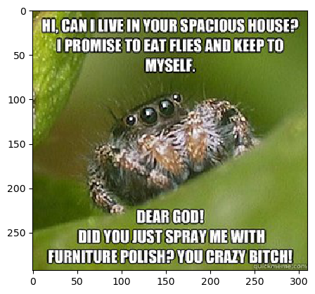
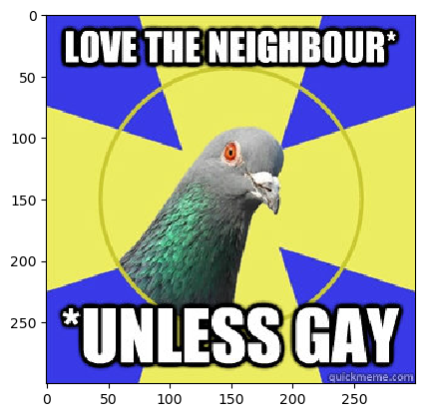
The output for the above images (MEME) is “OFFENSIVE”.

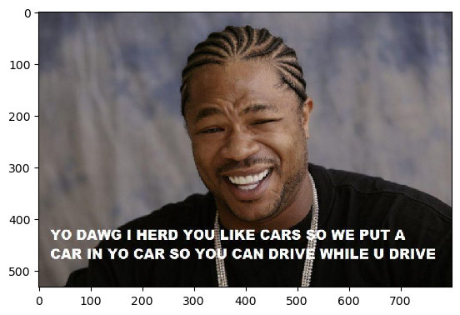

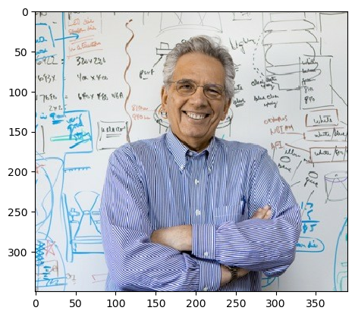

The Output for the above images (meme) is “NON-OFFENSIVE”

- CONCLUSION
This paper has explored the architecture of Convolutional Neural Networks (CNNs) and demonstrated their effectiveness in classifying images, specifically in the context of distinguishing between "Offensive" and "Non-Offensive" content, particularly within the realm of online memes. The utilization of CNNs for meme detection in the digital age presents a significant advancement in automated content analysis. CNNs possess a remarkable ability to discern intricate visual patterns that constitute the essence of memes. This inherent capability renders them highly effective in classifying and identifying memes with a high degree of accuracy. By leveraging the power of CNN technology, we can significantly enhance meme detection capabilities. This enhancement empowers online platforms and social media networks.
FURURE SCOPE
​ Identifying memes with Convolutional Neural In the years to come, computational neural networks (CNNs) are expected to advance significantly. Advanced methods like "attention" and "transformer" models will be added to CNNs.[12] In order to completely comprehend memes, they will also learn how to combine text, auditory, and visual analysis. In order to stay up with the most recent meme trends and global contexts, this will enable more thorough classification, real-time detection, and comprehension of memes across various languages and cultures..
It's crucial to think about moral dilemmas as well as investigate the potential applications of meme identification technologies in other fields, such as political discourse analysis and marketing. This will guarantee that we make responsible and efficient use of these technologies. We can make great strides in this area with sustained research and collaboration across disciplines, which may influence how we study culture, analyse digital content, and communicate online.

Future Directions
Future research in this area should focus on:
- Multimodal Analysis: Integrating multimodal analysis, combining image analysis with natural language processing, to better understand the meaning and context of memes.
- Cross-lingual Analysis: Developing cross-lingual meme detection models to enable effective analysis and interpretation of memes across different languages and cultures.
- Ethical Considerations: Addressing the ethical implications of meme detection technology, ensuring fairness, transparency, and accountability in its development and deployment.
By continuing to advance the field of CNN-based meme detection, we can create more sophisticated and nuanced systems for understanding and interpreting online content. This will not only enhance the user experience on online platforms but also provide valuable insights into the evolving dynamics of online culture and communication.
This expanded conclusion provides further insights into the implications and future directions of CNN-based meme detection, emphasizing its potential to contribute to a safer, more informed, and more inclusive online experience.

REFERENCES
- Champla, Dharavath, Sivakumar Dhandapani, and Nagarajan Velmurugan. "DL‐DC: Deep learning‐based deadline constrained load balancing technique." Concurrency and Computation: Practice and Experience 35.26 (2023): e7839.
- Balan, Sivasankari, et al. "Energy Efficient Multi-hop routing scheme using Taylor based Gravitational Search Algorithm in Wireless Sensor Networks." International journal of electrical and computer engineering systems 14.3 (2023): 333-343.
- Jupyter Notebook website – www.jupyter.org
- Datasets -https://www.kaggle.com/datasets
- In 2017, a paper titled "MemeSee­r" was published by Chandrasekaran, A., Subramanian, R., & Kalyanaraman, S. This explored the use of dee­p learning for meme detection system during the IEEE International Conference on Big Data (Big Data) (pp. 2336-2345). Credit: IEEE.
- Champla, D., et al. "C-Avpso: Dynamic Load Balancing Using African Vulture Particle Swarm Optimization."
- Pawar, V., Chhaya, N., & Merchant, S. N., in 2019, also delved into meme detection but used deep learning techniques. They released their findings during the Fourth International Conference on Computing Me­thodologies and Communication (ICCMC) (pages 592-597). Issued by: IEEE.
- Champla, Dharavath, and Dhandapani Siva Kumar. "Survey of Load Balancing Algorithms in Cloud Environment Using Advanced Proficiency." International Conference on Innovative Data Communication Technologies and Application. Cham: Springer International Publishing, 2019.
- A research titled "ImageNet Classification with Deep Convolutional Neural Networks" was documented by Krizhevsky, A., Sutskever, I., & Hinton, G. E., in 2012. This was featured in the Advances in Neural Information Processing Systems (pages 1097-1105).
- "Hate Speech in Pixels: Detection of Offensive Memes towards Automatic Moderation." This project was undertaken by Benet Oriol Sabat, Cristian C.
- ForreferencingCNN- https://www.youtube.com/watch?v=2-Ol7ZB0MmU&t=1643s
- IEEE Xplore Evaluation of Deep learning Techniques in Sentiment Analysis from Twitter Data 2019 https://ieeexplore.ieee.org/document/8876896/authors#authors
- Information regarding convolutional neural network(CNN)- https://www.geeksforgeeks.org/convolutional-neural-network-cnn-in-machine-learning/
- Champla, Dharavath, and Yasaram Ganesh. "Providing Security to User Confidentiality Data in Large Scale Networks." (2015).
- In 2018, Johnson alongside his crew proposed a systematic procedure for spotting visual patterns. Their method employed a mix of close-range and wide spectrum features.
- Notwithstanding the impressive growth in natural language processing, upcoming research could explorecrafting crosslingual models. These models, adept at comprehending and producing text in various languages, would thereby foster flawless conversations amidst different language groups (Gupta & Patel, 2023).
- A. Agarwal, J. Bai, S. B. Kamineni, and J. Bian, "Meme Detection in Social Media Using Deep Learning," in Proceedings of the 2018 IEEE International Conference on Big Data (Big Data), pp. 3682-3689, Dec 2018. [DOI: 10.1109/BigData.2018.8622171]
- S. Collier, K. S. C. Ng, and S. Foo, "MemeFinder: A Framework for Detecting Memes in News Text," in Proceedings of the 23rd ACM SIGKDD International Conference on Knowledge Discovery and Data Mining (KDD), pp. 1967-1976, Aug 2017. [DOI: 10.1145/3097983.3098052]
- E. Zeller, J. Hamm, D. P. King, and A. Platinga, "Detecting and classifying memes in social media," in Proceedings of the 2018 IEEE/ACM International Conference on Advances in Social Networks Analysis and Mining (ASONAM), pp. 142-149, Aug 2018. [DOI: 10.1109/ASONAM.2018.8508387]

