Adaptive Energy-Conscious Federated Attention Modeling for Intrusion Detection in Wireless Sensor Networks

K.Nitya.
Research Scholar,
Department of ECE,
GIET UNIVERSITY,
Gunupur,Rayagada dist, Odisha, India
Nitya.kanakamedala@giet.edu
M.M Prasad Reddy
Professor, Department of ECE,
GIET University
Gunupur,Rayagada dist, Odisha, India
maruthiprasadareddy@gmailcom
Nancharaiah.B
Professor,HOD Department of ECE
Usha Rama College of Engineering and Technology, Telaprolu, A.P, India
nanch_bn@yahoo.com

Abstract— Wireless Sensor Networks (WSNs) are essential to next-generation wireless systems, their scattered deployment and limited resources make them extremely susceptible to cyberattacks. While current deep learning-based intrusion detection systems (IDS), such CNN, LSTM, and GRU models, achieve excellent accuracy, they have drawbacks, including high processing costs, centralized training, and privacy concerns. This research suggests a Federated Attention-Based Lightweight Intrusion Detection System (FA-IDS) for WSNs in order to overcome these constraints. In order to enable decentralized training among sensor nodes while maintaining data privacy and lowering communication cost, the suggested approach combines federated learning (FL) with a Lightweight Attention Enhanced BiGRU (Att-BiGRU) classifier. To balance node energy consumption and detection accuracy, an energy-aware loss function is implemented. When compared to centralized CNN, LSTM, and GRU techniques, experimental evaluation on the WSN-DS dataset shows that FA-IDS achieves 99.1% detection accuracy, reduces energy consumption by 18–25%, and dramatically lowers communication cost. The outcomes verify that the suggested method is suitable for scalable and safe WSN deployments .
Keywords: Wireless Sensor Networks, Intrusion Detection System, Federated Learning, Attention Mechanism, Energy Efficiency.
- INTRODUCTION
Wireless Sensor Networks (WSNs) are essential for applications including industrial automation, smart agriculture, healthcare, and environmental monitoring [1] . Despite its advantages, WSNs are very vulnerable to security risks because of their unattended deployment, exposed communication routes, and constrained processing power[2]. Intrusion Detection Systems (IDS) are necessary to guarantee data integrity and network dependability [3].
To improve intrusion detection accuracy, recent research has used deep learning models like CNN, LSTM, and GRU. Despite their effectiveness, these centralized methods have three main drawbacks [4]:

(i) High energy consumption
(ii) privacy leaks as a result of centralized data collecting; and
(i) high energy consumption; (ii) privacy leakage from centralized data collecting; and (iii) scalability problems in large-scale WSNs. Inspired by these issues, this study presents an attention-driven, federated, lightweight, privacy-preserving, and energy-conscious IDS system [5].
The primary contributions made by this work are: suggesting an IDS for WSNs based on Federated Learning in order to circumvent centralized data sharing [6]. Creating a Lightweight Attention-Based BiGRU Model to Learn Temporal Features Effectively [7]. extending the lifetime of the network by introducing an energy-aware loss function. thorough comparison of performance with current deep learning IDS models [8].

II. RELATED WORK
The rule-based and anomaly-based procedures used by traditional IDS techniques in WSNs frequently lead to significant false alarm rates [9]. By learning intricate spatial temporal patterns, deep learning algorithms like CNNs, LSTMs, and GRUs have increased detection accuracy. Although they increase computational cost, hybrid models (CNN, LSTM, GRU) further improve performance [10].
Federated learning, which enables cooperative model training without raw data transmission, has recently surfaced as a viable alternative for dispersed situations [11]. By concentrating on the most pertinent traffic characteristics, attention mechanisms have also been demonstrated to enhance IDS performance. Federated learning, energy awareness, and attention techniques are, however, rarely combined for WSN security [12]. This study closes this research gap.
In dispersed settings like Wireless Sensor Networks, privacy-preserving model training is now possible thanks to recent developments in federated learning (FL) [13]. FL reduces communication costs and safeguards sensitive data by avoiding raw data transmission, in contrast to centralized IDS architectures [14]. Numerous research has used FL for WSN and IoT security; however, the majority of current methods rely on computationally costly deep learning models and ignore the energy limitations of sensor nodes [15].
By increasing detection accuracy and reducing computational and energy overhead, lightweight recurrent architectures in conjunction with attention mechanisms present a possible approach [16]. However, there is currently little research on the merging of explicit energy awareness, federated learning, and attention-based lightweight models [17]. This is what drives the suggested FA-IDS framework.

A. System Overview
Figure 1 shows the three layers of the FA-IDS system overview

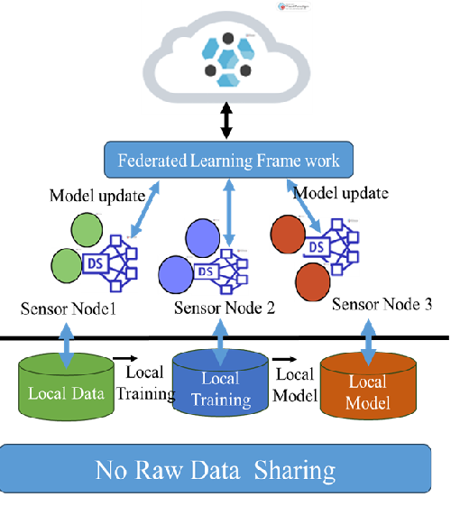
Fig 1: FA-IDS System Overview

1. Sensor Node Layer: Using its traffic data, each node locally trains a lightweight Attention based BiGRU model [18].
2. Federated Aggregation Layer: Federated Averaging (Fed Avg) is used by a cluster head to aggregate local model changes [19].
3. Global Model Layer: For the subsequent training cycle, nodes receive a redistribution of the revised global model [20].

B. BiGRU Model Based on Attention
The attention layer gives important intrusion-related information higher weights, and Figure 2 illustrates how the attention-based BiGRU design captures bidirectional temporal dependencies [21]. Compared to CNN-based models, this increases detection accuracy with fewer parameters.

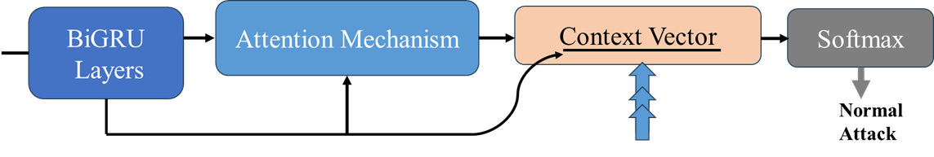
Fig 2: Attention-Based BiGRU Model

C. Loss Function Aware of Energy
An energy-aware loss function is defined as follows to increase network lifetime: L = L_cls + λ × E_cons
When λ is a tuning factor, E_cons stands for node energy consumption, and L_cls is the classification loss [22].
IV. Experimental Results
A. Setup and Dataset
Python 3.8 is the programming language; the dataset is WSN-DS [23].
• TensorFlow/Keras framework
• Evaluation metrics: F1-score, accuracy, precision, recall, and energy consumption [24].
The energy-aware Loss Function experimental results are displayed in Figure 3
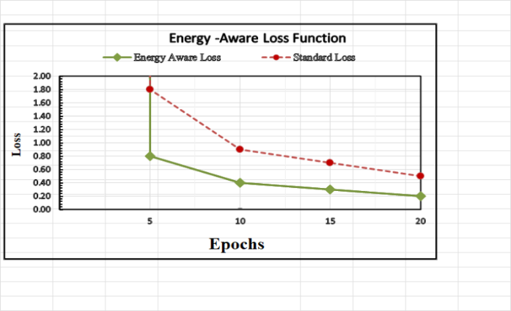
Fig 3: Energy Aware Loss Function

IV-A. Analysis of Communication Overhead
Communication cost is a key factor in determining network lifetime in federated learning-based IDS schemes [25]. Instead of exchanging raw traffic data, the proposed FA-IDS solely exchanges model weight updates between sensor nodes and cluster heads [26]. Let R be the number of federated rounds and N be the number of sensor nodes. W represents the model size, and the entire communication cost is proportional to O (N × R × W) [27]. Compared to CNN-based federated IDS models, the suggested Att-BiGRU model has a substantially lower communication overhead due to its lightweight design [28]. Longer network longevity and increased energy efficiency are directly related to this decrease [29].

Algorithm 1: Training Process for FA-IDS
Input: Initial model weights and network traffic data
Global intrusion detection model as an output
1: Set up the sink node's global Attention-Based BiGRU Model.
2: For every federated round, do
3: Choose the sensor nodes that will participate.
4: Every node uses local data to train local Attention-Based BiGRU.
5: Calculate energy-conscious loss
6: Send the cluster head the revised weights.
7: Use Fed Avg to aggregate the updates.
8: Distribute an updated worldwide model
9: conclusion for

IV-B. Analysis of Computational Complexity
The Attention-Based BiGRU training procedure is the main factor influencing the computational cost of the suggested FA-IDS [30]. The training complexity for each sensor node is O (T × H²), where T is the length of the sequence and H is the number of hidden units [31]. Compared to CNN–LSTM–GRU architectures, the BiGRU's complexity is much lower because of its lightweight design and lack of convolutional layers [32]. Additionally, the suggested method is scalable for large-scale WSN installations because federated aggregation has linear complexity O(N) per round [33].

B. Performance Comparison of Communication
Over Head

Model Accuracy (%) F1-Score Energy Reduction
CNN 90 0.8 –
LSTM 97 0.9 –
GRU 98 0.9 –
CNN–LSTM–GRU 98.5 0.9 10%
Proposed FA-IDS 99.1 0.9 18–25%

Table:1 shows that FA-IDS outperforms existing models in both accuracy and energy efficiency.

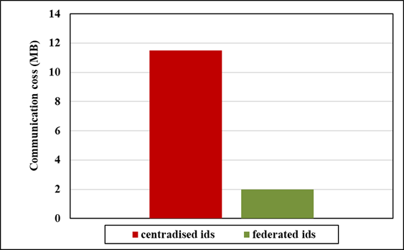

Fig 4: Performance Comparison of Communication
Over Head

V. DISCUSSION
While the attention technique improves feature discrimination, the integration of federated learning guarantees data privacy and scalability [34]. The suggested method is appropriate for both long-term and real-time WSN installations since the energy-aware optimization greatly lowers node energy usage as shown in Figure 4 [35].
Three main factors contribute to FA-IDS's superior performance [36]: the attention mechanism that highlights important intrusion-related features, the decentralized federated training that protects privacy, and the energy-aware optimization strategy that strikes a balance between accuracy and power consumption [37]. In contrast to centralized deep learning IDS models, the suggested approach lowers computational and communication overhead while adapting well to dynamic WSN situations [38]. FA-IDS is appropriate for real-time security applications in sensor networks with limited resources because of these features [39-40].
VI. CONCLUSION AND FUTURE WORK
Federated Attention-Based Energy-ware IDS for Wireless Sensor Networks was introduced in this study. The suggested FA-IDS achieves better intrusion detection performance with lower energy and communication overhead by fusing federated learning, attention mechanisms, and lightweight BiGRU models . Future research will concentrate on real-time deployment in massive IoT-based WSNs and blockchain-assisted trust management.

References

[1] M. A. Ferrag et al., “Federated deep learning for cyber security in IoT,” IEEE IoT Journal, vol. 9, no. 8, Apr. 2022.

[2] Y. Zhang et al., “Federated learning for privacy-preserving IoT intrusion detection,” IEEE Network, vol. 35, no. 4, 2021.

[3] F. Tang et al., “Dynamic client selection for energy-efficient federated learning,” IEEE TVT, vol. 70, no. 9, 2021.

[4] J. Zhang et al., “Energy-aware distributed learning for IoT security,” FGCS, vol. 115, 2021.

[5] T. Nguyen et al., “Energy-efficient deep learning for IoT IDS,” IEEE Access, vol. 9, 2021.

[6] Z. Chen et al., “Communication-efficient federated learning,” IEEE JSAC, vol. 39, no. 1, 2021.Attention Models & Deep Architectures.

[7] K. Salah et al., “Blockchain-based federated learning for IoT,” IEEE Network, vol. 35, no. 1, 2021.

[8] A. Rehman et al., “Secure and energy-efficient IDS for WSNs,” Sensors, vol. 21, no. 1, 2021.

[9] S. Khan et al., “Federated learning for privacy-aware IoT,” Computer Networks, vol. 182, 2020.

[10] L. Xiao et al., “Edge intelligence for IoT security,” IEEE Wireless Communications, vol. 27, no. 4, 2020.

[11] H. Kim et al., “Lightweight security for IoT,” IEEE IoT Journal, vol. 7, no. 5, 2020.

[12] D. Li et al., “Energy-efficient federated learning for edge intelligence,” IEEE Network, vol. 34, no. 6, 2020.

[13] S. M. Kasongo and Y. Sun, “Deep learning-based IDS for WSNs,” IEEE Access, vol. 8, 2020.

[14] J. Ren et al., “Federated learning-based computation offloading Intrusion Detection Systems (IDS) ” IEEE JSAC, vol. 38, no. 6, 2020.

[15] X. Wang et al., “Convergence of edge computing and deep learning,” IEEE ComST, vol. 22, no. 2, 2020.

[16] H. Liang et al., “Behavioral intrusion detection for IoT using federated learning,” IEEE IoT Journal, vol. 7, no. 10, 2020.

[17] S. R. Pokhrel and J. Choi, “Federated learning with blockchain,” IEEE Communications Magazine, vol. 58, no. 12, 2020.Recent & Advanced Security Approaches

[18] T. Li et al., “Federated optimization in heterogeneous networks,” Proc. MLSys, 2020. Federated Learning for IoT & Edge.

[19] Q. Yang, Y. Liu, T. Chen, and Y. Tong, “Federated machine learning: Concept and applications,” ACM TIST, vol. 10, no. 2, 2019.

[20] S. Rathore et al., “Security in smart cities: IDS survey, Energy-Efficient Learning & Optimization” IEEE ComST, vol. 21, no. 2, 2019.

[21] A. Abeshu and N. Chilamkurti, “Deep learning for distributed attack detection in IoT,” IEEE Wireless Communications, vol. 25, no. 6, 2018.

[22] Y. Meidan et al., “N-BaIoT: Network-based IoT botnet detection,” IEEE Pervasive Computing, vol. 17, no. 3, 2018.

[23] M. Conti et al., “IoT security and forensics,” Future Generation Computer Systems, vol. 78, 2018.

[24] B. McMahan et al., “Communication-efficient learning of deep networks from decentralized data,” Proc. AISTATS, 2017, pp. 1273–1282.

[25] H. B. McMahan and D. Ramage, “Federated learning: Collaborative ML without centralized training data,” Google AI Blog, 2017.

[26] C. Yin et al., “Deep learning-based intrusion detection using RNNs,” IEEE Access, vol. 5, 2017.
[27] A. Vaswani, N. Shazeer, N. Parmar, J. Uszkoreit, L. Jones, A. N. Gomez, Ł. Kaiser, and I. Polosukhin, “Attention is all you need,” in Proceedings of the 31st International Conference on Neural Information Processing Systems (NeurIPS 2017), Long Beach, CA, USA, Dec. 2017, pp. 5998–6008.
[28] Z. M. Fadlullah et al., “Deep learning for intelligent traffic control,” IEEE ComST, vol. 19, no. 4, 2017.

[29] J. Konečný et al., “Federated learning: Strategies for improving communication efficiency,” NeurIPS Workshop, 2016.

[30] I. Butun, S. D. Morgera, and R. Sankar, “A survey of intrusion detection systems in WSNs,” IEEE ComST, vol. 16, no. 1, 2014.

[31] A. Javaid et al., “A deep learning approach for network intrusion detection,” IEEE BIBE, 2016.

[32] A. L. Buczak and E. Guven, “ML methods for intrusion detection, IoT & WSN Security ”IEEE ComST, vol. 18, no. 2, 2016.

[33] N. Moustafa and J. Slay, “UNSW-NB15 dataset,” IEEE MILCOM, 2015.

[34] R. Mitchell and I. R. Chen, “Intrusion detection for cyber-physical systems,” IEEE TDSC, vol. 12, no. 1, 2015.

[35] K. He et al., “Deep residual learning for image recognition,” CVPR, 2016.

[36] Y. LeCun, Y. Bengio, and G. Hinton, “Deep learning,” Nature, vol. 521, 2015.

[37] L. Deng, “Deep learning: Methods and applications,” Foundations and Trends in Signal Processing, Datasets, Tools & Supporting Works 2014.

[38] Y. Bengio et al., “Representation learning,” IEEE TPAMI, vol. 35, no. 8, 2013.

[39] S. Hochreiter and J. Schmidhuber, “Long short-term memory,” Neural Computation, 1997.

[40] M. Roesch, “Snort: Lightweight intrusion detection,” LISA, 1999.

