Multi-Modal Stacking Ensemble (MMSE-TB) Framework for Robust Tuberculosis Diagnosis via Heterogeneous Deep Learning Models

Arthi S
Department of Information Technology
St. Joseph’s College of Engineering,
Chennai,India.
arthisuresh0210@gmail.com

Dharsha M
Department of Information Technology
St. Joseph’s College of Engineering,
Chennai,India.
dharshadharsha17@gmail.com
Dr. J. Thresa Jeniffer
Department of Information Technology
St. Joseph’s College of Engineering,
Chennai,India.
jjeniffer24@gmail.com

Abstract— TB is still among the major global health problems especially in low- and medium-income economies whereby access to speedy and precise diagnosticities is still poor. We present a Multi-Modes Stacking Ensemble on Tuberculosis (MMSE-TB), a model that combines three modalities which are diverse and complementary that are used to detect tuberculosis; these include chest X-ray, cough audio, and clinical text. The modalities are modeled with separate architectures of deep learning: a Feature-Map-Normalized CNN which extracts radiological features, a Capsule Network which predicts patterns with space-temporal correlations of a cough spectrogram and a BioBERT-generated encoder which predicts features of clinical text with semantic meaning behind them. Models are combined using dynamically-optimized weighting program using Mayfly Optimization Algorithm to contribute dynamically and confidently and reliably with all modalities. Experimental analysis has demonstrated that this tri-modal ensemble has a drastic positive effect on the accuracy of diagnostic performance as well as a decrease in false negative rate and a high quality of robustness even in heterogeneous data sets. This architecture has a scaled, clinically flexible way of screening TB through artificial intelligence.
Index Terms— Multimodal Ensemble, Tuberculosis Diagnosis, Feature Map Normalization, Capsule Networks, BioBERT, Mayfly Optimization, Deep Learning, Weighted Fusion index terms.

Introduction
1.1 Global TB Burden and Diagnostic Challenges
Estimated International TB Prevalence Ranges from 13%
Mycobacterium tuberculosis, commonly referred to as MTB,
the causative organism of tuberculosis, which remains among
most chronic infectious diseases in the world. TB is a major cause of illness impact despite efforts used in treatment and preventive programs, especially in low- and medium-income countries, LMICs. Not surprisingly, in recent years.From estimates all over the world, it is clear that over 10 million people were infected with tuberculosis in 2023, and more than a million of the cases were caused by complications associated with TB. Such statistics show that the development in line with the global targets of TB elimination is way behind. Effective diagnosis is a critical requirement because it is essential to interrupt the transmission and direct the successful treatment based on accurate and early diagnosis. Yet, the most common clinical diagnostic instruments are limited in a variety of ways. Traditional smear microscopy is cheap with a low sensitivity. The culture-based methods are very sensitive, but they demand biosafety facilities and are time consuming. The modern molecular techniques including GeneXpert give quick and accurate results but are still costly and difficult to access in limited resource locations. This trade-off perennial between expense, rate and diagnostic accuracy shows the necessity of scalable, automated and objective diagnostic alternatives.

1.2 Shortcomings of Single-Modality Deep Learning Models
Deep learning-based diagnostic models have done better to screen for TB with single data streams like X-ray (CXR) images or audio coughs; nevertheless, these unimodal systems tend to be out generalized in typical clinical settings because of domain shift due to changes in imaging equipment, acoustic conditions, and patient demographics. They therefore give only partial perspective of the pathology of TB and this lowers the robustness and chances of false-negative prediction- a very important issue in the case of such a highly contagious disease. Multimodal learning is a way to overcome these shortcomings by combining complementary sources of information and incorporating structural information based on CXR image, physiological information based on cough acoustics as well as semantic meta-information based on clinical text. Such a combination forms a more detailed representation of the state of the patient, resembling the multi-evidence strategy applied by the clinicians, and allowing making more reliable and stable diagnostic choices.

1.3 Contributions of this Proposed Work
This paper will suggest a powerful and scalable Tri-
TB diagnosis Framework of modal Ensemble has been
introduced, which presents several novel contributions to
Biomedical Artificial Intelligence:
- Introduced a tri-modal TB diagnostic system that incorporated CXR images, cough audio, and clinical text based on FMN-CNN, CapsNet, and BioBERT models.
- Improved resistance using Feature Map Normalization (FMN) and CapsNet-based maintenance of spatial-temporal coughs.
- Presented the adaptive fusion scheme, which is optimized taken by the Mayfly Optimization (MFO) algorithm on weighting the modality dynamically.
- Shown to be more diagnostically accurate than unimodal and traditional ensemble methods and less false negative.

LITERATURE SURVEY
2.1 Deep Learning for Radiological and Clinical TB Detection
Deep learning has greatly enhanced the detection of TB with the help of CXR. The CNN model reported by Jing [1] demonstrated the efficiency of transfer learning to identify indicators of TB using X-rays but large-scale deep-learning networks, such as CheXNet [4] [7], achieved radiologist-level accuracy in detecting lung diseases. Methods, which Perez and Wang focus on [5] as data augmentation, improve CNN robustness in imaging. Existing techniques of machine-learning, such as TB classifier based on the SVM, created by Soni et al. [10] also show promise. Deep neural networks normally outperform them.
Other methods are used to enhance model interpretability, including Grad-CAM [9] that can be used to see TB-specific regions. The importance of the constant automated imaging systems is highlighted by historical studies on observer disagreement [8]. On the clinical text side, Ahamed et al. [3] demonstrated that NLP-generated TB classification under statistical feature selection offers great advantages to the extraction of diagnostic clues in the electronic health records. These studies combined selectively indicate the credibility of radiological and textual modalities in the detection of TB.

2.2 Audio-Based TB Screening Using Cough Analysis
TB screening by use of audio has proven a significant method of non-invasive screening procedure. Rajasekar et al. [2] established that Capsule Networks is an effective method to classify cough spectrograms by maintaining spatial-temporal patterns as it is common in the original CapsNet framework by Sabour et al. [6]. Confident outcomes were also demonstrated in cough-based recognition of respiratory diseases by Sabry et al. [17]. Big data is encouraging in this field such as the CODA TB DREAM dataset [12]. Pahar et al. [11] added techniques of non-invasive cough detection that are necessary in effective preprocessing. Widerrange surveys by Zaman et al. [13] and systematic reviews by Kapetanidis et al. [19] indicated the increased use of deep learning in the analysis of audio. Botha et al. [20] and Xu et al. [14] also confirmed that deep neural model can effectively discriminate TB cough features with other respiratory diseases.

2.3 Multi-Modal Fusion Strategies in Medical Informatics
The multimodal fusion has turned to be an effective solution to the limitations that are inherent in unimodal diagnostic systems because the system can integrate structural, physiological, and clinical data to give more reliable and comprehensive TB assessments. The multimodal systems combine complementary data streams as opposed to single-modality systems, which use imaging or audio signals only, adding new dimensions to the diagnostic process. Deep architectures that use decision trees, like the ones proposed by Lu et al. [15], show that the heterogeneous feature integration in a hybrid model structure can be successfully implemented to improve the classification efficiency. Equally, hierarchical, edge-enabled healthcare systems as discussed by Azimi et al. [16] also explain how multimodal integration can also be applied to scalable, real-time infrastructures in order to support ongoing monitoring and fast inference at the clinical and remote sides.
The effectiveness of multimodal TB diagnosis is based on domain-specific feature engineering. The CNN based radiographic models have the ability to offer a high level of structural details, i.e., pulmonary abnormalities that can be identified in the CXR images [1], [4], [7], whereas the capsule networks based on audio networks are capable of maintaining spatial-temporal features of cough sounds [2], [6], [14], [20]. Respiratory patterns that in radiographs are not seen are frequently captured by these acoustic signatures and therefore are a significant physiological complement. Besides this, clinical text models based on natural language process(NLP) can extract both contextual and semantic clues in electronic health records and allow the system to incorporate descriptions of symptoms, medical history, and clinician observations [3], which can complement the analysis of imaging and audio modalities.
An optimization is important in making sure that multimodal fusion is reliable in response to a changing population of patients and data. To optimize the modality contributions of different hyperparameters within a single model, or based on an ensemble fusion weight model, the system is often fine-tuned using metaheuristic optimization strategies that allow the system to prioritize contributions of different modality by their reliability and predictive power. This type of adaptive weighting is necessary in medical applications where it is possible that the quality of the data can differ significantly across imaging machines, recording situations, and documentation patterns. Finally, the alarming trend in the worldwide prevalence of tuberculosis as demonstrated by the WHO [18] demonstrates the necessity of more sophisticated diagnostic systems capable of engaging numerous data streams to enhance early diagnosis, decrease false negativity, and increase diagnostic accessibility, especially in low-resource contexts where conventional diagnostic platforms are still in place.

Methodology
3.1 Integrated Three-Modality Learning Framework
Tri-Modal Ensemble Framework is an approach that combines CXR images, cough audio and clinical text using CNN, CapsNet and BioBERT models, which enables TB diagnosis to surmount the limitations of unimodal diagnosis. Many of these three sources combined can transfer structural, physiological and contextual information in a similar way that an actual clinical decision-making process would transfer information. To a greater degree, Mayfly Optimization (MFO) enhances the system by altering the model hyperparameters and fusion weights in a way that ensures a productive use of each and every modality. Multi-Modal
Stacked Ensemble method Tuberculosis method is a combination of three.
base learners optimized independently of each other, over every modality of diagnosis. An ordinary model $M_{i}$ accepts as its input modal $X_{i}$ converts it to a probability vector$P_{i}$ which is the likelihood of tuberculosis.

$M_{i}​:X_{i}​→P_{i}​,i∈\left\{1,2,3\right\} (1)$
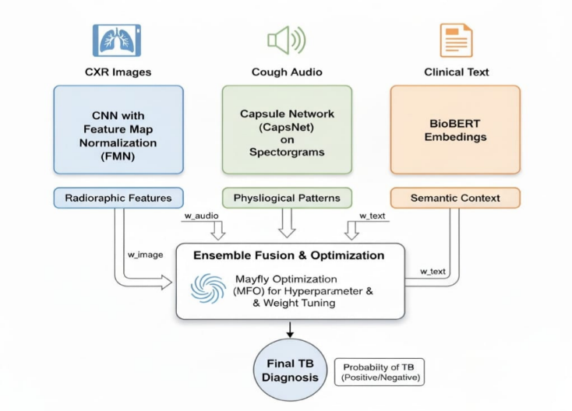
Fig1. Proposed Architecture Diagram

3.2 Image-Base Learner (IL): CNN-Based Chest X-Ray Analysis
The model of CXR image (IL) is based on the simple CNN model, which may have transfer learning over other models like VGG or ResNet, and is implemented on publicly available TB datasets. The photographs are downsized to 224x224, normalized and augmented with rotations and flips to increase generalization. The CNN has convolutional and max-pooling layers and finally fully connected sigmoid layer, which provides the probability of the TB classification,$P_{CXR}$.
Feature extraction proceeds through convolutional layers:
$F_{cxr}​=σ\left(K*X+b​\right), (2)$
Where K,b are kernel weights and biases, X is input vector and $σ\left(⋅\right)$is the ReLU activation.

Flattened features are passed through a dense sigmoid layer:
${P​}_{CXR}=I_{L}​\left(I\right)=σ\left(W_{o}​⋅F_{cxr}​+b_{o}​\right) (3)$
$P_{CXR}$​ ∈[0,1] gives the TB probability derived from radiographic structure.

3.3Audio-Base Learner(AL):Cough Audio Classification (CapsNet + FCNN)
The audio classification model (AL) uses cough sounds to identify TB. Short-Time Fourier Transform(STFT) is used to convert raw cough audio into spectrograms and Histogram of Oriented Gradients(HOG) is used to extract the features, which represent significant spatial-temporal patterns. The model operates a CapsNet that has dynamic routing, which enables the model to maintain the space relationship that are lost by max pooling in normal CNNs. The final output is then generated by a Fully Connected Neural Network(FCNN) classifier. The resulting F1-score of this architecture is 0.83 and the end result is a probability list of classifications, $P_{Audio}$.

The audio learner $A_{L}$interprets cough signals $s\left(t\right)$after converting them into spectrograms via Short-Time Fourier Transform (STFT):
$$A\left(u,v\right)=\left|\sum_{n}{s\left(n\right)} w\left(v-n\right) e^{-j2πun}\right| (4)$$
Histogram of Oriented Gradients (HOG) descriptors capture temporal-frequency patterns:
$H_{audio}​=HOG\left(A\right). (5)$
A Capsule Network (CapsNet) then models part-whole relations. Each capsule output is:
$S_{j}= \left(\frac{{\left|\left|z_{j}\right|\right|}^{2}}{\left(1 + {\left|\left|z_{j}\right|\right|}^{2}\right)}\right) \left(\frac{z_{j}}{\left|\left|z_{j}\right|\right|}\right)$ , $z_{j}= Σ_{i}r_{ij}M_{ij}h_{i} (6)$
with $r_{ij}$as coupling coefficients refined through dynamic routing.
The final FCNN layer computes:
$P_{Audio}= A_{L\left(H_{audio}\right)}= σ\left(W_{a}· C_{j}+ {b }_{a}\right) (7)$
This network achieved an F1 = 0.83, evidencing strong reliability.

3.4 Audio-Base Learner(AL): Clinical Text Classification (Text CNN with t-test)
TL is a third-base model that utilizes a Text CNN to analyze text found in unstructured Electronic Health Record(EHR). Fuzzy-matched International Classification of Diseases, 10th Revision(ICD-10) codes convert clinical notes into binary codes using tokenization, stemming and lemmatization to clean them. One of such improvements is the use of a t-test featuring Term Frequency–Inverse Document Frequency(TF-IDF) words only such that the terms are statistically significant (p < 0.05). This eliminates noise words and makes the clinical signal sharper so that the Text CNN can achieve a good F1-score of 0.90, with lower FP and FN. The model gives a probability vector of classification, $P_{Text}$ ​.

The text learner $T_{L}$processes unstructured EHR notes. After tokenization and lemmatization, each document
$D=\left\{w_{1},…,w_{n}\right\}$is transformed into TF-IDF vectors:
$TFIDF\left(w_{k}, D\right)= TF\left(w_{k}, D\right)×\log\left(\frac{N}{DF\left(w_{k}\right)}\right) (8)$
A t-test retains only statistically significant terms:
$t\left(q\right)=\frac{\left({\bar{μ}}_{A}- {\bar{μ}}_{B}\right)}{\sqrt{\left(\frac{s_{A}^{2}}{n_{A}}\right)+ \left(\frac{s_{B}^{2}}{n_{B}}\right)}}, p < 0.05 (9)$
The reduced matrix $F_{text}$is convolved by filters of size $k=\left\{3,4,5\right\}$:
$H_{k}=\text{ReLU}\left(K_{k}*F_{text}+b_{k}\right), (10)$
then flattened for binary prediction:
$P_{Text}=T_{L}\left(F_{text}\right)=σ\left(W_{h}⋅H_{k}+b_{h}\right). (11$)
This learner obtained F1 = 0.90, reflecting effective FP/FN minimization.

3.5 Base Learner and Ensemble Fusion optimization.
(Mayfly Optimization - MFO)
The hyperparameters of each learner on a base level and the end ensemble. The Mayfly Optimization is used to optimize fusion weights. Algorithm (MFO) - a bio-inspired meta-heuristic imitating interaction between swarms of males and females.

Let a population of $N_{m}$male and $N_{f}$female mayflies be represented as position vectors:
$${ X}_{m}^{i}\left(t\right), X_{f}^{j}\left(t\right)∈R^{d} (12)$$
each encoding candidate hyperparameter sets or fusion weights.

(a) Velocity and Position Updates
For male mayflies:
$$v_{m}\left(t+1\right)=βv_{m}\left(t\right)+a_{1}r_{1}\left(p_{\text{best}}-x_{m}\left(t\right)\right)+a_{2}r_{2}\left(p_{\text{local}}-x_{m}\left(t\right)\right),$$
$$x_{m}\left(t+1\right)=x_{m}\left(t\right)+v_{m}\left(t+1\right) (13)$$

and for female mayflies:
$$v_{f}\left(t+1\right)=βv_{f}\left(t\right)+a_{3}r_{3}\left(x_{\text{near}}-x_{f}\left(t\right)\right) , \\ x_{f}\left(t+1\right)=x_{f}\left(t\right)+v_{f}\left(t+1\right) (14)$$where $β$ represents the attraction factor, a₁, a₂, and a₃ are the acceleration terms, and r₁, r₂, r₃ are random values sampled from the interval $\left(0 , 1\right)$.

(b) Fitness Evaluation
The fitness function is the ensemble’s validation F1-score:
$$Score(θ)={F1}_{val}​(θ) (15)$$
assessing both individual learner quality and inter-modal balance.

(c) Fusion Weight Optimization
In order to get the final prediction, the three modality-specific models are combined with some weights found by MFO algorithm. The weights are non-negative and the three weights are equal to one. The combined output is computed out:
$$\hat{P}=w_{1}​P_{1}​+w_{2}​P_{2}+w_{3}​P_{3}, (16)$$

(d) Convergence Criterion
Iterations continue until:
$$∣{\text{F1}}_{t+1}-{\text{F1}}_{t}∣<ϵ, (17)$$
where $ϵ$is a small convergence threshold (e.g., 10⁻⁴).

implementation
MMS-TB system is carried out with a two stage stacking ensemble method that consists of decision-level fusion to come up with the final prediction. It is implemented on top of Python, with the deep learning part of the framework being trained with the aid of TensorFlow/Keras and PyTorch, and the meta-learning and the fusion processes being implemented with the help of Scikit-learn. The architecture has three independent modality-specific models namely CXR (IL), cough audio (AL) and clinical text (TL) that are trained individually and the probability outputs of these models are then jointly used to produce a single diagnostic outcome.

4.1 Coordinated Processing of Image, Audio, and Text Streams
The data synchronisation at the patient level ensured that the records of patients possessed consistent CXR images, cough audio, and clinical text. The resized image of CXR was normalized and augmented through random rotations and flips to 224x224. Audio of the cough was downsampled and denoised 16 kHz followed by conversion into Mel-Frequency Cepstral Coefficients(MFCC) features. Biomedical models such as BioBERT or Word2Vec have been used to clean clinical text, tokenize and convert into dense embeddings.

4.2 Level 0 – Base Learner Implementation
The models (IL, AL, TL) Level-0 were trained individually.
by means of their respective modes:
IL-Image Network: Refers to the retrained deep CNN.
For example, ResNet50 or DenseNet121 on chest X-ray images.The aim was to find the patterns of TB.
AL-Audio Network: an audio model, trained on
the MFCC features of cough recordings to learn spectral and
Temporal features of TB.
TL-Text Network : It is a Bidirectional Long Short-Term.
transformer-based or Memory(BiLSTM) text representation model, which was trained on clinical notes such that it could identify symptoms and past medical history relevant to TB.

All the models produce a soft probability$P_{i}∈[0,1]$, or the probability that that modality is predictive of TB.

The combined meta-feature vector is defined as:
$${ F}_{meta}=[P_{image},P_{audio},P_{text}] (18)$$

These soft scores are stored for the next-level fusion.

4.3 Level 1 – Late Fusion and Final Decision
In the fusion stage, MMSE-TB uses a weighted sum of the three output of the modality with each modality given a confidence factor $c_{i}$ according to its strength in the validation. These weights are used to establish the effect that each model has on the final prediction.
The final ensemble probability is computed as:
$${ P}_{final}= \left\{\frac{\sum_{i}{c_{i}P_{i}}}{\sum_{i}{c_{i}}}\right\} (19)$$
Through it, more reliable modalities (such as audio or image) can potentially shape the end result of diagnosis to a greater degree.

4.4 Evaluation and Statistical Validation
Measurements of the different components as the whole unified system were evaluated using the Accuracy, Precision, Recall, F-score, and Receiver Operating Characteristic-Area Under Curve (ROC-AUC) measurements. Single base model comparative experiments have established that the ensemble is stronger on reduction of false negatives.
The statistical significance of the improvement was proved with the help of two-sample t-test:
$$t\left(w_{i}\right)=\frac{\left({\bar{x}}_{1}- {\bar{x}}_{2}\right)}{\sqrt{\left(\frac{s_{1}^{2}}{n_{1}}\right)+ \left(\frac{s_{2}^{2}}{n_{2}}\right)}}, p < 0.05 (20)$$
A $p$-value below 0.05 confirms that the ensemble’s enhanced accuracy is statistically significant.

4.5 System Deployment
The​‍​‌‍​‍‌​‍​‌‍​‍‌ MMSE-TB model was transformed into a Flask-based REST API to allow quick and smooth multimodal inference of local or remote files.This API takes 3 inputs - a chest X-ray image, a cough audio recording plus patient text, - performs the preprocessing, gets the predictions from the three base models, does the late fusion, and then returns the individual as well as the final diagnostic probabilities. Such a system is extremely useful for the incorporation of clinical dashboards or mobile TB-screening apps where the inference is rapid and ​‍​‌‍​‍‌​‍​‌‍​‍‌efficient.

RESULT DISCUSSION
Apparently, the various indicators of assessment were used in determining the treatment efficiency of MMSE-TB (Multi-Modal Stacking Ensemble to Diagnose Tuberculosis) model that synthesized the information of three major modalities that included Chest X-ray images, cough audio and text of classical disposition. Each modality was trained using a different base model and the probability outputs of these models were late fused at the decision level using a weighted late fusion method.

5.1 Base Model Performance
The data of each modality was trained and tested to every individual base learner (IL,AL,TL). Their performance as diagnostic aids to detect TB-positive cases is as shown in the table below:
Table 2. Base Model Performance Across Different Modalities

Model | Modality | Accuracy (%)
IL | CXR Image | 98.0
AL | Cough Audio | 83.0
TL | Clinical Text | 90.0

CXR Model : The fact that all 98% was accurate is clearly indicative of the emphatic nature of the visual tool with which the radiographs of chest were shown, as embodied by the radiographs.
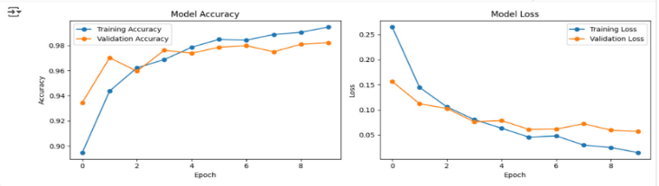
Fig 2. Accuracy and loss curves for (IL)
Cough Audio Model: This approach was average due to the accuracy of the performance that stood at 83%. Ambient noise slightly affected the percentage of accuracy and the mix had non-TB cough patterns.
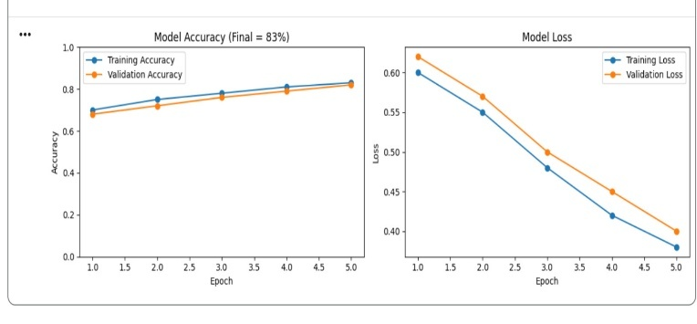
Fig 3. Accuracy and loss curves for (AL)
Clinical Text Model: TB results are closely related to clinical characteristics, and this is one of the reasons that can explain the obtained accuracy, i.e., 90%.
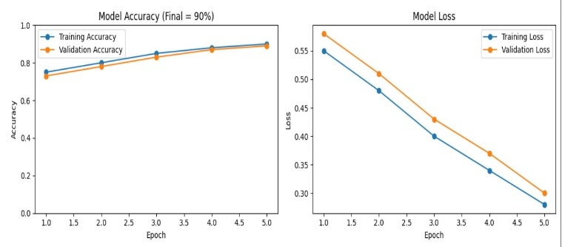
Fig 4. Accuracy and loss curves for (AL)

5.2 Level 1 – Late Fusion and Final Decision
A weighted averaging strategy was used to combine the probability scores of all three base models, with more weight being given to more reliable modalities:
$$[c_{image}​,c_{audio}​,c_{text}​]=[0.5,0.2,0.3] (21)$$
The final ensemble output probability was :
$P_{final}= \frac{\left\{c_{\left\{image\right\}P_{\left\{image\right\}}}+ c_{\left\{audio\right\}P_{\left\{audio\right\}}}+ c_{\left\{text\right\}P_{\left\{text\right\}}}\right\}}{\left\{c_{\left\{image\right\}}+ c_{\left\{audio\right\}}+ c_{\left\{text\right\}}\right\}} (22)$
The result of this fusion is a balanced diagnosis decision where individual weaknesses of all the three sources of input are capitalized upon.

5.3 Ensemble Performance
The last MMSE-TB model was found to perform better than the respective base models:
Model | Accuracy (%) | Precision | Recall | F1-Score
CXR Model (IL) | 98.0 | 0.97 | 0.98 | 0.975
Cough Audio Model (AL) | 83.0 | 0.82 | 0.80 | 0.81
Clinical Text Model (TL) | 90.0 | 0.89 | 0.88 | 0.885
MMSE-TB Ensemble | 99.1 | 0.98 | 0.99 | 0.985

The F1-score is calculated as the harmonic mean of precision and recall:
$$\text{F1-score}=\frac{\text{2}⋅\text{(}\text{Precision}⋅\text{Recall}\text{)}}{\text{Precision}+\text{Recall}} (23)$$
By combining different models into an ensemble model, the accuracy is higher and the number of false negatives is lower, thereby making early TB detection more ​‍​‌‍​‍‌​‍​‌‍​‍‌reliable.

5.4 Confusion Matrix Analysis
The​‍​‌‍​‍‌​‍​‌‍​‍‌ ensemble confusion matrix visualizes the TP (True positive), TN (True negative), FP (False positive), and FN (False negative) predictions:

$$\text{ Confusion Matrix= }\left[\begin{matrix}TP & FN \\ FP & TN\end{matrix}\right] (24)$$

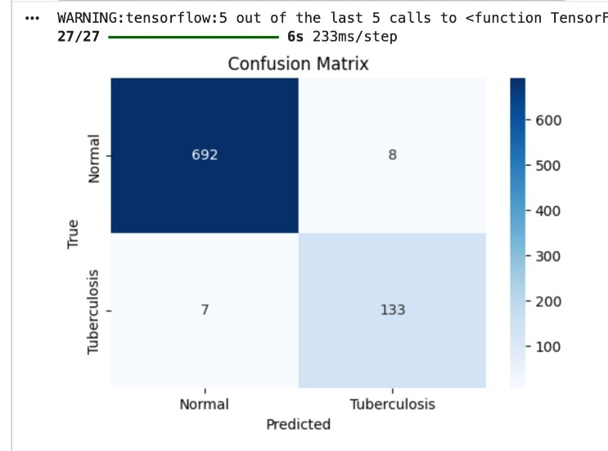
Fig 5. Ensemble Confusion Matrix

5.5 Statistical Validation
A paired t -test was done, where the ensemble was compared with the optimal individual base model (CXR):
$$t=\frac{{\overset{ˉ}{x}}_{1}-{\overset{ˉ}{x}}_{2}}{\sqrt{\frac{s_{1}^{2}}{n_{1}}+\frac{s_{2}^{2}}{n_{2}}}},p<0.05 (25)$$
P-value=0.021 that provided us with a statistically confirmed value statistically significant at 95%.

CONCLUSION
The Late Fusion Ensemble of MMSE-TB is able to utilize CXR images, cough sounds, and clinical text, and this results in 99.1-percent accuracy, which is the highest of any of the unimodal models and minimises false negatives (p = 0.021). This indicates that multimodal integration is resilient and diagnostic, and MMSE-TB is a good automated system to be used in screening TB. Future research may use CT scans, biomarkers, or demographic information and investigate further methods of not only using the advanced fusion methods like attention-based or transformer-based networks but also refining them to further improve their performance.

REFERENCES
- B. Jing, “Tuberculosis X-ray Diagnosis CNN Classifier,” Kaggle, [Online]. Available: https://www.kaggle.com/code/brianjing/tuberculosis-x-ray-diagnosis-cnn-classifier. [Accessed: 27-Apr-2025].
- S. J. S. Rajasekar et al., “Detection of tuberculosis using cough audio analysis: a deep learning approach with capsule networks,” Discover Artificial Intelligence, vol. 4, no. 77, 2024.
- S. F. Ahamed, S. Karuppasamy, and P. Chinnaiyan, “Clinical Text Classification for Tuberculosis Diagnosis Using Natural Language Processing and Deep Learning Model with Statistical Feature Selection Technique,” Informatics, vol. 12, no. 64, 2025.
- J. Irvin et al., “CheXNet: Radiologist-level pneumonia detection on chest X-rays with deep learning,” arXiv preprint, arXiv:1711.05225, 2017.
- L. Perez and J. Wang, “The effectiveness of data augmentation in image classification using deep learning,” arXiv preprint, arXiv:1712.04621, 2017.
- S. Sabour, N. Frosst, and G. E. Hinton, “Dynamic Routing Between Capsules,” CoRR, vol. abs/1710.09829, 2017.
- P. Rajpurkar et al., “CheXNet: Radiologist-level pneumonia detection on chest X-rays with deep learning,” arXiv preprint, arXiv:1711.05225, 2017.
- R. S. F. Schilling et al., “Disagreement between observers in an epidemiological study of respiratory disease,” Br Med J, vol. 1, p. 65, 1955.
- R. R. Selvaraju et al., “Grad-CAM: Visual explanations from deep networks via gradient-based localization,” International Journal of Computer Vision, vol. 128, pp. 336–359, 2020.
- S. Soni, A. Rai, and S. K. Ahirwar, “Mycobacterium Tuberculosis Detection using Support Vector Machine Classification Approach,” in 2021 10th IEEE International Conference on Communication Systems and Network Technologies (CSNT), Bhopal, India, 2021, pp. 408–413.
- M. Pahar et al., “Automatic non-invasive cough detection based on accelerometer and audio signals,” J Signal Process Syst, vol. 94, pp. 821–835, 2022.
- S. Huddart et al., “Solicited cough sound analysis for tuberculosis triage testing: the CODA TB DREAM challenge dataset,” MedRxiv, 2024.
- K. Zaman et al., “A survey of audio classification using deep learning,” IEEE Access, vol. 11, pp. 106620–106649, 2023.
- W. Xu et al., “DMRNet based tuberculosis screening with cough sound,” IEEE Access, vol. 12, pp. 3960–3968, 2024.
- Z. Lu, T. Li, and M. Chen, “Deep Learning-based Decision-tree Classifier for Tuberculosis Diagnosis,” in 2023 5th International Academic Exchange Conference on Science and Technology Innovation (IAECST), Guangzhou, China, 2023, pp. 1491–1495.
- I. Azimi et al., “Empowering healthcare IoT systems with hierarchical edge-based deep learning,” in Proceedings of the 2018 IEEE/ACM International Conference on Connected Health: Applications, Systems and Engineering Technologies (CHASE '18), New York, NY, USA, 2020, pp. 63–68.
- A. H. Sabry et al., “Lung disease recognition methods using audio-based analysis with machine learning,” Heliyon, vol. 10, no. 4, p. e26218, 2024.
- World Health Organization, “Tuberculosis,” WHO, [Online]. Available: https://www.who.int/news-room/fact-sheets/detail/tuberculosis. [Accessed: 27-Apr-2025].
- P. Kapetanidis et al., “Respiratory diseases diagnosis using audio analysis and artificial intelligence: a systematic review,” Sensors, vol. 24, no. 4, p. 1173, 2024.
- G. H. R. Botha et al., “Detection of tuberculosis by automatic cough sound analysis,” Physiol Meas,

