Mathematical models of dimensional error and fit behavior in FDM 3D printed shaft–hole assemblies

Aleksandar Ivanov
Department of Machine Tools and Manufacturing, Faculty of Mechanical and Manufacturing Engineering
University of Ruse
Ruse, Bulgaria
akivanov@uni-ruse.bg,
ORCID 0000-0002-1030-0352
Nikolay Stankov
Department of Machine Tools and Manufacturing, Faculty of Mechanical and Manufacturing Engineering
University of Ruse
Ruse, Bulgaria
nstankov@uni-ruse.bg.
ORCID 0000-0002-1379-6744
Danko Tonev
Department of Machine Tools and Manufacturing, Faculty of Mechanical and Manufacturing Engineering
University of Ruse
Ruse, Bulgaria
dtonev@uni-ruse.bg
ORCID 0000-0001-5011-665
Svetlana Koleva
Department of Machine Tools and
Manufacturing, Faculty of Mechanical
and Manufacturing Engineering
University of Ruse
Ruse, Bulgaria
svetla@uni-ruse.bg
ORCID 0000-0001-9586-1011
Yuksel Aliev
Department of Computer Systems and
Technologies, Faculty of Electrical Engineering
Electronics and Automatics
University of Ruse
Ruse, Bulgaria
yaliev@uni-ruse.bg
ORCID 0000-0001-5432-2046

Abstract—This paper presents a study on the dimensional accuracy of parts manufactured using 3D printers. For this purpose, both desktop and professional 3D printers operating with FDM technology are used. Three-dimensional models and real prototypes of two types of machine elements are developed: a shaft and a bushing. The 3D models are created in the CAD system SolidWorks. The preparation of the parts for manufacturing on the 3D printers is discussed, as well as the specific aspects of their measurement on a coordinate measuring machine. The printed parts are measured on a coordinate measuring machine in order to obtain reliable data on the diametral dimensions. The experimental results show a clear influence of the printer design on diametral accuracy, with the industrial printer achieving the best results. For the investigated process parameters, all three printers produce interference fits between shafts and holes, and the developed mathematical models allow compensation of the systematic error and adjustment of the nominal diameters to realize different types of fits on the same equipment.
Keywords— FDM, 3D printers, 3D models, CAD, coordinate measuring machine, mathematical correlation model, coefficient of determination, standard deviation

Introduction
Fused Deposition Modeling (FDM) is a process of modeling by depositing molten material, also known as Fused Filament Fabrication (FFF), where a meltable filament is used. This paper investigates the dimensional accuracy of parts manufactured with 3D printers. The parts are modeled in a CAD system.
In prototyping with the FDM technology, the object is built by depositing molten material layer by layer. The material, which is a plastic in the form of a filament, passes through a preheated extruder that applies a molten layer of plastic onto the build plate or onto the already manufactured layers of the model. The print head or the build plate moves along the X, Y, and Z axes. How these movements are performed depends mainly on the design of the 3D printer.
This study is financed by the European Union - NextGenerationEU, through the National Recovery and Resilience Plan of the Republic of Bulgaria, project № BG-RRP-2.013-0001.
The materials used are thermoplastic polymers in filament form. The most commonly used materials are PLA, ABS, PET-G, ASA, TPU, and others.
3D printing can be used to manufacture single parts, small and medium series, architectural models, machine components, automotive parts, prototypes or finished models, and souvenirs.
The production of prototypes is an integral part of modern manufacturing. The purpose of a physical prototype is to make it easier to understand the idea of the design team and to partially or fully investigate the functional parameters of the prototyped products. In modern industry, prototypes are often used for preliminary testing of Digital Twin technologies [1, 2], where they are an indispensable tool and an integral part of the process of validation and commissioning of technologies. Prototypes are usually required before the start of serial production of the parts.
A significant problem with FDM technologies is that the information sent to specialized 3D printing CAM applications (slicers) contains the parts with their nominal dimensions. Due to their nature, these fully automated prototyping technologies generate the dimensions of the product components in a fully automatic way. The machine operators practically cannot influence the dimensional accuracy.

LITERATURE REVIEW
When parts are manufactured by rapid prototyping, a key problem is the accuracy with which they are obtained. This is especially critical when assemblies consisting of multiple parts have to be produced. In order to assemble two parts, a clearance is required. The actual clearance obtained depends mainly on the accuracy with which the parts are manufactured. The aim of this study is to determine the limits of the dimensional scatter and the trend in the change of the surface dimensions obtained by FDM 3D printing.
Many factors influence the accuracy. Some of them are shown in Fig. 1 [3, 4, 5, 6, 7, 8, 9].
The type of material used, the preparation, and initial setup of the 3D printer also have an effect. The approximation of the surfaces of the 3D models should not be neglected either.

The process of creating a prototype includes 3D modelling, conversion of the model to an STL file, slicing of the faceted surface into multiple layers, manufacturing of the prototype of the model, and finishing operations.
STL files are the format most commonly used by the software that controls rapid prototyping equipment to transmit the 3D information required for the production of 3D models
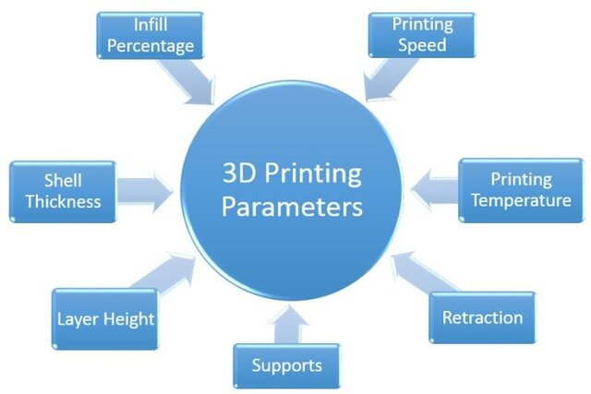
- Factors affecting accuracy.
The STL format approximates the surfaces of solid and surface bodies in CAD files, as well as the surfaces of scanned models, using triangles. For example, a cube can be represented with 12 triangles – two per face – in order to describe its surface (Fig. 2)
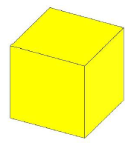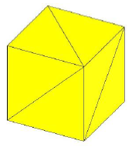
а) б)
- Surface approximation of 3D solid or surface bodies. a) Solid or surface cube; b) representation of the cube by an STL file
The more complex the surface is, the more triangles are required to represent it.
Depending on the desired approximation accuracy of the surface, a part can be represented with a different number of triangles, and as the approximation accuracy increases, the number of triangles also increases.

Investigated objects

Development of 3D models of a shaft and a bushing;
Two of the most common machine elements are considered: a shaft and a bushing. The 3D models of the investigated parts are shown in Fig. 3 and Fig. 4. The part models are designed and created in the CAD system SolidWorks [10].
The use of modern CAD systems significantly facilitates the development of a given product. The design work is carried out in 3D space. It is possible to create 3D models of parts, subassemblies, and complete assemblies
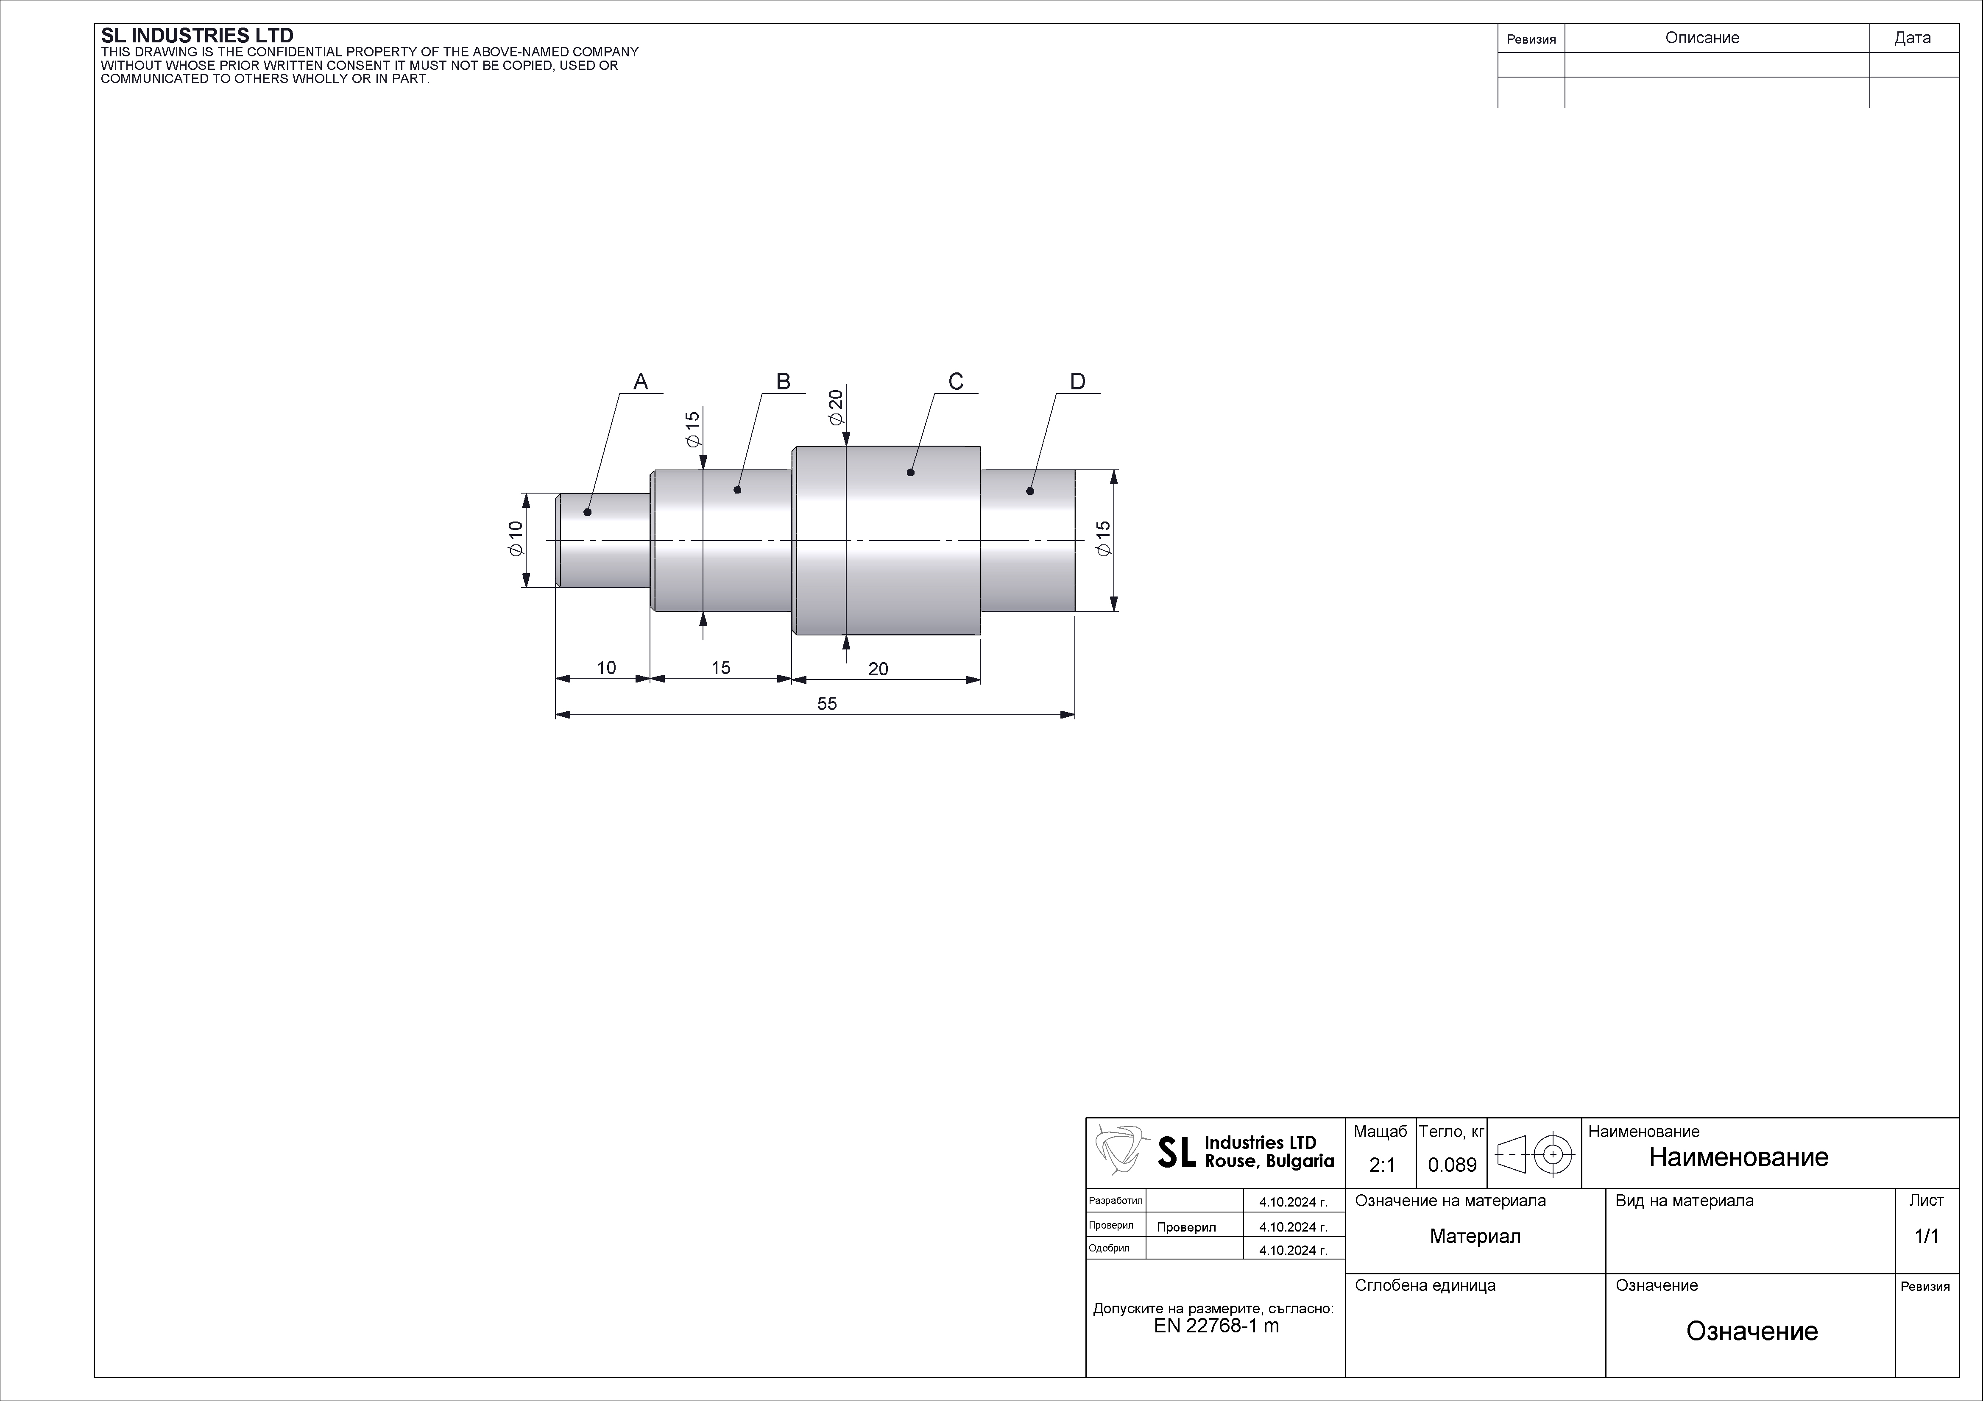
- 3D model of the Shaft part.
In the figure, the drawing of the shaft part is shown. The C surfaces of multiple identical parts will be the main subject of the investigation. During measurement, the part will be located (fixtured) by surface D.
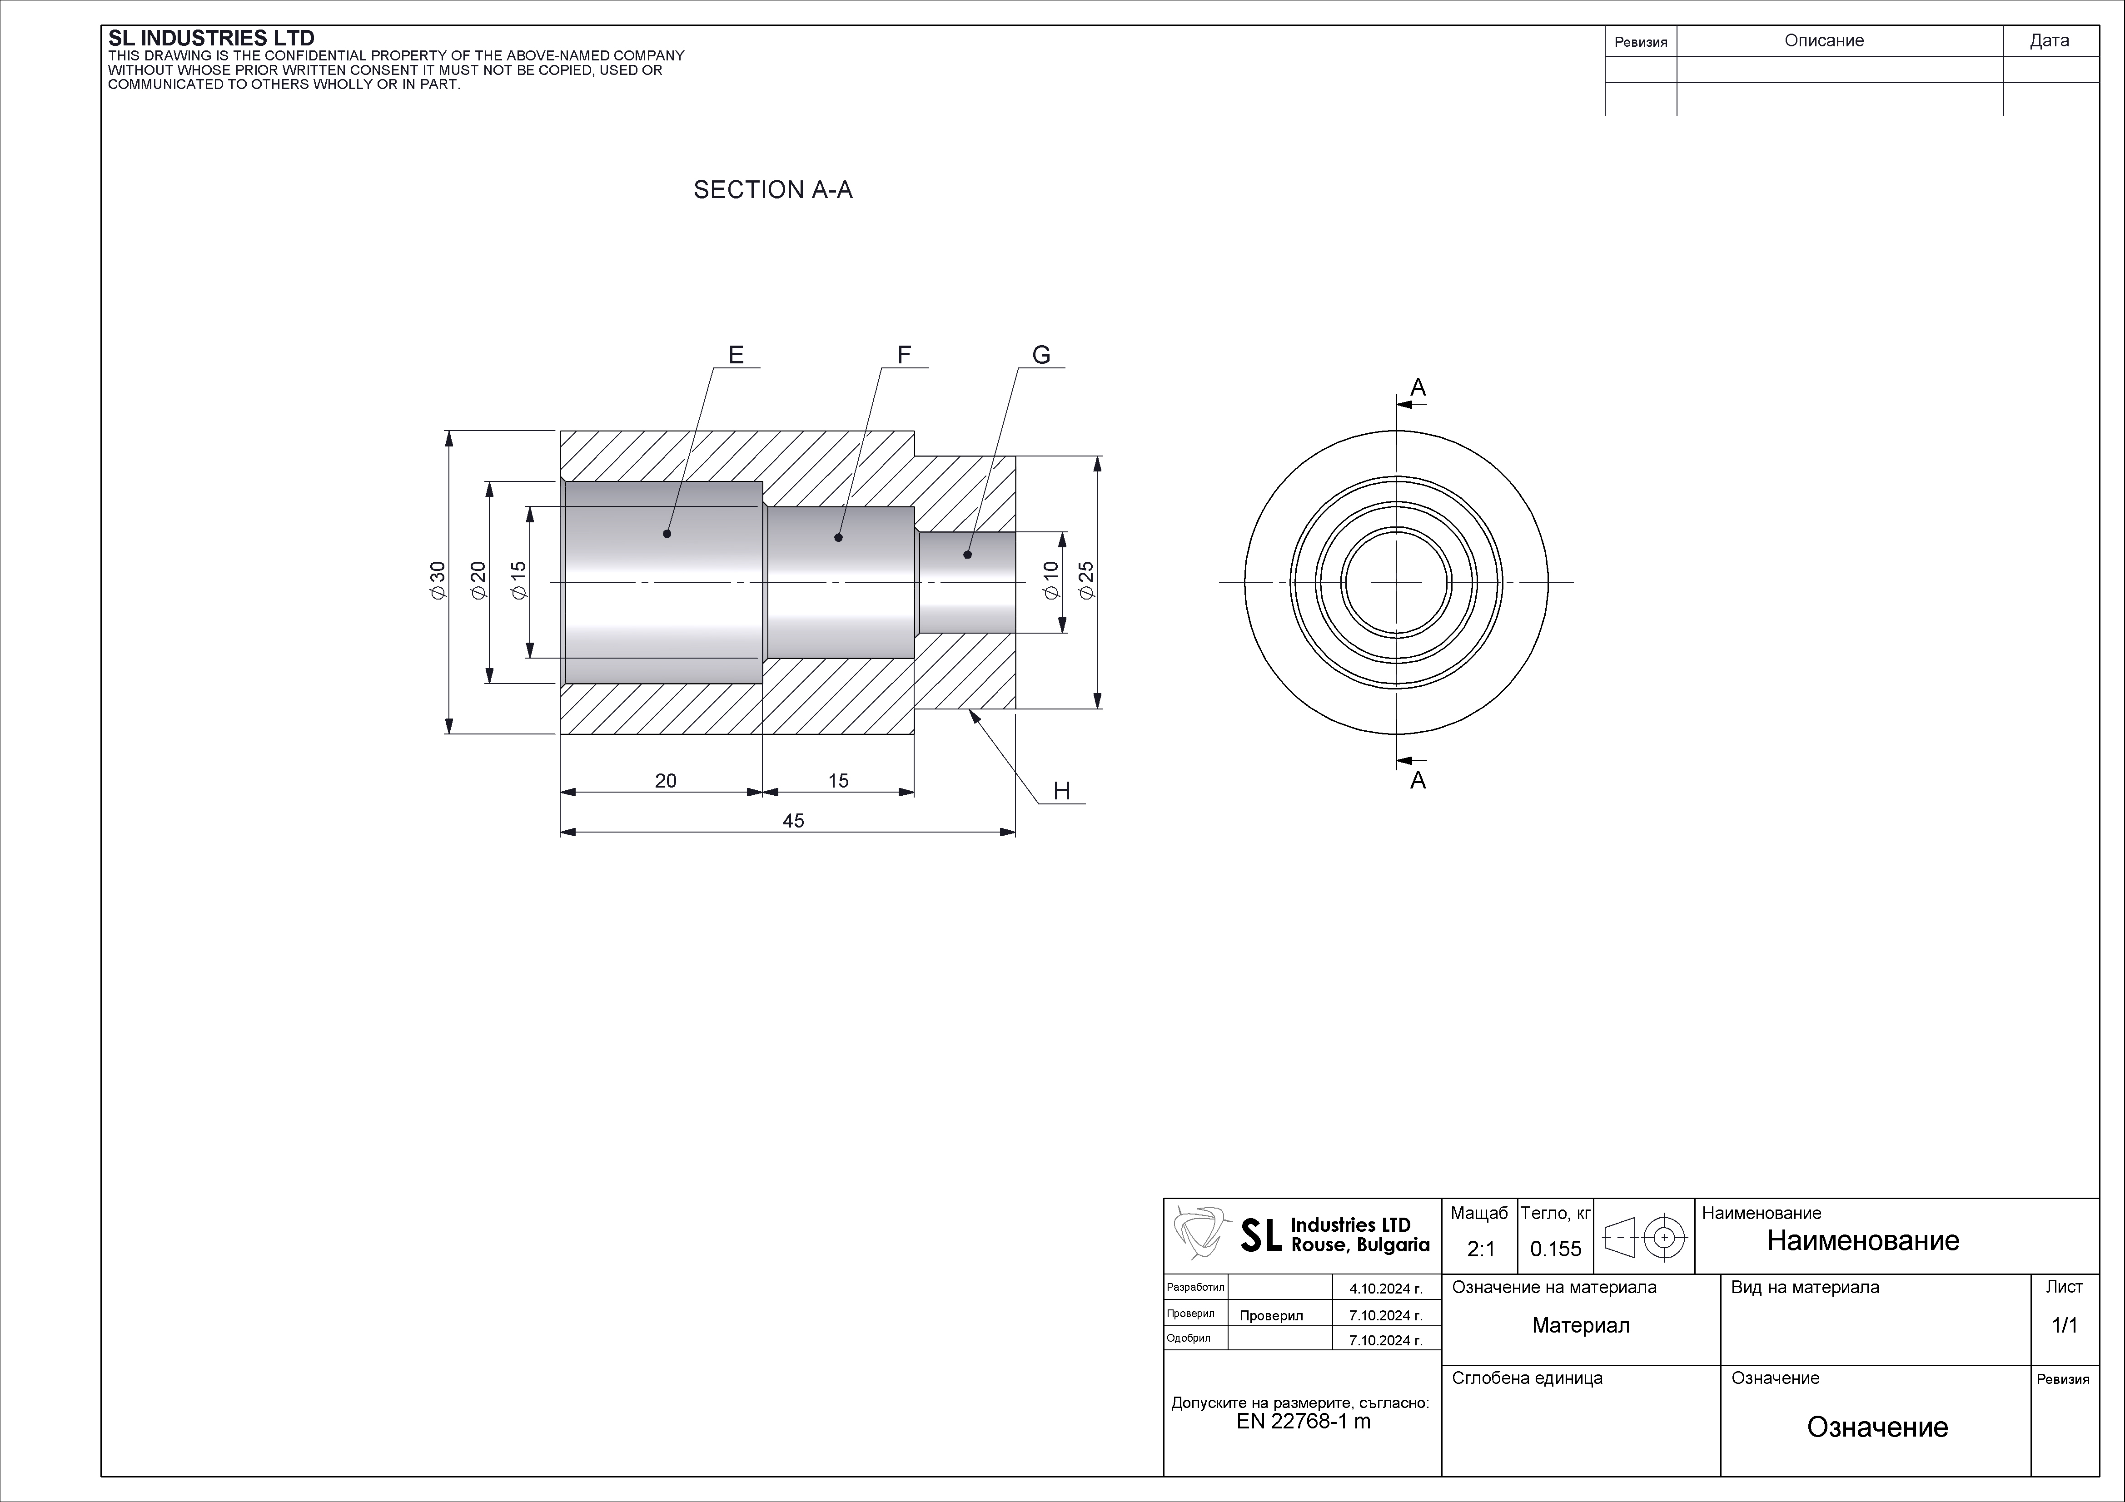
- 3D model of the Bushing part.
In the figure, the drawing of the bushing part is shown. The main subject of the investigation will be the surfaces marked E. During measurement, the part will be located (fixtured) by surface H.
After the 3D models of the parts are created, they must be saved in STL format so that they can be processed by the software used to generate the control program for the 3D printer.

Processing of the files and creation of the control program;
The files are processed using specialized software. In most cases, the printer manufacturers provide their own software for their 3D printers.
In addition to the factors mentioned above, the position and orientation of the model on the printer's build plate also affect the manufacturing accuracy. In other words, it matters where the part is located on the plate. The most stable position is in the center of the build plate, so both models are placed in its center. This means that each model is manufactured individually.
In the following figures, the two models are shown during their processing in the software. After the processing is completed, a control program is generated, which can be used by the 3D printers.
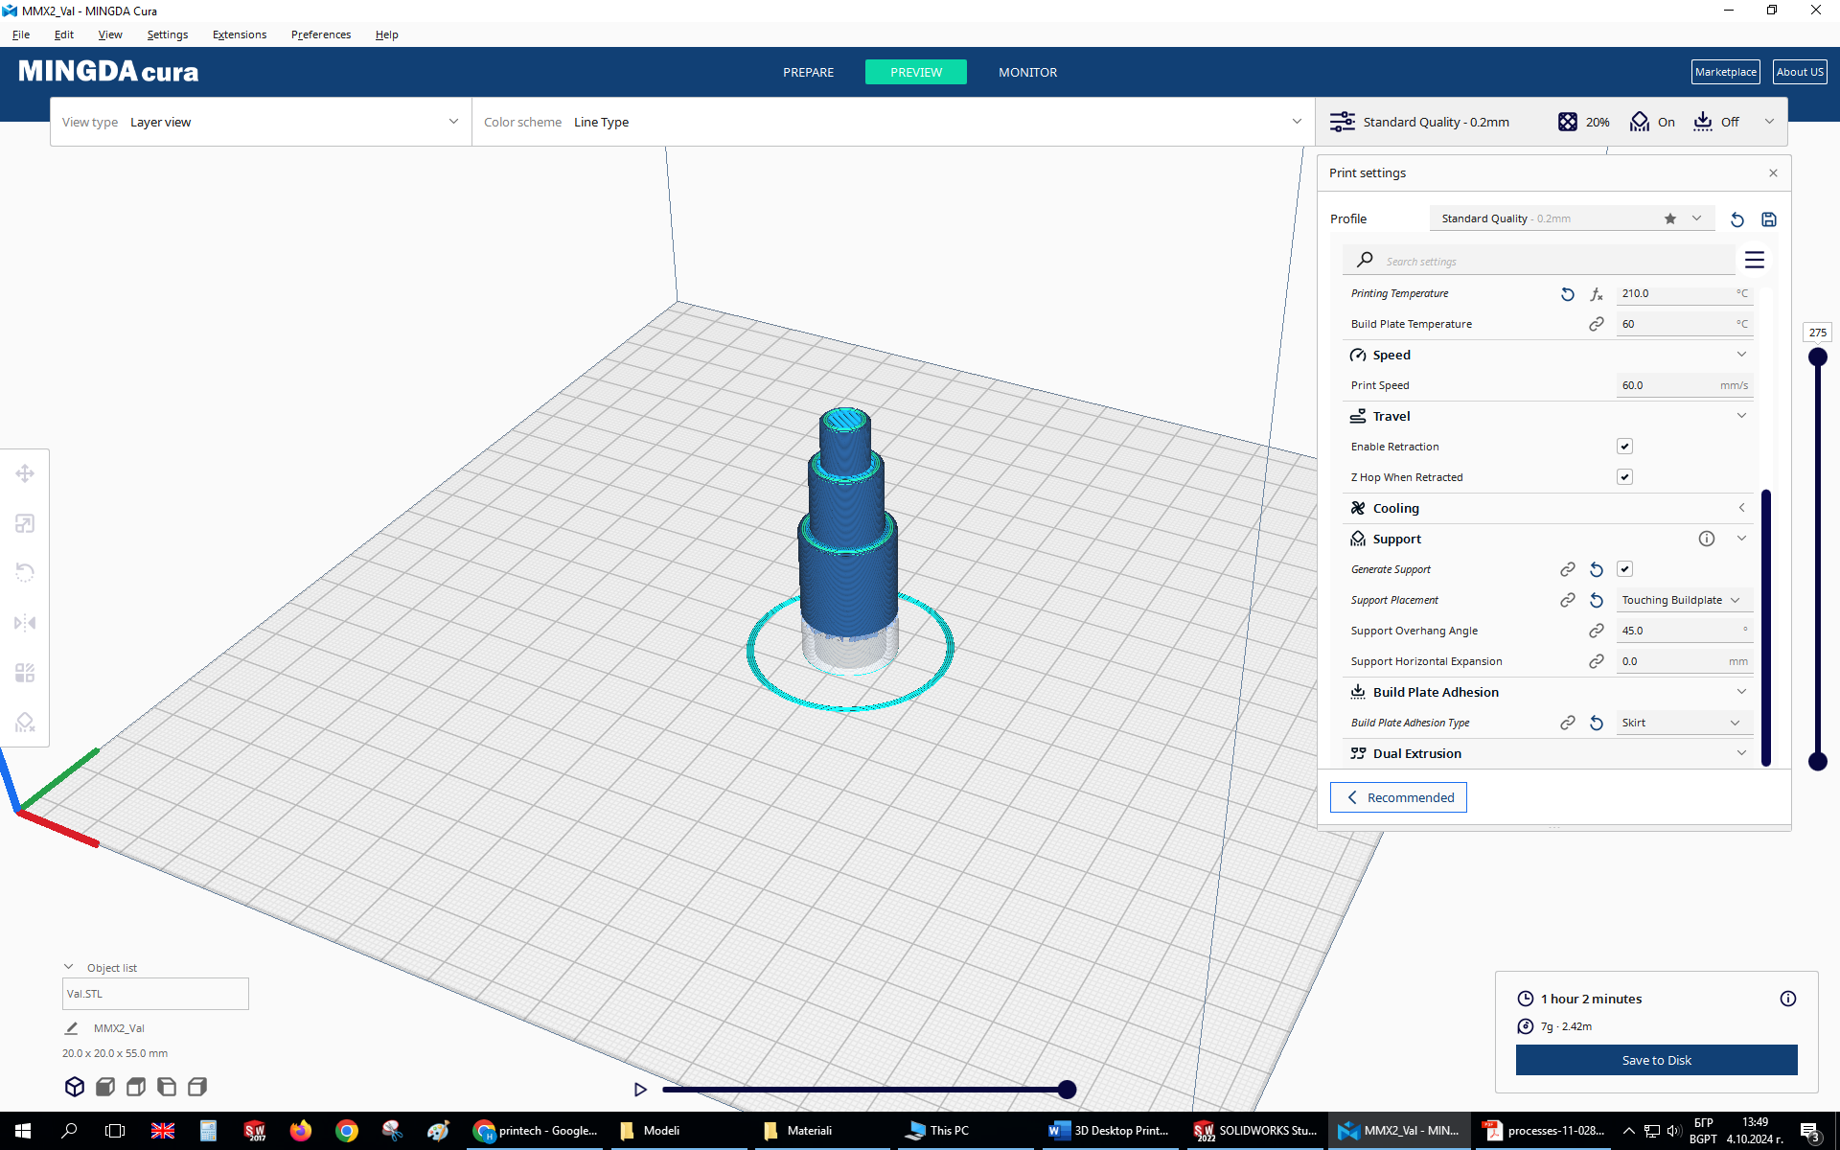
- Processing of the Shaft part with the MINGDA Cura v.1.4.11 [11].
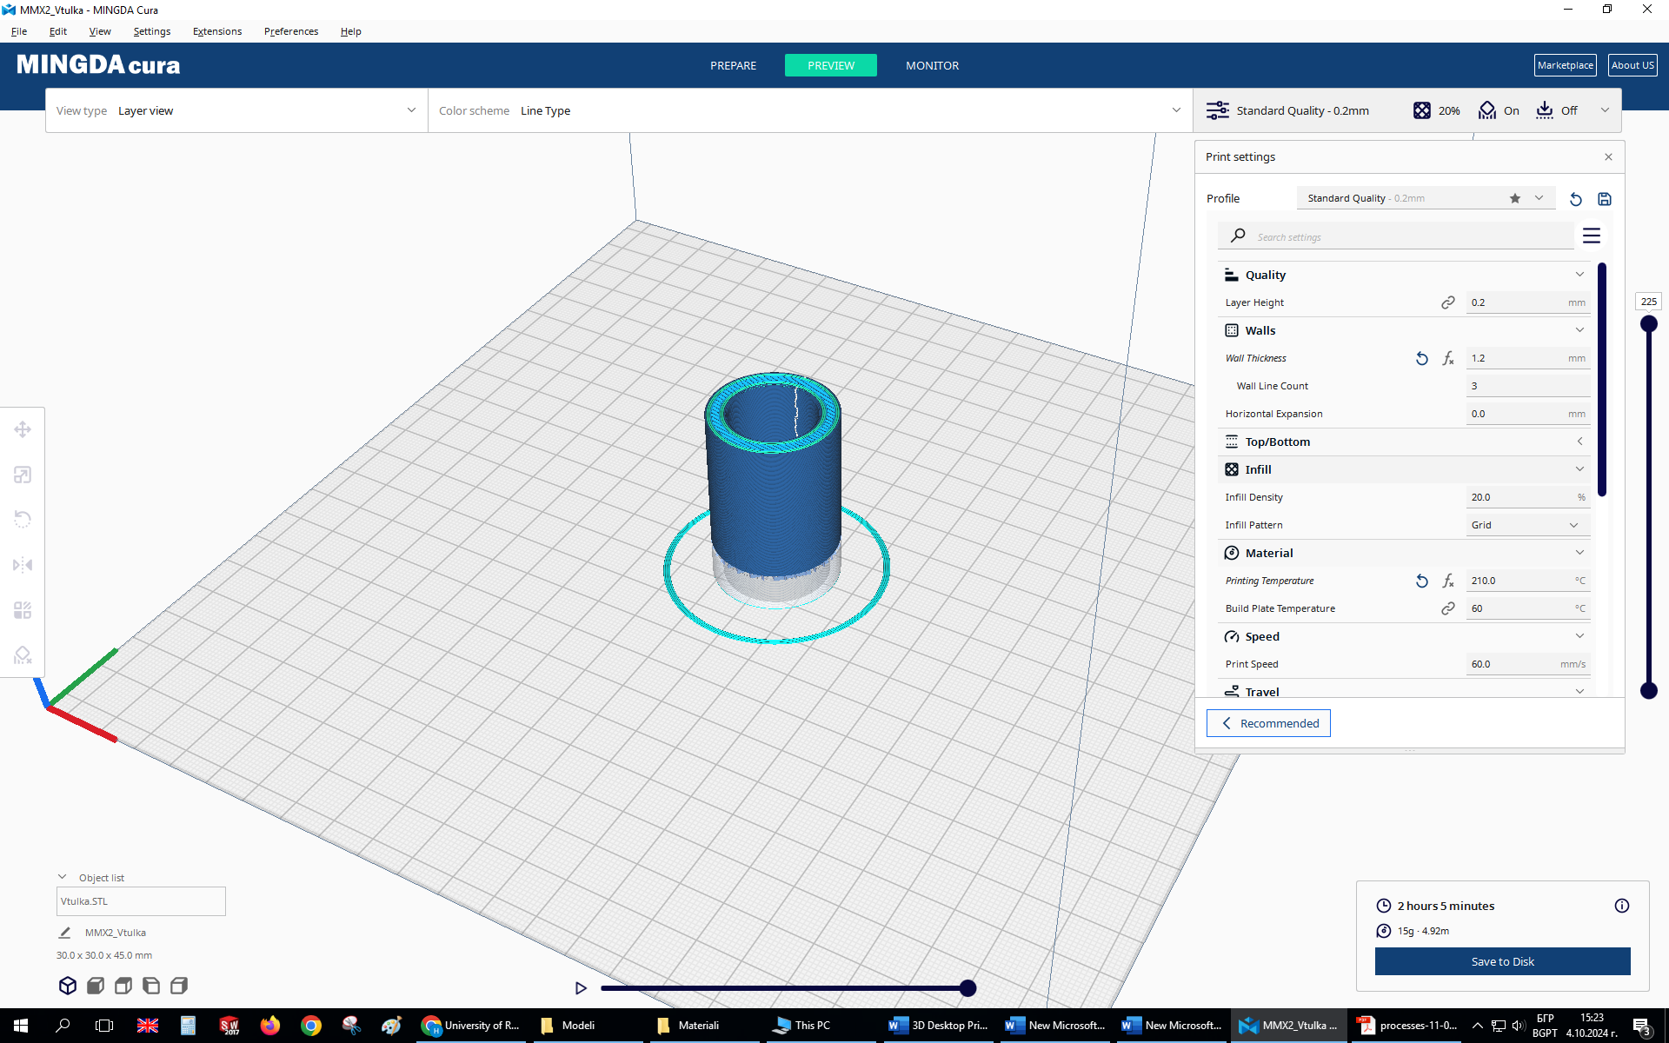
- Processing of the Bushing part using MINGDA Cura v. 1.4.11[11].

Manufacturing of the prototypes.
Table 1 shows the main parameters used for the manufacturing of the parts, as well as the printers’ settings.
- 3D printers’ settings
Parameter | Value
Nozzle diameter, mm | 0,4
Layer thickness, mm | 0,2
Wall thickness, mm | 1,2
Infill density, % | 5
Extruder temperature, °C | 200
Bed temperature, °C | 60
Printing speed, mm/s | 60
Extruder cooling, % | 100
Support material, % | 5
Material | PLA, White, MingDa
Filament diameter, mm | 1,75
Two desktop 3D printer models and one industrial 3D printer will be used:
- Desktop 3D printer 1 – the characteristic feature of this type of machine is that its linear guides consist of an aluminum rail with rubber rollers on both sides.
- Desktop 3D printer 2 – the characteristic feature of this type of machine is that its linear guides are cylindrical steel rods with linear ball bearings.
- Industrial 3D printer 3 – the characteristic feature of this type of machine is that its linear guides are prismatic steel rails with ball bearing carriages
For the purposes of the experiment, the following numbers of each part type will be manufactured:
- 3D printer 1: 30 shaft parts and 30 bushing parts
- 3D printer 2: 30 shaft parts and 30 bushing parts
- 3D printer 3: 30 shaft parts and 30 bushing parts
Thus, the total number of parts that must be produced for the experiment on all three printers is 180.
On Figure 7 and Figure 8, the manufacturing process of the shaft and bushing prototypes on 3D printer 1 and 3D printer 3 is shown.
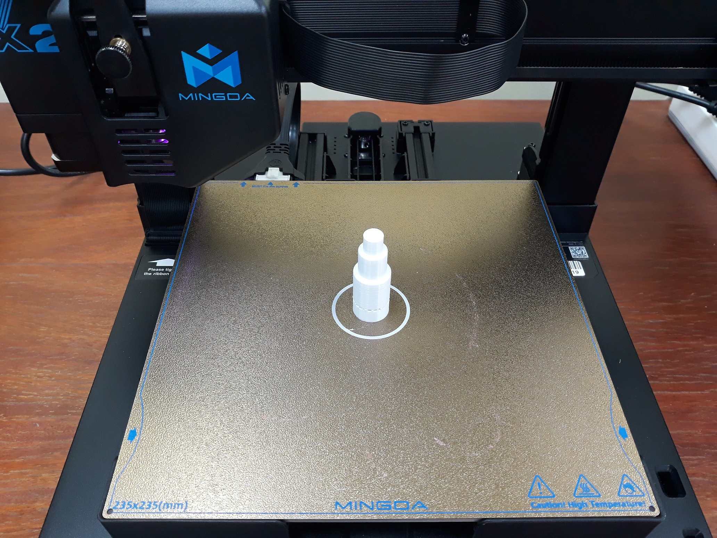
- Shaft part after manufacturing on 3D printer 1.
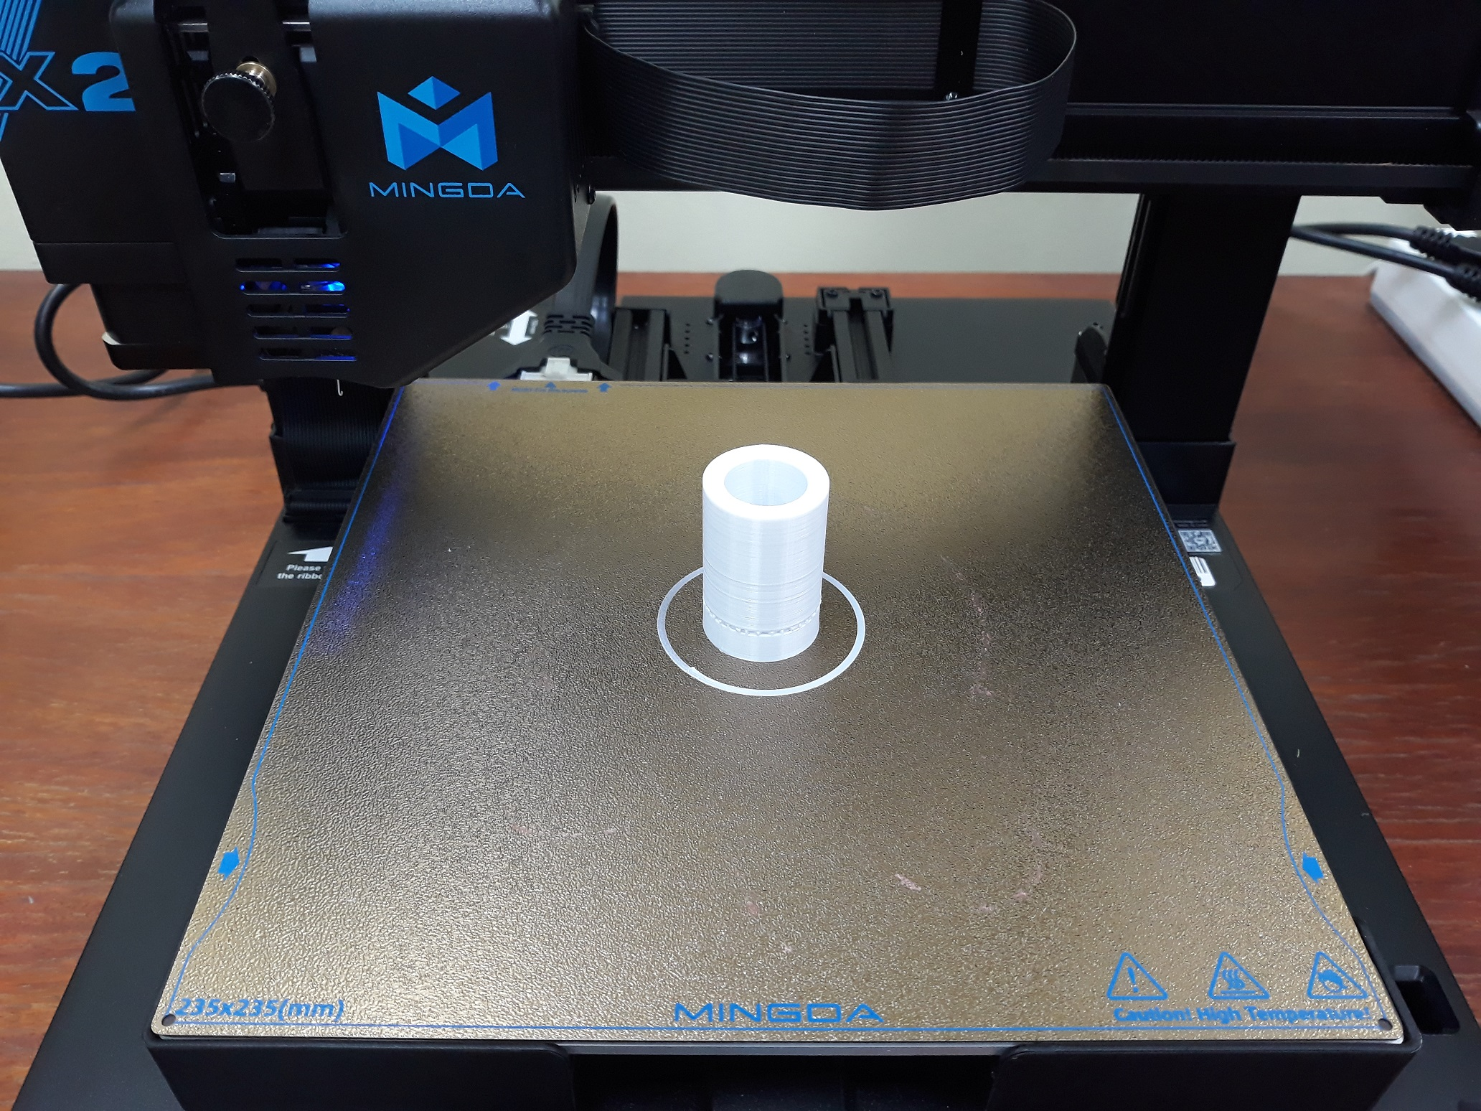
- Bushing part after manufacturing on 3D printer 1.
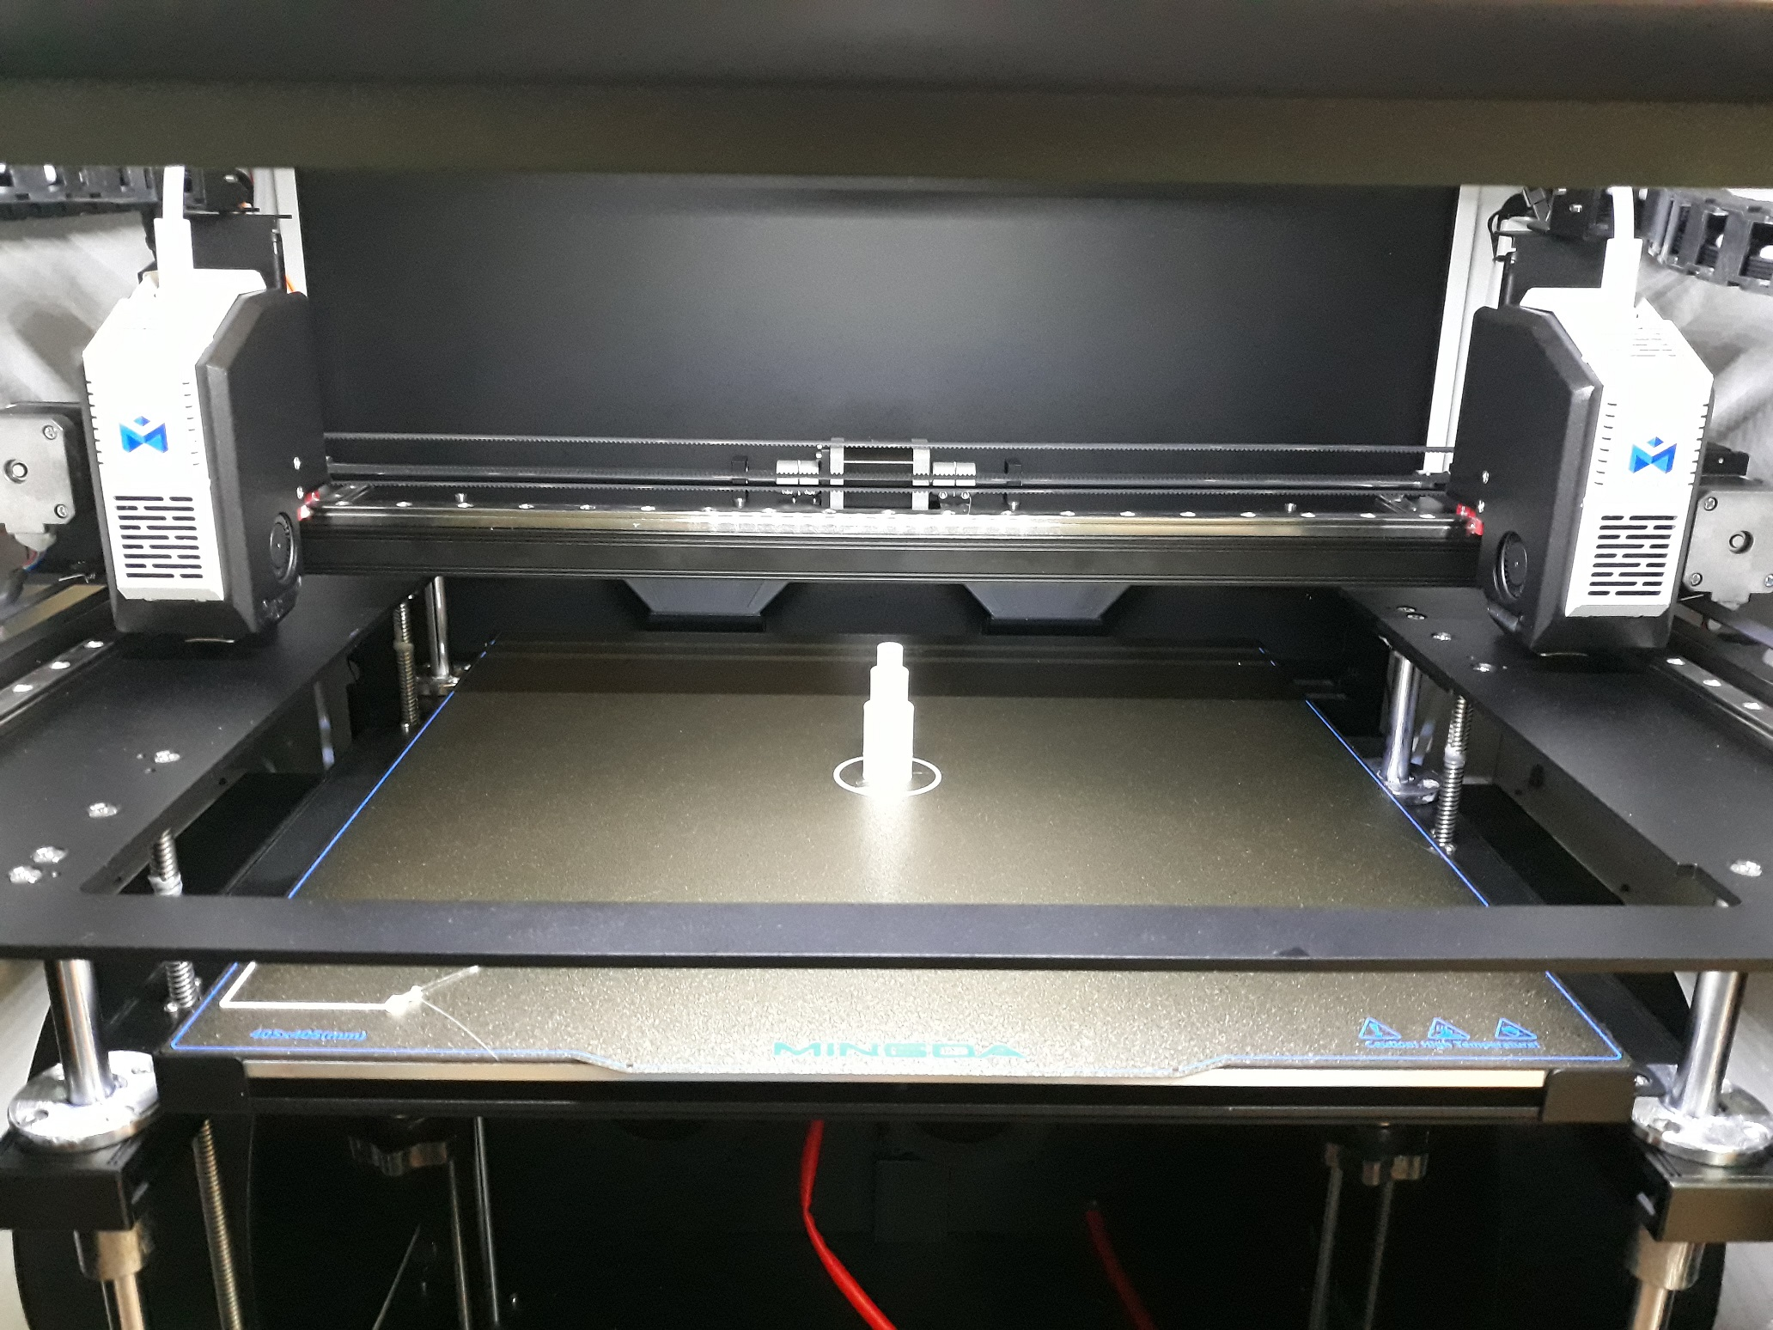
- Shaft part after manufacturing on 3D printer 3.
The parts after manufacturing are shown in Figures 10 and 11.
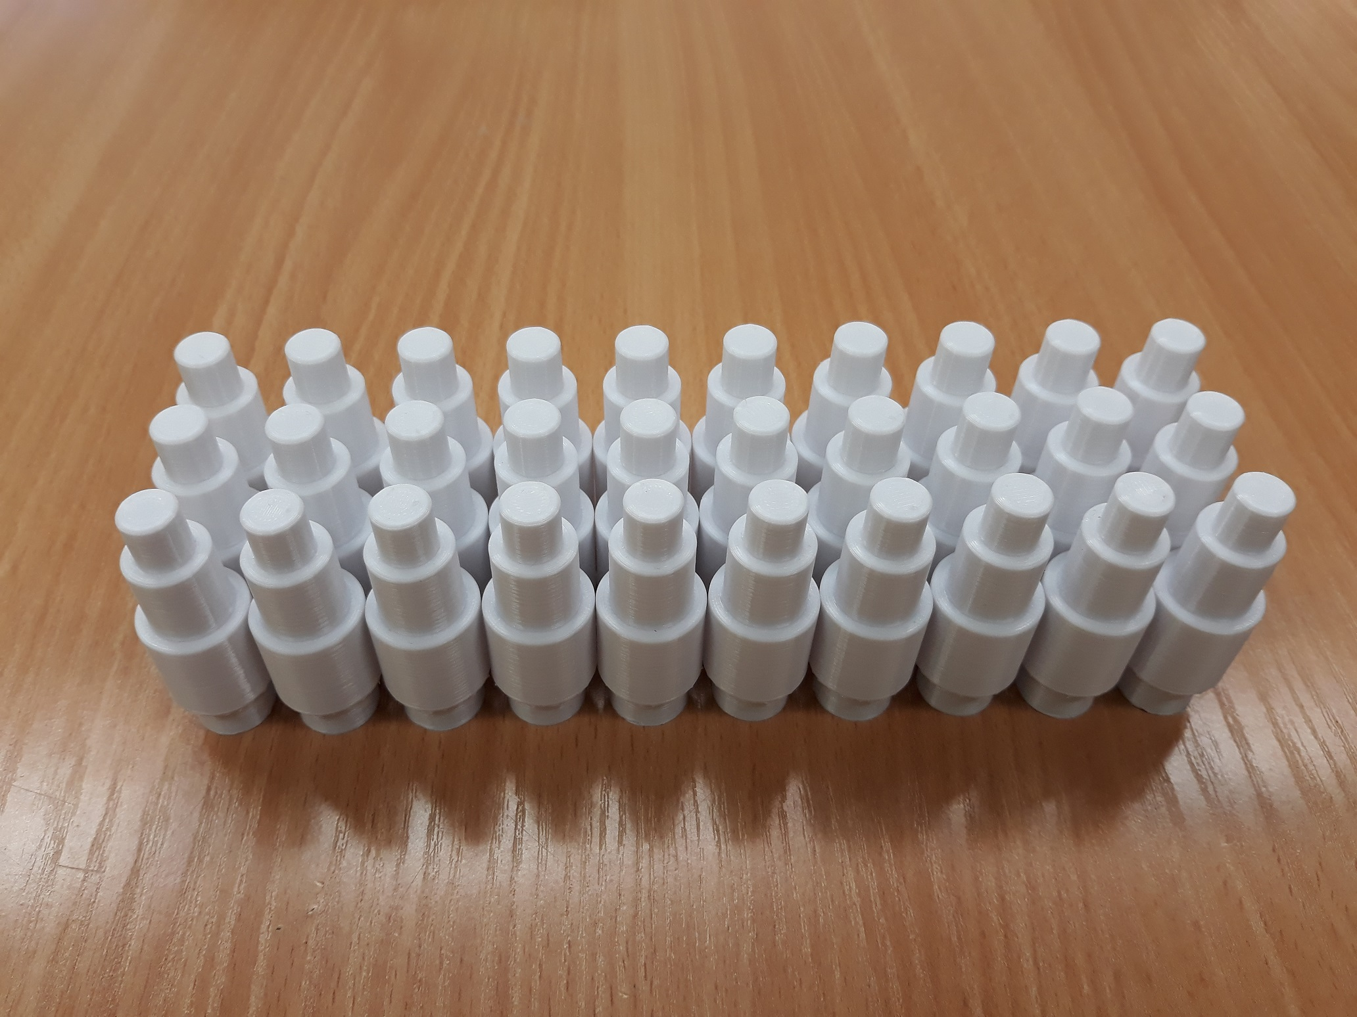
- Shaft parts after manufacturing on 3D printer 3.
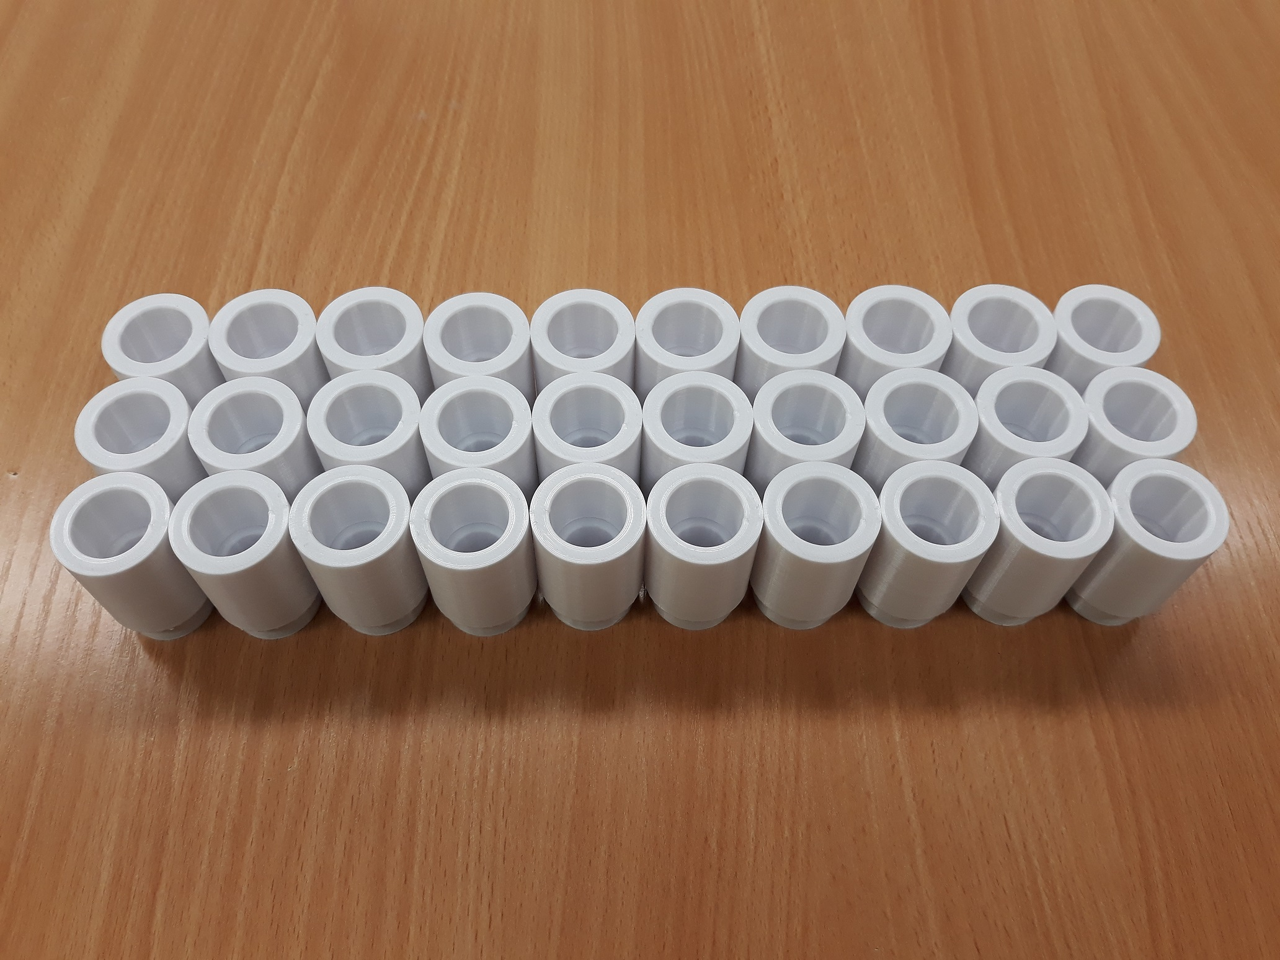
- Bushing parts after manufacturing on 3D printer 3.

Measurement of the investigated parts.
The parts produced on the 3D printers were measured on a coordinate measuring machine. The machine is an Axiom too CMM (Fig. 12) [12]. It is equipped with a Renishaw probe with a ruby tip of 2 mm in diameter.
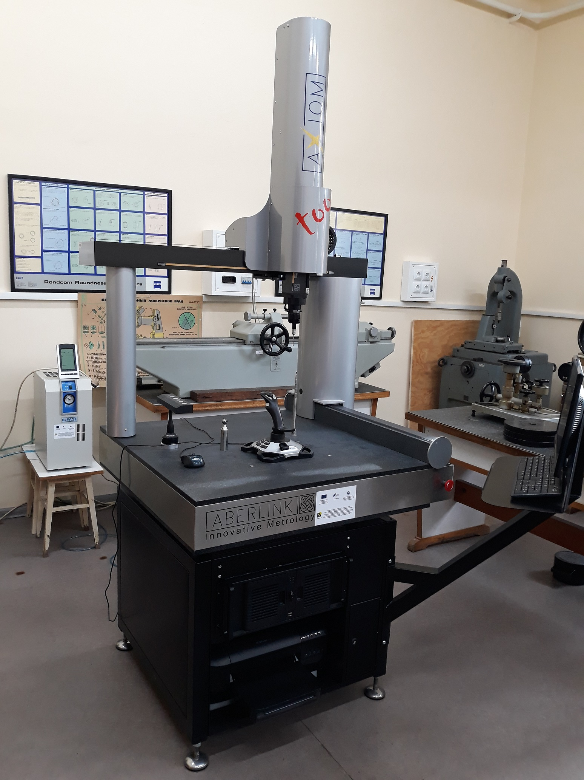
- Coordinate measuring machine.
The coordinate measuring machine (CMM), provides the required accuracy for the evaluation of the diametral dimensions of the 3D printed cylindrical surfaces. The machine was calibrated in advance according to the manufacturer’s requirements, and before the start of the measurements a check with a reference cylinder was performed in order to verify the accuracy in the measurement of diameters.
All measurements were performed under controlled environmental conditions. The room temperature was maintained at about 20–22 °C. During the measurements no external influences such as intensive ventilation, changes in humidity, etc. were allowed, as these could affect the stability of the measuring system and the dimensions of the parts. The parts themselves were kept in the room for at least 4 hours before measurement in order to reach thermal equilibrium with the surroundings.
On Figure 13 and Figure 14, the setup of the shaft part and the bushing part is shown. The parts are mounted in a special chuck. Each of the surfaces indicated in Figure 3 and Figure 4 is measured by probing multiple points. In this way, both the size and the form of the surface are determined.
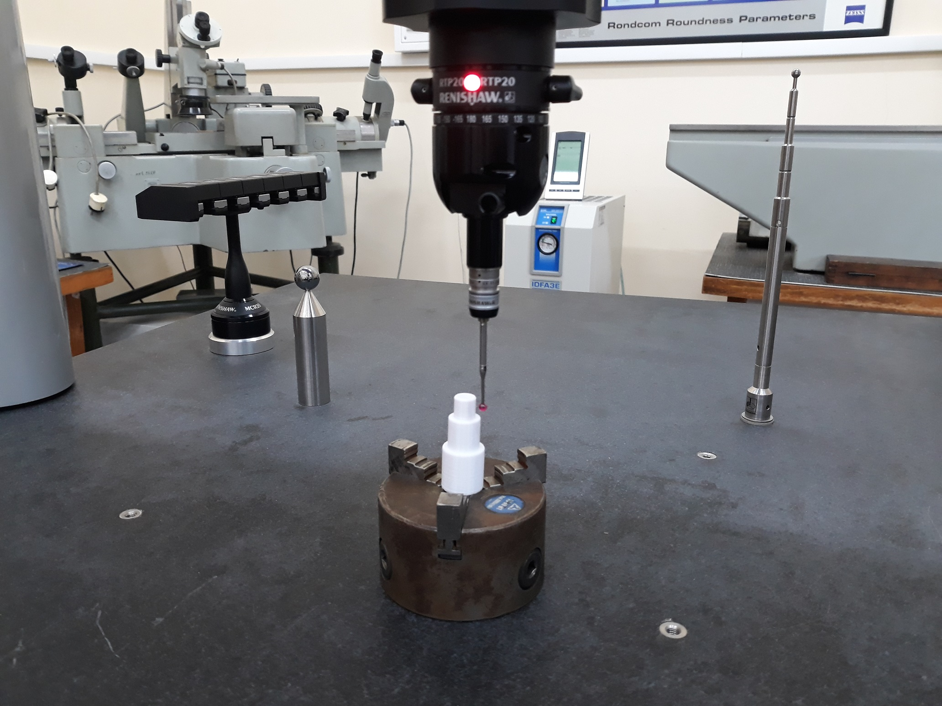
- Locating, fixturing and measurement of the Shaft part.
Each part was located and clamped on the measuring machine in a way that does not introduce additional deformations. Even if small deformations occur, they remain far from the measurement zone.
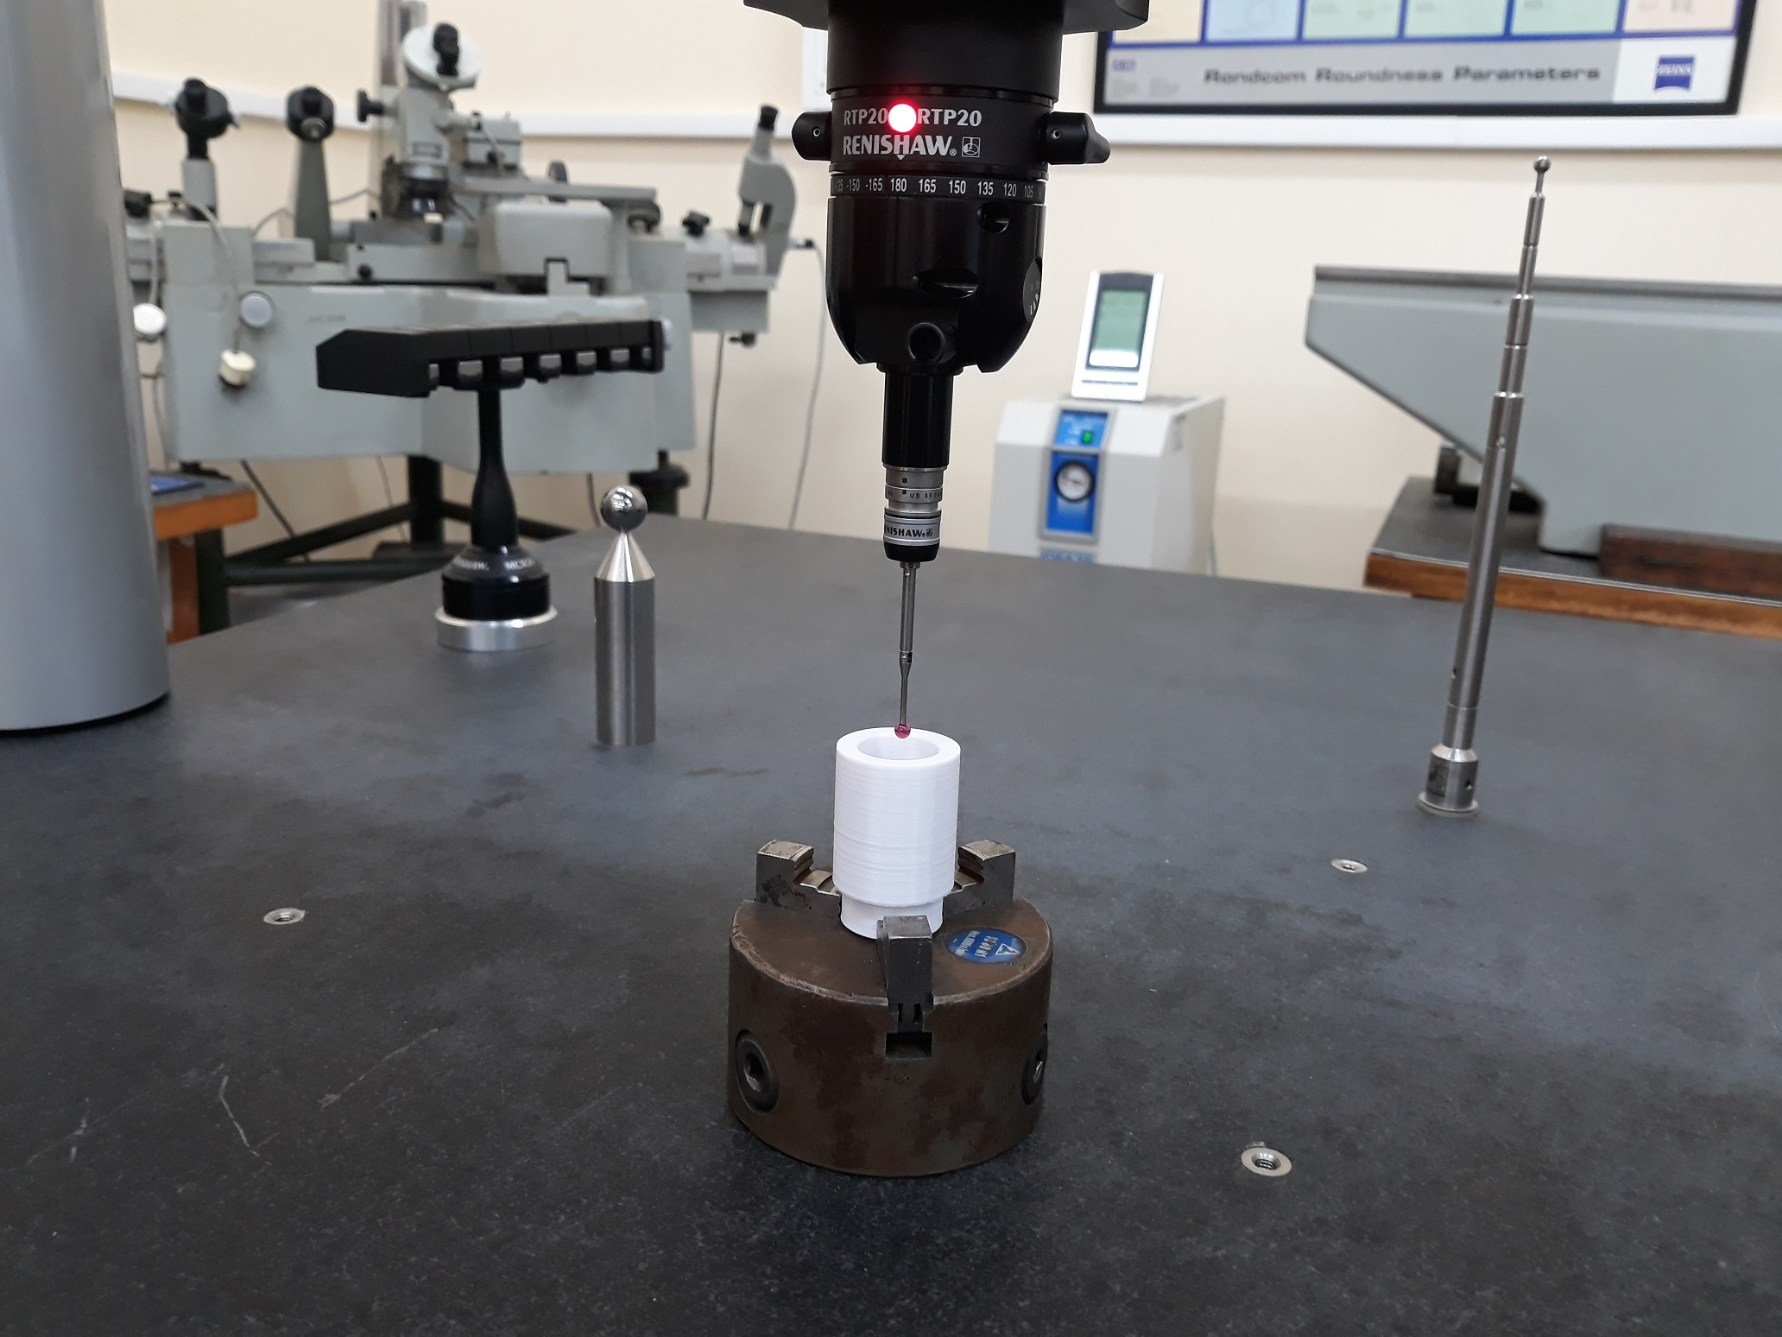
- Locating, fixturing, measurement of the Bushing part.
The measured points were processed by the CMM software using the least squares method. An ideal cylindrical surface was approximated from these points and its diameter was determined. In this way, the influence of local surface deviations is minimized and a representative value of the diametral dimension is obtained for each part. For the purposes of the subsequent statistical analysis, all diametral dimensions are automatically stored in tabular form.
For each of the three printers, series of 30 parts were measured, including both shafts and their corresponding holes. All parts were numbered according to the order of their production.
For example, the first shaft in the series produced on 3D printer 1 was numbered 1.01 and the thirtieth 1.30. In this way, the measurement data can be used in the development of mathematical correlation models that describe the change of the dimensions as a function of time (or the number of produced parts). This makes it possible to clearly distinguish the systematic component of the error from the random scatter of the dimensions.
The measurements carried out in this way make it possible to create a reliable and comparable database for the three investigated printers. Based on these measurements, the influence of the design features and parameters of the printers on the accuracy of the obtained diametral dimensions can be evaluated, as well as the nature of the random and systematic errors can be identified.

Measurement results, mathematical models and analysis.
In investigating the parameters of the machined surfaces, measurements were performed only on the cylindrical surfaces with a diameter of Ø20 mm. This choice is based on an informal division of the printed external and internal cylindrical surfaces into two main diameter ranges, below and above Ø15–25 mm. Therefore, the central value of this range, Ø20 mm, was selected.
Figures 15 to 20 show the measurement results for all three printers and for both part types. The measured diameters of the 30 parts in each series are plotted against the part index, which makes it possible to visualize both the systematic trend and the random scatter of the dimensions.
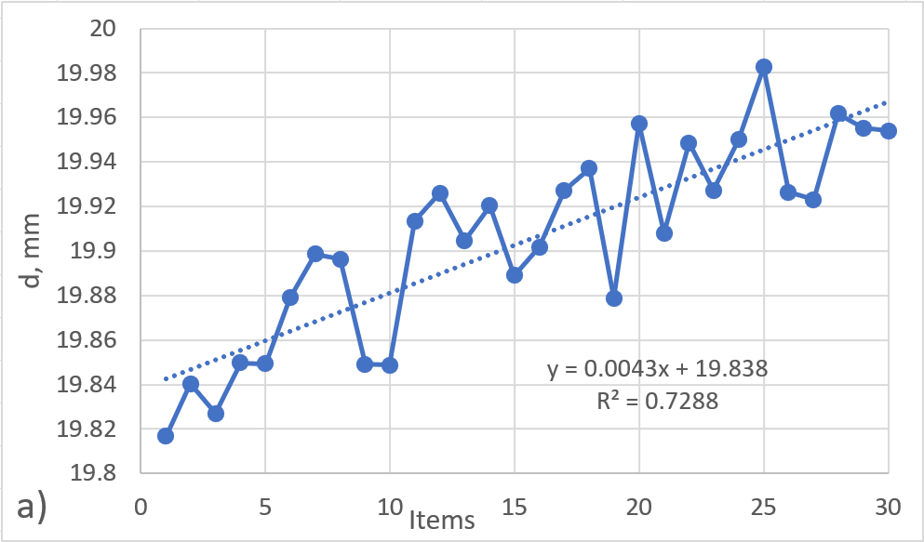
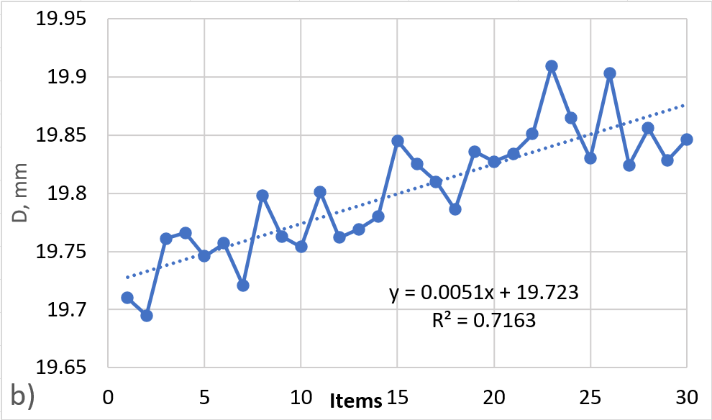
- Measured (a) shaft and (b) hole diameters for 3D printer 1 (30 parts)
The mathematical correlation models, the corresponding coefficients of determination, the standard deviations Sy, the residual standard deviations S_{res}, and the minimum and maximum values of the prediction interval for an individual value are presented in Table 2.
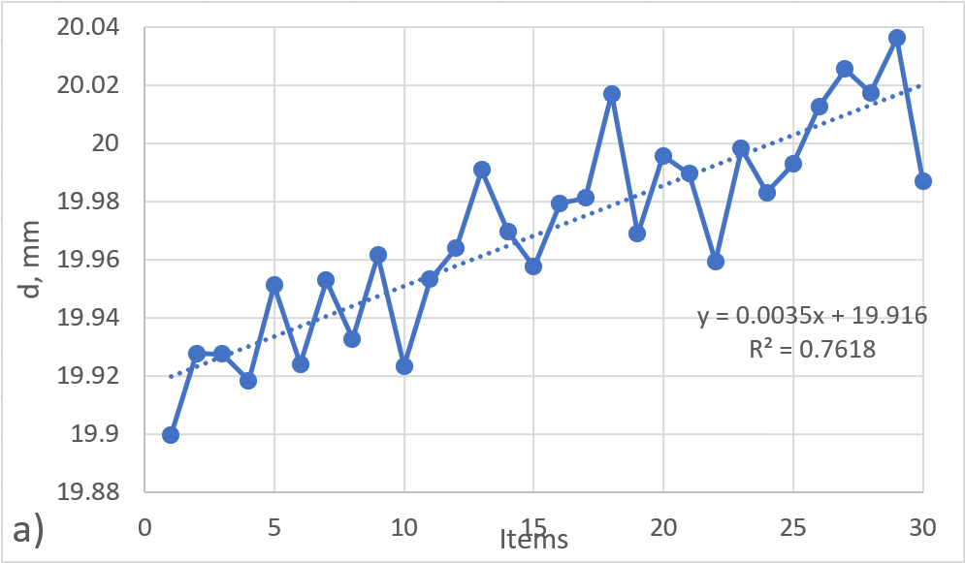
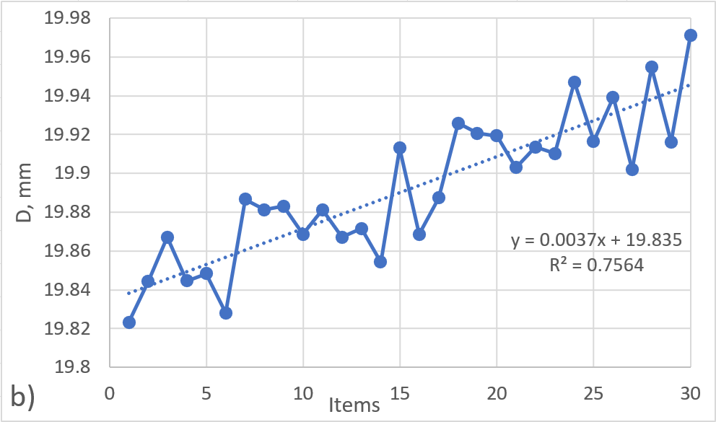
- Measured (a) shaft and (b) hole diameters for 3D printer 2 (30 parts)
The three printers used in the experiment yield different results in terms of the accuracy of the obtained diametral dimensions, and these results correlate with the design type of each printer. The smallest scatter of the measured surface dimensions is observed for the third printer.
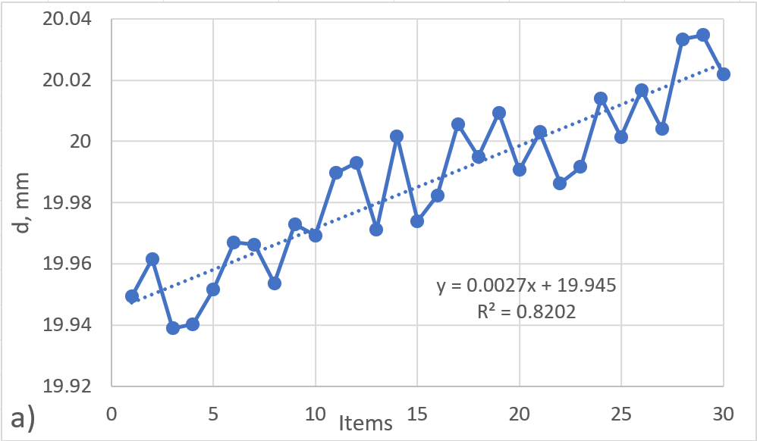
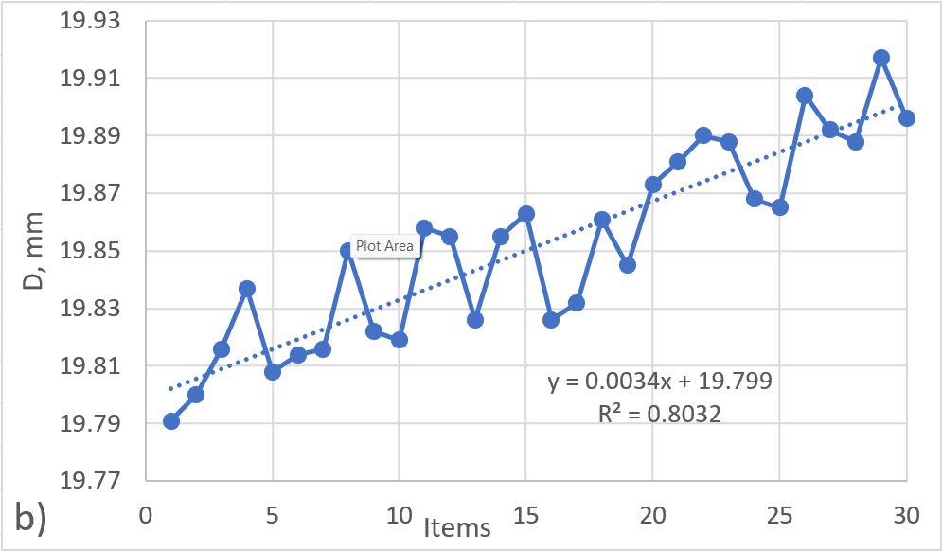
- Measured (a) shaft and (b) hole diameters for 3D printer 3 (30 parts)
This is confirmed by the standard deviations Sy obtained from the statistical processing of the data. The residual standard deviation S_{res} is used to evaluate the scatter of the current values in the samples from each experiment. Lower values of this indicator correspond to smaller fluctuations in the dimensions.
- Mathematical modeling of the results

After processing the data, and as seen from the mathematical correlation models, the presence of a systematic error (trend) is observed, represented by the second term in the model. The most probable reason for this systematic factor is thermal deformation of the printers. For the second and third 3D printers, its intensity is lower, which can be attributed to their larger overall dimensions.

Discussion
This study has several limitations that should be taken into account when interpreting the results. Only three desktop FDM printers of a similar design were analyzed. Therefore, the dependencies obtained cannot be directly transferred to other designs or industrial systems. Only one material (PLA) and one fixed set of process parameters (nozzle diameter, layer thickness, infill density, temperatures, and speeds, see Table 1) were used. Other materials and combinations of parameters could give different quantitative results. The geometry is limited to simple cylindrical parts of the shaft and sleeve type with a diameter of about 20 mm. Only diametrical dimensions are evaluated. More complex shapes, larger parts, and other types of geometric and shape deviations are not considered. The experiments were conducted in a laboratory environment with controlled environmental conditions.
In addition to the reported random effects, a number of external factors also affect dimensional accuracy. These include local temperature changes around the printer, filament quality and storage conditions, material heterogeneity, and differences between the set and actual temperatures of the nozzle and bed. Added to these are wear and tear on mechanical components and inaccurate calibration of the axes. These influences are difficult to control in daily operation and manifest themselves as additional scatter in the measured data. As a result, the transferability of the resulting correlation models to other machines and operating conditions is limited.
Knowledge of the mathematical correlation model that describes the 3D printing process for a given printer makes it possible to compensate for the systematic error. In this case, only random errors will affect the dimensional accuracy. Analysis of the causes of the random scatter makes it possible to reduce the influencing factors to:
- local variation of the temperature around the printer zone, including opening of the room door
- variation in filament diameter
- material inhomogeneity
- variable moisture content of the material
- nonuniform motion (interpolation) along the axes
- nonuniform cooling in the extrusion zone

- vibrations due to external influences
Data are presented for the prediction interval for an individual value ±2 S_{res}, within which a given measured value is expected to fall with a confidence level of 95.45%. Again, a correlation is observed between the width of this interval and the printer parameters, with the third printer giving the best results. The experimental data show that, for the assembly of a shaft and a bushing, all three printers produce an interference fit. In other words, the shafts have dimensions larger than the internal diameters of the bushings. This is also confirmed by the constant term of the mathematical correlation models that describe the dimensional variation.

Conclusions
As a result of the conducted experiment, the following conclusions can be drawn:
The accuracy of the diametral dimensions of the surfaces is correlated with the size and parameters of the printers. The diametral dimensions of the parts produced on each of the printers allow only an interference fit to be obtained.
To reduce the influence of random scatter, the factors affecting dimensional accuracy, mainly those related to the environment and the material, must be minimized. The systematic factor can be compensated if the mathematical model describing the process is known.
From a practical point of view, the obtained correlation models can be used as a calibration tool for each individual printer. By measuring a small series of simple cylindrical test parts and identifying the systematic trend, the nominal CAD dimensions or the input dimensions in the slicing software can be adjusted so that the resulting parts match the desired shaft or hole size. In this way, the systematic error is compensated and only random deviations remain, which significantly improves the predictability of the fit between mating elements. The results also indicate that printers with larger overall dimensions and a more rigid structure tend to exhibit smaller systematic trends and narrower prediction intervals, which is important when selecting a machine for dimension-critical applications.
Future work will focus on extending the study to other thermoplastic materials (such as ABS, PET-G and ASA), a wider range of process parameters and more complex geometries. Additional types of dimensional and form deviations will be included in order to develop more general multivariate models that relate the process parameters and environmental conditions to the resulting part dimensions. Finally, the proposed approach will be validated on real industrial components and assemblies, with the aim of formulating design guidelines and tolerance recommendations for FDM parts used in functional mechanical joints.
The mathematical models describing the change of part dimensions as a function of time can be used to predict the resulting part dimension and to compensate it, in order to obtain the desired diametral dimensions of the mating elements. Based on the known mathematical model, it becomes possible in practice to realize all three types of fits: clearance, transition, and interference.

Acknowledgment
This study is financed by the European Union - NextGenerationEU, through the National Recovery and Resilience Plan of the Republic of Bulgaria, project № BG-RRP-2.013-0001.

References
- T. G. Felix Leitenberger, “Architecture of the Digital Twin in Product Validation for the Application in Virtual-Physical Testing to Investigate System Reliability,” DS 111: Proceedings of the 32nd Symposium Design for X. The Design Society, 2021. doi: 10.35199/dfx2021.10.
- E. Y. Hua, S. Lazarova-Molnar, and D. P. Francis, “Validation of Digital Twins: Challenges and Opportunities,” 2022 Winter Simulation Conference (WSC). IEEE, pp. 2900–2911, Dec. 11, 2022. doi: 10.1109/wsc57314.2022.10015420.
- E. Kluska, P. Gruda, and N. Majca-Nowak, “The Accuracy and the Printing Resolution Comparison of Different 3D Printing Technologies,” Transactions on Aerospace Research, vol. 2018, no. 3, pp. 69–86, Sept. 2018, doi: 10.2478/tar-2018-0023.
- K. Antreas and D. Piromalis, “Employing a Low-Cost Desktop 3D Printer: Challenges, and How to Overcome Them by Tuning Key Process Parameters,” mechanics, vol. 10, no. 1, pp. 11–19, Apr. 2021, doi: 10.5923/j.mechanics.20211001.02.
- M. M. Hanon, L. Zsidai, and Q. Ma, “Accuracy investigation of 3D printed PLA with various process parameters and different colors,” Materials Today: Proceedings, vol. 42, pp. 3089–3096, 2021, doi: 10.1016/j.matpr.2020.12.1246.
- B. Ekinci and A. Ehrmann, “Influence of Printing Parameters on the Dimensional Accuracy of Concave/Convex Objects in FDM Printing,” ASEC 2022. MDPI, p. 40, Dec. 05, 2022. doi: 10.3390/asec2022-13811.
- I. Grgić, M. Karakašić, H. Glavaš, and P. Konjatić, “Accuracy of FDM PLA Polymer 3D Printing Technology Based on Tolerance Fields,” Processes, vol. 11, no. 10, p. 2810, Sept. 2023, doi: 10.3390/pr11102810.
- J. R. Chen, J. Morris, A. Wentworth, V. Sears, A. Duit, E. Erie, K. McGee and S. Leng, “Three-dimensional printing accuracy analysis for medical applications across a wide variety of printers,” J. Med. Imag., vol. 10, no. 02, Apr. 2023, doi: 10.1117/1.jmi.10.2.026501.
- M. N. Ahmad, M. R. Ishak, M. M. Taha, F. Mustapha and Z. Leman, “A Review of Natural Fiber-Based Filaments for 3D Printing: Filament Fabrication and Characterization,” Materials, vol. 16, no. 11, p. 4052, May 2023, doi: 10.3390/ma16114052.
- https://www.solidworks.com, SolidWorks, 3D Design Software, 2025. Accessed: 17 Nov. 2025
- https://www.3dmingda.com, 3D printing R&D and production, Shenzhen MINGDA Technology Co., Ltd., 2025. Accessed: 17 Nov. 2025
- https://www.aberlink.com, Three-coordinate measuring machine, 2025. Accessed: 17 Nov. 2025

