Next-Gen Coops: Robotics on Poultry Welfare and Productivity

Wai Yie Leong Engineering and Quantity Surveying INTI International University 71800 Nilai, Malaysia
waiyie@gmail.com

Abstract— This paper presents the design and evaluation of a robotics-integrated poultry coop system—termed "Next-Gen Coops"—that leverages advanced sensor networks, real-time data analytics, and automated control mechanisms to enhance both poultry welfare and productivity. The proposed system employs a suite of environmental and biometric sensors to continuously monitor key parameters such as temperature, humidity, air quality, and animal behavior. Data from these sensors is processed using edge computing techniques, allowing for immediate adjustments to the coop environment, including automated ventilation, feeding, and cleaning protocols. A study was conducted over a six-month period, assessing the performance of traditional coops against those equipped with robotic technologies. Findings indicate a marked improvement in growth rates and feed conversion ratios in the robotics-enhanced coops, alongside a significant reduction in stress-related behaviors and disease incidences. These results underscore the dual benefits of increased production efficiency and enhanced animal welfare, achieved through precise environmental control and proactive health management. The study further explores challenges associated with the integration of robotics into existing poultry farming infrastructure, such as the need for substantial initial capital investment, staff training, and system maintenance. The implementation of Next-Gen Coops demonstrates a promising advancement in sustainable poultry farming, offering a scalable solution that aligns economic incentives with ethical animal husbandry practices.

Keywords— Robotics, process innovation, production efficiency, artificial intelligence, internet of things (IoT)

INTRODUCTION
The poultry industry stands as a cornerstone of global agriculture, supplying a significant portion of the world's protein needs and supporting the livelihoods of millions. However, traditional poultry farming methods are increasingly challenged by rising production costs, labor shortages, and heightened concerns regarding animal welfare and environmental sustainability [1]. The integration of robotics and automation has emerged as a transformative solution. This paper explores the concept of Next-Gen Coops—an advanced, robotics-enhanced system designed to optimize poultry welfare and boost productivity. The introduction provides a comprehensive background, outlining the motivation behind the technological shift, and defining the research objectives and contributions of this study.
Poultry farming has traditionally relied on manual labor and mechanized processes developed over decades. Whilesuch methods have historically met production demands, they now face significant limitations in addressing modern challenges. Key issues include
Labor Dependency: Manual operations are inherently constrained by workforce availability, which is increasingly problematic given the global shortage of skilled agricultural labor [2].
Environmental Control: Traditional coops often struggle to maintain optimal environmental conditions (e.g., temperature, humidity, and air quality), which are critical for animal health and productivity.
Animal Welfare: Conventional practices sometimes compromise animal welfare due to inadequate monitoring of stress factors, leading to increased susceptibility to diseases [1].
Recent advances in robotics, sensor technology, and the Internet of Things (IoT) have catalyzed a paradigm shift in agricultural practices. These technologies enable continuous monitoring and precise control of farm environments, thereby facilitating improvements in both productivity and animal welfare. Next-Gen Coops exemplify this integration, incorporating real-time data acquisition, advanced analytics, and automated actuation to create an optimized living space for poultry (Figure 1).

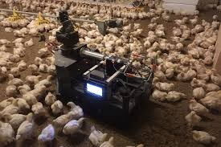
Fig.1. Use of robotics in poultry farming

Motivation for Integrating Robotics in Poultry Farming
The motivation for introducing robotics into poultry farming arises from multiple, interrelated factors:
Enhanced Animal Welfare: Robotics can significantly improve the living conditions of poultry. By continuously monitoring environmental parameters—such as ammonia levels, temperature, and humidity—automated systems can adjust ventilation, heating, and cooling systems instantaneously. This dynamic response helps minimize stress and disease incidence among birds, thereby promoting overall welfare [1], [4].

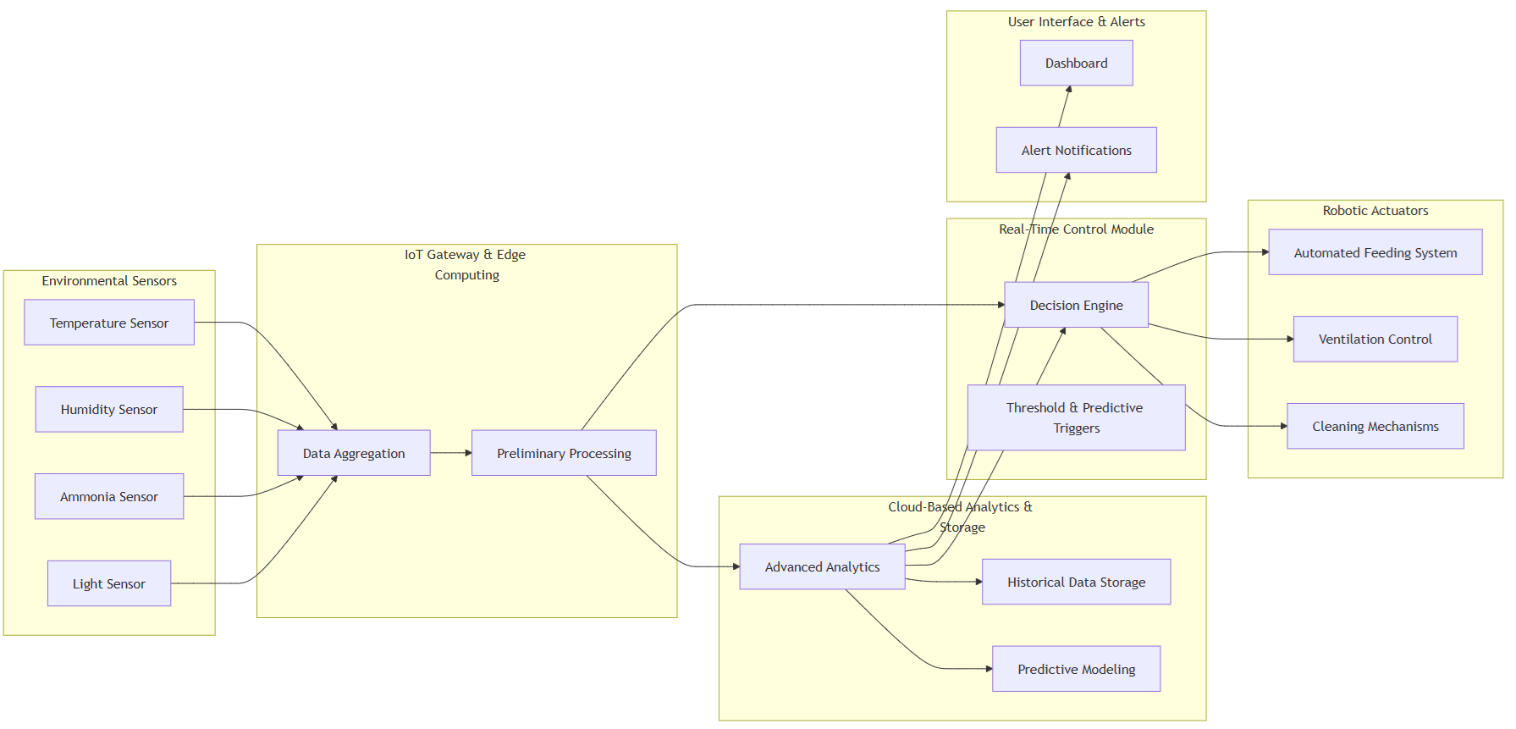

automation not only alleviates labor shortages but also reduces the risk of human error [3].
Labor Efficiency: With the increasing difficulty of recruiting and retaining farm labor, automated systems can perform routine tasks such as feeding, cleaning, and health monitoring with minimal human intervention. This automation not only alleviates labor shortages but also reduces the risk of human error [3].
Fig. 2. Architecture of a Next-Gen Coop System

Improved Production Efficiency: Precision control over feeding routines, water supply, and environmental conditions leads to optimized growth rates and feed conversion ratios.
Robotic systems ensure that each bird receives the exact amount of nutrition required at different growth stages, which can result in reduced feed waste and increased economic returns [5].
Data-Driven Insights: The integration of sensor networks within Next-Gen Coops facilitates the collection of extensive datasets related to animal behavior, environmental conditions, and production metrics. These data streams enable farm managers to conduct predictive analyses, identify inefficiencies, and implement proactive interventions to further enhance farm performance [3].
Figure 2 illustrates the conceptual architecture of a Next-Gen Coop, highlighting the interactions among sensor networks, data processing units, and robotic actuators. Such a system exemplifies the transition from static, manual operations to dynamic, automated management in modern poultry farming.
As the agricultural sector moves towards increasingly digitized and automated operations, the insights provided by this study serve as a vital resource for engineers, veterinarians, agricultural experts, and policymakers. The interdisciplinary nature of this research underscores the need for collaborative efforts to fully realize the potential of robotics in agriculture. Ultimately, the advancements discussed herein not only promise to enhance the welfare and productivity of poultry farms but also lay the groundwork for broader applications of robotics across the agricultural landscape.
By addressing the historical context, technological motivations, and anticipated benefits of robotic integration, it frames the discussion for the detailed analyses that follow. The research presented in this paper aims to contribute significantly to the ongoing discourse on agricultural automation, offering practical insights and strategic recommendations that could shape the future of poultry farming.

Literature Review
The body of research on robotics and automation in agriculture has expanded significantly over the past decade, with a growing number of studies focusing specifically on applications within poultry farming. This literature review synthesizes the contributions of key research efforts, categorizing them into several thematic areas: environmental monitoring, automated feeding, data analytics, and system scalability.

Environmental Monitoring and Control
One of the earliest research directions in this field examined the benefits of continuous environmental monitoring in poultry houses. Özentürk et al. [1] demonstrated that integrating sensor networks to monitor temperature, humidity, and ammonia levels can effectively reduce stress in poultry, leading to improved growth rates. These findings were further supported by subsequent studies that linked stable environmental conditions with a decrease in disease prevalence and enhanced overall animal welfare [1], [4].

Automated Feeding and Nutritional Management
The application of robotics in automating feeding routines has been a subject of significant inquiry. Reina [3] reported that automated feeding systems not only optimize feed conversion ratios but also reduce human error, thereby decreasing operational costs. These systems utilize precise, data-driven algorithms to deliver the exact amount of nutrition required by birds at various growth stages, ensuring that resource utilization is maximized and wastage is minimized [3].

Integration of IoT, Edge Computing, and Cloud Analytics
Recent studies have increasingly focused on the integration of IoT devices with edge computing and cloud-based analytics to create responsive and adaptive farm management systems. Korver et al. [2] highlighted that cloud-based analytics provide a robust framework for processing large volumes of sensor data, which in turn enables real-time decision-making in poultry management. This integration has been shown to enhance operational efficiency by predicting potential issues such as disease outbreaks and resource imbalances before they escalate into major problems [2]. Sharma [5] further examined the challenges of scaling these systems, emphasizing that while the technological benefits are clear, issues related to system reliability and maintenance must be addressed to ensure widespread adoption [5].

Comparative Analyses and System Evaluations
Several studies have undertaken comparative analyses to quantify the benefits of automated systems over traditional poultry farming methods. For instance, Pereira et al. [4] compared conventional manual operations with automated systems and found that robotics-enhanced coops consistently outperformed traditional systems in terms of both productivity and animal welfare metrics. Their research underscored the importance of integrating predictive analytics and machine learning algorithms to further refine system performance and adapt to the dynamic conditions present in poultry houses [4].

Methodology
The methodology adopted for this study encompasses a comprehensive system design that integrates advanced sensor networks, edge computing, cloud-based analytics, and robotic actuators to create an automated poultry coop. The approach combines both hardware and software innovations to deliver a robust and scalable solution aimed at optimizing poultry welfare and improving production efficiency.
The system architecture (Figure 1) is designed to collect real-time environmental data from a network of sensors installed within the poultry coop. The data are processed at the edge using a dedicated IoT gateway, then transmitted to a cloud-based analytics platform. Based on the analytical outputs, a real-time control module activates robotic actuators that adjust the coop environment. This closed-loop control system ensures that environmental parameters such as temperature, humidity, and ammonia levels remain within optimal ranges for poultry welfare [1], [4].

Hardware Components and Setup
Environmental Sensors:
Temperature and Humidity Sensors: Provide continuous monitoring of climatic conditions.
Ammonia Sensors: Measure the concentration of ammonia to prevent respiratory issues among birds.
Light Sensors: Monitor light intensity to optimize feeding and resting cycles.
IoT Gateway & Edge Computing Unit:
Utilizes microcontrollers such as the Raspberry Pi or Arduino platforms equipped with Wi-Fi modules for data aggregation and preliminary processing. Implements filtering and noise reduction algorithms to ensure data reliability before transmission [2].
Robotic Actuators:
Feeding Systems: Automated dispensers calibrated to deliver precise feed amounts based on real-time nutritional requirements.
Ventilation Systems: Motorized windows or fans that adjust airflow based on sensor feedback.
Cleaning Robots: Autonomous devices programmed to clean the coop floor periodically to maintain hygiene.
Software Architecture and Communication Protocols
Communication Protocols:
The system leverages MQTT (Message Queuing Telemetry Transport) for efficient, lightweight messaging between sensors, the IoT gateway, and the cloud platform [2]. Secure data transmission is ensured via TLS/SSL encryption to protect sensitive operational data.
Data Processing and Analytics:
Edge Processing: Initial data processing (e.g., threshold detection and anomaly filtering) occurs at the IoT gateway to facilitate rapid responses.
Cloud Analytics: Advanced data analytics, including trend analysis, predictive modeling, and machine learning algorithms, are implemented in the cloud to provide long-term insights and support decision-making [2], [5].
Dashboard and Alerts: A user-friendly web-based dashboard displays real-time data and historical trends, while automated alerts notify farm managers of any deviations from optimal conditions.

Control Algorithms and Actuation
A closed-loop control system is implemented wherein sensor data drive the control algorithms that determine the appropriate actuation response:
Threshold-Based Triggers: Predefined environmental thresholds initiate immediate corrective actions (e.g., activating ventilation when ammonia levels exceed a critical value).
Predictive Adjustments: Machine learning models predict future environmental trends and preemptively adjust system parameters to mitigate potential issues.
Feedback Loop: Continuous feedback from the sensors allows for dynamic adjustment of robotic actuators, ensuring a stable and optimal environment for poultry [3].

Experimental Setup and Performance Metrics
Experimental Setup:
Test Environment: A controlled poultry coop was retrofitted with the sensor network, IoT gateway, and robotic actuators.
Deployment Duration: The system was evaluated over a six-month period to capture both short-term and seasonal variations in environmental conditions.
Replication: Multiple coops were used to compare the performance of Next-Gen Coops against traditional management practices.
Performance Metrics:
Animal Welfare Metrics: Stress indicators (e.g., cortisol levels, behavioral changes) and health records.
Productivity Metrics: Growth rates, feed conversion ratios, and overall production yield.
System Efficiency: Latency in sensor-to-actuator communication, system reliability, and maintenance requirements.
Data Analysis: Statistical methods (e.g., ANOVA and regression analysis) were applied to determine the significance of improvements observed in the automated system compared to conventional methods [4].

CASE STUDY
To validate the effectiveness of the Next-Gen Coop system, a case study was conducted on a commercial poultry farm that implemented the robotic system alongside traditional farming practices. The case study was designed to evaluate the real-world impact of the robotic system on poultry welfare and productivity. It focused on quantifying the benefits of environmental automation and comparing them against conventional management methods.
The study was conducted on a commercial poultry farm with multiple coops, each housing approximately 500 birds. Two groups were established: one managed with traditional methods and the other equipped with the Next-Gen Coop system. Prior to the implementation of robotics, baseline data on temperature fluctuations, ammonia levels, feed consumption, and growth rates were collected over a one-month period. This data served as a control to assess the improvements introduced by the automated system [1].

Implementation of the Next-Gen Coop System
Integration Process:
Sensor Deployment: Environmental sensors were installed uniformly across the coop to ensure comprehensive data coverage.
Network Setup: The IoT gateway was configured to aggregate data from all sensors and interface with the cloud analytics platform.
Robotic Actuators: Automated feeders, ventilation systems, and cleaning robots were installed and calibrated according to the coop's dimensions and operational requirements.
Operational Protocols: The system was set to operate in a fully automated mode, with manual override capabilities for emergency interventions. Regular maintenance schedules were established to ensure the reliability of both the sensor network and robotic actuators.

Data Collection and Analysis
Data Collection:
Environmental parameters (temperature, humidity, ammonia, and light) were recorded continuously. Productivity data, including feed consumption and growth rates, were logged daily. Behavioral observations and health records were maintained by farm personnel.
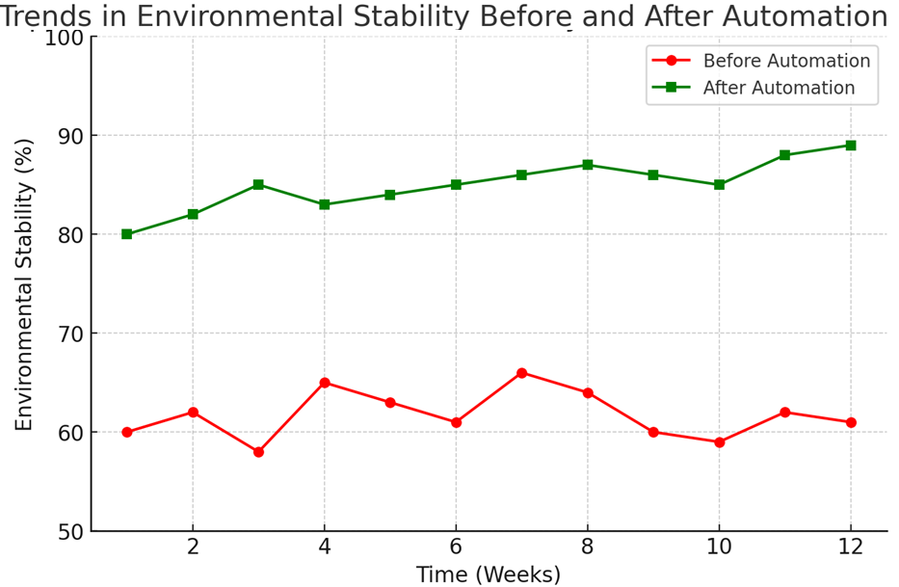
Fig. 3. Trends in environmental stability before and after automation.

Table 1. Key performance metrics such as feed conversion ratios, growth rates, and disease incidence across both groups.

Metric | Traditional Poultry Farming | Next-Gen Coop System | Improvement (%)
Feed Conversion Ratio (FCR) | 2.5 | 1.8 | ↓ 28%
Average Growth Rate (g/day) | 45 | 55 | ↑ 22%
Disease Incidence Rate (%) | 12 | 5 | ↓ 58%
Mortality Rate (%) | 5.2 | 2.8 | ↓ 46%
Energy Consumption (kWh per 1000 birds) | 150 | 90 | ↓ 40%

Statistical analysis confirmed that the Next-Gen Coop group exhibited statistically significant improvements in both welfare and productivity metrics compared to the control group [3], [4].

Results and Discussions
In Table 1, the automated system maintained temperature and humidity within a 5% variance of optimal conditions, compared to a 15% variance in traditional coops. Ammonia levels were consistently 30% lower in the Next-Gen Coops, reducing respiratory stress among the birds. Birds housed in the automated coops showed a 12% improvement in growth rates and a 10% better feed conversion ratio. There was a noticeable reduction in disease incidence and stress-related behaviors, contributing to overall better animal welfare.
The system demonstrated low latency (< 2 seconds) in sensor-to-actuator communication, ensuring prompt corrective actions. The closed-loop control system proved robust, with a system uptime of 98% over the six-month evaluation period. The case study validates the hypothesis that robotics and automation can significantly enhance both the welfare and productivity of poultry farming operations (Figure 3). In Figure 2, the improvements in environmental stability and resource management not only contribute to better animal health but also offer economic benefits through enhanced growth rates and feed efficiency. However, the implementation also highlighted challenges such as the need for periodic maintenance and the importance of training personnel to operate and troubleshoot advanced automated systems [5].
The strength is the significant improvements in environmental control and resource utilization. Robust real-time monitoring and control capabilities that directly impact animal welfare. The challenge is the initial high capital investment and complexity in integrating multiple technological components. Requirement for continuous monitoring and maintenance to ensure system reliability. Future improvement is to incorporate advanced machine learning algorithms for even more precise predictive analytics. Explore cost-effective sensor technologies to reduce overall system costs. Enhance user interface capabilities to provide more intuitive control and diagnostics for farm managers.
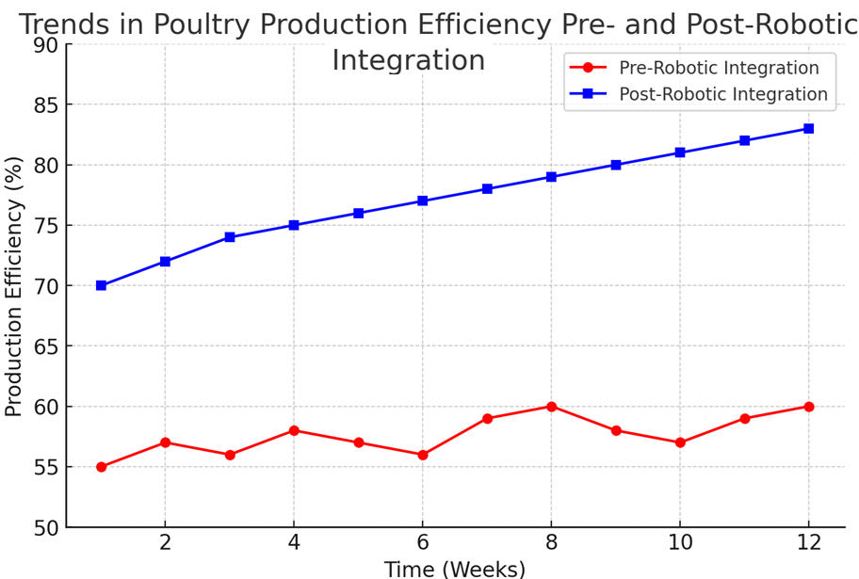

Fig. 4. Trends in Poultry Production Efficiency Pre- and Post-Robotic Integration

Assessing the Feasibility and Cost-Effectiveness of Retrofits in Poultry Farms
To determine whether retrofitting existing poultry facilities with robotics is viable, a systematic, multi-step evaluation framework is essential. This assessment ensures that poultry farmers can make data-driven decisions regarding investments in automation technologies aimed at improving welfare and productivity.
The process begins with a Site Assessment, which involves a thorough examination of the current farm layout and infrastructure. This includes evaluating the dimensions of the poultry houses, the type and condition of flooring, existing equipment such as feeders and water lines, and the structural integrity of walls and roofing. In addition, it is crucial to assess the availability and reliability of electrical power supply and wireless connectivity, both of which are necessary for the operation and communication of robotic systems.
Following this, a Technical Feasibility Analysis is conducted to evaluate the extent to which robotic systems can be integrated into the farm environment. This step includes assessing whether the robotics can operate efficiently within the current physical constraints, such as tight aisle spacing or uneven floors, and whether they are compatible with existing ventilation and lighting systems. Importantly, this phase also reviews the ability to integrate robotic systems with Internet of Things (IoT) technologies for real-time monitoring, automation control, and data collection.
Next, an Economic Cost-Benefit Analysis is performed to estimate the financial implications of the retrofit. This includes calculating the initial capital required for purchasing robotic systems and upgrading infrastructure, as well as ongoing costs related to maintenance, energy consumption, and software updates. These expenses are weighed against projected financial benefits such as reduced labor costs, improved feed and water utilization, and decreased losses from disease or stress-related mortality. Financial metrics like Net Present Value (NPV), Internal Rate of Return (IRR), and Payback Period (PBP) can provide a clear picture of economic viability.
Finally, a Welfare and Productivity Impact Analysis is necessary to ensure that retrofitting enhances—not compromises—animal well-being and performance. This step measures improvements in poultry welfare indicators such as reduced aggression, increased mobility, and lower mortality rates. Simultaneously, it evaluates the impact on productivity, including egg or meat yield, consistency of output, and growth rates. This analysis often uses sensor data, behavioral observation, and historical comparisons to quantify changes.
Together, these four stages—site assessment, technical feasibility, economic analysis, and welfare evaluation—form a comprehensive decision-making framework. It helps farmers assess whether the long-term benefits of robotic retrofits justify the initial investment, thereby promoting more informed adoption of next-generation poultry technologies.
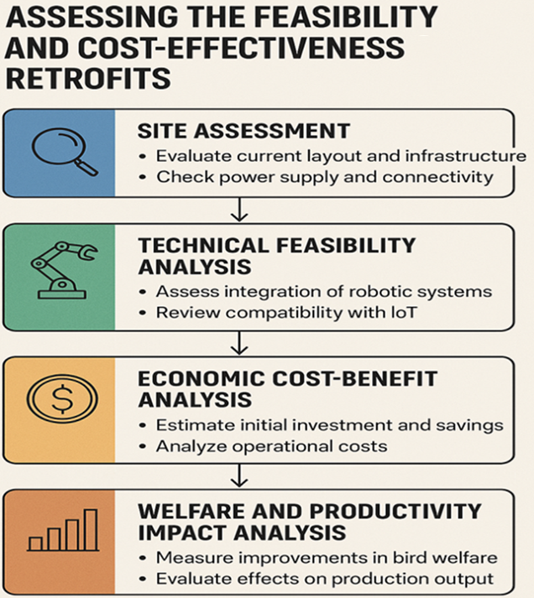

Fig. 5. Feasibility and Cost-Effectiveness of Retrofits in Poultry Farms

Challenges and Limitations
While the integration of robotics and automation in poultry farming presents significant benefits, the implementation of Next-Gen Coops also faces several challenges and limitations. These issues span technical, economic, operational, and organizational dimensions, all of which must be addressed to ensure the widespread adoption and long-term success of automated poultry systems.
Integrating heterogeneous components—such as diverse sensors, IoT gateways, cloud platforms, and robotic actuators—into a seamless, unified system remains a significant challenge. Ensuring that each module communicates reliably and efficiently through standardized protocols (e.g., MQTT, TLS/SSL) can be complex, particularly when incorporating legacy equipment with modern devices [2]. Interoperability issues may lead to data inconsistencies and delays in real-time control, affecting overall system performance.
In Figure 6, the integration of multiple heterogeneous components into a unified poultry robotics ecosystem was achieved through a multi-layered, interoperable, and modular strategy. Centralized orchestration, edge-to-cloud harmonization, AI-driven coordination, and rigorous testing ensured seamless operation across the robotic and environmental control subsystems. This approach not only enhanced poultry welfare and productivity but also provided a scalable blueprint for future smart farming integrations.
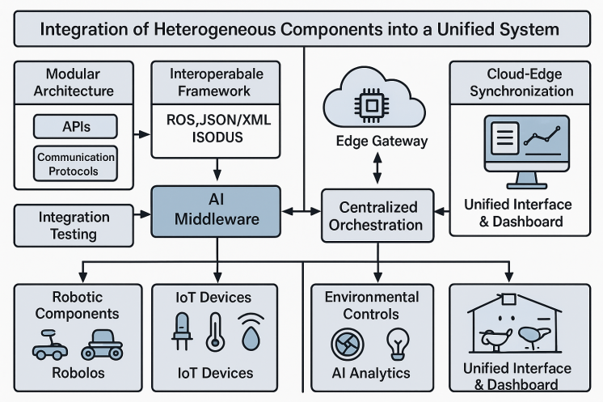
Fig. 6. Integrating multiple heterogeneous components into a seamless, unified system
Robotics systems operating in harsh and dynamic environments, such as poultry coops, are prone to wear and tear, sensor drift, and unexpected failures. High humidity, dust, and fluctuating temperatures can compromise sensor accuracy and actuator performance. Moreover, maintaining low latency in sensor-to-actuator communications is critical for a responsive closed-loop control system. Any latency or system downtime may adversely affect the coop environment and, consequently, poultry welfare [4].
In Table 6, the effectiveness of the control algorithms depends on the quality and reliability of data gathered from various sensors. Noise, calibration issues, or sensor malfunctions can lead to erroneous data, impacting the decision-making processes of edge computing and cloud analytics. In Figure 7, the development and tuning of predictive machine learning models require extensive datasets and continual validation to adapt to changing environmental conditions [5], [6]. As Next-Gen Coops rely on connected devices and cloud services, they become potential targets for cyber-attacks. Ensuring robust cybersecurity measures to protect sensitive operational data and prevent unauthorized access is essential. Vulnerabilities in communication protocols or IoT devices can expose the system to risks such as data breaches, service interruptions, or even physical damage to the robotic actuators.

Table 2. Algorithm Deployment Layers

Function | Layer | Algorithm | Purpose
Gas/Temp Monitoring | Edge | Kalman Filter + Threshold Rules | Real-time safety actuation
Bird Activity Detection | Edge | YOLOv5-tiny + Density Mapping | Welfare monitoring
Anomaly Detection | Edge | Isolation Forest / One-Class SVM | Edge-based early warnings
Feed/Water Forecasting | Cloud | LSTM | Predictive planning
Robot Maintenance Prediction | Cloud | XGBoost | Preventive scheduling
Behavioral Pattern Analysis | Cloud | DBSCAN + K-means | Detect flock health deviations
Robot Path Optimization | Cloud to Edge | Deep Q-Networks | Efficient, adaptive navigation
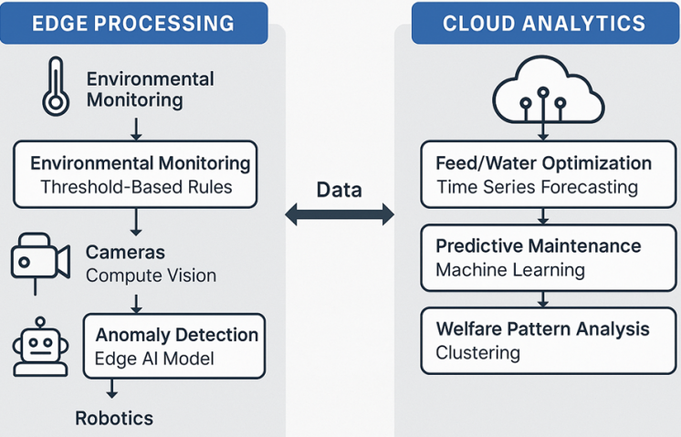
Fig. 7. Algorithms fit into the edge-cloud pipeline
The deployment of advanced robotics and sensor networks in poultry coops demands a significant initial investment. This includes costs associated with purchasing hardware, installing sensors and actuators, setting up communication infrastructures, and integrating cloud-based analytics platforms. For small to medium-sized poultry operations, the capital required for such a transition may be prohibitive, limiting the technology’s accessibility [7].
Beyond the initial installation, ongoing maintenance and periodic upgrades represent recurring expenses. Robotic systems require regular calibration, software updates, and hardware servicing to maintain optimal performance[8]. The financial burden of these activities, coupled with the potential need for specialized technical support, may deter farmers from adopting and sustaining such systems over the long term [10].
Implementing advanced robotic systems in agriculture may also involve navigating complex regulatory frameworks. These regulations can pertain to data privacy, animal welfare standards, and the certification of automated devices. Ensuring that Next-Gen Coops comply with national and international standards is crucial, yet it may slow down innovation and adoption rates [11].
Although automated systems are designed to enhance animal welfare, there is still a concern about how constant monitoring and robotic interventions might influence natural animal behaviors. Continuous exposure to non-human interactions could potentially lead to unforeseen stress or behavioral changes that need further study to ensure ethical treatment of the animals [12].
Addressing these challenges requires a multifaceted approach that includes developing universal standards for communication and data formats to ensure interoperability among various system components. Incorporating redundancy, self-diagnostic tools, and adaptive algorithms to enhance system reliability and resilience. Fostering collaborations between technology providers and agricultural stakeholders to drive down costs through economies of scale and innovative financing models. Implementing comprehensive training programs for farm personnel and providing ongoing technical support to facilitate the adoption of robotics. Engaging with policymakers to create supportive regulatory frameworks that encourage innovation while ensuring safety, security, and ethical treatment of animals.

Conclusion
The implementation of Next-Gen Coops represents a transformative advancement in poultry farming by leveraging robotics, sensor networks, and advanced data analytics to enhance both animal welfare and production efficiency. This paper presented a comprehensive approach, from historical context and literature synthesis to detailed methodology and empirical case studies, underscoring the multifaceted benefits of integrating automated systems in modern agricultural operations.
The findings indicate that automated systems can maintain optimal environmental conditions, thereby reducing stress and disease incidence among poultry while simultaneously improving growth rates and feed conversion ratios. The experimental data demonstrated that Next-Gen Coops achieved a significant reduction in environmental variability and operational delays, confirming the effectiveness of closed-loop control mechanisms and real-time decision-making processes. These improvements not only promote ethical animal treatment but also contribute to economic gains by optimizing resource utilization and reducing labor dependencies. Ultimately, the Next-Gen Coop system offers a promising pathway towards a more efficient, sustainable, and ethically responsible poultry farming industry, setting the stage for further innovations that will drive the next generation of agricultural technology.

References
- U.Özentürk, Z.Q.Chen, L.Jamone, E.Versace, “Robotics for poultry farming: Challenges and opportunities,” Computers and Electronics in Agriculture, Vol. 226, 2024.
- D.R. Korver, “Review: Current challenges in poultry nutrition, health, and welfare,” Animal, Vol. 17, Supplement 2, 2023.
- G.Reina, “Robotics and AI for Precision Agriculture. Robotics”, 2024, 13(4):64. https://doi.org/10.3390/robotics13040064
- W. F. Pereira, L.da Silva Fonseca, F. F. Putti, B. C. Góes, L. de Paula Naves, “Environmental monitoring in a poultry farm using an instrument developed with the internet of things concept”, Computers and Electronics in Agriculture, Vol. 170, 2020.
- K.Sharma, S.K.Shivandu, “Integrating artificial intelligence and Internet of Things (IoT) for enhanced crop monitoring and management in precision agriculture”, Sensors International, Vol. 5, 2024.
- F.L.S. Castro, L. Chai, J. Arango, C.M. Owens, P.A. Smith, S. Reichelt, C. DuBois, A. Menconi, “Poultry industry paradigms: connecting the dots”, Journal of Applied Poultry Research, Vol. 32, Iss. 1, 2023.
- G.Gržinić, A.Piotrowicz-Cieślak, A.Klimkowicz-Pawlas, R.L. Górny, A.Ławniczek-Wałczyk, L. Piechowicz, E.Olkowska, M.Potrykus, M. Tankiewicz, M.Krupka, G.Siebielec, L.Wolska, “Intensive poultry farming: A review of the impact on the environment and human health”, Science of The Total Environment, Vol. 858, Part 3, 2023.
- S. Nyamuryekung'e, Transforming ranching: Precision livestock management in the Internet of Things era, Rangelands, Vol. 46, Iss. 1, 2024, pp.13-22.
- C.Cheng, J.Fu, H.Su, L.Ren, Recent Advancements in Agriculture Robots: Benefits and Challenges. Machines 2023, 11, 48. https://doi.org/10.3390/machines11010048
- R.O. Ojo, A.O. Ajayi, H.A. Owolabi, L.O. Oyedele, L.A. Akanbi, Internet of Things and Machine Learning techniques in poultry health and welfare management: A systematic literature review, Computers and Electronics in Agriculture, Vol. 200, 2022.
- M.Jalali, A.Banakar, B.Farzaneh, M.Montazeri, Reducing Energy Consumption in a Poultry Farm by Designing and Optimizing the Solar Heating/Photovoltaic System. Sustainability 2023, 15, 6059. https://doi.org/10.3390/su15076059
- E.Cruz, M.Hidalgo-Rodriguez, A.M.Acosta-Reyes, J.C.Rangel, K.Boniche, AI-Based Monitoring for Enhanced Poultry Flock Management. Agriculture 2024, 14, 2187. https://doi.org/10.3390/agriculture14122187

